**Sudoku Visualizer Application**

*Project report (PEP) submitted in fulfilment of the requirements for the Degree of*



**BACHELOR OF TECHNOLOGY in**

**COMPUTER SCIENCE AND ENGINEERING**

By

**KRITI**

**(12217521)**

SUBJECT

9SK01 - CSES003

**School of Computer Science and Engineering**

Lovely Professional University

Phagwara, Punjab (India) July, 2024 INDEX

|  |  |  |
| --- | --- | --- |
| Sno. | Topics | Page no. |
| 1. | Introduction | 3 |
| 2. | FeaturesCore FeaturesAdditional Features | 4-5 |
| 3. | Technical DetailsClass StructureKey MethodsGUI Components | 6-7 |
| 4. | User Experience | 8 |
| 5. | Future Enhancements | 8 |
| 6. | Images | 9-10 |
| 7. | Github Link | 11-14 |
| 8 | Conclusion | 15 |

**Introduction**

The Sudoku Visualizer application is a graphical user interface (GUI) tool developed using Java Swing. It allows users to solve Sudoku puzzles, receive hints, and visualize the solving process step-by-step. The application generates random Sudoku puzzles and provides functionalities for solving, hinting, and resetting the puzzle. Additionally, users can manually input numbers into the Sudoku grid, with real-time validation to ensure correct entries.

Sudoku is a logic-based, combinatorial number-placement puzzle. The objective is to fill a 9x9 grid with digits so that each column, each row, and each of the nine 3x3 subgrids that compose the grid (also called "boxes", "blocks", or "regions") contain all of the digits from 1 to 9. The puzzle starts with some cells already filled with numbers, and the goal is to complete the grid following these constraints.

Rules of Sudoku:

* Each row must contain the digits 1 to 9 without repetition.
* Each column must contain the digits 1 to 9 without repetition.
* Each 3x3 subgrid must contain the digits 1 to 9 without repetition.

**Features**

1. Core Features

* Random Sudoku Puzzle Generation: The application generates random Sudoku puzzles using a backtracking algorithm. The puzzle includes both filled and empty cells, adhering to standard Sudoku rules.
* Sudoku Solver: The application includes a solver that uses a backtracking algorithm to find the solution to the puzzle. The solving process is visualized step-by-step, with a delay adjustable by the user.
* Hint Provider: Users can request a hint, which will provide a valid number for one of the empty cells.
* Input Validation: The application validates user inputs in real-time. If the input is invalid (i.e., not between 1 and 9 or violates Sudoku rules), the cell background turns red. If the input is valid, the cell background turns yellow.
* Puzzle Reset: Users can reset the puzzle to its initial state, preserving the originally generated numbers and clearing user inputs.
* Control Buttons: The interface includes buttons for solving the puzzle, providing hints, resetting the puzzle, and exiting the application.

1. Additional Features

* Adjustable Solving Speed: A slider allows users to adjust the delay between steps in the solving process, providing control over the visualization speed.
* Stop Button: Users can stop the solving process at any time, which is useful for observing the intermediate steps or if they decide to solve the puzzle manually.
* End Game Button: An "Exit Game" button allows users to close the application.

**Technical Details**

1. Class Structure

* SudokuFrame: The main class extending JFrame and representing the Sudoku Visualizer application. It initializes the GUI components and handles user interactions.
* SolverWorker: A nested class extending SwingWorker, responsible for solving the Sudoku puzzle in a background thread and updating the GUI to visualize the solving process.
* SudokuStarter: A Starter class which is have start button to start the game.

1. Key Methods

* SudokuFrame Constructor: Initializes the GUI components, including the Sudoku grid, buttons, and slider.
* Sets up the initial Sudoku puzzle and adds event listeners to the buttons and cells.
* validateInput(int row, int col): Validates the user input in the specified cell, changing the cell background color based on the validity of the input.
* generateRandomSudoku(): Generates a random Sudoku puzzle by filling the diagonal blocks, filling the remaining cells, and removing digits to create a puzzle.
* solveWithVisualization(int[][] board): Solves the Sudoku puzzle using a backtracking algorithm with visualization. The method publishes intermediate states of the board to update the GUI.
* resetBoard(): Resets the Sudoku board to its initial state, clearing user inputs and restoring the original puzzle.

1. GUI Components

* JTextField[][] cells: A 2D array of text fields representing the Sudoku grid cells.
* JButton solveButton, hintButton, resetButton, EndButton, stopButton: Buttons for solving the puzzle, providing hints, resetting the puzzle, exiting the application, and stopping the solver, respectively.
* JSlider speedSlider: A slider to adjust the speed of the solving visualization.

**User Experience**

The Sudoku Visualizer provides an intuitive and interactive user experience. Users can easily input numbers, receive real-time feedback on their inputs, and visualize the solving process. The adjustable solving speed and the ability to stop the solver provide flexibility and control over the visualization.

**Future Enhancements**

* Improved Puzzle Generation: Implement more sophisticated puzzle generation algorithms to ensure a wider variety of puzzles with varying difficulty levels.
* Enhanced Hint System: Provide more detailed hints, such as highlighting rows, columns, or blocks where the next valid number can be placed.
* User Customization: Allow users to create and solve their own custom Sudoku puzzles.
* Performance Optimization: Optimize the solving algorithm to handle larger puzzles or different variants of Sudoku.
* Additional Visual Aids: Implement visual aids such as highlighting conflicting cells or showing possible candidates for each cell.

**Images**

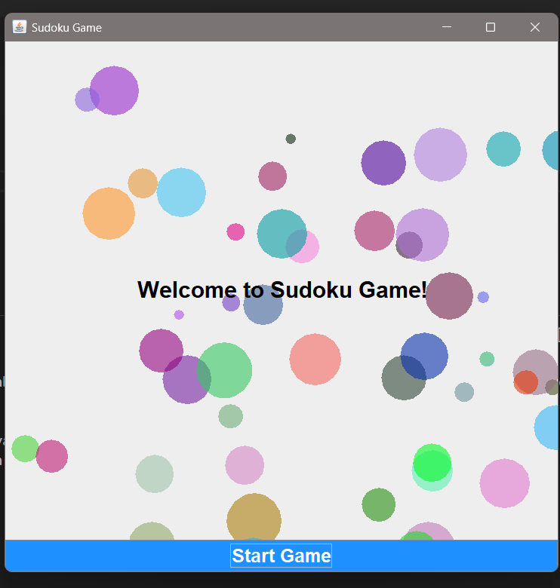

Starting page

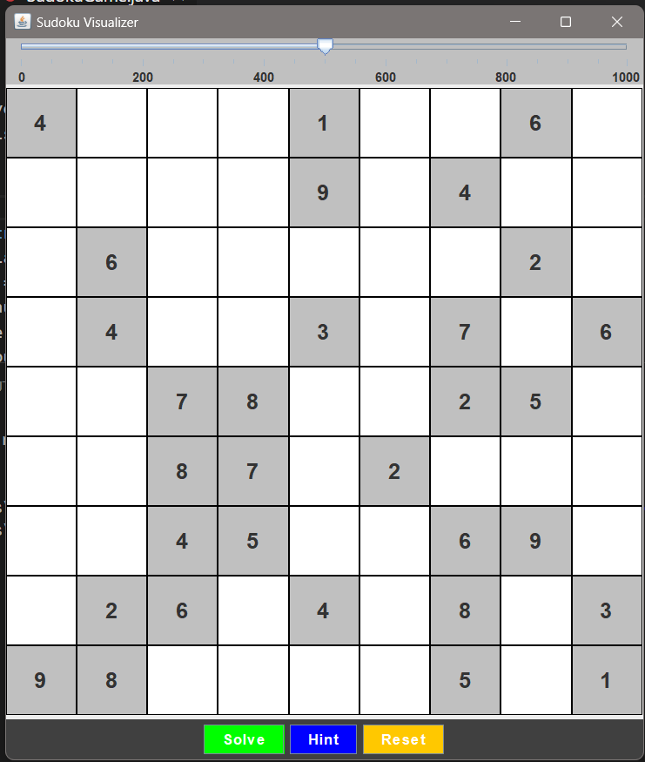 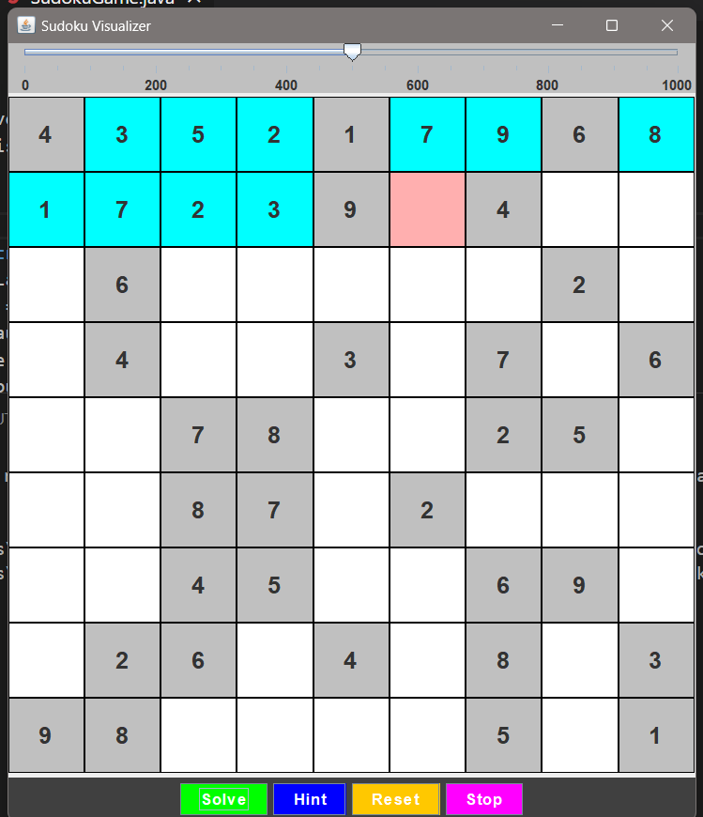 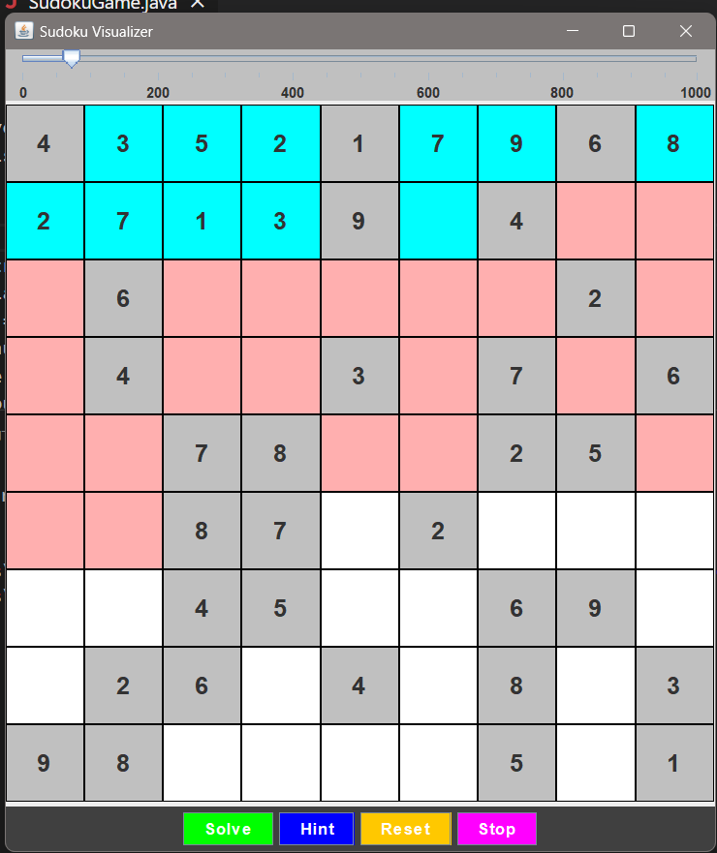 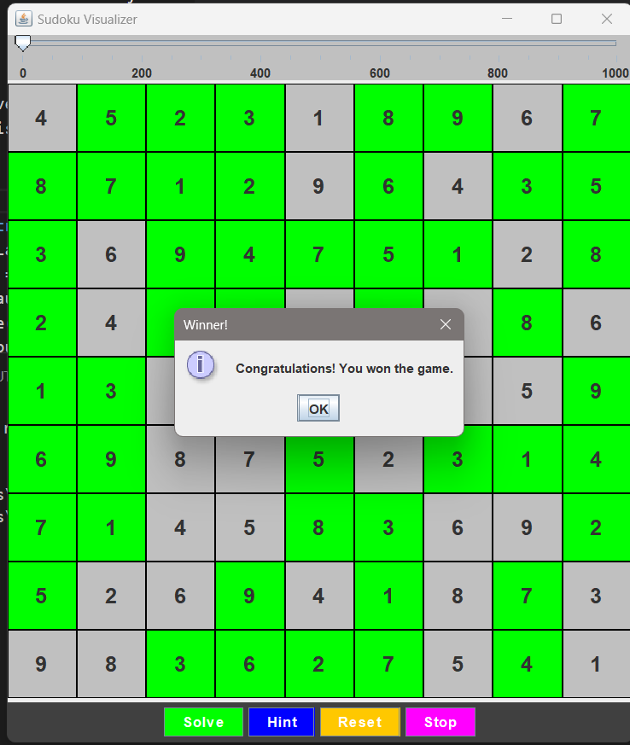 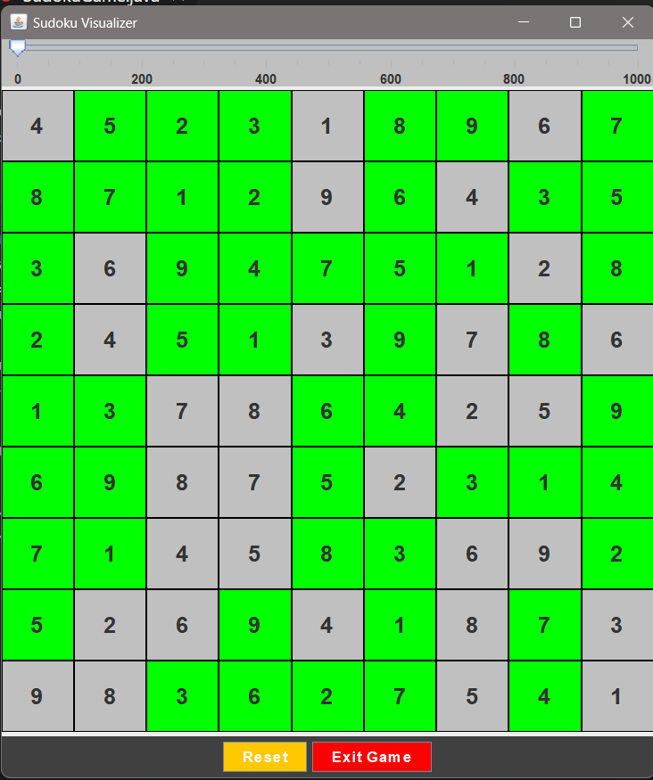

Sudoku 1st page

Solving

Backtracking

Solved

Exit

**Github Link**

[**https://github.com/yesiamkriti/SudokuVisualizer**](https://github.com/yesiamkriti/SudokuVisualizer)

**Conclusion**

The Sudoku Visualizer application is a robust tool for solving and visualizing Sudoku puzzles. With its interactive features, real-time validation, and adjustable solving speed, it offers an engaging experience for both casual users and Sudoku enthusiasts. Future enhancements can further improve its functionality and user experience, making it a comprehensive tool for Sudoku puzzle solving and visualization.