Using Heroku

First, a membership must be created to access the Heroku platform.

You can use the Signup Heroku page for this process. After creating the account and logging in, we need to define the SSH Key from the Account Settings page.

In this way, we will be able to easily transfer the applications we developed on our computer to Heroku via SSH via the Heroku CLI. First, let's install the CLI.

Heroku CLI

We can download Heroku to our computer in many ways4.

Homebrew is of course one of them.



After the download, we can find out whether the download is healthy or not by checking the version.

If you don't get an error message, everything is fine. Now we need to integrate our subscription that we created on the heroku web page with the CLI.

After executing this command, the Heroku CLI Login page will open in our default browser. After entering our user information correctly, we can now control heroku with the CLI. Don't forget, you can get an autocomplete notification after the installation process. For Autocomplete configuration, simply execute the following command.



Separate completion paths for bash and zsh will be forwarded after the command is executed:

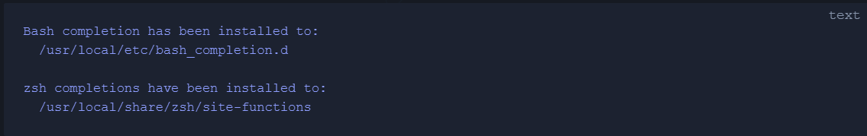

Finally, we can end the process by executing the following command for Zsh.