Name of the task : researching javascript libraries and frameworks

Estimate time of task : 3 hours

Actual time of task : 3 hours

**What is JavaScript Framework? Why use them at all?**

**JS frameworks are JavaScript programming libraries that have pre-written code to use for standard programming functions and tasks. It’s a framework to create websites or web applications around.**

**Let’s start with why do we need JavaScript frameworks?   
First and foremost, it will increase your productivity. Think of it as a workaround of sorts: you have to write fewer code manually because there are already pre-written and ready-to-use functions and patterns. Some components of the website do not need to be custom-made, so you can build and expand on pre-built ones. Frameworks are more adaptable for website design and most website developers prefer it.**

**Top 10 JavaScript framework for Web Developers**

**I am going to share some of the most useful JavaScript frameworks and library you can use for web development. The list includes frameworks like [Angular](https://javarevisited.blogspot.com/2018/06/top-10-angular-tutorials-and-courses-for-web-developers.html" \l "axzz5Ie75bPFF), Ember.JS,**[**Node.JS**](http://javarevisited.blogspot.sg/2018/01/top-5-nodejs-and-express-js-online-courses-for-web-developers.html)**, and libraries like [jQuery](http://www.java67.com/2018/04/top-5-free-jquery-courses-for-web-developers.html) and**[**ReactJS**](https://hackernoon.com/the-2018-react-js-roadmap-4d0a43814c02)

**1.Node.js**

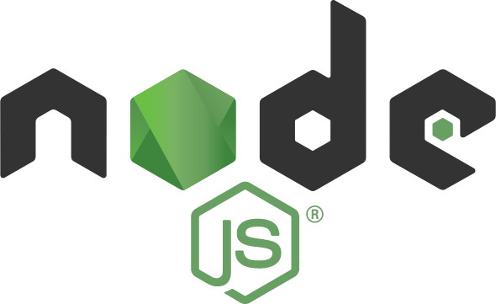

**Node.js is an open-source, server-side platform built on the Google Chrome JavaScript Engine.**

**It’s also free and runs on various platforms (Windows, Linux, Unix, Mac OS X, etc.) Node.js uses an asynchronous, event-driven, non-blocking I/O model that makes it lightweight and efficient.**

**Node.js’ package ecosystem, npm, is also the largest ecosystem of open source libraries in the world.**

**2.React JS**

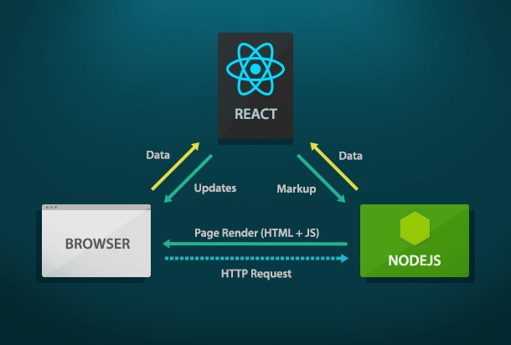

**What You Should Already Know**

**Before starting with React.JS, you should have intermediate experience in:**

**• HTML**

**• CSS**

**• JavaScript**

**What is React?**

**React is a JavaScript library for building user interfaces.**

**React is used to build single page applications.**

**React is a JavaScript library created by Facebook.**

**React is a tool for building UI components.**

**React.JS History**

**Current version of React.JS is V16.8.6 (March 2019).**

**Initial Release to the Public (V0.3.0) was in July 2013.**

**React.JS was first used in 2011 for Facebook's Newsfeed feature.**

**Facebook Software Engineer, Jordan Walke, created it.**

**The create-react-app version 2.0 package was released in October 2018.**

**Create-react-app version 2.0 supports Babel 7, webpack 4, and Jest23.**

**React Getting Started**

**To use React in production, you need NPM and Node.js**

**To get an overview of what React is, you can write React code directly in HTML.**

**But in order to use React in production, you need NPM and Node.js installed.**

**How to Write React Applications?**

**You can write React applications in two ways, Javascript or JSX (Javascript Extension).**

**JSX is generally preferred. This is because writing user interfaces in Javascript is difficult.**

**JSX structure has a code structure similar to HTML and helps you control the data. The purpose of JSX is to provide convenience when creating components on React.**

**Below you will see examples written in JSX and Javascript respectively. The practicality and convenience of writing code in React with JSX is evident even with these two examples.**

**metin içeren bir resim

Açıklama otomatik olarak oluşturuldu**

**Babil**

**Due to its javascript structure, it can work, view and process on all web browsers. If we take a React application written in JSX; Meanwhile, a structure is needed to establish this connection.**

**This is where we come across Babel.**

**Babel is an open source Javascript compiler. It converts JSX code to Javascript code.**

**In this way, applications made with React can be viewed in all web browsers without any problems.**

**Dom (Document Object Model)**

**The structure we call the skeleton of a web page is written in HTML.**

**Every structure you see on a page written in HTML is a document object model. If you want to make a change or update on them, you can do so with HTML.**

**We said you can do it with HTML, but of course this is not the only way to do it. While changing the page structure with HTML does not cause a problem in static pages, it can cause problems in dynamic pages. We can say that the page we call static is the pages before Javascript that do not interact with the user. With the arrival of Javascript, dynamic pages that we call interactive have started to take place in our lives. Day by day, as its usage increased, the user traffic increased with it.**

**For a developer using JSX, this update can be done with React and JSX. It accomplishes such updates by creating a fictitious DOM element called the Virtual DOM. Whenever there is a change in a DOM element, React updates this imaginary DOM element.**

**Let's say; you are shopping on a shopping site. You add products to your cart. Sometimes you delete and sometimes add new ones. If the whole system is renewed for each process it does each time, it will be a waste of time and the system will slow down. Instead, you see changes reflected on a virtual DOM, and eventually the real DOM updates. In this way, a gain in performance is achieved.**

**SPA (Single Page Application)**

**We said that Single Page Applications, which we call SPA, are being created with React. Let's talk about that now. Before SPA, let's start with what we call classic "Multi Page Applications".**

**Multiple Page Applications have a system that retrieves the information required for HTML from the server each time. The easiest way to understand will be when you see a new section on a page, and the page refresh. This system experiences a timeout because it pulls data from the server every time.**

**Single Page Applications was born as a solution to this timeout. In this form of application, the data is not received from the server, it happens in the user's browser.**

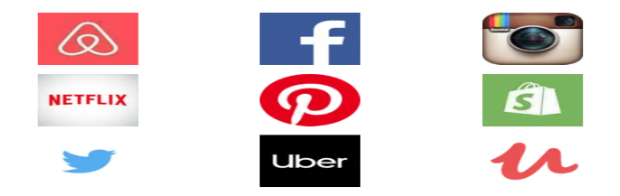**Comanes That Prefer Using React**

**import React from 'react';**

**import ReactDOM from 'react-dom';**

## **import App from './App';**

## **import * as serviceWorker from './serviceWorker';**

## **ReactDOM.render**

## **( <App />, document.getElementById('root') );**

## **serviceWorker.unregister();**

## **3.Vue.js**

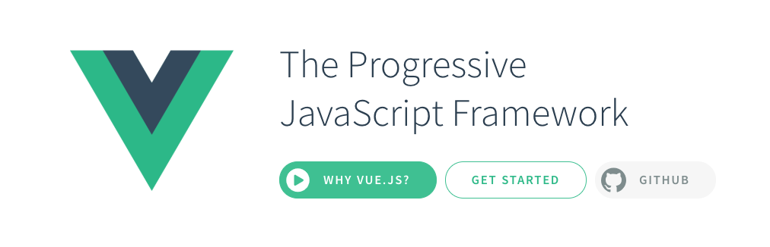

**It entered our lives in 2016.Vue.js is another open-source progressive JavaScript framework for building user interfaces, similar to React.Its dual integration mode is one of the most attractive features for creating high-end SPA or Single Page Application. It is a much reliable platform for developing cross-platform.**

**4. jQuery**

**jQuery is probably the most popular JavaScript library out there which provides so many features for modern-day development.You can use jQuery API for event handling, animation and manipulating of the HTML document, also known as DOM. Besides this, jQuery is being used with Angular and React App building tools too. In short, one of the must-know JavaScript library for web development.**

**5.Ember.js  
Ember.js is another popular, open-source JavaScript web framework which is based on the Model and View pattern.It allows to create single page web applications.It has integrated features like templates also known as handlebars that helps in writing less code and have the ability to update themselves with a change in data. Ember.js can be installed via NPM.**

**metin, küçük resim içeren bir resim

Açıklama otomatik olarak oluşturuldu**

**6. Backbone.js  
Backbone.js is a JavaScript library with a RESTful JSON interface and is based on the Model, View, and Presenter design paradigm. Backbone.js provides structure to heavy web applications.**

**7. Meteor JS  
Meteor or MeteorJS is a full-stack JavaScript platform for developing modern web and mobile applications.**

**8. Angular  
Angular previously known as Angular JS is a single web development framework developed by Google for both desktop and mobile web applications.**

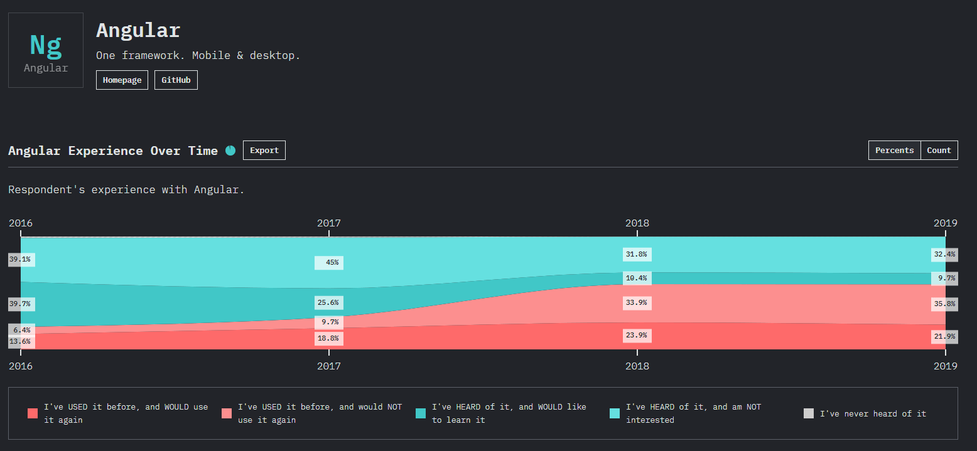 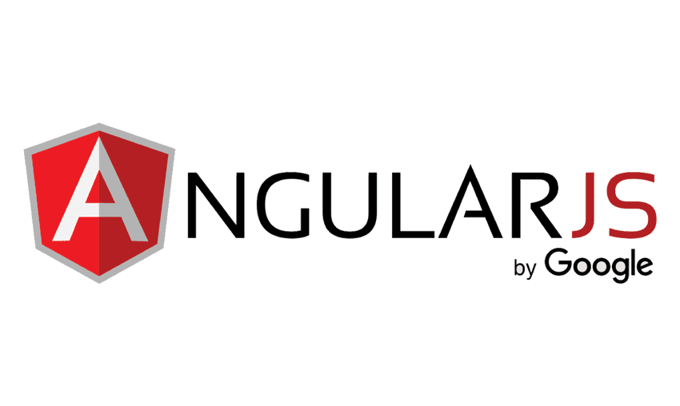

## **9. Polymer JS The polymer is another open-source JavaScript library that helps you create custom reusable HTML elements, which can be used to build performant, maintainable web applications.**

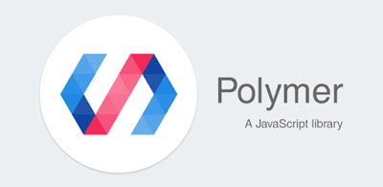

## **10. [Webix](https://webix.com/)**

**Webix is a multi-widget JS UI framework that focuses on cross-platform web development.**

My next week: To continue researching javascript libraries and frameworks.

Estimated duration: 3 hours