Set proxy for connecting to Internet. This is needed to install Jenkins Plugins.

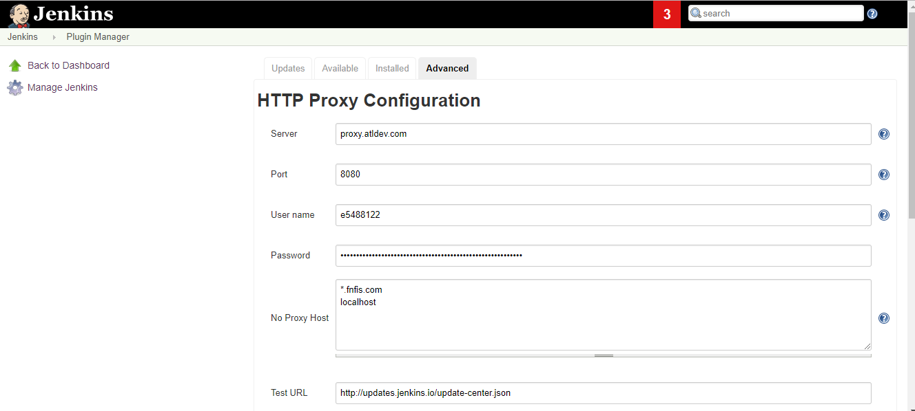

Install the GITHUB plugin.

Set up Shell executable for shell scripts to work. Install GIT bash and call the path like below.

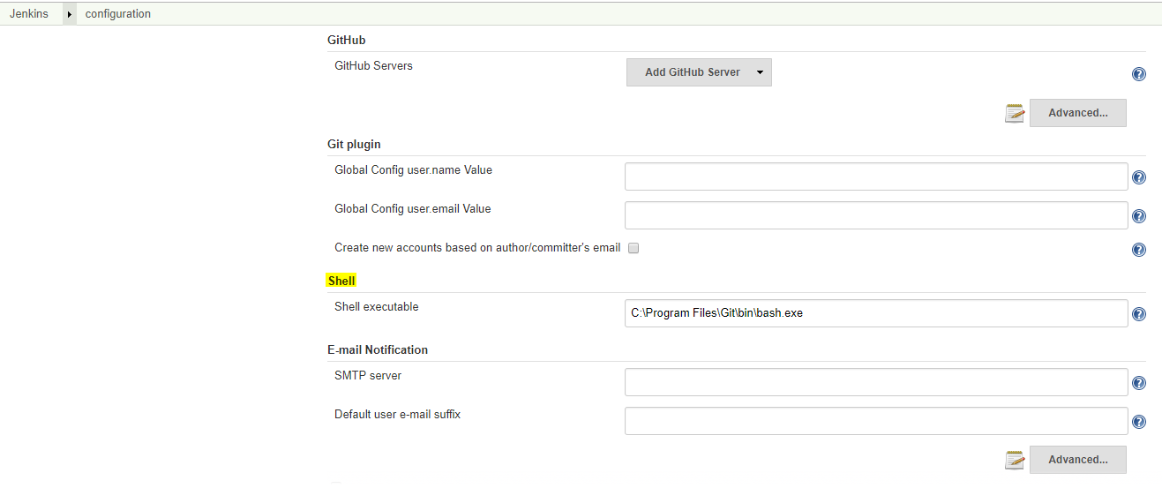

Set the Global Tool configuration to GIT.exe:

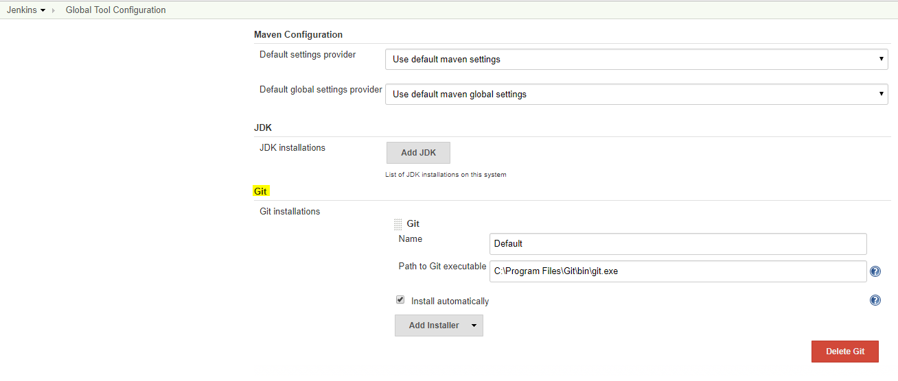

Set up SSH from local to github.

Open git bash and type “ssh-keygen”

This produces SSH key:

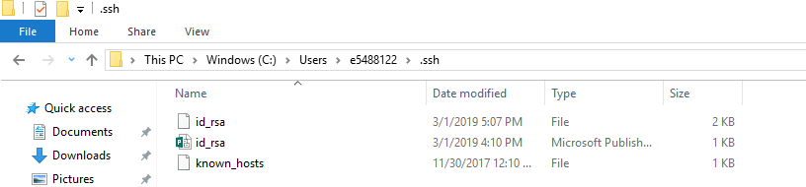

Add the SSH key below:

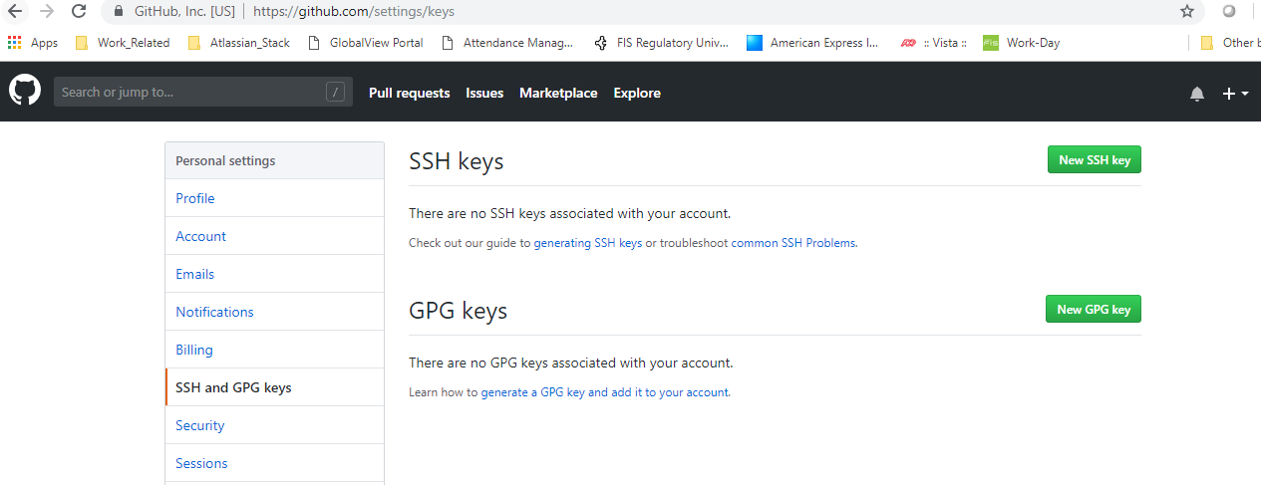

Open Git bash and set git config username and mail id.

Try git clone <git_hub_repo> to see if you are able to successfully clone using gitbash for github repo.

Jenkins Job Configuration:

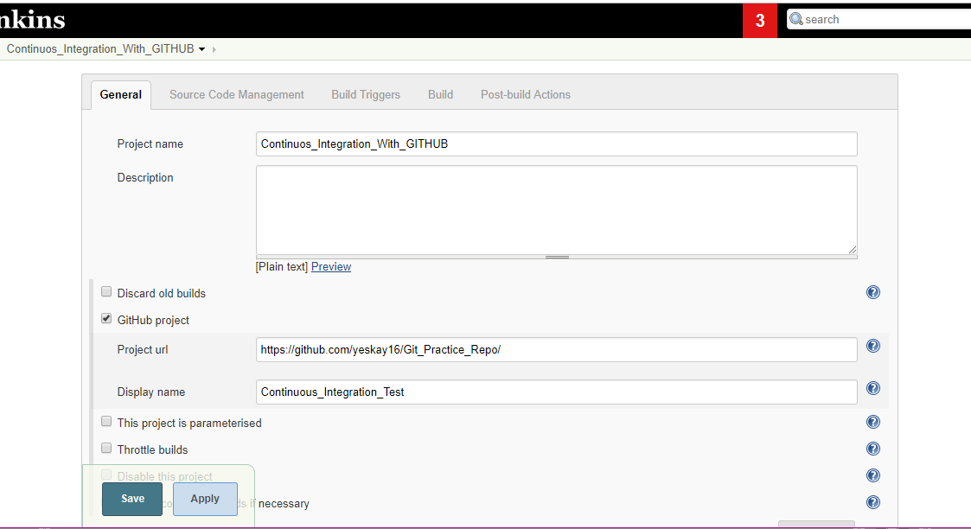

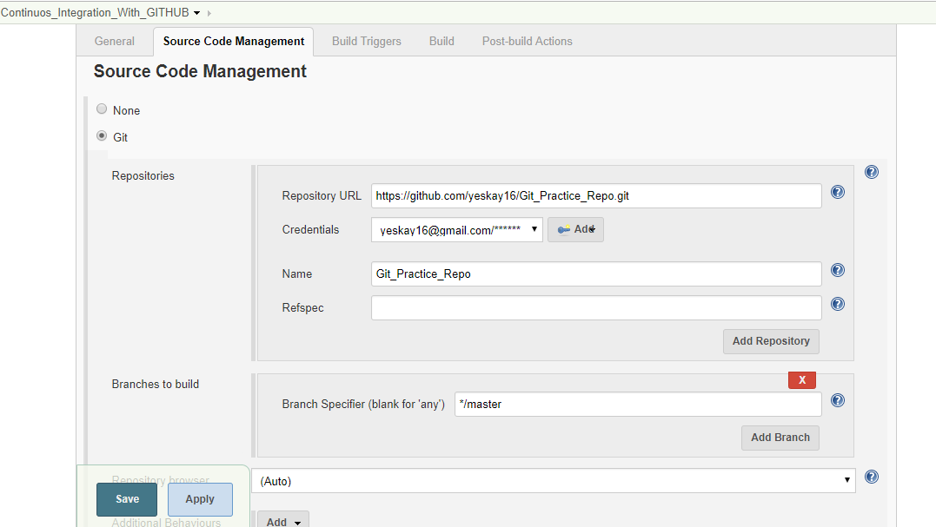

Credential:

Give the user id and pwd of github that you use to connect via browser.

Defalut branch is master.

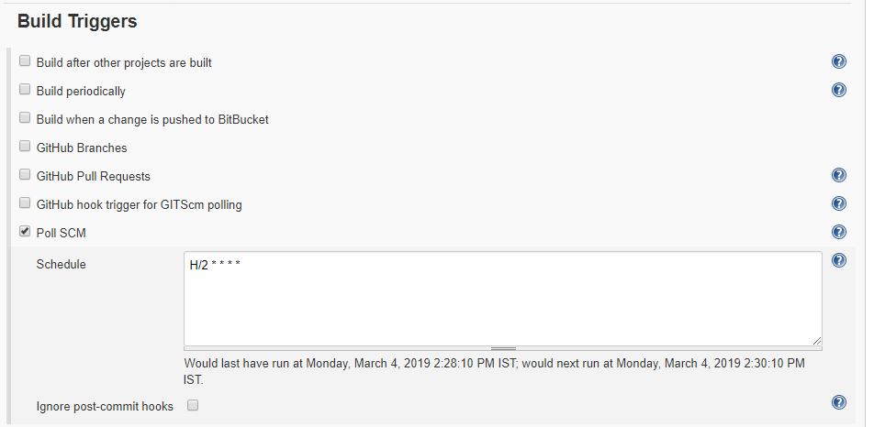

Poll scm every 2 mins

Build script to run.

