Coherence Checking Phase: Experimental Results and Discussion
This section documents the implementation and evaluation of the narrative coherence checking phase of the project. The broader dissertation proposes a spoken narrative evaluation pipeline that combines voice cleanliness checking, transcription, and semantic coherence verification. The work reported here focuses specifically on the text-based coherence module after transcription.
1. Purpose of This Phase
The objective of this phase was to determine whether a short narrative is coherent or incoherent. A coherent story is defined as one whose sentences follow a plausible causal and temporal order, while an incoherent story contains disrupted ordering or semantic inconsistency. This module is intended to operate after the audio quality and transcription stages of the full system. Therefore, the input to the model is text, and the output is a binary coherence decision with a confidence score.
This focus is directly connected to the literature review. Early coherence models such as the Entity Grid model of Barzilay and Lapata [1] and discourse-relation approaches such as Lin et al. [2] represent coherence as transitions between sentence-level discourse states. Later transformer models, beginning with BERT [3], showed that pretrained contextual representations can capture richer semantic and syntactic patterns. However, the literature also warns that sentence-order discrimination is not a complete substitute for deep narrative understanding. Pishdad et al. [7] argue that shuffled-order tasks only partially approximate true coherence. For this reason, the current phase is treated as an empirical coherence classifier and a foundation for later integration with richer entity/state tracking.
2. Dataset and Label Construction
The coherence model was trained using the ROCStories dataset, which contains 52,665 five-sentence everyday stories. This dataset was selected because it provides naturally coherent short narratives with clear temporal and causal progression, making it suitable for training a coherence verifier.
Each original ROCStories entry was treated as a positive coherent example. To create negative examples, the five sentences of each story were shuffled while ensuring that the shuffled order was not identical to the original order. This produced one incoherent sample per coherent sample. The resulting task is binary classification: label 1 for coherent stories and label 0 for incoherent stories.
A key methodological correction was applied to avoid data leakage. Instead of generating shuffled negatives first and then splitting the dataset, the raw stories were split first into training, validation, and test sets. Negative examples were then generated separately inside each split. This prevents the same story from appearing in both training and test sets in different orders.
Item | Value
Raw ROCStories entries | 52,665 stories
Story length | 5 sentences per story
Positive class | Original sentence order
Negative class | Shuffled sentence order
Negative samples per positive story | 1
Train split | 73,730 labeled examples
Validation split | 15,800 labeled examples
Test split | 15,800 labeled examples
3. Models Compared
The experiment compared simple statistical text classifiers and transformer-based models. The classical models were included to establish non-neural baselines and to test whether surface lexical patterns alone were sufficient. Transformer models were then evaluated because the literature shows that pretrained contextual encoders are strong at sentence-level and paragraph-level language understanding [3].
The preliminary model screening used a smaller quick run to compare candidate architectures. RoBERTa achieved the highest test F1 and ROC-AUC among the transformer candidates, while the classical baselines performed substantially lower. This justified selecting RoBERTa for the official full-dataset run.
Model | Validation F1 | Test F1 | Test ROC-AUC | Interpretation
RoBERTa base | 0.8681 | 0.8840 | 0.9400 | Best preliminary transformer model
DeBERTa base | 0.8675 | 0.8610 | 0.9203 | Strong competitor but lower test F1
BERT base uncased | 0.7006 | 0.6989 | 0.7531 | Original transformer baseline
DistilBERT base uncased | 0.6674 | 0.6674 | 0.5534 | Fast but much weaker
Word TF-IDF + Linear SVM | 0.6540 | 0.6416 | 0.6395 | Best classical baseline
Word TF-IDF + Logistic Regression | 0.6493 | 0.6371 | 0.6318 | Comparable classical baseline
4. Justification for Selecting RoBERTa
RoBERTa was selected as the official coherence model for four reasons. First, it achieved the strongest preliminary transformer performance, with the highest test F1 score and ROC-AUC. Second, it improved substantially over the original BERT baseline, indicating that the stronger pretraining strategy of RoBERTa was useful for this task. Third, it clearly outperformed classical TF-IDF models, showing that contextual language representations are important for modeling narrative flow. Fourth, its performance aligns with the literature review: while earlier entity-grid and discourse models capture explicit transitions [1], [2], transformer encoders can learn broader semantic relationships between events without manually engineered discourse features [3].
The choice of RoBERTa also responds to the limitations discussed by Pishdad et al. [7]. Although shuffled-order classification is not a complete measure of story coherence, selecting the strongest contextual encoder provides a robust baseline for this stage of the project. The final system can later be extended with entity-state or graph-based reasoning, as discussed in the related work on entity memory and structured grounding [4], [5].
5. Official Full-Dataset Training Setup
After preliminary comparison, RoBERTa base was trained on the full leak-free ROCStories split. The model was fine-tuned as a two-class sequence classifier. Stories were represented as a single input sequence with sentence boundaries separated using the [SEP] marker. The maximum sequence length was 128 tokens, which is sufficient for the short five-sentence ROCStories format.
Parameter | Value
Selected model | roberta-base
Maximum length | 128 tokens
Batch size | 16
Maximum epochs | 5
Learning rate | 2e-5
Weight decay | 0.01
Warmup ratio | 0.1
Selection metric | Validation F1
Best epoch | 5
6. Training Behavior
Training showed steady improvement across the five epochs. Training accuracy increased from 0.8863 to 0.9945, while validation F1 increased from 0.9461 to 0.9609. The validation results did not collapse despite the rise in training accuracy, suggesting that the model improved generalization rather than simply memorizing the training set. However, because the training accuracy became very high by epoch 5, future work should continue to monitor overfitting when using harder negative samples such as adjacent sentence swaps or sentence replacement.
Epoch | Train Loss | Train Accuracy | Validation F1 | Validation ROC-AUC
1 | 0.2678 | 0.8863 | 0.9461 | 0.9859
2 | 0.1578 | 0.9559 | 0.9494 | 0.9892
3 | 0.1021 | 0.9762 | 0.9567 | 0.9900
4 | 0.0571 | 0.9876 | 0.9586 | 0.9908
5 | 0.0277 | 0.9945 | 0.9609 | 0.9910
7. Final Test Results
The best RoBERTa checkpoint, selected using validation F1, was evaluated on the held-out test split. The model achieved a test F1 score of 0.9627 and ROC-AUC of 0.9919. Because the test set was balanced between coherent and incoherent examples, accuracy and F1 are both meaningful. The high ROC-AUC and PR-AUC show that the model is not only accurate at the default threshold but also ranks coherent examples above incoherent examples consistently across thresholds.
Metric | Value
Accuracy | 0.9622
Precision | 0.9516
Recall | 0.9739
F1-score | 0.9627
Matthews Correlation Coefficient | 0.9247
ROC-AUC | 0.9919
PR-AUC | 0.9901
Inference speed | 511.09 examples/second
True Label / Prediction | Predicted Incoherent | Predicted Coherent
True Incoherent | 7,509 | 391
True Coherent | 206 | 7,694
The confusion matrix shows that the model made 391 false coherent predictions, where incoherent shuffled stories were classified as coherent, and 206 false incoherent predictions, where original stories were classified as incoherent. The model therefore showed slightly higher recall for coherent stories than for incoherent stories. This behavior is acceptable for the current use case if the system is designed to avoid rejecting valid user stories too aggressively, but threshold adjustment may be considered if detecting incoherence is prioritized.
8. Relationship to Literature Review
The results support several conclusions from the literature review. First, the weak performance of TF-IDF baselines confirms that surface-level lexical features are limited for coherence checking. This is consistent with earlier coherence research, which emphasizes transitions between entities, discourse roles, and event relations rather than isolated word frequencies [1], [2].
Second, the improvement from BERT to RoBERTa supports the importance of strong pretrained contextual encoders. BERT introduced bidirectional transformer pretraining and established the foundation for modern language understanding [3]. RoBERTa, as a stronger variant of this family, was more effective in the present experiment at detecting plausible event order.
Third, the experiment also confirms the caution raised by Pishdad et al. [7]. The model performs very strongly on shuffled sentence detection, but this does not prove full human-level narrative understanding. A story may be locally ordered but still contain deeper contradictions involving entity attributes, locations, or goals. This limitation connects directly to the entity-memory work discussed in the literature review [4] and to structured grounding approaches such as Chain-of-Thought scene analysis [5]. Therefore, the RoBERTa model should be presented as the implemented coherence classification module for this phase, while entity-state tracking remains a future enhancement for detecting deeper long-range contradictions.
Finally, this text-based phase complements the voice cleanliness literature. Models such as NISQA [11] and QualiSpeech-based assessment [12] address whether the audio signal is clean enough for transcription. The RoBERTa coherence model addresses the next stage: whether the transcribed story is logically ordered. Together, these modules support the dissertation goal of evaluating both the perceptual quality and semantic consistency of spoken narratives.
9. Limitations and Future Work
The negative examples were generated through sentence shuffling. This is useful for controlled training, but it does not cover every type of real-world incoherence.
The model detects global order disruption well, but it does not explicitly identify entity states or explain contradictions in the same way a graph-based tracker would.
Future experiments should include harder negative strategies, such as adjacent sentence swaps, sentence replacement from another story, and entity contradiction examples.
The final spoken-narrative system should evaluate robustness after ASR transcription errors, because noisy transcripts may affect coherence classification.
An explainability component should be added to highlight which sentence caused the incoherence decision.
10. Summary
This phase implemented and evaluated the narrative coherence checking module of the project. RoBERTa base was selected after comparison with classical baselines and other transformer models. On the official full ROCStories split, it achieved 0.9622 accuracy, 0.9627 F1-score, 0.9919 ROC-AUC, and 0.9901 PR-AUC. These results justify using RoBERTa as the current coherence classifier in the project pipeline. At the same time, the literature review shows that future work should extend this classifier with explicit entity-state tracking and more challenging coherence tests to move beyond shuffled-order discrimination toward deeper narrative understanding.
11. Figures and Visual Results
The following figures should be used alongside the numerical tables above. They visualize the learning behavior of the selected RoBERTa model and summarize its held-out test performance.
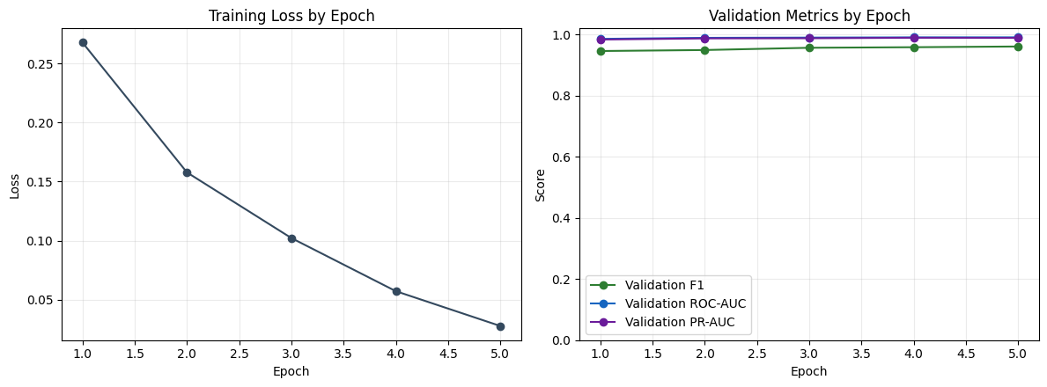
Figure 1: Training loss and validation metric curves across epochs.
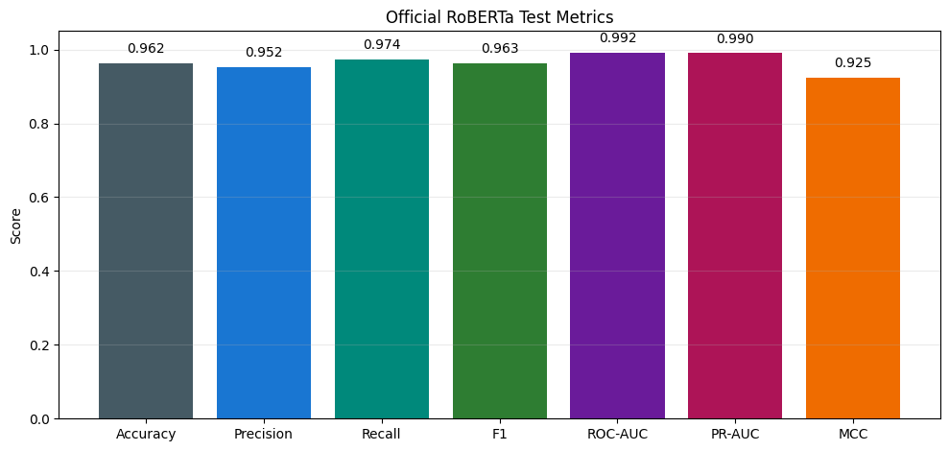
Figure 2: Final official RoBERTa test metrics.
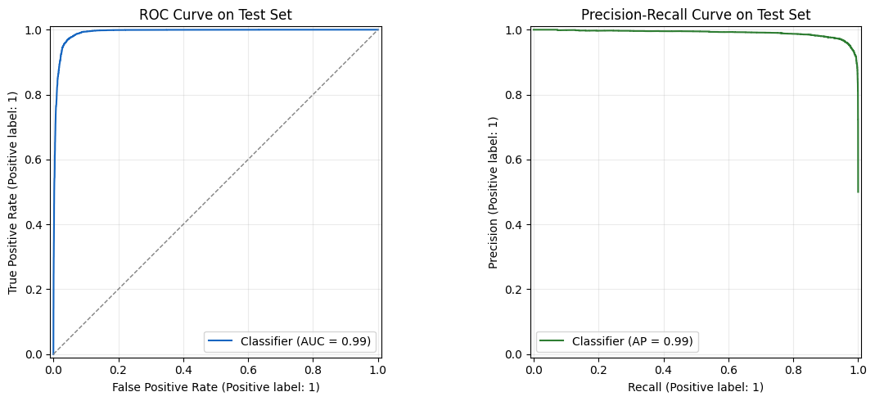
Figure 3: ROC and Precision-Recall curves on the held-out test set.
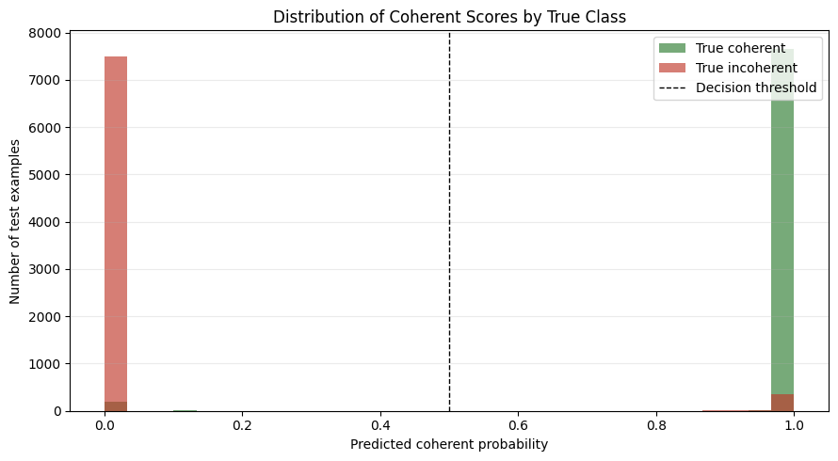
Figure 4: Distribution of predicted coherent scores by true class.
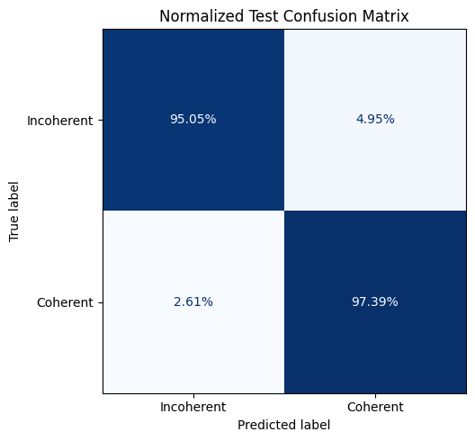
Figure 6: Normalized test confusion matrix
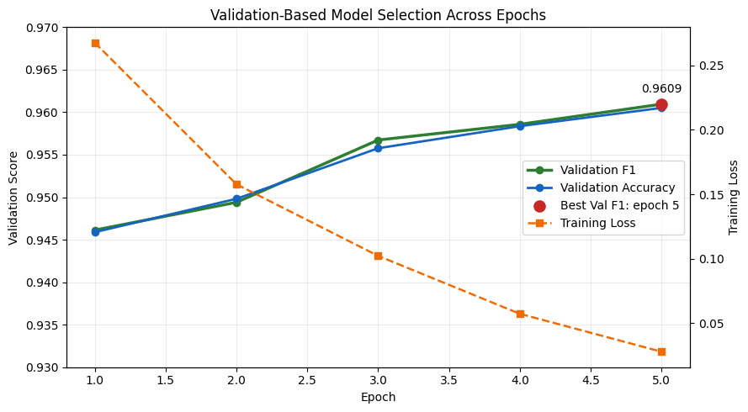
Figure 7: Validation-Based Model Selection

Narrative Coherence Analysis
============================
Sentences: 24
Window size: 5
Stride: 1
Overall coherent score: 0.5475
Lowest window score: 0.0000
Final label: Incoherent
Severity: Strongly incoherent

Sentence Split
--------------
1. Layla had been preparing for the city science fair for almost two months.
2. Every afternoon after school, she walked to her grandfather's garage and worked on a small solar-powered water pump.
3. Her first design leaked badly, so she replaced the weak plastic tube with a stronger one.
4. By the end of the week, the pump could move water from one bucket to another without using a battery.
5. Layla wrote her results in a notebook and packed the model carefully in a cardboard box.
6. On the morning of the fair, Layla woke up before her alarm and checked the box again.
7. Her mother made breakfast while Layla printed the final copy of her poster.
8. They drove to the exhibition hall and arrived early enough to choose a table near the window.
9. Layla set up the pump, filled the buckets, and taped her poster to the display board.
10. When the judges came by, she explained how sunlight powered the small motor.
11. The judges asked Layla several questions about cost, materials, and possible uses in villages with limited electricity.
12. Layla answered each question calmly because she had practiced with her grandfather the night before.
13. One judge smiled and wrote a long note on his clipboard.
14. After the presentation, Layla walked outside to call her grandfather and tell him that everything had gone well.
15. He congratulated her and told her to stay near her table until the winners were announced.
16. Suddenly, Layla was back in the garage two weeks earlier, searching for the missing plastic tube before she had ever tested the pump.
17. She wondered whether she should still go to the science fair, even though the judges had already praised her project that morning.
18. A few minutes later, her mother called from the exhibition hall and asked why Layla had abandoned her table.
19. Layla grabbed the cardboard box, although the pump was still supposed to be sitting on display.
20. When Layla returned to the hall, the final results were already posted near the entrance.
21. Her name appeared in second place, and several students gathered around to ask how the pump worked.
22. Layla smiled and began explaining the design again, but then realized that the buckets on her table were empty.
23. She refilled them, placed the solar panel under the window, and demonstrated the pump one more time.
24. This time, everyone clapped because the water flowed smoothly from one bucket to the other.
Written report
Narrative Coherence Analysis
============================
Sentences: 24
Window size: 5
Stride: 1
Segmentation mode: paragraph
Overall coherent score: 0.8944
Lowest window score: 0.4733
Final label: Incoherent
Severity: Uncertain

Sentence Split
--------------
1. Layla had been preparing for the city science fair for almost two months.
2. Every afternoon after school, she walked to her grandfather's garage and worked on a small solar-powered water pump.
3. Her first design leaked badly, so she replaced the weak plastic tube with a stronger one.
4. By the end of the week, the pump could move water from one bucket to another without using a battery.
5. Layla wrote her results in a notebook and packed the model carefully in a cardboard box.
6. On the morning of the fair, Layla woke up before her alarm and checked the box again.
7. Her mother made breakfast while Layla printed the final copy of her poster.
8. They drove to the exhibition hall and arrived early enough to choose a table near the window.
9. Layla set up the pump, filled the buckets, and taped her poster to the display board.
10. When the judges came by, she explained how sunlight powered the small motor.
11. The judges asked Layla several questions about cost, materials, and possible uses in villages with limited electricity.
12. Layla answered each question calmly because she had practiced with her grandfather the night before.
13. One judge smiled and wrote a long note on his clipboard.
14. After the presentation, Layla walked outside to call her grandfather and tell him that everything had gone well.
15. He congratulated her and told her to stay near her table until the winners were announced.
16. Suddenly, Layla was back in the garage two weeks earlier, searching for the missing plastic tube before she had ever tested the pump.
17. She wondered whether she should still go to the science fair, even though the judges had already praised her project that morning.
18. A few minutes later, her mother called from the exhibition hall and asked why Layla had abandoned her table.
19. Layla grabbed the cardboard box, although the pump was still supposed to be sitting on display.
20. When Layla returned to the hall, the final results were already posted near the entrance.
21. Her name appeared in second place, and several students gathered around to ask how the pump worked.
22. Layla smiled and began explaining the design again, but then realized that the buckets on her table were empty.
23. She refilled them, placed the solar panel under the window, and demonstrated the pump one more time.
24. This time, everyone clapped because the water flowed smoothly from one bucket to the other.

Window Scores
-------------
Window 1 (P1 S1-S5): Coherent | Strongly coherent | coherent=0.9999 | ######################## | incoherent=0.0001
Window 2 (P2 S6-S10): Coherent | Strongly coherent | coherent=0.9996 | ######################## | incoherent=0.0004
Window 3 (P3 S11-S15): Coherent | Strongly coherent | coherent=0.9999 | ######################## | incoherent=0.0001
Window 4 (P4 S16-S19): Incoherent | Uncertain | coherent=0.4733 | ###########------------- | incoherent=0.5267
Window 5 (P5 S20-S24): Coherent | Strongly coherent | coherent=0.9995 | ######################## | incoherent=0.0005

Readable Advice
---------------
- At least one section falls below the coherence threshold, so the full story is flagged as incoherent.
- Review these lowest-scoring ranges first: S16-S19.
- For long stories, paragraph-aware scoring is used by default to avoid confusing natural paragraph transitions with incoherence.

Flagged Sections
----------------
P4, S16-S19: Suddenly, Layla was back in the garage two weeks earlier, searching for the missing plastic tube before she had ever tested the pump. She wondered whether she should still go to the science fair, even though the judges had already praised her project that morning. A few minutes later, her mother called from the exhibition hall and asked why Layla had abandoned her table. Layla grabbed the cardboard box, although the pump was still supposed to be sitting on display.

