Smart ERP Core
Nexus ERP
Project Report
An HR ERP with analytics, AI-assisted recruitment and machine-learning predictions
Final version · 2026-10-02

Table of contents

If the table of contents is empty, right-click it in Word and choose "Update Field".

1. Introduction

1.1 Context
Human-resources teams make their decisions from scattered sources: an HR file per employee, spreadsheets for salaries and training, a mailbox full of CVs. Answering a simple question ("which teams lose the most people, and why?") often takes days. At the same time, recent AI techniques make it possible to read CVs automatically, to answer questions asked in plain language and to estimate risks from historical data.

1.2 Goal of the project
Smart ERP Core, branded Nexus ERP in the application, is an HR-focused ERP that brings these sources together and adds an AI layer on top of them. It gives HR staff:
- dashboards that show the state of the workforce at a glance (headcount, turnover, pay, engagement, recruitment);
- the daily HR processes in one place (employee files, leave requests, performance reviews, job openings, applications, hiring);
- AI tools that save time (CVs read and ranked automatically, a chatbot that answers from the live data, interview questions prepared for each candidate);
- machine-learning predictions that help decide where to act (who may leave and why, what a training budget could change).

1.3 What was delivered
Part | Content
Web application | Angular front end with a professional sidebar layout, 26 pages, a public home page and careers site
Business API | Spring Boot back end: security, HR processes, analytics, notifications, audit, e-mails
AI engine | FastAPI service: chatbot that also draws the chart you ask for, CV reading, candidate ranking, recruiter tools, two ML models
Data | a Python ETL that turns two public data sets into a coherent company
Operations | Docker Compose for the whole application, a README, this report

2. The application at a glance

2.1 Who uses it
Role | What they can do
HR manager / manager | all analytics, employees and teams, leave approval, reviews, recruitment (openings, applicants, ranking, hiring), AI tools
Administrator | everything above, plus users and roles, the audit log and the AI models page
Employee | "My space": their own file, reviews, trainings, pay history and leave requests
Candidate (no account) | the public careers site: browse open jobs and apply with a CV

Every account belongs to an employee file: new hires get theirs at the Hire step, and an administrator can give an account to an existing employee who has none (section 6.3).
The public address opens a home page with two separate choices: "I'm looking for a job" (the careers site, no account needed) and "I work at Nexus" (the sign-in page). Candidates never have to go through the sign-in page, and the sign-in page has its own "Careers" button outside the form.
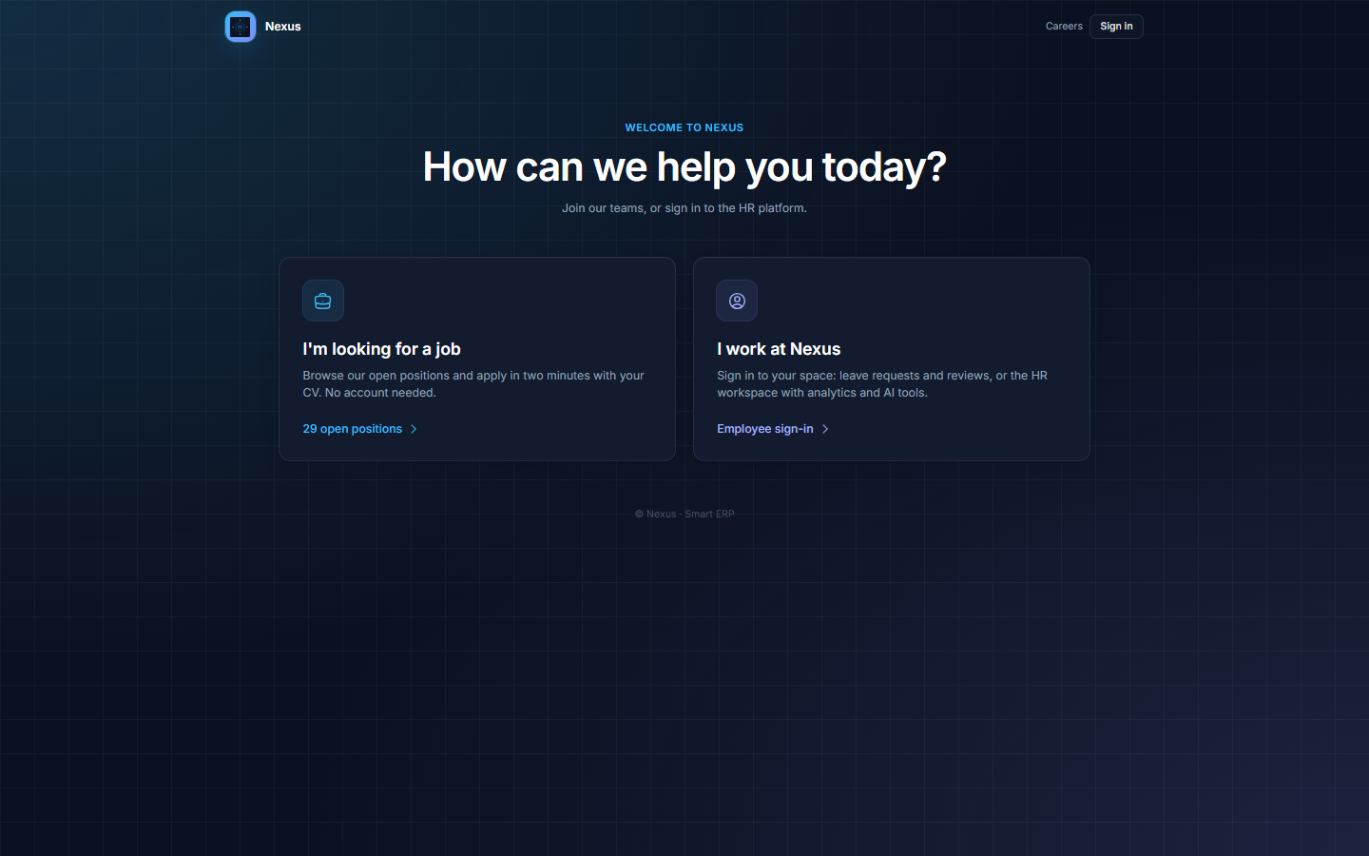
Figure 1: Public home page: candidates and employees each have their own entrance
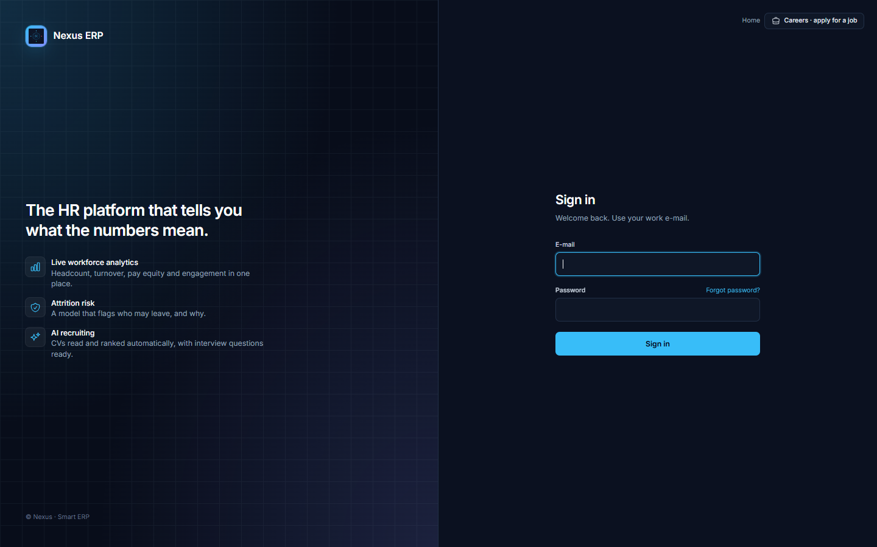
Figure 2: Sign-in page, with the careers link outside the form
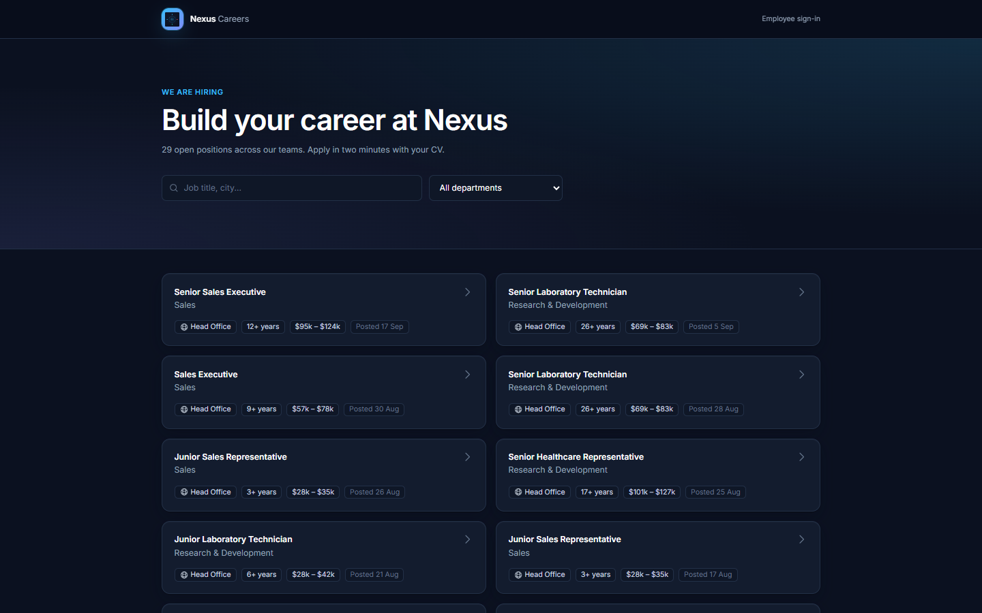
Figure 3: Public careers site: the job board
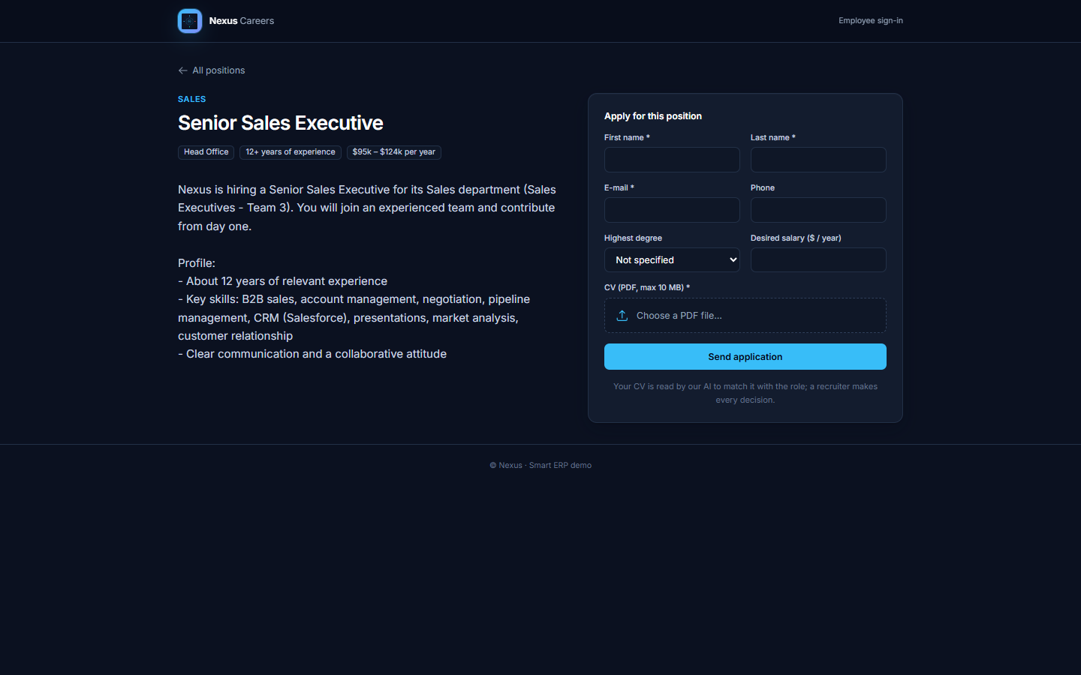
Figure 4: Public careers site: a job and its application form

2.2 Main features
Area | Features
Analytics | overview KPIs, turnover by team and department, retention curves, pay and pay equity, training investment, performance vs engagement, recruitment funnel, time to hire
People | employee list with search and CSV export, employee file, departments and teams, leave requests with approval, performance reviews
Recruitment | job openings (with an AI-written description), public applications, automatic CV analysis, AI ranking of the candidates, semantic CV search, interview questions, offer and hire
AI & strategy | HR chatbot with charts chosen by the AI and pinned to the dashboard, budget advisor with a what-if simulator and an approval step, retention strategy with the people to talk to first
Platform | notifications, audit log, users and roles, model monitoring and retraining, password reset, e-mails

3. Architecture

3.1 Overview
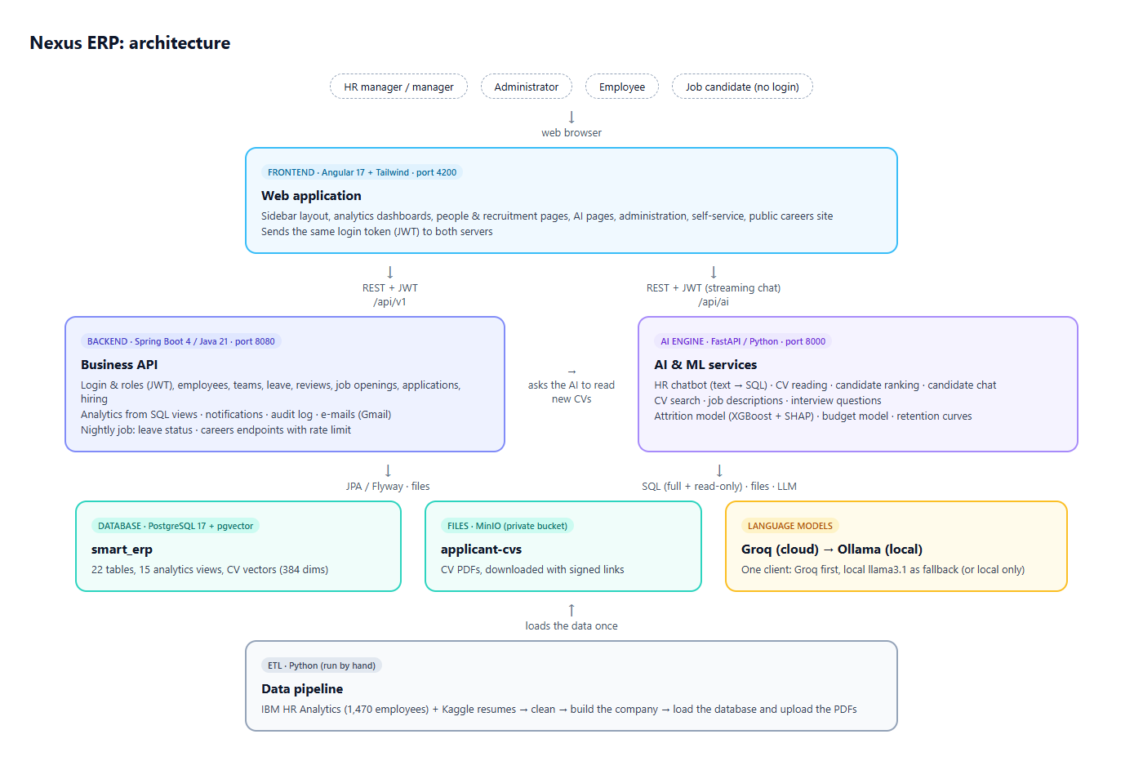
Figure 5: Architecture of the application
The application is made of three servers and two storage services:
- the frontend (Angular) runs in the browser and calls two APIs with the same login token;
- the backend (Spring Boot) owns the business data and rules: people, recruitment, leave, security;
- the AI engine (FastAPI, Python) hosts everything that needs AI or machine learning;
- PostgreSQL (with the pgvector extension for CV vectors) stores the data; MinIO stores the CV PDFs in a private bucket;
- the language models are reached through one client: Groq in the cloud first, Ollama on the machine as a fallback (or alone, to keep data local).

The ETL is not part of the running application: it is run by hand to (re)build the company data.

3.2 Technologies
Layer | Technology | Why
Frontend | Angular 17, Tailwind CSS, ApexCharts | components loaded per page, fast styling, interactive charts
Backend | Java 21, Spring Boot 4, Spring Security (JWT), JPA / Hibernate, Flyway, Thymeleaf e-mails | robust business API, versioned database schema
AI engine | Python, FastAPI, XGBoost, scikit-learn, SHAP, sentence-transformers, pdfplumber | the Python ML / NLP ecosystem
Language models | Groq (gpt-oss-120b), Ollama (llama3.1) | fast cloud model, private local fallback
Storage | PostgreSQL 17 + pgvector, MinIO | relational data + vector search, S3-compatible files
Operations | Docker Compose, pgAdmin | one command to start everything

3.3 How the parts talk to each other
- The backend issues a JWT at sign-in (email + role, valid 24 h). The frontend sends it to both servers; the AI engine checks it itself with the shared secret, so it needs no database lookup.
- The backend calls the AI engine in one case: when a candidate applies, it asks for the new CV to be read, with a short-lived service token.
- The AI engine reads the database directly, with two connections: a normal one, and a read-only one with a 10-second limit used for the chatbot's generated SQL.
- All secrets (database, JWT, e-mail, MinIO, Groq) live in .env files that are never committed.

4. Data

4.1 Sources
Real HR data is never public, for privacy reasons. The project uses two public data sets:
Source | Content | Use
IBM HR Analytics Employee Attrition & Performance | 1,470 employees simulated by IBM data scientists with realistic relationships: department, role, level, salary, overtime, travel, satisfaction scores, performance, years in role, who left… | the company's workforce
Kaggle Resume dataset | 2,484 real CVs (text and PDF) in 24 job categories | the job applicants

4.2 The ETL pipeline
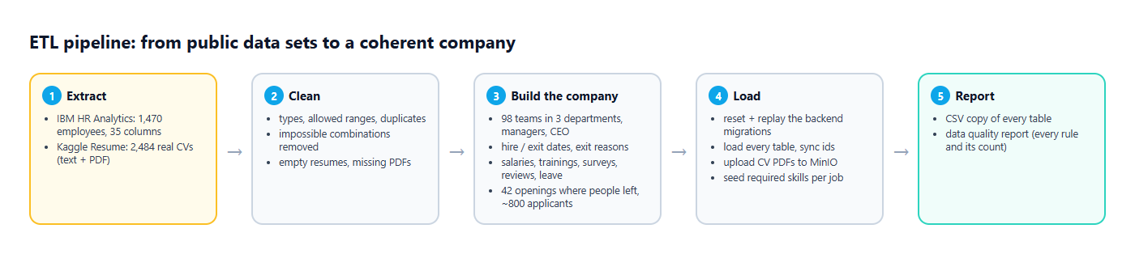
Figure 6: ETL pipeline
In short, the ETL (ETL/main.py --load-db):
- extracts the two files;
- cleans them: types, allowed ranges, duplicates, impossible combinations (e.g. more years in the company than in the career);
- builds the company: 98 teams in 3 departments, a management hierarchy up to a CEO, hire and exit dates, an exit reason for every leaver written from their own data, salary history, trainings, surveys, performance reviews, leave requests, and 42 job openings where people actually left, each receiving 14 to 25 real CVs (about two thirds from a related field, the rest unrelated so the AI has something to rank low);
- loads everything: it rebuilds the schema from the backend's own migrations, loads the tables, uploads the CV PDFs to MinIO and seeds the skills required per job;
- reports: a CSV copy of every table and a data-quality report.

4.3 What is real and what is generated
Real (IBM / resumes) | Derived by rules from the real data | Generated (identifiers, details)
department, role, level, salary, raise, overtime, travel, commute, education, satisfaction, performance, trainings count, years columns, who left, CV texts and PDFs | teams, managers, roles, titles, dates, exit reasons, salary history, job openings, which job each CV applies to | names, e-mails (at example.com for candidates), phone numbers, exact days, training courses, application statuses, review comments, leave requests

The generation uses a fixed seed: every run produces exactly the same company.

4.4 Result
Table | Rows
Employees | 1,470 (1,233 active, 237 who left) in 98 teams
User accounts | 1,470 (3 admins, 29 HR managers, 169 managers, 1,269 employees) + the admin
Salary history / trainings / surveys | 2,896 / 4,115 / 1,470
Performance reviews / leave requests | 1,467 / 2,255 (44 waiting for approval)
Recruitment | 42 openings (13 filled), 802 applicants with real CVs

5. Database

5.1 Structure
The schema is defined once, by the backend's Flyway migrations (V1 to V6), and the ETL replays the same files. It has 23 tables in five groups.
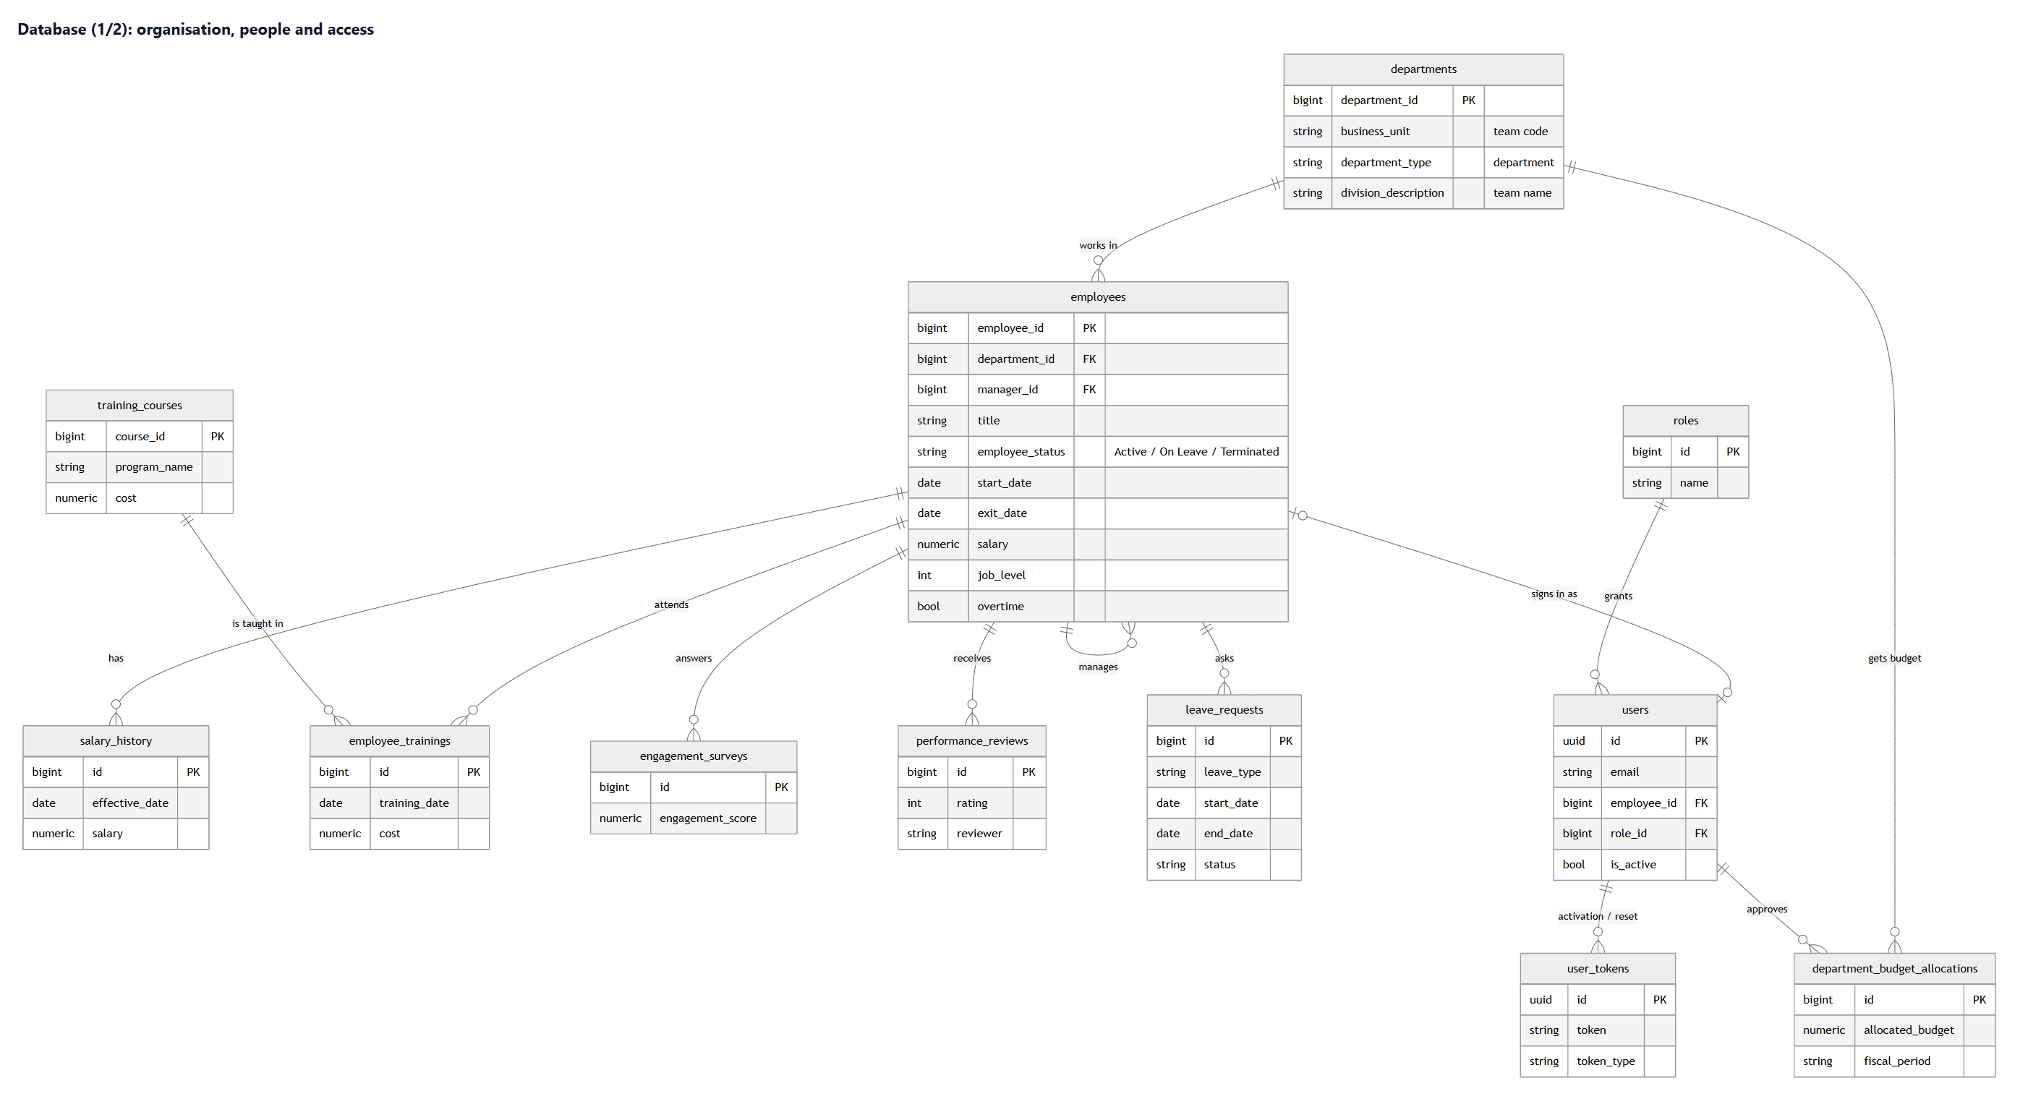
Figure 7: Database, part 1: organisation, people and access
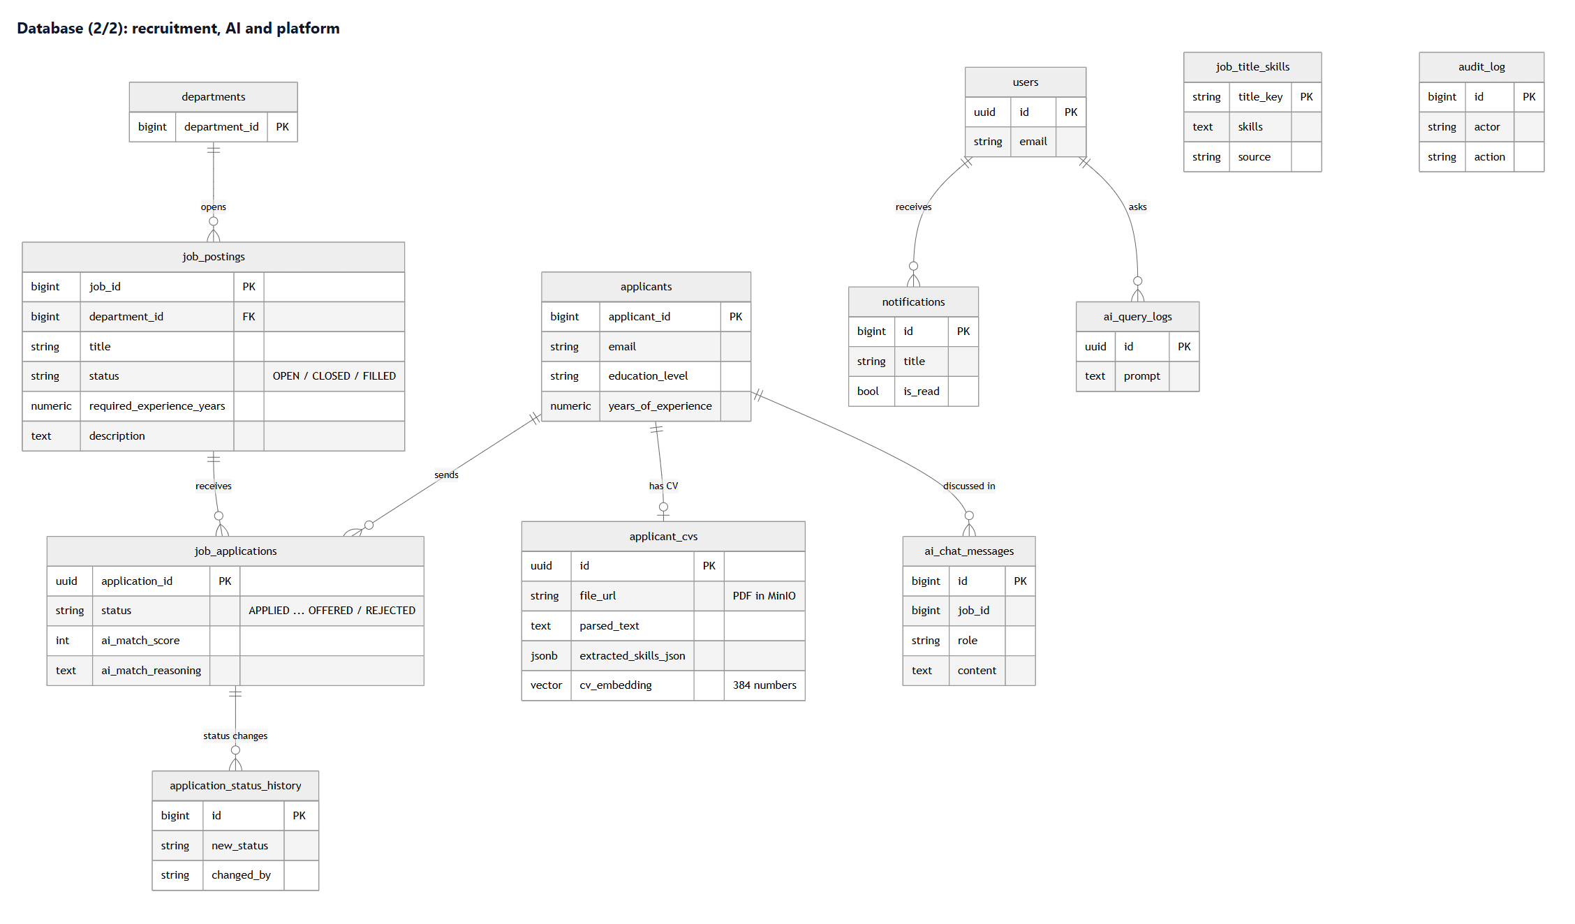
Figure 8: Database, part 2: recruitment, AI and platform
Group | Tables | Notes
Organisation | departments (= teams), employees | each employee has a team and a manager (self-reference)
People | salary_history, employee_trainings, training_courses, engagement_surveys, performance_reviews, leave_requests | one employee → many rows
Access | users, roles, user_tokens | one account per employee; tokens for activation and password reset
Recruitment | job_postings, applicants, job_applications, application_status_history, applicant_cvs, job_title_skills | a CV has its text, its skills (JSON) and its vector (384 numbers) for the AI; a job keeps its screening checklist, and each application the checked checklist with the evidence (V5)
Platform | notifications, audit_log, ai_chat_messages, ai_query_logs, department_budget_allocations, ai_saved_charts | messages, traceability, AI history, approved budgets, charts pinned from the chatbot (V6: the question, the SQL and the chart description, never the numbers)

5.2 Analytics views
Fifteen SQL views compute the indicators once, in the database, for the dashboards and the AI: turnover per team and per department, salary distribution, pay by gender, recruitment funnel, time to hire, training investment, top performers, and the feature tables of the two ML models. The chatbot can only read these views, through a read-only database role.

6. Backend (Spring Boot)

6.1 Organisation
The code is organised by business domain, each with the same layers: entities (tables), repositories (queries), services (rules), controllers (HTTP endpoints).
Package | Content
security | sign-in, accounts, roles, JWT, password rules, activation and reset links
hr | employees, teams, job openings, applications and their status rules, hiring, careers endpoints, leave, reviews, budget allocations
me | the signed-in employee's own data
admin | users and roles, audit log
analytics | read-only access to the SQL views, KPIs
shared | e-mails, file storage, notifications, audit, AI engine client, error handling

6.2 Security
Rule | How
Who can call what | public: sign-in, password pages, careers; admin: accounts, audit; HR roles: everything under /hr and /analytics; any signed-in user: their own space and notifications
Passwords | stored with BCrypt; at least 8 characters with a letter and a digit
Sessions | stateless JWT, 24 h
Candidates | at most 5 applications per 10 minutes per IP address; PDF only (checked by content), 10 MB
Errors | one readable JSON message format; 401 / 403 / 404 / 422 / 429 used consistently

6.3 Business rules worth knowing
- Application workflow: APPLIED → IN REVIEW → INTERVIEWING → OFFERED or REJECTED. An offered or rejected application is closed. Every change is dated, saved in the status history and in the audit log, and an e-mail is sent to the candidate.
- Hiring is one transaction: it creates the employee, the first salary line, the user account, closes the application and fills the opening, then sends the activation e-mail.
- Accounts always belong to an employee. Besides hiring, the only way to create an account is the administrator's "New account" page, which lists only current employees who have no account yet; the administrator picks one, enters the e-mail, a temporary password and the role (employee, manager, HR manager or administrator). The server refuses an account without an employee, a second account for the same person, or an account for someone who has left. (The old open "register" address was removed.)
- Job openings: the title is chosen from the existing jobs (the latest opening of that job pre-fills the team, experience and salary) or typed as a new title. The description is always written by the AI and the opening cannot be published without it (checked by the frontend and by the server).
- E-mails are sent only after the database commit, so a rolled-back action never sends a message.
- Leave: only current employees can ask, and never in the past. A nightly job (also run at start-up and right after an approval) switches employees to "On Leave" on the first day of an approved leave, and back to "Active" the day after it ends.
- Automatic CV analysis: after a public application is saved, a background task asks the AI engine to read the CV and notifies HR when it is done.

7. AI engine
The AI engine is a FastAPI service. Every route requires the backend's token with an HR role (retraining requires an administrator). It exposes about twenty endpoints, grouped below by feature.

7.1 The language-model client
One small client is used by every feature. It calls Groq first and falls back to the local Ollama model; it can ask for strict JSON answers (and retries if the answer is not valid JSON) and can stream answers word by word. Setting LLM_PROVIDER=ollama keeps all data on the machine.
Two details make it reliable in practice:
- when Groq answers "too many requests" (its free tier limits the tokens per minute), the client waits as long as Groq asks and tries again (up to 3 times) before falling back to Ollama;
- every call is logged with the model that answered (for example LLM answer from groq (openai/gpt-oss-120b)), so it is always clear which model produced a result.

7.2 HR chatbot (text to SQL)
The user asks a question in plain language; the model writes an SQL query over the allowed views, the query is checked (one SELECT only, allowed views only, no system functions) and runs on the read-only connection; the model then summarises the rows in two or three sentences.
The answer is streamed: the server first sends the table (as soon as the query has run, in about two seconds), then the written answer word by word while the model writes it, as a series of small JSON messages. Everything that can fail (understanding the question, the safety checks, the query) happens before the stream starts, so a problem is reported as a normal error. The widget shows the table (with a CSV download), a chart when the result lends itself to one, and the answer as it is being written. The most frequent questions are suggested.
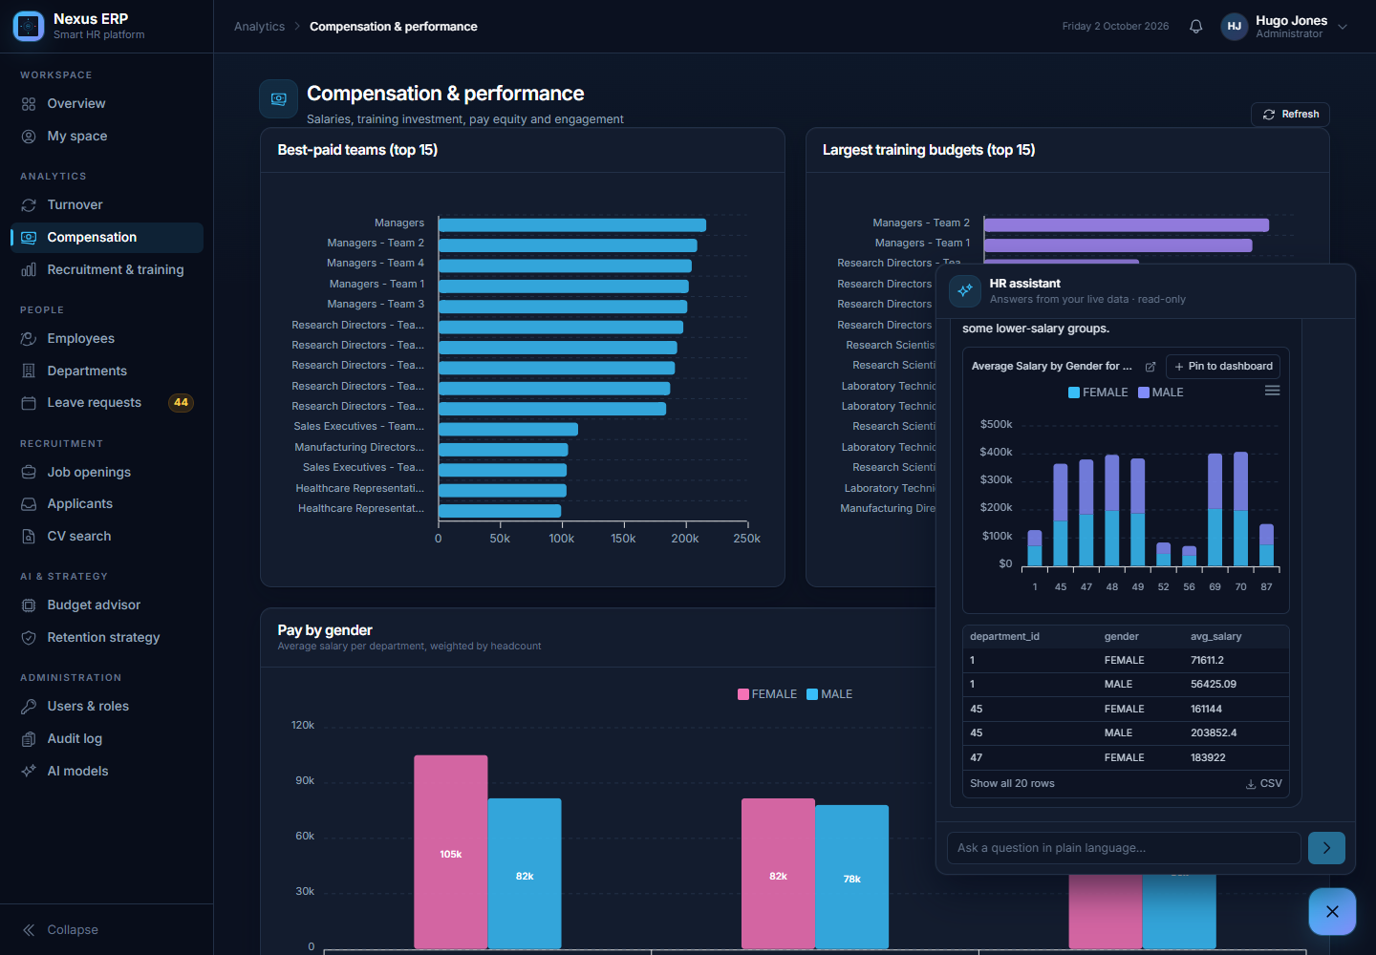
Figure 9: HR assistant: the table, the chart chosen by the AI, then the answer written word by word

Charts on demand
A chart is drawn only when the user asks for one, so a simple question gets a simple answer. There are two ways:
- in the question itself: "average salary by department and gender as a stacked bar chart", "plot hires per year", "graphique des salaires..." (a short list of English and French words such as chart, graph, plot, pie, "as a line" is recognised by code; "line managers" is not mistaken for a line chart);
- with the Create a chart button under any table, after the answer.

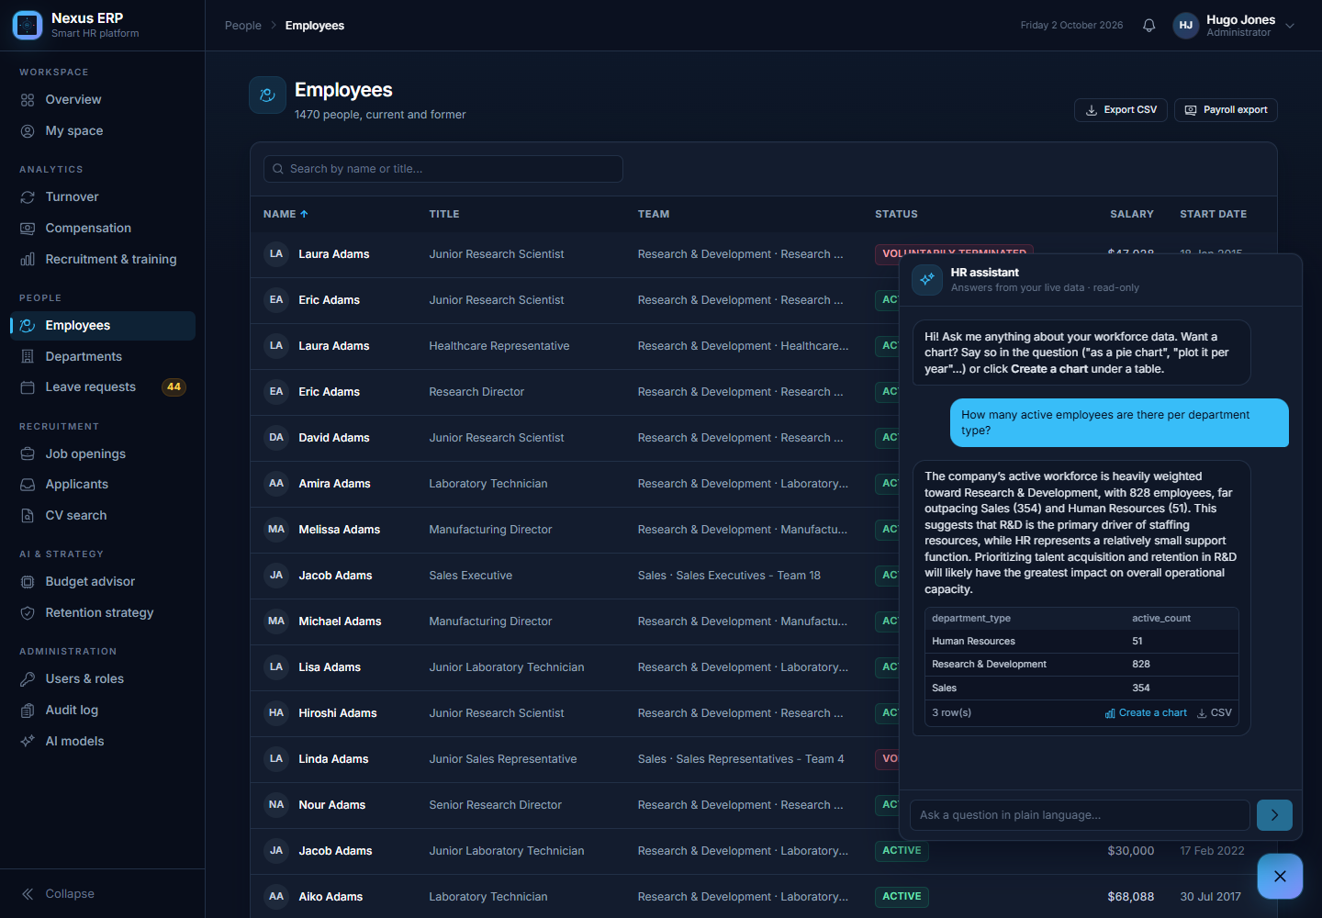
Figure 10: A plain question: table and answer, no chart, with the "Create a chart" button
To choose the chart, right after the table the model receives only the question, the two previous questions (so a follow-up such as "now as a pie chart" works) and the column names with their type and up to three example values, never the whole result, and answers with a short chart description in JSON:
Field | Meaning
type | bar, horizontal bar, stacked bar, line, pie, donut or scatter
x / y | the column for the categories (or the dates) and the number columns to draw
series | an optional column that splits the data into groups (for example gender, one colour each)
y_format | number, money or percent, for the axis and the tooltips
title | a short title

This description is checked by code before it is sent: every column must exist in the result, the drawn values must be numbers (three at most), the group column must be text, and a pie keeps one value and at most 12 slices (time series are ordered by the SQL itself). If the description is wrong it is corrected (a pie with groups becomes a bar chart) or dropped, and the user is told that no chart fits (for example a single number). The model never produces the drawing itself, only this small description, so a wrong answer can never show invented numbers: the numbers always come from the SQL result.
When the question asks for a chart, it arrives as one more message in the stream, about one second after the table; the button re-runs the (re-checked) query on the read-only connection and asks the model the same way. To give complete charts, the SQL rule is: lists of people are limited to 10 rows, but grouped results (per department, per year...) return every group, up to 50.
Each chart has three actions:
- Enlarge: the chart opens in a large window;
- Download: PNG, SVG or CSV from the chart menu;
- Pin to dashboard: the question, the SQL and the chart description are saved for this user (table ai_saved_charts, at most 24 per user). The SQL is checked again with the same rules as the chatbot before it is saved.

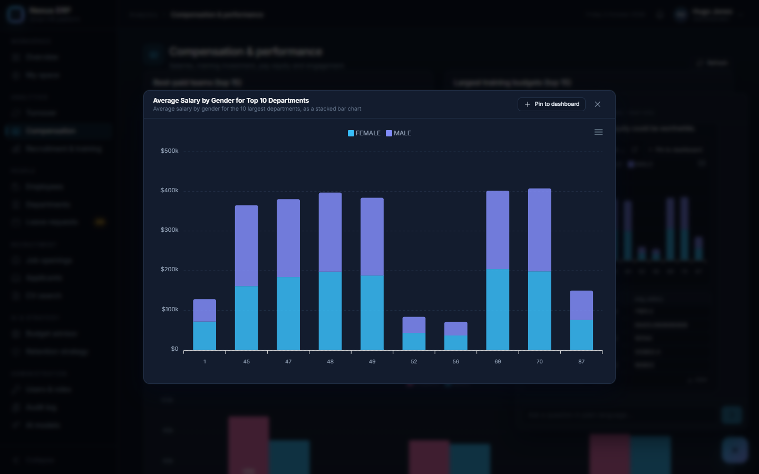
Figure 11: Enlarged chart, with the pin button
Pinned charts appear in a My charts section of the Overview page. Each time the page opens, their SQL is run again on the read-only connection, so the numbers are always up to date and no language model is involved (it is instant and free). A chart whose query fails (for example after a view has changed) shows the error in its card instead of breaking the page.
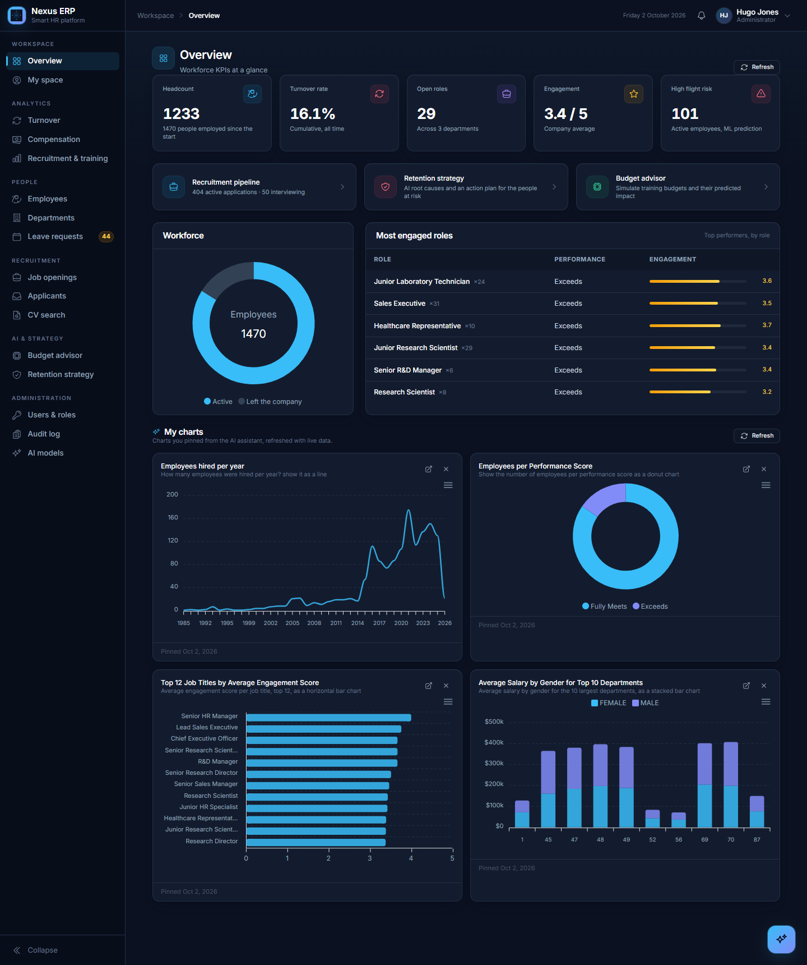
Figure 12: Overview with "My charts": four charts asked in plain language and pinned

7.3 Reading CVs
The PDF is downloaded from the private bucket with a signed link and turned into text. The model extracts the skills, the years of experience, the education level and the last job titles as JSON; the values are checked (e.g. years between 0 and 50) and a vector (a list of 384 numbers that represents the meaning of the CV) is computed and stored for the search and the ranking.

7.4 Ranking candidates for a job: requirement by requirement
The ranking works like a recruiter's screening grid.
- A checklist per job. The model reads the job (title, description, required skills) and writes 5 to 8 concrete requirements that can be checked in a CV, each marked must-have (at most 4) or nice-to-have, e.g. "B2B sales experience", "Salesforce CRM proficiency". The required years of experience are added as a must-have. The checklist is saved with the job and shown at the top of the page.
- Pre-selection. Three quick signals that need no language model (skill coverage, closeness of past job titles, closeness of the CV text to the job) choose the candidates worth a full review (up to 25 per job).
- One review per candidate. The model receives the checklist and the candidate's CV (contact details and name removed) and marks every requirement met, partial or missing, quoting the evidence from the CV ("Account Manager (Billing Services)"). It is told to be strict: nothing that is not written counts. The years requirement is checked by code, because language models are unreliable with arithmetic. Reviews run two at a time.
- The score is computed from the checklist, not chosen by the model:

Rule | Value
Points per requirement | met = 1, partial = 0.5, missing = 0
Weight | a must-have counts double
Score | points obtained ÷ points possible × 100
Missing must-haves | one caps the score at 60, two or more at 40

So a candidate who is excellent on the nice-to-haves but lacks an essential requirement cannot reach the top, and every score can be checked line by line by a recruiter. The summary under each candidate says, for example, "Must-haves met: 4/5, nice-to-haves: 1/3; missing: Strong negotiation abilities".
Complete reviews are saved with their checklist, so the page opens instantly the next time; Recalculate rebuilds the checklist and reviews everyone again. A candidate whose review could not be done (no model available) is shown after the reviewed ones with a "pre-screen" score and is retried at the next search. The page also says how many CVs have been read and can analyse the others with a progress bar. The interview questions reuse the checklist, so the gaps they explore are exactly the requirements found missing or partial.
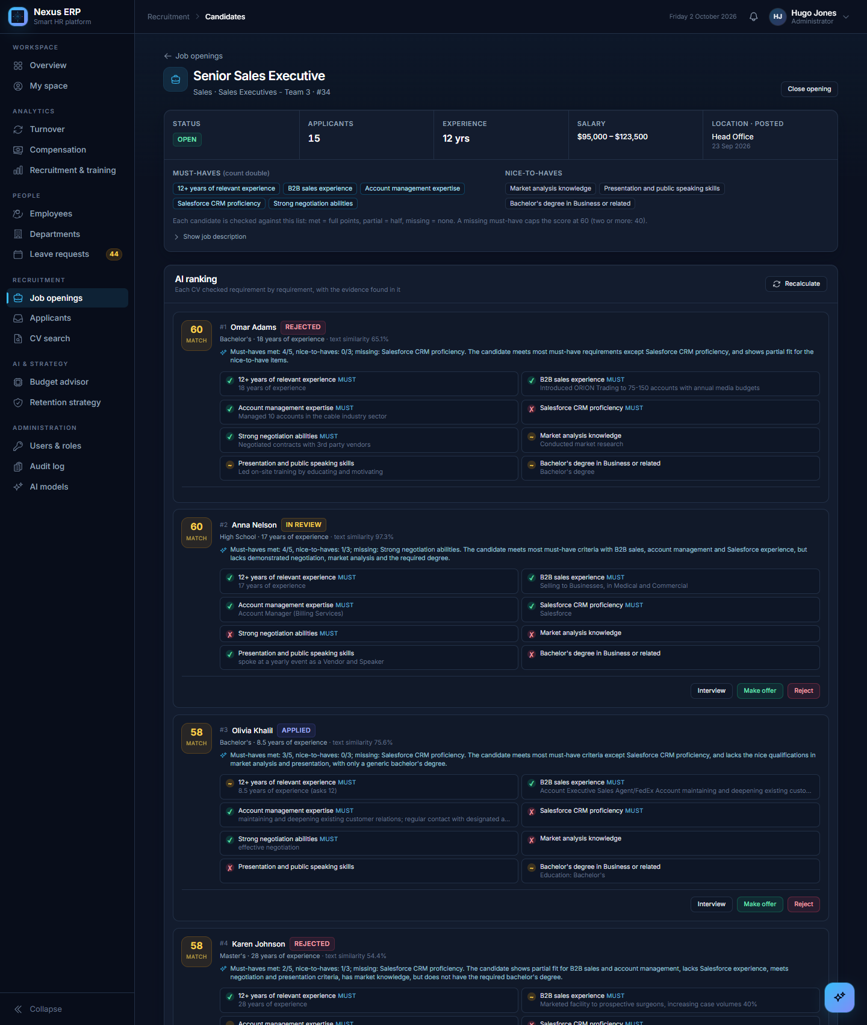
Figure 13: AI ranking: the job's checklist and each candidate checked requirement by requirement, with the evidence from the CV

7.5 Recruiter tools
- Candidate chat: questions about one candidate for one job, answered only from the CV and the job (contact details and the name are removed before anything is sent to the model), streamed and saved.
- Interview questions: the model lists the gaps between the CV and the job and proposes questions to check the gaps and confirm the strengths.
- Job description writer (mandatory for every new opening): the model writes the description from the title, the team, the required years and optional notes from HR. The notes can be rough ("must speek french, travell 2 days a week"): the model rewrites them correctly into the text. For a title that already exists, its skills are fixed and reused, so every opening of the same job is screened on the same requirements; for a new title the model defines 8 to 12 skills, which are saved for the next openings. The model is told to use only the facts given (no invented reporting line, benefits or team size), and the layout (intro, Responsibilities, Profile) is normalised by code.
- CV search: a description of the wanted profile is turned into a vector and compared with all CV vectors (fast thanks to a vector index).

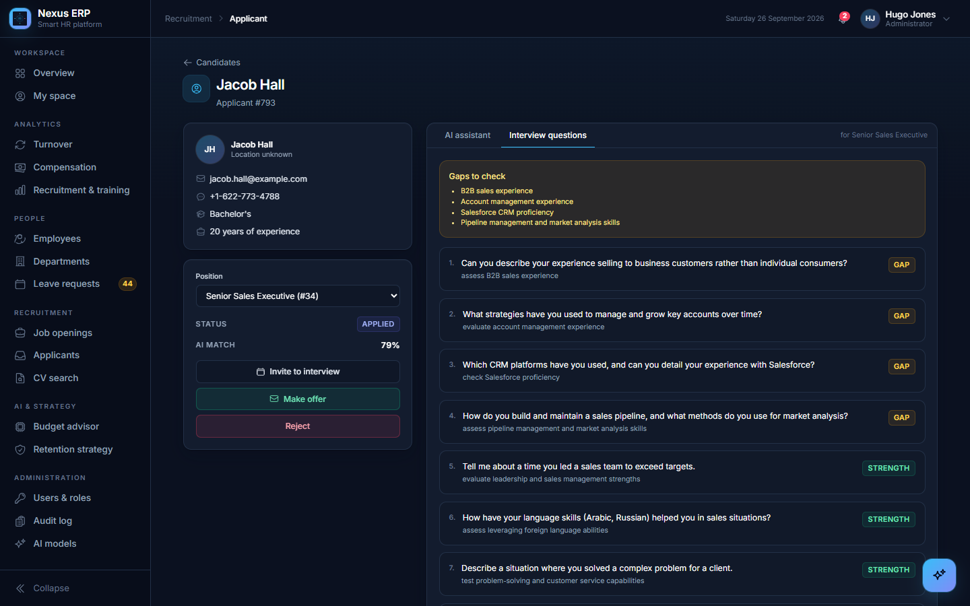
Figure 14: Interview questions prepared for a candidate
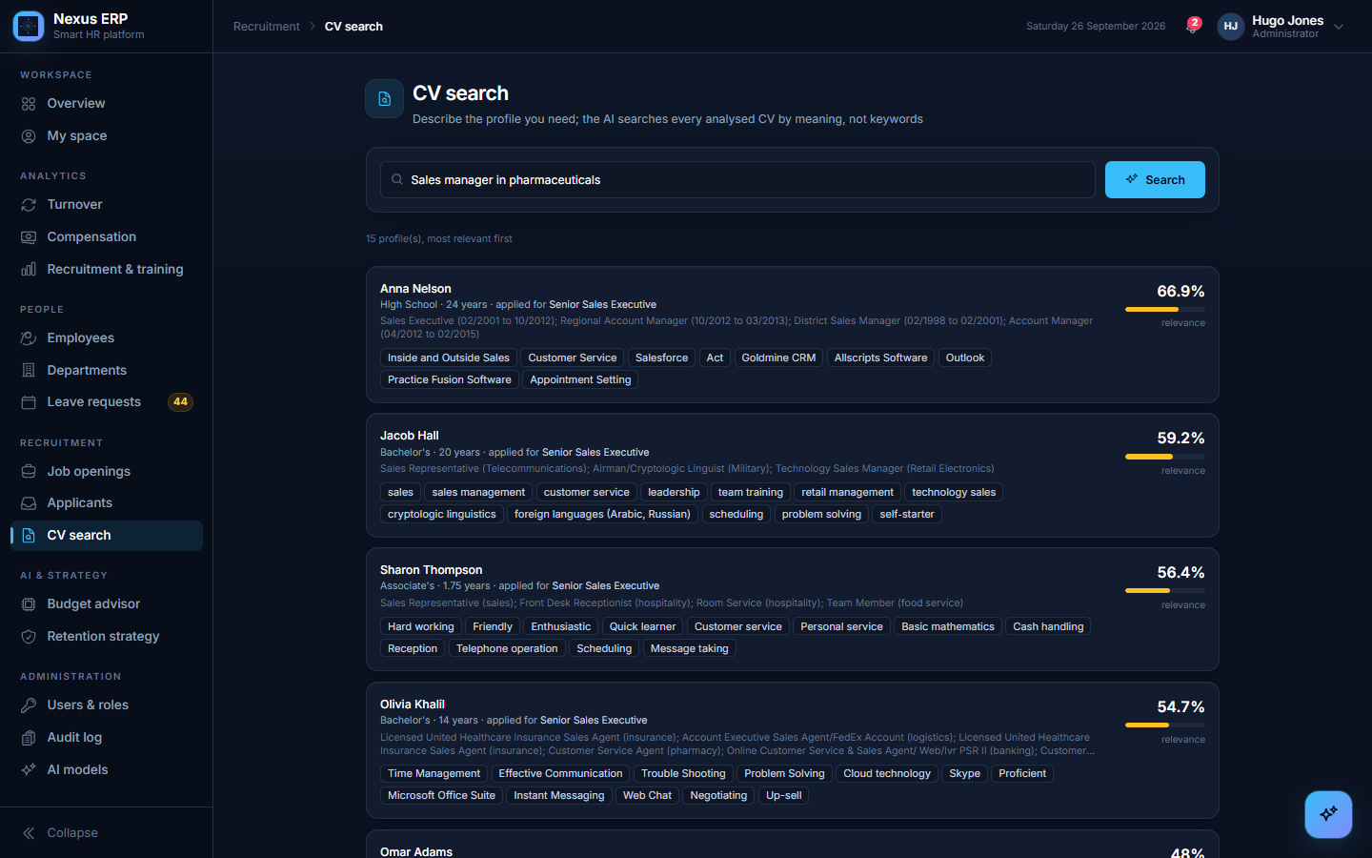
Figure 15: Semantic CV search

8. Machine-learning models

8.1 Attrition risk (who may leave, and why)
What it does. For each current employee, the model estimates the probability of leaving and lists the three factors that raise it the most.
How it works, in short.
- It learns from the 1,470 employees, 237 of whom left, using 22 facts per person (job level, overtime, stock options, years since the last promotion, distance from home, satisfaction scores…). Gender, age and marital status are deliberately not used.
- The algorithm is XGBoost, a set of decision trees that each correct the previous ones.
- Quality is measured with cross-validation: the data is split in 5 parts, the model learns on 4 and is tested on the 5th, five times. Every employee is scored by a model that never saw them, so the scores are honest.
- SHAP explains each prediction: how much each fact pushed that person's risk up.
- The "high risk" threshold is not set by hand: it is the value that best balances precision and recall (see below).

The scores, explained.
Score | Ours | What it means | Best possible | Why not higher
Ranking quality (ROC AUC) | 0.82 | take one person who left and one who stayed: 82% of the time the model gives the higher risk to the one who left (0.50 = a coin toss) | 1.00; above 0.80 is good for people data | leaving also depends on things no database holds: an outside offer, a move, family, health, a conflict with a manager
Precision of the alerts | 56% | of 100 people flagged "high risk", 56 really left | 100% (no false alarm) | only 16% of employees leave: a rare event is hard to catch without false alarms. A false alarm only costs a conversation
Recall | 54% | of 100 people who left, 54 would have been flagged in advance | 100% | precision and recall pull against each other; the threshold is the best balance
F1 | 0.55 | one number combining precision and recall | 1.00; 0.50–0.60 is normal for this kind of problem | same reasons
Alert threshold | 28% | risk from which someone is flagged. It looks low, but the normal risk is 16%, so it is about twice the normal risk | chosen automatically | —
Detection of leavers (PR AUC) | 0.58 | quality of the alerts at every threshold; guessing gives 0.16, so the model is about 4 times better | 1.00 | always low for rare events; what matters is the distance to chance
Simple model for comparison | 0.83 | a much simpler model (logistic regression) gets the same ranking quality | the advanced model should be higher | the links in this data are simple; XGBoost is kept because it explains each person's risk

Result. About 163 of the 1,233 current employees are flagged. The main drivers found are overtime, job level, stock options, job role, career length and number of previous employers, the drivers known in HR research. The retention page turns them into a strategy written by the language model and lists the people to talk to first; each employee file shows that person's risk and drivers.
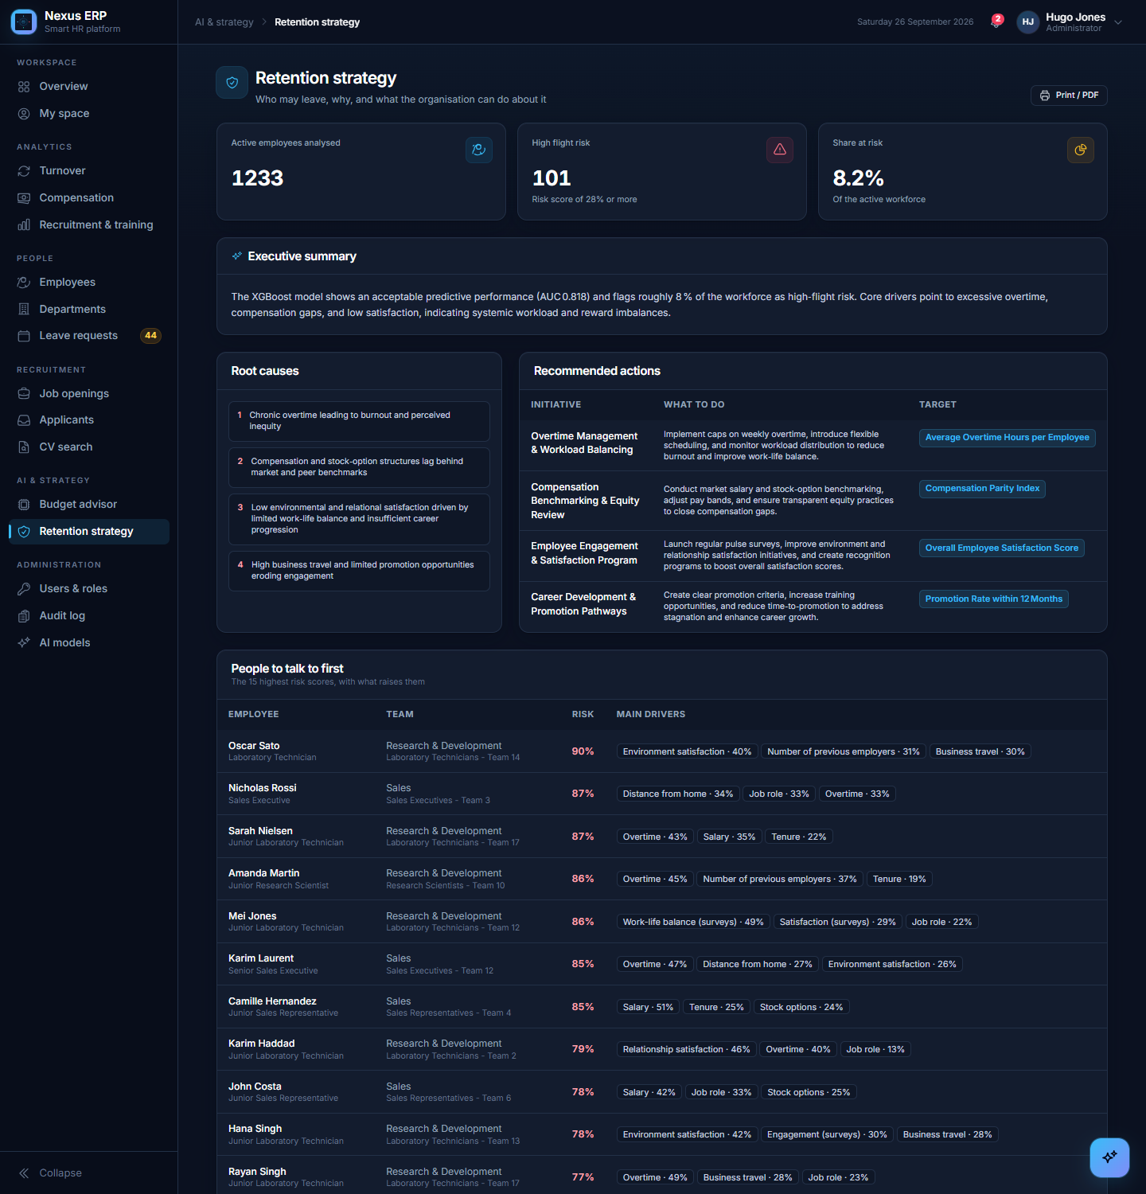
Figure 16: Retention strategy
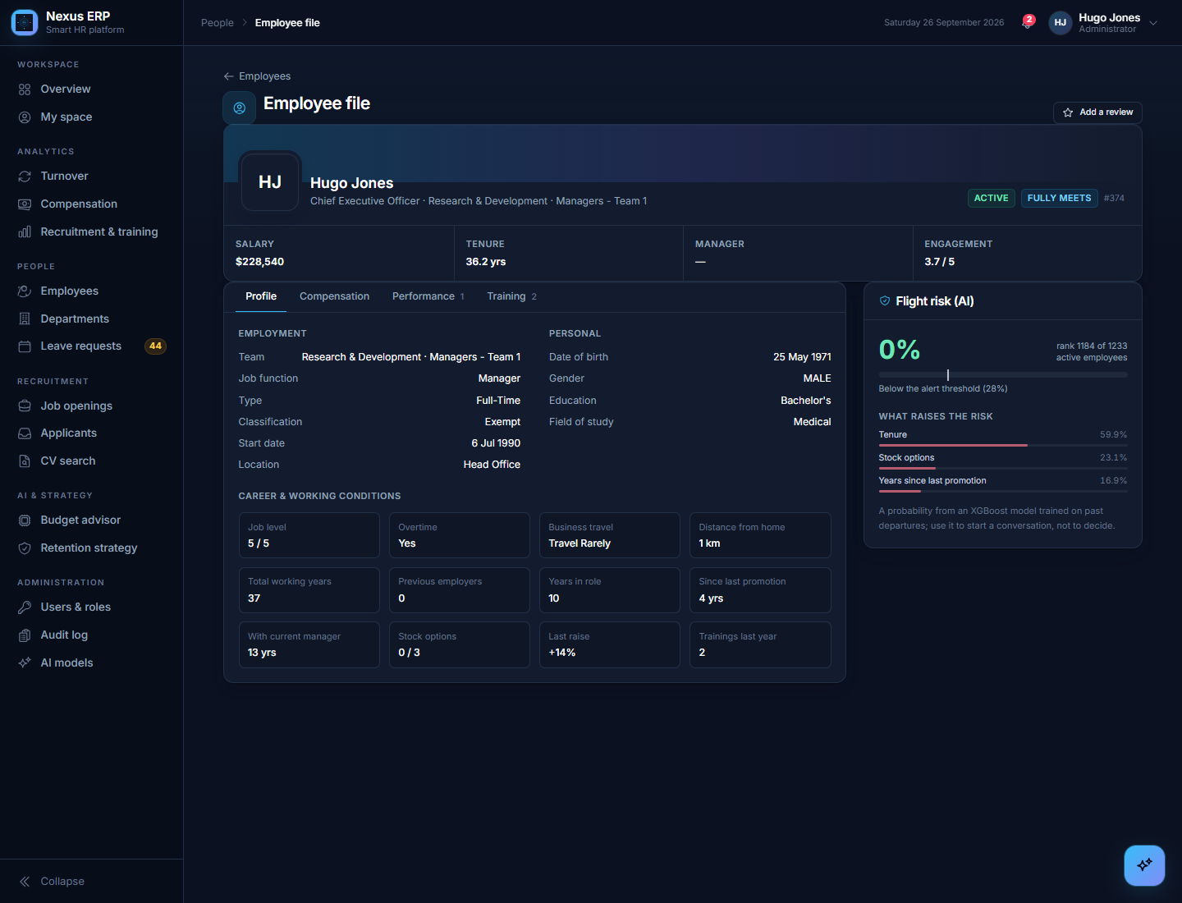
Figure 17: An employee file with the flight-risk card

8.2 Retention curves
For each department, a Kaplan-Meier curve shows the share of hires still employed after 1, 2, … 10 years, counting people still employed up to today. The median tenure is the year when fewer than half are still there. This answers "how long do people stay?" without any model.
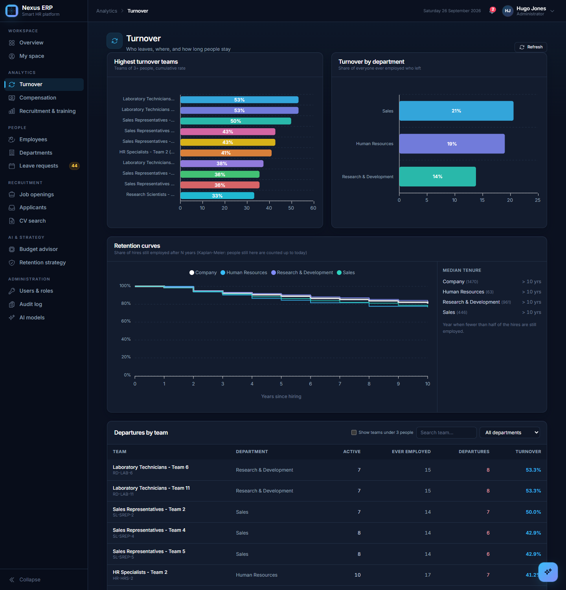
Figure 18: Turnover page with the retention curves

8.3 Training budget advisor
What it does. For each team, it predicts how the average performance would change with a different training budget, finds the budget with the best predicted performance, lets HR simulate any amount and approve an allocation.
The scores, explained.
Score | Ours | What it means | Best possible | Why not higher
Share of performance explained (R²) | −0.26 | how much of the differences between teams the model explains; 0 = no better than always predicting the average; below 0 = worse | 1.00; 0.50 or more is useful | in the IBM data the performance rating is almost always 3 or 4 and the training cost per team comes from a price list: there is almost nothing to learn
Average error | 0.077 | the prediction is off by 0.077 rating points, while team averages only vary by about 0.093 | 0 | the error is as large as the differences: the model cannot tell teams apart
Teams used | 98 | one example per team of 3 people or more | several hundred (e.g. several years of budgets per team) | a company only has so many teams

Conclusion. The budget advisor works as a tool (curve, simulator, approval, memo), but on this data it has no predictive power, and the application says so clearly on every budget page. With real budgets and varied performance ratings the same pipeline can become useful.
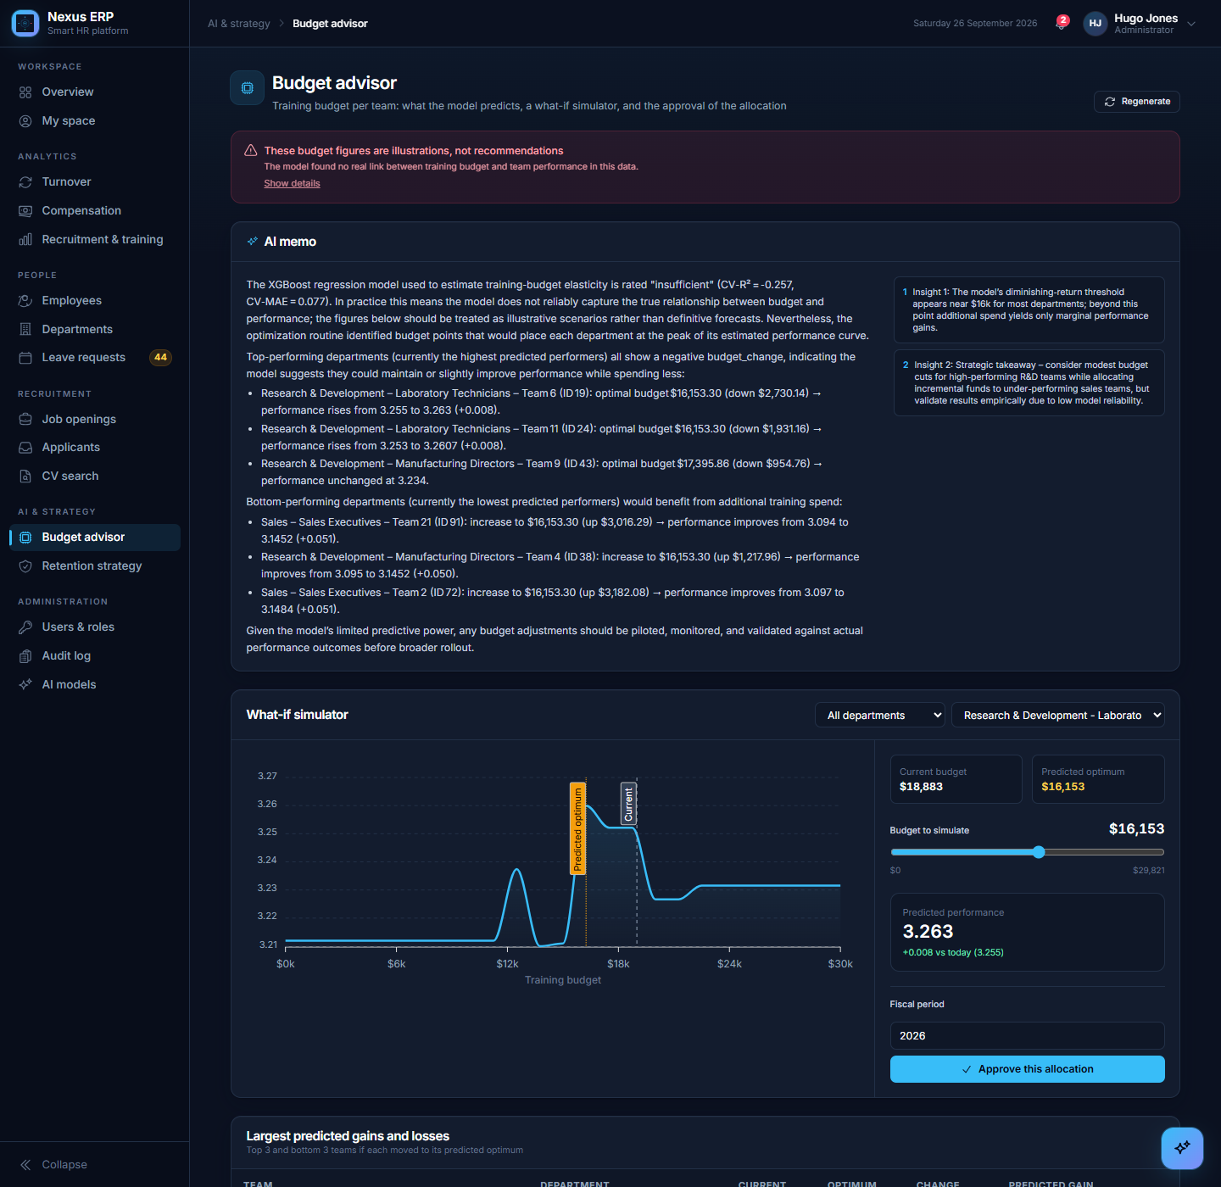
Figure 19: Budget advisor: what-if simulator and approval

8.4 Model monitoring
The AI models page (administrators) shows every score above with its plain-language explanation, the training date, and a button to retrain both models on the current data.
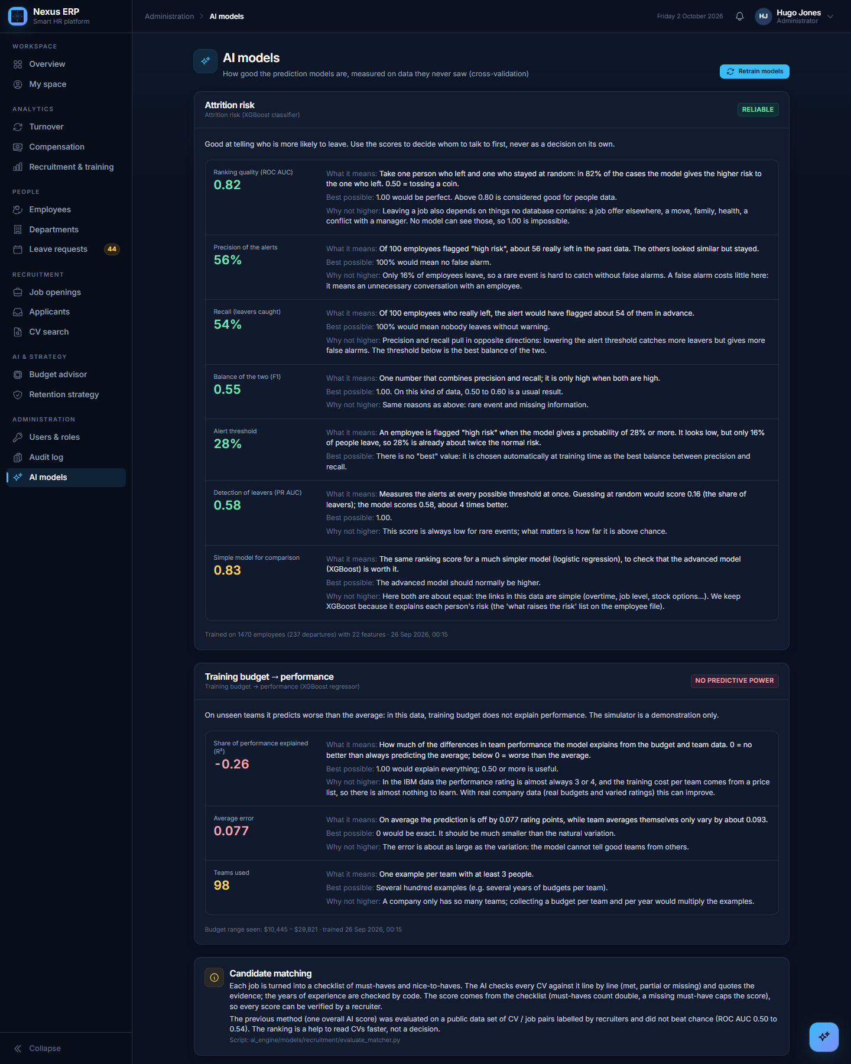
Figure 20: AI models page

8.5 How good is the candidate ranking?
The first version of the ranking (one overall score from the model, blended with similarity signals) was tested on a public data set of CV / job pairs labelled by recruiters ("good fit", "potential fit", "no fit"): the text similarity reached a ROC AUC of 0.54 and the model's overall judgment 0.50, which is no better than chance. That result led to the current method: instead of one opaque number, the model answers precise questions (is this requirement in the CV, and where?), and the score is computed by fixed rules. On the "Senior Sales Executive" opening, the candidates with sales, account-management and Salesforce experience come first, with the exact lines of their CV as evidence, and unrelated profiles score below 30.
The method is more precise and fully explainable, but it is not yet *measured* on real hiring decisions. The next step is to compare its scores with the company's own decisions (interviews, offers, hires recorded in the status history) and, once a few hundred decisions exist, to learn the weights from them. In every case the ranking remains a help to read CVs faster; a recruiter reviews every candidate.

9. Frontend (Angular)

9.1 Design
- Layout: a sidebar grouped by area (Workspace, Analytics, People, Recruitment, AI & strategy, Administration) showing only what the role allows, with icons, the active page marked, badges (e.g. leave requests waiting), and a compact icon mode; a top bar with the page path, notifications and the user menu.
- Design system: one set of cards, buttons, tables, tabs, badges and alerts in a dark theme, used by every page.
- Pages are loaded on demand; the analytics data is loaded once and shared between the four analytics pages.
- Security: routes are protected by role; an expired session sends the user back to the sign-in page.

9.2 Analytics
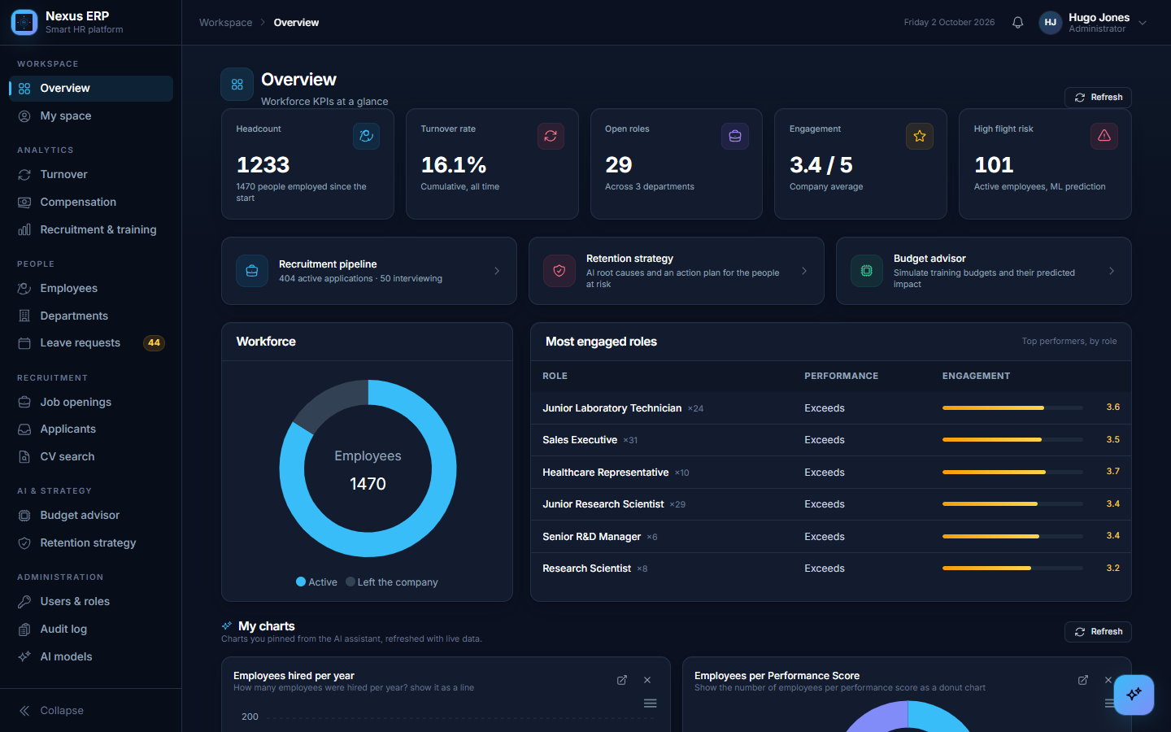
Figure 21: Overview
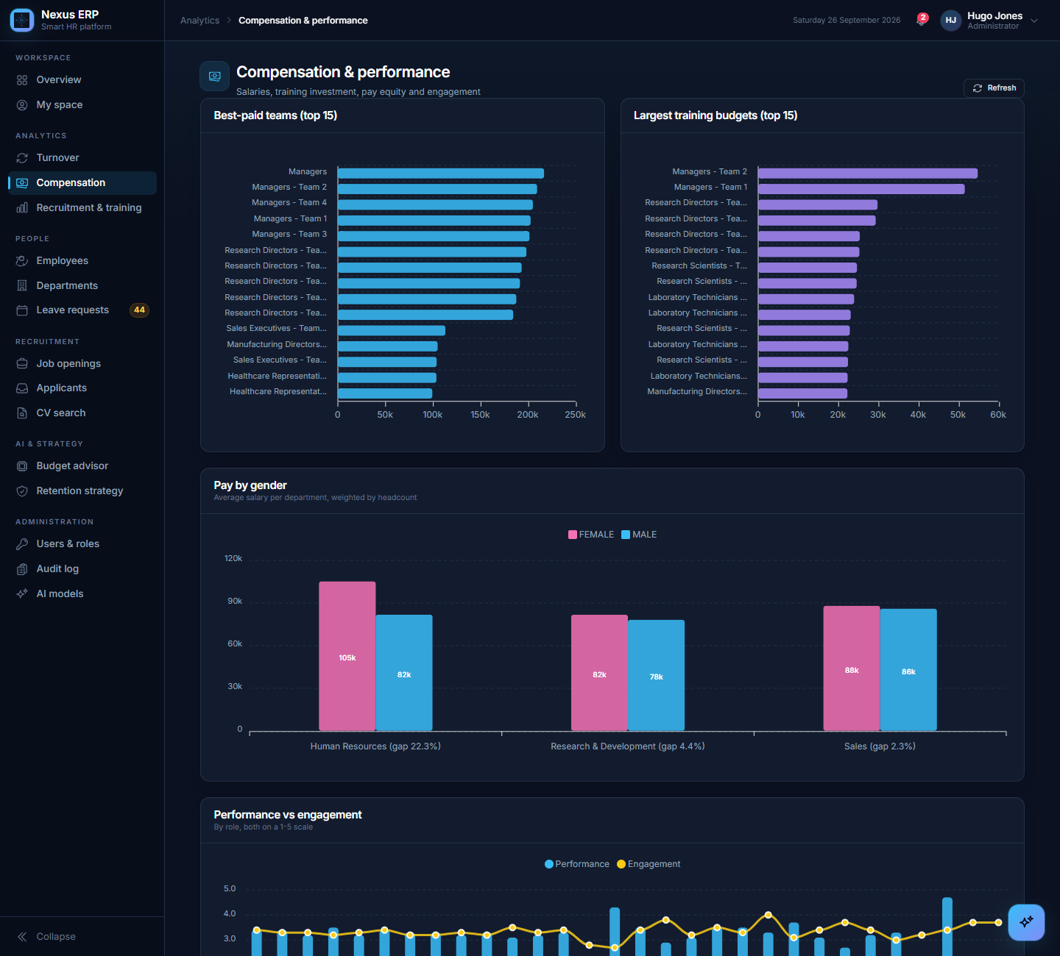
Figure 22: Compensation and performance
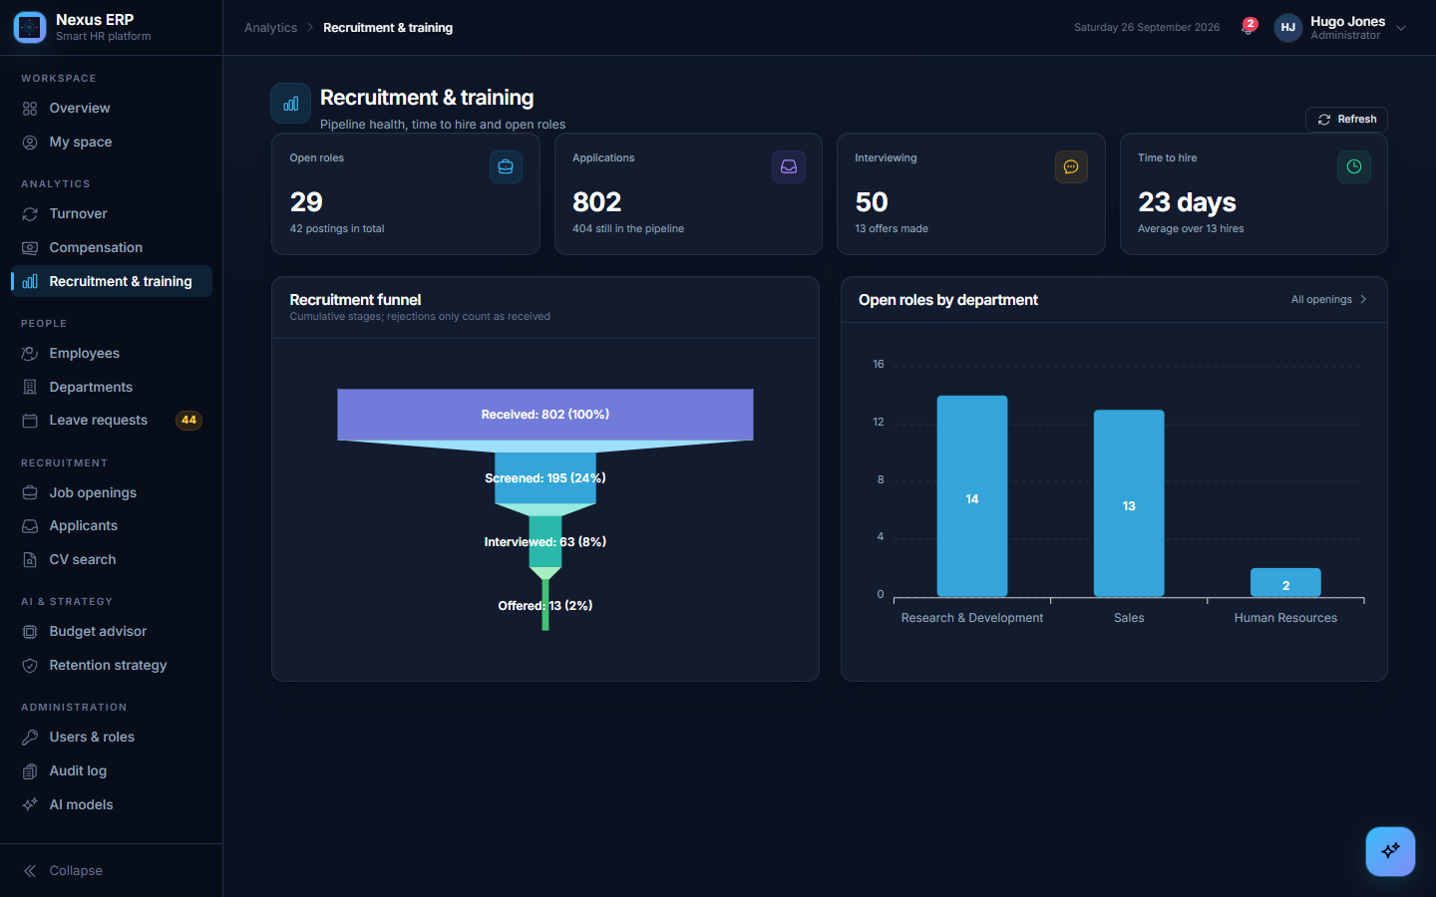
Figure 23: Recruitment and training

9.3 People
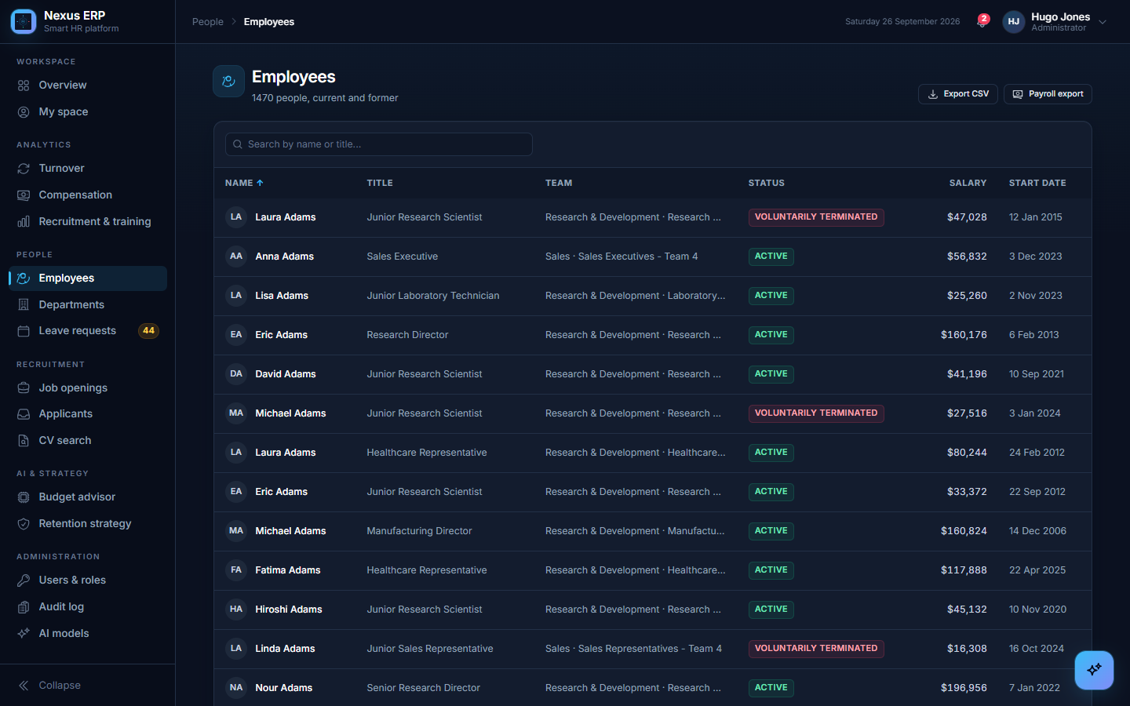
Figure 24: Employees
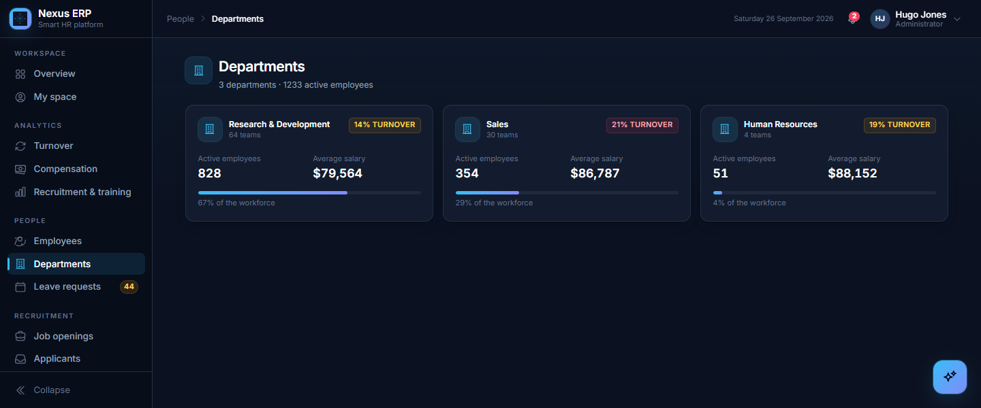
Figure 25: Departments
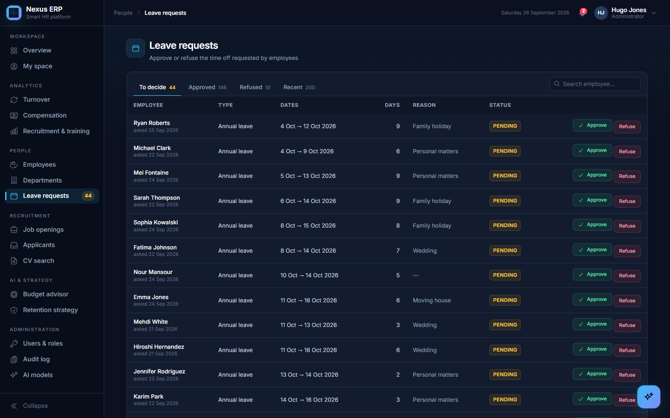
Figure 26: Leave requests

9.4 Recruitment
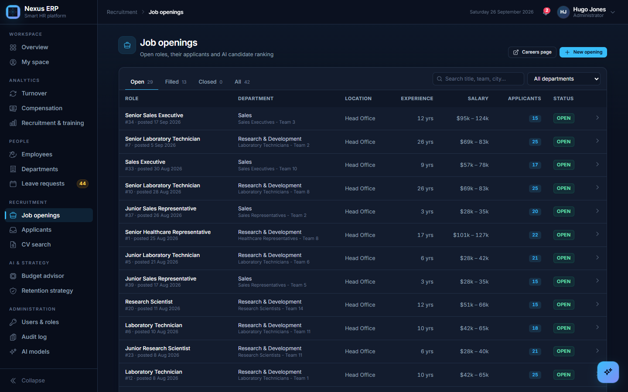
Figure 27: Job openings
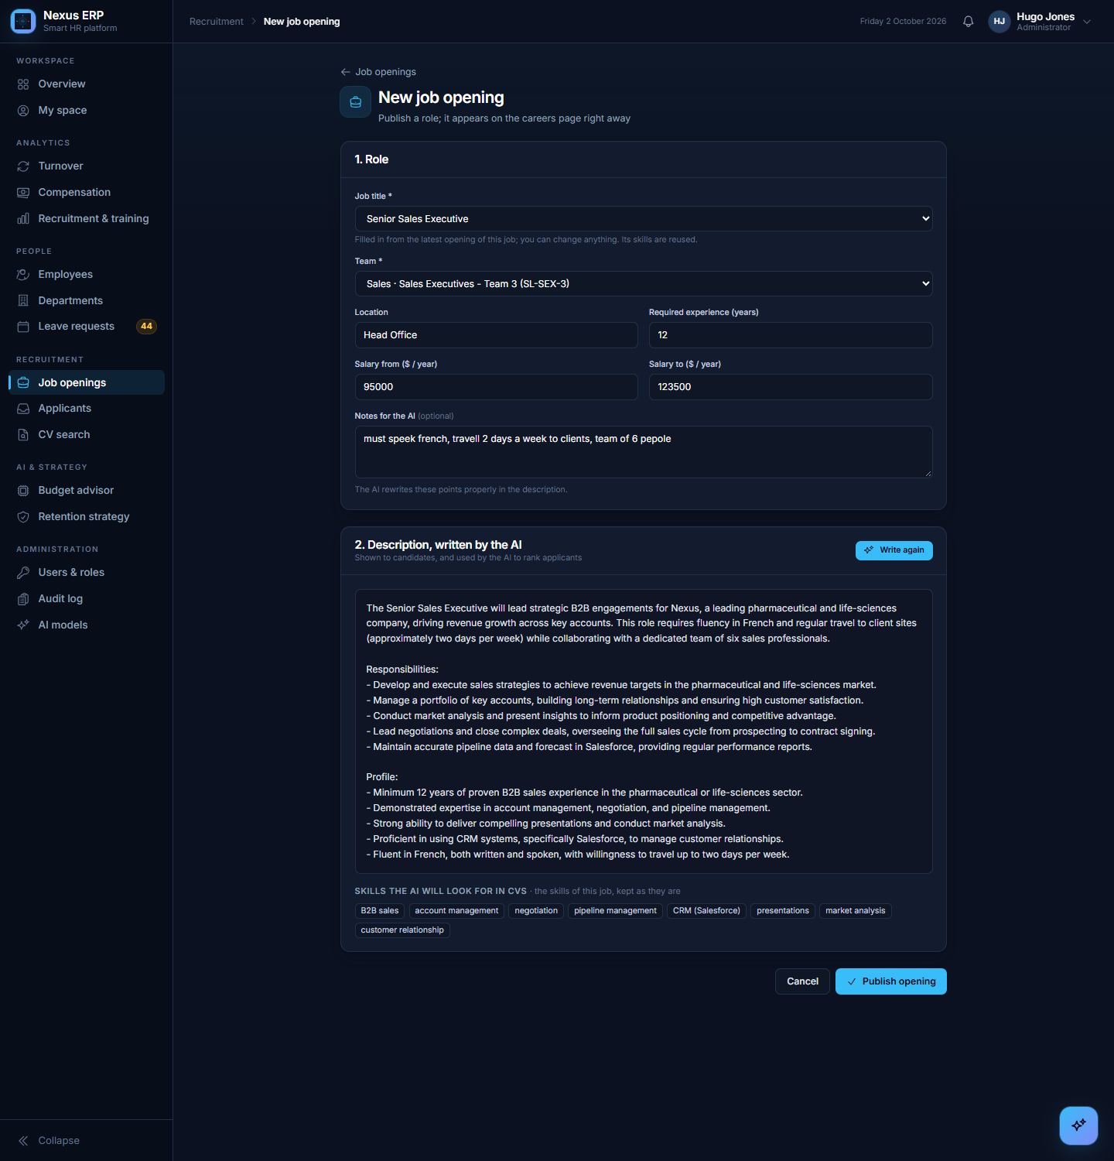
Figure 28: New job opening: an existing title, rough notes, and the description written by the AI with the job's skills
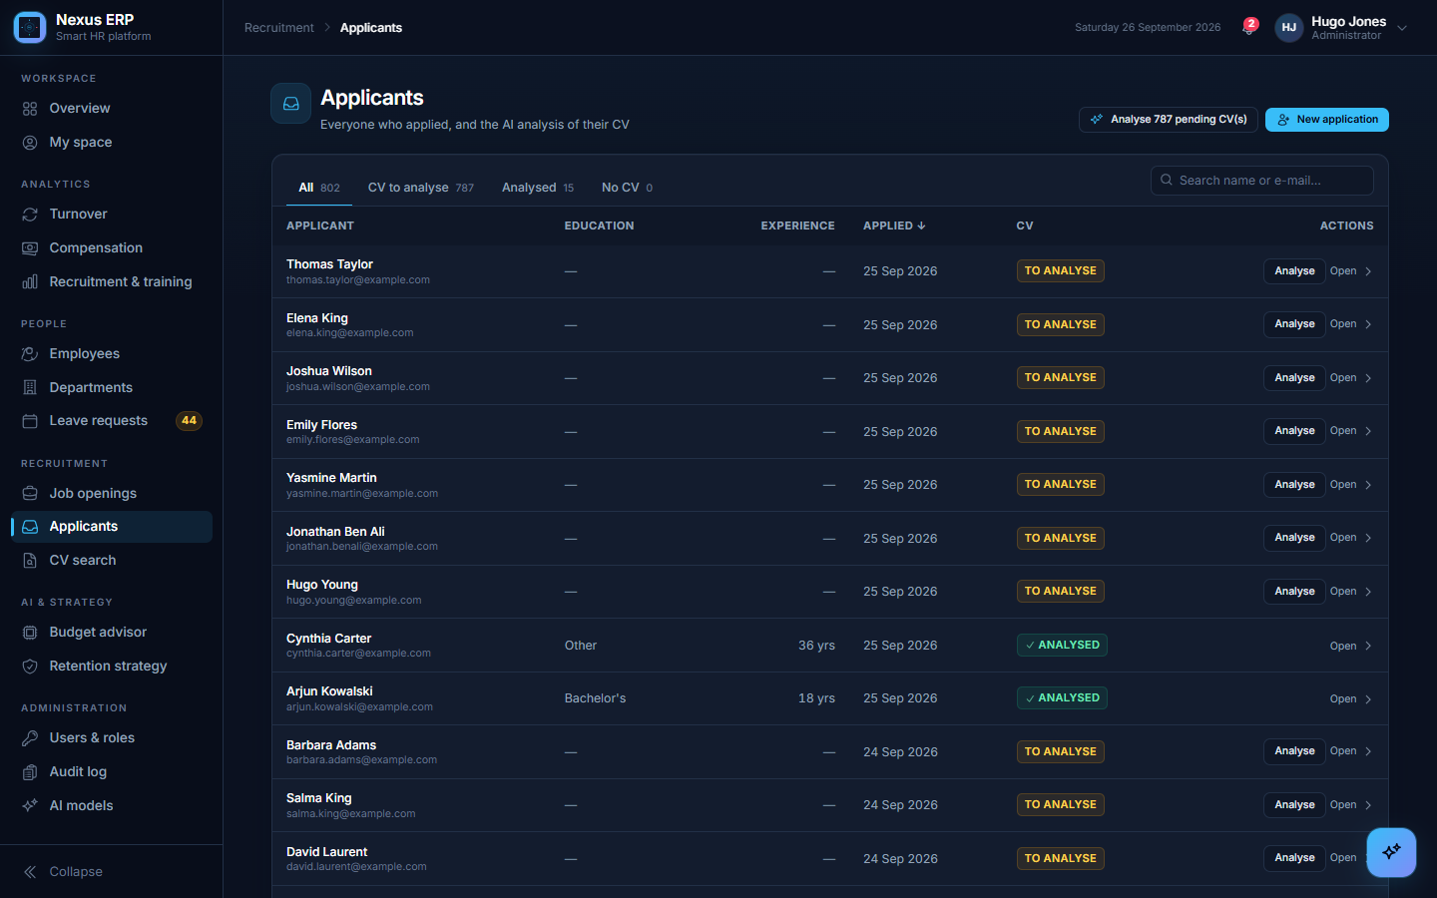
Figure 29: Applicants and CV analysis

9.5 Administration and self-service
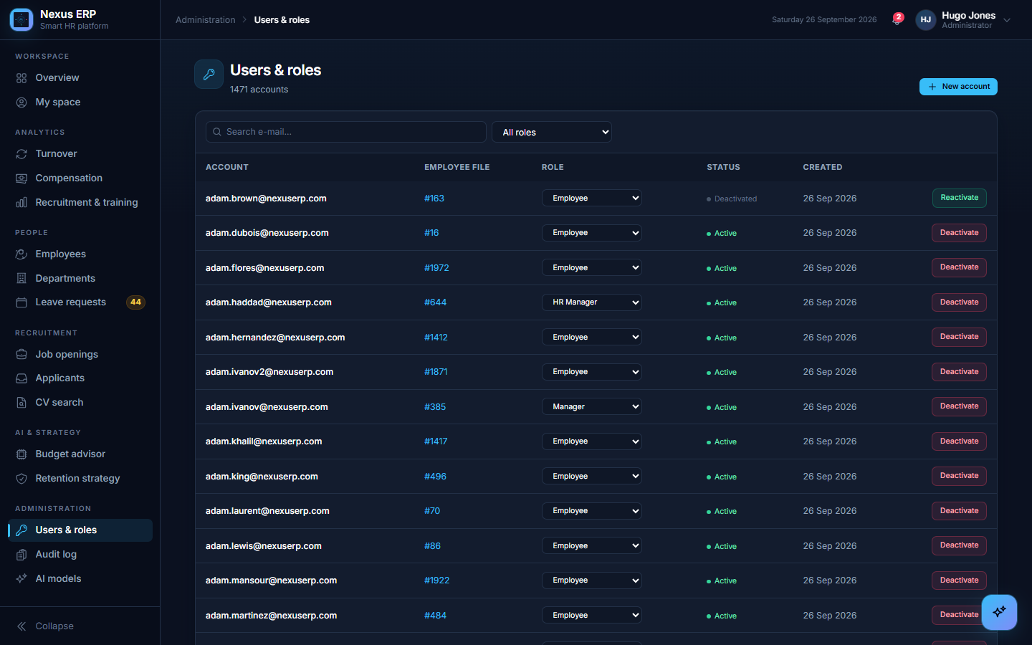
Figure 30: Users and roles
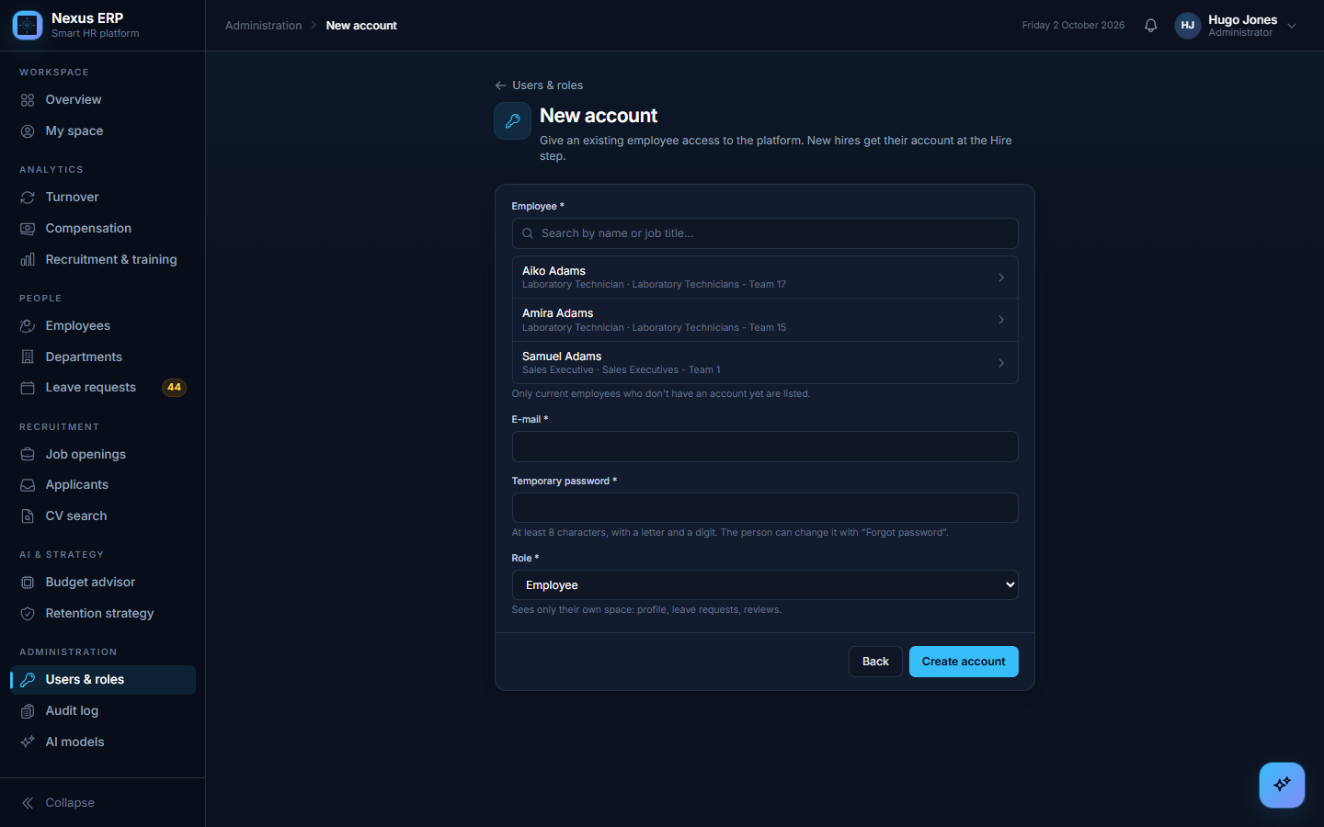
Figure 31: New account: only current employees without an account can be chosen
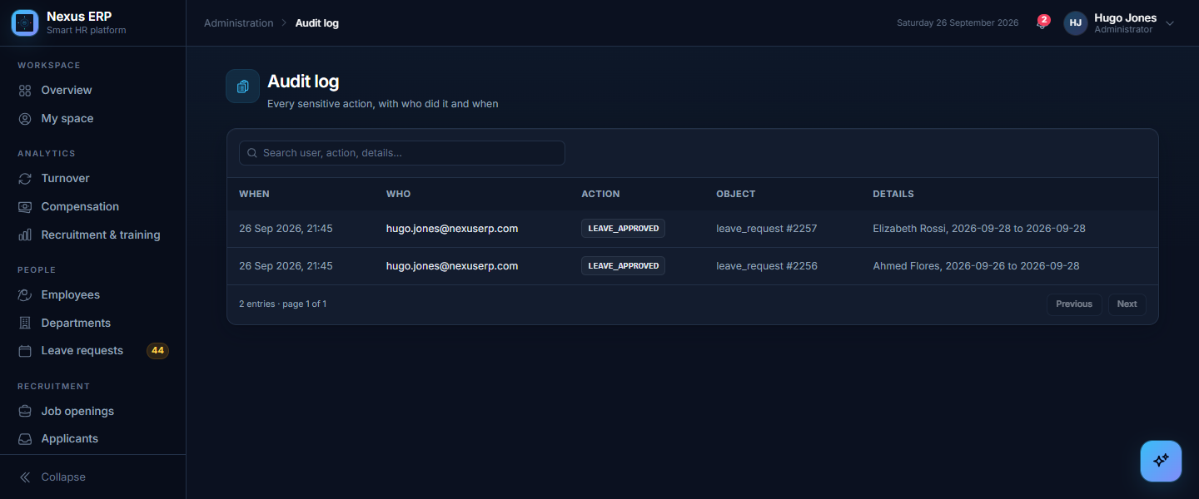
Figure 32: Audit log
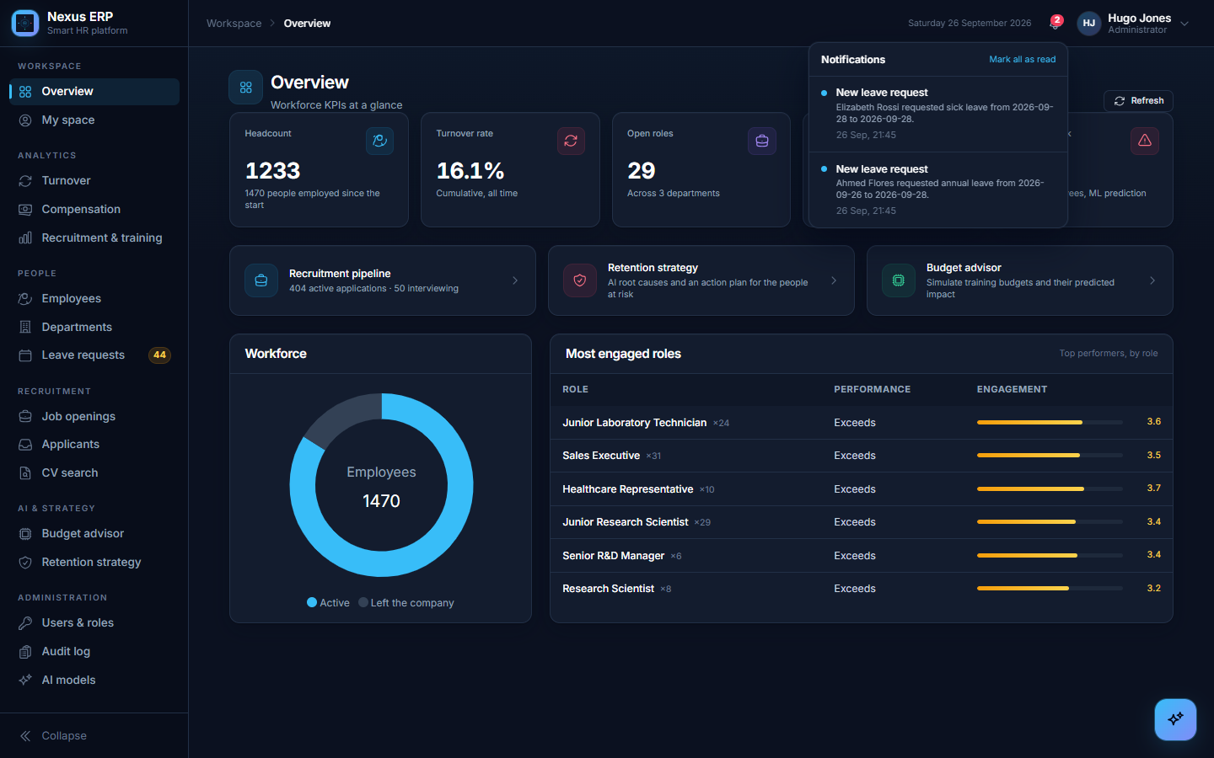
Figure 33: Notifications
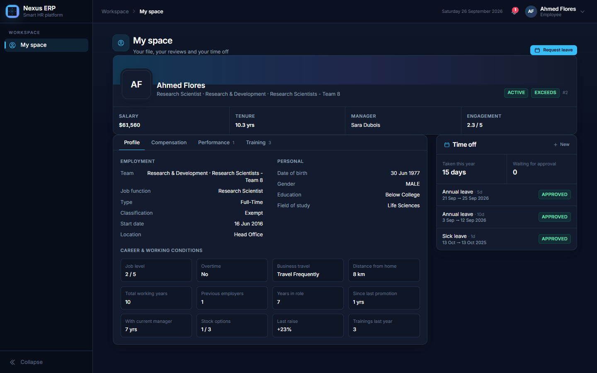
Figure 34: My space (employee view)

10. Main workflows

10.1 From application to hire
- A candidate applies on the careers site with a PDF CV.
- The backend checks the file, saves the application and notifies HR; in the background the AI engine reads the CV and HR is notified again.
- On the job opening, HR sees the job's checklist and the ranked candidates, each with the requirements met, partial or missing and the evidence from the CV.
- HR opens a candidate, asks the AI questions about the CV, prepares the interview, then moves the application to interview, offer or rejection; the candidate receives an e-mail each time.
- HR hires the candidate: the employee file and the account are created, the opening is filled, and the new employee receives a link to choose a password.

10.2 Leave request
- The employee asks for leave in "My space"; HR is notified and the sidebar badge increases.
- HR approves or refuses; the employee is notified.
- On the first day of an approved leave the employee's status becomes "On Leave", and "Active" again the day after it ends.

10.3 Training budget
- The advisor shows each team's current budget (the cost of the trainings its people followed), the predicted curve and the optimum.
- HR simulates an amount and approves it for a period; the allocation is recorded with the approver and appears in the history and the audit log.

11. Security and privacy
Topic | Measure
Access | roles checked by the backend and the AI engine; every page protected by role
Secrets | .env files never committed; admin credentials from the configuration
CV files | private bucket, downloaded only with short-lived signed links
Data sent to a cloud model | e-mail, phone and name removed from the CV; a local-only mode is available
Chatbot | read-only database role, allowed views only, query checks, 10-second limit
Fairness | gender, age and marital status excluded from the attrition model
Traceability | audit log of sensitive actions; status history of applications
Candidates' e-mails in the demo data | example.com addresses, so the application can never e-mail a real person

12. Deployment
The whole application starts with one command, docker compose up -d --build (frontend on port 4200, backend 8080, AI engine 8000, database, MinIO, pgAdmin). The data is (re)loaded by running the ETL once. The README gives the complete step-by-step procedure: prerequisites, configuration files, start and stop, data loading, backup and restore, troubleshooting.

13. Validation
The application was validated end to end on a separate copy of the infrastructure (a throwaway database and file store), never on the working data:
- the ETL loads the full company, the backend migrations run and the database structure is validated at start-up;
- every page was opened with an administrator account, and the employee account only reaches "My space";
- recruitment: a public application with a PDF is saved, its CV is analysed automatically and HR is notified; the CVs of an opening are analysed from the page and ranked requirement by requirement (15 of 15 reviewed, with evidence, and instantly from the cache the second time); interview questions are generated; a job opening is created with the AI description;
- chatbot: the table arrives after about two seconds, then the answer is written word by word; an unsafe query is refused before the stream starts;
- accounts: an account without an employee, or a second account for the same employee, is refused; a new account is linked to the chosen employee, who then disappears from the list; the old register address answers 404;
- chatbot without chart request: a plain question returns the table and the answer only; "Create a chart" then adds one; a question asking for a pie chart gets it directly;
- job openings: for an existing title the skills are kept; for a new title (Clinical Data Analyst) the model defined 12 skills; rough notes were rewritten correctly; publishing without a description is refused;
- charts: the AI chose the requested type for each test question (stacked bar by department and gender, line per year, pie and donut shares, horizontal bar for the top 12 job titles) about one second after the table; charts were pinned, listed with fresh data, enlarged and deleted; a pin with a DELETE query was refused;
- language model: when Groq's per-minute limit is reached, the client waits and retries, and the log shows which model answered each call;
- leave: an approved leave starting today switches the employee to "On Leave", back to "Active" once it has ended;
- budget: an allocation is approved and recorded; the audit log shows these actions;
- the models were retrained from the AI models page;
- security: requests without a token or with the wrong role are refused; the rate limit on applications works.

14. Limits and future work
Limit | Next step
The data is realistic but simulated (IBM) | retrain the attrition model on the company's own history before using it for decisions
The budget model has no predictive power on this data | collect real budgets per team and per year, and more varied performance ratings
The requirement-based ranking is explainable but not yet measured on real decisions | compare it with the company's own interviews, offers and hires, then learn the weights from them
Groq's free tier limits the tokens per minute, which slows the first ranking of a large opening | a paid tier, or the local model with a GPU
CV analysis in bulk runs from the open page or a command | a background job queue
English CVs only are well handled by the embedding model | a multilingual model for French CVs
Leave and review data are not yet used by the attrition model | add them as features and compare the quality
Exports | Excel / PDF export of every dashboard
Pinned charts belong to one user | share a chart with a team, choose its place and size on the dashboard

15. Conclusion
Nexus ERP shows how an HR ERP can combine classic processes with AI in a useful and honest way. The dashboards and processes cover the daily work of an HR team; the AI features remove repetitive work (reading and ranking CVs, preparing interviews, answering data questions); the attrition model finds real drivers and points to the people to talk to first. Just as important, every AI result is presented with its limits: the quality of each model is measured on data it never saw, explained in plain words, and shown where it is used, so that the tool supports HR decisions instead of replacing them.

Glossary
Term | Meaning
ERP | Enterprise Resource Planning: one application for the processes of a company
ETL | Extract, Transform, Load: read raw data, clean and reshape it, load it into the database
KPI | Key Performance Indicator (headcount, turnover rate…)
Turnover rate | share of employees who left
API | the interface through which the front end talks to a server
JWT | a signed token proving who the user is and their role
LLM | Large Language Model (e.g. Llama 3, GPT-OSS)
Text to SQL | a language model turning a question into a database query
Vector / embedding | a list of numbers representing the meaning of a text; close meanings give close vectors
XGBoost | a machine-learning algorithm made of many small decision trees
SHAP | a method that explains how much each input pushed a prediction up or down
Cross-validation | testing a model on data it did not learn from, several times, to measure its real quality
ROC AUC | ranking quality of a classifier: 0.5 = random, 1.0 = perfect
Precision / recall | share of alerts that are right / share of real cases that are caught
R² | share of the variation explained by a model: 0 = no better than the average, 1 = perfect
Kaplan-Meier curve | share of people still employed after N years, counting people still employed up to today
Flyway | a tool that applies the database changes (migrations) in order
MinIO | a file store compatible with Amazon S3

