LOW POWER MODES

What are LOW-POWER MODES :
Low power modes are special modes designed to reduce MCU‘s power consumption ,
modes may vary between product another. Each mode is designed for a specific range of applications. Low power modes vary between product and another in this document
we will cover low power modes that are available in the STM32L476RG
LOW-POWER MODES :
The ultra-low-power STM32L476xx supports seven low-power modes to achieve the best compromise between low-power consumption, short startup time, available peripherals and available wakeup sources
Sleep mode :
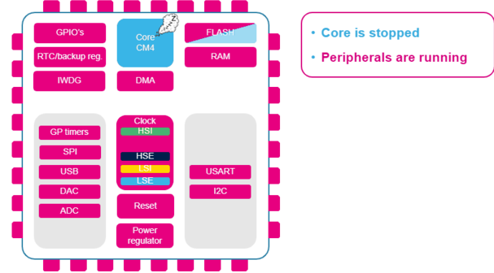

In Sleep mode, only the CPU is stopped. All peripherals continue to operate and can wake up the CPU when an interrupt/event occurs
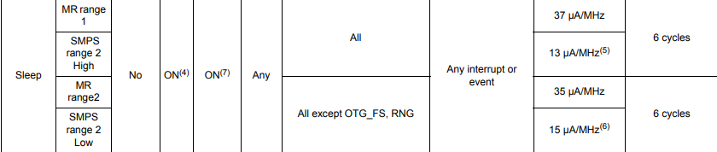
/* USER CODE BEGIN 3 */

HAL_Delay(1000);
HAL_SuspendTick();
HAL_PWR_EnterSLEEPMode(PWR_MAINREGULATOR_ON,PWR_SLEEPENTRY_WFI);
HAL_ResumeTick();

Low-power run mode
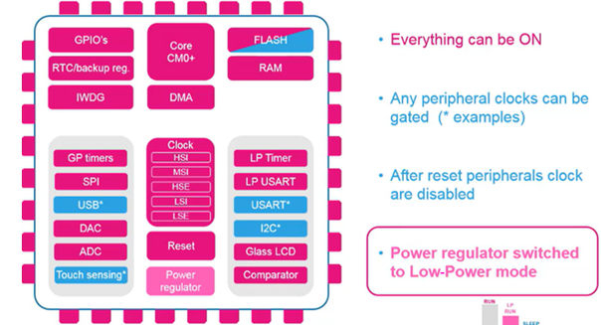
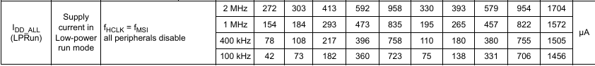
This mode is achieved with VCORE supplied by the low-power regulator to minimize the regulator's operating current. The code can be executed from SRAM or from flash, and the CPU frequency is limited to 2MHz. The peripherals with independent clock can be clocked by HSI16
/* USER CODE BEGIN WHILE */
while (1)
{ /* USER CODE END WHILE */

/* USER CODE BEGIN 3 */
HAL_Delay(2000);
HAL_PWREx_EnableLowPowerRunMode();

}
/* USER CODE END 3 */
Low Power Sleep mode
This mode is entered from the low-power run mode. Only the CPU clock is stopped. When wakeup is triggered by an event or an interrupt, the system reverts to the low
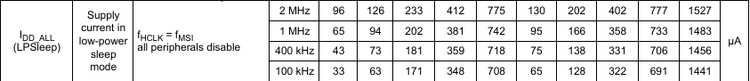
/* USER CODE BEGIN 3 */
HAL_Delay(2000);
HAL_SuspendTick();
HAL_PWR_EnterSLEEPMode(PWR_LOWPOWERREGULATOR_ON, PWR_SLEEPENTRY_WFI);
HAL_ResumeTick();

Stop modes :
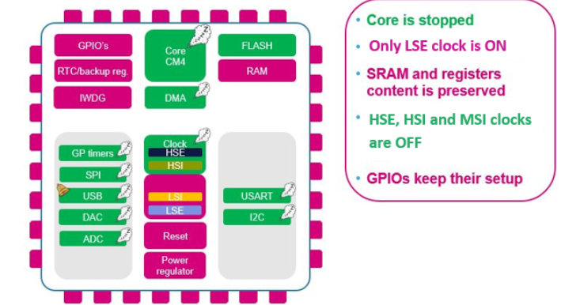
In stop mode, you need disable IRQ_handler and Suspend tick
Stop 0 mode 120ua
The general recommendation for entering stop mode is to set all unused GPIOs into analog mode. This mode deactivates the input Schmitt trigger and has no pull up or pull down, which ensures the lowest consumption from each pin.
GPIO_InitStructure.Pin = GPIO_PIN_All;
GPIO_InitStructure.Mode = GPIO_MODE_ANALOG;
GPIO_InitStructure.Pull = GPIO_NOPULL;
GPIO_InitStructure.Pin = GPIO_PIN_All;
GPIO_InitStructure.Pin &= ~(GPIO_PIN_13);
GPIO_InitStructure.Mode = GPIO_MODE_ANALOG;
GPIO_InitStructure.Pull = GPIO_NOPULL;
HAL_GPIO_Init(GPIOC, &GPIO_InitStructure);

Stop mode achieves the lowest power consumption while retaining the content of SRAM and registers. All clocks in the VCORE domain are stopped, the PLL, the MSI RC, the HSI16 RC and the HSE crystal oscillators are disabled. The LSE or LSI can be kept running.
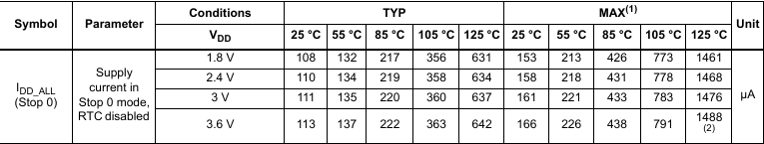
/* Infinite loop */
/* USER CODE BEGIN WHILE */
while (1)
{
/* USER CODE END WHILE */

/* USER CODE BEGIN 3 */

HAL_Delay(1000);
HAL_SuspendTick();
HAL_PWREx_EnterSTOP0Mode(PWR_SLEEPENTRY_WFI);
HAL_ResumeTick();
}
/* USER CODE END 3 */

Stop1 mode
Stop 1 offers the largest number of active peripherals and wake-up sources, a smaller wake-up time but a higher consumption than Stop 2.
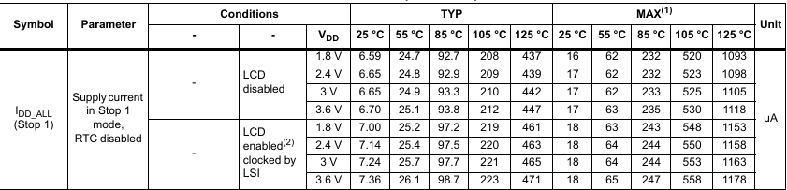
HAL_PWREx_EnterSTOP1Mode(PWR_SLEEPENTRY_WFI);

Stop2 mode
In Stop 2 mode, most of the VCORE domain is put in a lower leakage mode.
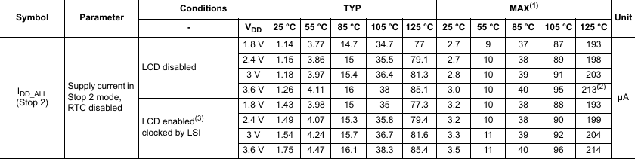
HAL_PWREx_EnterSTOP2Mode(PWR_SLEEPENTRY_WFI);

Standby mode

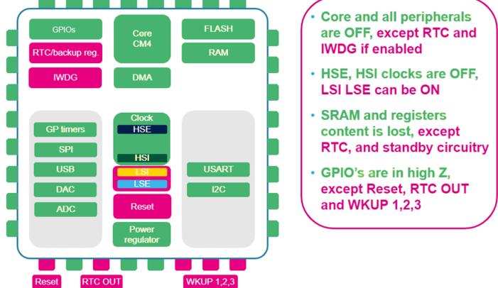
The Standby mode is used to achieve the lowest power consumption with BOR. The internal regulator is switched off so that the VCORE domain is powered off. The PLL, the MSI RC, the HSI16 RC and the HSE crystal oscillators are also switched off. The RTC can remain active (Standby mode with RTC, Standby mode without RTC). The brown-out reset (BOR) always remains active in Standby mode. The state of each I/O during standby mode can be selected by software: I/O with internal pull-up, internal pull-down or floating. After entering Standby mode, SRAM1 and register contents are lost except for registers in the Backup domain and Standby circuitry. Optionally, SRAM2 can be retained in Standby mode, supplied by the low-power Regulator (Standby with SRAM2 retention mode). The device exits Standby mode when an external reset (NRST pin), an IWDG reset, WKUP pin event (configurable rising or falling edge), or an RTC event occurs (alarm, periodic wakeup, timestamp, tamper) or a failure is detected on LSE (CSS on LSE). The system clock after wakeup is MSI up to 8 MHz.
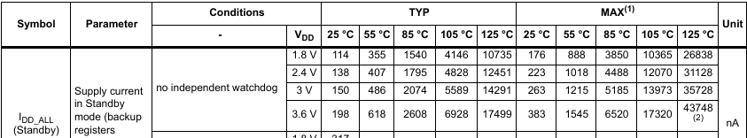
__HAL_PWR_CLEAR_FLAG(PWR_FLAG_WU);
/* USER CODE END 2 */
/* USER CODE BEGIN 3 */
HAL_Delay(2000);
HAL_PWR_EnterSTANDBYMode();

Shutdown mode
The Shutdown mode permits to achieve the lowest power consumption. The internal regulator is switched off so that the VCORE domain is powered off. The PLL, the HSI16, the MSI, the LSI and the HSE oscillators are also switched off. The RTC can remain active (Shutdown mode with RTC, Shutdown mode without RTC). The BOR is not available in Shutdown mode. No power voltage monitoring is possible in this mode, therefore the switch to Backup domain is not supported. SRAM1, SRAM2 and register contents are lost except for registers in the Backup domain. The device exits Shutdown mode when an external reset (NRST pin), a WKUP pin event (configurable rising or falling edge), or an RTC event occurs (alarm, periodic wakeup, timestamp, tamper). The system clock after wakeup is MSI at 4 MHz
HAL_PWREx_EnterSHUTDOWNMode();
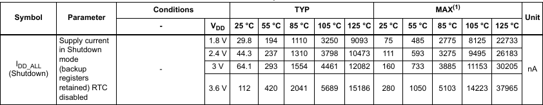

Mode | CPU State | Clocks | SRAM Retention | Regulator State | Wake-up Sources | Power  Cons. | Wake-up Latency | Use Case
Sleep | CPU halted | All running | Yes | Main regulator ON | Any interrupt | Moderate | Immediate | CPU idle, peripherals active
Stop 0 | CPU halted | All stopped | Yes | Main regulator ON | Interrupts, events | Low | Few µs | Fast wake-up, moderate power save
Stop 1 | CPU halted | All stopped | Yes | Main regulator low-power | Interrupts, events | Lower | Tens of µs | Better power saving, slower wake-up
Stop 2 | CPU halted | All stopped | Yes | Main regulator OFF | Interrupts, events | Lowest  in stop  modes | Hundreds of µs | Ultra-low power, longer wake-up
Standby | CPU off | All stopped | No (except backup SRAM) | Main regulator OFF, backup powered | External pins, RTC, reset | Ultra-low  (nA) | ms | Deep sleep, max power saving
Shutdown | CPU off | All stopped | No | All regulators OFF | External reset, wake-up pins | **Lowest (nA)** | Long | Extreme low power, rare wake-up

MAIN regulator vs LP regulator

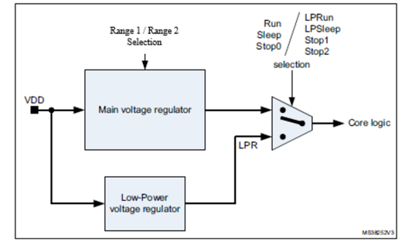
Two embedded linear voltage regulators supply most of the digital circuitries: the main regulator (MR) and the low-power regulator (LPR).
• The MR is used in the Run and Sleep modes and in the Stop 0 mode.
• The LPR is used in Low-Power Run, Low-Power Sleep, Stop 1 and Stop 2 modes. It is also used to supply the 32 Kbyte SRAM2 in Standby with SRAM2 retention.
• Both regulators are in power-down in Standby and Shutdown modes: the regulator output is in high impedance, and the kernel circuitry is powered down thus inducing zero consumption.
The ultralow-power STM32L476xx supports dynamic voltage scaling to optimize its power consumption in run mode. The voltage from the Main Regulator that supplies the logic (VCORE) can be adjusted according to the system’s maximum operating frequency. There are two power consumption ranges:
• Range 1 with the CPU running at up to 80 MHz.
• Range 2 with a maximum CPU frequency of 26 MHz. All peripheral clocks are also limited to 26 MHz.

Aspect | Main Regulator | Low-Power (LP) Regulator
Purpose | Provides full voltage and current for normal operation | Provides reduced voltage/current for low power operation
Power Consumption | Higher power consumption | Lower power consumption
Output Voltage | Stable, full voltage (e.g., 1.2 V or 1.1 V) | Slightly lower voltage to save power
wake-up Latency | Faster wake-up because voltage is stable | Slower wake-up due to voltage ramp-up
Use in Low Power Modes | Used in Stop 0 mode (fast wake-up) | Used in Stop 1 and Stop 2 modes (deeper power savings)
Effect in System | Allows quicker resumption of CPU and peripherals | Slower resumption but significantly reduces leakage current

Practical tips about using lo power modes
The key to using low-power modes is not in the low-power mode functions themselves. As shown, these functions are composed of at most two low-level functions. The essential factor is proper environment preparation, so the microcontroller unit (MCU) can enter low-power modes without issues.
Many users report that they cannot enter low-power mode correctly, and the MCU still consumes more current than expected. In most cases, the issue is not related to the low-power mode function itself.
Before entering low-power mode, especially stop mode or deeper modes, complete the following steps:
- Disable interrupts.
- Disable SysTick.
- Clear debug registers.
- Set all unused pins to analog mode.
- Clear the power flag: __HAL_PWR_CLEAR_FLAG(PWR_FLAG_WU);

