STM32-TIMERS(Beginners-intermediate)

Peripheral BASICS:
A timer peripheral in STM32 is a hardware block used to measure time, generate periodic events, create PWM signals, count external pulses, and trigger interrupts or DMA transfers. It works by incrementing or decrementing an internal counter at a rate derived from the timer input clock.
Timer basic workflow is based on few registers
Register | Full Name | Purpose | Simplified Role
PSC | Prescaler | Divides the timer input clock to make the counter run slower. | Sets the timer tick speed
ARR | Auto-Reload Register | Defines the counter top value; when the counter reaches it, an update event occurs and the counter rolls over. | Sets the timer period
CNT | Counter Register | Holds the current counter value and changes as the timer counts up or down. | Shows the current timer count
CCR | Capture/Compare Register | Stores a compare value used for PWM generation, input capture, or output compare events. | Sets compare/capture point
RCR | Repetition Counter Register | Repeats update events a specified number of times before generating the final update event; mainly used in advanced timers. | Controls update event repetition

Types of Timers in STM32
Timer type | Main purpose | Typical features | Common use cases
Basic timers  (TIM6/TIM7) | Provide simple time base generation | Simple counting, update event, interrupt/DMA support, no capture/compare channels | Time base, periodic interrupts, DAC trigger
General-purpose timers  (TIM2/3/4/5) | Offer flexible timing and waveform functions | Counter, prescaler, auto-reload, capture/compare channels, PWM, input capture, output compare, encoder mode | PWM generation, frequency measurement, pulse counting, motor control, event timing
Advanced-control timers  (TIM1/8) | Designed for high-performance and power electronics control | All GP timer features plus complementary outputs, dead-time insertion, break input, repetition counter, advanced PWM control | Motor control, inverter control, power conversion, safety-critical switching
HRTIM | High-resolution and very precise timer control | Very high timing precision, multiple timer units, fine waveform generation, sophisticated synchronization and triggers | Digital power supplies, high-frequency SMPS, advanced motor/power applications
LPTIM | Low-Power Timer | designed for applications that must keep running while the MCU is in low-power modes | can operate from low-speed clock sources such as LSI, LSE,

BASIC timers:
configuring a basic timer is not that much complex
there not a lot of option
besides configuring PSC ARR and CCR
-auto reload preload feature : The auto-reload preload feature controls when the value written to the ARR register takes effect. When preload is enabled, the new ARR value is first written to a shadow buffer and is transferred to the active ARR only at the next update event. This prevents the timer period from changing immediately in the middle of a counting cycle, which helps avoid glitches and ensures smoother PWM or timing behavior. When preload is disabled, the ARR value updates immediately, so the timer period can change right away.
-TRGO feature : TRGO stands for Trigger Output. It is a signal generated by a timer and sent to other peripherals or other timers to synchronize actions. In other words, TRGO lets one timer act as a master to trigger another timer or peripheral as a slave.
It have 2 options :
-Update event : this is the most used option. TRGO is produced every time the timer reaches an update event,
Enable(CNT_EN): this makes TRGO related to the timer enable signal. It is useful when another peripheral should be synchronized with the moment the timer starts.
General purpose timers :
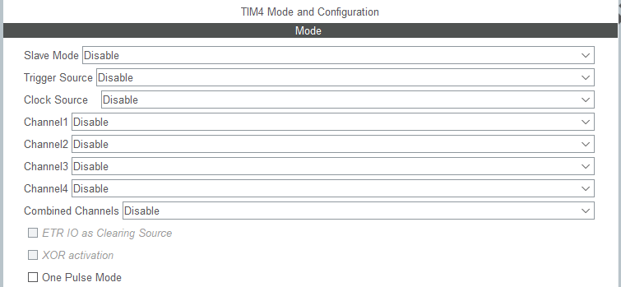
GPTIM configuration window is composed of:
Field | Purpose
Slave Mode | Configures the timer to be controlled by an external trigger from another timer or signal
Trigger Source | Selects which internal or external signal is used as the trigger input for slave mode or synchronization.
Clock Source | Chooses how the timer is clocked, for example from the internal clock, external pin, or another trigger source.
Channels | Configures timer channelx for functions like PWM, input capture, or output compare.
Combined Channels | Links two channels together for special modes such as combined PWM or synchronized compare/capture behavior.
OnePulse Mode | Configures the timer to generate only a single pulse or one-shot timing event instead of continuous operation.
for slave mode :
Slave Mode | Purpose | Brief behavior
ExternalClockMode 1 | Use a trigger as the timer clock | The timer counter increments on each valid trigger pulse instead of the internal clock.
Reset Mode | Reset the timer on trigger | Timer runs freely When a trigger arrives, the counter is reset and a new counting cycle starts.
Gated Mode | Count only while trigger is active | The timer counts only when the trigger signal is enabled/high.
Trigger Mode | Start counting on trigger event | The trigger starts the timer counting, then the timer runs using its selected clock.
Combined Reset Trigger Mode | Reset and start together | A trigger both resets the counter and starts the timer operation in a synchronized way.

Trigger source :
Term | Description
ITR | Internal trigger connection between timers inside the MCU. Refer to the TIMx internal trigger connection table in the reference manual.
ETR | External trigger input coming from a physical pin. It is used to control, clock, or synchronize the timer from outside the MCU.
Channel modes :
Mode | Purpose
Input Capture | the timer channel listens to an external signal and stores the current CNT value into CCR when a selected edge occurs, such as rising or falling edge. This is used to measure pulse width, frequency, or period
Output Compare | ,the timer continuously compares CNT with CCR. When they become equal, the timer generates an event or changes the output state
PWM Generation | the timer uses ARR to define the period and CCR to define the duty cycle.
ADVANCED TIMERS features:
advanced timers are an upgraded version from GP timers
they share same things but with added features like :
-complementary output channel: Generate paired outputs like high-side and low-side PWM signals.
-Break input: Forces outputs into a safe state immediately in fault conditions.(urgent stop)

LOW POWER TIMER:
Modes | Description
**Counts internal clock events** | LPTIM counts clock ticks from an internal low-power clock source such as **LSI** or **LSE**.
**Standalone: counts external Clock events** | LPTIM counts external pulses independently.
**Encoder mode from IN1 IN2** | Quadrature encoder interface used to measure rotary encoder position and direction using two input phases.

