University / Institute Name
Department / Program
Graduation Internship Report
GoFit - Complete Fitness Mobile Application, Coach Marketplace, and Administration Platform
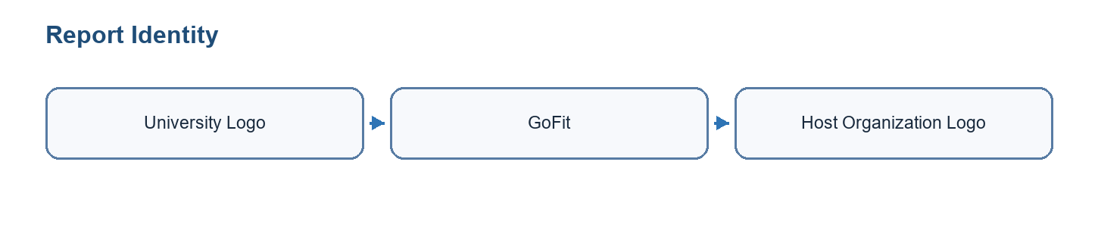
Figure 0.1: University and GoFit visual identity area
Field | Value
Prepared by | Student full name to be completed
Academic supervisor | Academic supervisor name to be completed
Professional supervisor | Company supervisor name to be completed
Host organization | GoFit / host company name to be completed
Academic year | 2025 - 2026
Table 0.1: Report identification

Validation / Signature Page
This page is reserved for the official validation of the graduation internship report. It should include the signatures of the academic supervisor, professional supervisor, jury members, and any required institutional stamp.
Role | Name | Signature | Date
Academic supervisor | To be completed
Professional supervisor | To be completed
Jury president | To be completed
Reviewer / examiner | To be completed
Table 0.2: Validation signatures

Acknowledgements
I would like to express my sincere gratitude to my academic and professional supervisors for their guidance, feedback, and availability throughout this graduation internship. Their support helped me transform the GoFit project from a broad fitness platform idea into a structured mobile, web, and backend solution.
I also thank the teaching staff and all people who contributed directly or indirectly to this work. Their advice, technical observations, and encouragement helped me improve the quality of the analysis, implementation, and documentation.

Dedication
I dedicate this work to my family, friends, mentors, and everyone who supported me during my academic journey and internship period. Their confidence and encouragement were essential during the demanding phases of design, development, testing, and report writing.

Table of Contents
The final table of contents should be generated or updated in Microsoft Word after all page numbers are finalized.

List of Figures
The list of figures should be updated after inserting the final exported diagrams and screenshots.

List of Tables
The list of tables should be updated after the final formatting pass.

General Introduction
Digital fitness has become an important part of modern health and training habits. Users increasingly expect mobile applications to help them plan workouts, follow progress, manage nutrition, receive reminders, and access professional coaching from a single experience. At the same time, coaches need tools to organize clients, programs, bookings, communication, and session follow-up without relying on several disconnected platforms.
The GoFit project responds to this context by proposing a unified fitness platform. It combines an Expo/React Native mobile application, a Supabase backend, and a Next.js administration panel. The mobile application supports authentication, onboarding, workout planning, exercise library browsing, active workout sessions, rest timer management, progress monitoring, nutrition-related features, coach marketplace flows, bookings, chat, programs, and user preferences. The administration panel provides operational control over users, coaches, exercises, workouts, analytics, settings, and activity logs.
The main objective of the internship was to design, implement, and document a complete software foundation for GoFit. The work included requirements analysis, Agile planning, database modeling, mobile and web development, backend integration, security considerations, testing, and deployment preparation.
This report is organized into six chapters. Chapter 1 presents the project context, problem statement, existing limitations, proposed solution, methodology, and modeling language. Chapter 2 describes Sprint 0, including actors, requirements, product backlog, Scrum organization, and global use case modeling. Chapters 3, 4, and 5 present the main development sprints: mobile foundation and workout core, progress and nutrition features, then coach marketplace and administration. Chapter 6 presents the working environment, architecture, technologies, deployment approach, and final validation. The report ends with a general conclusion, bibliography, and appendices.

1 Project Study

1.1 Project Context
GoFit is positioned in the digital fitness and coaching domain. The project targets users who want to organize training, monitor progress, and access fitness support through a mobile application. It also targets coaches who need a more structured way to present their services, follow clients, schedule sessions, and communicate. Finally, it includes an administration layer for managing content and platform operations.
The technical context is a multi-part product: an Expo/React Native mobile application for iOS and Android, a Next.js web administration panel, and a Supabase backend providing PostgreSQL, authentication, storage, and security policies. This architecture allows the project to separate mobile user experience, administrative workflows, and backend persistence.

1.2 Host Organization Presentation
The host organization or project environment supported the development of GoFit as a graduation internship project. The work was conducted with regular supervision, progressive validation, and a Scrum-inspired organization. The project owner and supervisors helped prioritize the scope around workout planning, progress tracking, coach marketplace flows, administration, and deployment preparation.

1.2.1 Presentation of the Company
The host company presentation should include the official organization name, business area, services, target clients, structure, and the department or team that supervised the internship. In this report, the project is described as GoFit, a software platform dedicated to fitness tracking, personalized coaching, and operational administration.

1.2.2 Company Logo
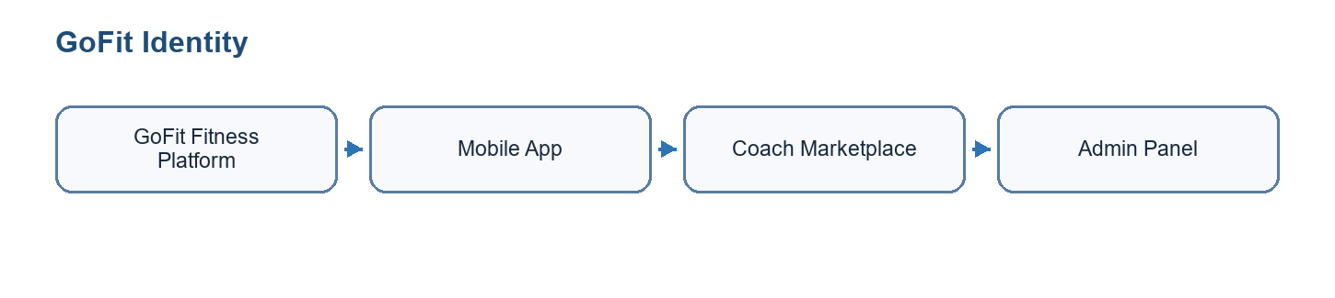
Figure 1.1: GoFit and host organization identity

1.3 Problem Statement
Many fitness users rely on several disconnected tools: one application for workout planning, another for nutrition, a spreadsheet for body measurements, messaging applications for coach communication, and separate calendars or payment tools for coaching sessions. This fragmentation reduces engagement, creates duplicated data entry, and makes long-term progress harder to understand.
For coaches, the issue is also operational. Managing client profiles, programs, bookings, messages, session packs, and progress follow-up across separate services increases administrative workload and reduces the quality of personalized support. Administrators also need a centralized interface to manage users, coaches, exercises, workouts, analytics, and platform content.

1.4 Study of Existing Conditions
Existing fitness solutions often focus on only one part of the user journey. Workout applications generally provide templates and logging, nutrition applications focus on meals and calories, and coaching platforms often specialize in booking or messaging. Although these tools may be strong individually, they do not always provide a coherent end-to-end experience for users, coaches, and administrators.
Manual processes also remain common. Coaches may use spreadsheets, messaging apps, calendar tools, and external payment links. Users may manually enter measurements and training notes without automated reminders, dashboards, or coach visibility. These conditions motivated the design of a more integrated GoFit platform.

1.5 Limits and Inconveniences of Existing Solution
- Fragmented experience across workout, nutrition, progress, booking, payment, and messaging tools.
- Limited coach-client connectivity and weak operational visibility for coaches.
- Manual progress tracking and reduced accuracy for body measurements.
- Lack of centralized administration for users, coaches, exercises, workouts, analytics, and settings.
- Difficulty maintaining consistent data security and access control when several tools are used.

1.6 Proposed Solution
The proposed solution is GoFit, a complete fitness platform composed of three main parts. The first part is a cross-platform mobile application built with Expo and React Native. It supports authentication, onboarding, user profile management, workout planning, exercise browsing, active workout sessions, rest timers, progress monitoring, nutrition-related features, coach marketplace flows, bookings, chat, and personalization settings.
The second part is a Next.js administration panel. It allows administrators to manage users, coaches, exercises, workouts, transactions, settings, notifications, and activity logs. The third part is a Supabase backend that provides authentication, PostgreSQL database, storage, realtime capabilities, and row-level security.

1.7 Adopted Development Methodology and Modeling Language
The project was organized using an Agile approach inspired by Scrum. This choice was appropriate because the product scope includes several connected modules and required regular adaptation after technical discoveries, UI/UX decisions, and backend constraints.

1.7.1 Comparison Between Traditional and Agile Methodologies
Criterion | Traditional methodology | Agile methodology
Planning | Most planning is completed before implementation starts. | Planning is refined continuously sprint by sprint.
Change management | Changes are costly and often delayed. | Changes can be integrated into the backlog.
Delivery | The product is delivered near the end of the project. | Working increments are delivered regularly.
Fit for GoFit | Less suitable because mobile, backend, and admin needs evolved during implementation. | Suitable because GoFit modules can be implemented and validated incrementally.
Table 1.1: Comparison between traditional and agile methodologies

1.7.2 Comparison Between Scrum and Kanban
Criterion | Scrum | Kanban
Cadence | Time-boxed sprints with planning and review. | Continuous flow without fixed sprint boundaries.
Roles | Product Owner, Scrum Master, and Development Team. | No mandatory roles.
Artifacts | Product backlog, sprint backlog, increment. | Visual board and work-in-progress limits.
Choice for GoFit | Selected because the internship had planned increments and deadlines. | Useful for task visualization but less structured for academic reporting.
Table 1.2: Comparison between Scrum and Kanban

1.7.3 Scrum
Scrum was used to structure the work into fixed iterations. The product backlog listed major GoFit features, each sprint selected a coherent subset, and each increment targeted a working part of the product. Sprint reviews and retrospectives supported feedback and improvement.
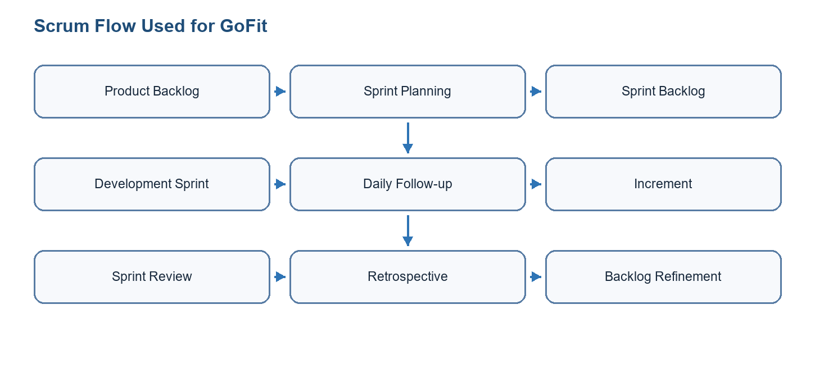
Figure 1.2: Scrum flow used for GoFit

1.7.4 Modeling Language / UML
UML was selected to model requirements and system design. Use case diagrams describe actors and system functions, class diagrams describe structural relationships, sequence diagrams describe interactions, and deployment diagrams describe the runtime environment.

1.8 Conclusion
This chapter presented the GoFit project, its context, problem statement, existing limitations, proposed solution, methodology, and modeling language. The next chapter presents Sprint 0, where requirements and project organization are formalized.

2 Sprint 0
Sprint 0 prepared the project before feature implementation. It clarified actors, requirements, backlog organization, sprint planning, and the global functional perimeter of GoFit.

2.1 Needs Assessment

2.1.1 Identification of Actors
Actor | Type | Description
Mobile user / client | Primary | Uses the mobile application to manage profile, workouts, nutrition, progress, bookings, packs, programs, and communication.
Coach | Primary | Creates a coach profile, manages clients, programs, session packs, availability, bookings, check-ins, and chat.
Administrator | Primary | Uses the web admin panel to manage users, coaches, exercises, workouts, transactions, notifications, settings, and analytics.
Supabase | External system | Provides authentication, PostgreSQL database, storage, realtime features, edge functions, and row-level security.
Payment/video/push services | External services | Support planned or implemented communication, notification, and marketplace capabilities.
Table 2.1: Identification of actors

2.1.2 Functional Requirements
ID | Requirement | Actor | Priority
FR-01 | Register, sign in, reset password, and manage authenticated sessions. | Mobile user / Coach / Admin | High
FR-02 | Complete onboarding and maintain personal profile, goals, units, preferences, and measurements. | Mobile user | High
FR-03 | Browse exercise library, view details, create custom workouts, and start workout sessions. | Mobile user | High
FR-04 | Track active workout progress with sets, reps, weights, rest timer, and workout summary. | Mobile user | High
FR-05 | View progress statistics, body measurements, consistency, and workout history. | Mobile user | High
FR-06 | Use marketplace features to find coaches, book sessions, buy packs, receive programs, and chat. | Mobile user / Coach | Medium
FR-07 | Allow coaches to onboard, manage clients, create programs, define availability, and follow check-ins. | Coach | Medium
FR-08 | Allow administrators to manage users, coaches, exercises, workouts, transactions, notifications, settings, and analytics. | Administrator | High
Table 2.2: Functional requirements

2.1.3 Non-Functional Requirements
ID | Category | Requirement
NFR-01 | Security | Authentication must be handled through Supabase Auth and data access must respect RLS policies.
NFR-02 | Performance | Mobile screens, lists, and admin pages must remain responsive during repeated daily use.
NFR-03 | Maintainability | The codebase must separate screens, components, services, stores, navigation, and database migrations.
NFR-04 | Usability | Workout, progress, coach, and admin flows must include clear navigation, loading states, and error messages.
NFR-05 | Scalability | The database model must support native workouts, custom workouts, sessions, coaches, clients, messages, and admin growth.
Table 2.3: Non-functional requirements

2.2 Project Structure and Management with Scrum

2.2.1 Scrum Team
Role | Assigned person | Responsibility
Product Owner | Supervisor / project owner | Prioritizes needs and validates the business value of GoFit features.
Scrum Master | Student / supervisor | Organizes sprint rhythm, removes blockers, and tracks progress.
Development Team | Student / team members | Designs, implements, tests, and documents the mobile app, backend, and admin panel.
Stakeholders | Academic and professional supervisors | Review increments and provide feedback.
Table 2.4: Scrum team

2.2.2 Product Backlog
ID | Epic / User story | Priority | Planned sprint
PB-01 | As a user, I want secure authentication and onboarding. | High | Sprint 1
PB-02 | As a user, I want to create, schedule, and execute workouts. | High | Sprint 1
PB-03 | As a user, I want an exercise library and workout history. | High | Sprint 1
PB-04 | As a user, I want to track progress, measurements, and nutrition. | High | Sprint 2
PB-05 | As a coach, I want onboarding, profile, client management, programs, bookings, and chat. | Medium | Sprint 3
PB-06 | As an administrator, I want dashboard, user, coach, exercise, workout, transaction, notification, and settings management. | High | Sprint 3
PB-07 | As the platform owner, I want deployment, monitoring, and release preparation. | High | Closing phase
Table 2.5: Product backlog
The GoFit backlog was not limited to a simple workout tracker. It was organized as a multi-module platform that covers the client experience, the coach experience, the administration experience, and the backend services required to connect them. The project inventory identifies more than two hundred functional items distributed across mobile client features, coach features, admin-panel features, backend functions, database migrations, realtime communication, storage, notification, and AI-assisted progress tracking.
Module | Main features | Implementation elements
Authentication and onboarding | Registration, login, session persistence, password reset, protected navigation, onboarding screens, profile creation, goals, units, preferences, and role-aware flows. | Supabase Auth, Expo Secure Store, auth store, protected navigators, user_profiles table, onboarding state.
Workout planning and execution | Exercise library, custom workouts, native workouts, day splits, workout builder, session tracking, sets, reps, weights, duration, workout summary, and history. | Exercises, workouts, workout_exercises, workout_sessions, workout services, Zustand stores, active-session screens.
Enhanced rest timer | Start, pause, resume, warning intervals, haptic feedback, audio cues, auto-advance settings, persistent timer preferences, and background-aware behavior. | Timer preferences, mobile UI controls, audio/haptic APIs, workout session integration.
Progress and measurements | Progress charts, workout statistics, consistency, body measurements, progress photos, AI-assisted draft measurements, manual correction, and validation notes. | Body measurement service, MediaPipe native module, MoveNet fallback, segmentation service, measurement tables.
Nutrition and saved meals | Nutrition logging foundations, saved meal management, meal item editing, reusable food entries, and history views where enabled. | Nutrition screens, saved meal services, local and Supabase-backed persistence.
Coach marketplace | Coach discovery, coach profiles, onboarding, certification/CV upload, pending validation, session packs, bookings, availability, client list, check-ins, programs, chat, video-session preparation, wallet, and settings. | Coach profile tables, marketplace screens, booking services, realtime chat, storage uploads, LiveKit token function where applicable.
Administration panel | Dashboard statistics, user management, coach validation, exercise/workout management, transactions, notifications, settings, activity logs, search, import/export, analytics, and protected admin routes. | Next.js App Router, server-side Supabase admin client, middleware, shadcn-style components, admin routes.
Backend and integrations | Authentication, PostgreSQL database, row-level security, storage, realtime messaging, push notifications, video-token generation, edge functions, migrations, and deployment configuration. | Supabase Auth, RLS policies, Edge Functions, Storage buckets, Realtime channels, Expo Push, environment variables.
Table 2.6: Detailed feature modules of GoFit
Product area | Approximate feature count | Examples
Mobile client | 116 | Authentication, onboarding, workouts, active sessions, rest timer, progress, measurements, nutrition, marketplace access, bookings, programs, chat.
Mobile coach | 35 | Coach onboarding, profile, dashboard, clients, client progress, notes, programs, calendar, availability, wallet, settings.
Admin panel | 55 | Dashboard, users, coaches, exercises, workouts, transactions, notifications, settings, analytics, imports/exports, activity logs.
Backend / Edge Functions | 43 | Database migrations, RLS, storage, realtime chat, push notification relay, video-token generation, AI measurement function support.
Table 2.7: Feature coverage by product area

2.2.3 Sprint Planning
Report sprint | Calendar source | Main goal | Main deliverables
Sprint 1 | 26 Jan - 9 Mar 2026 | Foundation and workout core | Requirements, UI/UX, setup, authentication, profile, workout planner, rest timer.
Sprint 2 | 9 Mar - 20 Apr 2026 | Advanced mobile tracking | Calendar, exercise library, progress tracking, notifications, body measurement groundwork.
Sprint 3 | 20 Apr - 29 Jun 2026 | Coach marketplace and administration | Coach onboarding, marketplace, packs, bookings, chat, programs, admin panel and tests.
Table 2.8: Sprint planning used in this report
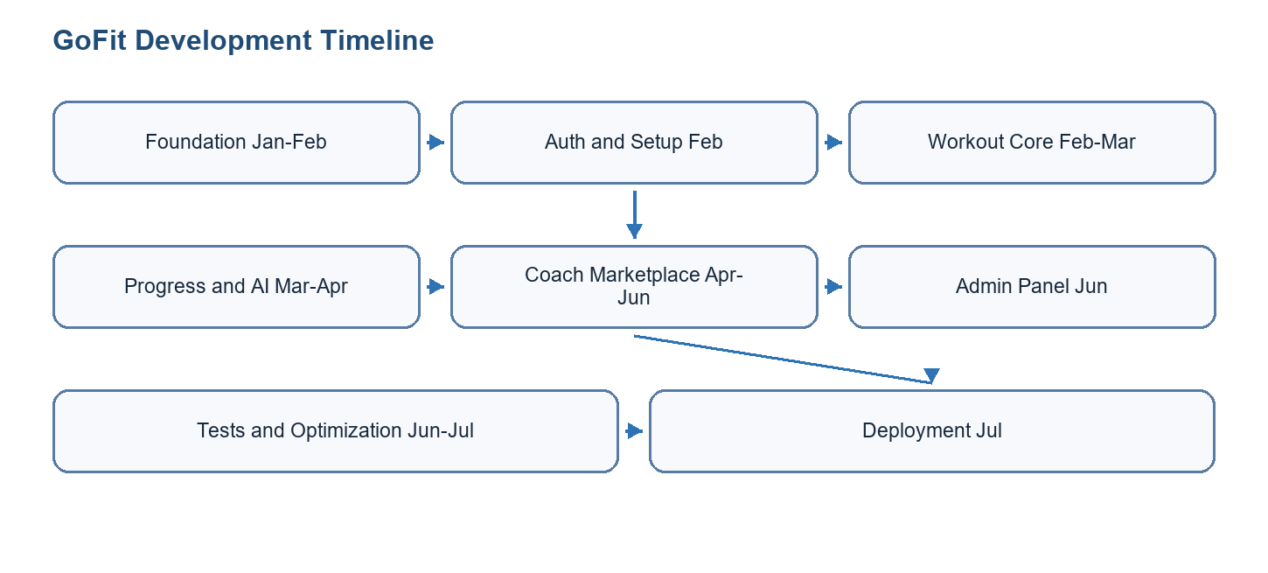
Figure 2.1: Gantt chart summary of GoFit development

2.2.4 Global Use Case Diagram
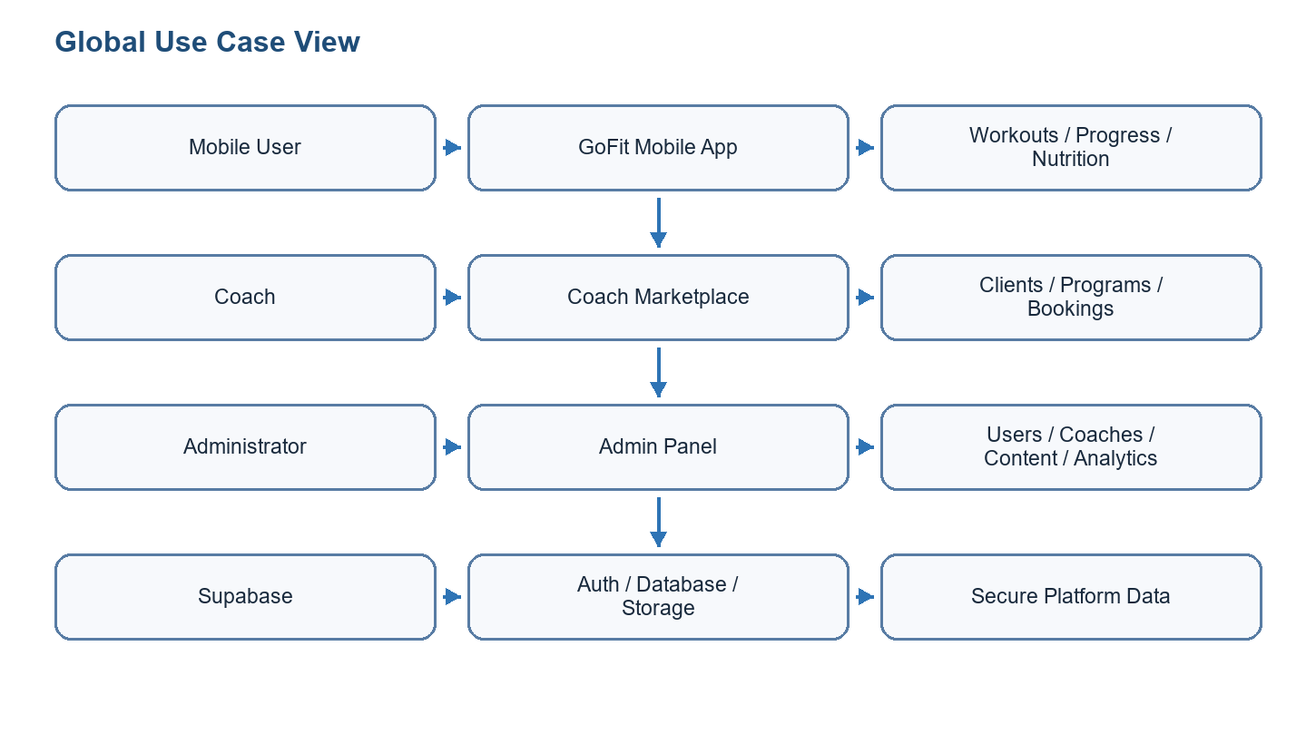
Figure 2.2: Global use case diagram

2.3 Project Management
The project was managed through a backlog and sprint-based organization. Technical work was divided between the mobile app, web admin panel, database migrations, backend functions, documentation, testing, and deployment preparation. The repository structure itself supports this organization through separate folders for GoFitMobile, admin-panel, database, and docs.

Conclusion
Sprint 0 established the functional and technical base of the project. It clarified actors, requirements, backlog priorities, sprint grouping, and the global use case perimeter. The next chapter presents Sprint 1, focused on the mobile foundation and core workout features.

3 Sprint 1
Sprint 1 focused on the GoFit foundation: project setup, authentication, onboarding, profile management, workout planning, workout session execution, and the enhanced rest timer.

3.1 Needs Assessment
The sprint needs were selected from the product backlog according to dependency order, user value, and technical feasibility.

3.1.1 Sprint Backlog
ID | Task | Priority | Result
S1-01 | Set up Expo/React Native, Next.js, Supabase, repository structure, and environment variables. | High | Completed foundation
S1-02 | Implement authentication, onboarding, profile management, and protected navigation. | High | Mobile auth flow ready
S1-03 | Implement workout templates, exercise configuration, workout sessions, and rest timer. | High | Workout core functional
S1-04 | Persist workout data through Supabase services and Zustand stores. | High | Mobile/backend connection validated
Table 3.1: Sprint 1 backlog

3.1.2 Sprint Class Diagram
Include classes/entities such as UserProfile, Workout, WorkoutExercise, Exercise, WorkoutSession, TimerPreferences, AuthService, WorkoutService, and WorkoutStore.
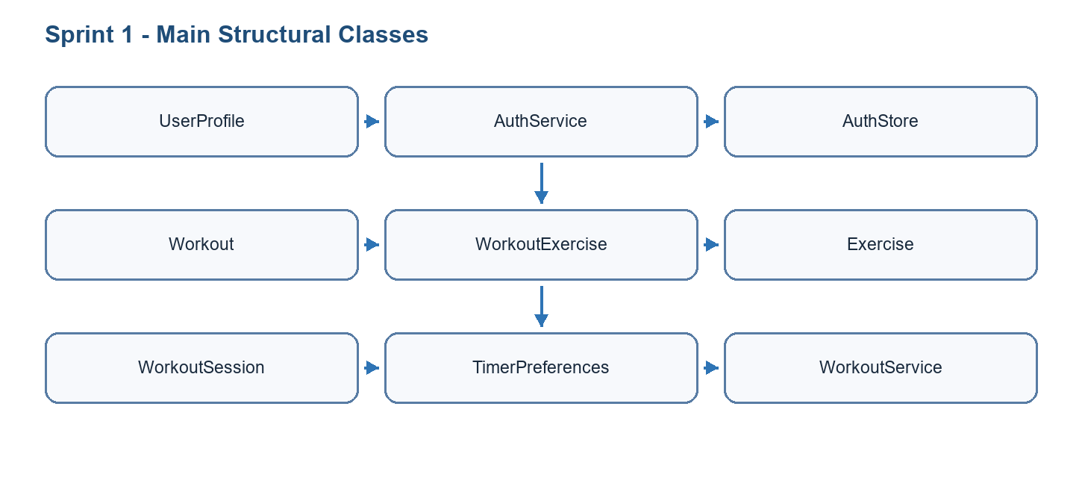
Figure 3.1: Class diagram of Sprint 1

3.2 Functional Specification of Requirements
This section specifies the sprint use cases and explains how the selected actors interact with the GoFit system.

3.2.1 Refined Use Case Diagram of Sprint 1
Actors: Mobile user and Supabase. Use cases: sign up, log in, complete onboarding, manage profile, browse workouts, create workout, start session, track sets, use rest timer.
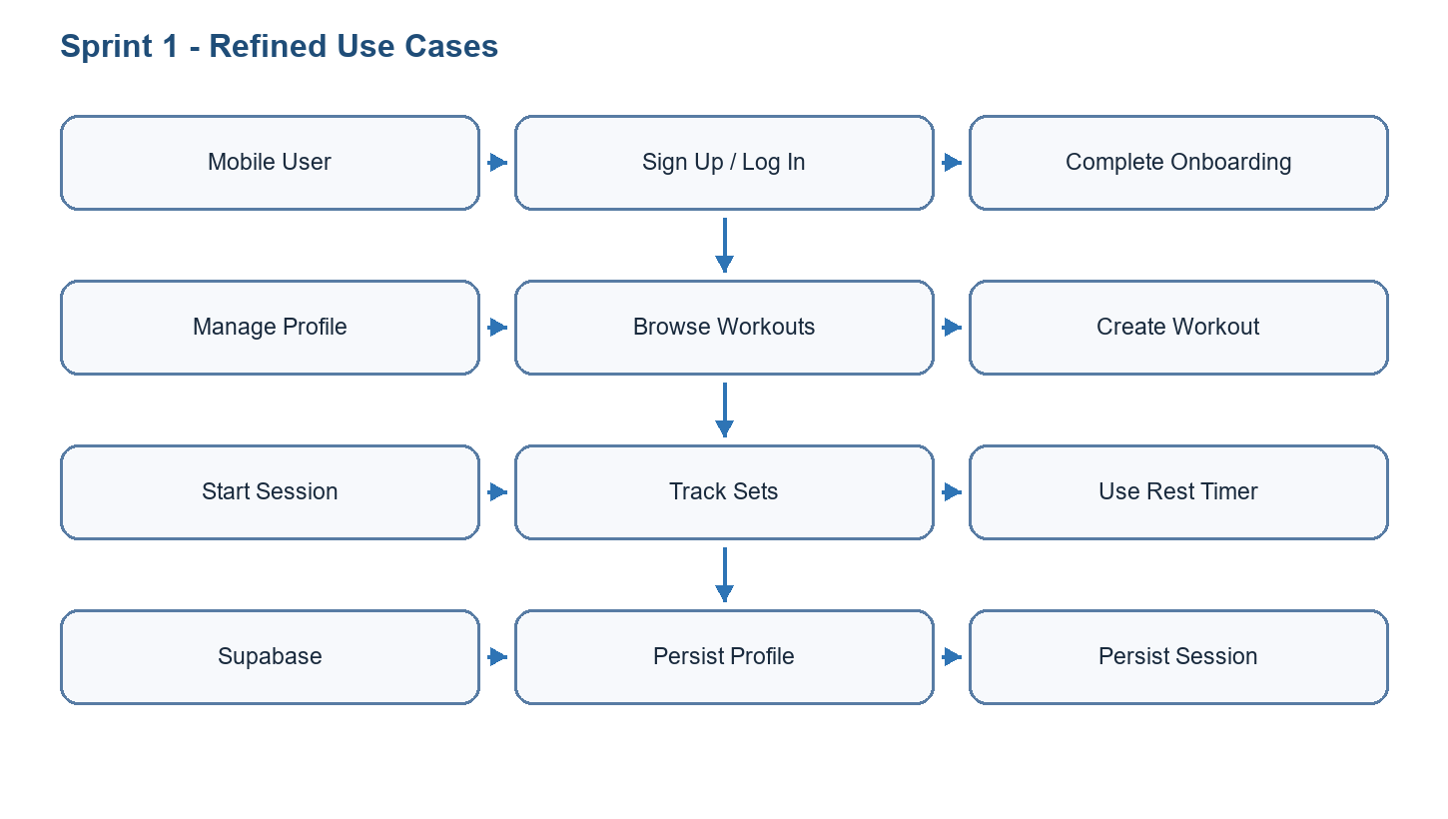
Figure 3.2: Refined use case diagram of Sprint 1

3.2.2 Use Case Analysis
Field | Description
Use case | Start and complete a workout session
Primary actor | Mobile user
Preconditions | The user is authenticated and a workout template exists.
Main scenario | The user selects a workout, starts a session, completes sets, uses the rest timer, and saves the workout summary.
Alternative scenarios | The user pauses, exits, or edits set data before completion.
Postconditions | A workout_sessions row stores duration, exercises_completed, calories, and notes.
Table 3.2: Use case textual description
Show login or workout-session flow: user action -> mobile screen -> Zustand store -> service layer -> Supabase -> UI update.
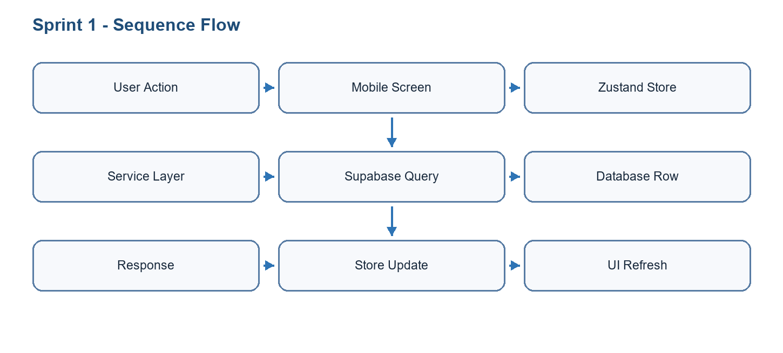
Figure 3.3: Sequence diagram of key use case

3.3 Realisation
The mobile foundation was implemented with Expo SDK 54 and React Native. Navigation separates authentication, onboarding, client app, and coach app flows.
Authentication uses Supabase Auth. The session is mirrored in the auth store, and protected navigation redirects users according to authentication and onboarding state.
The workout model separates templates from execution logs. Workouts and exercises are configured before execution, while workout_sessions store actual completed activity.
The enhanced rest timer includes animated display, audio and haptic feedback, warning intervals, auto-advance configuration, and persisted preferences.
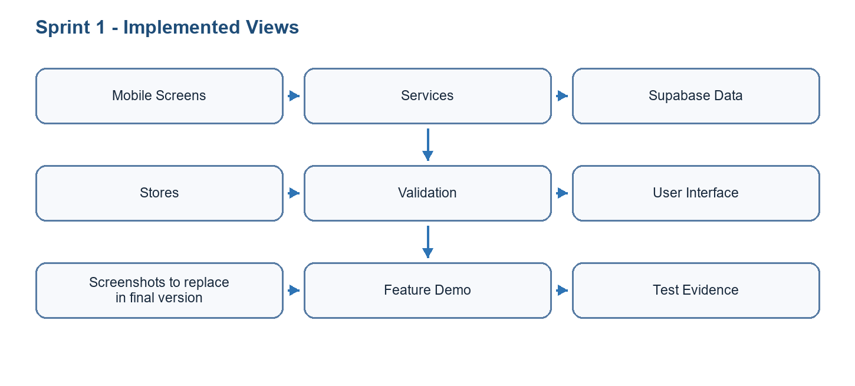
Figure 3.4: Realisation summary of Sprint 1

3.4 Sprint Tests
Test | Scope | Expected result | Status
T1 | Authentication | Valid credentials open the correct navigator. | Passed / to confirm
T2 | Workout creation | A custom workout is saved with ordered exercises. | Passed / to confirm
T3 | Workout session | Sets, reps, weights, rest time, and summary are stored. | Passed / to confirm
T4 | Rest timer | Timer starts, pauses, resumes, warns, and completes. | Passed / to confirm
Table 3.3: Sprint test cases

3.5 Sprint Burn Down Chart
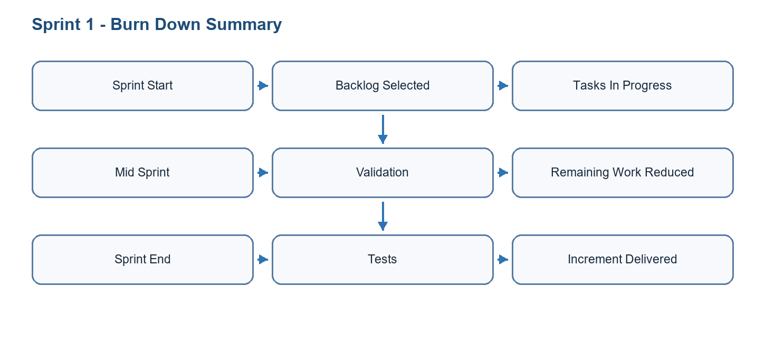
Figure 3.5: Burn down chart for Sprint 1

Conclusion
Sprint 1 delivered a coherent increment of the GoFit platform and prepared the dependencies required by the following sprint.

4 Sprint 2
Sprint 2 extended the mobile experience with exercise library improvements, calendar planning, progress tracking, notifications, nutrition-related tracking, and body measurement groundwork.

4.1 Needs Assessment
The sprint needs were selected from the product backlog according to dependency order, user value, and technical feasibility.

4.1.1 Sprint Backlog
ID | Task | Priority | Result
S2-01 | Implement exercise library search, detail views, images, and filtering. | High | Library usable
S2-02 | Implement calendar, workout history, and progress statistics. | High | Tracking views ready
S2-03 | Add notification settings and reminders. | Medium | Reminder flow integrated
S2-04 | Prepare body measurement and progress-photo features. | Medium | AI measurement groundwork documented
S2-05 | Implement nutrition or saved meal flows where applicable. | Medium | Nutrition module draft integrated
Table 4.1: Sprint 2 backlog

4.1.2 Sprint Class Diagram
Include Exercise, Workout, WorkoutSession, BodyMeasurement, ProgressPhoto, NotificationPreference, NutritionEntry, SavedMeal, and related services/stores.
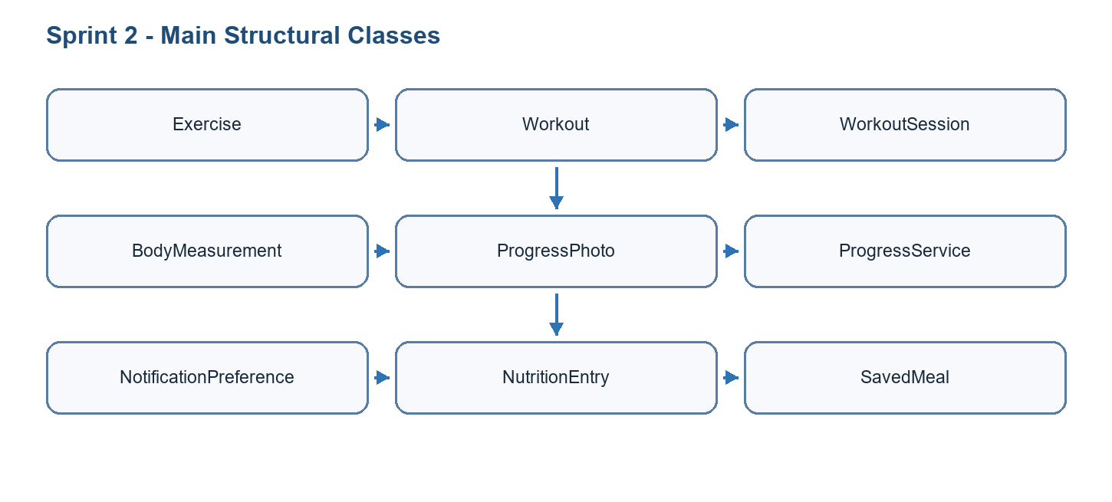
Figure 4.1: Class diagram of Sprint 2

4.2 Functional Specification of Requirements
This section specifies the sprint use cases and explains how the selected actors interact with the GoFit system.

4.2.1 Refined Use Case Diagram of Sprint 2
Actors: Mobile user and Supabase. Use cases: search exercise, view exercise detail, plan workout on calendar, view progress, log measurements, configure notifications, track nutrition.
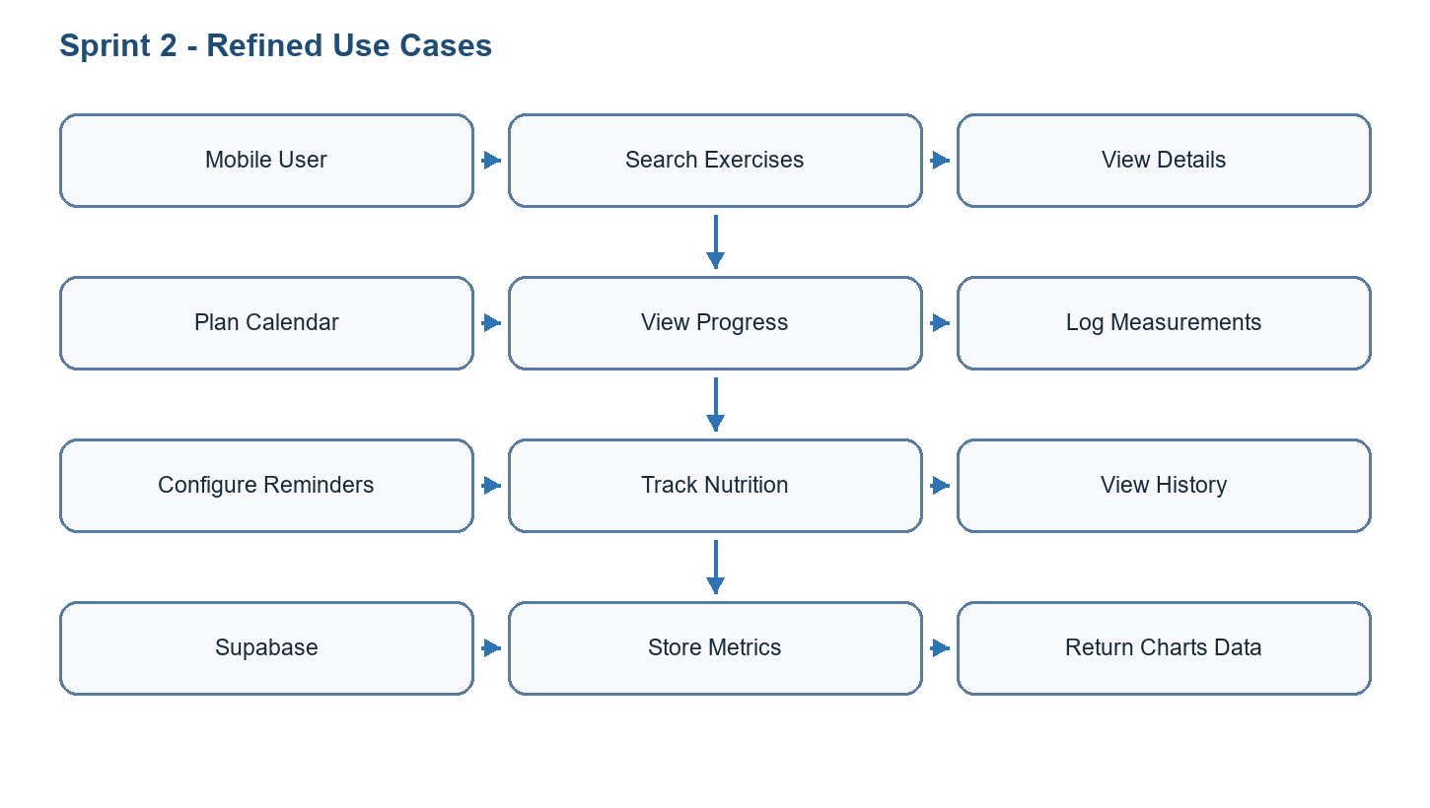
Figure 4.2: Refined use case diagram of Sprint 2

4.2.2 Use Case Analysis
Field | Description
Use case | View progress dashboard
Primary actor | Mobile user
Preconditions | The user is authenticated and has workout, measurement, or nutrition history.
Main scenario | The user opens progress screens, selects a metric, and views charts or history.
Alternative scenarios | If no data exists, the system displays an empty state and invites the user to log data.
Postconditions | The user obtains a clear view of fitness evolution over time.
Table 4.2: Use case textual description
Show progress tracking flow: user opens progress screen -> store requests stats -> service queries workout_sessions/body_measurements -> chart renders data.
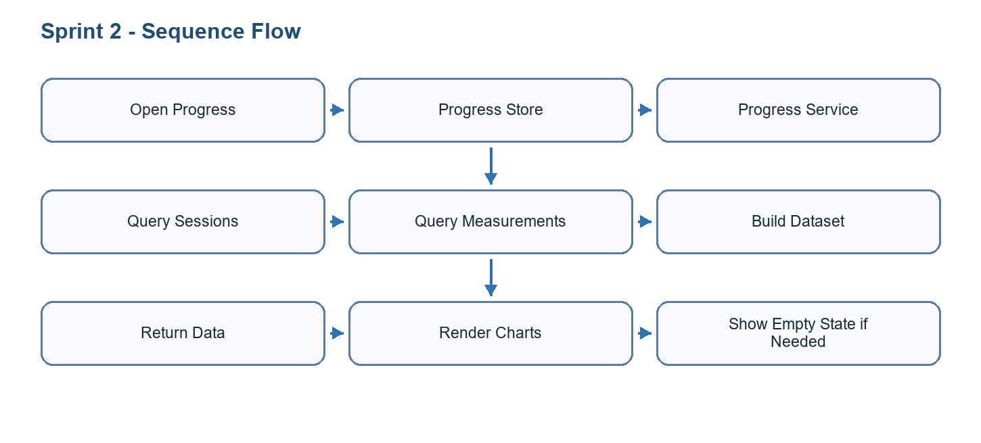
Figure 4.3: Sequence diagram of key use case

4.3 Realisation
The exercise library provides access to workouts, exercises, detail screens, and workout builder flows. Exercise metadata is loaded through service layers and cached by stores.
Progress screens present workout statistics, body measurements, consistency, and record details. These views help users interpret their evolution rather than only log isolated sessions.
Notification features support reminders and inbox-style communication. Push-token registration and notification preferences are part of the infrastructure.
The body measurement work explores AI-supported progress tracking. It is positioned as a fitness-progress feature, not a medical or tailoring-grade measurement system.
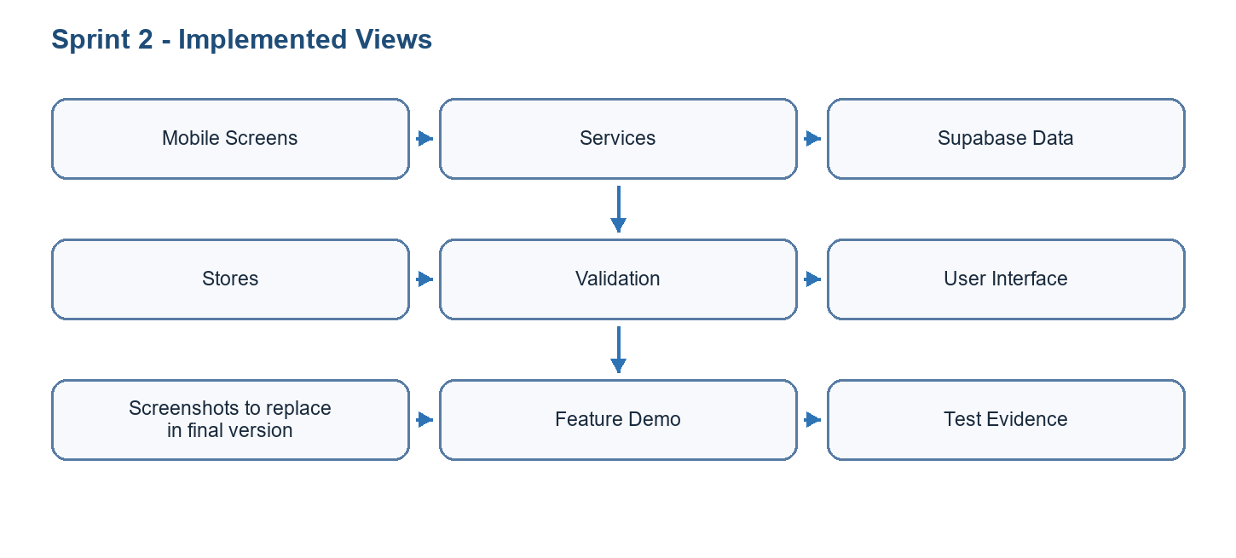
Figure 4.4: Realisation summary of Sprint 2

4.3.1 AI Body Measurement and Computer Vision Pipeline
One of the most distinctive parts of GoFit is the AI-assisted body measurement feature. Its objective is to help users follow physical progress from photos, without replacing manual tape measurements and without claiming medical or tailoring-grade precision. The feature is designed as an assisted workflow: the system analyzes front and side photos, generates draft values for chest, waist, hip, and shoulder, explains capture-quality issues, then lets the user review and correct the values before saving them as progress data.
The pipeline starts on the mobile device. The user captures or selects front and side images. The application runs pose detection to locate key body landmarks, segmentation to isolate the person silhouette when available, feature extraction to transform image geometry into measurable indicators, and a measurement estimator to produce draft values. The result is presented with confidence, warnings, and manual editing fields. This design is important because computer vision can support progress tracking, but a single two-dimensional image cannot directly recover exact body circumferences in all conditions.
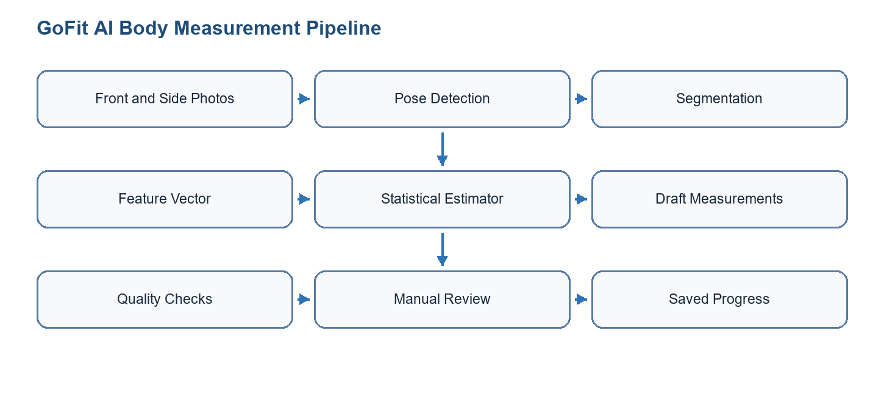
Figure 4.6: AI and computer vision pipeline for body measurements

4.3.2 Models and Artifacts Used
The project evolved from a keypoint-only prototype toward a more robust pose-and-segmentation architecture. The first implementation used MoveNet Lightning through react-native-fast-tflite because it is lightweight and suitable for on-device inference. Later research and implementation introduced MediaPipe Tasks Vision because its pose landmarker provides richer landmarks and a native Android path for faster and more reliable analysis.
Model / artifact | Role in GoFit | Input / output | Status and reason
MoveNet Lightning (.tflite) | Initial on-device pose detection and fallback path. | Resized 192 x 192 RGB image; 17 body keypoints with confidence scores. | Implemented through react-native-fast-tflite. Useful as a lightweight baseline, but limited for body measurement because 17 keypoints do not describe torso outline or body depth.
MediaPipe Pose Landmarker Full (pose_landmarker_full.task) | Main candidate for richer body-pose analysis. | Image input; 33 normalized landmarks, optional world landmarks, visibility/presence scores, pose count, and inference time. | Implemented in the local Expo native module on Android. It improves body coverage over MoveNet and supports better pose-quality checks.
MediaPipe Pose Landmarker Heavy | Potential higher-accuracy candidate. | Same landmark structure as the Full model, with heavier computation. | Not adopted by default. It is reserved for comparison only if Full is accurate enough and device performance remains acceptable.
selfie_multiclass_256x256.tflite | Experimental segmentation research artifact. | 256 x 256 float image input; 256 x 256 x 6 class output. | Investigated but not treated as the final silhouette model because the body mask was unstable in mirror/direct capture scenarios.
MediaPipe Image Segmenter (selfie_segmenter.tflite) | Person-mask extraction for segmentation-assisted measurement. | Image input; 256 x 256 confidence masks and category mask for background/person. | Integrated in the native MediaPipe module. It provides a cleaner person mask than the earlier multiclass experiment, but it still needs validation and gating.
Statistical depth estimator | Converts extracted features into draft circumferences. | Feature vector using height, front widths, side depths, ratios, pose scores, and mask quality indicators. | Used as a pragmatic baseline. It is not a trained medical model; it produces draft progress estimates and must remain editable by the user.
Future regression/PCA estimator | Target research direction for stronger measurement prediction. | Labeled dataset of body features and manual/tape measurements. | Planned improvement based on statistical body-measurement literature. It would replace rigid formulas with learned predictors once enough validation data exists.
Table 4.4: AI and computer vision models used in GoFit

4.3.3 Pose Detection: MoveNet and MediaPipe
Pose detection is responsible for finding anatomical landmarks that anchor the measurement process. In the first GoFit prototype, MoveNet Lightning detects 17 keypoints such as nose, shoulders, elbows, wrists, hips, knees, and ankles. These points are enough to estimate body orientation and basic proportions, but they are not enough to measure chest, waist, and hip circumference directly. For example, a shoulder keypoint tells where the shoulder is, but it does not describe the width of the torso at chest level or the depth of the body from the side view.
The MediaPipe Pose Landmarker Full model improves this stage by producing 33 landmarks and richer metadata. The local module returns image dimensions, pose count, normalized landmarks, world landmarks when available, and inference time. The GoFit Android implementation loads the bundled pose_landmarker_full.task asset, decodes the image URI, applies EXIF rotation, runs MediaPipe detection, and returns a typed result to the TypeScript layer. This makes the measurement workflow more reliable because the application can inspect landmark visibility, check whether core points are present, and reject only captures that are genuinely unusable.
The project keeps MoveNet as a fallback because it is already integrated in the mobile JavaScript service and can continue to support devices or builds where the native MediaPipe module is not available. This fallback strategy reduces deployment risk while the native module reaches parity across Android and iOS.

4.3.4 Segmentation and Body Mask Extraction
Segmentation is the second computer-vision component. Its role is to separate the person from the background and provide body-outline information. This is necessary because circumference estimation cannot be based only on joint coordinates. The pose model can locate shoulder, hip, and torso reference lines; the segmentation mask can then estimate front-view widths and side-view depths around the chest, waist, and hip levels.
The project first examined selfie_multiclass_256x256.tflite. That model exposes a 256 x 256 x 6 output rather than a simple binary body mask, which required class selection, argmax maps, connected-component cleanup, and debugging overlays. Real tests showed that the resulting mask could be unstable, especially with mirror photos, phone occlusion, and direct capture conditions. For this reason, the report classifies it as an experimental research artifact instead of a final production model.
The later implementation uses MediaPipe Image Segmenter with selfie_segmenter.tflite in the local native module. The Android bridge returns confidence masks, category masks, labels, quality scores, and inference timing. The TypeScript segmentation service decodes the masks, thresholds the person class, builds a cleaned binary mask, extracts sampled class grids for debugging, anchors scan lines using pose landmarks, and measures chest, waist, and hip widths/depths. This gives GoFit a more explainable measurement pipeline because each generated number can be traced back to pose landmarks, mask rows, and quality gates.
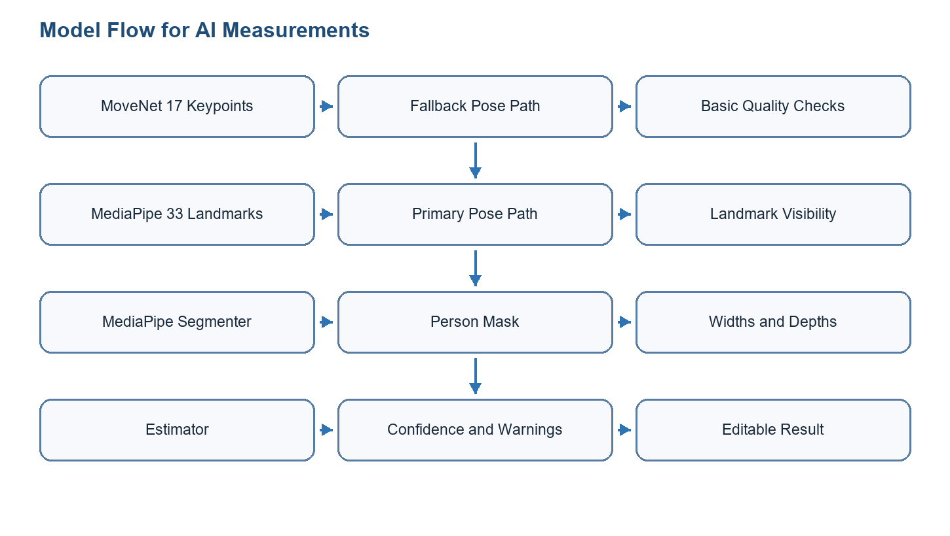
Figure 4.7: Pose and segmentation model flow

4.3.5 Feature Vector and Measurement Estimation
The measurement service builds a structured feature vector before calculating the final draft values. This is a strong architectural choice because the application does not mix raw pixels, pose confidence, segmentation quality, and final centimeter values in a single opaque formula. Instead, it records the intermediate indicators that explain why a measurement was accepted, warned, or rejected.
Feature group | Examples | Purpose
User scale | Declared height in centimeters, person height in pixels, scale in cm/px, height-span fraction. | Converts image measurements into approximate real-world dimensions and detects bad framing.
Pose quality | Front and side pose model source, mean landmark score, visible core keypoints, body center, top and bottom normalized positions. | Checks whether the user is visible, centered, and sufficiently detected.
Front geometry | Front shoulder width, hip width, estimated waist width, chest/waist/hip mask widths. | Measures visible body widths from the front photo.
Side geometry | Side shoulder width, side-to-front ratio, chest depth, abdomen depth, side mask depths. | Approximates body depth, which is essential for circumference estimation.
Segmentation quality | Raw coverage, clean coverage, body class index, mask bounds, fragmentation, class grid, person threshold. | Detects unstable masks and prevents unreliable segmentation from overriding safer estimates.
Estimator outputs | Draft chest, waist, hip, shoulder, depth source, confidence, failed checks, quality issues. | Produces editable progress values and explains uncertainty to the user.
Table 4.5: Body measurement feature vector
The estimator currently combines geometric measurements with sex-aware statistical depth assumptions. In practical terms, the service uses the user's height and body proportions to estimate a scale, then uses front widths and side/depth information to produce draft circumferences. When segmentation depth passes quality and sanity gates, it can contribute to the estimate; otherwise the service falls back to statistical priors. This prevents a bad mask from producing extremely wrong values.
Research notes in the project also identify a stronger long-term direction: use a labeled dataset of photos and manual measurements to train regression, ridge regression, gradient-boosted trees, PCA-based, or body-shape models. Such a model would learn the relationship between extracted features and real measurements instead of relying mainly on hand-built formulas. For the PFE scope, the current implementation is correctly presented as an AI-assisted progress estimator with validation and manual correction.

4.3.6 Validation Results and Limitations
Device tests confirmed that MediaPipe can run inside the Android development client and that the pose model detects one person with high landmark visibility in normal capture conditions. Example observations showed mirror-front captures around 0.99 pose score, side captures around 0.97 to 0.98 in good conditions, and inference times that varied by device and image conditions. Direct capture also worked but may show different inference times and body framing behavior.
The main limitation is not pose detection; it is reliable circumference estimation from consumer photos. Early segmentation experiments produced thin or unstable masks in some scans, and earlier formulas generated unstable chest, waist, and hip values. Later statistical-depth experiments were more stable across repeated scans, but the project documentation correctly notes that those values are still draft estimates, not ground truth. Therefore, the application keeps a manual review screen and should store corrected values when the user has measured with a tape.
Validation item | Expected practice | Target / interpretation
Reference measurements | Measure chest, waist, hip, and shoulder with a tape before comparing with the AI result. | The tape value is the reference value for validation.
Capture conditions | Use good lighting, full body visible, fitted clothes, front photo, side photo at approximately 90 degrees, and consistent distance. | Bad framing, loose clothing, phone occlusion, and angled mirrors must be flagged.
AI result | Record the draft AI value before manual correction. | Used to calculate absolute error and identify model weaknesses.
Manual correction | Allow the user to edit the values before saving. | Saved corrected values should match the user's real measurement.
Fitness-progress target | Use approximate progress targets rather than tailoring or medical targets. | Chest error ideally below 8 cm; waist and hip below 6 cm; shoulder below 5 cm.
Confidence | Confidence must decrease when pose, segmentation, scale, or repeated-scan stability is weak. | The report should avoid claiming 100 percent confidence for unstable captures.
Table 4.6: AI measurement validation protocol
Component | Current status | Remaining work
MoveNet pose fallback | Implemented in TypeScript service through react-native-fast-tflite and bundled model asset. | Keep as fallback and compare against MediaPipe outputs.
MediaPipe pose Android module | Implemented with bundled pose_landmarker_full.task, EXIF rotation handling, 33 landmarks, world landmarks, pose count, and inference time. | Complete parity and production testing across iOS and Android release builds.
MediaPipe image segmentation | Implemented in native module with selfie_segmenter.tflite, confidence/category masks, labels, and quality scores. | Improve segmentation quality gates and verify on more body types, clothes, lighting, and camera setups.
Feature vector | Implemented with pose, scale, geometry, segmentation, confidence, and debug fields. | Export validation datasets and compare AI estimates with tape measurements.
Estimator | Statistical baseline and segmentation-gated depth source available. | Train or calibrate a stronger model once enough labeled examples exist.
User workflow | Draft measurement, quality warnings, and manual review approach defined. | Finalize UX copy, screenshots, and submission-ready validation evidence.
Table 4.7: AI implementation status
In conclusion, the AI module is a meaningful technical contribution because it combines on-device inference, native module integration, pose landmarks, segmentation masks, typed feature vectors, statistical estimation, and validation methodology. At the same time, the report must be transparent: GoFit uses AI to assist progress tracking, not to replace professional body measurement.

4.4 Tests
Test | Scope | Expected result | Status
T1 | Exercise library | Search and detail screens return expected exercise data. | Passed / to confirm
T2 | Progress charts | Charts handle populated and empty states. | Passed / to confirm
T3 | Notifications | Permissions and reminders behave correctly on device. | Manual device test required
T4 | Nutrition/progress | Entries persist and appear in history. | Passed / to confirm
Table 4.8: Sprint test cases

4.5 Sprint Burn Down Chart
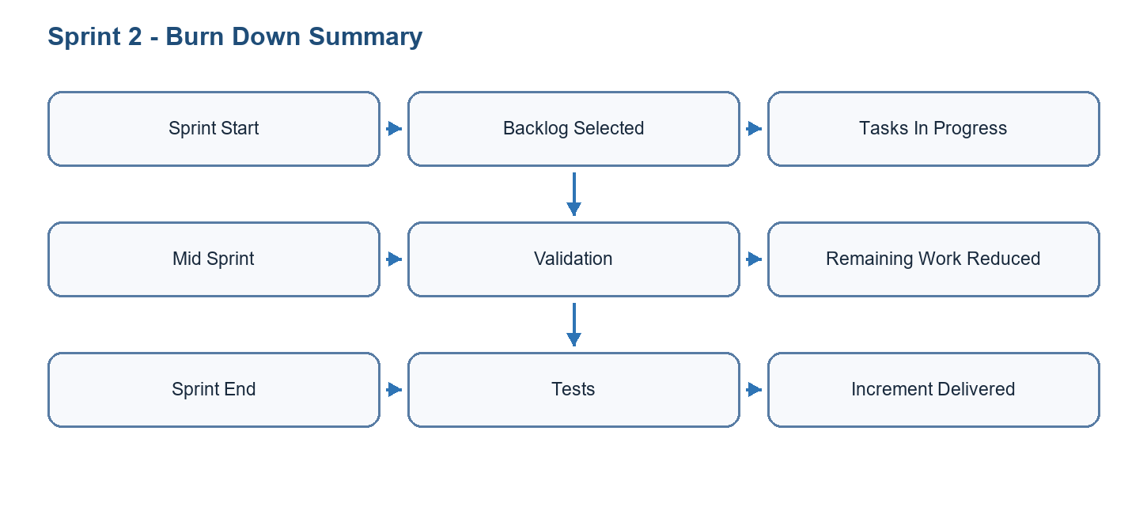
Figure 4.8: Burn down chart for Sprint 2

Conclusion
Sprint 2 delivered a coherent increment of the GoFit platform and prepared the dependencies required by the following sprint.

5 Sprint 3
Sprint 3 focused on coach marketplace features and administration. It added coach onboarding, coach/client flows, bookings, session packs, chat, programs, and a web admin panel for operational management.

5.1 Needs Assessment
The sprint needs were selected from the product backlog according to dependency order, user value, and technical feasibility.

5.1.1 Sprint Backlog
ID | Task | Priority | Result
S3-01 | Implement coach authentication, onboarding, CV/certification upload, and pending review flow. | High | Coach onboarding ready
S3-02 | Implement marketplace, coach detail, session booking, session packs, chat, and programs. | High | Marketplace flows implemented
S3-03 | Implement coach dashboard, clients, calendar, profile, wallet, and settings. | Medium | Coach app area structured
S3-04 | Implement admin panel dashboard, users, coaches, exercises, workouts, transactions, notifications, settings, and analytics. | High | Admin platform operational
Table 5.1: Sprint 3 backlog

5.1.2 Sprint Class Diagram
Include CoachProfile, Client, SessionPack, PurchasedPack, Booking, Conversation, Message, Program, AdminUser, Exercise, Workout, Transaction, Notification, and AuditLog.
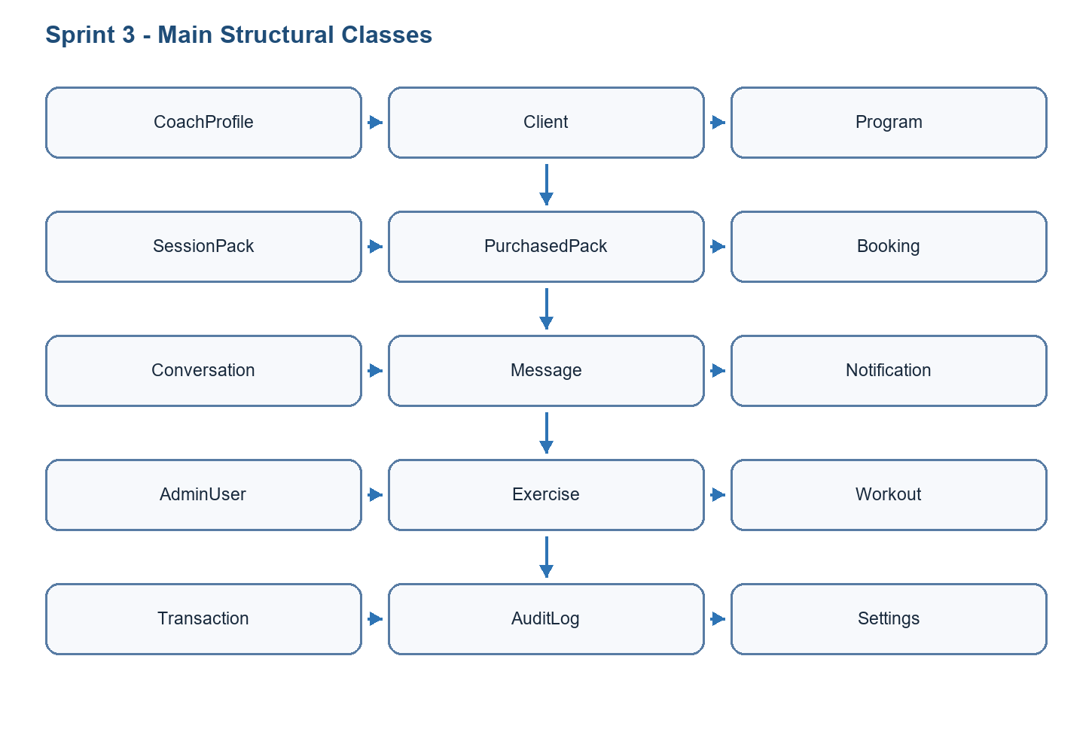
Figure 5.1: Class diagram of Sprint 3

5.2 Functional Specification of Requirements
This section specifies the sprint use cases and explains how the selected actors interact with the GoFit system.

5.2.1 Refined Use Case Diagram of Sprint 3
Actors: Mobile user, coach, administrator, Supabase. Use cases: browse coaches, book session, buy pack, chat, create program, manage clients, validate coach, manage content.
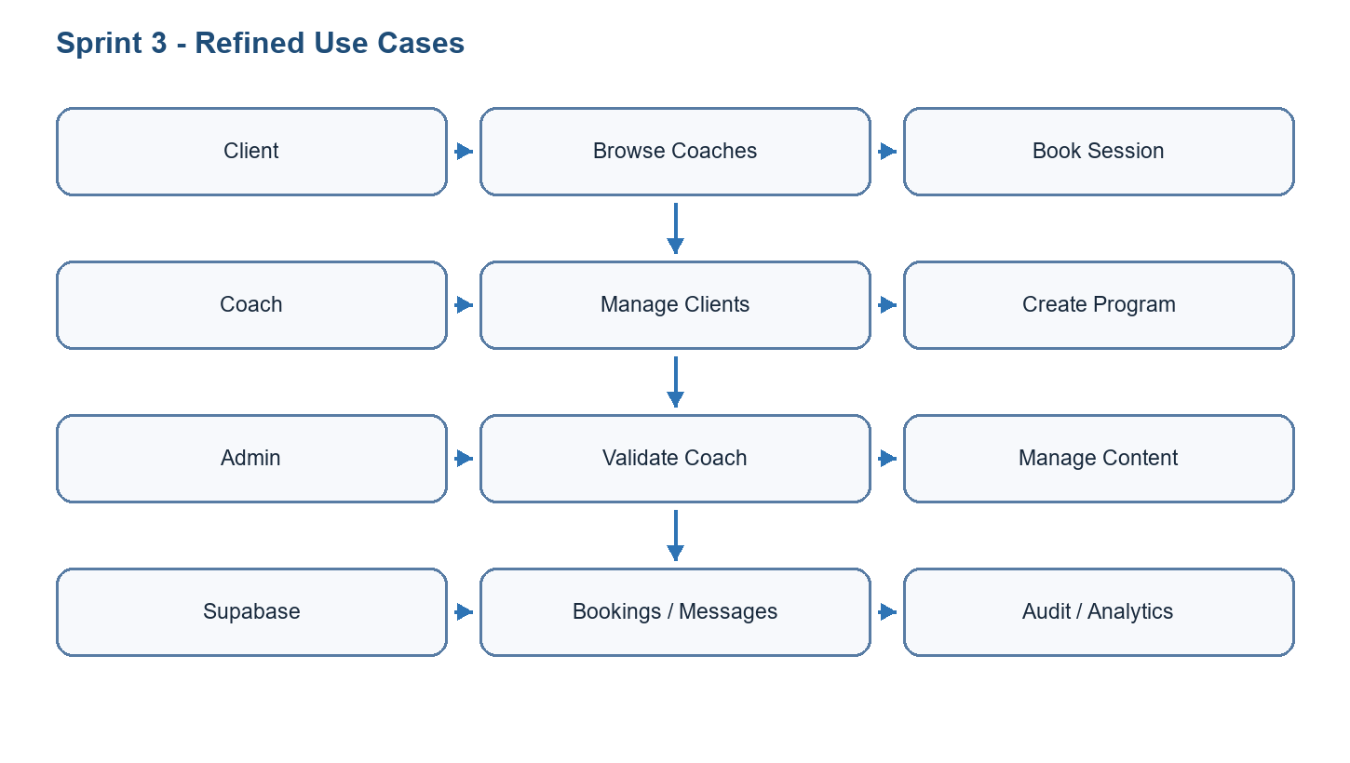
Figure 5.2: Refined use case diagram of Sprint 3

5.2.2 Use Case Analysis
Field | Description
Use case | Book a coaching session
Primary actor | Mobile user
Preconditions | The user is authenticated, a coach profile is available, and a session slot or pack exists.
Main scenario | The user opens marketplace, selects a coach, chooses a slot or pack, confirms booking, and receives confirmation.
Alternative scenarios | The slot is unavailable, payment/session pack is missing, or the booking is cancelled.
Postconditions | The booking is stored and visible to both client and coach.
Table 5.2: Use case textual description
Show booking or chat flow: client selects coach -> creates booking/conversation -> Supabase persists data -> coach dashboard updates.
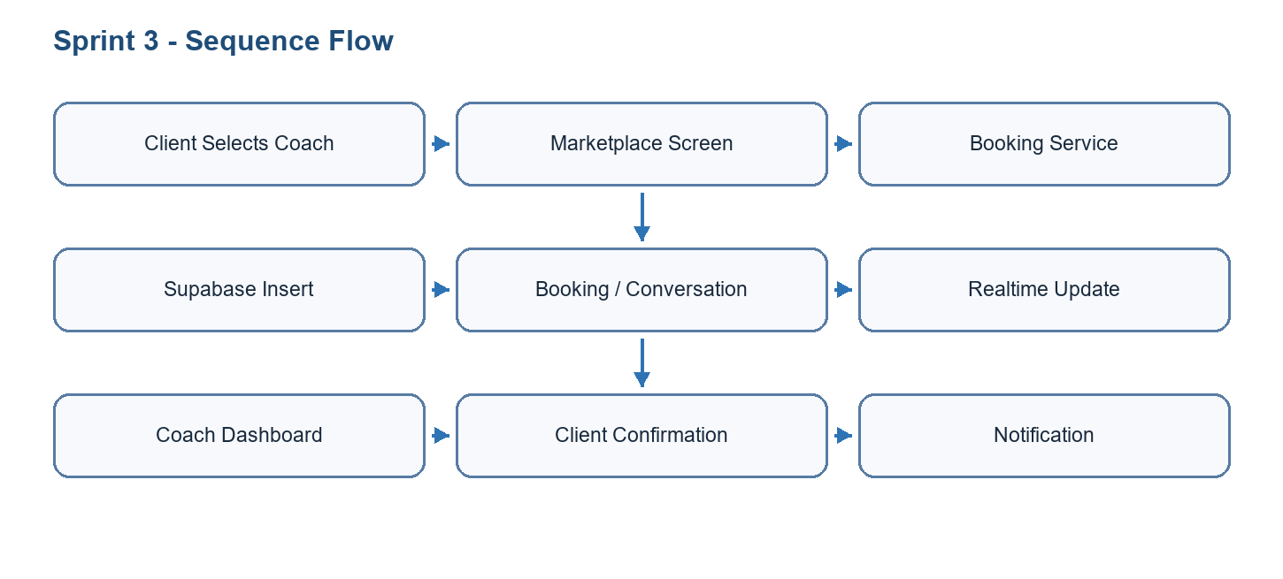
Figure 5.3: Sequence diagram of key use case

5.3 Realisation
Coach-related screens include coach authentication, onboarding, profile preview, pending validation, dashboard, clients list, client detail, client progress, notes, programs, calendar, chat, wallet, and settings.
Marketplace flows allow users to browse coaches, view coach profiles, book sessions, manage packs, access programs, and communicate through chat.
The admin panel uses Next.js App Router, server-side data access, protected middleware, and Supabase admin clients. It includes dashboard stats, user management, coach management, exercise/workout CRUD foundations, transactions, notifications, activity logs, settings, search, import/export, and analytics components.
Security is handled through authentication, admin role checks, service-role usage on server-side routes where intended, and Supabase RLS for user-scoped data.
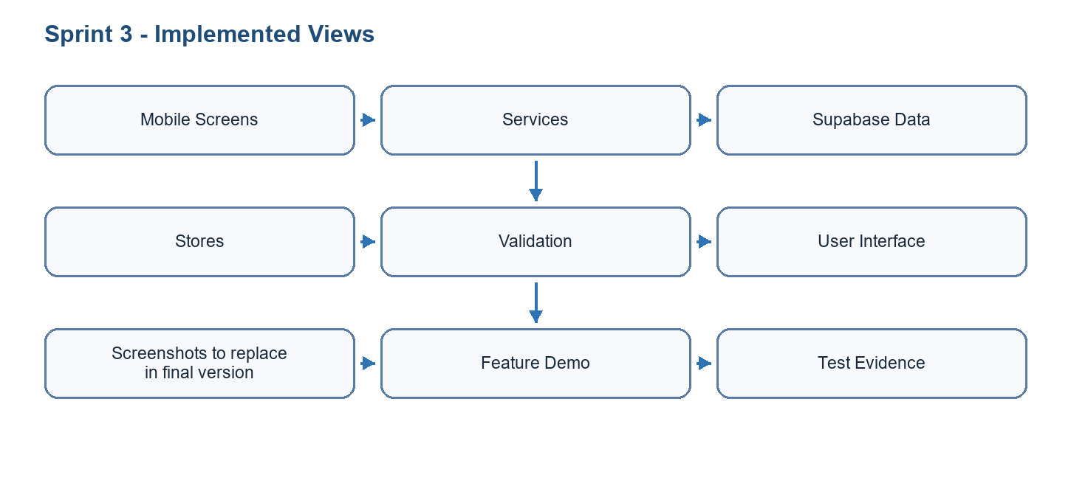
Figure 5.4: Realisation summary of Sprint 3

5.4 Tests
Test | Scope | Expected result | Status
T1 | Coach onboarding | Coach profile data and documents can be submitted and reviewed. | Passed / to confirm
T2 | Marketplace | Clients can browse coaches and navigate to booking/detail flows. | Passed / to confirm
T3 | Chat/bookings/packs | Conversation and booking records persist correctly. | Passed / to confirm
T4 | Admin panel | Protected admin pages load data and restrict non-admin users. | Passed / to confirm
Table 5.3: Sprint test cases

5.5 Sprint Burn Down Chart
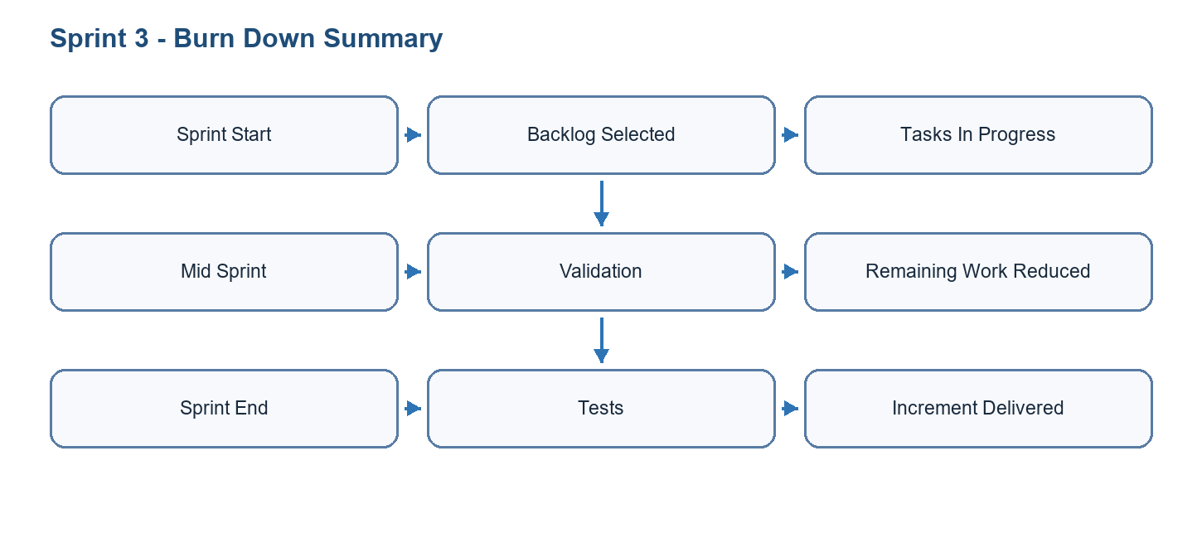
Figure 5.5: Burn down chart for Sprint 3

Conclusion
Sprint 3 delivered a coherent increment of the GoFit platform and prepared the dependencies required by the following sprint.

6 Deployment and Closing Phase
This chapter presents the working environment, architecture, technology choices, deployment strategy, and final validation of GoFit.

6.1 Working Environment

6.1.1 Material Environment
Resource | Specification | Purpose
Development machine | Windows 11 workstation with modern multi-core CPU and sufficient RAM | Mobile, web, backend, and documentation work
Android emulator / device | Model and version to confirm | Mobile testing
iOS simulator / device | Model and version to confirm | Mobile testing when available
Cloud services | Supabase, optional Vercel/EAS/Expo services | Backend, admin deployment, and mobile builds
Table 6.1: Hardware/material environment

6.1.2 Software Environment
Software / Tool | Version / Stack | Use
Expo / React Native | Expo SDK 54, React Native 0.81 | Cross-platform mobile app
TypeScript | Project TypeScript configuration | Typed mobile and web development
Next.js | Next.js admin panel | Web administration interface
Supabase | PostgreSQL, Auth, Storage, Realtime, Edge Functions | Backend services and security
Zustand | Persisted stores | Mobile state management
React Navigation | Stack and tab navigation | Mobile routing
Tailwind CSS / shadcn-style UI | Admin UI stack | Web interface styling
Git | Repository versioning | Source control and collaboration
Table 6.2: Software environment

6.2 Architecture and Technological Choices

6.2.1 Physical Architecture Diagram
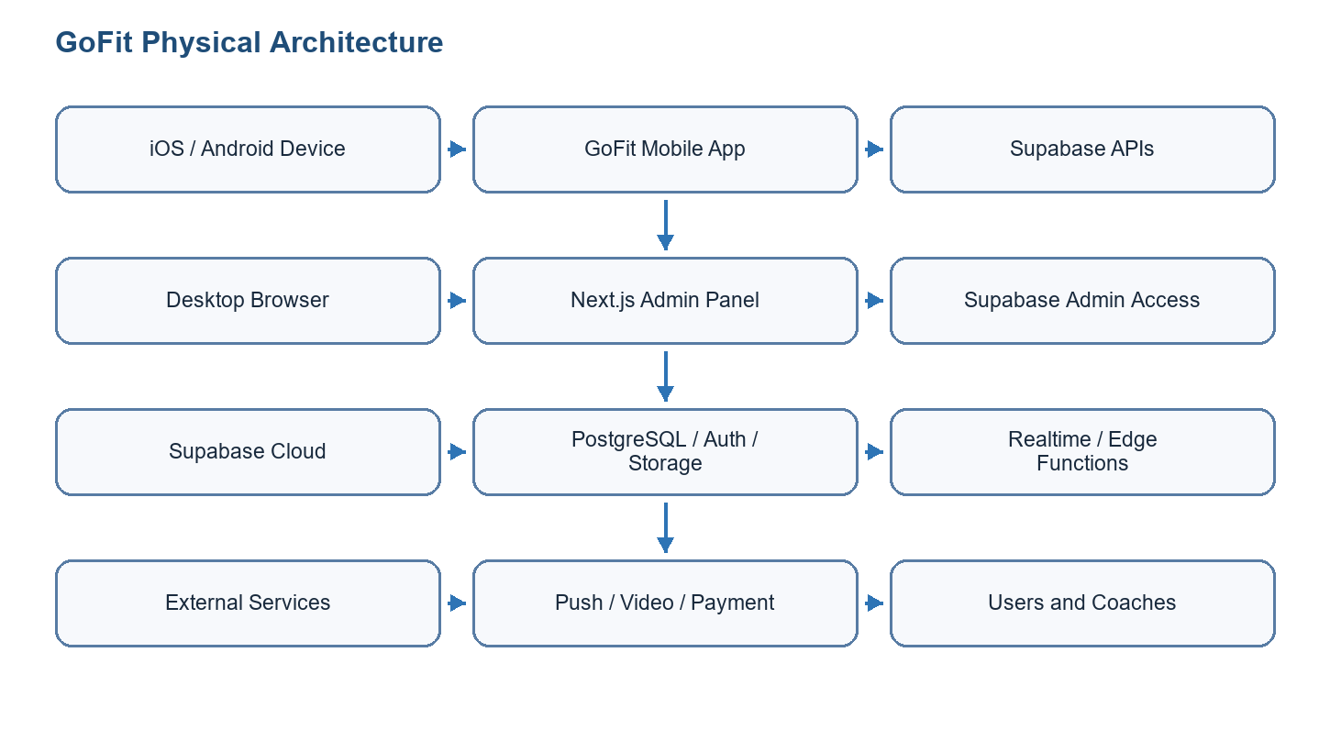
Figure 6.1: Physical architecture diagram

6.2.2 Technologies
Expo and React Native were selected to target Android and iOS with a shared TypeScript codebase. Supabase was selected because it provides authentication, PostgreSQL, storage, realtime features, and security policies without requiring a custom backend server for every feature. Next.js was selected for the administration panel because it supports server-side rendering, route handlers, and secure server-side access to privileged Supabase operations.

6.2.3 Architecture Pattern
The mobile application follows a layered structure: presentation screens and reusable components, navigation, Zustand stores, domain services, and infrastructure clients such as Supabase. The admin panel follows a web application structure based on Next.js routes, server/client components, API route handlers, and Supabase admin utilities. The backend follows a database-centered BaaS architecture with migrations, row-level security, views, functions, storage, and edge functions.

6.2.4 Logical Architecture Diagram
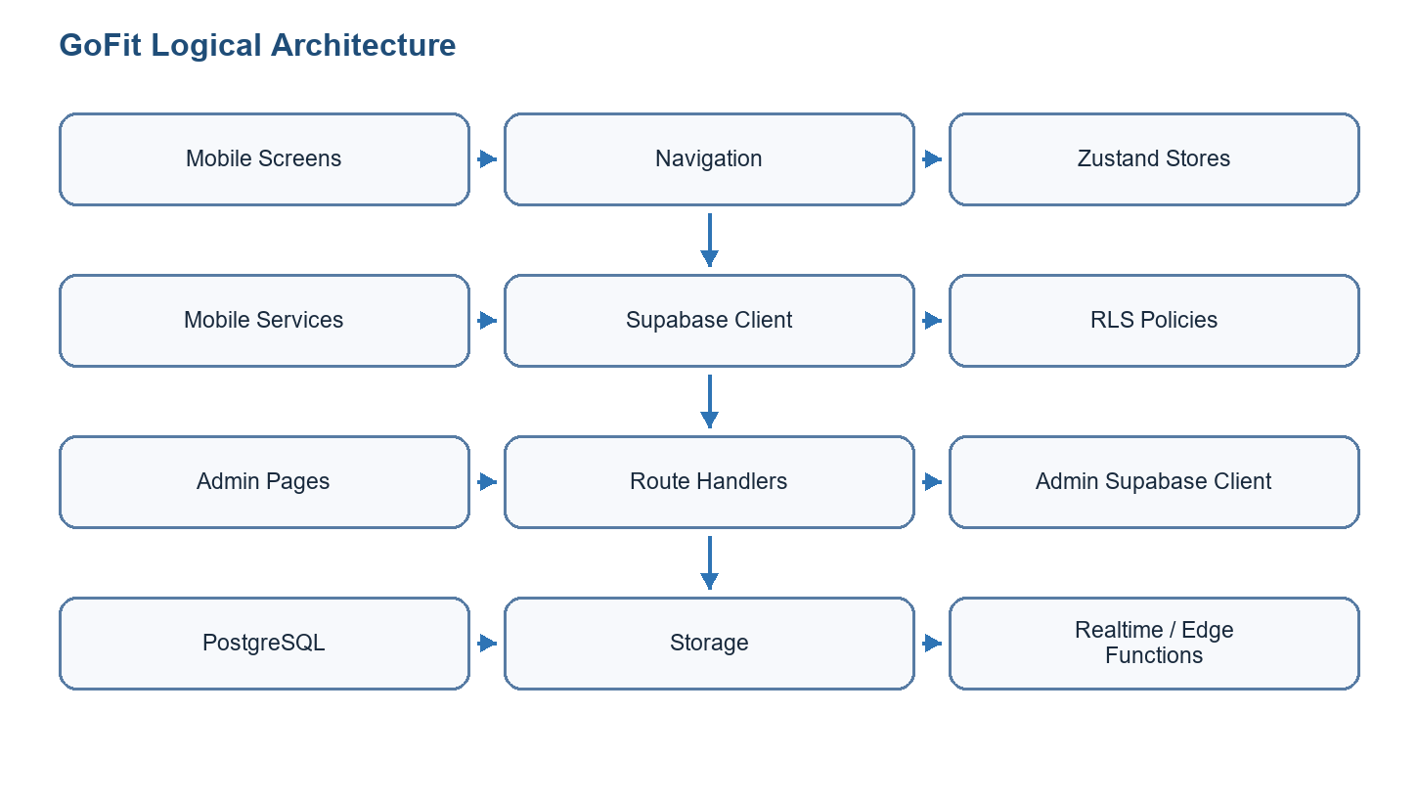
Figure 6.2: Logical architecture diagram

6.3 Deployment

6.3.1 Deployment Diagram
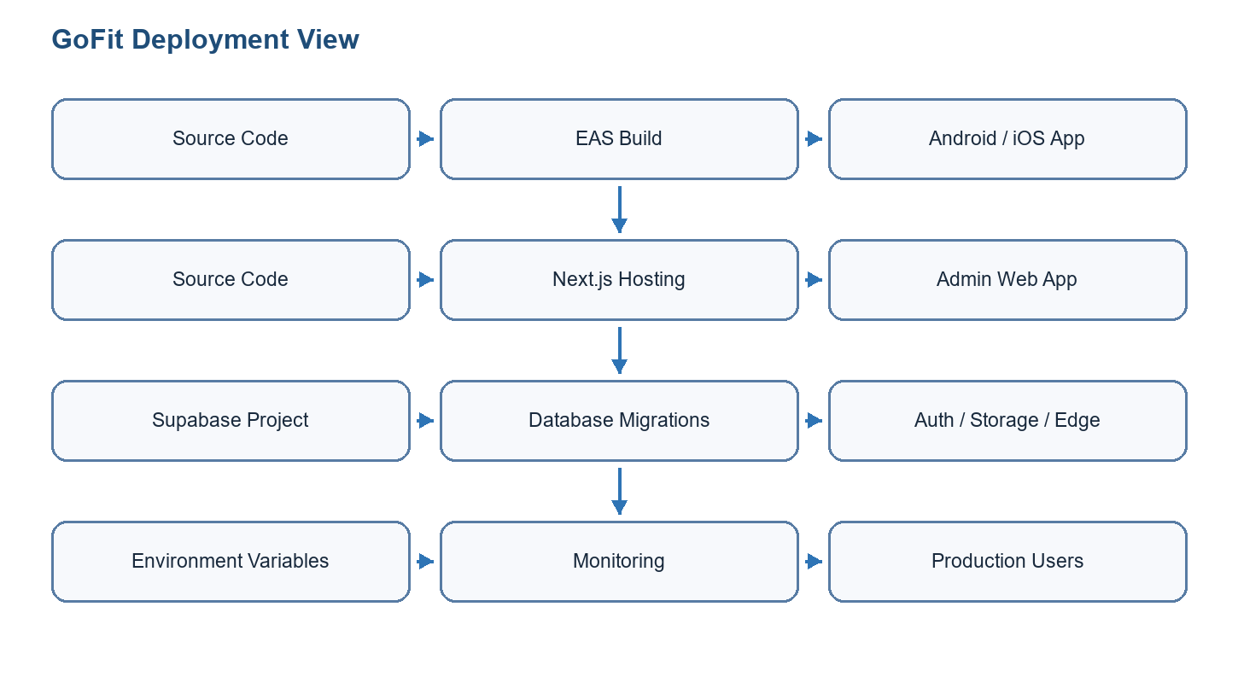
Figure 6.3: Deployment diagram

6.3.2 CI/CD or Hosting
The mobile application can be built using Expo/EAS for Android and iOS. The web administration panel can be hosted on a Next.js-compatible platform such as Vercel. Supabase hosts the database, authentication, storage, realtime features, and edge functions. Environment variables must be separated by environment, and service-role keys must remain server-side only.

6.3.3 Test Results
Test type | Scope | Result | Notes
Manual functional tests | Authentication, onboarding, workout, progress, coach, and admin flows | To finalize | Run on real devices and browser before submission.
Database validation | Migrations, RLS, foreign keys, service queries | Partially validated | Use Supabase SQL editor and app flows.
Admin tests | Protected routes and CRUD/API behavior | Partially validated | Confirm admin role and service-role boundaries.
Deployment checks | EAS build, Next.js hosting, Supabase env variables | To finalize | Required before production release.
Table 6.3: Final test results

General Conclusion
The GoFit graduation internship project produced a complete software foundation for a modern fitness platform. It combines a mobile application for clients and coaches, a web administration panel, and a Supabase backend. The project covers authentication, onboarding, profile management, workout planning, exercise library, active workout sessions, rest timer, progress tracking, nutrition-related flows, coach marketplace features, bookings, chat, programs, notifications, analytics, administration, and deployment preparation.
The project also provided important technical learning: multi-platform architecture, database normalization, row-level security, service-layer design, state management, mobile UX, admin-panel security, and Agile organization. Remaining work before final production release includes final device testing, complete store builds, payment/video production hardening if required, final screenshots, monitoring, and institutional formatting.

Bibliography
Reference | Source | Use
[1] | Expo documentation | Mobile application development and EAS build process
[2] | React Native documentation | Cross-platform mobile UI and APIs
[3] | Supabase documentation | Authentication, database, storage, realtime, RLS, and edge functions
[4] | Next.js documentation | Administration panel, App Router, server components, route handlers
[5] | Scrum Guide | Scrum roles, artifacts, events, and iterative methodology
[6] | GoFit repository documentation | Project-specific architecture, features, database, and sprint planning
Table B.1: Bibliography

Appendices
Appendix A should include exported UML diagrams, architecture diagrams, Gantt chart, burn down charts, and selected application screenshots. Appendix B may include SQL migration excerpts, test evidence, and deployment checklists.

