1. **The web browser connects to the web server and sends an HTTP request (via the protocol stack) for the desired web page**

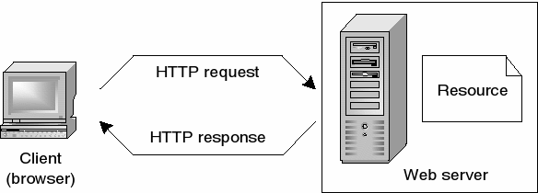

1. **To become a Web Developer, you should have an understanding of HTML, CSS, and JavaScript. It's also recommended to learn about CSS and CSS frameworks. Developing these fundamental web development skills will give you the foundation and logic for communicating with programming languages.**

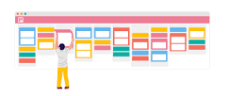

1. **I choose to learn web development to learn how to serch and have a clear understanding about web. The goal here is to get in a job market**