SSH BRUTE FORCE ATTACK
Detection & Analysis Report
Using Wazuh SIEM | MITRE ATT&CK Mapped | Python Integration in Progress
Analyst  Yessy | Target System  KALI-UTM (10.11.3.106) | Attack Type  SSH Brute Force | Date  April 21, 2026

MITRE Tactic  Credential Access | MITRE Technique  T1110 - Brute Force | Wazuh Rule  5712 (Level 10) | Tool Used  Wazuh v4.14.4

Executive Summary
This report documents a hands-on cybersecurity lab exercise in which an SSH brute force attack was simulated against a Kali Linux virtual machine monitored by the Wazuh SIEM platform. The goal was to demonstrate the full attack detection lifecycle: enabling the attack surface, understanding detection rules, executing the attack, observing alerts in real time, and documenting findings.

Wazuh successfully detected the brute force activity and fired Rule 5712 (Level 10), confirming the platform's effectiveness as a real-time threat detection tool. All findings are mapped to the MITRE ATT&CK framework.

Project Update: This lab is part of an ongoing cybersecurity project that is now beginning to incorporate Python scripting. Python is being introduced to automate analysis tasks, parse Wazuh logs programmatically, and build custom tooling around the SIEM environment. This marks an exciting step forward in the project's technical depth.

MITRE ATT&CK Framework Mapping
This attack maps to the following MITRE ATT&CK technique:

Field | Details
Tactic | Credential Access (TA0006)
Technique | T1110 – Brute Force
Sub-technique | T1110.001 – Password Guessing
Description | Adversaries attempt to gain access to accounts by systematically guessing passwords using non-existent usernames over SSH.
Platform | Linux (Kali GNU/Linux 2023.3)
Protocol Targeted | SSH (Port 22)
Wazuh Rule Triggered | 5712 – sshd: brute force trying to get access to the system. Non-existent user.
Rule Level | 10 (Medium-High severity)
Compliance Tags | PCI DSS 11.4, 10.2.4, 10.2.5 | HIPAA 164.312.b | NIST-800-53 SI.4, AU.14, AC.7

Step-by-Step Attack Walkthrough
STEP 1 Activate SSH on Kali Linux
Before any attack can be simulated or detected, the target machine needs to be listening for SSH connections. SSH was enabled on the Kali Linux virtual machine running inside UTM on an Apple Silicon Mac.

Commands executed on Kali Linux:
sudo systemctl start ssh
sudo systemctl status ssh
ifconfig

What we confirmed:
- SSH service status: active (running) since Tue 2026-04-21 12:10:54 PDT
- Server listening on 0.0.0.0 port 22 (all interfaces)
- Kali IP address confirmed: 10.11.3.106

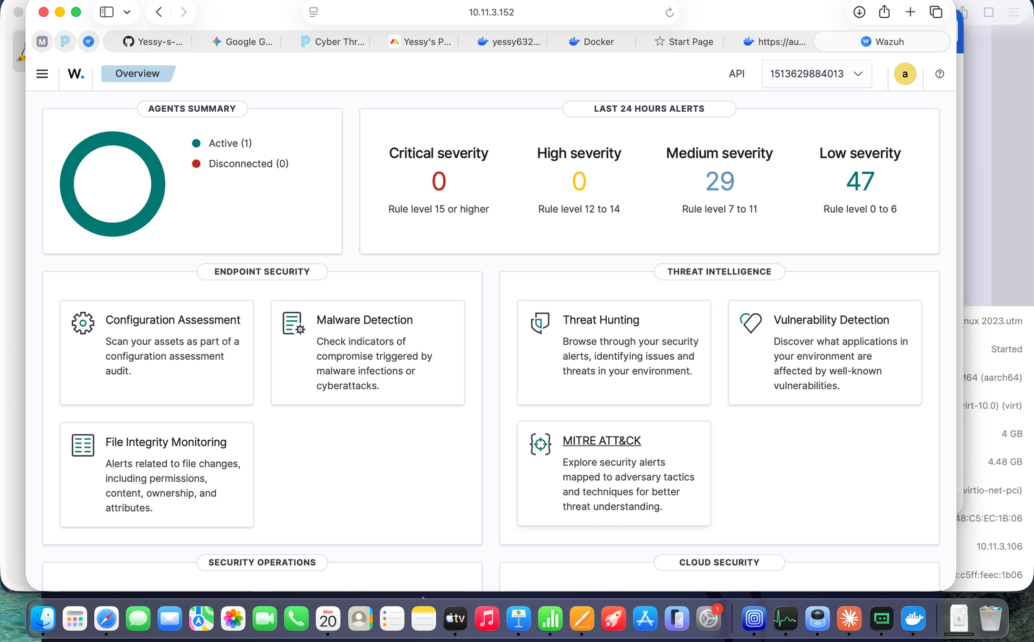
Figure 1 – Wazuh Dashboard Overview showing 1 active agent (KALI-UTM) and 29 medium + 47 low severity alerts in the last 24 hours

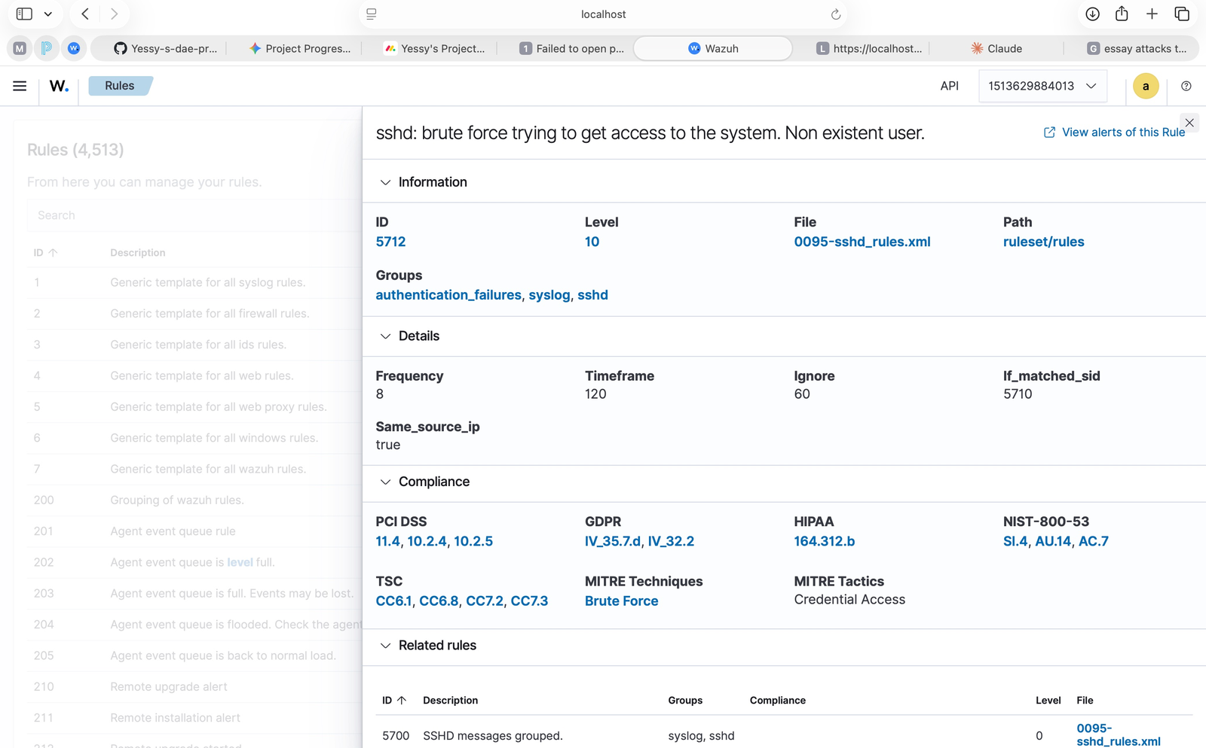
Figure 2 – Kali Linux terminal showing SSH service active and running on port 22, with IP address 10.11.3.106 confirmed via ifconfig

Why this matters:
SSH is one of the most commonly targeted services in real-world attacks. Automated bots constantly scan the internet for open SSH ports on port 22. By enabling it, we created the attack surface that Wazuh would monitor.

STEP 2 Review Wazuh Detection Rule 5712
Before running the attack, we studied the Wazuh rule that would detect it. Understanding the rule helps us know the threshold that triggers an alert and what evidence Wazuh collects.

Rule 5712 – Key Details:
Rule ID | 5712
Rule Level | 10 (Medium-High – triggers as medium alert in Wazuh)
Description | sshd: brute force trying to get access to the system. Non-existent user.
File | 0095-sshd_rules.xml
Groups | authentication_failures, syslog, sshd
Frequency | 8 attempts within 120 seconds from same IP
Same Source IP | true
Parent Rule | 5710 – sshd: Attempt to login using a non-existent user
MITRE Technique | T1110 – Brute Force
MITRE Tactic | Credential Access

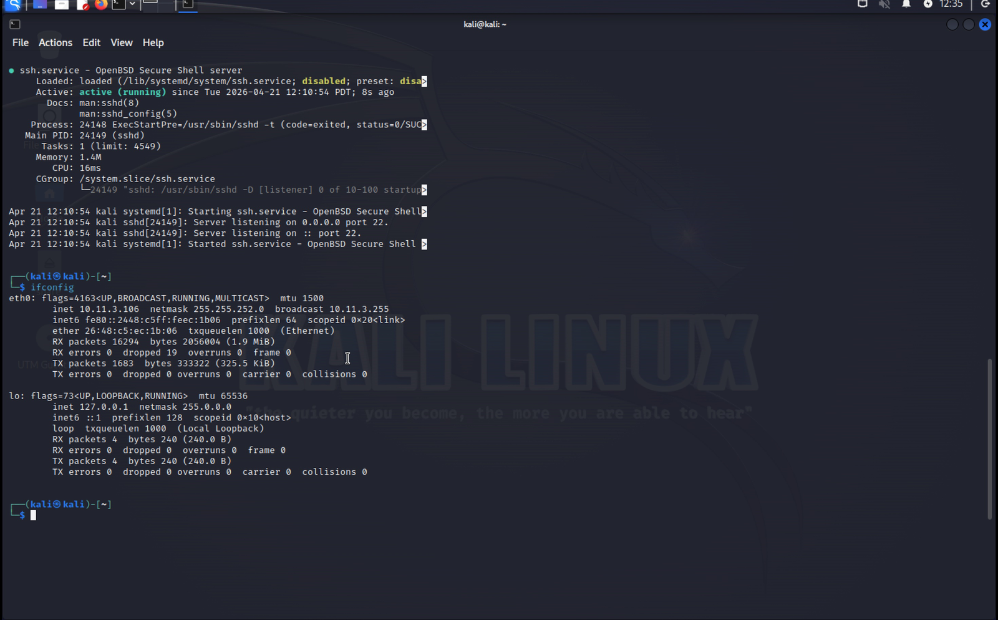
Figure 3 – Wazuh Rules panel showing Rule 5712 detail: Level 10, frequency of 8 attempts in 120 seconds, MITRE mapped to Credential Access / Brute Force

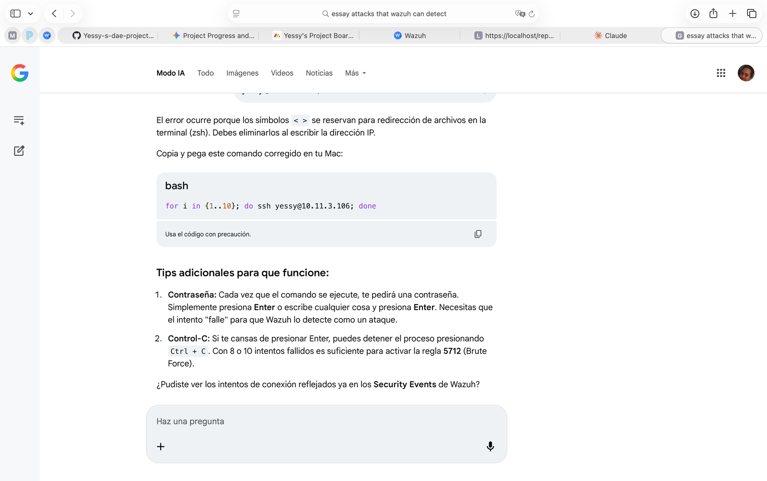
Figure 4 – The raw XML file (0095-sshd_rules.xml) inside Wazuh showing the rule definitions for SSH including Rules 5700-5712

In plain English:
Rule 5712 fires when the same IP address attempts to log in with a username that does not exist on the system, 8 or more times within 2 minutes. It builds on Rule 5710 (single failed attempt) – once 8 of those fire from the same source, the brute force alert triggers.

Compliance tags triggered:
- PCI DSS 11.4, 10.2.4, 10.2.5 – monitoring and testing security controls
- HIPAA 164.312.b – audit controls for electronic systems
- NIST 800-53 SI.4, AU.14, AC.7 – system monitoring and account lockout

STEP 3 Simulate SSH Brute Force Attack
With SSH running on Kali (10.11.3.106) and Wazuh monitoring the agent, the brute force attack was simulated from the Mac host. The goal: generate enough failed login attempts to cross Rule 5712's threshold.

Attack command used:
for i in {1..10}; do ssh yessy@10.11.3.106; done

What happened:
- The loop attempted to SSH into Kali 10 times using the username 'yessy'
- 'yessy' is a non-existent user on the Kali system
- Each attempt prompted for a password – wrong passwords were entered intentionally
- After each failure SSH returned: Permission denied, please try again
- After 3 failed tries per session: Permission denied (publickey, password)
- Connection closed by 10.11.3.106 port 22 – then the loop started the next attempt

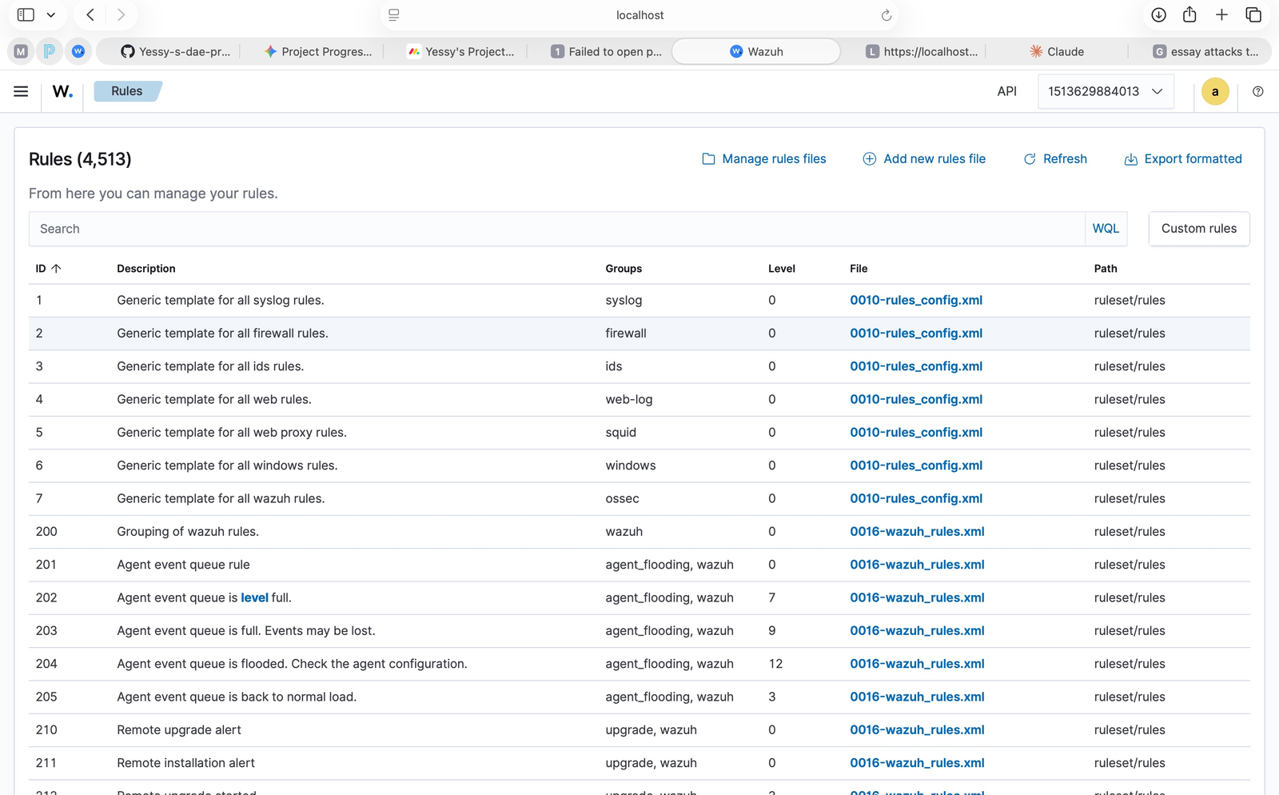
Figure 5 – Mac terminal showing the SSH brute force loop in action: repeated 'Permission denied' responses and connection closures from Kali (10.11.3.106)

Note: The zsh shell on Mac initially gave a parse error with angle brackets in the command. The corrected bash-compatible syntax shown above was used after quick troubleshooting. This demonstrates real-world problem-solving during a lab exercise.

STEP 4 Observe Alerts in Wazuh
After running the brute force command, the Wazuh Threat Hunting module was used to review the security events. The KALI-UTM agent (ID: 001) showed a clear spike in authentication failure events.

Alerts Summary Table:
Rule ID | Description | Level | Count | Severity
5710 | sshd: Attempt to login using a non-existent user | 5 | 17 | Low-Med
5503 | PAM: User login failed. | 5 | 5 | Low-Med
2502 | syslog: User missed the password more than one time | 10 | 4 | Medium
5712 | sshd: brute force trying to get access. Non-existent user. | 10 | 2 | ⚠ Medium

Total: 28 alerts | 0 successful logins | 0 critical (Level 12+) events

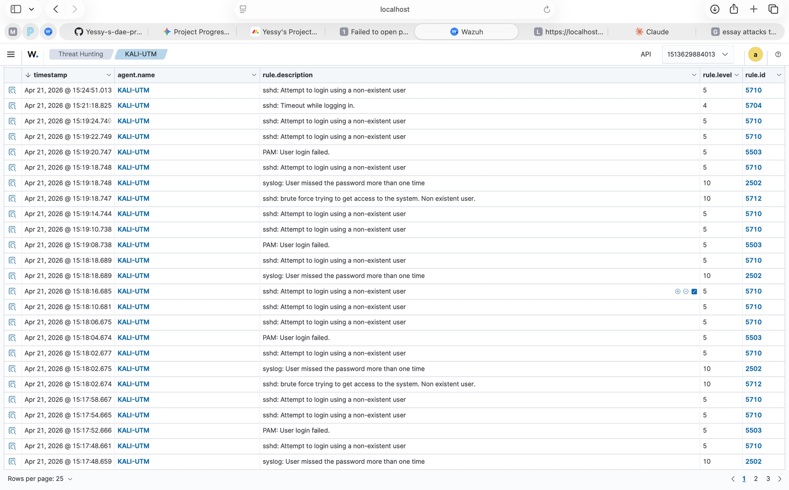
Figure 6 – Wazuh Threat Hunting Events view showing 53 total hits for agent KALI-UTM with a clear spike at 15:00 – exactly when the brute force ran

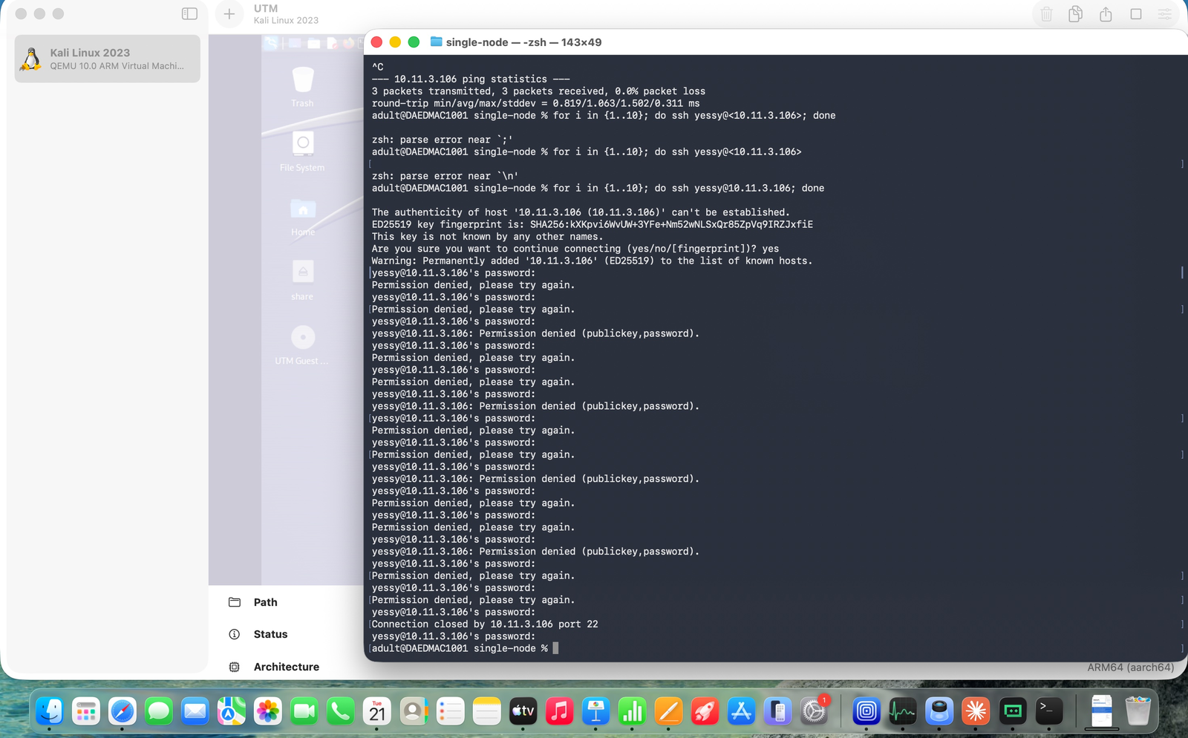
Figure 7 – Detailed alert list in Wazuh showing Rule 5712 (brute force) and Rule 5710 (individual attempts) firing in sequence from KALI-UTM

What the alerts confirmed:
- Multiple Rule 5710 events – each individual failed SSH login attempt captured
- Rule 5712 fired twice – confirming the brute force threshold was crossed
- Rule 2502 correlated the repeated wrong-password pattern via syslog
- All events tied to agent KALI-UTM (ID: 001) at IP 10.11.3.106

STEP 5 Document the Process – Findings & Lessons Learned
This final step captures the key findings, what was proven, and the security lessons demonstrated through this exercise.

What Was Proven
- Wazuh successfully monitors SSH authentication in real time
- Rule 5712 correctly triggered after 8+ failed login attempts within 2 minutes
- The alert included full context: source agent, timestamp, and rule ID
- The Threat Hunting module made it easy to trace the full attack timeline
- The agent (KALI-UTM) was properly enrolled and reporting to the Wazuh manager

Environment Used
Wazuh Server | Docker single-node deployment (manager, indexer, dashboard) v4.14.4
Wazuh Agent | KALI-UTM – Agent ID 001 on Kali Linux 2023.3 (ARM64)
Attacker Host | Mac (Apple Silicon) running UTM/QEMU virtual machine
Network | 10.11.3.0/22 subnet – host-only between Mac and VM
Attack Tool | Native OpenSSH client via shell loop (no special tools needed)
Monitoring | Wazuh Dashboard at https://localhost (Docker-hosted)

Security Lessons Demonstrated
- Lesson 1: SSH brute force is a real, common attack – bots scan the internet for open port 22 constantly
- Lesson 2: SIEM tools like Wazuh are essential – without it, failed logins would be invisible unless manually reviewing /var/log/auth.log
- Lesson 3: Rule tuning matters – the 120-second window and same_source_ip filter avoid false positives from normal users mistyping
- Lesson 4: Compliance is built-in – detecting brute force automatically satisfies PCI DSS, HIPAA, and NIST requirements
- Lesson 5: Defense recommendations: use SSH key-only auth, fail2ban, change default port, and enable Wazuh Active Response

Python Integration – Next Steps
The project is now beginning to incorporate Python. This is a natural and powerful progression – Python allows us to go beyond the Wazuh dashboard and interact with security data programmatically.

Python is being introduced to this project to enable:
- Log parsing – reading and analyzing /var/log/auth.log to extract failed login attempts programmatically
- Wazuh API integration – querying the Wazuh REST API with Python to pull alerts, agent status, and rule hits automatically
- Alert automation – writing scripts that trigger notifications or responses when specific rules like 5712 fire
- Custom reporting – generating summaries and statistics from raw Wazuh event data without manually clicking through the dashboard
- Future: building tools that correlate multiple attack indicators across agents and time windows

Example Python direction (Wazuh API query):
import requests
# Authenticate and query Wazuh API for Rule 5712 alerts
response = requests.get('https://localhost:55000/alerts?rule.id=5712',
headers={'Authorization': 'Bearer <token>'}, verify=False)
print(response.json())

Adding Python to this project demonstrates a full-stack security engineering mindset: not just using tools, but building automation and custom tooling on top of them – a key skill in real SOC and security engineering roles.

Recommended Mitigations (Real-World)
Control | Description
Disable Password Auth | Require SSH key pairs only – eliminates password guessing entirely
Use fail2ban | Auto-blocks IPs after N failed attempts at the firewall level
Change SSH Port | Moving from port 22 to a non-standard port reduces automated scanning
Wazuh Active Response | Configure Wazuh to auto-block attacker IPs when Rule 5712 fires
Python Alert Scripts | Use Python to build custom alerting on top of Wazuh for faster response

Conclusion
This lab successfully demonstrated a complete attack detection cycle. Starting from a zero-access position, SSH was enabled on Kali Linux, Rule 5712 was studied and understood, a brute force attack was simulated, and the resulting alerts were captured and analyzed in Wazuh – all backed by real screenshots from the live environment.

The exercise proves practical competency in: endpoint security monitoring, SIEM rule analysis, threat hunting, attack simulation, and compliance framework mapping (MITRE ATT&CK, PCI DSS, HIPAA, NIST 800-53).

With Python now entering the picture, this project is leveling up from a tool-user perspective to a security engineer perspective – building automation, custom queries, and programmatic analysis on top of the Wazuh platform.

Report prepared by Yessy | April 21, 2026 | Wazuh SIEM Lab Exercise

