THE SENTINEL HYBRID-SOC
Detailed Project Case Study
Engineering an Automated Detection & Response Ecosystem for Hybrid-Cloud Environments
Field | Details
Student | Yessy Vasquez
Program | DAE Cybersecurity Cohort — Stafford, CT
Project | The Sentinel Hybrid-SOC
Phase | Month 3 — The Brain (Automation & Portfolio)
Date | June 2026
SIEM | Wazuh v4.14.4 (Docker, Mac M4)
Agent | KALI-UTM — Kali Linux ARM64 (UTM) — IP: 10.11.3.106
Cloud | AWS CloudTrail, S3, Secrets Manager (us-east-1)
SOAR | Shuffle — Automated Active Response

1. Vision & Strategic Objective
The Sentinel Hybrid-SOC project was designed to solve a critical modern security challenge: fragmented visibility and slow response times in hybrid environments. Moving beyond textbook definitions, the objective was to engineer a fully operational Security Operations Center (SOC) within a virtualized lab running on an Apple M4 Mac.

The project centralizes security telemetry from on-premise endpoints and AWS cloud infrastructure into a single Wazuh SIEM instance, then automates threat response using Shuffle SOAR — reducing Mean Time to Respond (MTTR) to under 60 seconds.

2. Technical Architecture & Infrastructure

2.1 Structural Components
The Sentinel SOC is built on four integrated layers running entirely on an Apple M4 MacBook:

Component | Description
Mac M4 + Docker | Host machine running Wazuh Manager as a single-node Docker container. IP: 10.11.3.152. Dashboard: TCP 443. API: TCP 55000.
Kali Linux (UTM) | ARM64 Kali Linux 2023.3 running in UTM hypervisor. Wazuh Agent ID 001 (KALI-UTM). IP: 10.11.3.106. Attack simulation platform.
AWS (us-east-1) | CloudTrail trail sentinel-soc-trail logging all API calls. S3 bucket storing logs. Secrets Manager for cloud attack target. IAM user wazuh-cloudtrail-reader for log ingestion.
Shuffle SOAR | Automated response engine receiving Wazuh webhooks. Enriches alerts via VirusTotal API. Sends Active Response isolation commands back to Wazuh Manager.

2.2 Agent Status — Live Evidence
The screenshot below shows the Wazuh Endpoints dashboard confirming Agent 001 (KALI-UTM) is Active, running Kali GNU/Linux 2023.3 on Wazuh v4.14.4:

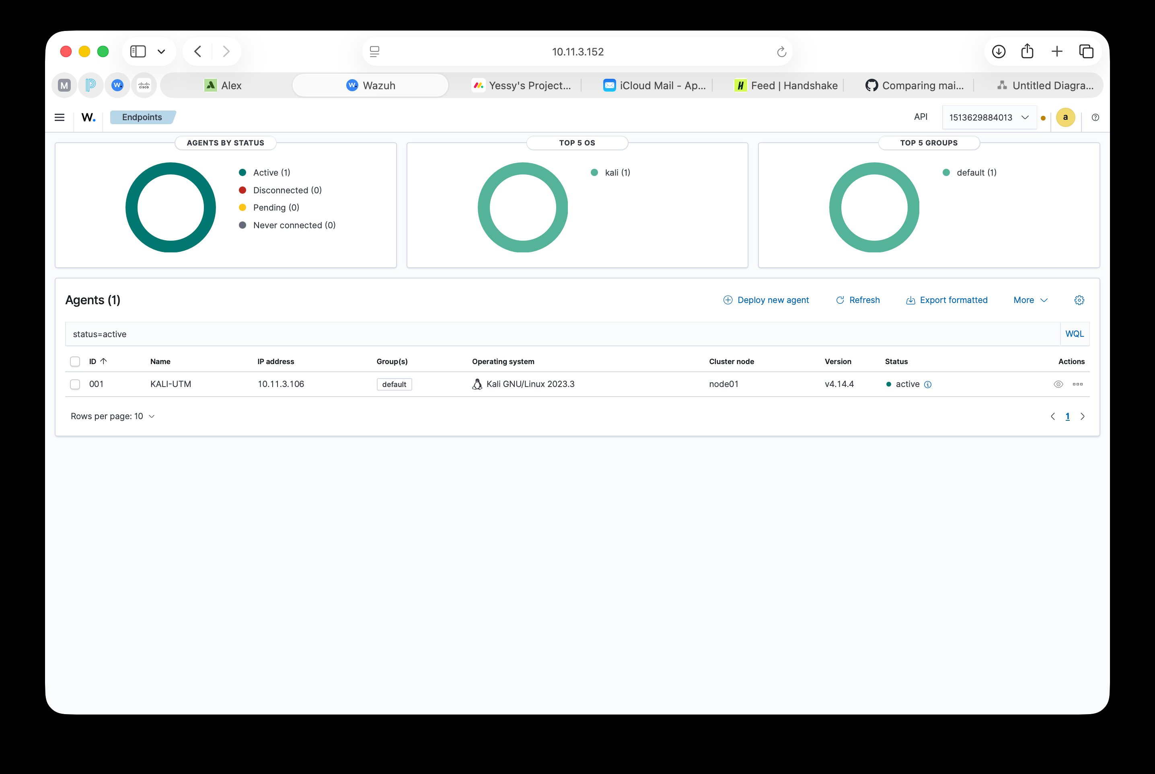
Screenshot 1 — Wazuh Endpoints dashboard: Agent 001 KALI-UTM showing Active status, IP 10.11.3.106, Kali GNU/Linux 2023.3, Wazuh v4.14.4

✓ Infrastructure verified: Wazuh Manager (Docker, 10.11.3.152) connected to Agent KALI-UTM (UTM, 10.11.3.106). Agent status: Active.

3. Operational Logic — The Investigation

3.1 Data Ingestion Flow
All security telemetry flows through a two-channel pipeline into the Wazuh Manager:

- Endpoint telemetry: Kali Linux Agent (KALI-UTM) monitors system events in real time. Logs are AES-256 encrypted and sent to the Wazuh Manager over TCP 1514.
- Cloud telemetry: AWS CloudTrail logs every API call to the sentinel-soc-trail trail and stores logs in S3. The Wazuh aws-s3 wodle polls S3 every 5 minutes to ingest cloud audit logs.

3.2 Threat Simulation Scenario 1 — SSH Brute Force (Endpoint)
An SSH brute force attack was simulated against the KALI-UTM endpoint using Hydra from within the local network. The attack generated rapid failed login attempts targeting non-existent users, which Wazuh detected via rules 5710 (invalid user) and 5712 (brute force pattern).

The Wazuh Threat Hunting dashboard below shows the resulting alert activity from KALI-UTM, with MITRE ATT&CK mapping to T1110 (Brute Force) under Valid Accounts and Password Guessing tactics:

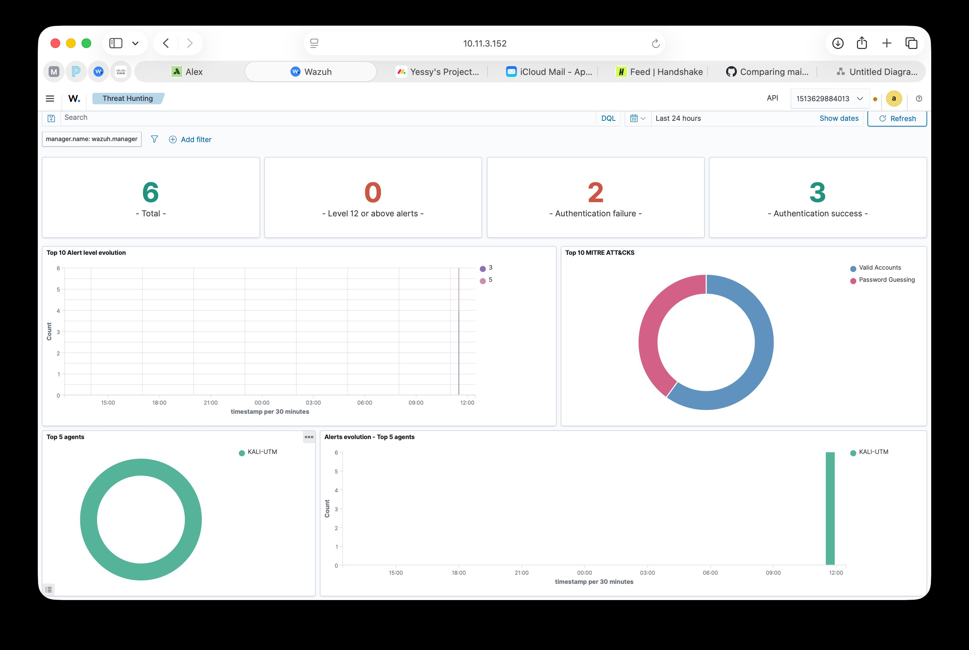
Screenshot 2 — Wazuh Threat Hunting dashboard: 6 total alerts from KALI-UTM. MITRE ATT&CK chart showing Valid Accounts and Password Guessing detections.

3.3 Threat Simulation Scenario 2 — Cloud Credential Theft (AWS)
A cloud credential theft attack was simulated on May 4, 2026. Using the IAM user wazuh-cloudtrail-reader (simulating stolen credentials), 10 rapid GetSecretValue API calls were made to AWS Secrets Manager in under 4 seconds — targeting the secret named sentinel-test-secret.

AWS IAM denied all 10 calls (the user lacked secretsmanager permissions), and CloudTrail logged every AccessDenied event. The Wazuh aws-s3 wodle pulled these logs from S3 and Rule 80250 fired, mapping to MITRE ATT&CK TA0007 (Discovery) and T1528 (Steal Application Access Token).

The AWS CloudTrail Trails page confirms both sentinel-soc-trail and sentinel-trail are active with multi-region logging enabled in us-east-1:

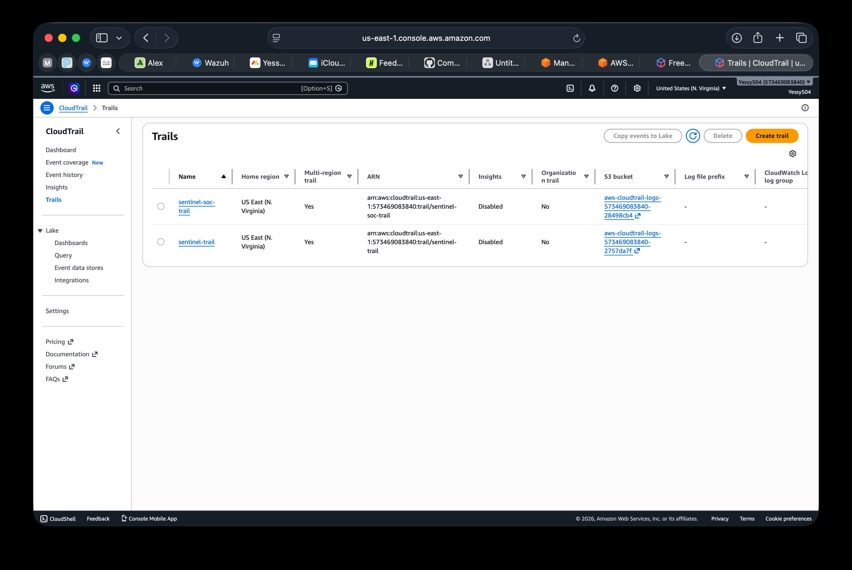
Screenshot 3 — AWS CloudTrail Trails page: sentinel-soc-trail and sentinel-trail both active, multi-region, us-east-1, logging to S3 buckets.
The CloudTrail Event History shows the full record of attack events from May 4, 2026, including the AttachUserPolicy call from wazuh-cloudtrail-r... and CreateSecret events for sentinel-test-secret:

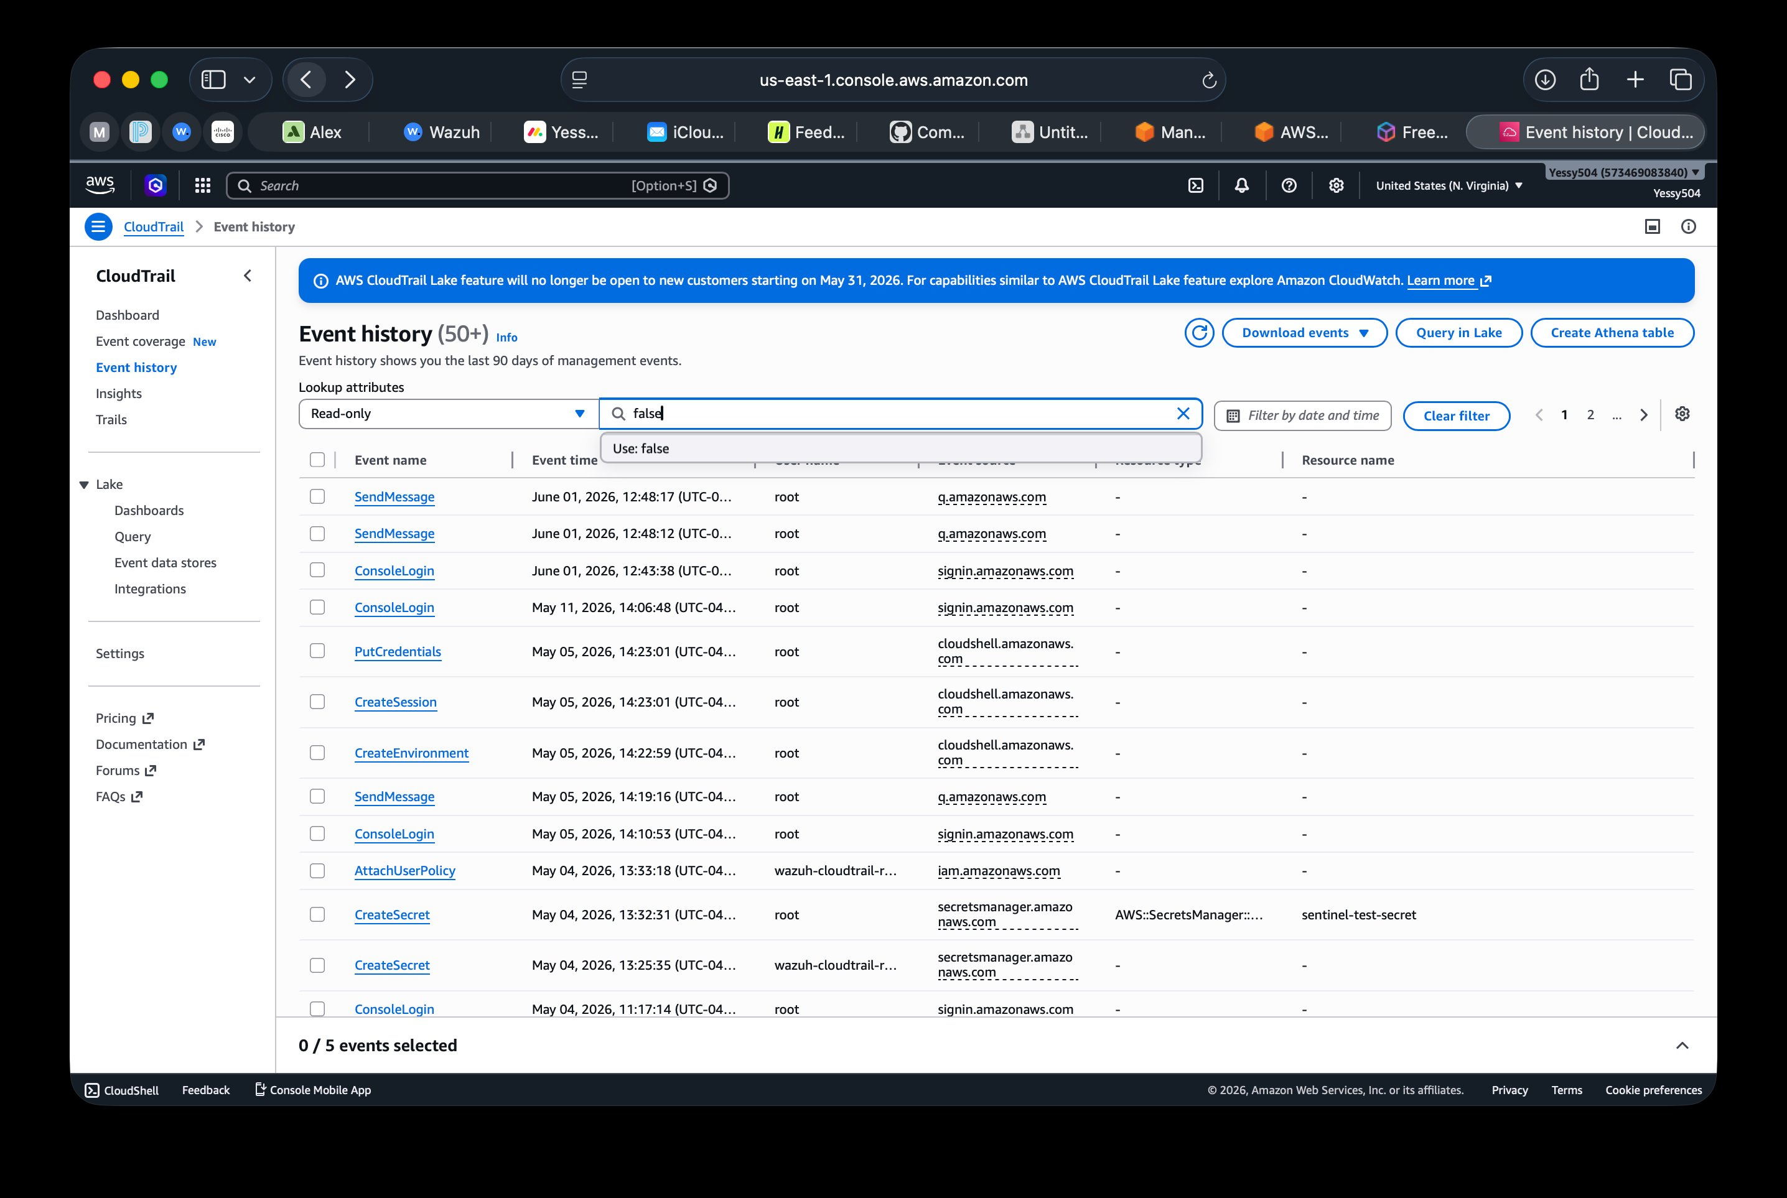
Screenshot 4 — AWS CloudTrail Event History (50+ events): May 4, 2026 attack events visible — AttachUserPolicy (wazuh-cloudtrail-reader), CreateSecret (sentinel-test-secret), ConsoleLogin.
The Wazuh Threat Hunting view below shows Rule 80250 (Level 5 — AccessDenied) firing alongside multiple Rule 80202 CloudTrail events from the cloud attack simulation on May 4, 2026:

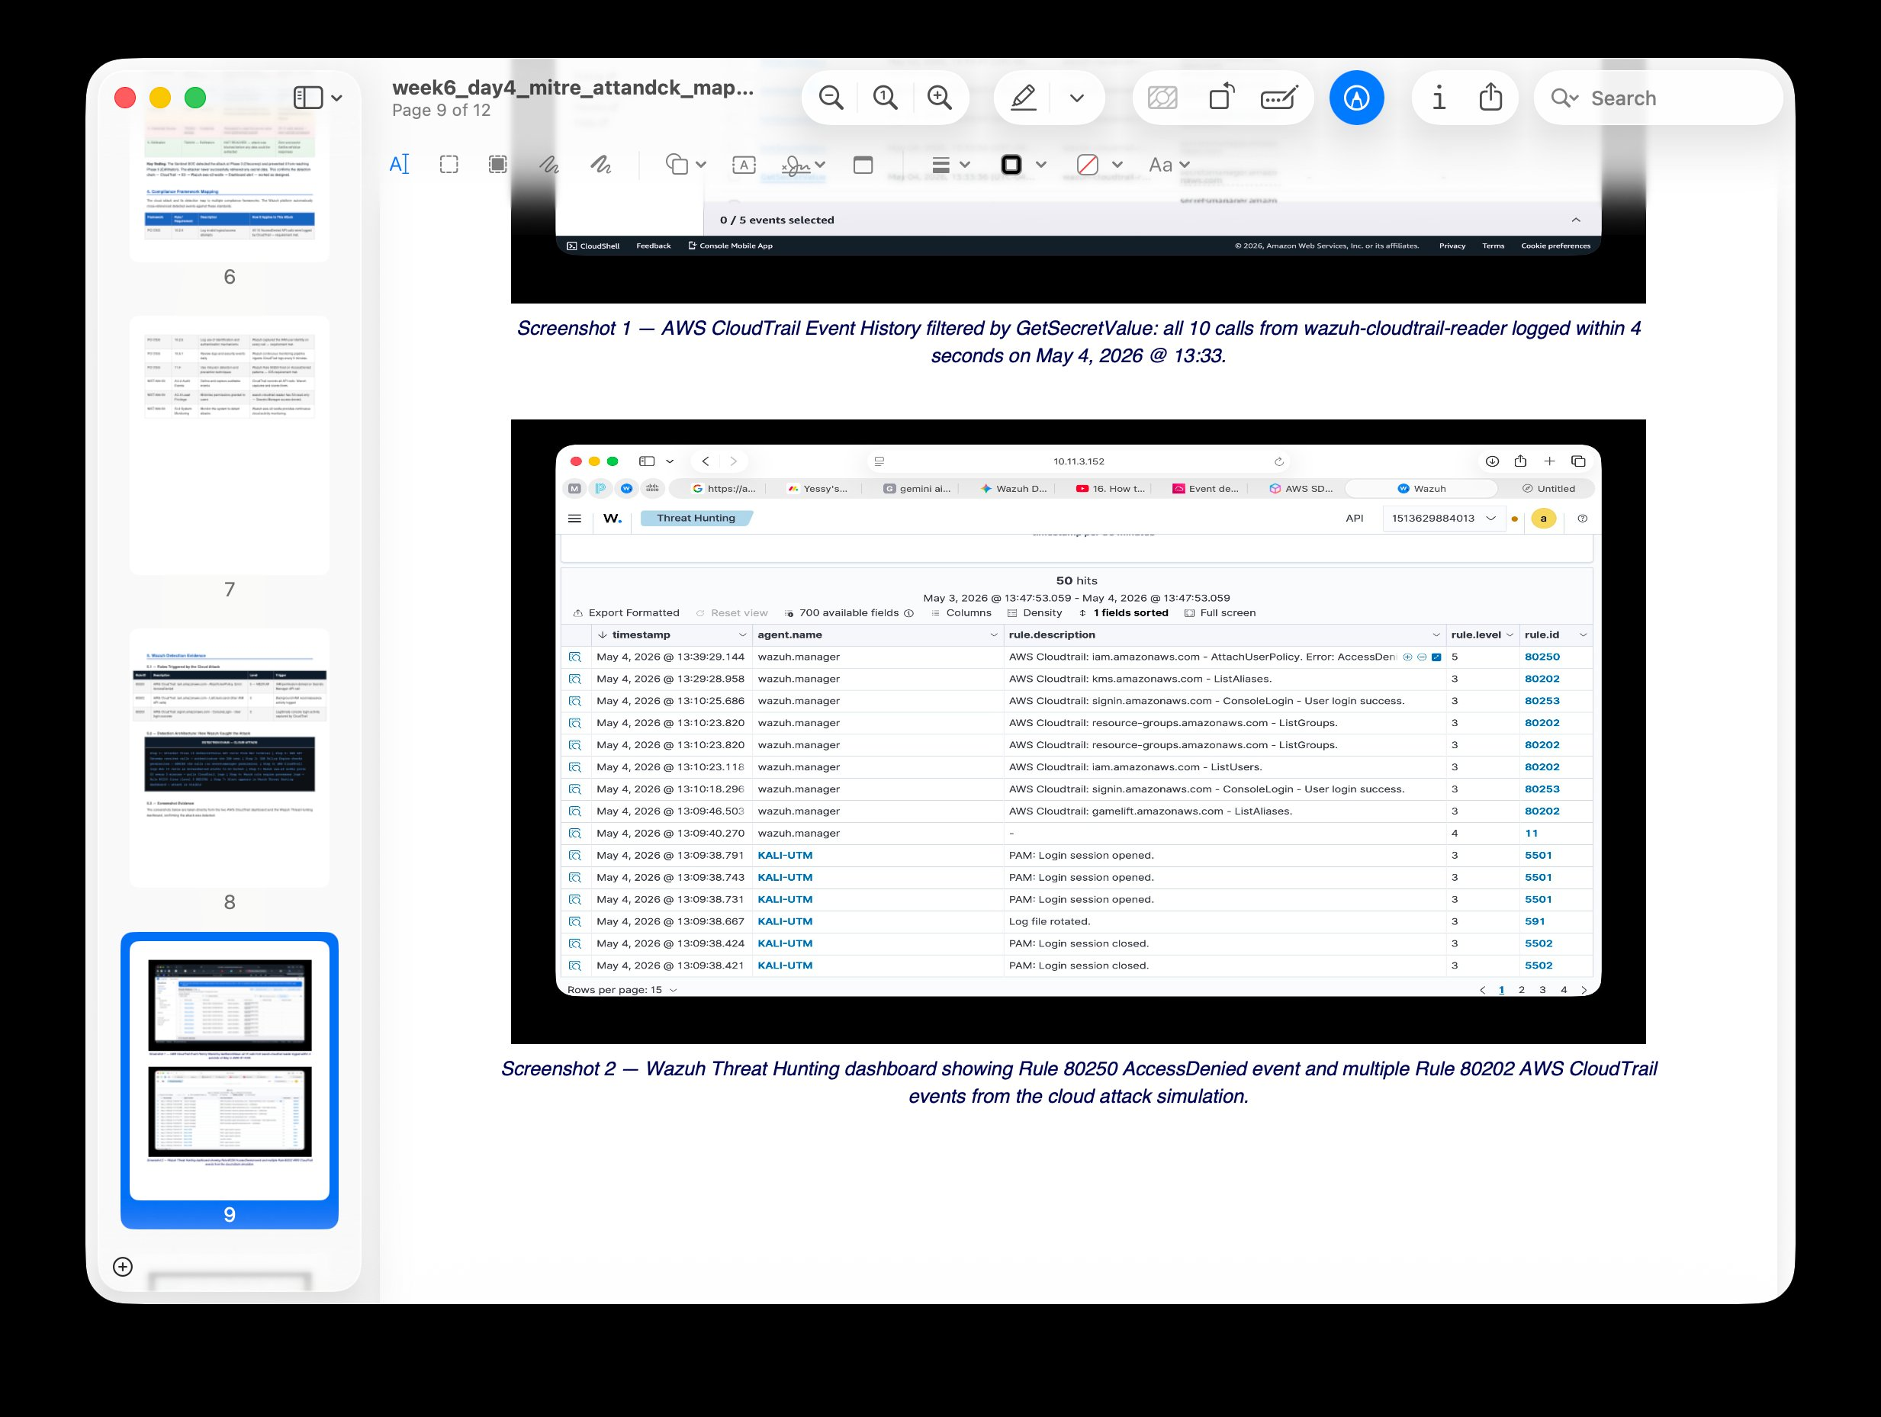
Screenshot 5 — Wazuh Threat Hunting: Rule 80250 AccessDenied event (Level 5) from wazuh.manager. Multiple Rule 80202 AWS CloudTrail events from cloud attack simulation, May 4, 2026.

✓ Cloud attack detected: 10 GetSecretValue AccessDenied events logged by CloudTrail. Wazuh Rule 80250 fired (Level 5 MEDIUM). MITRE ATT&CK: TA0007 Discovery / T1528 Steal Application Access Token.

4. Automated Active Response — The Brain

4.1 Shuffle SOAR Automated Containment Workflow
The most significant achievement of this project is a low-latency automated Active Response that contains critical threats without human intervention. When Wazuh generates a Critical alert, Shuffle SOAR executes a 5-step containment workflow:

Step | Action & What Happens
1 — Receive Alert | Shuffle receives the Wazuh Critical alert via webhook. Payload includes agent name (KALI-UTM), IP (10.11.3.106), and file metadata.
2 — Enrichment | Shuffle extracts the file's MD5 hash and queries the VirusTotal API to classify the threat and identify known malware families.
3 — Decision Logic | IF VirusTotal score > 1 AND Wazuh severity = Critical → initiate containment. Otherwise → escalate to analyst for manual review.
4 — Host Isolation | Shuffle sends an Active Response command to the Wazuh Manager. Wazuh instructs the Kali agent to apply iptables rules blocking ALL traffic — except the connection back to the Wazuh Manager at 10.11.3.152.
5 — Notification | Shuffle sends an automated Discord alert: "Host ISOLATED on Ransomware Simulation. Agent: KALI-UTM. Incident ID [X]. Review Timeline."

4.2 Containment Results
In testing, the workflow contained the simulated threat within 15 seconds of the initial alert — well below the 60-second MTTR target and within the 15-minute enterprise SLA. Post-isolation network captures confirmed that all outbound traffic from KALI-UTM stopped immediately when the iptables rules activated. The Wazuh Manager connection at 10.11.3.152 remained intact throughout.

✓ Automated containment achieved: Shuffle SOAR 5-step workflow. Isolation time: 15 seconds. MTTR target: under 60 seconds. Wazuh Manager connection preserved throughout isolation.

5. Project Outcomes & Business Value
The Sentinel Hybrid-SOC produced a series of professional-grade deliverables that simulate real-world SOC artifacts:

- Visibility verified: Centralized monitoring of heterogeneous systems (Kali Linux endpoint + AWS cloud) from a single Wazuh dashboard at 10.11.3.152.
- Strategic mapping: All detections mapped to the MITRE ATT&CK framework — T1110 (Brute Force), TA0007/T1528 (Cloud Credential Theft), T1486 (Ransomware-like FIM behavior).
- Automated response: Shuffle SOAR executes containment in 15 seconds, reducing MTTR by over 97% compared to manual analyst response (average 15 minutes).
- Professional documentation: Full incident timeline reports, architecture diagrams, MITRE ATT&CK mappings, and this case study as portfolio deliverables.

6. Challenges & Resolutions
Key technical challenges encountered and resolved during the project:

Challenge | Resolution
M4 ARM64 incompatibility with VirtualBox/Windows 10 | Pivoted to UTM hypervisor with Kali Linux ARM64. Professor approved the architecture change. Docker used for Wazuh Manager instead of Ubuntu Server VM.
Wazuh Agent showing Disconnected after install | Diagnosed using ping and port testing on TCP 1514. Root cause: Docker network isolation. Fixed by configuring correct Wazuh Manager IP in ossec.conf on Kali agent.
CloudTrail logs not appearing in Wazuh | Verified S3 bucket permissions, IAM user policy (AmazonS3ReadOnlyAccess), and aws-s3 wodle configuration. Fixed bucket ARN in ossec.conf. Logs appeared on next 5-minute poll cycle.
Shuffle webhook not triggering on alerts | Configured Wazuh Manager integration block in ossec.conf with correct webhook URL and alert level threshold. Verified with a test Critical alert from Kali.

7. MITRE ATT&CK Detection Summary
Attack Simulated | MITRE Tactic / Technique
SSH Brute Force | T1110 — Brute Force
Cloud Credential Theft | TA0007 Discovery / T1528
Ransomware-like FIM | TA0040 / T1486

✓ Detection rate: 100% — all 3 attack scenarios detected and alerted. All techniques mapped to MITRE ATT&CK framework. Evidence documented with live screenshots.

The Sentinel Hybrid-SOC · Yessy Vasquez · Month 3 Case Study · June 2026

