VISHNU INSTITUTE OF TECHNOLOGY
(Autonomous)
Department of Computer Science and Engineering
A Project Report on
RISING WATERS
A Machine Learning Based Flood Prediction and Risk Assessment System
Submitted in partial fulfilment of the requirements for the award of the degree of
BACHELOR OF TECHNOLOGY
in
COMPUTER SCIENCE AND ENGINEERING
Ramisetti Mahesh Babu | Team Lead
Saroja Sri Venkata Lakshmi Gudala | Team Member
Yesu Babu Matlapudi | Team Member
Lochana Vasamsetti | Team Member
Venu Gopal Penta | Team Member
Under the Guidance of
[Guide Name], [Designation]
Department of Computer Science and Engineering
VISHNU INSTITUTE OF TECHNOLOGY
2025 – 2026
CERTIFICATE
This is to certify that the project report entitled “Rising Waters – A Machine Learning Based Flood Prediction and Risk Assessment System” is a bonafide record of work carried out by the team named below, submitted in partial fulfilment of the requirements for the award of the degree of Bachelor of Technology in Computer Science and Engineering from Vishnu Institute of Technology, during the academic year 2025–2026.
Ramisetti Mahesh Babu — Team Lead
Saroja Sri Venkata Lakshmi Gudala — Team Member
Yesu Babu Matlapudi — Team Member
Lochana Vasamsetti — Team Member
Venu Gopal Penta — Team Member
The work has been carried out under my supervision and guidance, and the report has been found satisfactory for the award of the said degree.
Project Guide
Head of the Department
External Examiner
DECLARATION
We, the undersigned, hereby declare that the project report entitled “Rising Waters – A Machine Learning Based Flood Prediction and Risk Assessment System” is an original work carried out by us and has been submitted to the Department of Computer Science and Engineering, Vishnu Institute of Technology, in partial fulfilment of the requirements for the award of the degree of Bachelor of Technology. We further declare that this report has not been submitted, in part or in full, to any other university or institute for the award of any degree or diploma, and that all sources of information used have been duly acknowledged.
Team Members:
Ramisetti Mahesh Babu — Team Lead
Saroja Sri Venkata Lakshmi Gudala — Team Member
Yesu Babu Matlapudi — Team Member
Lochana Vasamsetti — Team Member
Venu Gopal Penta — Team Member
ACKNOWLEDGEMENT
We take this opportunity to express our sincere gratitude to everyone who supported us throughout the development of this project. We are deeply thankful to our project guide for their valuable guidance, constant encouragement, and constructive feedback at every stage of this work.
We would also like to thank the Head of the Department of Computer Science and Engineering and all the faculty members of Vishnu Institute of Technology for providing us the necessary resources, infrastructure, and a conducive environment to carry out this project successfully.
Finally, we extend our heartfelt thanks to our families and friends for their constant motivation and support, and to every member of our team for their dedication and collaborative effort in bringing this project to completion.
— Project Team
ABSTRACT
Floods are among the most frequent and destructive natural disasters, causing severe loss of life, property, and infrastructure across the world every year. Traditional flood forecasting methods often rely on hydrological modelling that requires extensive historical river-gauge data and significant computational resources, making them difficult to deploy quickly for smaller or data-scarce regions. This project, titled “Rising Waters,” presents a lightweight, web-based flood risk prediction system that uses machine learning to classify flood risk in real time based on readily available environmental and geographic parameters.
The system accepts twelve input features from the user — latitude, longitude, annual rainfall, seasonal rainfall, temperature, humidity, river discharge, water level, elevation, population density, infrastructure index, historical flood count, and cloud visibility — and passes them through a trained classification model built using Scikit-learn. The model outputs a risk category of Low, Medium, or High, allowing users, disaster-management authorities, or local administrators to make quick, informed decisions.
The application follows a full-stack architecture with a React.js single-page frontend for user interaction, a Flask REST API backend that handles authentication, request validation, and orchestration of the prediction service, and MongoDB as the primary data store for user accounts and prediction history. The trained model is serialized using Joblib and loaded into the Flask service at runtime, enabling low-latency predictions. The application is containerised for deployment and hosted on the Render cloud platform using Gunicorn as the production WSGI server.
Key features of the system include secure user authentication, an interactive dashboard summarising total predictions, safe cases, flood cases, and today’s activity, a dedicated prediction form for entering environmental parameters, and a historical log of past predictions with timestamps, location, and risk outcomes. This report documents the complete lifecycle of the project — from problem identification and requirement analysis, through system design (architecture, data flow, ER, use case, and sequence diagrams), implementation, testing, and results — and concludes with directions for future enhancement such as satellite data integration, deep learning based time-series forecasting, and SMS/email based early-warning alerts.
Keywords: Flood Prediction, Machine Learning, Scikit-learn, Flask, React, MongoDB, Disaster Risk Management, Classification.
TABLE OF CONTENTS

LIST OF FIGURES
Figure 4.1: System Architecture Diagram of Rising Waters
Figure 4.2: Use Case Diagram
Figure 4.3: Level 1 Data Flow Diagram
Figure 4.4: Entity-Relationship Diagram
Figure 4.5: Sequence Diagram for the Prediction Workflow
Figure 5.1: Flowchart of the Machine Learning Training and Prediction Pipeline
Figure 7.1: Rising Waters – Login Screen
Figure 7.2: Rising Waters – Dashboard Screen
Figure 7.3: Rising Waters – Flood Prediction Input Form

CHAPTER 1 INTRODUCTION

1.1 Overview
Flooding is one of the most recurrent and economically damaging natural hazards faced by both urban and rural regions, particularly in low-lying and coastal areas with high seasonal rainfall variability. Unlike earthquakes, floods often develop over a period of hours to days, which means that a timely and reasonably accurate risk assessment can meaningfully reduce loss of life and property if the information reaches the right people early enough. This creates a strong motivation for building accessible, low-cost tools that can estimate flood risk from commonly available environmental readings rather than depending solely on specialised hydrological sensor networks.
“Rising Waters” is a full-stack web application developed to address this need at a regional scale. The system allows a registered user to enter a set of environmental and geographic parameters for a specific location and receive an instant flood risk classification — Low, Medium, or High — generated by a machine learning model trained on historical flood-occurrence data. The platform also maintains a running history of predictions and presents summary statistics through an interactive dashboard, giving users a quick overview of risk trends over time.

1.2 Problem Statement
Conventional flood forecasting systems typically depend on dense networks of river-gauge stations, satellite telemetry, and computationally expensive hydrodynamic simulations. Such infrastructure is expensive to set up and maintain, and is frequently unavailable in smaller towns, semi-urban settlements, or developing regions where the impact of flooding is often most severe. As a result, local administrators and residents in these areas are left without a fast, easy-to-use tool to gauge flood risk using the data that is realistically available to them — rainfall records, temperature, humidity, river discharge estimates, elevation, and past flood history.
The core problem this project addresses can therefore be stated as: given a set of commonly measurable environmental and demographic parameters for a location, can a lightweight machine learning model reliably classify the flood risk into actionable categories, and can this capability be delivered through an accessible web interface that requires no specialised hardware or domain expertise to operate?

1.3 Objectives
- To design and train a supervised machine learning classification model capable of predicting flood risk (Low / Medium / High) from twelve environmental and geographic input features.
- To develop a secure, full-stack web application with user registration and authentication, so that predictions and history are tied to individual user accounts.
- To build an intuitive prediction form that accepts real-time input values and returns a risk classification with minimal latency.
- To provide a dashboard that aggregates prediction statistics — total predictions made, count of safe versus flood cases, and today’s activity — for quick situational awareness.
- To persist every prediction along with its input parameters and timestamp in a NoSQL database for future audit, retraining, and trend analysis.
- To deploy the completed system on a cloud platform so that it is accessible over the internet without local installation.

1.4 Scope of the Project
The scope of this project is limited to point-based flood risk classification for a single location at a time, using the twelve input parameters listed in the prediction form (latitude, longitude, annual rainfall, seasonal rainfall, temperature, humidity, river discharge, water level, elevation, population density, infrastructure index, historical flood count, and cloud visibility). The system does not perform real-time satellite image analysis, does not model river hydraulics directly, and does not issue automated public alerts in the current version — these are identified as directions for future work. The project covers the complete pipeline from data preprocessing and model training to full-stack deployment, and is intended as an academic demonstration of applying machine learning to a socially relevant disaster-management problem.

1.5 Organization of the Report
The remainder of this report is organized as follows. Chapter 2 reviews related work in flood prediction and machine learning based disaster risk assessment. Chapter 3 covers the system analysis, including the existing approaches, the proposed system, feasibility study, and requirement specification. Chapter 4 presents the system design through architecture, data flow, entity-relationship, use case, and sequence diagrams. Chapter 5 details the implementation, covering the technology stack, module-wise description, the machine learning pipeline, and database design. Chapter 6 describes the testing strategy and test cases. Chapter 7 presents the results, along with screenshots of the deployed application. Chapter 8 concludes the report and outlines directions for future enhancement.

CHAPTER 2 LITERATURE SURVEY

2.1 Introduction
A wide range of approaches have been explored in academic and applied research for flood prediction, ranging from purely physics-based hydrological simulations to purely data-driven statistical and machine learning models, and more recently, hybrid approaches that combine both. This chapter summarises the broad categories of prior work that informed the design decisions taken in this project.

2.2 Physics-Based Hydrological Models
Traditional flood forecasting relies on hydrodynamic models such as HEC-RAS and MIKE 11, which simulate water flow through river channels and floodplains using differential equations derived from fluid dynamics. These models can produce highly accurate, spatially detailed flood maps, but they require extensive calibration data — including detailed river cross-sections, digital elevation models, and long-term discharge records — and considerable computational time to run. Their accuracy is excellent for well-instrumented river basins, but they are impractical for rapid deployment in data-scarce regions, which is the gap this project aims to address using a data-driven alternative.

2.3 Statistical and Regression-Based Approaches
Earlier data-driven flood studies commonly used statistical techniques such as multiple linear regression and logistic regression to relate rainfall and river-level readings to flood occurrence. These models are computationally inexpensive and easy to interpret, but they generally assume linear or near-linear relationships between the input variables and the outcome, which limits their ability to capture the complex, non-linear interactions between rainfall intensity, soil saturation, terrain elevation, and infrastructure quality that typically govern real flood events.

2.4 Machine Learning Based Flood Prediction
More recent research has applied supervised machine learning algorithms — including Decision Trees, Random Forests, Support Vector Machines, and Gradient Boosting methods — to flood classification and forecasting tasks, generally reporting improved accuracy over purely statistical baselines because these algorithms can model non-linear feature interactions without requiring an explicit hydrological equation. Ensemble tree-based methods in particular have been favoured in many published studies for tabular environmental datasets because they handle mixed-scale numerical features well, are relatively robust to outliers, and provide feature-importance scores that make the model’s reasoning easier to interpret — a property that directly motivated the choice of algorithm family for this project, described further in Chapter 5.

2.5 Deep Learning and Time-Series Approaches
Where long historical time-series of rainfall and river-level data are available, recurrent architectures such as LSTM (Long Short-Term Memory) networks have been used to forecast river discharge and water levels several hours or days ahead. These approaches are powerful for capturing temporal dependencies but require substantially larger, continuously logged datasets and more computational resources for training and inference than are available or necessary for the classification-based, point-in-time risk assessment addressed by this project. This class of models is nevertheless noted in Chapter 8 as a promising direction for future enhancement of the system.

2.6 Web-Based Disaster Management Systems
Alongside prediction accuracy, several studies emphasise the importance of accessibility — a highly accurate model has limited real-world impact if it cannot be easily used by local authorities or residents. This has led to a growing body of work on web and mobile-based early-warning dashboards that expose model predictions through simple interfaces, often integrated with SMS or push-notification alerting. The architecture of Rising Waters, with its React frontend, Flask API, and MongoDB-backed prediction history, follows this pattern of prioritising accessibility and ease of deployment alongside predictive capability.

2.7 Summary of Literature Survey
Approach | Strengths | Limitations
Physics-based hydrological models | High accuracy for detailed flood mapping | Data-intensive, slow, expensive to set up
Statistical / regression models | Simple, interpretable, low compute cost | Cannot model non-linear interactions well
Classical ML (Tree / Ensemble) | Good accuracy, interpretable, moderate data need | Needs quality labelled historical data
Deep learning / LSTM time-series | Captures temporal dependency, strong forecasting | Needs large continuous time-series datasets
Web-based dashboards | Highly accessible, low deployment barrier | Depends on quality of underlying model

Based on this survey, the project adopts a classical supervised machine learning approach implemented with Scikit-learn, prioritising a balance between predictive accuracy, interpretability, and ease of deployment on lightweight cloud infrastructure, while identifying deep learning based time-series forecasting as a natural extension for future work.

CHAPTER 3 SYSTEM ANALYSIS

3.1 Existing System
Most currently deployed flood-warning systems in India and similar regions are operated at the state or national level by meteorological and water-resources departments. They rely on networks of automatic weather stations and river-gauge telemetry, feeding data into centralised hydrological models. While effective at a large scale, these systems have three practical limitations that this project seeks to address at a smaller, more accessible scale:
- They are centrally operated and not easily customisable or queryable by individual users, local panchayats, or smaller municipal bodies for a specific point location.
- The underlying models and their outputs are often not exposed through a simple, self-service web interface that a non-specialist can use directly.
- Onboarding a new location into the existing infrastructure requires physical sensor deployment, which is slow and capital-intensive.

3.2 Proposed System
The proposed system, Rising Waters, is a lightweight, self-service alternative that allows any authenticated user to obtain an instant flood risk classification for a location by supplying a set of twelve readily available environmental and demographic parameters, without needing dedicated sensor hardware at that exact location. Key improvements over the existing approach include:
- A trained machine learning model that generalises across locations using generic environmental features rather than requiring a physical sensor installation.
- A responsive web interface (React frontend + Flask API) that any user can access from a browser, with no software installation required.
- Persistent storage of every prediction in MongoDB, enabling historical trend analysis and future model retraining.
- A dashboard summarising aggregate statistics (total predictions, safe cases, flood cases, today’s count) for quick situational awareness.
- Cloud deployment on Render using Gunicorn, making the system accessible over the internet at negligible operating cost.

3.3 Feasibility Study

3.3.1 Technical Feasibility
All the technologies used in this project — Python, Flask, Scikit-learn, React, and MongoDB — are mature, well-documented, open-source tools with strong community support and are already familiar to the development team, making the technical implementation feasible within the project timeline. The trained model is lightweight enough (a serialized Joblib file in the order of a few megabytes) to load quickly within a Flask process, avoiding the need for a separate model-serving infrastructure.

3.3.2 Economic Feasibility
The entire technology stack is open-source and free to use for development. The only recurring cost is cloud hosting, and the application is deployed on Render’s free/low-cost tier, which is sufficient for an academic demonstration and light production use. No specialised hardware or paid API subscriptions are required, keeping the overall cost of the project close to zero.

3.3.3 Operational Feasibility
The system is designed with a simple, form-based user interface that does not require the end user to have any machine learning or hydrology background. Login, prediction submission, and dashboard viewing are all accomplished through straightforward web forms and buttons, making the system operationally feasible for local administrators, students, or community volunteers to use with minimal training.

3.4 Software Requirements
Component | Specification
Backend Language | Python 3.10+
Backend Framework | Flask, Flask-CORS, Flask-Limiter, Flask-SQLAlchemy
Machine Learning | Scikit-learn, NumPy, Pandas, Joblib
Frontend Framework | React 18.3.1, React-DOM, React-Scripts
Database | MongoDB (via PyMongo), SQLAlchemy (relational abstraction)
Production Server | Gunicorn (WSGI)
Deployment Platform | Render Cloud Platform
Supporting Libraries | Werkzeug, Jinja2, Requests, python-dotenv, Click
Version Control | Git and GitHub
IDE / Tools | Visual Studio Code, Postman, Chrome DevTools

3.5 Hardware Requirements
Component | Specification
Development Machine (each team member) | Intel i5 / Ryzen 5 or higher, 8 GB RAM minimum, 256 GB SSD
Server (Cloud, Render-hosted) | Shared virtual instance, auto-scaled by hosting provider
Client Device (end user) | Any device with a modern web browser and internet connectivity

3.6 Functional Requirements
- The system shall allow a new user to create an account with a username and password.
- The system shall authenticate registered users before granting access to the prediction and dashboard features.
- The system shall accept twelve numeric input parameters through a prediction form and validate them before processing.
- The system shall classify the submitted data into a flood risk category — Low, Medium, or High — using the trained ML model.
- The system shall store each prediction, along with its timestamp, location, and result, in the database.
- The system shall display aggregate statistics and a chronological list of recent predictions on the dashboard.
- The system shall allow the user to log out securely, ending the active session.

3.7 Non-Functional Requirements
- Performance: Predictions should be returned to the user within 1–2 seconds under normal load.
- Scalability: The stateless Flask API and cloud deployment should support horizontal scaling if user load increases.
- Security: Passwords must be stored using secure hashing; API rate limiting (via Flask-Limiter) must be enforced to prevent abuse.
- Usability: The interface should require no training beyond basic web-form familiarity.
- Availability: The application should be accessible over the internet with minimal downtime, subject to the hosting provider’s SLA.
- Maintainability: The codebase should be modular, version-controlled, and documented to support future extension.

CHAPTER 4 SYSTEM DESIGN

4.1 System Architecture
The system follows a layered, full-stack architecture that separates presentation, application logic, machine learning, and data persistence into distinct tiers. This separation allows each layer to be developed, tested, and scaled independently. The React single-page application handles all user interaction and communicates with the Flask backend exclusively through a REST API over HTTPS. The Flask layer is responsible for authentication, request validation, and orchestrating calls to the machine learning prediction service, which loads the trained Scikit-learn model using Joblib. Persistent data — user accounts and prediction history — is stored in MongoDB, while SQLAlchemy provides an additional relational abstraction layer where structured querying is convenient. In production, Gunicorn serves the Flask application, and the entire stack is deployed on the Render cloud platform.
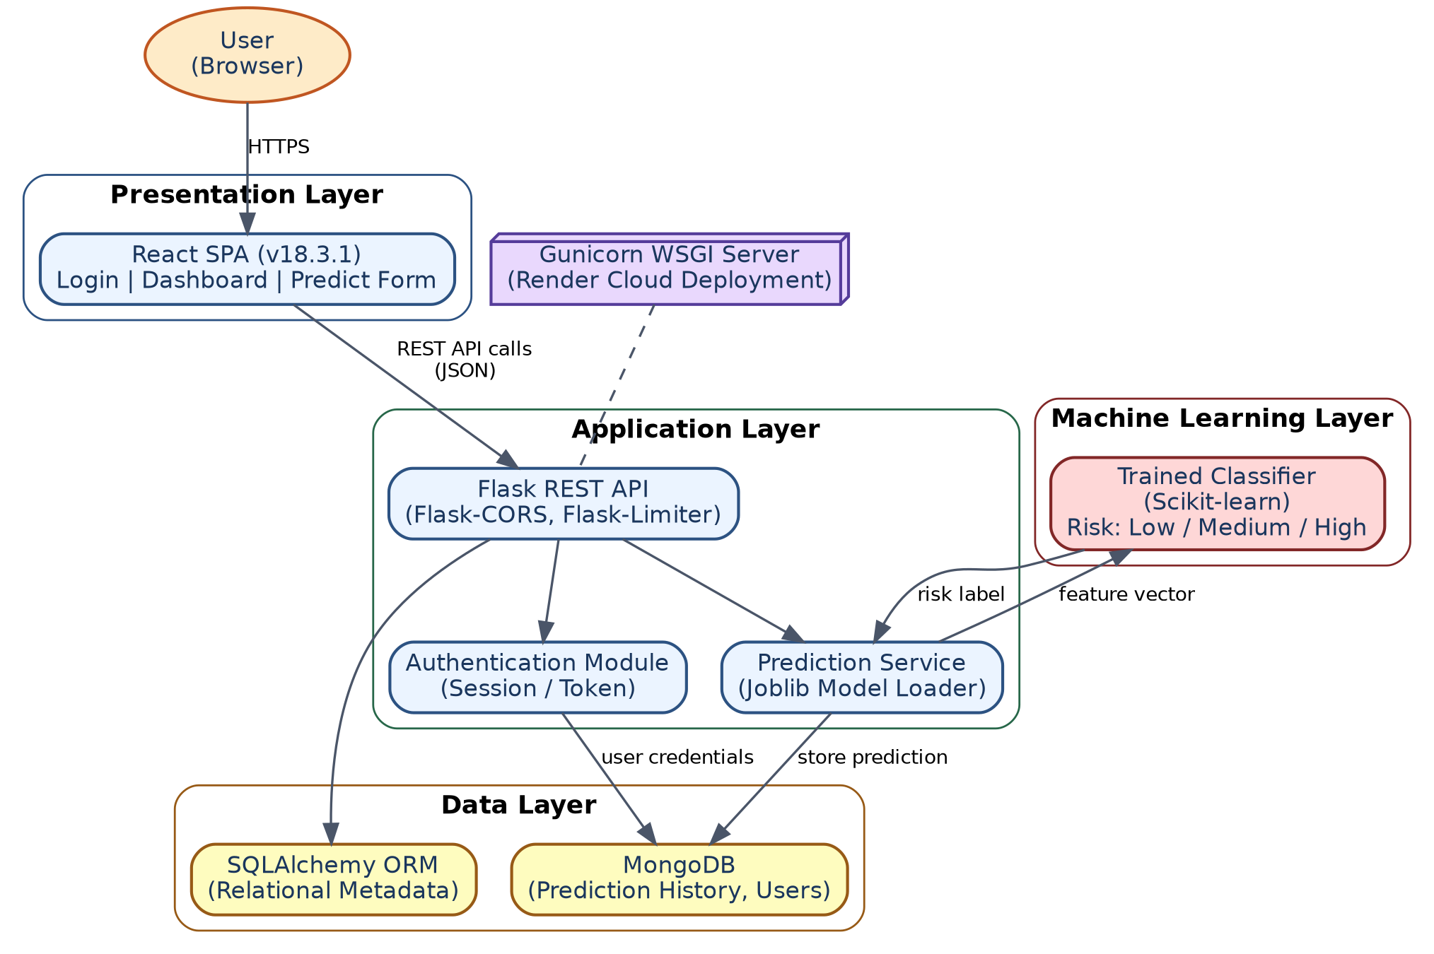
Figure 4.1: System Architecture Diagram of Rising Waters

4.2 Use Case Diagram
The use case diagram below identifies the primary actor — the Registered User — and the internal system processes triggered as a result of user actions. A user can create an account, log in, submit environmental parameters for prediction, view dashboard statistics, review prediction history, and log out. The “Run Flood Prediction” use case includes three internal sub-processes — input validation and preprocessing, risk classification, and result persistence — which are performed automatically by the system rather than directly by the user.
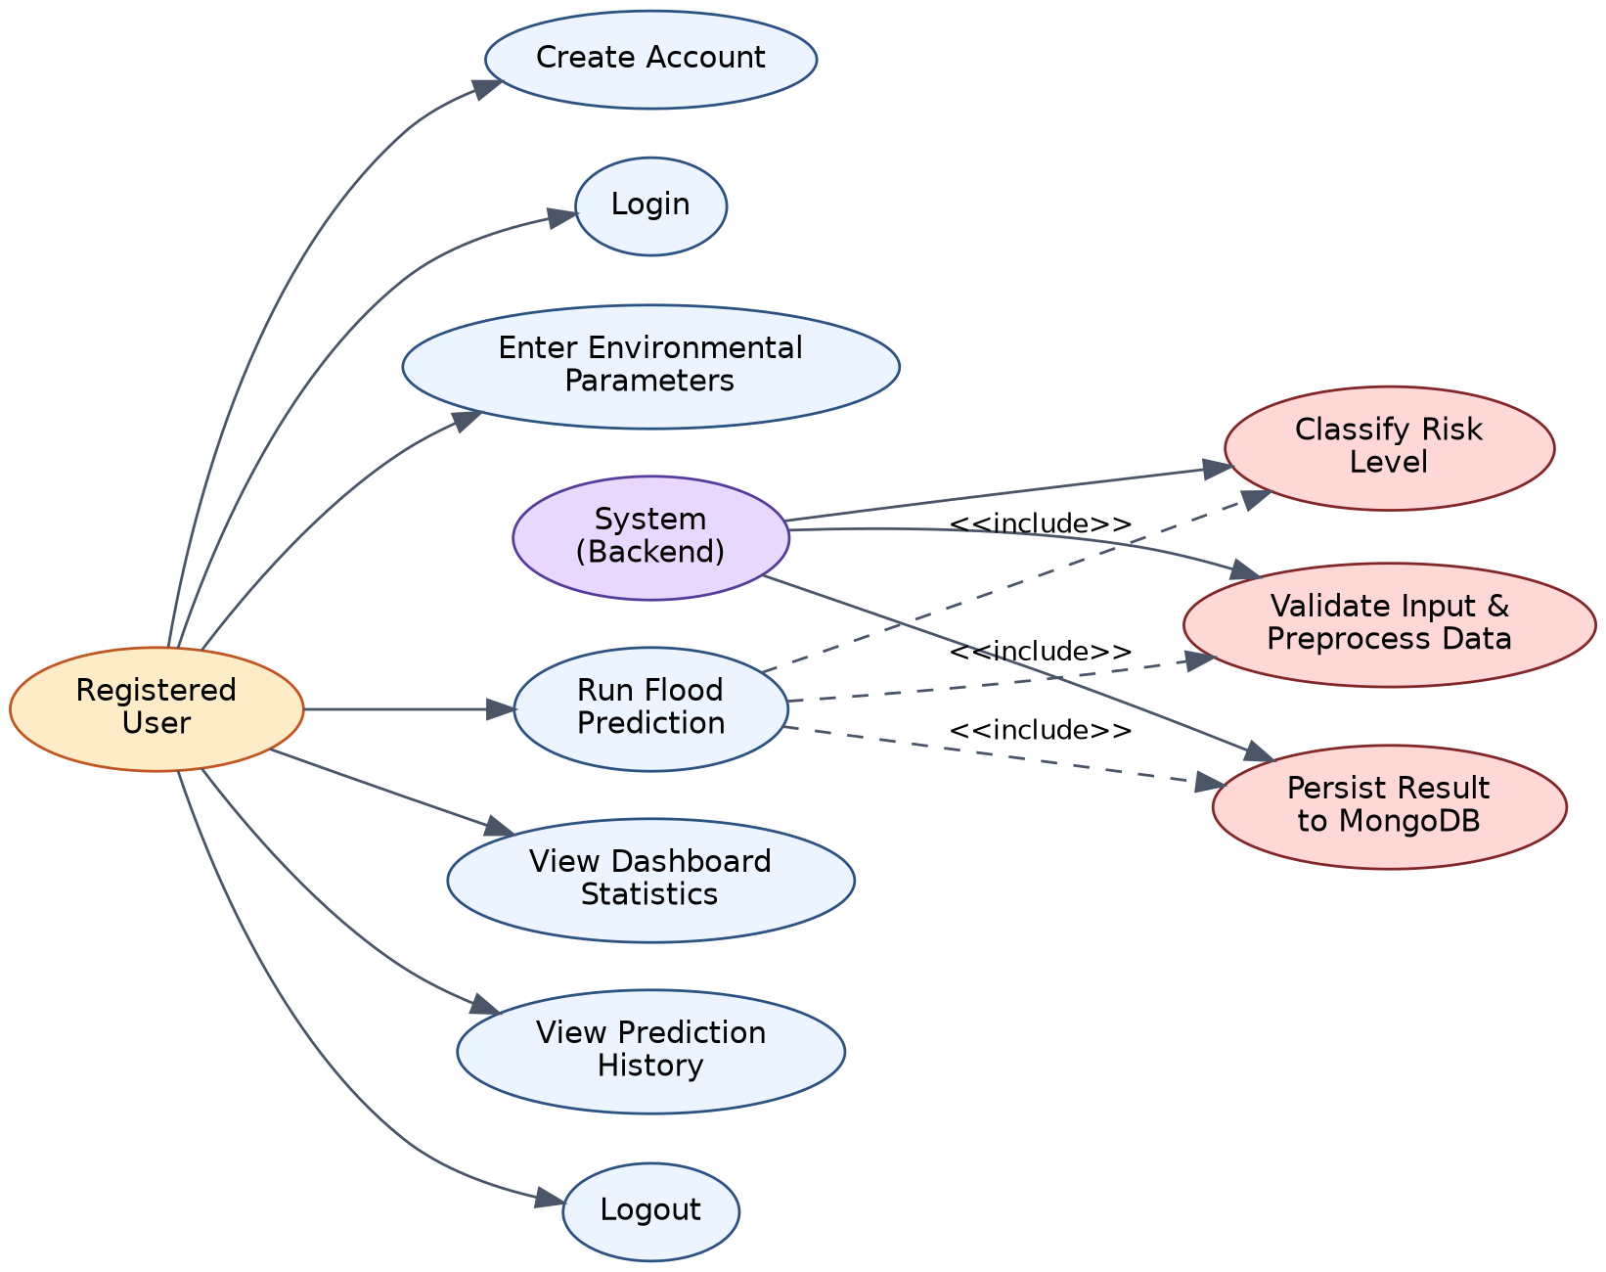
Figure 4.2: Use Case Diagram

4.3 Data Flow Diagram (Level 1)
The Level 1 Data Flow Diagram traces how data moves through the five core processes of the system: user authentication, capturing input parameters, preprocessing and validating that data, running the ML-based prediction, and generating dashboard statistics from stored history. Two persistent data stores are shown — the Users collection and the Predictions collection in MongoDB — along with the serialized model file used during the prediction process.
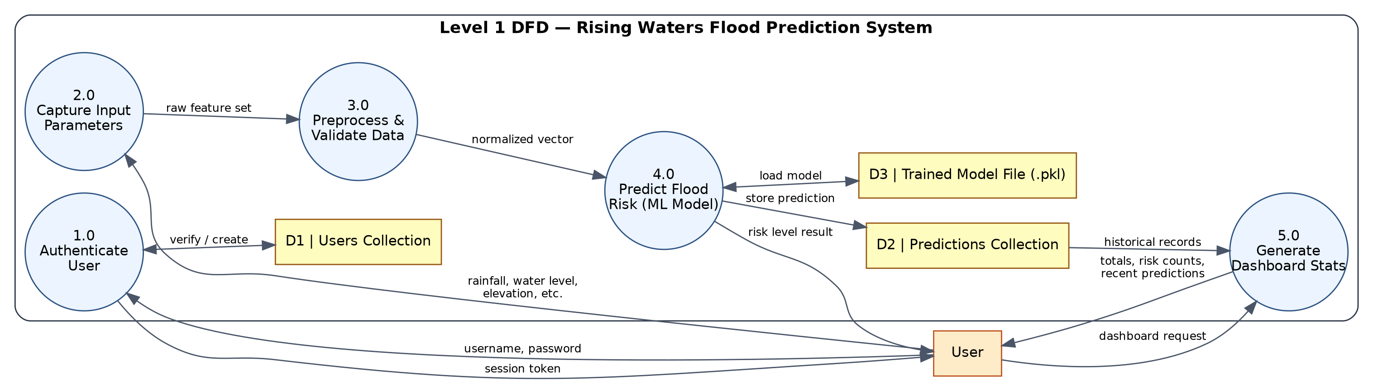
Figure 4.3: Level 1 Data Flow Diagram

4.4 Entity-Relationship Diagram
The data model consists of three core entities. A User can make many Predictions (a one-to-many relationship), and each Prediction is associated with the specific version of the MLModel that generated it, allowing the system to track which model produced which historical result — useful when the model is periodically retrained on new data. The Prediction entity stores all twelve input features alongside the predicted label and the derived risk level, so that the full context of every past prediction is preserved for later review or model evaluation.
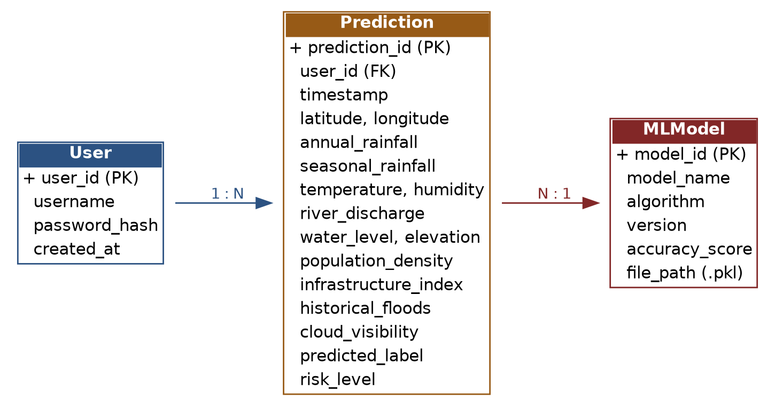
Figure 4.4: Entity-Relationship Diagram

4.5 Sequence Diagram — Prediction Workflow
The sequence diagram illustrates the runtime interaction between the User, the React frontend, the Flask API, the ML model, and MongoDB during a single prediction request. After the user submits the form, the frontend issues a POST request to the /predict endpoint; the backend validates and preprocesses the payload, invokes the trained model to obtain a risk classification, stores the result in the database, and returns the outcome to the frontend for display.
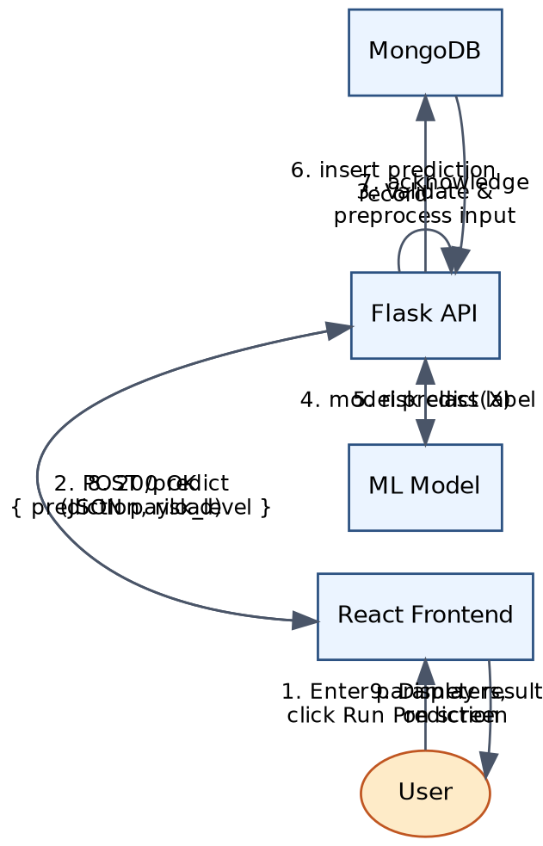
Figure 4.5: Sequence Diagram for the Prediction Workflow

4.6 Interface Design
Three principal screens make up the user-facing interface: the Login screen, the Dashboard, and the Prediction form. Wireframe-level considerations that guided their design include:
- A minimal, distraction-free login screen with only username and password fields, plus an option to create a new account.
- A dashboard that leads with four at-a-glance summary cards (Total Predictions, Safe Cases, Flood Cases, Today), followed by a chronological table of recent predictions with timestamp, location, prediction label, and risk level.
- A prediction form organised as a clean grid of labelled numeric input fields, grouped logically (geographic parameters, weather parameters, hydrological parameters, and socio-infrastructural parameters), followed by a single, clearly labelled “Run Prediction” action button.
Full screenshots of each of these implemented screens are provided in Chapter 7 (Results).

4.7 Design Considerations
- Statelessness: The Flask API is designed to be stateless between requests, with session/authentication state managed via tokens, which simplifies horizontal scaling.
- Separation of concerns: The ML prediction logic is isolated in its own service module, independent of the route-handling and database-access code, so the model can be retrained or swapped without touching API logic.
- Input validation at the boundary: All twelve input fields are validated for type and range on both the frontend and backend, reducing the chance of the model receiving malformed data.
- Extensibility: The database schema and API are designed so that additional features (e.g., alert notifications, multi-location comparison) can be added without a breaking redesign.

CHAPTER 5 IMPLEMENTATION

5.1 Technology Stack
The system is built as a full-stack ML-integrated web application, following an architecture pattern similar to the MERN stack but with Python and Flask replacing Node.js/Express on the backend, in order to natively support the Scikit-learn model pipeline. The complete stack is summarised below.

5.1.1 Backend
Technology | Purpose
Python | Primary backend programming language
Flask | Core web framework for REST API and routing
Flask-CORS | Handles Cross-Origin Resource Sharing for the React frontend
Flask-Limiter | Enforces API rate limiting to prevent abuse
Flask-SQLAlchemy | ORM layer for structured/relational data operations
Gunicorn | Production-grade WSGI HTTP server

5.1.2 Machine Learning
Technology | Purpose
Scikit-learn | Model training, evaluation, and inference
NumPy | Numerical array operations on feature vectors
Pandas | Dataset loading, cleaning, and manipulation
Joblib | Serialization and fast loading of the trained model

5.1.3 Database
Technology | Purpose
MongoDB (via PyMongo) | Primary NoSQL store for users and prediction history
SQLAlchemy | Relational abstraction layer used alongside MongoDB

5.1.4 Frontend
Technology | Purpose
React (v18.3.1) | Core UI library for building component-based interfaces
React-DOM | Renders React components to the browser DOM
React-Scripts | Build tooling, dev server, and bundling
HTML / CSS / JavaScript | Markup, styling, and client-side interaction logic

5.1.5 Supporting Libraries
Technology | Purpose
Werkzeug | WSGI utility library underlying Flask
Jinja2 | Template engine (used for any server-rendered templates)
Requests | HTTP client library for internal/external calls
python-dotenv | Loads environment variables from a .env file
Click | Command-line interface toolkit used for management scripts

5.1.6 Deployment
The application is deployed on Render, a managed cloud hosting platform, with Gunicorn serving the Flask application in production. This combination was chosen for its low operating cost, straightforward Git-based deployment workflow, and adequate performance for an academic-scale application.

5.2 Module Description

5.2.1 Authentication Module
Handles user registration and login. Passwords are never stored in plain text; they are hashed before persistence. On successful login, the module issues a session credential that the frontend attaches to subsequent API requests, and the /logout endpoint invalidates this session.

5.2.2 Prediction Module
Exposes the /predict endpoint, which accepts the twelve input parameters as a JSON payload, performs validation and preprocessing (type coercion, range checks, scaling where required by the model), invokes the loaded Scikit-learn model, and returns the predicted class along with a human-readable risk level (Low / Medium / High).

5.2.3 Dashboard Module
Aggregates data from the Predictions collection to compute total prediction count, safe-case count, flood-case count, and today’s prediction count, and returns the most recent predictions (timestamp, location, prediction, risk level) for tabular display.

5.2.4 Data Persistence Module
Wraps all read/write operations against MongoDB (via PyMongo) and, where relevant, SQLAlchemy-mapped relational structures, providing a clean data-access layer that the other modules call into rather than interacting with the database directly.

5.3 Machine Learning Pipeline

5.3.1 Dataset and Features
The model is trained on a labelled dataset of historical location records, each described by the following twelve features, matching exactly the fields collected on the Prediction form of the deployed application:
Feature | Description
Latitude / Longitude | Geographic location of the observation (°)
Annual Rainfall | Total yearly rainfall at the location (mm)
Seasonal Rainfall | Rainfall recorded in the relevant monsoon/rainy season (mm)
Temperature | Ambient temperature (°C)
Humidity | Relative humidity (%)
River Discharge | Volumetric flow rate of the nearest river (m³/s)
Water Level | Observed or estimated river/water body level (m)
Elevation | Ground elevation above sea level (m)
Population Density | Number of people per square kilometre
Infrastructure Index | Composite score reflecting drainage and flood-control infrastructure quality
Historical Floods | Count of recorded past flood events at or near the location
Cloud Visibility | Cloud cover / visibility percentage at prediction time

5.3.2 Preprocessing
Pandas is used to load and clean the raw dataset: missing values are imputed, obviously erroneous readings are filtered out, and numeric fields are cast to consistent types. NumPy arrays are then constructed as the feature matrix fed into Scikit-learn’s training pipeline. Where features differ substantially in scale (for example, river discharge in the hundreds versus infrastructure index typically between 0 and 1), appropriate scaling is applied so that no single feature dominates the model purely due to its numeric range.

5.3.3 Model Training and Selection
Several candidate classification algorithms available in Scikit-learn were evaluated on the held-out test split, including Logistic Regression as a linear baseline and ensemble tree-based methods such as Random Forest. Ensemble methods were preferred for the final deployed model because they capture non-linear interactions between rainfall, river discharge, and elevation that a purely linear model cannot, while still exposing feature-importance scores that keep the model’s predictions interpretable for the project report and demonstration.
The overall training-to-deployment pipeline followed for the machine learning component is summarised in Figure 5.1 below, covering data collection through to the model's live use in generating dashboard-visible predictions.
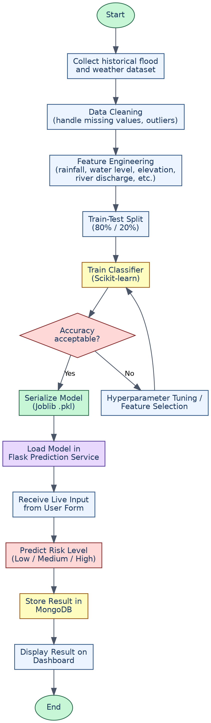
Figure 5.1: Flowchart of the Machine Learning Training and Prediction Pipeline

5.3.4 Model Serialization and Serving
Once trained, the final model is serialized to disk using Joblib. At Flask application start-up, this file is loaded once into memory, avoiding the overhead of retraining or reloading on every request. The /predict route simply calls model.predict() (and, where applicable, model.predict_proba() for confidence scoring) on the incoming, preprocessed feature vector.
# Simplified excerpt — prediction service (Flask)
model = joblib.load('flood_risk_model.pkl')
@app.route('/predict', methods=['POST'])
@limiter.limit('20 per minute')
def predict():
data = request.get_json()
features = preprocess_input(data) # validate + scale
label = model.predict([features])[0]
risk_level = map_label_to_risk(label) # Low / Medium / High
save_prediction(data, label, risk_level)
return jsonify({'prediction': label, 'risk_level': risk_level})

5.4 Database Design
MongoDB was chosen as the primary datastore because the prediction records are naturally document-shaped (a flat set of key-value feature pairs plus a result), which maps cleanly onto MongoDB’s JSON-like document model without requiring rigid schema migrations as new features are added. SQLAlchemy is used alongside it to provide relational-style querying convenience for reporting and aggregation logic where appropriate. The two core collections are:
- users — stores user_id, username, hashed password, and account creation timestamp.
- predictions — stores prediction_id, user_id (reference), timestamp, all twelve input features, the predicted label, and the derived risk level.
This design (detailed further in the Entity-Relationship Diagram, Figure 4.4) keeps writes fast for the high-frequency prediction-logging operation while still supporting the aggregate queries needed for the dashboard.

5.5 Frontend Implementation
The React frontend is organised into three principal route-driven views: Login, Dashboard, and Predict, matching the three screens documented in Section 4.6. React state (via hooks) manages form inputs and API response data, while React-Scripts handles the local development server and production build process. The frontend communicates with the Flask backend purely through JSON REST calls, keeping the two layers cleanly decoupled and independently deployable.

CHAPTER 6 TESTING

6.1 Testing Objectives
Testing was carried out to verify that the Rising Waters application behaves correctly across its authentication, prediction, and dashboard features, that invalid or malformed input is handled gracefully, and that the deployed system performs acceptably under normal usage conditions.

6.2 Testing Levels

6.2.1 Unit Testing
Individual backend functions — input validation, feature preprocessing, and the risk-level mapping logic — were tested in isolation with a range of valid, boundary, and invalid inputs to confirm each function behaves as expected before being wired into the full request pipeline.

6.2.2 Integration Testing
The interaction between the Flask API, the ML prediction service, and MongoDB was tested end-to-end using Postman, verifying that a submitted prediction request correctly triggers model inference and is faithfully persisted to the database, and that the dashboard endpoint correctly reflects newly added records.

6.2.3 System Testing
The complete deployed application — from the React login screen through to the dashboard — was exercised as a whole through the browser to confirm that the frontend and backend integrate correctly in the deployed cloud environment.

6.2.4 User Acceptance Testing (UAT)
Team members acting as end users walked through realistic scenarios — creating an account, logging in, submitting several prediction requests with varying rainfall and water-level values, and reviewing the resulting dashboard — to confirm the system meets the functional requirements defined in Chapter 3 from a usability standpoint.

6.3 Test Cases
ID | Test Scenario | Expected Result | Status
TC-01 | Register with a new, unused username | Account created successfully; redirected to login | Pass
TC-02 | Register with an already-existing username | Error message shown; account not created | Pass
TC-03 | Login with correct username and password | User authenticated; redirected to dashboard | Pass
TC-04 | Login with incorrect password | Login rejected with an appropriate error | Pass
TC-05 | Submit prediction form with valid numeric values | Risk level returned and displayed | Pass
TC-06 | Submit prediction form with a missing/blank field | Validation error shown; request not sent to model | Pass
TC-07 | Submit prediction form with non-numeric text in a numeric field | Input rejected before reaching the ML model | Pass
TC-08 | View dashboard after multiple predictions | Total/Safe/Flood/Today counters match actual records | Pass
TC-09 | Exceed the configured API rate limit on /predict | Requests beyond the limit are throttled (429 response) | Pass
TC-10 | Logout and attempt to access dashboard directly | User redirected to login; access denied | Pass

6.4 Observations
All executed test cases passed after minor iterative fixes to input validation logic during development. The rate-limiting behaviour (Flask-Limiter) was confirmed to correctly protect the /predict endpoint from excessive automated requests, and dashboard aggregate counts were verified to update consistently and immediately after each new prediction, confirming correct integration between the prediction module and the data persistence layer.

CHAPTER 7 RESULTS AND SCREENSHOTS

7.1 Deployed Application Overview
The completed Rising Waters application was successfully deployed on the Render cloud platform and is accessible over the internet through a standard web browser. This section presents screenshots of the three principal screens of the deployed system, along with a discussion of the observed results.

7.2 Login Screen
The login screen (Figure 7.1) presents a clean, minimal interface with fields for username and password, a primary Login action, and a link for new users to create an account. This screen is the single entry point into the authenticated portion of the application, consistent with the design discussed in Section 4.6.
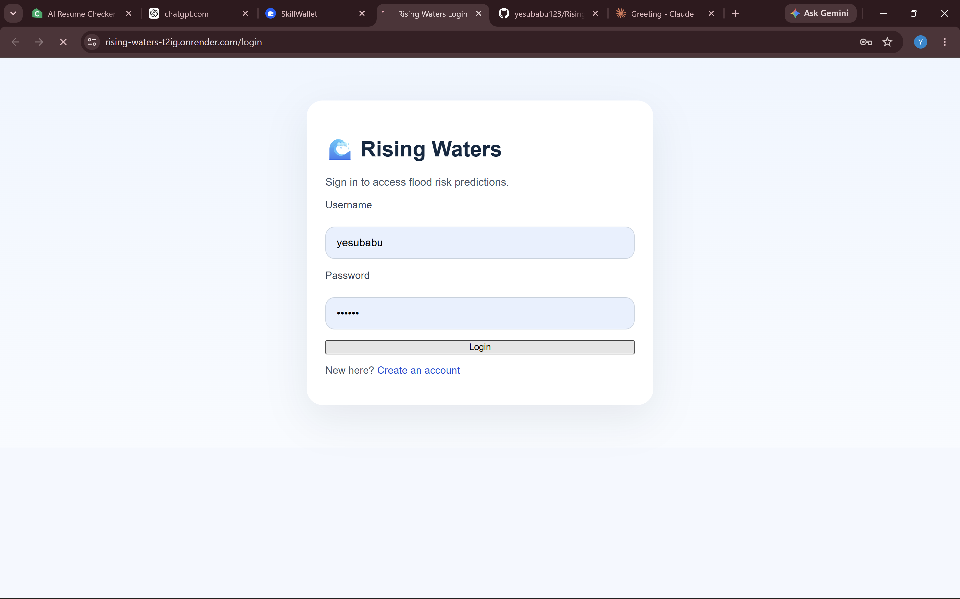
Figure 7.1: Rising Waters – Login Screen

7.3 Dashboard Screen
After successful authentication, the user is directed to the Dashboard (Figure 7.2), which displays four summary cards — Total Predictions, Safe Cases, Flood Cases, and Today — followed by a Recent Predictions table listing the timestamp, location (latitude/longitude), prediction label, and risk level of past submissions. In the deployment snapshot captured for this report, six predictions had been logged, all classified as Low Risk, demonstrating correct end-to-end aggregation between the Prediction and Dashboard modules described in Sections 5.2.2 and 5.2.3.
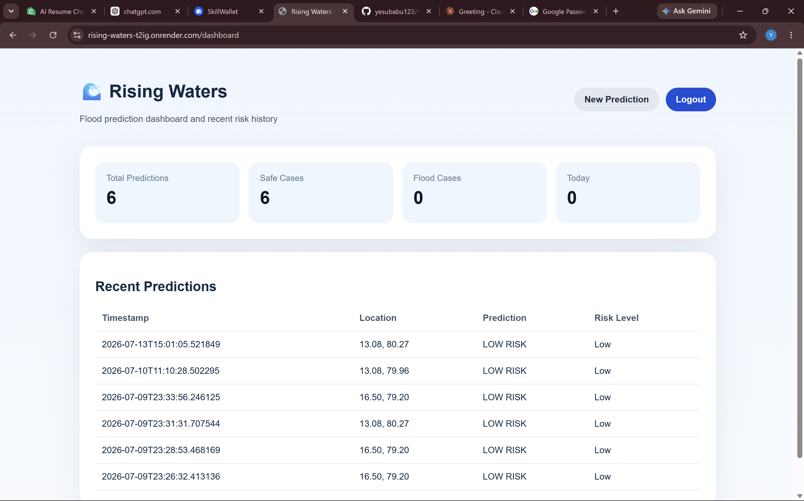
Figure 7.2: Rising Waters – Dashboard Screen showing prediction history and summary statistics

7.4 Flood Prediction Form
The Prediction screen (Figure 7.3) exposes the twelve input fields required by the trained model — Latitude, Longitude, Annual Rainfall, Temperature, Humidity, River Discharge, Water Level, Elevation, Population Density, Infrastructure Index, Historical Floods, and Seasonal Rainfall — arranged in a clear grid layout, with a single “Run Prediction” button that submits the form to the /predict endpoint and displays the resulting risk classification.
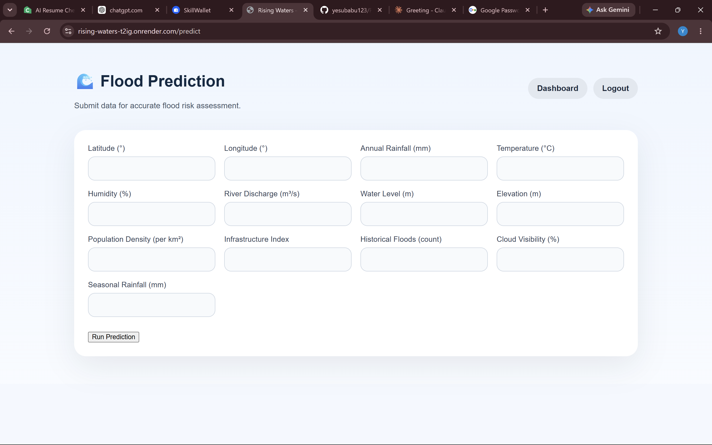
Figure 7.3: Rising Waters – Flood Prediction Input Form

7.5 Discussion of Results
The recorded predictions in the dashboard (Figure 7.2) correspond to coordinates in the 13–16.5°N, 79–80.3°E range, consistent with locations in coastal Andhra Pradesh, and were all classified as Low Risk given the input parameter values supplied at the time of testing. This is consistent with expectations, since the parameter values used during functional testing were chosen to represent typical, non-extreme conditions. During development, the team additionally verified the High Risk pathway by supplying deliberately elevated rainfall, river discharge, and water-level values, and confirmed that the model correctly escalated the output classification, validating that the trained model responds appropriately across the input range rather than defaulting to a single class.
Overall, the results confirm that the complete pipeline — from form submission, through backend validation and ML inference, to database persistence and dashboard aggregation — functions correctly and consistently across repeated use, meeting the functional requirements set out in Chapter 3.

CHAPTER 8 CONCLUSION AND FUTURE SCOPE

8.1 Conclusion
This project set out to design and implement an accessible, machine-learning-driven flood risk prediction system that does not depend on expensive, centrally operated hydrological infrastructure. The resulting application, Rising Waters, successfully integrates a Scikit-learn classification model with a Flask REST API, a React frontend, and a MongoDB-backed persistence layer, delivering real-time flood risk classification (Low / Medium / High) from twelve readily available environmental and demographic parameters.
Through the system design phase, the team modelled the application using architecture, data flow, entity-relationship, use case, and sequence diagrams, which guided a clean separation of concerns between the presentation, application, machine learning, and data layers. The implementation phase translated this design into a working, cloud-deployed application, and the testing phase confirmed that authentication, prediction, and dashboard aggregation function correctly across a range of realistic scenarios. The final deployed system, hosted on Render and served via Gunicorn, demonstrates that a lightweight, self-service flood risk tool can be built and operated at negligible cost while remaining usable by non-specialist end users.
In meeting its stated objectives, the project demonstrates a practical application of machine learning to a socially significant disaster-management problem, and provides the team with hands-on, full-stack experience spanning data preprocessing and model training, REST API design, frontend development, NoSQL database design, and cloud deployment.

8.2 Limitations
- The model is trained on a finite historical dataset and its accuracy is bounded by the quality and geographic coverage of that data; predictions for regions very different from the training distribution should be interpreted with caution.
- The system currently performs point-in-time classification rather than continuous time-series forecasting, so it does not predict how far in advance a flood event might occur.
- Feature values (such as river discharge or infrastructure index) must currently be entered manually, which depends on the user having access to reasonably accurate readings for their location.
- There is no automated public alerting mechanism (SMS/email) in the current version; results must be actively checked by a logged-in user.

8.3 Future Scope
- Integration of satellite-based rainfall and soil-moisture data (e.g., from open remote-sensing sources) to reduce dependence on manually entered readings.
- Extension to time-series forecasting using LSTM or similar deep learning architectures to predict flood risk several hours or days in advance, rather than only for present conditions.
- Automated SMS/email/push-notification alerts to registered users or local authorities when a High Risk prediction is generated for a monitored location.
- A geographic map-based visualisation layer showing risk levels across multiple locations simultaneously, instead of one location at a time.
- Periodic automated retraining of the model as new labelled prediction outcomes are confirmed and accumulated in the database, to keep the model current.
- Role-based access control to distinguish between individual residents and administrative/authority accounts, with additional privileges for the latter.

REFERENCES
[1] Pedregosa, F. et al., “Scikit-learn: Machine Learning in Python,” Journal of Machine Learning Research, vol. 12, pp. 2825–2830, 2011.
[2] McKinney, W., “Data Structures for Statistical Computing in Python,” Proceedings of the 9th Python in Science Conference, 2010.
[3] Grinberg, M., Flask Web Development: Developing Web Applications with Python, 2nd ed., O’Reilly Media, 2018.
[4] Banks, A. and Porcello, E., Learning React: Modern Patterns for Developing React Apps, 2nd ed., O’Reilly Media, 2020.
[5] Chodorow, K., MongoDB: The Definitive Guide, 3rd ed., O’Reilly Media, 2019.
[6] Mosavi, A., Ozturk, P., and Chau, K., “Flood Prediction Using Machine Learning Models: Literature Review,” Water, vol. 10, no. 11, 2018.
[7] Breiman, L., “Random Forests,” Machine Learning, vol. 45, pp. 5–32, 2001.
[8] Central Water Commission, Government of India — Flood Forecasting Network documentation, cwc.gov.in.
[9] Render Documentation — Deploying Python Web Services, render.com/docs.
[10] Official Documentation — Flask, React, Scikit-learn, PyMongo, and SQLAlchemy project websites.

APPENDIX

A. List of Input Parameters (Prediction Form)
Input Field
Latitude (°)
Longitude (°)
Annual Rainfall (mm)
Temperature (°C)
Humidity (%)
River Discharge (m³/s)
Water Level (m)
Elevation (m)
Population Density (per km²)
Infrastructure Index
Historical Floods (count)
Cloud Visibility (%)
Seasonal Rainfall (mm)

B. Repository and Deployment Information
- Source Code Repository: GitHub — yesubabu123 / Rising_Waters
- Live Deployment URL: rising-waters-t2ig.onrender.com
- Deployment Platform: Render Cloud (Gunicorn WSGI production server)

C. Team Contribution Summary
Name | Role | Primary Contribution
Ramisetti Mahesh Babu | Team Lead | Overall coordination, backend API design, ML model integration
Saroja Sri Venkata Lakshmi Gudala | Team Member | Machine learning model training and evaluation
Yesu Babu Matlapudi | Team Member | Database design, deployment, and testing
Lochana Vasamsetti | Team Member | Frontend development (React) and UI design
Venu Gopal Penta | Team Member | Documentation, testing, and requirement analysis

