SRI CHANDRASEKHARENDRA SARASWATHI VISWA MAHAVIDYALAYA
(UNIVERSITY ESTABLISHED UNDER SECTION 3 OF UGC ACT 1956)
ENATHUR, KANCHIPURAM – 631 561

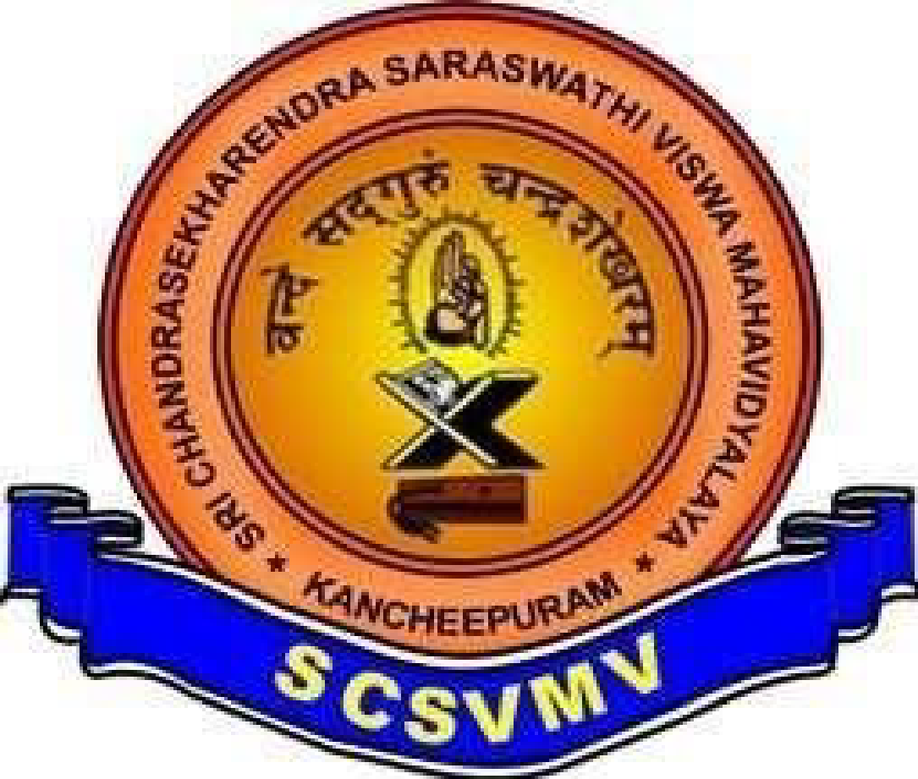
DEPARTMENT OF COMPUTER SCIENCE & ENGINEERING

Name: R .Yeswanth Sai
Reg. No: 11249M021
Class: [S7] II B.TECH-IT
Course Name: OOPS LEETCODE Problems

