**Breast Cancer Prediction and Comparative Analysis**

**INTRODUCTION**

Breast cancer is a major public health concern that affects millions of people globally. Female breast cancer is currently the most often diagnosed cancer globally, surpassing lung cancer. In 2020, an expected 2,261,419 new breast cancer cases were identified in women worldwide. Breast cancer tumors can be classed as benign or malignant. Fibroadenomas are solid, smooth, hard, non-cancerous (benign) lumps that do not spread throughout the body. They may be uncomfortable or painful, but they are not life-threatening. Ductal carcinoma in situ, invasive ductal carcinoma, inflammatory breast cancer, and metastasis are all malignant tumors, which are cancerous growths that can spread beyond the breast tissue and affect other body organs. The difference between benign and malignant breast cancers is critical because it influences the best course of therapy. Machine Learning (ML) can reliably determine the kind of tumor by analyzing massive volumes of data and extremely complicated patterns. In this article, we classified the topic as a Binary Classification problem and used four distinct classification algorithms, including support vector machines and random forests, to predict breast cancer based on patient data and imaging findings.

**Objective**

Breast cancer is a condition that is frequently discussed these days. It is one of the most widely distributed disorders. It is critical to detect the illness so that women may begin treatment as soon as possible. It is preferable to have an accurate and timely diagnosis. The major purpose of this research is to assist pathologists in predicting cancer types more quickly.

**DATASET ACQUISITION**

We conducted our research using the dataset from the University of Wisconsin Hospitals Madison Breast Cancer Database. The dataset's characteristics are calculated using a digitised picture of a breast cancer sample obtained by fine-needle aspiration. These qualities enable us to deduce the properties of the cell nuclei shown in the picture. Breast Cancer Wisconsin Diagnostic includes 569 occurrences (Benign: 357, Malignant: 212), two classes (62.74% benign and 37.26% malignant), and 11 integer valued features (-Id, Diagnosis, Radius, Texture, Area, Perimeter, Smoothness, Compactness, Concavity, Concave points). -Symmetry (fractal dimension).

|  |  |
| --- | --- |
| **FEATURES** | **DESCRIPTION** |
| Radius | It is the mean of distances from the centre to the points on the circumference |
| Texture | The standard deviation of the grey-scale values |
| Perimeter | Circumference of Tumour |
| Area | Area of the Tumour |
| Smoothness | It is the local deviation in radius |
| Compactness | Defined as [(perimeter^2)/area - 1] |
| Concavity | The gravity of concave portions on the silhouette |
| Concave points | Number of concave portions on the silhouette |
| Symmetry | A balanced and proportionate similarity that is found in two halves of an object |
| Fractal dimension | It is a characteristic parameter used to describe the irregular extent of coastline |

**Data Preprocessing**

When it comes to developing a machine learning model, data pre-processing is the first step that signals the start of the process. Typically, real-world data is imprecise, inconsistent, and erroneous (including mistakes and outliers), and it frequently lacks particular attribute values and trends. This is where data pre-processing comes into play: it helps to calm, format, and organize raw data, making it ready to use in machine learning models.

**Proposed System:**

Breast cancer detection is incredibly crucial in today's medical environment. Breast cancer is one of the most serious cancers that may affect women. Breast cancer (BC) has two types: benign (noncancerous) and malignant. Malignant cancer is described as a curable kind of cancer, but benign cancer is listed as an incurable condition. Changes in genes, intense pain, size and form, fluctuations in breast color (redness), and skin texture are all indications of breast cancer. Machine learning is used to make predictions. To diagnose breast cancer, many classification approaches are applied, such as Support Vector Machine (SVM) and Random Forest. These methods belong to the domain of supervised machine learning. These methods are used to predict the development of breast cancer. These algorithms' accuracy results are assessed.

**Proposed System Architecture:**

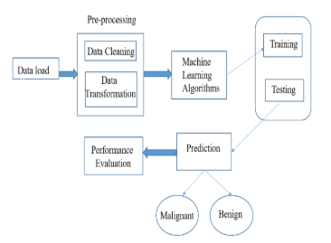

**LITERATURE REVIEW**

The author of [1] hypothesized that breast cancer may be predicted using a dataset obtained from the Wisconsin Breast Cancer repository. The data collection includes 569 data points and 30attributes. LogisticRegression's accuracy is around 96.5%.   
  
In [2], the author compares ML algorithms for breast cancer prediction. The article incorporates machine learning approaches such as decision trees and logistic regression. This research makes use of the WDBC dataset, which has 570 rows and 32 columns. According to the research, logistic regression provided 94.4% accuracy, but decision tree provided around 95.14% accuracy; hence, the decision tree method was chosen to provide more accurate predictions.

In [3], the author suggested work on detecting breast cancer risk factors using machine learning algorithms. The Support Vector Machine classifier is compared with the Naive Bayes.  
The Wisconsin diagnostic breast cancer dataset was used to make breast cancer predictions. The SVM method performed excellently, demonstrating accuracy up to 97.91% as opposed to the NB algorithm, which delivered 95.6% accuracy.

In [4], the author suggested work on Breast Cancer analysis using the K Nearest Neighbor method. The author employed KNN to predict breast cancer. The Manhattan distance with K = 1 produces an accuracy of around 98.40%, but the Euclidean distance with K = 1 produces a high accuracy of approximately 98.70%.

In [5] the author worked on an intelligent system employing SVM based classifier for predictive breast cancer detection and prognosis. Support vector machines (SVMs)-based classifiers outperform Bayesian classifiers and artificial neural networks for the diagnosis and prognosis of breast cancer sickness. The enhanced SVM method performed admirably, displaying high values for great significant to 96.91, specificity up to 97.67 percent, and sensitivity up to 97.84 percent.

**SYSTEM REQUIREMENTS:**

**HARDWARE REQUIREMENTS:**

* System: Pentium i5 Processor.
* Hard Disk: 1 TB.
* Monitor: 15’’ LED
* Input Devices: Keyboard, Mouse
* Ram: 16 GB

**SOFTWARE REQUIREMENTS:**

* Operating system: Windows 11.
* Coding Language: Python with ML.

**TEST RESULTS AND OUTPUT**

STEP-1: First we have to open our “main” in python idle

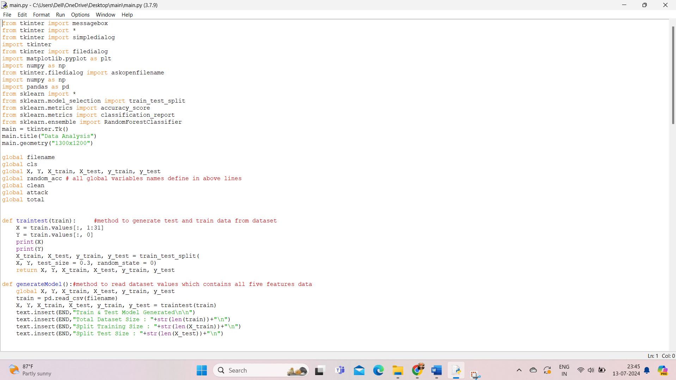

STEP -2 : Later we have to run the code then our main page will be as output

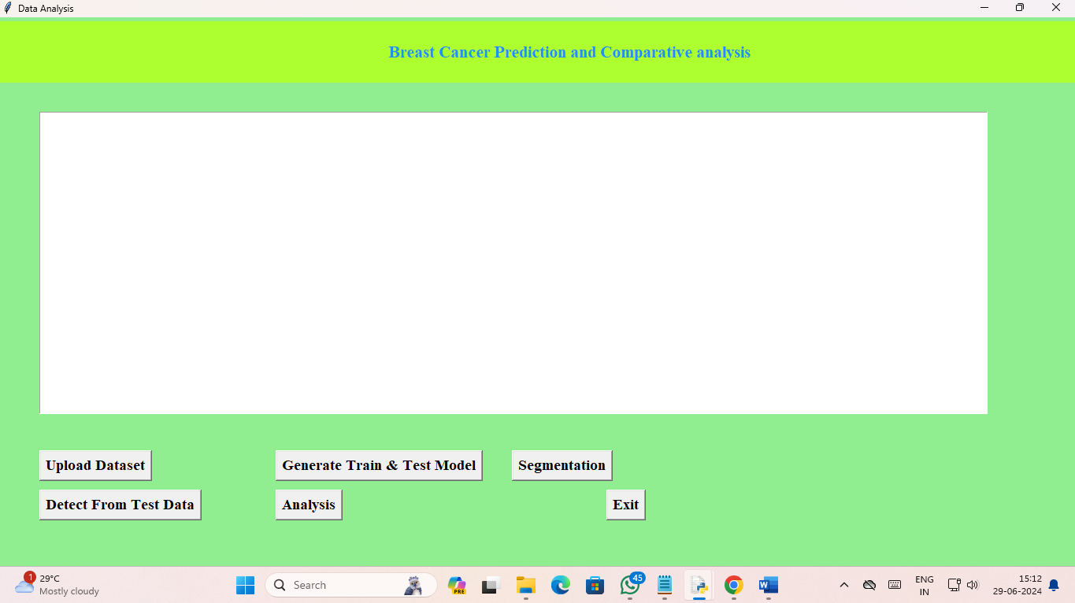

STEP- 3: Next, we must upload the data set which is “data_clean” for prediction.

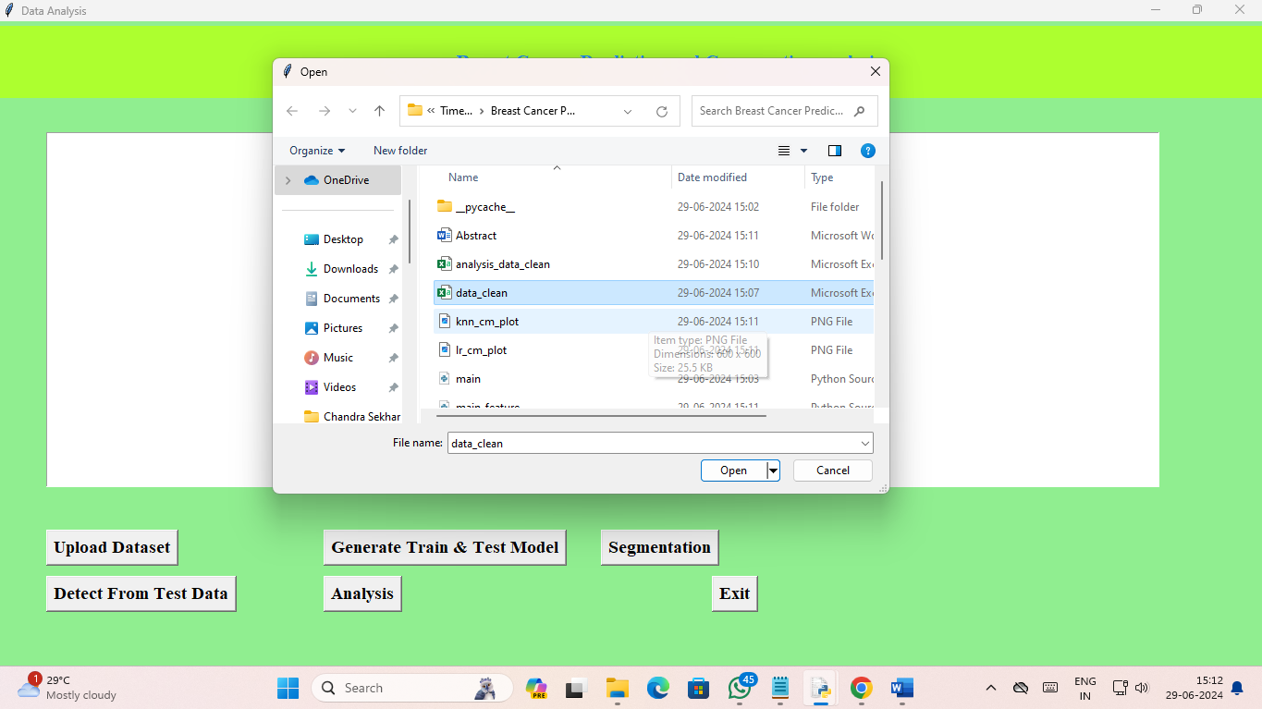

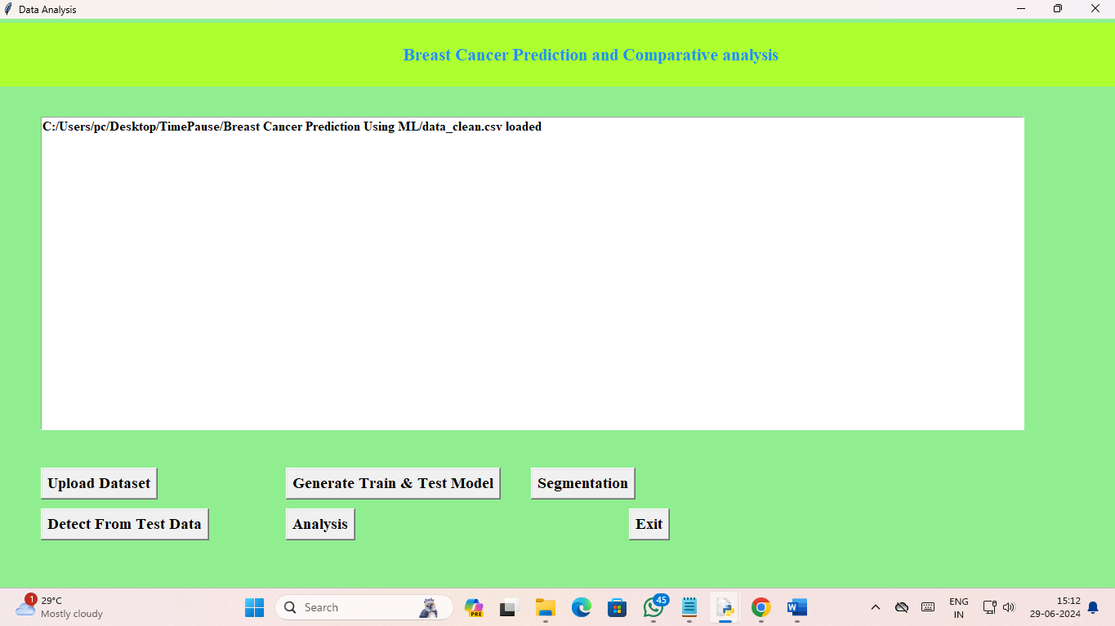

STEP- 4: In this step we split the Train test

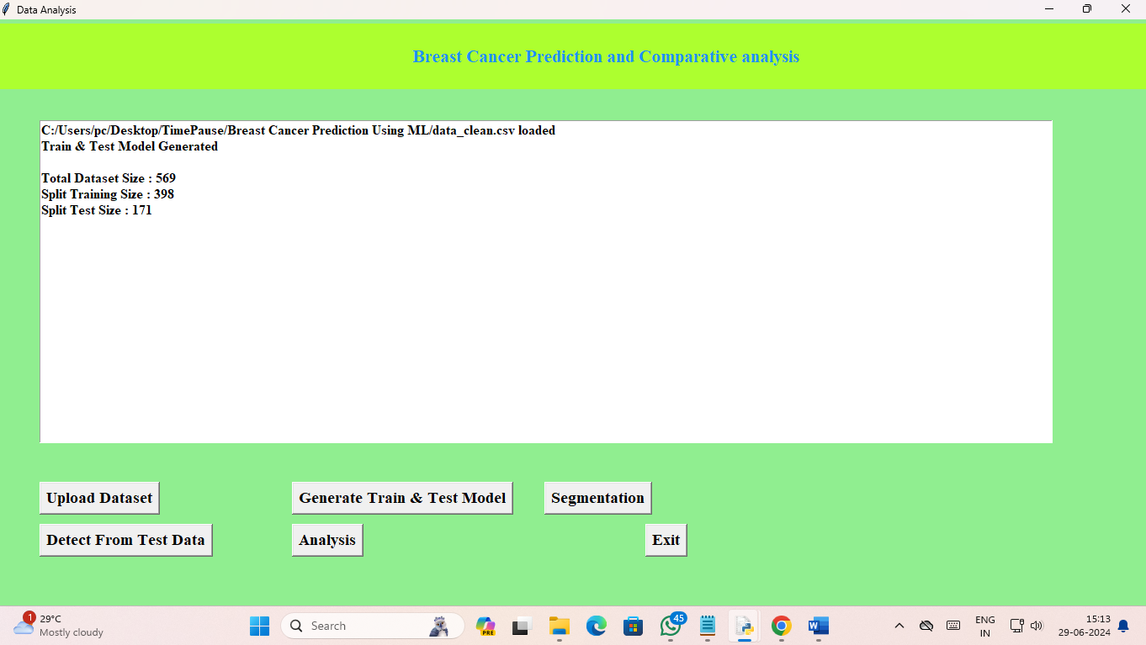

STEP – 5: The next step here is segmentation which we applied “Random Forest Classification”

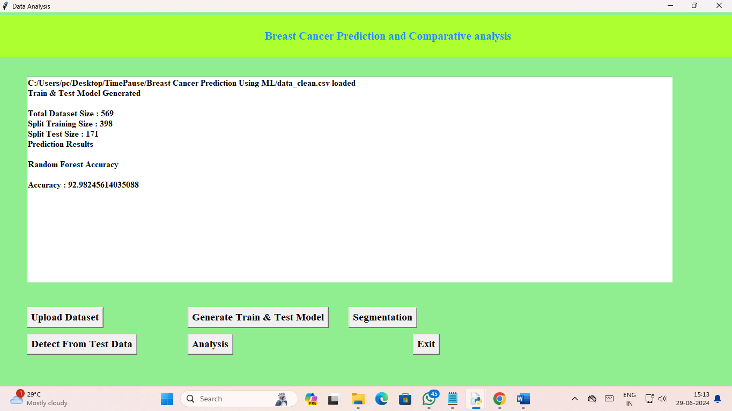

STEP – 6: Next step is “Detect from Test Data” means input the test sample which is “test.csv”

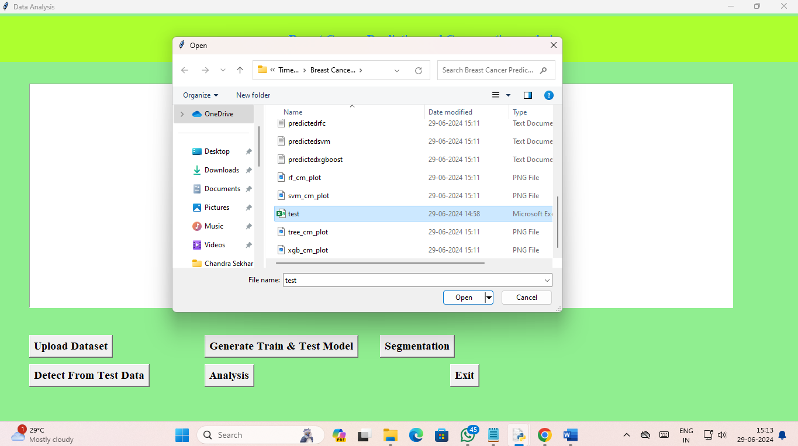

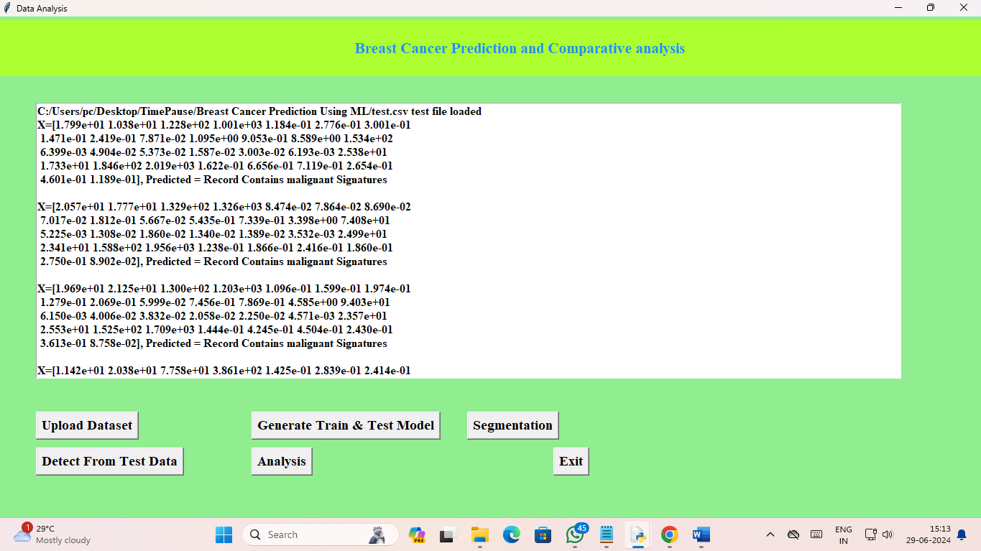

STEP-7: Next step is Analysis in this step we have used different machine learning algorithms such as “Random Forest Analysis”, “XG BOOST”, “SVM”, “KNN”, “DECISION TREE”, “LINEAR REGRESSION”

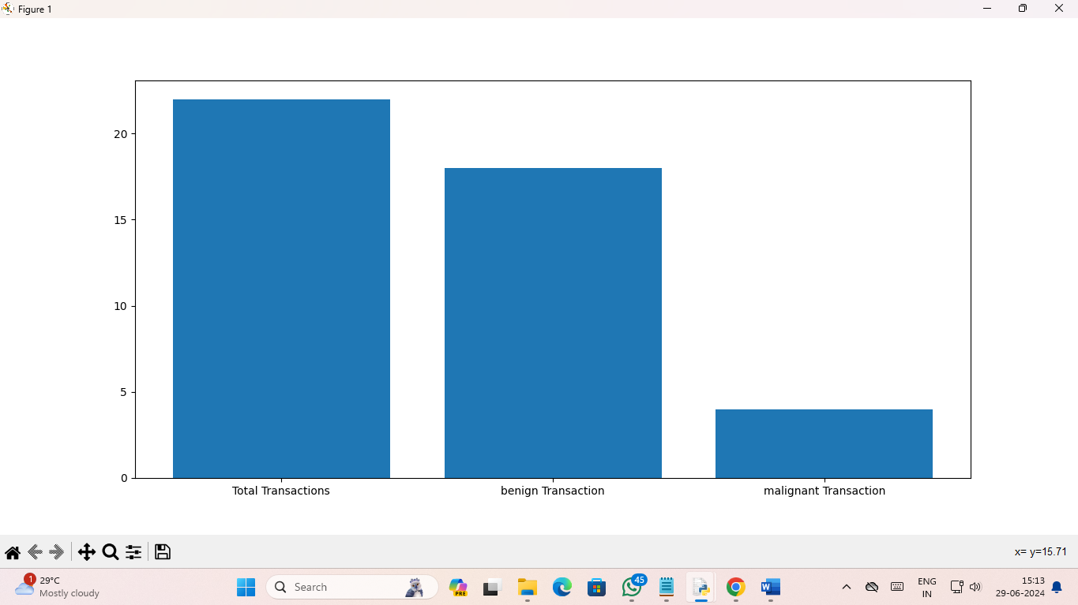

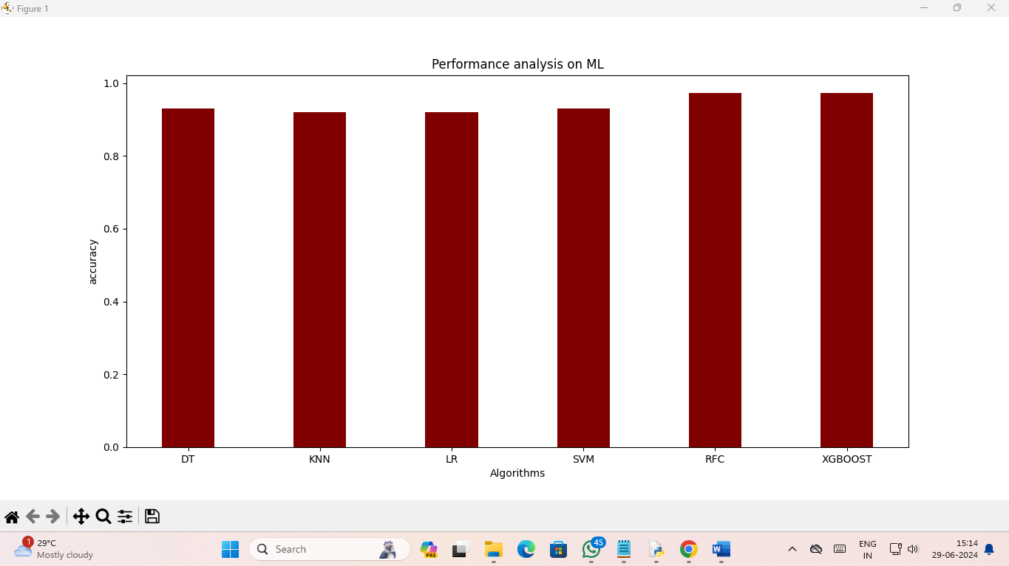

STEP-8: In this last step it shows the accuracy of our project with 6 different machine learning algorithms

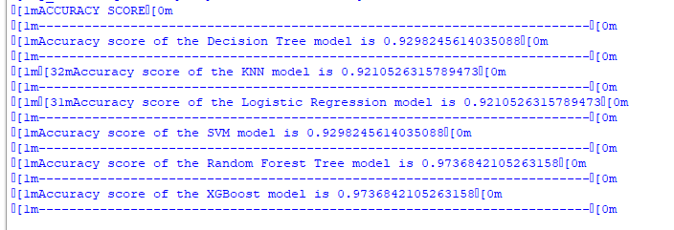

**CODE:**

from tkinter import messagebox

from tkinter import *

from tkinter import simpledialog

import tkinter

from tkinter import filedialog

import matplotlib.pyplot as plt

import numpy as np

from tkinter.filedialog import askopenfilename

import numpy as np

import pandas as pd

from sklearn import *

from sklearn.model_selection import train_test_split

from sklearn.metrics import accuracy_score

from sklearn.metrics import classification_report

from sklearn.ensemble import RandomForestClassifier

main = tkinter.Tk()

main.title("Data Analysis")

main.geometry("1300x1200")

global filename

global cls

global X, Y, X_train, X_test, y_train, y_test

global random_acc # all global variables names define in above lines

global clean

global attack

global total

def traintest(train): #method to generate test and train data from dataset

X = train.values[:, 1:31]

Y = train.values[:, 0]

print(X)

print(Y)

X_train, X_test, y_train, y_test = train_test_split(

X, Y, test_size = 0.3, random_state = 0)

return X, Y, X_train, X_test, y_train, y_test

def generateModel():#method to read dataset values which contains all five features data

global X, Y, X_train, X_test, y_train, y_test

train = pd.read_csv(filename)

X, Y, X_train, X_test, y_train, y_test = traintest(train)

text.insert(END,"Train & Test Model Generated\n\n")

text.insert(END,"Total Dataset Size : "+str(len(train))+"\n")

text.insert(END,"Split Training Size : "+str(len(X_train))+"\n")

text.insert(END,"Split Test Size : "+str(len(X_test))+"\n")

def upload(): #function to upload tweeter profile

global filename

filename = filedialog.askopenfilename(initialdir="dataset")

text.delete('1.0', END)

text.insert(END,filename+" loaded\n");

def prediction(X_test, cls): #prediction done here

y_pred = cls.predict(X_test)

for i in range(50):

print("X=%s, Predicted=%s" % (X_test[i], y_pred[i]))

return y_pred

# Function to calculate accuracy

def cal_accuracy(y_test, y_pred, details):

accuracy = accuracy_score(y_test,y_pred)*100

text.insert(END,details+"\n\n")

text.insert(END,"Accuracy : "+str(accuracy)+"\n\n")

return accuracy

def runRandomForest():

global random_acc

global cls

global X, Y, X_train, X_test, y_train, y_test

cls = RandomForestClassifier(n_estimators=50,max_depth=2,random_state=0,class_weight='balanced')

cls.fit(X_train, y_train)

text.insert(END,"Prediction Results\n\n")

prediction_data = prediction(X_test, cls)

random_acc = cal_accuracy(y_test, prediction_data,'Random Forest Accuracy')

def predicts():

global clean

global attack

global total

clean = 0;

attack = 0;

text.delete('1.0', END)

filename = filedialog.askopenfilename(initialdir="dataset")

test = pd.read_csv(filename)

test = test.values[:, 1:31]

total = len(test)

text.insert(END,filename+" test file loaded\n");

y_pred = cls.predict(test)

f = open("op1.txt", "a")

for i in range(len(test)):

if str(y_pred[i]) == '2.0':

attack = attack + 1

text.insert(END,"X=%s, Predicted = %s" % (test[i], 'Record Contains benign Signature')+"\n\n")

f.write(str("X=%s, Predicted = %s" % (test[i], 'Record Contains Signature')+"\n\n"))

else:

clean = clean + 1

text.insert(END,"X=%s, Predicted = %s" % (test[i], 'Record Contains malignant Signatures')+"\n\n")

f.write(str("X=%s, Predicted = %s" % (test[i], 'Record Contains malignant Signatures')+"\n\n"))

f.close()

def graph():

height = [total,clean,attack]

bars = ('Total Transactions','benign Transaction','malignant Transaction')

y_pos = np.arange(len(bars))

plt.bar(y_pos, height)

plt.xticks(y_pos, bars)

plt.show()

import main_feature

font = ('times', 16, 'bold')

title = Label(main, text='Breast Cancer Prediction and Comparative analysis')

title.config(bg='greenyellow', fg='dodger blue')

title.config(font=font)

title.config(height=3, width=120)

title.place(x=0,y=5)

font1 = ('times', 12, 'bold')

text=Text(main,height=20,width=150)

scroll=Scrollbar(text)

text.configure(yscrollcommand=scroll.set)

text.place(x=50,y=120)

text.config(font=font1)

font1 = ('times', 14, 'bold')

uploadButton = Button(main, text="Upload Dataset", command=upload)

uploadButton.place(x=50,y=550)

uploadButton.config(font=font1)

modelButton = Button(main, text="Generate Train & Test Model", command=generateModel)

modelButton.place(x=350,y=550)

modelButton.config(font=font1)

runrandomButton = Button(main, text="Segmentation", command=runRandomForest)

runrandomButton.place(x=650,y=550)

runrandomButton.config(font=font1)

predictButton = Button(main, text="Detect From Test Data", command=predicts)

predictButton.place(x=50,y=600)

predictButton.config(font=font1)

graphButton = Button(main, text="Analysis", command=graph)

graphButton.place(x=350,y=600)

graphButton.config(font=font1)

exitButton = Button(main, text="Exit", command=exit)

exitButton.place(x=770,y=600)

exitButton.config(font=font1)

main.config(bg='LightGreen')

main.mainloop()

**REFERENCES**

* S. Ara, A. Das, and A. Dey, "Malignant and Benign Breast Cancer Classification using Machine Learning Algorithms," 2021 International Conference on Artificial Intelligence (ICAI), 2021.
* Sultana, Jabeen, and Abdul Khader Jilani. "Predicting Breast Cancer Using Logistic Regression and Multi-Class Classifiers." International Journal of Engineering & Technology [Online], 7.4.20 (2018): 22–26. Web. November 30, 2019.
* P. Sathiyanarayanan, S. Pavithra, M.Sai Saranya, and M.Makeswari, "Identification of breast cancer using the Decision Tree Algorithm," 2019 IEEE International Conference on System, Computing, Automation, and Networking (ICSCAN), 2019.
* M.D. Bakthavachalam, Dr.S. Albert, and Antony Raj, "Breast Cancer Analysis using K-Nearest Neighbor Algorithm," 2020 International Conference on Artificial Intelligence (ICCS), 2020.
* Puneet Yadav et al. "Diagnosis of Breast Cancer Using Decision Tree Models and SVM", International Research Journal of Engineering and Technology, Vol. 5, Issue 3, March 2018.
* Medjahed, Seyyid Ahmed, Tamazouzt Ait Saadi, and Abdelkader Benyettou. "Breast cancer diagnosis by using knearest neighbor with different distances and classification rules."
* Kriti Jain et al. “Breast Cancer Diagnosis Using Machine Learning Techniques”, International Journal of Innovative Science, Engineering, and Technology, volume 5, issue 5, May 2018.
* Zheng, Bichen, Sang Won Yoon, and Sarah S Lam. "Breast cancer diagnosis based on feature extraction using a hybrid of Kmeans and support vector machine algorithms." Expert Systems with Applications 41.4 (2014): 1476–1482.