# REGULATORY REQUIREMENTS FOR CLINICAL TRIALS IN INDIA:

* Good research contributes to evidence-based medicine and thus better and improved patient care with the ultimate goal of promoting health. Research, however, is a laborious, time and labour intensive task that can take months or even years to reach fruition. Drug development research, in particular, is long and arduous and bringing a single new drug costs on an average USD 1.78 billion and takes approximately 13.5 years from discovery to the market. Drug development research is primarily funded by the pharmaceutical industry including the process of human testing (Phase I-IV studies). These studies (called clinical trials or regulatory studies) are conducted with the academician as the principal investigator largely in academic centres. The pharmaceutical industry funds or 'sponsors' the studies and ensures compliance with the country's regulatory requirements. Academicians, however, also carry out their own research and these studies are called as 'Investigator initiated studies' (IISs). Here, the academician raises funds for the study through his efforts from various sources including possibly the pharmaceutical industry. In these IISs, he dons the dual mantle of an investigator and 'sponsor' and thus directly becomes responsible for ensuring regulatory compliance.
* Anaesthesia as a speciality straddles several diverse disciplines that include various branches of surgery and medicine as well as critical care and pain management among others. The past three decades have also seen remarkable advances in the field of anaesthesia, some of which include pulse oximetry, end-tidal gas monitoring, introduction of propofol and the laryngeal mask airway. Anaesthesiologists are uniquely positioned to carry out translational research given the data-rich environment in which they practice and this research can be used successfully to guide evidence-based practice of the discipline as also public health policy. Regardless of the nature of the research (Regulatory Clinical Trials or IISs), knowledge of the regulatory requirements is an essential imperative for researchers.

1. THE NATIONAL REGULATORY BODY(CDSCO):

* The Central Drugs Standard Control Organization (CDSCO) is the National Regulatory Authority in India. Its equivalent counterparts elsewhere include the United States Food and Drug Administration (US FDA), Health Canada and the European Medicines Agency.
* CDSCO is an arm of the Ministry of Health and Family Welfare, Government of India. Its mission is to safeguard and enhance public health by assuring the safety, efficacy and quality of drugs, cosmetics and medical devices.
* The Drugs Controller General of India (DCGI) is an official of the CDSCO who is the final regulatory authority for the approval of clinical trials in the country.
* His ambit, in addition, also extends to inspections of trial sites, inspections of sponsors of clinical research and manufacturing facilities in the country, oversight of the Central Drugs Testing Laboratory (Mumbai) and the Regional Drugs Testing Laboratory as also heading the Indian Pharmacopeia Commission among various other roles, responsibilities and functions.

1. DEPARTMENT OF HEALTH RESEARCH AND THE INDIAN COUNCIL OF MEDICAL RESEARCH:

* The Indian Council of Medical Research (ICMR) is the apex body that is responsible for the formulation, coordination and promotion of biomedical research.
* It receives funding from the Ministry of Health and Family Welfare and the Department of Health Research, Government of India.

1. KEY DOCUMENTS IN CLINICAL RESEARCH:

### *(Drugs and Cosmetics Act (1940) and Drugs and Cosmetics Rules (1945))*

* This act first came into being in 1940 and regulates the import, manufacture and distribution of drugs in the country to ensure that drugs and cosmetics sold in the country are safe, effective and conform to essential quality standards.
* It has Chapters, Rules and Schedules[[6](https://www.ncbi.nlm.nih.gov/pmc/articles/PMC5372399/#ref6),[7](https://www.ncbi.nlm.nih.gov/pmc/articles/PMC5372399/#ref7)] and is amended at regular intervals to ensure greater safety, efficacy and drug quality.
* The Schedule Y along with rules 122A, 122B, 122D, 122DA, 122DAC and 122E (see below) is the key document that governs clinical research in the country. Per law, it is mandatory that all clinical research that falls under the ambit of Schedule Y complies with the necessary requirements.
* It has 12 appendices, formats for clinical trial protocols, informed consent forms, ethics committee (EC) approval templates and a format for serious adverse event (SAE) reporting.

1. ETHICAL GUIDELINES ON CLINICAL RESEARCH IN INDIA

The revised ICMR guidelines released in 2006 is called the 'Ethical Guidelines for Biomedical Research on Human Participants' and remains valid as of today, and a revised version is expected in 2017. This guideline covers two broad aspects of clinical research – the general principles that need to be followed and guidance regarding special areas of research (e.g., research in children or herbal research). Researchers are expected to be familiar with both these documents and abide by the requirements in the former and the guidance in the latter.

1. CLINICAL TRIALS REGULATIONS INDIA:

What would possibly happen if all the drugs and vaccines are removed altogether from our world? Quite intimidating. Ebola, Aids, Swine flu... all will feed voraciously on the human population. To stop them we need medicines; good and improved medicines. But how could we do that? Significance of Medical Research and Clinical Trials should be seen under this perspective. Drug development is a process that calls for utmost care.  
A clinical trial in simple terms can be defined as a set of practice that helps certify a new drug molecule as safe and efficacious before reaching the market.  
In fact "any research study that prospectively assigns human participants or groups of humans to one or more health-related interventions to evaluate the effects on health outcomes" can be defined as a clinical trial.  
Clinical interventions include drugs, cells and other biological products, surgical procedures, radiologic procedures, devices, behavioral treatments, process-of-care changes, preventive care. To determine the safety and efficacy of drug research on humans is always warranted, but one needs to be cautious and vigilant as to how the players in this field undertakes the process. Adherence to the principles of good clinical practices or GCPs, including adequate human subject protection universally recognized as a critical requirement to the conduct of research involving human subjects. Most countries have adopted good clinical practice principles as laws or regulations. In India, compliance with GCP guidelines issued by the Central Drugs Standard Control Organization or the CDSCO is recommended.  
This article aims to give a brief outline of the Indian scenario regarding Clinical Trial initiation, current regulatory framework and its effectiveness in reality.

1. **DRUGS AND COSMETIC RULES**

New chemical entities cannot be administered to human subjects in a clinical trial without permission from the Drugs Controller General of India. Such permission may be obtained by submitting to the DCGI an application for a clinical trial. The application must include a protocol for the study, a draft of the Informed Consent Document, a list of proposed investigators who have agreed to participate in the study, and background information about the drug in accordance with Schedule Y of the Drugs & Cosmetics Rules.  
It takes almost 12 weeks to obtain permission for a clinical trial for most investigatory drugs. The duration may be longer for drugs with special significance to the healthcare concerns of the country or those that may be considered controversial since these are liable to be referred to the Indian Council of Medical Research for comments.

1. **ICMR**   
   The ICMR guidelines for clinical trials mandates setting up of Ethics Committees or EC's at the institutional levels, for the purpose of scrutinizing and approving a clinical trial before it begins; and to to conduct periodic reviews of the progress of the trial. Ethics Committees are not merely ethics advisors and facilitators of clinical trials. They not only reflect on ethical aspects of research, but also play the role of ethics regulator for the DCGI. Their power to conduct ethics review, including the power to reject trials not conforming to ethical standards laid down in the ICMR's ethical guidelines, flows from the legal requirement wherein the DCGI provides clearance to clinical trials only on the condition that they will be reviewed and certified by an EC. Also, approval by the Ethics Committee is not a necessary precondition for regulatory permission to conduct a clinical trial provided the applicant submits an undertaking that the study will not be initiated at individual sites without prior EC approval.   
     
   An example to show the gravity of administrative irregularity in this area is the official statistics published by the Indian Council of Medical Research itself. In 2002, the ICMR conducted a survey of 149 ICMR-supported ongoing clinical research/trials in 71 institutions but interestingly, despite ICMR being the funder, only 36 institutions responded. While all 36 claimed to have institutional ethics committees in place, only 23 had standard operating procedures for their review functions and only 14 claimed that they had trained IEC members in research bioethics. Besides, of the 149 research projects analyzed in this study, only 107 (72%) researchers had furnished IEC clearance certificates. This data alone gives proof that despite the presence of broad guidelines and means of its enforcement, India lacks proper regulatory mechanism to put them in force.

Ironically, though the DCGI fully depends on ECs for implementing ethical standards in clinical trials, there is absolutely no direct linkage of any kind between the DCGI and ECs. The DCGI neither cares for the proper functioning of ECs nor assures their competence as these tasks are left to institutions which have a direct interest in trials.   
Further, ECs do not report to an independent public authority that is responsible for supervising these committees and ensuring their proper and competent functioning. Nor is their expenditure financed by public funds. Thus they are, in reality, either self-sufficient private bodies obliged to the institutions or independent private entities charging for their services. There is no transparency of their functioning and no public scrutiny of their review and regulation of clinical trials. So, despite a substantial period after forming the EC's in India, it still remains an enigma.

**9. Informed consent**

Is an essential requirement of medical trials, which denotes that the patient undergoing treatment as part of the study should be made aware of the trial being conducted, the drugs being administered on him and its possible side effects. But the country has, at several instances witnessed gross violations of human rights and ethical values while conducting trials on volunteers enrolled in studies. In 1999, without obtaining consent of the patients who were under treatment in the government-run Regional Cancer Centre in   
Similarly, in 2002, the pharma giant Novo Nordisk conducted multi-centre phase III clinical trials of a diabetes drug even before receiving the results of animal studies. The study report found that the drug, ragaglitazar, caused urinary bladder tumors in rats; and this should have been known before the drug went for phase I trials. In 2003, Mumbai-based Sun Pharmaceutical Industries Ltd. launched a promotional-cum-research programme by getting private doctors to prescribe the anti-cancer drug Letrozole to more than 400 women as a fertility drug for ovulation induction. The company then publicized the doctors' reports to other doctors as "research", using their network of medical representatives. The drug was prescribed despite the fact that it was known to be toxic to embryos.  
  
These are only a few of the numerous shocking human rights violations that have been exposed in the area of clinical trials. These instances throws light on the lacunae in the   
Another flaw in the Indian healthcare regulation is the lack of consistency in the licensing procedure. Currently, the interpretation and enforcement procedure varies from one state to another. This variation in procedures creates little accountability, in case an issue arises. At the same time, attempts by the Central government to create a Central Drug Authority is highly appreciable. Such a move gains significance in the context that the US and European drug giants are increasingly outsourcing their clinical testing to the rapidly developing economies like China, India and Africa.

1. **ISSUES AND CHALLENGES**

Challenge 1: Lack of Public Participation in Clinical Research

The research participants give consent to participate in a clinical study after being fully informed about the study. They are the heart of the clinical research enterprise. Given the stringent regulatory requirements, the number of patients per study is increasing. There is a need to go beyond the bastions, hence the focus is on India. Currently very few eligible patients are aware that they can participate in research studies and recruitment is often difficult and resource-intensive.

Challenge 2: Lack of Awareness and Education about Clinical Research

Awareness may be defined as having the perception or knowledge of an event. In a subject recruitment context, awareness suggests that patients can be recruited for a clinical trial only if they have knowledge of it. Research indicates that lack of awareness of clinical trials is a key reason why potential patients do not participate.

Challenge 3: Lack of an Adequately Trained Workforce

Clinical research requires the expertise of many kinds of investigators, including physicians, dentists, public health workers, research nurses, raters, psychologists, laboratory technicians, dieticians, computer programmers and others. With the growing need of clinical research participants, there is a shortage of adequately trained workforce.

Challenge 4: Training in Clinical Research

Clinical research training is an important issue given the gap between supply and demand for trained professionals in India. To foster expertise in clinical research, organizations have started training their employees on ICH-GCP Guidelines and Company Policies, then exposing them to hands-on training in their respective departments: clinical operations, data management, regulatory, study drug management or quality assurance. Until recently, there were no structured, formal training courses focusing on clinical research.

Challenge 5: Regulatory Hurdles

All clinical trials in India are carried out under Schedule Y (Appendix 5) of the Drugs and Cosmetics Act of 1940 (Act) and the Drugs and Cosmetics Rule of 1945 (Rule). Both pieces of legislation have been amended several times over the years, the most recent amendments to both were in June 2005. A Sponsor needs to file an Investigational New Drug (IND) with the Central Drugs Standard Control Organization (CDSCO). A clinical trial cannot be initiated until written permission from the chief of CDSCO; the Drugs Controller General India (DCGI) has been issued to the sponsor.

Challenge 6: Ethical Issues

Ethical issues include incorporating the national and international ethical principles, human subject protection issues and proper functioning of EC. It is responsible for safeguarding the dignity, rights, safety and wellbeing of all trial participants.

1. **THE BENEFITS OF PARTICIPATING IN CLINICAL TRIALS**

(1) If person have a disease that cannot be treated with an existing drug or regimen, participation might provide you with a successful treatment before it becomes available to others and have the opportunity to access cutting edge biomedical innovation which could be life saving and improves health outcomes.

(2) The global clinical development programs are an opportunity for physicians and medical Students to improve their skills by conducting research in accordance with international standards.

(3) Indian hospitals receive reimbursements for participating in clinical trials, which will benefit all patients served by that hospital for example; Pfizer has donated a $100,000 bone density testing machine to each of six hospitals testing its osteoporosis drug.

(4) Enhance the clinical practice of evidence based medicine, through record keeping and better patient communication by exposure of the Indian health care system to the discipline of international clinical research.

(5) Economic interests will encourage India’s regulatory authorities to clarify the rules, expand their resources, and improve skill levels.

(6) Participating in clinical trials also gives physicians a chance to be on the cutting edge of new technologies and scientific developments that open their eyes to medical innovation and encourages scientific thinking.

(7) Clinical research creates employment for site personnel, study monitors, and ancillary services, with an economic impact on the whole community.

(8) The drugs and protocols offered during clinical trials are often provided at no cost to participants. Patients who have trouble affording the drugs or treatment they need may consider enrolling in a clinical trial in order to access the protocols that may help them.

(9) Some patients have no alternatives for treatment and permanent debilitation or deaths are imminent. In such cases, participation in a clinical trial may give them hope or possibilities that do not exist otherwise.

(10) Many drugs, devices and therapies have previously been tested on white men, and found safe and useful. Fewer trials have been designed and run for women, minorities, or children. Participation in a trial that broadens the use of a good drug for one of these less tested groups is useful to humanity.

**12. THE RISKS OF PARTICIPATING IN CLINICAL TRIALS**

(1) There may be unpleasant side effects or outcomes, may last only a short time, or they may affect you for the rest of your life.

(2) Patients do not know whether they are receiving the experimental drug or treatment, or a previously approved drug or treatment, or even a placebo (a dummy treatment). Therefore, if the reason you decide to participate is because you hope to try a treatment that is not yet publicly available, you usually have, at best, a 50% chance of receiving that treatment.

(3) The treatment being studied may have no positive effect, either because you aren't really receiving the treatment being studied and the treatment isn't appropriate to help you.

(4) The long time and attention required of participants involved. It may require hours of testing, miles of travel, hospital stays or complicated dosing.

(5) New doesn't always mean better.

* **Why and How India Became a Favourable Destination for Clinical Trials?**

1. Global share of CTs in India

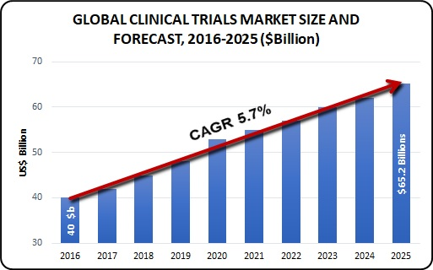

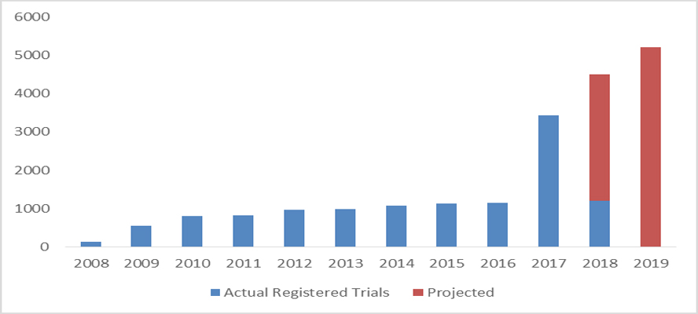

1. % of registered trials

