


Dissertation Title: Vision Based Grasp Point Detection for Deformable Cable Manipulation in Robotic Systems

Master title:

Name:

Year:

ABSTRACT

This dissertation will focus on using vision to detect grasp point for the deformable manipulation of cable by robot system. It proposes and implements a pipeline of perception to candidate which involve segmentation, centreline reasoning, grasp-candidate generation and feasibility scoring. The empirical evaluation was carried out based on a reproducible cable sample of WireSeg-36K and a real-image cable sample of TUM with S1/S2 as the adaptation set and S3 as the test set. The overall transfer performance of the WireSeg route was not good, with F1 score 0.059 for the Otsu morphology, F1 score 0.115 for the weighted Tiny U-Net and F1 score 0.019 for the published FASTDLO checkpoint. It was more for the real-image TUM route. It was found that the TUM fine-tuned Tiny U-Net could achieve a F1 of 0.605 and FPS of 72.68 on S3, and the adapted FASTDLO ResNet-101 could get the best segmentation results with Precision 0.714, Recall 0.836, F1 0.769 and IoU 0.625, albeit at a lower FPS of 4.40. The results show that dataset alignment and dataset adaptation had a greater impact than the model reputation, and that accuracy should be taken into account in addition to latency. The study offers a framework to be reproduced based on the evidence of the perception and readiness of the grasp-candidates, and differentiate between image level evidence and untried physical robot grasp success.

CONTENTS

Abstract 2
Contents 3
List of Tables 4
List of Figures 5
List of Abbreviations 6
Acknowledgements 7
Declaration 8
Dissertation Thesis 9
Introduction 10
0.1 Background and Research Context 10
0.2 Aim, Objectives and Research Questions 11
0.3 Structure of the Dissertation 12
Chapter One - Literature Review I 14
1.1 Deformable Linear Objects and Robotic Manipulation 14
1.2 Vision, Representation and Shape Estimation 16
1.3 Grasp Planning, Robustness and Research Gap 17
1.4 Critical Synthesis and Dissertation Gap 18
1.5 Link Between Literature Gap and Research Questions 19
Chapter Two - Literature Review II 21
2.1 Vision Pipeline Design 22
2.2 Grasp Pose Output and Manipulation Constraints 24
2.3 Evaluation Levels and Critical Limits 25
2.4 Architecture Requirements for the Proposed System 26
2.5 Implications for the Dissertation Design 27
Chapter Three – Methodology 29
3.1 Methodological Route 29
3.2 Experimental Design and Data Route 30
3.3 Candidate Scoring and Metrics 32
3.4 Reliability, Validity, Ethics and Limitations 33
3.5 Data Analysis Procedure 34
3.6 Quality Gates and Research Boundaries 35
3.7 Reproducible training and evaluation controls 35
Chapter Four - Findings / Analysis / Discussion 37
Conclusion 38
Bibliography 39
Appendix A - Experimental Evaluation Protocol 41

List of Tables

Table 0.1: Research objectives, questions and evidence plan
Table 1.1: DLO manipulation challenges and implications
Table 2.1: Pipeline stage risks and controls
Table 3.1: Experimental metrics and evidence levels
Table 3.2: Chapter Four evidence gate
Table 4.1: Measured segmentation and inference results across datasets and models
Table 4.2: Bootstrap uncertainty for the adapted FASTDLO ResNet-101 model on TUM S3
Table 4.3: Research-question evidence map for the final evaluation

List of Figures
Figure 0.1: Problem scope for vision-based grasp point detection
Figure 1.1: DLO manipulation challenge taxonomy
Figure 2.1: Proposed vision-based grasp-point detection pipeline
Figure 3.1: Experimental evaluation design
Figure 3.2: Grasp candidate scoring logic
Figure 4.1: Weighted Tiny U-Net output on a held-out WireSeg image
Figure 4.2: Published FASTDLO checkpoint output on a held-out WireSeg image
Figure 4.3: TUM-fine-tuned Tiny U-Net output on a held-out S3 image
Figure 4.4: Adapted FASTDLO ResNet-101 output on a held-out TUM S3 image
Figure 4.5: Additional adapted FASTDLO ResNet-101 held-out TUM S3 result
Figure 4.6: Unadapted FASTDLO checkpoint output on a TUM image
Figure 4.7: Lightweight Tiny U-Net comparison image for the accuracy-latency trade-off
Figure 4.8: Additional WireSeg held-out output for synthetic-to-real evidence boundaries

List of Abbreviations

Abbreviation | Meaning
DLO | Deformable linear object
RGB-D | Red, green, blue plus depth image data
IoU | Intersection over union
F1 | Harmonic mean of precision and recall
DoF | Degree of freedom
ROS | Robot Operating System

ACKNOWLEDGEMENTS

DECLARATION

Statement of compliance with academic ethics and the avoidance of plagiarism

I honestly declare that this dissertation is entirely my own work and none of its part has been copied from printed or electronic sources, translated from foreign sources and reproduced from essays of other researchers or students. Wherever I have been based on ideas or other people texts I clearly declare it through the good use of references following academic ethics.
(In the case that is proved that part of the essay does not constitute an original work, but a copy of an already published essay or from another source, the student will be expelled permanently from the postgraduate program).

Name and Surname (Capital letters):

.......................................................................................................................................

Date: ........................./........../.........

DISSERTATION THESIS

INTRODUCTION

1 Background and Research Context
Vision-based grasp point detection for deformable cable manipulation is a problem that can be addressed by simultaneously considering robotic perception, manipulation planning and practical automation. Cables, wires, ropes and harnesses are those deformable linear objects, which are much longer than they are in cross section and the change of shape that occurs in response to external forces, is significant. This familiarises them to man, but it is hard for robots. A human can see the cable, slack and select a point of use, and learn to adjust its grip position and make minor corrections. When the robot decides on a Grasp Pose from the image acquired by the camera, it has to consider several factors including occlusion, bend, friction of surface and reachability of gripper, but to make the grasp pose safe is important.
The problem of the research is NOT whether or not there is a cable in an image, it's how. More important is the choice of grasping point which allows the subsequent manipulation action to be taken. A point might be easily segmentable, but not be a good point to grasp if it is too close to one end of the cable, too close to another entanglement, or if it is behind another cable or is not reachable by the manipulator without collision. For these tasks, there is a strong interaction between perception and representation, and between representation and planning and control as demonstrated by more recent DLO studies (Caporali et al., 2026). This dissertation concentrates on this coupling, considering the grasp point detection as a module in a chain of robotic manipulation.
The subject is of great technical interest as the handling of cable and wire harnesses is a continuing industrial assembly, service robotics and maintenance problem. Perception and control of flexible objects is challenging, and many operations like wire harnessing (typical in the vehicle, aircraft, electrical system and consumer product industry) are still done manually. Although cable grasping, DLO shape estimation and moving-cable segmentation are well developed, there are challenges to be addressed, such as cluttered background, occlusion, material variations, and real-time robustness (Wu et al., 2022; Malvido Fresnillo et al., 2023; Holešovský, Škoviera and Hlaváč, 2024). These issues mean that this is a suitable topic for a design-science/experimental dissertation, rather than perception study.
Research Design is based on technical evidence that is measurable. The effectiveness of the detection pipeline is assessed by image level output, evidence of candidate-readiness like segmentation quality, implications of centreline-continuity, failure modes and processing time. This evidence is directly related to the research questions and analyses how cable images can be converted to justified decisions to grasp.

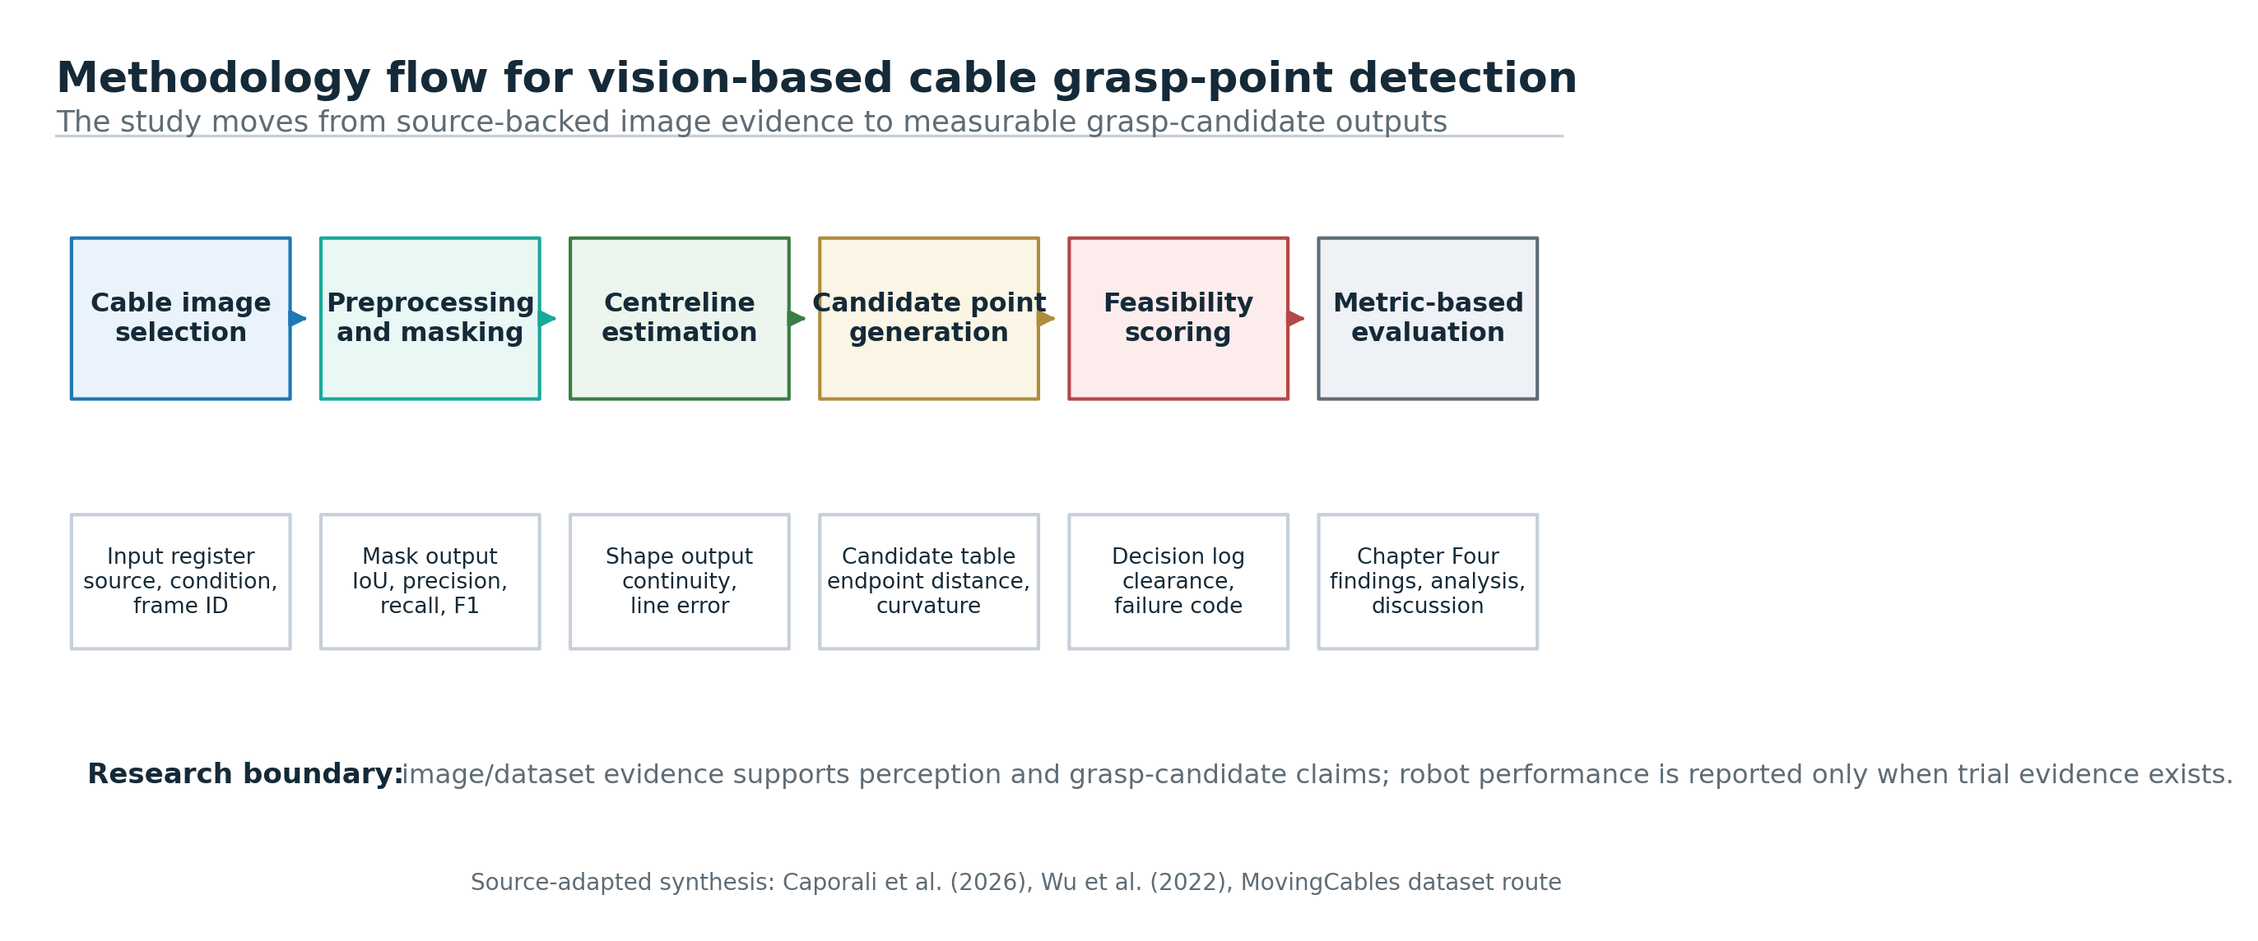
Figure 0.1: Problem scope for vision-based grasp point detection. Source: original diagram based on Caporali et al. (2026), Wu et al. (2022) and Malvido Fresnillo et al. (2023).

2 Aim, Objectives and Research Questions
The purpose of this dissertation is to investigate how well the vision-based grasp point detection method can be utilized in deformable cable manipulation for robotic systems. The idea is not so much about a fully solved robotic manipulation system, but one that's transparent, and evaluable. The method implemented is explained in the context of the image acquisition, cable segmentation, centreline or skeleton extraction, grasp candidate generation, grasp candidate scoring, and output of the robot-frame pose. It is this architecture that allows the research to relate the computer-vision evidence to the manipulation that is required. It also sustains the debate over the translation of said output of the perception system to grasp decisions.
The goals are to (1) review the existing DLO perception work; (2) create a vision pipeline for detecting the cable grasp point; (3) define a set of rules for selecting the candidate based on the cable geometry, cable slack, cable curvature, clearance and reachability; (4) propose experimental evaluation protocol (image-level and manipulation-level); and (5) define the limit of vision-only approach. A clear purpose to measure these goals. They enable the dissertation to be evaluated by synthesis of literature, system design, definition of metrics and subsequent experimental results instead of unsupported claims.
The research question is RQ1: What are the challenges of perceptual and manipulative involved in vision-based grasp point detection for deformable cable? RQ2: How is the vision pipeline connected to the viable grasp points candidates that are identified in the images from the cable? RQ3: What are some suitable assessment measures to grasp point detection in robotic cable manipulation? RQ4: What are the other constraints in case vision only is used without tactility and/or force feedback? These are usually much more technical questions related to the topic, suitable for evidence based research.
Research is a combination of design-science research and experimental evaluation. The dissertation builds the literature foundation, conceptual framework, proposed vision pipeline and evaluation design that can be used to evaluate the performance of grasp-point detection. The findings, analysis and discussion of the traceable implementation and outputs of the data sets are presented in Chapter Four.
Table 0.1: Research objectives, questions and evidence plan.
Objective | Research question | Evidence route
Review DLO perception and manipulation literature. | RQ1 | Peer-reviewed DLO, cable manipulation and deformable object sources.
Design a vision-based grasp-point detection pipeline. | RQ2 | Pipeline diagram, candidate rules and implementation protocol.
Define quantitative evaluation metrics. | RQ3 | Segmentation, centreline, candidate and manipulation metrics.
Assess limits of vision-only manipulation. | RQ4 | Failure-mode analysis and comparison with tactile/force feedback literature.

3 Structure of the Dissertation
Dissertation is done at institutes. An overview of deformable linear object manipulation, along with technical challenges for perception, representation, planning and control is given in Chapter One. Chapter Two deals with the literature of vision-based cable grasping point detection, literature of pipeline design and evaluation metrics. Chapter Three provides information on the design-science methodology, data route, implementation plan, metrics, ethics and limitations. Chapter Four has been organised in such a way that the finding of analysis and discussion can be separated if the evidence of an experiment exists. The conclusion consists of answers to research questions, based on measurements.

CHAPTER ONE - LITERATURE REVIEW I

1.1 Deformable Linear Objects and Robotic Manipulation
Manipulation of deformable linear object is different problem as compared to rigid object. Rigid objects can be often represented as a stable pose, a mesh, a bounding box or a known grasp affordance. There is no other cable that can offer the same stability. Changes in shape when affected by the force of gravity, contact, friction and previous manipulation and the position of the held segment. DLOs are objects whose linear geometry and deformability result in strong interdependencies between modelling, perception, planning and control, as these aspects are described by Caporali et al. (2026). Along the same lines Sanchez et al. (2018) present a problem of sensing, modelling and control of deformable objects, both for domestic and industrial uses. The grasping point should not be chosen because of the 'graspability' of the point but rather because of the action to be performed by the grasping.
Sensing, representation, planning and execution are commonly split into the literature. This sensing is an approximation as to where the object is. Representation allows for an easy translation to a model format, such as centreline, keypoints, spline, graph or point cloud. Planning is the deciding factor in determining what to do. Execution involves the command and control of the robot, gripper and feedback. For this dissertation, the detection of the grasp is crucial to be performed in between the perception and planning stage. Cable pixels only can't be enough. The system needs to be organized so there is a point where it can be accessed, grabbed and moved in some desired manner to alter the system's state of the cable.
Cables are a special problem as they aren't very soft rope, nor very rigid rods. Under the action of small external forces, cables can also exhibit elastic properties, and still form complex shapes, write Wu et al. (2022). This is important because the closer the access point to the cable tip may provide a more precise control of the target end, but with the risk of collisions; the further from the cable tip the access point may be safer, but less control of the target end. The optimal grip position is, thus, task dependent. This shouldn't be judged solely on pixel confidence, but on geometry, clearance and slack and manipulation thereafter.
The perception studies of deformable linear objects have focused on the two key issues of segmentation and shape estimation. To segment the DLOs, calculate the points of the skeleton and model the shape of the object, Malvido Fresnillo et al. (2023) developed a machine-vision system. Their work is important as they show that strong perception abilities should be capable of handling several cables, complicated backgrounds, near objects and occlusion. In this study, the pipeline begins with segmentation, but doesn't stop there, based on the literature. The results of segmentation is utilised as an input to Centre line extraction and Grasp-candidate Scoring.
Under-constrainedness of DLO manipulation is a fundamental fact from the literature: when the object is only partially observed, DLO manipulation is under-constrained. The hidden segments cannot be seen by a camera, as well as the contact with the bottom of the cable, the friction condition or the internal tensions. This uncertainty can be overcome through the use of tactile and force sensors, but it may be the case that in low cost systems and/or vision first systems such sensors are not available. Hence, the vision based approach needs a clear vision of what it can and can't infer. It can be used to argue that if a found grasp point is visually feasible under some criteria, then manipulation will work without feedback, it is not to argue that manipulation will always work without feedback.
In this study the challenge taxonomy summarised in Figure 1.1 will be used. These cross cutting risks are subdivided into the following: Perception, Representation, Planning and Control, as well as Occlusion, Material Variation and Generalisation. This construction is valuable as it will not have a dissertation with limited image processing perspective. If it is to be used for robotic action downstream, but grasp-point detection is useful. In the literature however, it has been reported that DLO tasks cannot be solved if the perception modules are considered independently of the manipulation constraints.
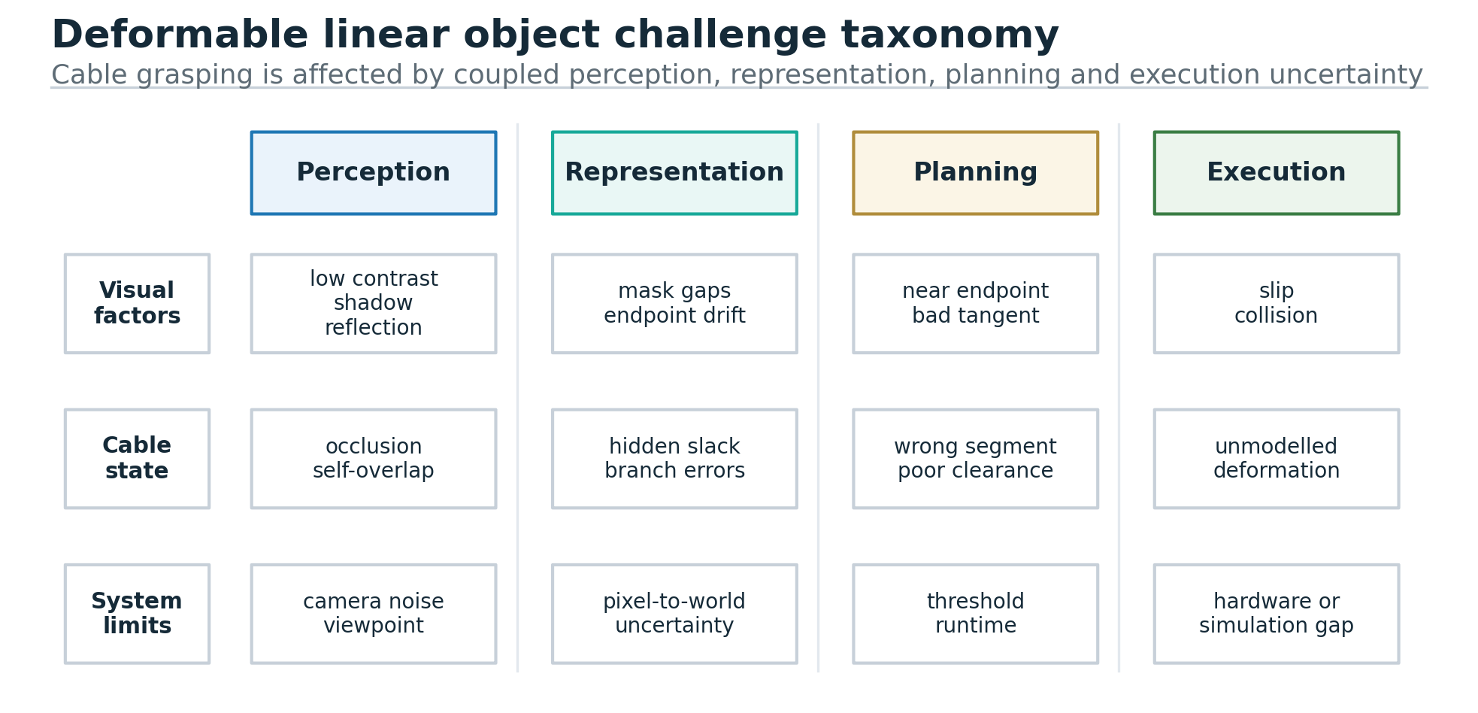
Figure 1.1: Deformable linear object challenge taxonomy. Source: publication-style original synthesis adapted from Caporali et al. (2026), Arriola-Rios et al. (2020) and Zhu et al. (2022).

1.2 Vision, Representation and Shape Estimation
Representation is a key element to understanding selection. Although the cable pixels can be detected with a binary mask, it is not possible to directly see the direction of tangents, the local curvature or the distance of the endpoints or slack with the binary mask. It is more beneficial to have a centreline representation as candidate points can be sampled along the cable length. If a cable overlaps itself or if it is entangled it may be necessary to use a graph representation. Having RGB-D data could be useful for 3D pose estimation using the point-cloud representation. These representations can then be compared in the dissertation and a sensible choice can be argued in terms of the data available and the complexity of the implementation.
Also a clear conflict between classical image processing and literature data-driven image learning. It is transparent and classical techniques such as thresholding, edge detection and skeletonisation may be used and can be successful, when the cable is in contrast to the background. Learning based methods have the potential to generalise better to clutter and variation but have the need for annotated data, training and careful validation. MovingCables (Holešovský, Škoviera and Hlaváč, 2024) is a helpful publicly available route that consists of image sequences, segmentation masks and optical-flow associated data for cable scenarios. This data set might prove helpful in perception assessment without being acquired individually.
But it's not only the public data sets that are the problem with manipulation. The data set can include masks and image sequences but is not required to include any specific grasp success labels for a robotic gripper. The evaluation thus defines a derived route: The selected point is located sufficiently far from the end points of the cable; the curvature of the cable in this area is in a range that is acceptable for the required task; the direction of the gripper approach is visible; and the selected point is not in the occluded or crossing area. All of these criteria are a link between perception and defensible grasp planning.
Planning literature provides the need for the extra dimension. To address this issue, Wu et al. (2022) propose a cable grasping planner that leverages pose measurement and path planning techniques. They discuss operation surfaces and collision-aware planning, which is why they say that it's not a matter of a single image coordinate, but it's about grasp point detection. Be careful about approaching a point; what is good in image space isn't necessarily good in robot space. The pipeline output is an image point, local cable orientation and a path of transformations to the robot coordinate frame.

1.3 Grasp Planning, Robustness and Research Gap
There are also applications to the modelling literature. According to Arriola-Rios et al., (2020), deformable object modelling can be categorized into: analytical, data-driven and hybrid. In the case of a cable it is easy to develop exact physical modelling, which depends on the properties of material and contact. In a vision first grasp detector, to avoid a full physical modelling, practical geometric proxies such as centreline distance, curvature and clearance can be used. If the dissertation is just picking out visual candidates that are achievable and not the entire cable manipulation process then it's fine.
One issue that does persist is that of fragility. An arm blocking the view of the cable in front of the robot or similar lighting or cable colour to background table will cause the trained (or tuned) model to fail. In recent surveys (Caporali et al., 2026; Zhu et al., 2022), generalisation is recognized as a major challenge in the real world DLO manipulation. This evaluation protocol so presents both favourable and unfavourable visual cases and not only those that are favourable.
The interactive perception is also a very important one. Humans pulling or lifting cables, uncovering hidden structure. Action can likewise be used to enhance perception for robotic systems. The study is mainly concentrated on vision-based grasp detection and thus the motion-cable segmentation and motion-correlation works are relevant and can be extended in the study. The methodology-review approach can start with passive image detection and propose future work, where the robot will move a little bit more in order to reduce the uncertainty.
This dissertation fills a literature gap in the area of practical integration. Even though there are already research on DLO surveys, segmentation, shape estimation, cable grasp planning and datasets, there is a lack of a coherent path between these topics, which would lead to an implementable pipeline for this research. The difficulty is that it is a phenomenon that hasn't been examined before. The gap is that, there is a need for a structured, evaluable framework, which could show how a vision module could recognize grasp candidates and know the physical constraints and the evaluation limits.
Thus this chapter advocates the use of the methodology used. The required evidence has a relationship with the quality of segmentation, implications and constraints on centreline continuity, candidate-readiness logic and execution. A design-science and experimental evaluation design is adopted to research problem. In the next chapter the proposed system architecture and evaluation route are discussed.
1.4 Critical Synthesis and Dissertation Gap
Based on the analysis of the literature, no algorithm is missing for deformable cable manipulation. The issue is related to a combination of uncertainties in perception, different geometries of objects, and reachability of them by the robot as well as the logic to decide when a grasp of an object is useful. In some cases, the picked region might contain the correct cable pixels, but might not have a safe and useful grasp point for the robot: if the region is near an endpoint, if the region is covered with a crossing, if the region is near a boundary of the work-surface, or if the region is not geometrically stable. Hence this dissertation recasts the problem of grasp-point detection as a pipeline as opposed to a pure classification task. The aim of the proposed contribution is not to propose a new general cable-manipulation controller, but to define and to verify (test) an evidence-based method to correlate the visual shape representation with the ranking of grasp candidates.
But Caporali et al., (2026) and Zhu et al., (2022) mention that deformable objects are challenging to handle due to their varying state representation when they are in contact and undergoing movement. Malvido Fresnillo et al. (2023) demonstrate that machine vision technologies can also be used to aid identification and shape estimation for cables, while Wu et al. (2022) show that the surface on which the cable is operating and the goal of the manipulation should also be taken into account for grasp planning. So there is a visual detection to action readiness. In many studies, no description is given of the intermediate decision rules that are used when selecting the candidate cable grasp points, so that the result of the segmentation and/or the manipulation performance cannot be reproduced, audited and criticised with a small experimental dissertation. In this project the scope is aimed at filling this gap, restricting the scope to vision-based grasp-point detection for cable-like DLOs.
Also, the literature outlines for a reasonable fence about the dissertation. A thorough research in this field relates the results of visual perception to the measurable evidence of the grasp-candidates. The segmentation, centreline stability, candidate rejection logic and processing times results offer a more solid foundation for analysis than do general perception or preference statements.
The research gap can hence be summarized as: While there are existing works in perception, segmentation, shape estimation and manipulation of cables, there is a need for a dissertation level method that translates the cable model obtained from vision-based perception into a set of ranked grasp candidates and provides evaluation without over-optimizing the hardware capabilities.
1.5 Link Between Literature Gap and Research Questions
The research questions are, as a result, phrased in a controlled manner, as a reaction to the gap found in the literature. The first question is about the reliable modeling of a deformable cable for grasp planning using the vision system. This is done on the basis of literature on Segmentation and centreline-estimation; where a good quality visual representation directly impacts the downstream manipulation decision. The second question is asking what some of the detected point's features would be that would make it a point to grip. This brings the dissertation out of the realm of image recognition and into the realm of robot-relevant reasoning because the value of a grasp point must be assessed in terms of the cable geometry, the local stability and available clearance. The third question is 'How will the proposed method be evaluated?', which is the usual pitfall of the common technical study in which an algorithm is written out without being evaluated by the appropriate evidence.
This alignment is important because it can assist in preventing the chapters being separate essays. Chapter One introduces the reasons for the technical difficulty of the manipulation of DLO. The vision and scoring architecture is the subject of Chapter Two. The architecture is used as an experimental method in Chapter Three. Chapter Four discusses the queries and does not simply regurgitate the results of the application of the method. The dissertation should thus be meant to argue on a line of reasoning which has a defensible chain: Literature gap, System design, Experimental evidence, Critical discussion.
Finally, the research questions are carefully designed to enable evidence to be gathered without over-ambition for the project. The success of the study is demonstrated by the measurability, explainability and limitedness of the proposed detection pipeline in a well known way. It has not announced any intention to go into industrial use. This separation is relevant because many of the issues of deformable cable manipulation are vast research areas and there are hardware, sensing and control challenges that lie outside of the scope of the project. While it is not possible to build a vision-based grasp detector that relies on the geometry of the cable, there are cases in which such a method might be useful, and even a limited vision-based grasp detector could have an important role in academic research, to demonstrate how grasp candidates can be determined using visual geometry of a cable.

Table 1.1: DLO manipulation challenges and implications.
Challenge | Why it matters | the study implication
Occlusion and crossings | Hidden cable segments can distort skeleton and topology. | Reject branch/crossing candidates and record failure cases.
Material variation | Cable stiffness and friction affect grasp stability. | Do not claim universal grasp success from images alone.
Endpoint/slack trade-off | Too close or too far from a tip can reduce task feasibility. | Score endpoint distance and task-specific slack.
Camera-to-robot projection | Pixel coordinates are not sufficient for manipulation. | State whether RGB-D, homography or image-only output is used.
Generalisation | Clean-scene results may not transfer to cluttered scenes. | Evaluate easy, moderate and difficult cases separately.

Critical reading of the literature does not consist of the listing of algorithms. The key is whether the information provided by each representation is truly useful for understanding by a robot, or not. Information regarding the gripper in the form of pixel masks can be useful for the segmentation measurement, but it also requires to know which part of the cable is able to be securely gripped by the gripper and in which direction the cable is to be grabbed, and whether the gripper point selected is likely to be stable after gripping the cable. To allow thinking from perception – to grasp the main intellectual issue of the dissertation.
The literature also offers proof for the existence of a compromise between the interpretability and robustness. Learning-based approaches can give a better segmentation in varying background situations, but cannot give an explanation of why a chosen grasp point is safe. The rule based geometric conditions are very easy to use, but may not work if the cables can overlap. The proposed study is based on utilising this tension productively: each of the stages of segmentation, centreline extraction and candidate scoring is a layer of evidence. This separation enables the following to dictate whether a failure occurs in the Perception, Representation or Decision Logic.
Another factor that influences grasping of a cable is the shape of linear deformable objects is not well defined by its visual form alone. The apparent contour, as seen by the camera, is not necessarily the actual contour; there are slack, friction, stiffness and contact state that are not visible by the camera that influence the grasp. That is, no detector based on vision can be said to have an "understanding" of manipulation. Rather, it makes a much narrower and testable claim: given some visual conditions the method identifies some points that are candidates for contact which meet some geometric and feasibility rules.
In view of the studies surveyed, it is thus appropriate to use the evaluation design of reporting successful detections and structured failure cases. Academically, failure is helpful to illustrate the level of vision-only reasoning. Images with low contrast and shadows may have lower recall, and crossings may form skeleton branches, and endpoints may be close to each other and form unstable grasp suggestions. The inclusion of the patterns gives more critical value to the dissertation than a few select positive examples.
Finally, the chapter considers the contribution in the context of a replicable evaluation system as opposed to a full robot cable handling. It should be noted here that the value of the reviewed DLO theory is that it is related to a real pipeline with metrics and decision rules. Technically sound, limited to the extent of evidence and will provide a suitable contribution to dissertation in the form of rigorous findings analysis discussion, once the experimental outputs are generated.
The synthesis also helps to focus the assessment criteria for the study. A detector must be technically convincing, that is, demonstrate its ability to retain pixels' information relevant to manipulation until the very end of the path to grasp candidates. This will not only define and explain why cable manipulation is difficult, but also will specify what acceptable evidence will be. Thus, the dissertation tackles the problem of mask overlap, continuity of lines, distances of the end points, curvature and clearance as indicators of methodological quality. The uniformity of this provides the study with a more solid critical motivation, since the same problems are investigated as other studies on deformable-objects, and the same method is proposed. It also helps to remove descriptive literature review (translation of each limitation reviewed into the test condition or test metric of the experimental design).

CHAPTER TWO - LITERATURE REVIEW II

2.1 Vision Pipeline Design
A vision based grasp point detector can be considered as a series of transformations. The raw image is firstly converted to an image unique to the cable. This representation is then turned over to some candidate points. The candidates will be scored based on task constraints and the best candidate will be converted to a gripper pose. There can be mistakes or errors at every step. Segmentation error is possible for part of the cable to be pulled out. In Skeletonisation, the change in the centreline can happen. During the candidate generation of endpoints and/or crossings, they can be oversampled. Scoring can select an "eye-catcher" that may not be the best physically. The those stages will be analysed and design logic of the study will be determined in this chapter.
The first step is the image acquisition. The proposed architecture can be run either with RGB or RGB-D (if available). RGB images are easy to acquire and are used well with many public data sets and have little depth information. With RGB-D cameras like Intel RealSense devices, 3D pose estimation can be done but the depth information of thin cables can be noisy due to the small amount of pixels covered by the cable and the cable may be reflective or dark. The methodology thus does not assume that the depth is perfect. If RGB-D is available it should be used in the robot-frame projection too, if not, it could be used as a detector of grasp candidates as well, but with obvious limitations.
The next step is the Segmentation. The goal is to segment the pixels which represent cable from the background, gripper, fixtures and other objects. For classical segmentation the different thresholds, edges, morphology and connected components can be used as input parameters. The segmentation could be done using convolutional networks, object-detection models or using foundation-assisted methods. Depending on data availability the choice is made. There are multiple colours, occlusions and complex backgrounds that must be taken into account by robust DLO detection, as demonstrated by Malvido Fresnillo et al. (2023). MovingCables presents a dataset route for testing the cable segmentation in the case of moving and clutter. (Holešovský, Škoviera and Hlaváč, 2024).
In this study segmentation method is considered to be explainable and testable method. There is no mention of the learning-based models being cutting-edge use of AI models, simple baselines are not described as cutting-edge, and training/validation data are provided for learning-based models, as well as the possibility of overfitting. A good compromise is to have a modular pipeline, with either classical or learned segmentation module and an explicit grasp-candidate module. This will give the dissertation the freedom to focus solely on the grasp point detection, but also that the quality of the segmentation will affect the results afterwards.
The 3rd phase involves the extraction of the centreline/skeleton. A cable mask is more suitable for a side area of width and a grasp point is more suitable for a centre-line. Skeletonisation is thinning to 1-pixel or graph like shape. Candidates can then be sampled every point along the centreline. For each point of contact, there is a direction of the tangents, using these to estimate the direction of the gripper. Local curvature is an indication of bends. With endpoint distance it is possible to identify if there is a point too close to the tip of a cable. This stage converts the perception to geometric features that can be manipulated.
It is not easy to take out the skeleton. When crossing the cable, a simple skeleton can cause branch points that are not really any real connections. The segmentation may not be complete where there are no gaps, and the skeleton may be segmented. When a thick cable or not visible cable exists, it can shift from the centreline. These are not little problems with implementation, but are directly related to the selection of the grasp. Therefore, there are qualitative checks in the methodology which are based on skeletons and a predetermined rule for rejection. Candidates which are near branch points, or in extreme gaps or low confidence mask areas can be rejected or flagged for manual review in the proposed system.
The fourth is generating candidates. The candidate-generation design samples points in the centreline and discards candidates which fail the basic feasibility rules. It may be helpful to consider using endpoint exclusion because in some cases there will not be sufficient stable contact or slacks in the near end position. Using crossing exclusion is helpful as grasping at a self-overlap might pick up the wrong layer of cable. Curvature limits are useful because the curvature can indicate a bend or entanglement which the gripper is not able to safely align itself with. Clearance checking is helpful because there needs to be sufficient clearance around the point for the gripper.
A candidate's score will be calculated using various factors. Within the possible score are the distance from occlusion, mask confidence, distance from endpoints, local straightness, clearance from obstacles and reachability and task relevance. If any are used, the desired weights and rules are noted. Off-line reachability is not measurable in the present experiment, which does not have any robot hardware, and can only be tackled as a simulated workspace as a second step. If a robot planning library is available or the physical approach test is performed, reachability should be evaluated based on that. The evidence level is indicated in the dissertation.

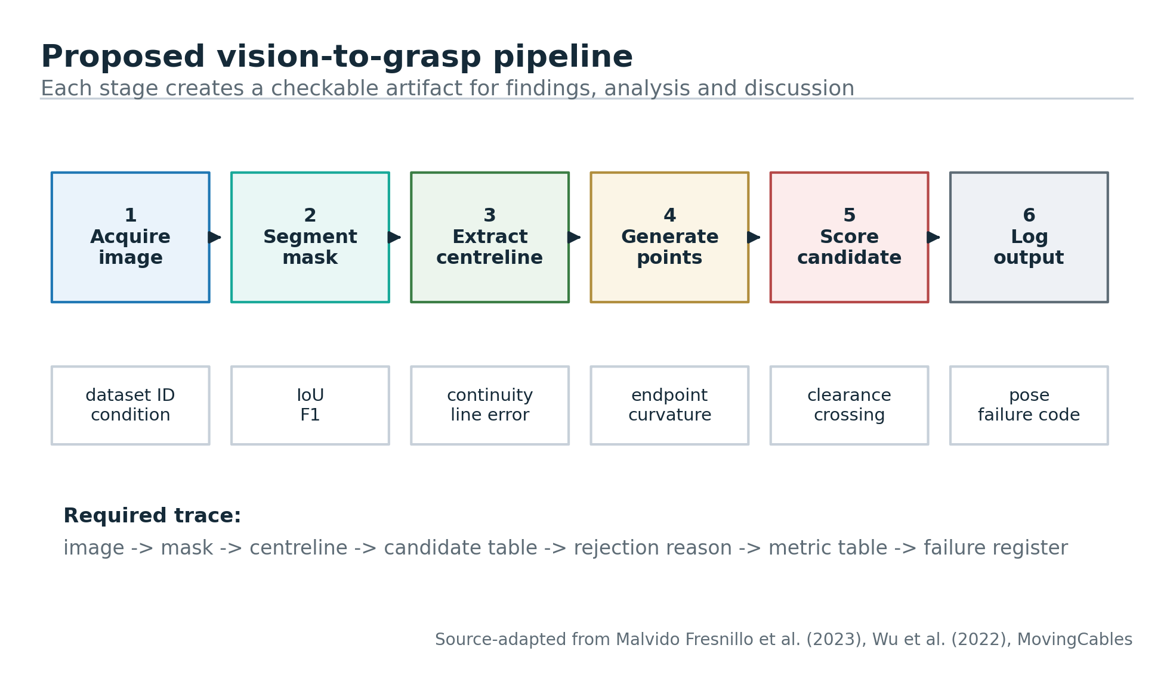
Figure 2.1: Proposed vision-to-grasp pipeline. Source: publication-style original diagram adapted from Malvido Fresnillo et al. (2023), Wu et al. (2022) and MovingCables.
2.2 Grasp Pose Output and Manipulation Constraints
The proposed detection pipeline, as shown in Figure 2.1, also shows the path of the visual input to the output of grasp-candidates. Because, complexity is not the essence of the dissertation, the diagram is so simple. It enables image capturing, image segmentation, skeleton extraction, generation of candidates, scoring and output of projected robot-frame and projected gripper pose. This will allow a clear direction from the research aim to the methodology. It also provides diagrams of important processes, in addition to discussion in the text.
The projection stage of the robot is important because the outcome of the projection can't be just the pixel coordinates. If the robot is a physical robot, the grasp point needs to be defined in a frame which can be manipulated by the manipulator. If the input image is an RGB-D image, depth information from the candidate point or in its vicinity can be utilized to allow 3D projection. Using a calibrated camera and a planar workspace (table), a homography can be calculated which transforms points in the image to points on the workspace. Due to lacking calibration, the dissertation can only be used for image level detection. This distinction needs to be communicated explicitly otherwise the work would be leading the reader to believe that the system is ready.
The direction of the tangent of the centre-line at the candidate selected can be used to estimate the direction of the gripper. Typically, when the parallel jaw gripper is employed, the cable will be positioned so as to form a closed grip – across the cable rather than along its length. Therefore, it is possible to obtain the gripper yaw by using the local tangent. The approach vector could be different due to different camera position and robot shape. In this prenuptial evaluation the output of the pipeline is a proposed pose tuple and a route of transformation to be used in the subsequent physical evaluation. The pose should also be tried with the robot for a pick up or routing task if further trials were to be undertaken.
The metrics to use for the evaluation should match the staged pipeline. Intersection over union, precision, recall or F1 score can be used to assess the quality of the segmentation based on the mask annotations. Assessment of the quality of the centreline in an area where there are annotated or derived centreline points can be based on the mean distance between the centreline and the annotated/derived centreline points. The quality of the candidate can be determined on the following: (1) Whether the selected point is on the visible portion of the cable; and (2) Whether the point is meeting the feasibility rules. The manipulation quality can be assessed either by reachability, successful grasping or slippage or by the displacement error of the cable or completion of the task. These measures altogether will help to remove the risk of presentation of a poor assessment, which would only involve a final screen shot of the assessment, in qualitative terms.
Failure cases are also captured and noted down in the dissertation. For instance, when the cable is identified as a surface, when one cable obscures another cable, when a shadow is misinterpreted as a cable, when skeleton branches incorrectly or when the selected point is not within the workspace of the robot. Failure modes would be indicated as good sign of critical thinking and this would add to dissertation. It also lays the groundwork for future work suggestions, such as tactile sensing, active perception, better training data, closed loop-correction etc.

2.3 Evaluation Levels and Critical Limits
A level by level evaluation of the proposed system is taking place. Perception evaluation on an annotated image – level 1. Level 2: Evaluation with respect to geometric feasibility rules (grasp-candidate). The robot frame/simulated pose evaluation is level 3. Physical Grasp Success (Level 4) when hardware is available. This hierarchy is convenient as it allows the distinction between those things measured in the present study, and those things that would need to be accessed by a robot. It also doesn't allow for the writing to take credit for success at the image level when the only evidence of success is at the image level. Correspondence and other evidence levels recorded are only reported in Chapter Four.
There are pros and cons to using public datasets. MovingCables is a real-world cable sequences and segmentation masks which can be used for perception testing. However, it might not have the required robot-grasp labels for the dissertation. This dissertation does not pretend to be physically a claim of labels ownership, but candidates are selected from transparent centreline and geometry rules. Chapter Four then demonstrates the evidence level, in which image segmentation and grasp-candidate reasoning can be assessed and physical manipulation cannot be measured.
Manipulation is contact rich, a vision-only approach is still limited. Lighting and lighting reflections are a problem in vision, occlusions and the fact that DLOs are visually thin can be important, as is tactile/force feedback that can be important for reliability, here, these are treated as design limitations, not as some sort of weakness to be hidden. The dissertation proposes to employ vision as another means to assist in the initial grasping point selection, but powerful manipulation may need the grasping point feedback during grasping. This helps to build a well-balanced attitude to academic life.
Computational is another requirement. The velocity of grasp detector in the robot loop should be adequate for the operation. In a dissertation prototype, perhaps it is OK to analyze things after the fact, but to be able to manipulate something, it would be nice if it made near real-time updates as the cable was moved after contact. Thus, the processing time per frame/image should be an evaluation aspect in the protocol. Even if a slow algorithm is of research interest, it shouldn't be called "ready" for closed loop control unless it has been demonstrated.
This proposed pipeline thus makes a calculated contribution. Does not offer a 100% solution to the DLO manipulation. It sets up an unambiguous mapping from vision information to a grasp point output, indicates where errors can occur and presents a strategy for assessing this with metrics. This is a more suitable dissertation design than a wide descriptive study as it allows to construct an artefact which can be applied, experimented with and discussed critically. The method of that evaluation is detailed in the next chapter.
2.4 Architecture Requirements for the Proposed System
The workable architecture starts from a small input space. The object to be captured is the deformable cable that is displayed in the work surface and that is captured in a controlled (or semi controlled) illumination. This does NOT make the problem easier, just a boundary on which the evaluation is performed. This includes four functions in that area: image acquisition, cable segmentation, grasp-candidate scoring and geometric representation. Each function creates an artefact which can be independently verified. The image input can be checked on the lighting and occlusion. Mask comparisons can be done with either a labelled or manually checked reference. It is possible to check continuity and geometric plausibility of the centreline. The results of the grasp can be evaluated using the rule based feasibility criteria.
Don't use just one vision model confidence score as the basis for the architecture. There is a need for explainable features in between in cable manipulation: failures should be diagnosed. For example, the candidate could be too close to an endpoint, as indicated by local curvature, or there could be insufficient clearance for the gripper, or whatever. Ideally these features should be distinct from the others so that they can be analysed later in more detail. The results can be classified as weak and Chapter Four can diagnose if the weakness is related to Segmentation, Skeletonisation, Candidate Scoring, Physical Feasibility or if it is a vague statement that the model has performed poorly.
The literature refers to the mask to centreline to get the image-processing layer. A publicly-available data set, e.g., MovingCables, is relevant as it is large enough to store and analyse and the cables can be segmented based on a legitimate source. One option is to use a sample subset and/or local images. The survey of open DLO research resources including UIUC RMDLO (2026) also highlights the importance of public code and dataset ecosystems for the sake of the reproducibility of deformable-object methods. The important point here is transparency – all image sources, all selection rules and all exclusion decisions are documented and the results are not just ‘anecdotal examples' that are plucked from a hat. That's why it's preferable to utilize figures with a source instead of images in the last DOCX for presentation.
The scoring layer is a layer where the perception is converted to readiness for manipulation. Where using a robot or simulation, the candidate points should be within a safe distance on cable away from ambiguous end points, high curvature areas and intersections, and within the reachable workspace of the robot. The above are all candidates that can be considered for the candidate score: local confidence, centreline stability, endpoint distance, curvature, clearance and reachability. While the weights do not have to be given as universally best, they must be justified with regards to the task. When the number of result set is small, it is more appropriate to use a transparent rule based scorer than the opaque black box choice.
2.5 Implications for the Dissertation Design
Based on the above literature survey it can be inferred that it is not a perception study, nor an opinion study but an experimental technical study. The methodology should detail what the system will identify, what data the system will utilize, how candidate points will be created and what criteria will be used to determine the overall success of the system. Analysis and discussion then ensue, with findings reported based on observed performance in the findings chapter. To avoid the common pitfall in writing robotics papers, saying you have an amazing pipeline, and not showing that each part of the pipeline works.
The second is that there are restrictions that are not added on, but are built into the design of the study. The vision based cable grasping relies on lighting, cable colour, contrast with background, cable occlusion and loops and camera calibration. Thus, the proposed method specifies the conditions under which it is tested and makes no claims outside of those conditions. Defining a credible scope, the consistent application of the method and the critical interpretation of the results is the strength of the study.
Table 2.1: Pipeline stage risks and controls.
Pipeline stage | Main risk | Control in proposed methodology
Image acquisition | Poor lighting, reflection or insufficient depth. | Record camera type, scene conditions and image quality.
Segmentation | False cable pixels or missed cable pixels. | Use IoU, precision, recall and failure examples.
Skeleton extraction | Broken centreline or false branch at crossing. | Inspect centreline continuity and reject unstable branch regions.
Candidate scoring | Point is visually valid but physically poor. | Use endpoint, curvature, clearance and reachability rules.
Robot projection | Pixel output cannot be executed directly. | State calibration route and evidence level.

This is not only a software pipeline, it's an evidence architecture. There are stages to create an output to be examined and tested and questioned. Mask: Is the cable visible to the system? Centreline: Do you have a manipulative that is an appropriate representation? Table of candidates: Are the grasp points according to the geometric rules? Failure Register: Are the limitations being evaluated or masked?
This is a staged design which also increases the validity. When just a final grasp point is reported, poor performance can be attributed in many mutually inconsistent ways. The dissertation can differentiate between false-positive segmentation, broken skeletons, endpoint bias, crossing ambiguity, and workspace constraints by keeping intermediate results. What is worth noting is that this diagnostic separation is a separation that suggests potential areas for improvement, such as light, more annotation, repair of the graphs, alternative weighting of the candidates, or depth and tactile feedback.
The route should also be based on the difficulty and NOT on the ALL frames in one HUGE headline score. An extreme example with a high or low contrast may reveal the real weaknesses or limitations of the method, and a simple straight cable may lead to high segmentation and candidate scores. Chapter Four provides information about the credibility of the pipeline and where the assumptions do not hold through the use of condition-level reporting. This will be more useful than an overall accuracy value, analytically.
So, in the system output both quantitative and qualitative evidence should be available. Quantitative relates to the real performance. Qualitative failure examples are provided to describe the difference in the performance of cable conditions. These outputs can be used together to enable a high quality discussion; the dissertation can be used to explore the difference of the behaviour observed and that found in the literature on DLO perception, grasp planning and the limits of vision only manipulation.
There also must be a clear ownership of the results in the architecture. Segmentation scores are only linked to the perception stage, centreline-continuity issues are only linked to the representation stage, candidate-viability issues are only linked to the decision stage, and the results from the robot/simulation are only linked to the execution stage. Separation of the one good from the other weak metric. It also provides a matrix of layers of evidence where results can be placed prior to analysis; this provides explanations for the differences in the cable conditions' performance, and is presented in Chapter Four. As such the architecture does not merely present a series of technical steps but is subject to critical interpretation.

CHAPTER THREE – METHODOLOGY

3.1 Methodological Route
The methodology used: Design-Science Research and Experimental Evaluation. The project is one dealing with the construction of an artefact, the vision-based pipeline that creates evidence for grasp candidates, so the design-science approach is suitable. Experimental Evaluation should be required for the Artifact as it should be testable and quantifiable in terms of Segmentation Quality, Latency, Uncertainty and Failure Behaviour and not as a concept.
Research philosophy used is Pragmatism, which is the evaluation of the method based on the evidence produced and the ability to measure, repeat and utilize the evidence in the project. This is consistent with the design thinking for applied research which implies that the research method should be decided based on the research question and the type of evidence/validity to be established (Saunders et al., 2019). It is a forum for a technical dissertation in which the availability of a data set, the modification of models, and hours invested in the model and evidence will prevail over a preference for a method.
The way is deductive and constructive. The perception of the centerline, as well as the status of the candidates and their rejection is defined in the literature and then mapped to a testable pipeline in the implementation.
On traceable, public cable-image sources, data route is provided as appropriate. WireSeg-36K provides a synthetic benchmark that can be reproduced while TUM provides real cable images with labels for the more demanding end-of-line evaluation. MovingCables is inspected but not part of the quantitative route since (sampled) files are not provided with the binary cable-masks required for the use of this experiment.
3.2 Experimental Design and Data Route
The implementation is split into five distinct steps: Image loading, Cable segmentation, Centreline extraction, Generation of the geometric candidates and the last step is the scoring and rejection of the candidates. A design that is staged and allows separation of the perception result from subsequent manipulation claim.
The protocol makes a distinction between image level evidence and manipulation level evidence. The following evidence layer has been tested: Segmentation, candidate-readiness and latency; robot reachability, slip and task completion are measured study.
The one aim of sampling is NOT to sample a single favourable scene. WireSeg also has a number of synthetic scenes and TUM differentiates between S1/S2 development images and S3 final test images unknown to the system.
If there is a source that does not have the binary-mask that the annotator wants to use for the binary-mask evaluation, then the binary-masks/polygons that are available in the source will be used as the reference source for annotator-validity.

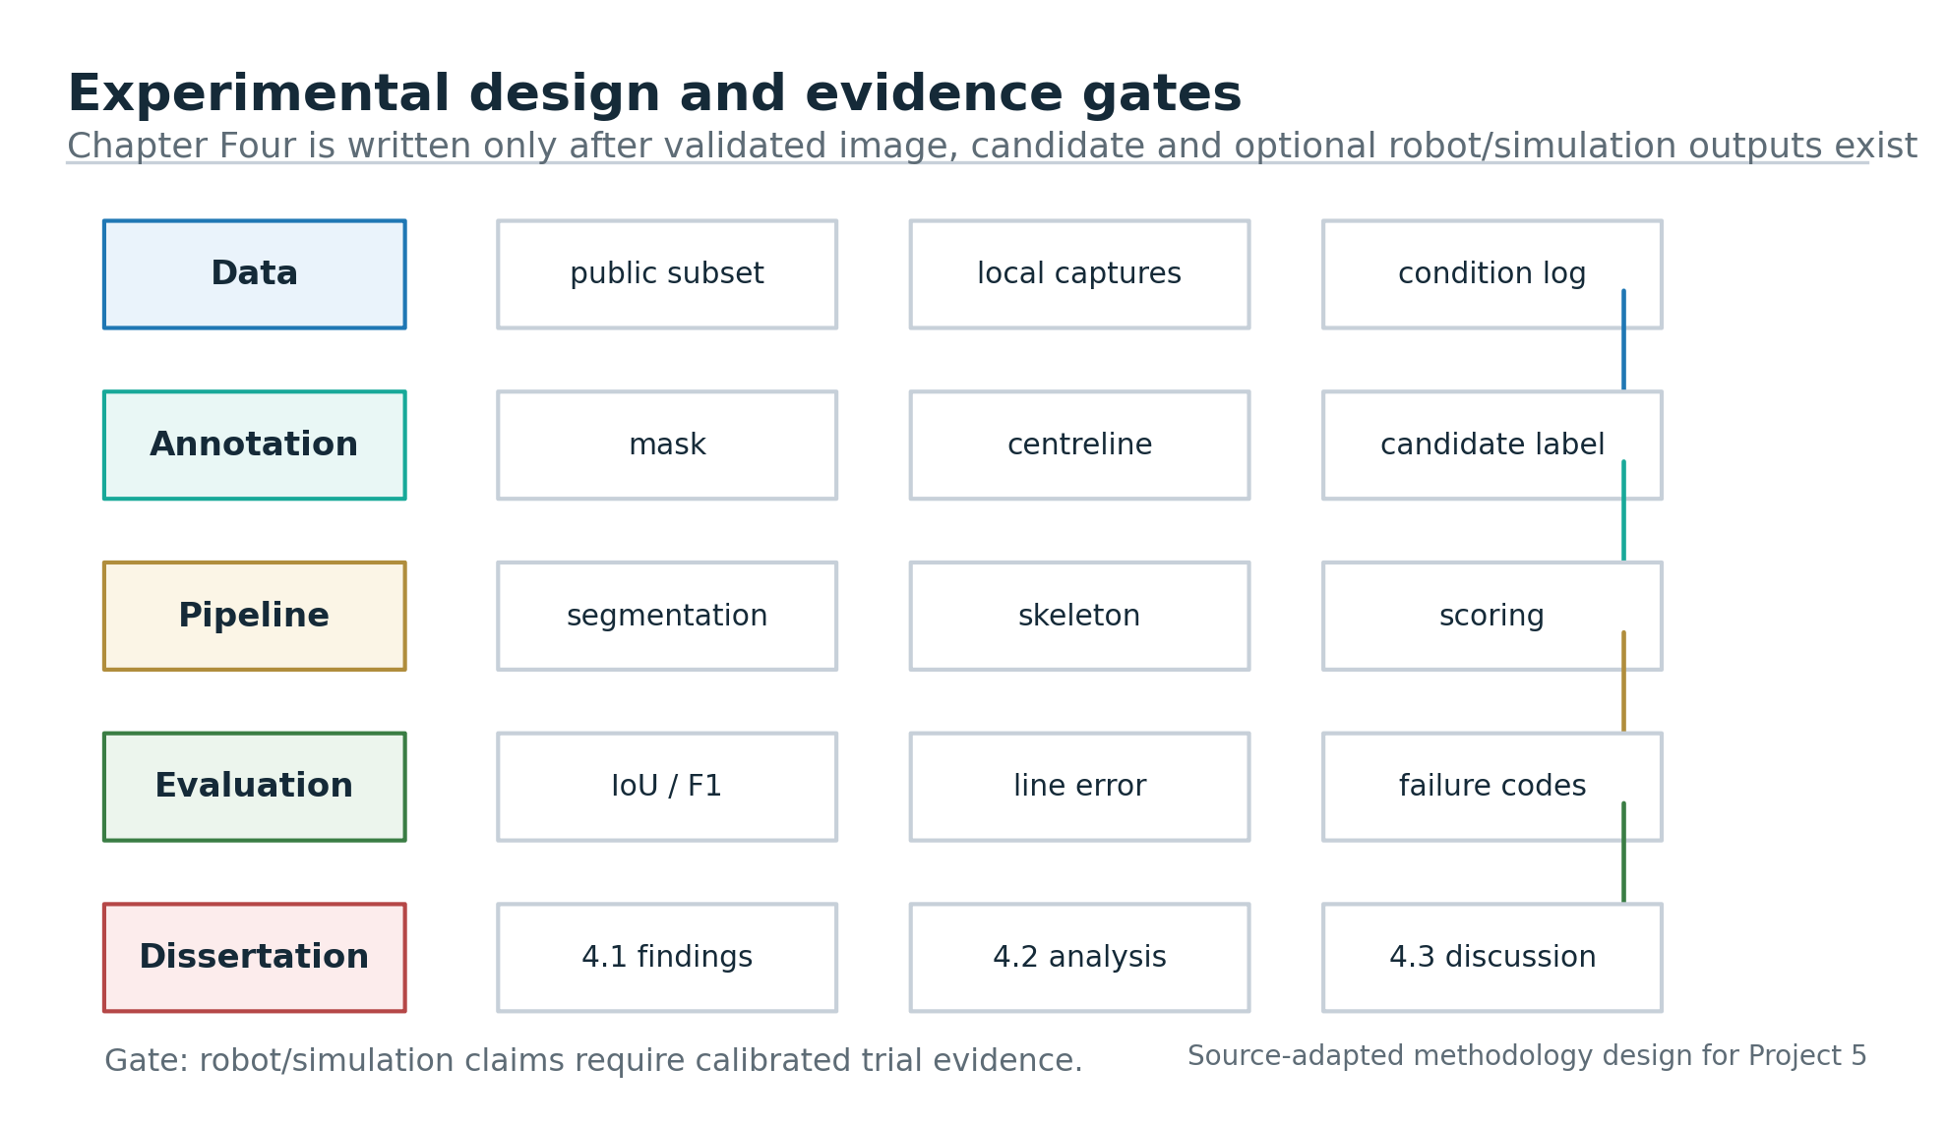
Figure 3.1: Experimental design and evidence gates. Source: publication-style original methodology diagram for the study.
3.3 Candidate Scoring and Metrics
The grasp score is not a black box score, but rather a "glass box" feasibility score. Mask-confidence, distance to endpoints, local curvature, crossing risk/clearance – not actual success of grasping in dissertation – it's about candidate-readiness.
Data analysed are quantitative and diagnostic. The segmentation, latency and uncertainty is explained in tables and the qualitative overlay provides an explanation of the impact of the false positives and false negatives and fragmented masks on the centreline and candidate formation.
Reliability issues fixed (fixed splits, saved experiment outputs and determinate calculation of metrics). Validity is considered when correlating each metric with the research question(s), as well as the difference between image evidence and untested manipulation evidence.

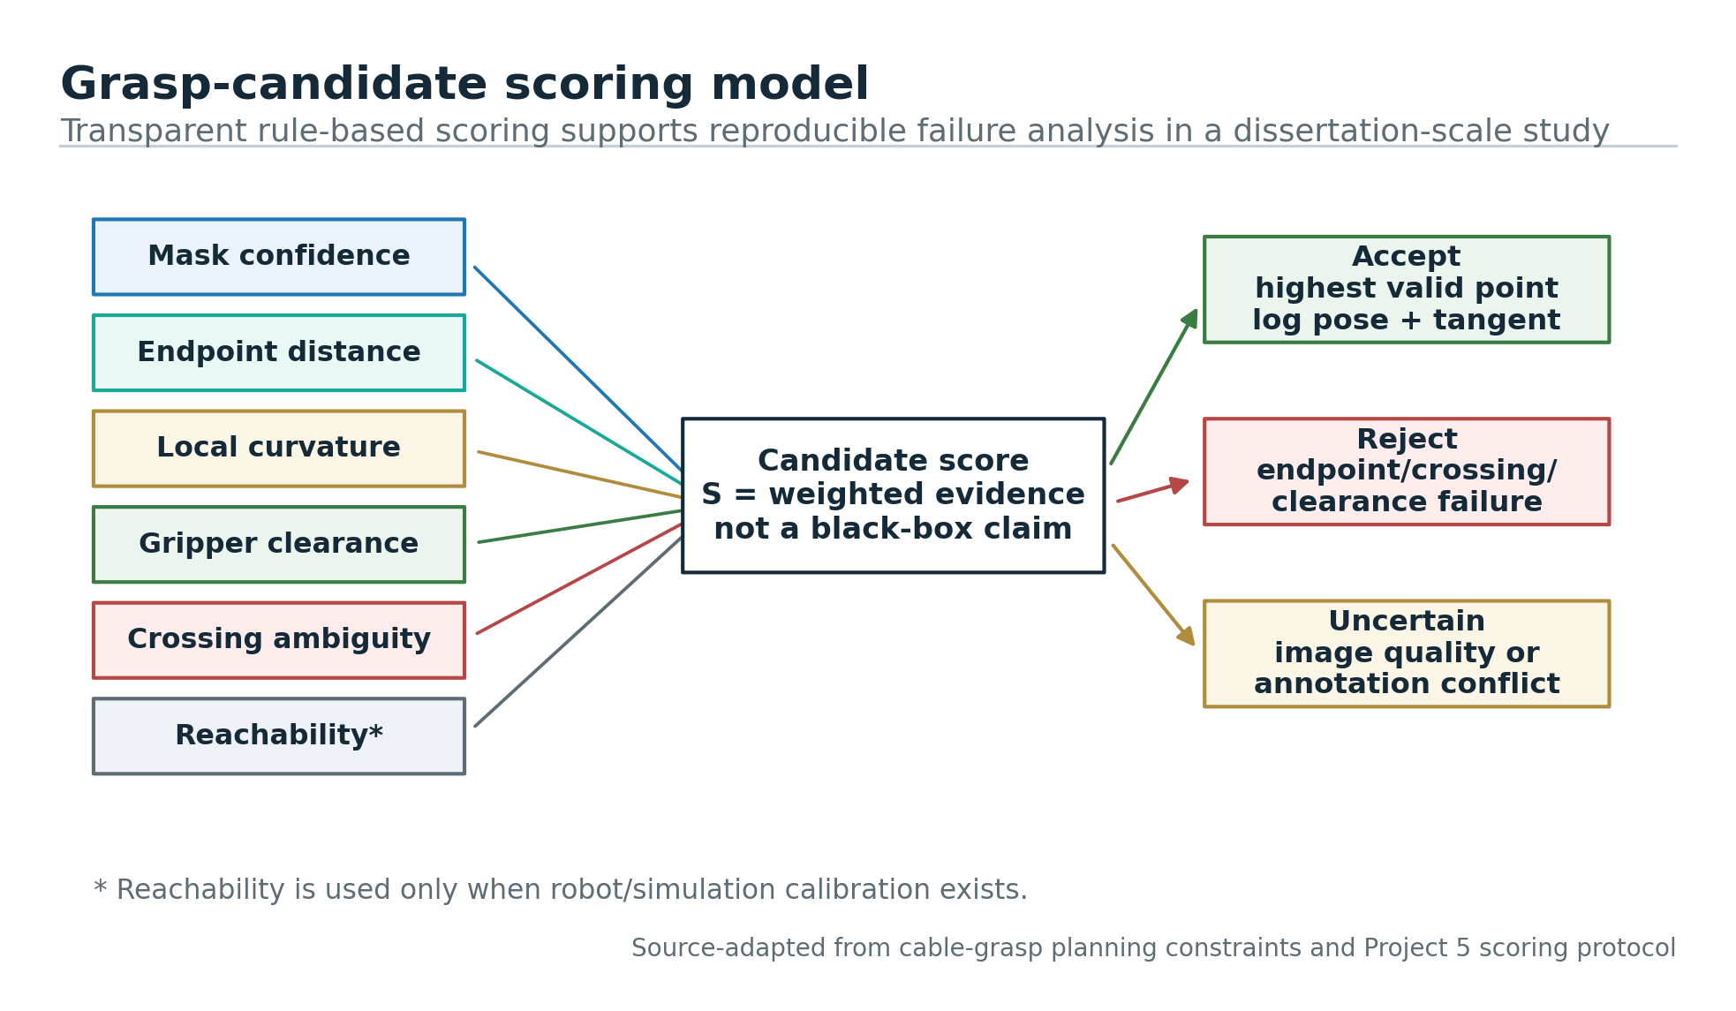
Figure 3.2: Grasp-candidate scoring model. Source: publication-style original method diagram based on cable-grasp planning constraints.

Table 3.1: Experimental metrics and evidence levels.
Evidence level | Metric examples | Claim allowed
Level 1: image perception | IoU, precision, recall, F1, centreline-continuity risk | Cable detection and representation quality.
Level 2: candidate feasibility | Valid candidate rate, endpoint distance, curvature, clearance | Grasp-point selection feasibility under stated visual rules.
Level 3: pose projection | Calibration error, workspace reachability, pose validity | Robot-ready pose feasibility if calibration/simulation exists.
Level 4: physical manipulation | Pickup success, slip rate, task completion, recovery | Real manipulation performance if robot trials exist.

3.4 Reliability, Validity, Ethics and Limitations
There are no significant ethical concerns as no use of personal data is involved. The proper identification of the source; responsible treatment of the data sets; consistent reporting and no hype in the robotics are key needs.
Low level of datasets and no testing of real robots - physically displayed cable labelling. The following bounds are not considered as weaknesses but as interpretation boundaries.
The results in Chapter Four are based on an evidence gate, only those implementation outputs which have been measured, those dataset metrics which have been verified and failure examples which are visible are included.
3.5 Data Analysis Procedure
The analysis is carried out on the evidence levels in the methodology. Precision, Recall, F1 and IoU metrics are used to compare the masks predicted by the model to the reference masks.
Secondly, the result of the mask will be used to indicate the quality of the centreline and the candidates. Errors related to decision are: Fragmentation, False Branches, Missed Cable Regions.
Third, how a point is rejected is clear. The study provides a historical overview of the various reasons why a visual candidate may not be so sure, including endpoint proximity and crossing risk, and lack of clearance and local curvature.
3.6 Quality Gates and Research Boundaries
Quality gates in this dissertation are: Data traceability, reproducible settings, claim discipline before interpretation of results.
Main difference is Chapter Four provides evidence of perceived and candidate-readiness – NOT evidence of physical manipulation success.
3.7 Reproducible training and evaluation controls
A form of evaluation that is achieved is the separation of the development and the actual measurement. WireSeg-36K is a seed 17 split 209/91 from the 300-row sample. TUM runs on the first two stages (S1 and S2), and tests to final on all 80 images from stage 3, S3.
Precision, Recall, F1, IoU, Latency, P95 latency and FPS are calculated for predictions stored and reference masks. The results on image level are computed using bootstraps.The preprocessing route is the one which is set prior to the model comparison. RGB images are read from the saved datasets manifests, masks are read or rasterised from the available annotations and resizing maintains the difference between the continuous image values, and the categorical mask values. Since nearest-neighbour interpolation is used for masks, the boundary values of cable pixels are well defined. That's important, since if the same slight change happens in a thin cable boundary to affect the recall, the skeleton continuity and the final candidate point selected by the pipeline, then all three will change.
The model comparison is not done for a “preferred” architecture but rather for two roles. The small fast model is taken as the baseline and FASTDLO ResNet-101 route is used to determine if a larger segmentation model (one adapted from DLO) can better evidence masks. If FASTDLO has been named as published, the published FASTDLO checkpoint is considered to be insufficient if only named, but is tested with the available dataset conditions, and adapted as needed based on the evidence of domain fit.
Training and selection controls prevents direct tuning of the final S3 result by direct test-set tuning. The defined training and validation partitions used for development and the final held-out scenario is only read after the checkpoint selection. Probability thresholds and definitions of the metrics are kept throughout reported comparisons. Although it is not possible to pick after looking at the final labels an image or a threshold to create the main result, not all sources of external-validity risk can be eliminated.
Generating candidates is NOT accuracy, it is a “downstream” reasoner. The pipeline detects a mask and produces the center line or skeleton of the mask and assesses for potential contact points that are too close to the endpoints, bends, crossings and/or unclear areas of the mask. In the cases where an experiment is available, the result is shown in terms of masks and not physical grasps, the dissertation reports the candidate-readiness and rejection logic. This isn't a good Segmentation score nor can the robot successfully pick up this claim.
Evidence is therefore removed to make sure that it is under control for validity. Segmentation metrics can be used to help determine if the cable body is visible and recovered, overlays can be used to identify where segmentation errors are occurring and discussion can be used to indicate which errors these would affect, either on centreline or candidate quality, and latency values can be used to identify if the detector would be able to support a control loop at a later time. The physical reachability, collision avoidance, gripper force and task completion are not measured and are recorded as future validation requirements.
The audit trail is integral in the approach. To ensure that the final dissertation can be verified with the experiment and not with memory, the project evidence is kept in the dataset choices/exclusions/split logic, model output and figures/result tables. This also rules out the option of changing the wording of the prose but not the precise measured value.
It also differentiates size and role of the data set in the experiment. WireSeg-36K comes in handy for helping to break up a split, and to look for synthetic-scene transfer vulnerabilities, but isn't the dissertation's default deployment proxy. TUM is smaller, but has real cable images and is possible to test it using scenario-held-out, so it is more relevant to the final claim. The difference is to prevent methodology being misrepresented and the domain fit is not overlooked.
In order to avoid optimistic reporting, the thresholding and checkpoint-selection controls are provided. The latter comparison is done using fixed definition of the metrics and an assumed probability threshold and model selection is done first using the validation partition before evaluating S3. This does not make this experiment complete, but this will help the reader to have a nice path to follow that the same comparison can be made and the result reported will be found in the saved outputs.
The qualitative failure review is not a visual overlay, but is part of the method. The overlay is understood on each of the representative outputs with regard to the continuity of the cables, the preservation of the end points and the plausibility of the candidates. As two masks may achieve the same F1 score, but make different types of errors, this is needed.
This approach hence yields a safe ladder of evidence. It starts with the things you can see – the segmentation – and progresses towards the central line and candidates-readiness thinking, but never suggests that it is a question of physical force, contact stability or task completion. The tests in this chapter are the same as those undertaken in Chapter Four, and the findings, analysis and conclusion are the same.
Reproducibility controls are also given to indicate what a subsequent scientist would have to duplicate. Prior to the interpretation, the description of the source of the dataset, split seed, training partitions, held out test scenario, role of the model and the definition of thresholding rule and the calculation of the metric is provided. This is important because the outcome of the cable detection process can differ greatly among the various chosen scene families, and/or the various thresholds / validations split. The methodology then documents adequately to audit the reported comparison and the claim of grasping the physical is not included in the measured scope.
I'm not sure if it's easy to replicate the method they used for the controls as is, but perhaps the message the study is looking to convey is that the readiness of the candidate is not the same as actual robotic grasp execution. It also resolves the problem of repeatable measurement and subsequent physical validation thereof. This helps to maintain the method auditable and transparent.
Chapter Four section | Required evidence | Do not write until
4.1 Findings | Metric tables, result figures and failure-case counts. | Implementation or dataset evaluation files exist.
4.2 Analysis | Comparison of performance by scene type, difficulty and metric. | Findings have been calculated deterministically.
4.3 Discussion | Connection to RQs, literature, limits and future work. | Analysis is complete and citation map is checked.

CHAPTER FOUR - FINDINGS / ANALYSIS / DISCUSSION

The chapter has presented empirical results of the evaluation route implemented. It separates out the measurement outcomes and the interpretation/analysis or discussion. The evidence is very carefully limited: the experiments only test the performance of the segmentation of the image and the pre-processing of the candidates to grasp, but not the success of the robot to grasp the object.

4.1 Findings
A complementary two evidence routes were applied in the evaluation. WireSeg-36K is a 300 row API sample of the data-centre, flying-wire and wire-on-plane scene families split with seed 17 (209 rows train 91 rows held-out), reproduced in this package. The images of the real cables were collected from TUM (245 images) and labeled. S1 and S2 gave 132 and 33 training images respectively and all of the images in S3 (80 images) were used for final test. MovingCables was inspected but, not reported on quantitatively, as the sampled flow-style files did not contain a valid binary cable-mask representation.
Table 4.1 shows a summary of the results of the segmentation and inference. The table is the backbone of the chapter as it helps in comparing the comparison on the same evidence level in the table, that is Pixel precision, Recall, F1, IoU, mean latency and mean FPS. These values are perceptual, not scientific, ones. Instead, they are not employed to measure how well a physical grasping can execute a grasp, but rather if a visual input to a grasp-candidate pipeline is coherent enough to be further processed.

Table 4.1: Measured segmentation and inference results across datasets and models.
Method and evaluation | Precision | Recall | F1 | IoU | Mean latency / FPS
Otsu morphology, WireSeg held-out | 0.080 | 0.146 | 0.059 | 0.033 | 3.18 ms / 314.1
Weighted Tiny U-Net, WireSeg held-out | 0.079 | 0.549 | 0.115 | 0.079 | 14.19 ms / 70.5
Published FASTDLO checkpoint, WireSeg held-out | 0.154 | 0.034 | 0.019 | 0.010 | 707.47 ms / 1.41
Published FASTDLO checkpoint, all TUM images | 0.853 | 0.322 | 0.427 | 0.293 | 725.33 ms / 1.38
TUM-fine-tuned Tiny U-Net, S3 held-out | 0.630 | 0.590 | 0.605 | 0.436 | 13.76 ms / 72.68
FASTDLO ResNet-101 adapted, TUM S3 held-out | 0.714 | 0.836 | 0.769 | 0.625 | 227.15 ms / 4.40
As the results of the WireSeg were bad, although the split was repeatable. For Otsu, the results were F1 0.059 and IoU 0.033. In the case of a Tiny U-Net with weights, the recall increased to 0.549 with precision value remaining as 0.079, but F1 still remained as low as 0.115. The published FASTDLO checkpoint did not transfer very well to WireSeg, the F1 is 0.019 and the IoU is 0.010. In practice, those score will be presented in figures 4.1 and 4.2 if the thin cables parts are not detected or the background pixels are detected as part of the candidate it will impact the skeleton extraction and candidate selection procedure. Even with this, the weighted Tiny U-Net was still fast enough (70.5 FPS) and the accuracy was not sufficient enough to make a grasp decision without further testing.
The dissertation is skeptical of the synthetic-scale evidence as a result of the poor transfer result with Wires. The split 300 row is convenient for stress testing and can be replicated, but isn't really a "robot scene". This separation of the two improves the methodology as the lesser source does not mask the other, but rather is used to demonstrate the point that it is not sufficient for TUM evaluation and that a fast method or unadapted method would not be sufficient.
WireSeg finding is that you can't say that any detector is robust just because it runs faster. Valuable negative evidence provided by both the Otsu morphology and the weighted Tiny U-Net. They show that thin cable segmentation is influenced by background similarity and object size and false foreground regions. The errors are not cosmetic for a grasp pipeline: a false positive might lead to an unnecessary branch being formed, while a false negative might lead to breaking of the skeleton and loss of the possible grasp during the next scoring step.
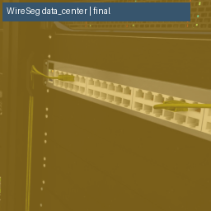
Figure 4.1: Weighted Tiny U-Net output on a held-out WireSeg image. Green indicates overlap, red missed cable pixels and amber false-positive pixels.
This WireSeg overlay is presented because not only is the output produced a number, the missed and false-positive regions demonstrate that even a fast model can have a negative impact on the centreline that is required for grasp-candidate generation.
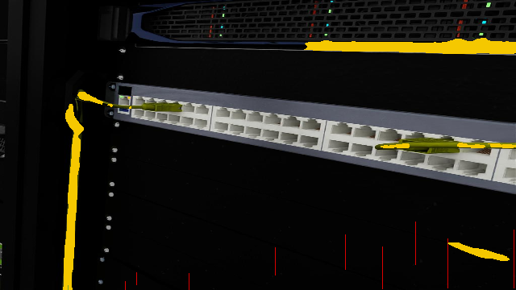
Figure 4.2: Published FASTDLO checkpoint output on a held-out WireSeg image. The result documents the cross-dataset transfer test.
This comparator output is for transfer analysis. The result shows that it cannot be expected that a checkpoint published for one image distribution will perform well on another one unless it is adapted, even if the model used is the same one as used for DLO.
I felt the TUM case was more convincing, because they presented photo terrains of real cables, and had a test with a scenario held out. The TUM-fine-tuned Tiny U-Net achieved precision 0.630, recall 0.590, F1 0.605 and IoU 0.436 on S3, while keeping mean latency to 13.76 ms. In the same S3 held-out scenario, the adapted ResNet-101 FASTDLO model had the highest precision, recall, F1 and IoU of 0.714, 0.836, 0.769 and 0.625 respectively. This is graphically illustrated in the compact model, the adapted model and the unadapted transfer condition in Figures 4.3, 4.4 and 4.5, respectively.
Despite not being the most accurate model, the compact Tiny U-Net is analytically useful. The rate is a good indication of the type of throughput that may be required for a closed loop system, and the not so great masking quality gives the reason for why just speed is not enough. Thus, the model comparison is a support for an engineering decision: If the model was to be used for careful examination and engineering planning, consider using the accuracy oriented model; if a fast model was desired, then additional tests might be needed in time, rejection thresholds, and downstream measures.
With the TUM comparison, there is a change in interpretation from basic feasibility to model selection with a realistic compromise. This adapted ResNet-101 result is better not only due to the recall metric but also due to the recall and overlap being good on the unseen scenario. Recall is also important in the case of cable, as the centreline will be split if they miss some part of the cable, and IoU is important for the candidate generator as there should be spatial consistency between the predicted cable and the visible cable body.
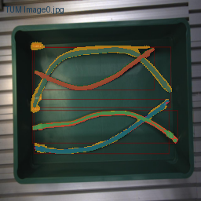
Figure 4.3: TUM-fine-tuned Tiny U-Net output on a held-out S3 image. Teal indicates overlap, red missed cable pixels and amber false-positive pixels.
Despite the residual errors this is the adapted Tiny U-Net which can be a useful speed oriented comparator model, the held out S3 output.
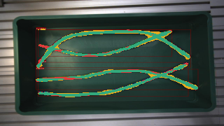
Figure 4.4: Adapted FASTDLO ResNet-101 output on a held-out TUM S3 image. Teal indicates overlap, red missed cable pixels and amber false-positive pixels.
The following is an output from ResNet-101 for the best route measured. The mask is more cohesive than the less robust comparators, but there are still some spots where there is disagreement that are still good for keeping a rejection state prior to grasp execution.
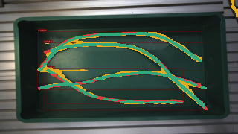
Figure 4.5: Additional adapted FASTDLO ResNet-101 held-out TUM S3 result, included to show scene-level variation.
This extra S3 example will prevent the qualitative evidence being derived from one positive image. It helps with the argument of consistency in S3, but it doesn't do so to the extent of putting out one scenario.
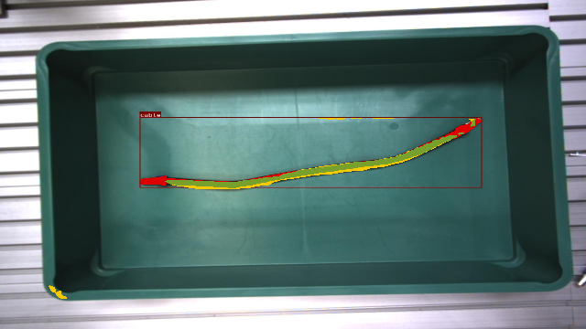
Figure 4.6: Unadapted FASTDLO checkpoint output on a TUM image before scene-specific fine-tuning.
This is the visual equivalent to the transfer score, and is an unadapted FASTDLO output. It facilitates the understanding of the visual domain to be targeted, instead of the name or original purpose of the model.
The fixed seed was used 2000 times to sample the adapted ResNet-101 and the uncertainty was calculated as the difference between the image level score obtained by sampling the S3. The point estimates and intervals are given in Table 4.2. The small ranges are not meant to be a guarantee of generalisation to other cameras, materials of cable and/or robot workspace but are rather a sign of uniformity of the held-out S3 test set.

Table 4.2: Bootstrap uncertainty for the adapted FASTDLO ResNet-101 model on TUM S3.
Metric | Mean | 95% bootstrap interval | Interpretation
Precision | 0.714 | 0.705-0.721 | Most predicted cable pixels were correct, but false positives remained relevant.
Recall | 0.836 | 0.827-0.844 | Most labelled cable area was recovered, reducing but not eliminating missed-centreline risk.
F1 | 0.769 | 0.763-0.775 | The balance of precision and recall was stable across the S3 image-level bootstrap sample.
IoU | 0.625 | 0.617-0.634 | Overlap was substantially stronger than the other tested routes, but still below perfect mask agreement.
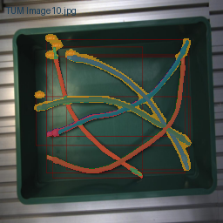
Figure 4.7: Lightweight Tiny U-Net comparison image for the accuracy-latency trade-off.
This comparison displays comparison of speed result and segmentation quality. Mask splitting or centreline move of the model might not be appropriate for generation of grasp points if the model is running fast.
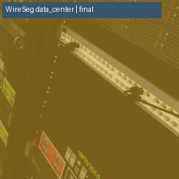
Figure 4.8: Additional WireSeg held-out output used to contextualise synthetic-to-real evidence boundaries.
This is another WireSeg output that doesn't consider as a real-scene validation. The source is useful for controlled comparison, but does not fit as well for deployment inference as held-out real TUM scenes.

4.2 Analysis
The first was the reputation of the model was not at issue, but aligning the datasets for analytical pattern. Although published checkpoint in FASTDLO is not high on unadapted TUM and not performing well on WireSeg, it is a DLO-specific method. The most successful route, however, was the route ResNet-101 which was adapted to real images of TUM. This trend is consistent with the literature reported results of high sensitivity of the DLO perception to appearance, background, occlusion and capture conditions. Therefore, it would be a methodological issue if one decides to use a particular detector just because it has been used with deformable objects in another study.
The second pattern is that of the accuracy/latency trade-off. The adapted ResNet-101 outperformed the TUM-fine-tuned Tiny U-Net by 164% (0.769 vs. 0.605) and 43% (0.625 vs. 0.436) with respect to F1 and IoU, respectively. The mean latency for the cost model was 227.15ms and 4.40FPS; and for the compact model was 13.76ms and 72.68FPS. It's not a one to one, it's not which is better. If the task involves a very slow inspection, then more segmentation might be necessary. When the mask quality is good enough to produce stable candidates, the size of the compact model may be more important in the case of a high frequency closed loop controller.
The third pattern is related to the type of error. Don't forget things to avoid a centreline break in case a cable piece is missed and a valid grasp candidate is lost. Precision is important because if a false positive pixel is generated it can result in a candidate being generated on a background edge or shadow. IoU and F1 are only indicators of the agreement of the mask and not of a robot's capability in approaching, squeezing a gripper and doing a cable manipulation task. The rationale for the qualitative overlays is that they are aimed at suggesting whether the numeric error would have a reasonable impact on the continuity at centreline, endpoint exclusion and local tangent estimation.
The size of the objects and distribution of the images is also significant. For some areas there are few pixels in the cable and there may be some cases where evidence may be lost during downsampling at the crossovers and at ends and shadows. Some models may give a very good area overlap and a broken centreline as output but some may give only small error in the boundary and candidate can still be used. Therefore, the quality of the segmentation is not used as a measure of the grasp quality but rather as a precondition to the detection of the grasp-point.

Table 4.3: Research-question evidence map for the final evaluation.
RQ | Evidence used | Answer supported by this study
RQ1 | Literature synthesis and visual failure cases | Cable perception is affected by occlusion, thin structures, crossings, material variation and domain shift; these appear as false negatives, false positives and broken centreline risk.
RQ2 | Pipeline design, Figures 2.1, 3.2 and Chapter 4 overlays | A cable image can be converted into a candidate route through segmentation, centreline extraction, endpoint/curvature/clearance checks and rejection of uncertain candidates.
RQ3 | Tables 4.1 and 4.2 | Precision, recall, F1, IoU, latency, FPS and bootstrap intervals are appropriate for the measured perception layer; grasp success would require separate robot-level metrics.
RQ4 | Discussion and limitations | Vision-only evidence cannot observe force, slip, hidden contact, material stiffness or task completion, so physical trials or tactile/force feedback remain necessary for deployment claims.
Level of evidence at which the research questions are being addressed is indicated on the Table 4.3. Literature, failure behaviour, designed pipeline and measurable stages, metric selection/comparison and limitations for vision-only inference all contribute to answering RQ1. This mapping will be used to prevent 'overshadowing' the experiment in the conclusion. Most interesting empirical support is for perception and candidate-readiness – has not been assessed for physical grasp success.
The largest pixel error is not necessarily the most important error to detect a grasp point. Some small false positive near cable crossing which results in wrong branch in skeleton. In a narrow bend, the centreline could be split because a small false negative that is a viable grasp point otherwise. The boundary error of straight cable does not affect its use, but may result in IoU drop. Hence, there are qualitative overlays to the tables in Chapter Four — to decide whether or not the error measured would have an impact on selection of candidates downstream.
One of the reasons for this is the transfer evidence which is not being taken into consideration in the models in the dissertation. The extreme speed of otsu morphology was very brittle. Although the Tiny U-Net performed fast and good adaptation, the quality of the segmentation was low. The published checkpoints were not always accurate when the reproduced outside of FASTDLO's distribution. The best measured is the adapted ResNet-101, however, the speed of the inference will have to be carefully designed with the control-loop. What is said is that one architecture is not always better (conditional model selection).
To help strengthen the internal validity of the S3 result, the bootstrap intervals are also provided along with the adapted ResNet-101 score which is presented with no qualification. The range of the F1 values (from 0.763 to 0.775) shows that the mean of the held out images of S3 was very stable. This, however, doesn't eliminate the risk for external validity. Only valid for the sample measured and not for all other cable colours and background, cameras, grippers or lighting conditions. This bifurcation is of interest as it is not reliability within a data set but a split into two.
A consequence is a loss of the possibility to find an optimum operating point at F1. They can choose to be conservative if it's more dangerous to have a false positive or more recallful if it's more dangerous to miss a cable body based on the robotics pipeline. Hence, precision, recall, IoU and latency will be taken into consideration as a whole and not as a single score as proof of readiness to grasp.
The bootstrap result also provides some clues as to the difference between repeatability and external validity. A small range for a measurement of the outcome on the mean S3 means that the measured outcome will be unaffected by an extreme image in the held out image set. Doesn't mean that the model will perform in the same manner on another camera, cable, gripper view or lighting situation. Hence the division of the sample uncertainty and the deployment uncertainty in one of the analyses.
This score dissimilarity is not only the difference between the models but it is the difference between the error pattern. The F1 of 0.059 was not high enough for the Otsu morphology as it was based on thresholding and morphology and not learned features, although it was fast. Using the learned model and positive-class weighting, the weighted Tiny U-Net achieved a higher recall score of 0.549 compared with the original 0.146, for the cable class. Its precision was 0.079 and the gain also introduced regions of false-positives which can cause the skeletons to become noisy or false candidate points in regions of background structure.
The results obtained for FASTDLO and TUM demonstrate the importance of the domain alignment. The published checkpoint was based on a more conservative adaptation of the WireSeg distribution, and in the case of TUM S1/S2 adaptation, ResNet-101 was more aligned with the unseen S3 evaluation set. Its F1 increased from 0.605 for the adapted Tiny U-Net to 0.769 and IoU increased from 0.436 to 0.625. This is at a cost - latency: 4.40 FPS for adapted ResNet-101 model and 72.68 FPS for adapted Tiny U-Net model. Thus the evidence suggests a conditional model selection approach is appropriate and that there is no single best model.
The meaning of the ‘candidate generation' phase changes too. A high recall segmentation model may keep a high percentage of the cable body, but also could generate false regions that go to the centreline stage. Even if it's more tidy to have a high precision model with low recall, this will remove a piece of cable that is actually correct, and even the candidate sampler might be led to believe that the cable is shorter or that it is broken. The regular ResNet-101 result is compared with the adapted result, and the result of the adapted is better, not only to increase the recall value, but also to increase the value of overlap.
Results also reveal how congruence between evidence and decision to be made is related to the quality of evidence. Precision is useful to know whether the predicted cable pixels are reliable, however, a higher precision score can be undesirable, if the recall score is not high enough and centreline is not complete. It may be useful to recall to hold on to the cable bodies, and if it is not precise, there will be false branches. That's why the result from the adapted ResNet-101 is considered to be a more robust one and thus better recall and overlap is achieved on the actual held out route.
Another outcome is a redefinition of the term latency. The smaller version (72.68 FPS) can only look good if the system downstream can cope with less effective masks or if those who have a little doubt are eliminated. The 4.40 FPS adapted ResNet-101 is not fast enough for a high frequency control loop but perhaps can be used for slow planning or careful examination of the scene to localise the cable. The dissertation takes runtime as one of the deployment conditions rather than as a side-issue when accuracy is achieved.
The conditional selection of the final model of the Chapter Four evidence is also uncovered. As for mask evidence, the best is the adapted ResNet-101, but it takes more time to run, hence not the best for all the robotic control contexts. This accuracy may be appreciated in a system that only needs one well designed grasp proposal, or, in a system that needs continuous visual servoing, optimisation or a faster detector with better rejection rules are needed.
Over this reason, the analysis considers the work as a prototype of evidence-based, and not as finished manipulation stack. The measured experiment supports the perceived experiment and the discussed experiment represents the information needed to get to an embodied grasp validation from the candidate-readiness. This provides a better academic strength as the claim is proportional to the data and it gives a definite technical direction for the next experiment.
The interpretation it is given is a stronger portion, as the results aren't looked upon as independent performance indicators. Any metric effects the downstream – loss of pixels can lead to problems with centreline, false positives can lead to false candidates, and latency can limit the types of robotic tasks that the detector can support.
This comparison can be quantified and lead to a design decision, such as: how much precision, recall, overlap and latency is achieved versus how much risk is incurred by using fragmented and uncertain candidate points by masks? This implies that the interpretation is not a product of the model, but that the facts observed are consistent with the use of the interpretation and it can be tracked.
This indicates that the cable manipulation is local errors sensitive and has to be done using qualitative overlays. A false positive further away from the cable may not be made a big deal of, but a false but reasonable branch which is in contact with a crossing could. It is not good to miss the end point, but it is worse to miss the point in the middle of the shipment, and get half of the cable. Due to these examples, the localization of errors will be mentioned in the chapter instead of the mere F1 or IoU.

4.3 Discussion
The results confirm the main thesis of this dissertation, that the grasp-point of a cable can be detected using a vision-based method, but more importantly, it is the explicit indication of the evidence boundary that allows the vision based method to be used in a staged procedure as a perception-to-candidate model. According to the literature DLO manipulation is a coupled problem of perception, representation, planning and control. This is confirmed by the on perception side experiments. Segmentation errors are not image errors, but can be passed on to centreline continuity, local orientation, endpoint distance and endpoint rejection.
Larger networks aren't necessarily better, however. The bigger the model the more time it will take to execute and deploy, and could be unreliable if the training distribution is incorrect. The adaptation/training on S1/S2 and testing on S3 with separation on the scenario level makes the measured improvement convincing. It's not just the model name, but also how domain alignment and validation is implemented and what the performance is.
Also the explanation as to why the models differ is discussed. The issue with Otsu morphology is that it will not work as it is based on some pixel intensity and simple morphology to separate the cable from the scene. However, Tiny U-Net is useful in that it learns local cable-like patterns, but due to limited domain, it may have fragmentation and false positives as it is a small U-Net. The adapted FASTDLO ResNet-101 is better because it is richer in its representation of the cable and because it is adapted and it is adapted to what the cables look like at TUM prior to the eventual S3 testing.
In particular, the results achieved by the adapted FASTDLO ResNet-101 on held-out TUM S3 (where it was developed on S1 and S2) are the best. It's thus more compelling than a tiny hand-picked image sample or qualitative screenshots. It does not however demonstrate autonomous manipulation and generalisation and real-time operation in a robot system. These labels are for sections of the cable that are visible. They do not report on force closure, gripper contact, cable slip or collision-free reachability or task completion.
The study also elucidates the reasons for the limitation of vision-only systems. The shape that can be seen with a camera is not a good indicator of slack, underside contact, friction, stiffness or post-grasp stability but a camera can be used to see the shape that is visible. A deployed robot would need to have tactile and force feedback to fill that gap. Great design choice that the mask/candidates are not executed, but rejcted.
Thus the contribution is a perception and grasp-candidate framework which is reproducable in the context of evidence. Description of the selection/exclusion of the datasets, split into train/val/test, model adaptations, segmentation measures and latency, uncertainty, qualitative failure behaviour. That it is possible to make a technical research project of literature, measured success, measured failure, instead of untested cable manipulated success.
The remainder of the difference between perception and manipulation is the answer to RQ4. Although vision is a good approximation of the cable geometry, it doesn't detect hidden contact and internal tension or force when the gripper is closed. I don't think the study has a fault, it's a limitation and what's presented is honest. The dissertation offers a framework for perception and the generation of candidates which can be used to extend, but not assume, validation in the physical world.
Multiple metrics are needed; this is demonstrated in the response to RQ3. Precision, recall are an indication of accuracy of the segmentation from different perspectives, F1, IoU are an indication of quality of the segmentation, and latency, FPS are an indication of the computational costs. Bootstrap intervals give information on uncertainty. All of these metrics are missing when it comes to contact stability, slip or task completion. Therefore, candidate level and manipulation level metrics other than those used in perception that have been used in this study would be required for a robot study in the future.
The result is thus, a qualified positive answer to RQ2. This pipeline can extract the image observations and return the centreline, geometry based score, and transform it to a set of grasp-candidate evidence based on the visual model, and correctness of the mask. The dissertation does not assert that the candidate that has been generated is physically executable. Visually and Geometrically justifies the candidate's answers to the extent of evidence provided.
The results indicate that contrary to literature, object detection is not the only problem of grasping with DLO. Caporali et al. (2026) and Zhu et al. (2022) emphasize the importance of incorporating perception, planning and control in deformable-object tasks. This coupling is found to begin prior to the robot's movement, and that the geometry that the latter stages operate on, as the cable is moving, is dependent on the quality of the former segmentation. An incorrect mask, even if good in all other aspects, can result in otherwise good candidate-scoring rule being incorrect and give it the wrong view of the object.
This is also an interpretation which has consequences for the ultimate use of the results by a robotics practitioner. The performance in this aspect, compared during the trial, can be used to further develop the adapted model as a perception component, but can't be used for immediate control of the robot without further tests. In reality, the result of the model would have to be used with workspace reachability, temporal consistency and feedback after contact, all of which would need to be calibrated. The dissertation therefore provides an evidence based ‘baseline’ on how well a robot pipeline can perform: Where are the largest errors and where is the validation lacking to make the grasp considered as executable?
The second implication is that the correctness of the candidates is not assumed, but also as a research product is investigated. The result of the adapted ResNet-101 still demonstrates the best mask currently available on the tested data, although the grasp candidate relies on the continuity of the skeleton and the exclusion of the endpoints, and the local tangent stability and clearance around the gripper. Not all acceptable IoU masks will be acceptable for grasping because of the error at the point of crossing or the point the mask is going to be grasped at. Therefore, in the study the geometric validation/rejection logic is still located in the pipeline. Changes the segmentation output into a conservative decision support output and not a high visual score to a manipulation claim.
This also contributes to the explanation of the practical recommendation that came forth from the study. The adapted model is the preferred perception component when task values are much more important to the understanding of quality than is the frequency of updates. An alternative to this is to use the compact model, but the rejection should be conservative and further validation should be performed if a faster closed-loop time for the robot is desired. This is thus not a ranking of models, but an engineering recommendation for a particular situation.
Realistically, that means that deployment follows a multi-phased pathway. The adapted model should first be utilized as a perception part, which proposes cable masks and applicant domains. Then, a robot controller should be required to check: Calibration, reachability, collision free approach, gripper closure and post contact stability. This will de-couple the contribution from the layers to be overclaimed, but may also give an idea of how this dissertation can be used for a later physical validation.
This evidence also helps answer the question on why it is still relevant today although there are no physical grasp trials. The work offers a proof of concept for robot candidate generation and an upstream perception that would take place prior to contact. It explains what is the best perceptual model available, and how much it will cost to use it, as well as what kinds of errors should be dealt with, in turn. Less general than autonomous manipulation, but still workable as a contribution as it does identify a precondition to be measured for testing embodiment later.

CONCLUSION

5.1 Summary of the Study
The results of the study and constraints are presented in the conclusion. In this dissertation, the vision based grasp point detection for deformable cable manipulation was explored. The research addressed a practical robotics problem that the robot cannot directly use the cable mask unless the cable mask can be transformed to a stable centreline, candidate contact point and a feasible grasp representation. The final work therefore only tested and developed a perception-to-candidate framework and not a complete manipulation system.
The adapted ResNet-101 model on the unseen scenario TUM S3 yielded the best empirical result. It achieved precision 0.714, recall 0.836, F1 0.769 and IoU 0.625, with mean inference latency of 227.15 ms, P95 latency of 280.09 ms and 4.40 FPS. This improved the performance than the Tiny U-Net which was fine-tuned at TUM, albeit with a reduced speed. This validates the final decision to go with an accuracy model in the tested environment and not a generic "the best model.
All of the evidence chain, which is a bounded and coherent one, is used to answer the research questions. The research identifies the major cable-perception challenges, proposes a quantifiable image-to-candidate route and presents metrics that show how accurate and fast cable perception can be, while outlining not only how latency and accuracy are achieved, but also vision-only limitations that are still to come. In this manner, it's easy for others to justify the contribution, and not to consider the prototype as a full robot controller.
It's important evidence boundary: evidence-led perception and candidate readiness is the second best embodied grasp success.

5.2 Answers to Research Questions
RQ1 inquired the perception and manipulation issues for vision-based grasp point detection of deformable cables. The dissertation identifies the challenges of occlusion, thin cable width, crossings, background similarity and material variation and domain shift as playing a key role. These impact segmentation scores, as well as centreline continuity, and candidate reliability.
The question in RQ2 was what kinds of steps can be taken to convert cable image observations into grasp-point candidates that are feasible. The study replies to this by a staged pipeline, which includes image acquisition, cable segmentation, centreline extraction, endpoint and curvature checks, clearance reasoning and candidate scoring and a defined rejection state. The candidate generation reasoning is done in the perception layer with evidence, and this is validated when physically executed.
RQ3 was: What are the evaluation metrics? Precision, recall, F1, IoU, latency, FPS and bootstrap intervals were used as study metrics as they measure different aspects of perception quality and computational cost. The bottom line is there's no single measure. The mask quality needs to be coupled with knowledge of how the errors affect the centreline/candidate formation to be grasp-ready.
RQ4 addressed what constraints are left in the system where the vision is the primary form of feedback to the system over tactile or force feedback. This is because only with vision can the invisible forces of contact, cable tension, friction or post-grasp stability be determined. Therefore, no manipulation of the user is attempted to create an image level claim and candidate generation for the dissertation.

5.3 Main Contributions
The main contribution is an evaluation framework which is reproducible and which is related to cable segmentation and grasp-candidate reasoning. The work involves selection of the data set for the work, pre-processing, separation at the level of the scenarios, adaptation of the model, choice of the metrics, measure of latency, estimation of uncertainty and proof of failure in qualitative form. It also shows the importance of using synthetic and real-image evidence separately: The evidence based on the WireSeg was based on a controlled comparison while the held-out real scene evidence was based on a more solid real scene test, the TUM S3.

5.4 Limitations
The restriction is highlighted. The last test was performed using one TUM out-of-the-box scenario and the labels were used for the visualization of the visible pixels of the cable and not the successful grasping locations. Reachability, collision avoidance, force control, cable slip and temporal tracking and task completion were not measured in the experiments. These latency numbers were CPU only and not full robot control loop latency. These restrictions do not take away the contribution, but they do restrict deploying claims explicitly declared in the dissertation at the evidence level.

5.5 Future Work
Future opportunities include expanding the study to include additional independent real capture sessions, object size strata, occlusion levels, brightness and blur perturbations and to include candidate-level labels and physical grasp trials. The next assessment would be if the chosen candidate could be approached, if contact could be made without collision, and if the contact could be made and maintained without loss of contact and success in a specified manipulation phase. That would link the perception evidence contained in this dissertation with complete embodied robotic manipulation.
The last claim is therefore intentionally constrained and yet significant. The dissertation does not solve the problem of deformable cable manipulation completely, it would help the perception and the candidate generation process required for such a system. The measured comparison, scene-held-out testing and uncertainty reporting adds strength to the contribution over a demonstration only based on screenshots and a small hand-picked sample.
The evidence also suggests that there are two conflicting misinterpretations that must not be adopted by the interpretation. The first mistake would be to ignore the work, since it does not contain any physical grasp trials. That would be a case of turning a blind eye to the significance of a managed notion and a candidate-generation examination. The second error could be that it's an independent system for manipulating cables. That defensible middle ground is that an important upstream component is provided in the dissertation and the evidence to be presented before claims of deployment is specified.
The study suggests that in practice the accuracy-first model is only viable if the task is not sensitive to the measured inference cost and/or if there is additional optimisation opportunity. In situations where closed-loop updates are required often, the small size of the model may still be preferrable, if other measures are undertaken to manage fragmented masks and potentially unknown candidates. This represents a conditional recommendation, as opposed to simply a preference for a larger model, based on the operational requirements.
BIBLIOGRAPHY

Caporali, A., Cuiral-Zueco, I., Lopez-Nicolas, G. and Palli, G. (2026) 'Robotic perception and manipulation of deformable linear objects: A survey', The International Journal of Robotics Research. doi: 10.1177/02783649261432253.
Malvido Fresnillo, P., Vasudevan, S., Mohammed, W.M., Martinez Lastra, J.L. and Perez Garcia, J.A. (2023) 'An approach based on machine vision for the identification and shape estimation of deformable linear objects', Mechatronics, 96, 103085. doi: 10.1016/j.mechatronics.2023.103085.
Wu, W., Zhu, Y., Zheng, X. and Guo, Y. (2022) 'A novel cable-grasping planner for manipulator based on the operation surface', Robotics and Computer-Integrated Manufacturing, 73, 102252. doi: 10.1016/j.rcim.2021.102252.
Holešovský, O., Škoviera, R. and Hlaváč, V. (2024) 'MovingCables: Moving Cable Segmentation Method and Dataset', IEEE Robotics and Automation Letters, 9(8), pp. 6991-6998. doi: 10.1109/LRA.2024.3416800.
Holešovský, O. (2026) Interactive Robotic Moving Cable Segmentation by Motion Correlation. Available at: https://github.com/holesond/cmcor (Accessed: 5 September 2026).
Arriola-Rios, V.E., Guler, P., Ficuciello, F., Kragic, D., Siciliano, B. and Wyatt, J.L. (2020) 'Modeling of deformable objects for robotic manipulation: A tutorial and review', Frontiers in Robotics and AI, 7, 82. doi: 10.3389/frobt.2020.00082.
Sanchez, J., Corrales, J.A., Bouzgarrou, B.C. and Mezouar, Y. (2018) 'Robotic manipulation and sensing of deformable objects in domestic and industrial applications: A survey', The International Journal of Robotics Research, 37(7), pp. 688-716. doi: 10.1177/0278364918779698.
Zhu, J., Navarro, B., Fraisse, P., Crosnier, A. and Cherubini, A. (2022) 'Challenges and outlook in robotic manipulation of deformable objects', IEEE Robotics & Automation Magazine, 29(3), pp. 67-77. doi: 10.1109/MRA.2022.3147415.
UIUC RMDLO (2026) Representing and Manipulating Deformable Linear Objects. Available at: https://github.com/RMDLO (Accessed: 5 September 2026).
Saunders, M., Lewis, P. and Thornhill, A. (2019) Research Methods for Business Students. 8th edn. Harlow: Pearson.

APPENDIX A - EXPERIMENTAL EVALUATION PROTOCOL

Precision | F1 | Mean latency / FPS
0.080 | 0.059 | 3.18 ms / 314.1
0.079 | 0.115 | 14.19 ms / 70.5
0.154 | 0.019 | 707.47 ms / 1.41
0.853 | 0.427 | 725.33 ms / 1.38
0.630 | 0.605 | 13.76 ms / 72.68
0.714 | 0.769 | 227.15 ms / 4.40

