User Interface Design

CODE: 23CSE113 LAB

Submitted by
Name | A.YESWANTH
Roll Number | AV.SC.U4CSE25003
Year/Sem/Section | 1st YEAR / SEM-2 / CSE-A
Credits | 03

Submitted to | DR .RAJ KUMAR BATCHU
Designation | ASST.PROFFESSOR (Sl. Grade)
Department | SCHOOL OF COMPUTING

DUOLINGO WEBSITE CLONE

SRH Website Clone
AIM: Create a fully functional clone of the SunRisers Hyderabad (SRH) official website using HTML, CSS, and JavaScript, replicating the appearance, layout, and interactive behaviour of a real-world, industry-level sports franchise web application.

About the Project:
This project involves font end of the creation of a clone of the Duolingo website — one of the most popular and widely recognized language learning platforms in the world. Its website is known for its clean design, vibrant colours, smooth interactions, and engaging user experience.
HTML5 | To structure the content and layout of the webpage
CSS3 | To style, design, and animate the visual appearance
JAVA SCRIPT To add interactivity: fire animations, squad filters, scroll effects
PROGRAM:
HTML PART:
<!-- NAV -->
<nav>
<a href="#" class="nav-logo">
<div class="nav-logo-icon">SRH</div>
<div class="nav-logo-text">Sun<span>Risers</span><br>Hyderabad</div>
</a>
<ul class="nav-links">
<li><a href="#matches">Matches</a></li>
<li><a href="#squad">Squad</a></li>
<li><a href="#news">News</a></li>
<li><a href="#about">About</a></li>
<li><a href="#" class="nav-cta">Fan Zone</a></li>
</ul>
</nav>

<!-- HERO -->
<section class="hero" id="home">
<div class="hero-fire-lines" id="fireLines"></div>
<div class="hero-bg"></div>

<div class="hero-badge">IPL 2026 Season</div>
<h1 class="hero-title">
Feel the Heat,
<span>Fear the Fire</span>
</h1>
<p class="hero-tagline">Sunrisers Hyderabad &mdash; Est. 2013 &mdash; Champions 2016</p>

<div class="hero-ctas">
<a href="#matches" class="btn-primary">View Fixtures</a>
<a href="#squad" class="btn-secondary">Meet the Squad</a>
</div>

<div class="hero-scroll" onclick="document.querySelector('.ticker').scrollIntoView({behavior:'smooth'})">
<svg width="16" height="24" viewBox="0 0 16 24" fill="none" stroke="currentColor" stroke-width="1.5">
<path d="M8 0v20M2 14l6 8 6-8"/>
</svg>
Scroll Down
</div>
</section>

<!-- TICKER -->
<div class="ticker">
<div class="ticker-inner" id="ticker">
<span class="ticker-item">SRH vs RCB &mdash; 6 June 2026 &mdash; Rajiv Gandhi Stadium <span class="ticker-sep">◆</span></span>
<span class="ticker-item">Abhishek Sharma &mdash; 1823 IPL Runs <span class="ticker-sep">◆</span></span>
<span class="ticker-item">Travis Head &mdash; 169.39 Strike Rate <span class="ticker-sep">◆</span></span>
<span class="ticker-item">Heinrich Klaasen &mdash; 105* Best Score <span class="ticker-sep">◆</span></span>
<span class="ticker-item">Pat Cummins &mdash; Captain &mdash; Coach: Daniel Vettori <span class="ticker-sep">◆</span></span>
<span class="ticker-item">SRH vs RCB &mdash; 6 June 2026 &mdash; Rajiv Gandhi Stadium <span class="ticker-sep">◆</span></span>
<span class="ticker-item">Abhishek Sharma &mdash; 1823 IPL Runs <span class="ticker-sep">◆</span></span>
<span class="ticker-item">Travis Head &mdash; 169.39 Strike Rate <span class="ticker-sep">◆</span></span>
<span class="ticker-item">Heinrich Klaasen &mdash; 105* Best Score <span class="ticker-sep">◆</span></span>
<span class="ticker-item">Pat Cummins &mdash; Captain &mdash; Coach: Daniel Vettori <span class="ticker-sep">◆</span></span>
</div>
</div>

<!-- STATS -->
<div class="stats-section">
<div class="stats-grid">
<div class="stat-item">
<div class="stat-number">287<span>/3</span></div>
<div class="stat-label">Highest Team Total (IPL Record)</div>
</div>
<div class="stat-item">
<div class="stat-number">13<span>+</span></div>
<div class="stat-label">Seasons of IPL Cricket</div>
</div>
<div class="stat-item">
<div class="stat-number">01</div>
<div class="stat-label">IPL Championship Title (2016)</div>

CSS PART:
*, *::before, *::after { box-sizing: border-box; margin: 0; padding: 0; }

:root {
--orange: #F05A00;
--orange-light: #FF7722;
--orange-glow: #FF6600;
--dark: #0A0A0A;
--dark2: #111111;
--dark3: #1A1A1A;
--dark4: #222222;
--gray: #888888;
--light: #F5F3EE;
--white: #FFFFFF;
--gold: #D4A017;
}

html { scroll-behavior: smooth; }

body {
font-family: 'Barlow', sans-serif;
background: var(--dark);
color: var(--white);
overflow-x: hidden;
}

/* ===== NAV ===== */
nav {
position: fixed;
top: 0;
left: 0;
right: 0;
z-index: 1000;
display: flex;
align-items: center;
justify-content: space-between;
padding: 0 60px;
height: 72px;
background: rgba(10,10,10,0.92);
backdrop-filter: blur(12px);
border-bottom: 1px solid rgba(240,90,0,0.2);
transition: all 0.3s;
}

.nav-logo {
display: flex;
align-items: center;
gap: 12px;
text-decoration: none;
}

.nav-logo-icon {
width: 44px;
height: 44px;
background: var(--orange);
clip-path: polygon(50% 0%, 100% 25%, 100% 75%, 50% 100%, 0% 75%, 0% 25%);
JAVA SCRIPT:
// Fire lines in hero
const container = document.getElementById('fireLines');
for(let i = 0; i < 20; i++) {
const line = document.createElement('div');
line.className = 'fire-line';
line.style.left = Math.random() * 100 + '%';
line.style.animationDelay = Math.random() * 5 + 's';
line.style.animationDuration = (2 + Math.random() * 4) + 's';
line.style.opacity = 0.3 + Math.random() * 0.5;
container.appendChild(line);
}

// Nav scroll effect
window.addEventListener('scroll', () => {
const nav = document.querySelector('nav');
if (window.scrollY > 80) {
nav.style.background = 'rgba(10,10,10,0.98)';
nav.style.borderBottomColor = 'rgba(240,90,0,0.35)';
} else {
nav.style.background = 'rgba(10,10,10,0.92)';
nav.style.borderBottomColor = 'rgba(240,90,0,0.2)';
}
});

// Squad filter
function filterSquad(btn, role) {
document.querySelectorAll('.filter-btn').forEach(b => b.classList.remove('active'));
btn.classList.add('active');
document.querySelectorAll('.player-card').forEach(card => {
if (role === 'all' || card.dataset.role === role) {
card.style.display = 'flex';
} else {
card.style.display = 'none';
}
});
}

OUTPUT: 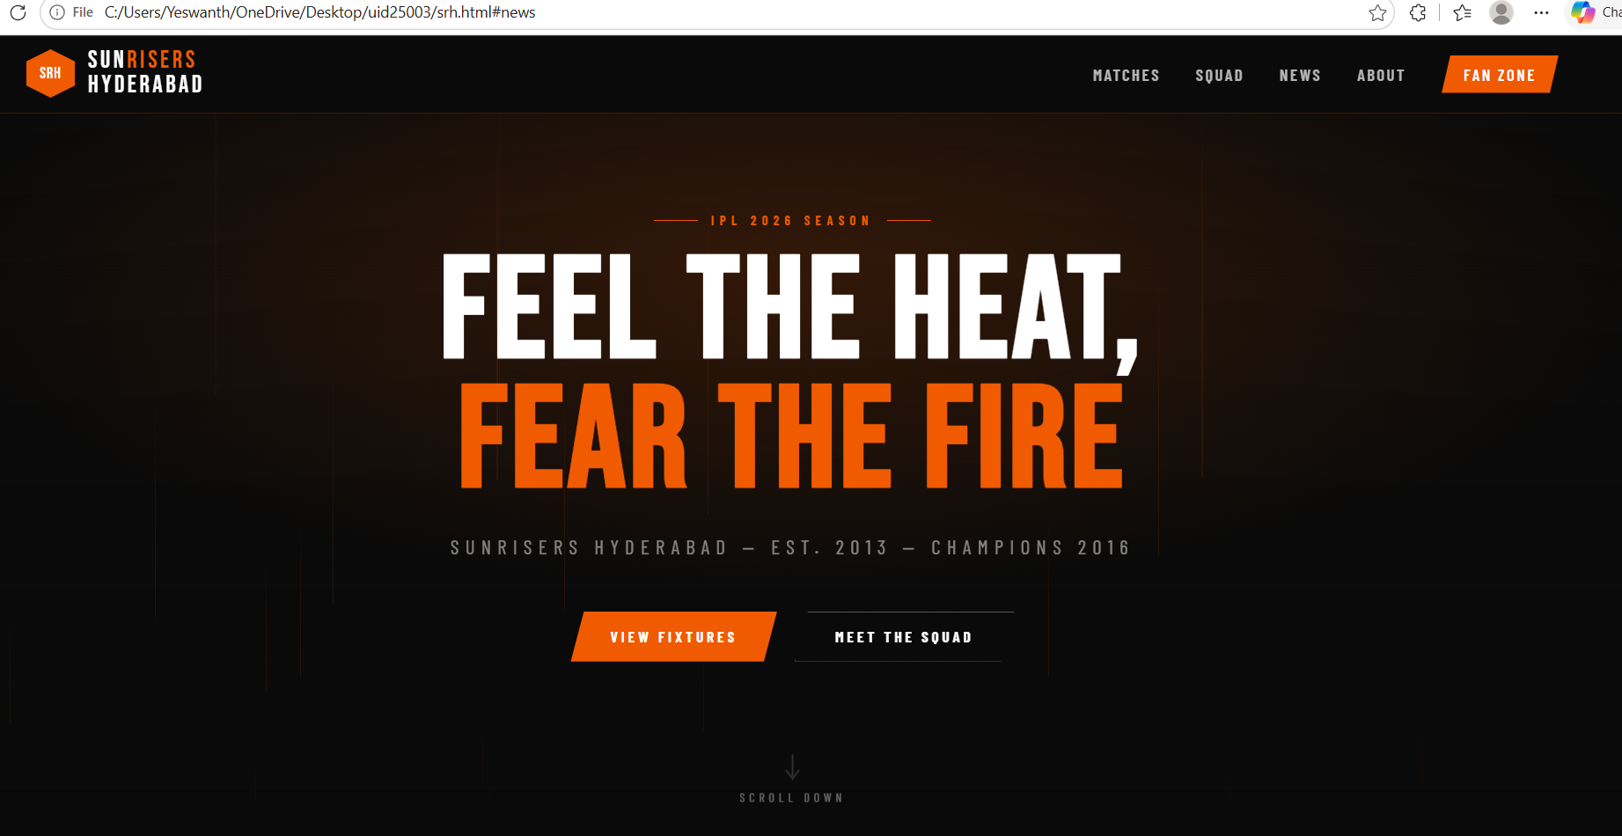

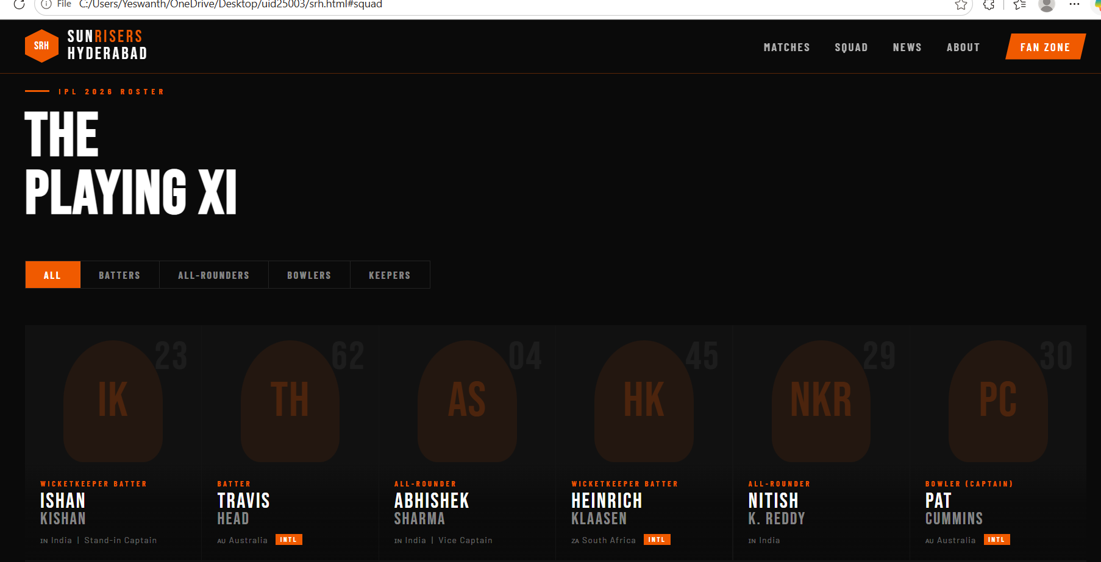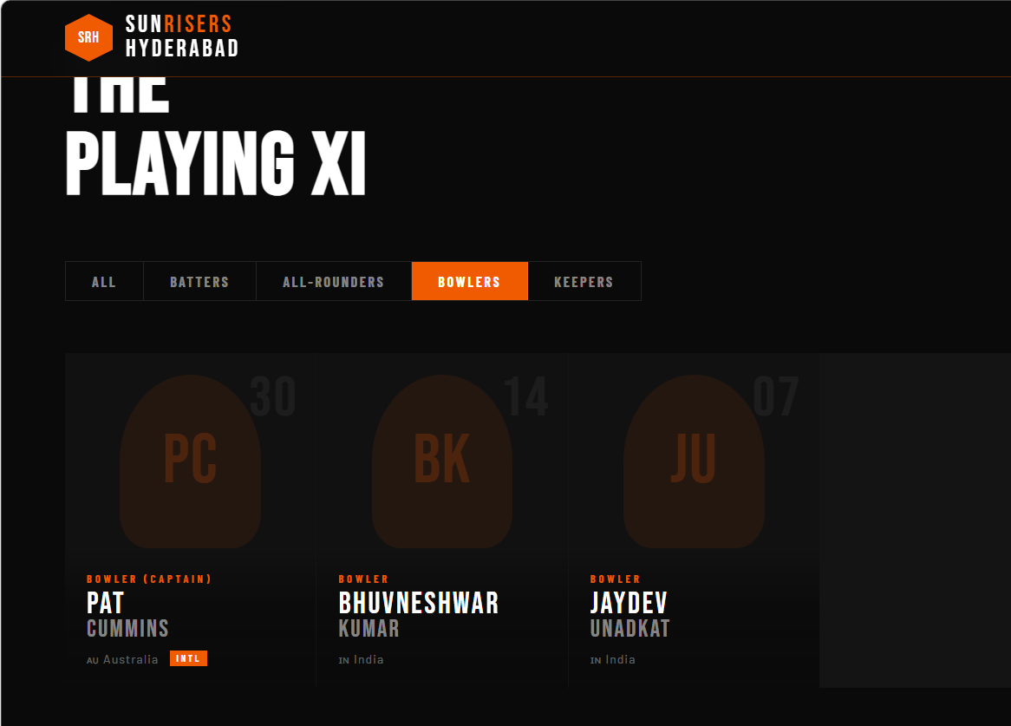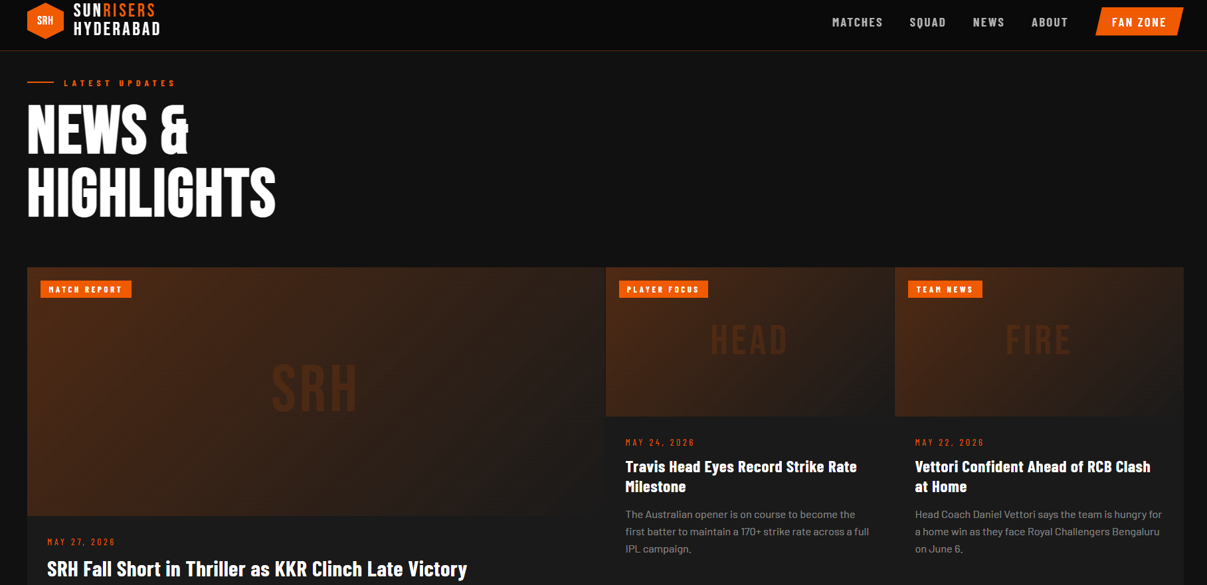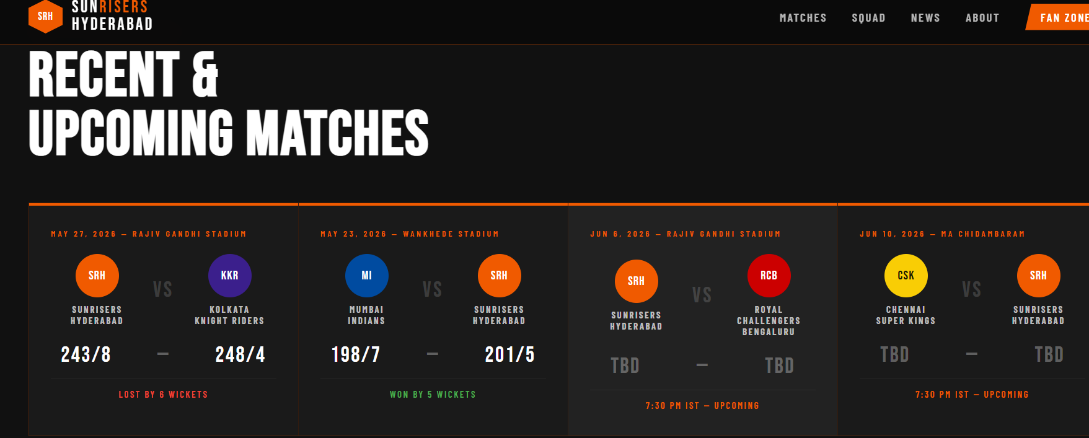
Explanation of TAGS:
HTML Tags:
Structural / Layout Tags
- <!DOCTYPE html> — Declares the document as HTML5. Always the first line.
- <html lang="en"> — The root element of the page. lang="en" helps browsers and screen readers identify the language.
- <head> — Contains metadata (not visible on the page): charset, viewport settings, title, and linked resources.
- <body> — Everything visible on the page lives here.
Head-specific Tags
- <meta charset="UTF-8"> — Sets character encoding so special characters render correctly.
- <meta name="viewport" ...> — Makes the page responsive on mobile devices.
- <title> — Sets the browser tab text.
- <link> — Links external resources. Used here to load Google Fonts and styles.css.
Navigation & Sectioning
- <nav> — Semantic tag for the navigation bar. Helps search engines and screen readers understand the purpose.
- <section> — Groups thematically related content (hero, features, stats, etc.). Each section is a self-contained chunk.
- <footer> — Semantic tag for the bottom of the page (links, copyright, socials).
Text & Heading Tags
- <h1> — The main page heading. There should only be one per page for SEO. Used in the hero.
- <h2> — Section headings (Features, Stats, etc.).
- <h3> — Sub-headings inside cards (Spaced Repetition, Gamification, etc.).
- <h4> — Used in the footer column titles.
- <p> — Paragraph text. Used for descriptive body copy throughout.
- <span> — An inline container with no semantic meaning. Used here to wrap flag emojis and badge text so they can be styled independently.
Interactive / Link Tags
- <a href="#"> — Anchor tag creating clickable links. href="#" is a placeholder (goes nowhere). Used for nav buttons, language pills, app badges, and footer links.
Graphics
- <svg> — Scalable Vector Graphics. Used to draw the Duolingo owl logo and hero owl entirely in code — no image files needed.
- <ellipse>, <circle>, <rect>, <path> — SVG shape elements used to build the owl illustration.
Div — the Generic Container
- <div> — A block-level container with no semantic meaning. Used extensively for grouping and layout purposes (cards, grids, rows, wrappers).

CSS Concepts:
:root and CSS Variables
Defines reusable custom properties for the entire SRH colour palette. Used throughout as var(--orange), var(--dark), etc., making it easy to update the entire colour scheme from one place.
:root {
--orange: #F05A00;
--orange-light: #FF7722;
--dark: #0A0A0A;
--dark2: #111111;
--white: #FFFFFF;
}

Reset (* , *::before, *::after)
Removes default browser margin and padding, and sets box-sizing: border-box so padding does not expand element sizes unexpectedly. Ensures consistent rendering across all browsers.

Flexbox (display: flex)
Used almost everywhere for layout — navbar, hero, ticker, match cards, squad grid, news grid, stats bar, sponsors row, and footer. Key properties used:
- justify-content — aligns items along the main axis (space-between, center, flex-end)
- align-items — aligns items along the cross axis (center, flex-start, flex-end)
- flex-direction — sets row or column layout
- gap — spacing between flex children without margins
- flex-wrap — allows items to wrap on smaller screens
- flex: 1 — makes an item grow to fill available space

CSS Grid (display: grid)
Used in the squad grid and news grid sections. Key properties:
- grid-template-columns: repeat(auto-fill, minmax(220px, 1fr)) — auto-wraps player cards responsively without needing media queries.
- grid-template-columns: 2fr 1fr 1fr — used in the news section for the large featured story plus two smaller cards.

clip-path
Creates the distinctive angular/parallelogram shape on all SRH buttons and the CTA elements, matching the geometric SRH jersey design aesthetic.
/* Angled button shape */
clip-path: polygon(12px 0%, 100% 0%, calc(100% - 12px) 100%, 0% 100%);

Transitions & Animations
- transition: all 0.2s — smooth hover effects on buttons, player cards, news cards, and nav links.
- @keyframes riseUp — animates 20 randomly placed fire lines rising from the bottom of the hero section, creating the signature fire effect.
- @keyframes ticker — scrolls the orange news/stats ticker bar from right to left in a continuous loop using translateX.
- @keyframes bounce — gently bobs the scroll indicator arrow up and down in the hero.

position: fixed
Applied to the <nav> so it stays pinned at the top of the screen as the user scrolls. Combined with backdrop-filter: blur(12px) for the frosted-glass dark effect.

linear-gradient & radial-gradient
Used extensively to create the dark fire aesthetic:
- radial-gradient in the hero — creates the subtle orange glow behind the hero text, mimicking fire light.
- linear-gradient on player cards — fades from transparent at the top to near-black at the bottom so player names remain readable.
- linear-gradient on fire lines — each animated line fades from orange at base to transparent at tip.

aspect-ratio
Applied to player cards (aspect-ratio: 3/4) to maintain a consistent portrait card shape regardless of screen size, without needing fixed pixel heights.

Media Query
@media (max-width: 900px) { ... }
Adjusts layout for mobile: hides the desktop nav links, stacks flex rows vertically, reduces padding, and collapses the news grid to a single column.

Class Selectors & Modifiers
Classes like .btn-primary, .btn-secondary, .result-win, .result-loss, .result-upcoming follow a modifier pattern. A base class sets shared styles and modifier classes layer on specifics. This keeps the CSS DRY (Don’t Repeat Yourself).

Tags Used :
<<!DOCTYPE>, <html>, <head>, <body>, <meta>, <title>, <link>, <nav>, <section>, <footer>, <h1>–<h2>, <p>, <a>, <div>, <span>, <svg>, <button>, <ul>, <li>
Final Thought:
This project proves that with just HTML, CSS, and JavaScript alone, you can build a fully functional, visually striking, and professional-looking sports franchise website that closely mirrors a real-world product used by millions of fans worldwide.

The SRH clone demonstrates mastery of front-end fundamentals — dark theme design, CSS animations, interactive JavaScript filters, responsive layout, and strong visual identity — making it a compelling portfolio piece and a solid foundation to build upon as you move into JavaScript frameworks and full-stack development

