NAME : CH.YESWANTH

ROLL NO :422131

SECTION :A

UNIX ASSIGNMENT 07

2. Write a shell script that list the memory usage and cpu usage of multiple machines.

SECOND.SH

#!/bin/bash

machines=("student@192.168.24.147" "student@192.168.24.123")

for machine in "${machines[@]}"; do

echo "Memory and CPU usage for $machine:"

echo "Memory Usage:"

ssh "$machine" 'free -m'

echo "CPU Usage:"

ssh "$machine" 'mpstat'

echo

done

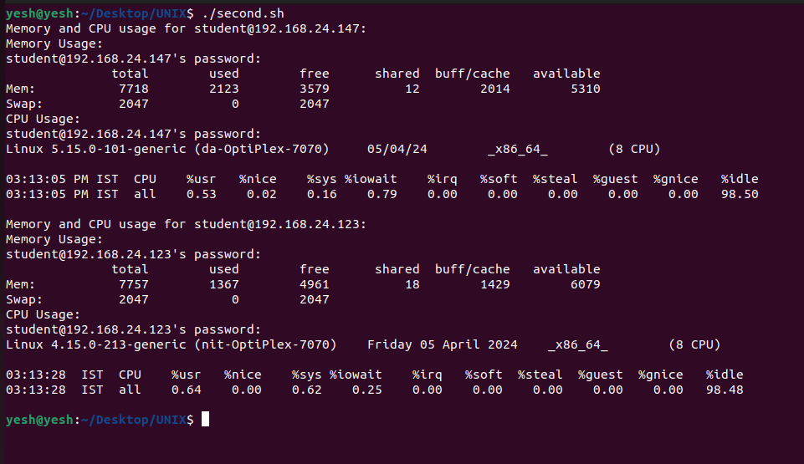

1. Write shell script for commands : more,nl,nice,passwd,pr,rlogin,rcp,rsh,talk,telnet,tput,tty,uname,wc,who,write

MORE COMMAND

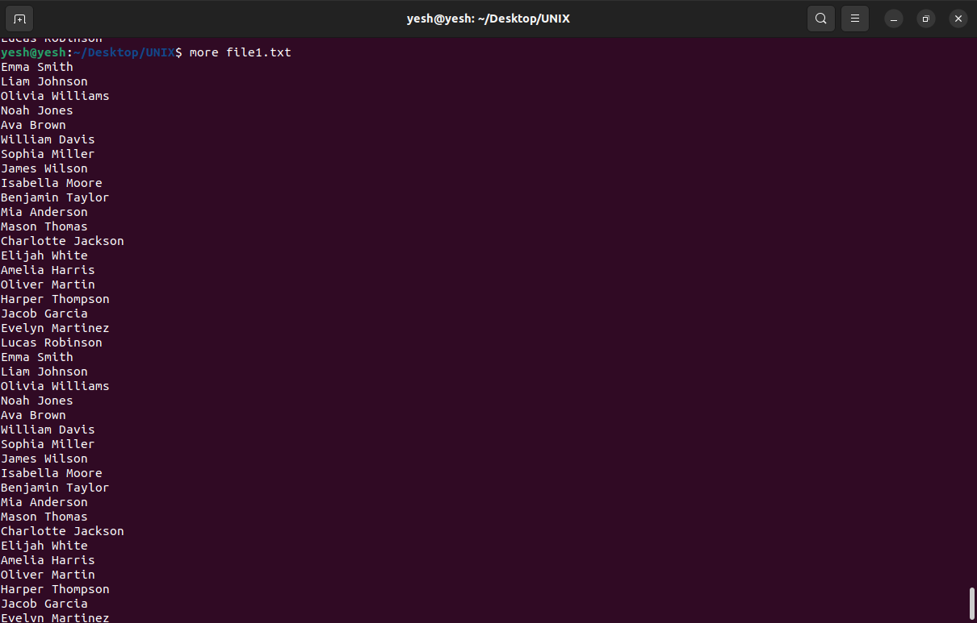

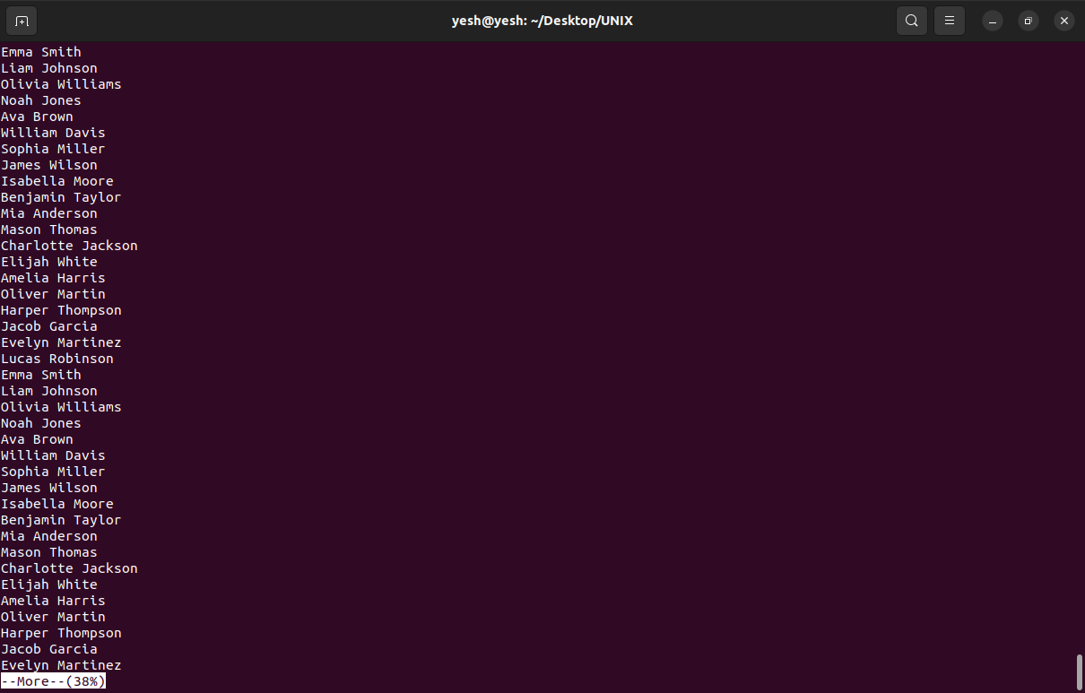

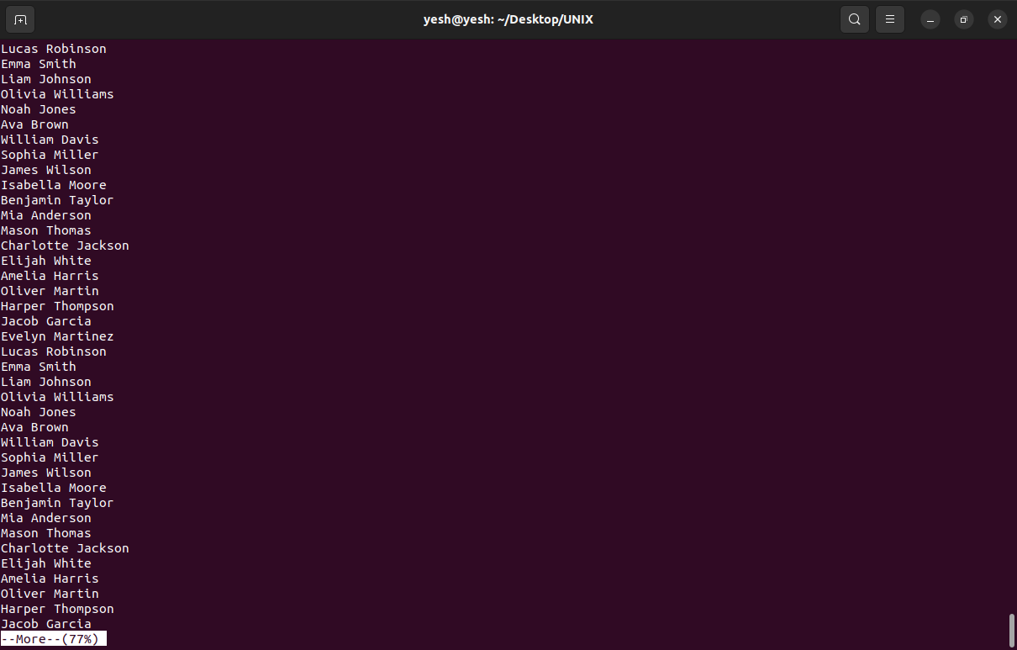

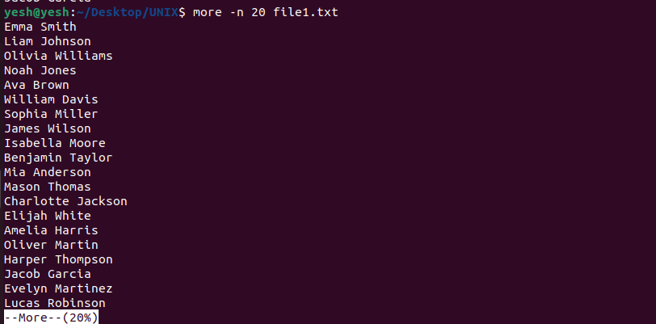

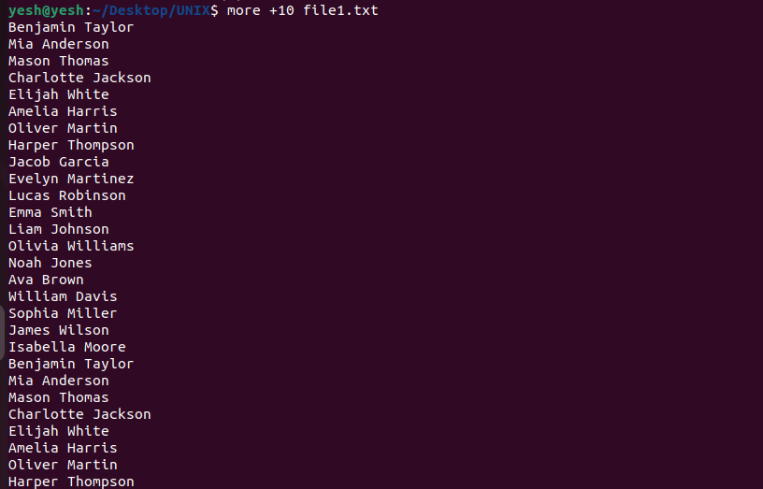

NL COMMAND

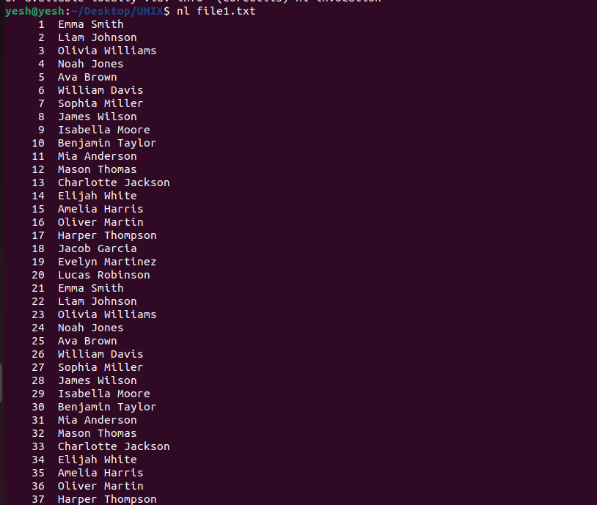

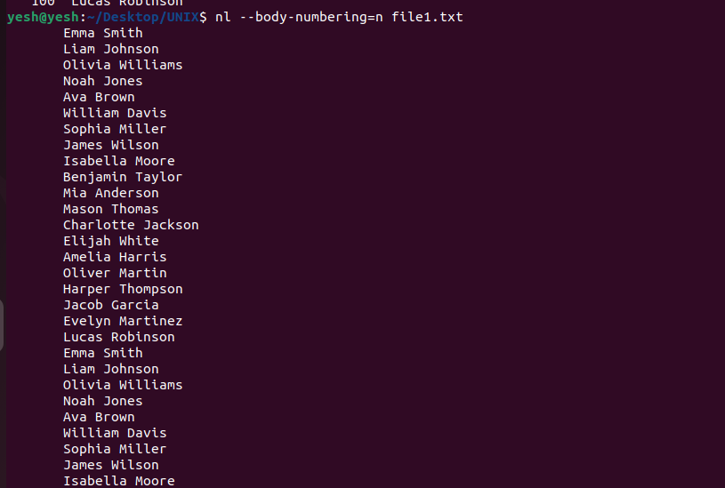

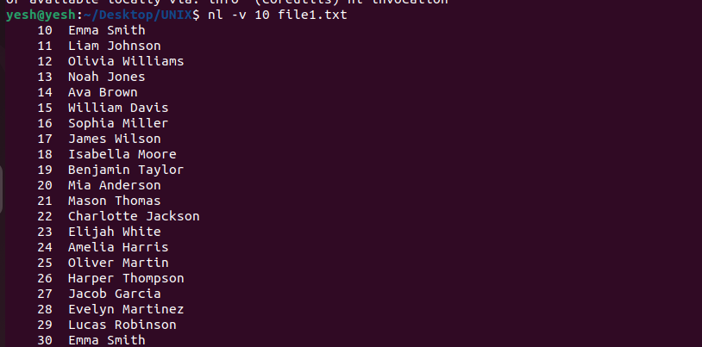

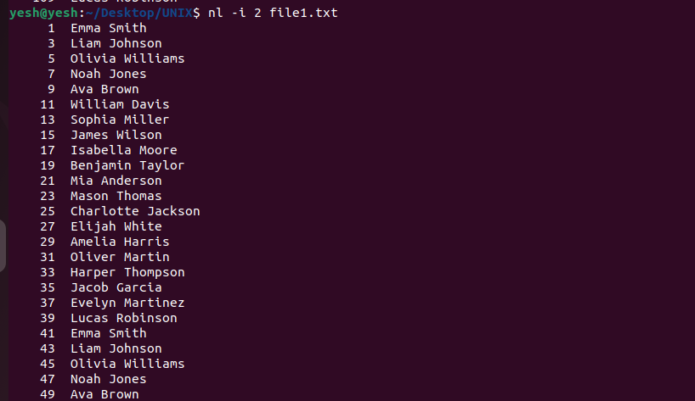

NICE COMMAND

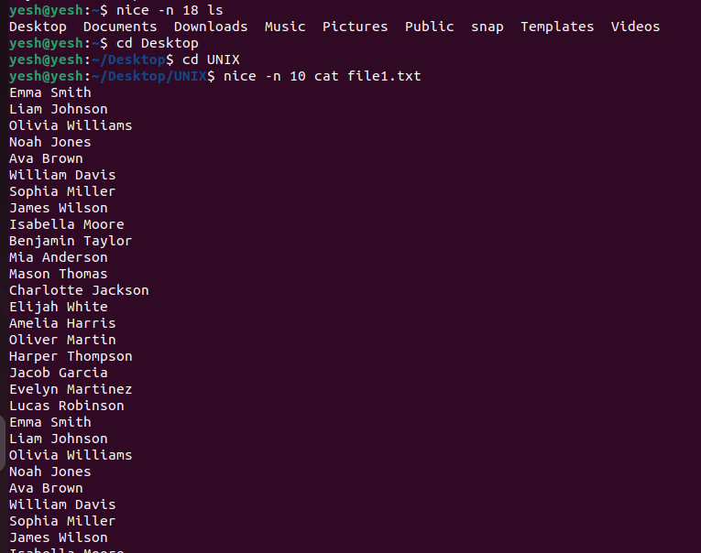

PRINTING NICENESS OF CURRENT PROCESSES

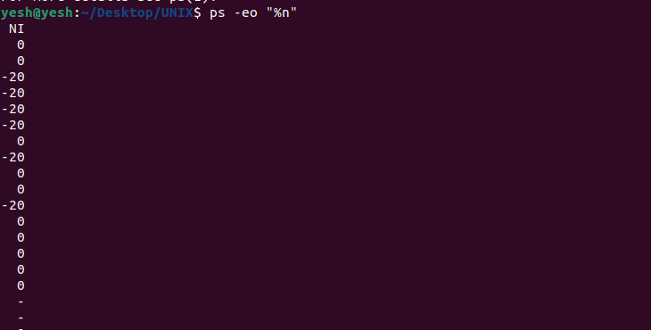

PASSWD

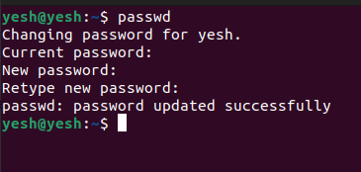

PR

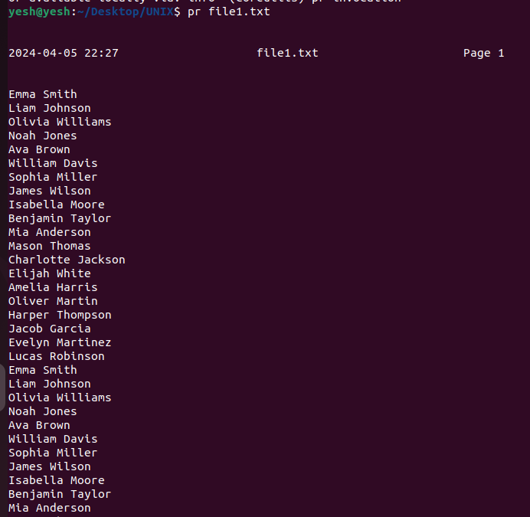

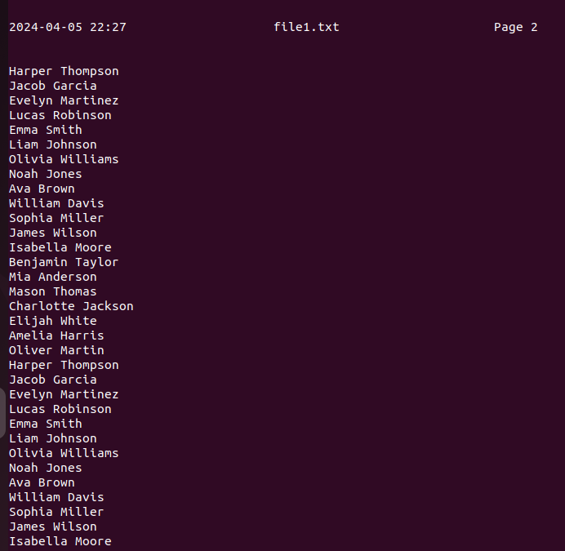

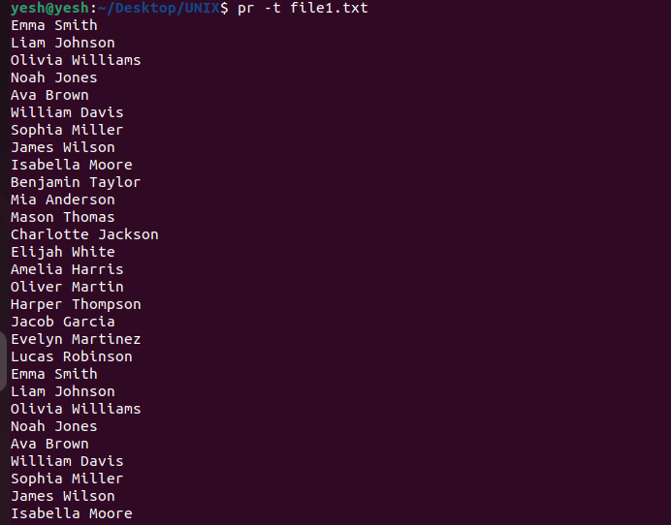

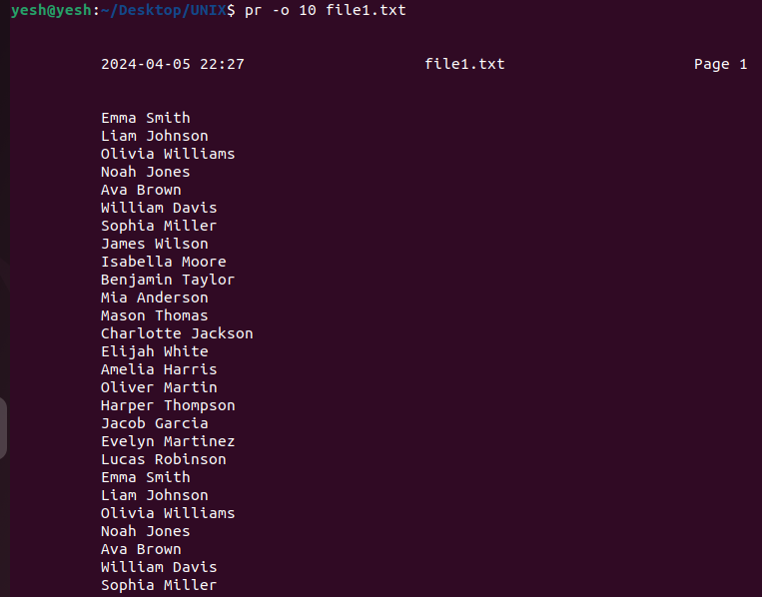

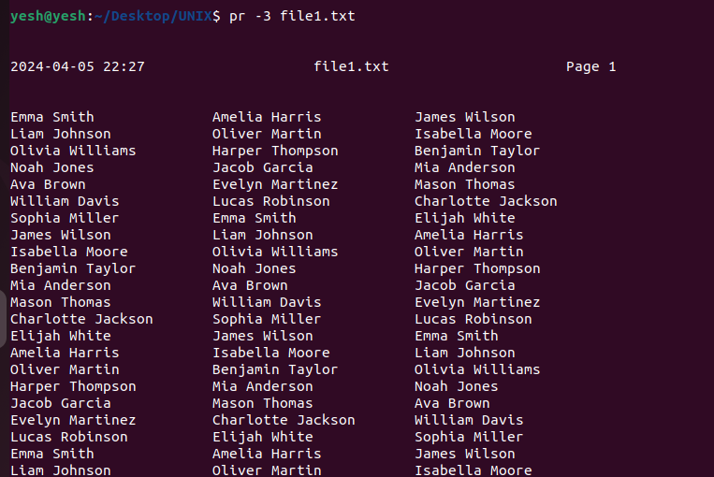

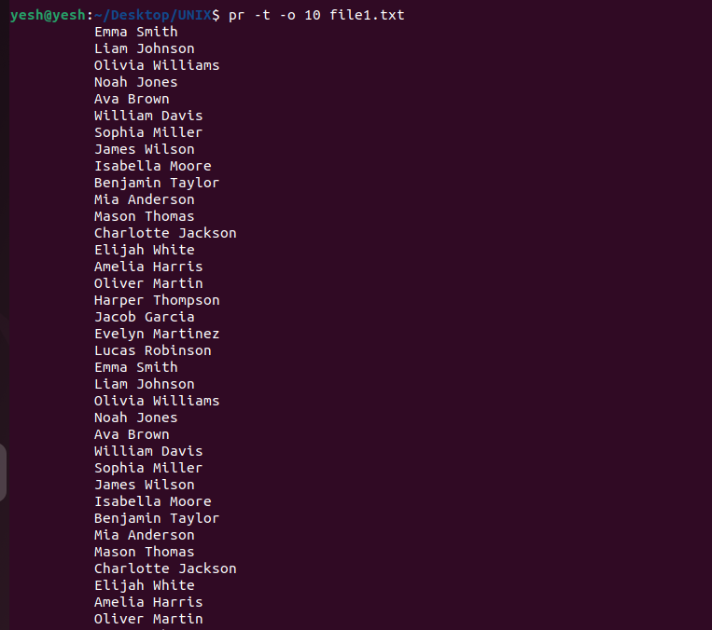

Rsync COMMAND(instead of rcp)

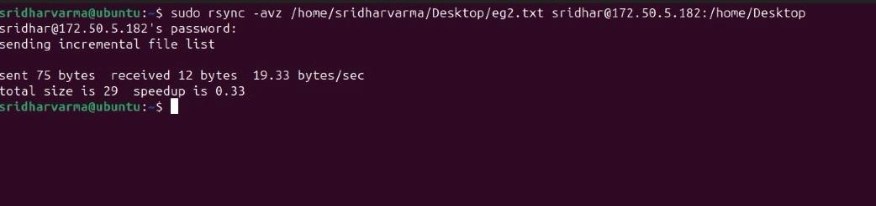

RLOGIN

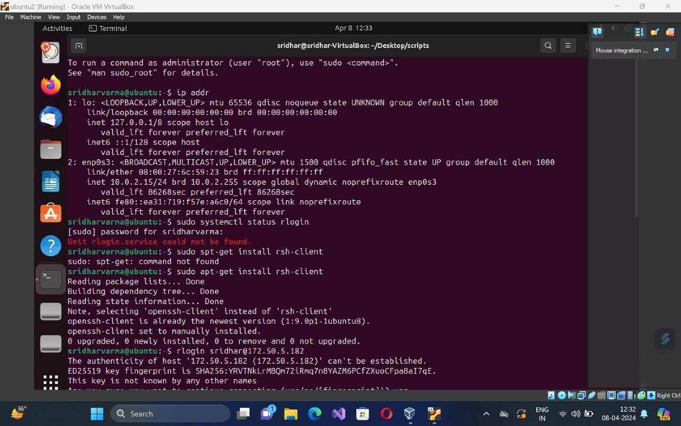

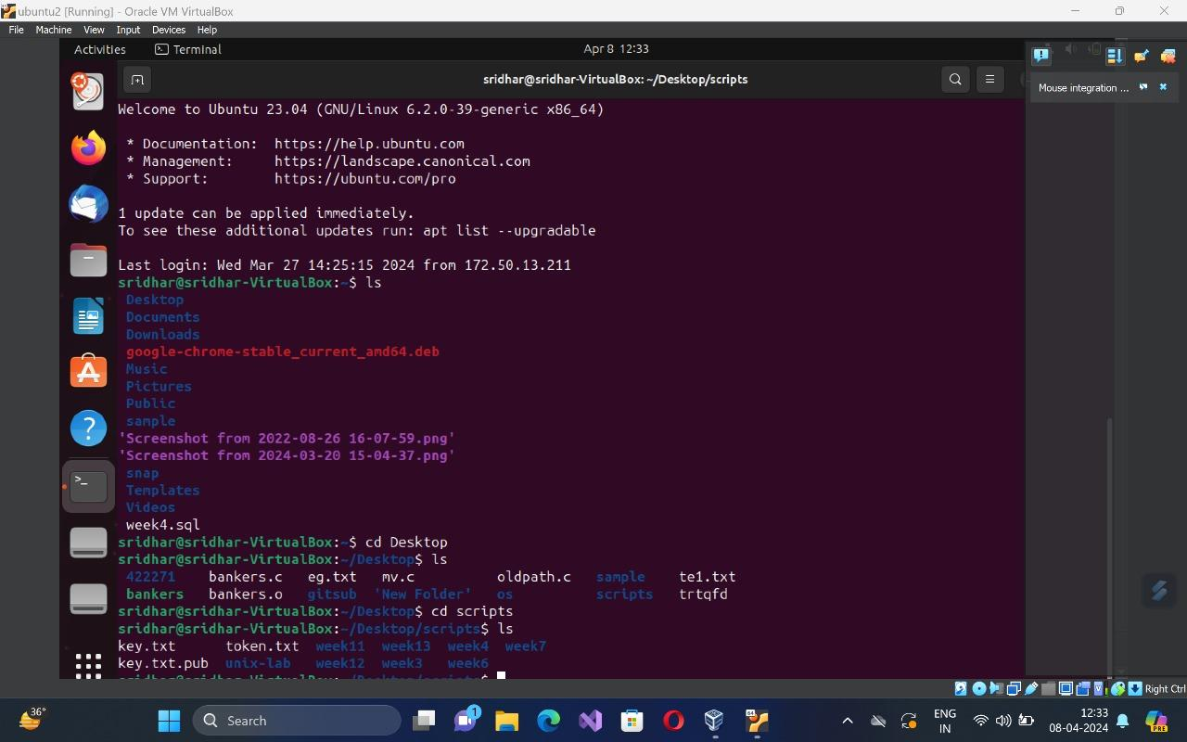

RSH

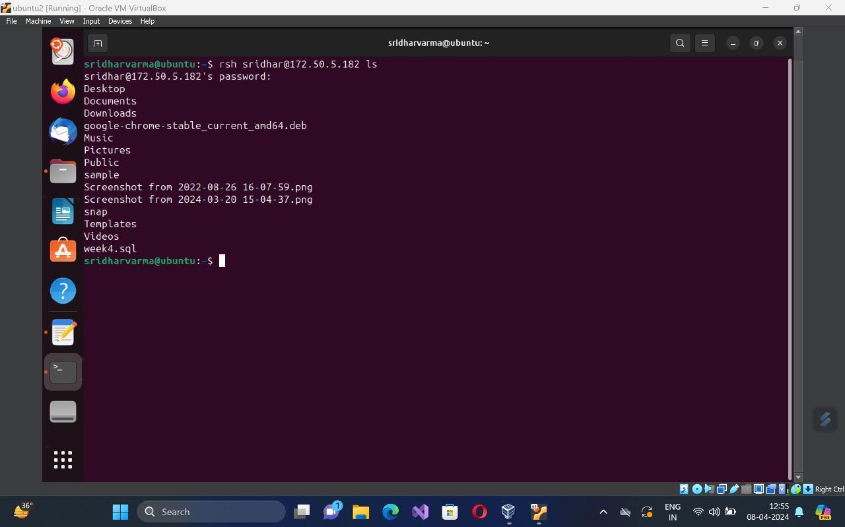

TALK

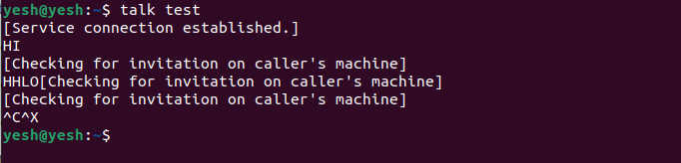

TELNET

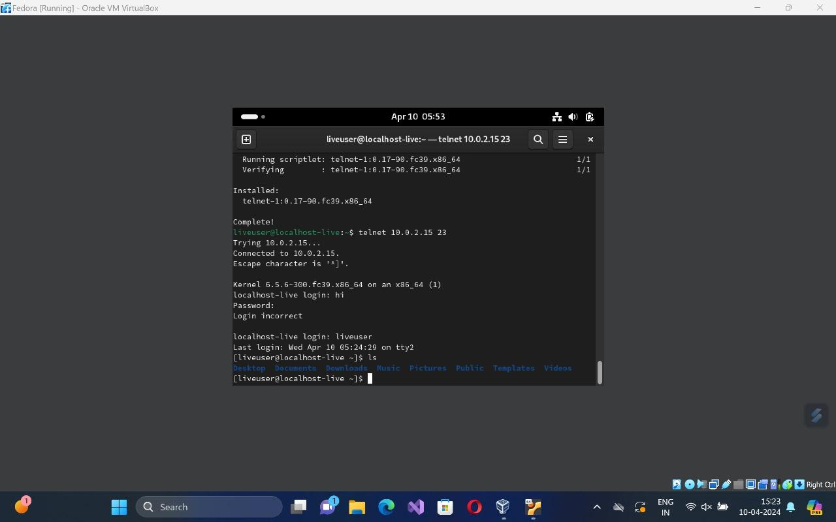

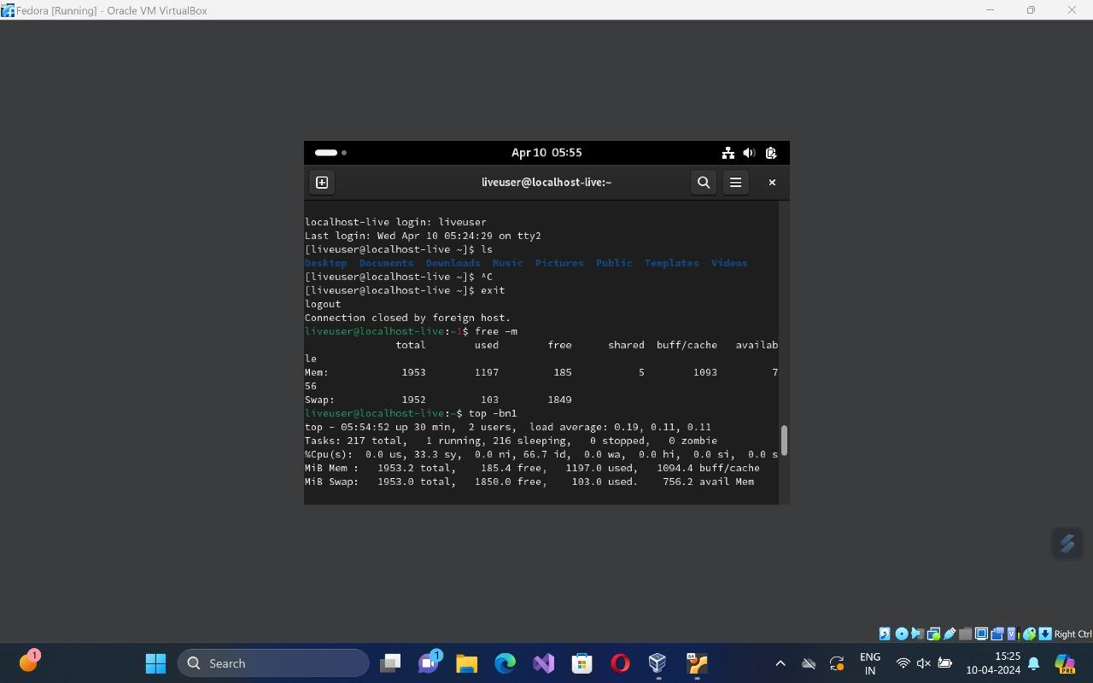

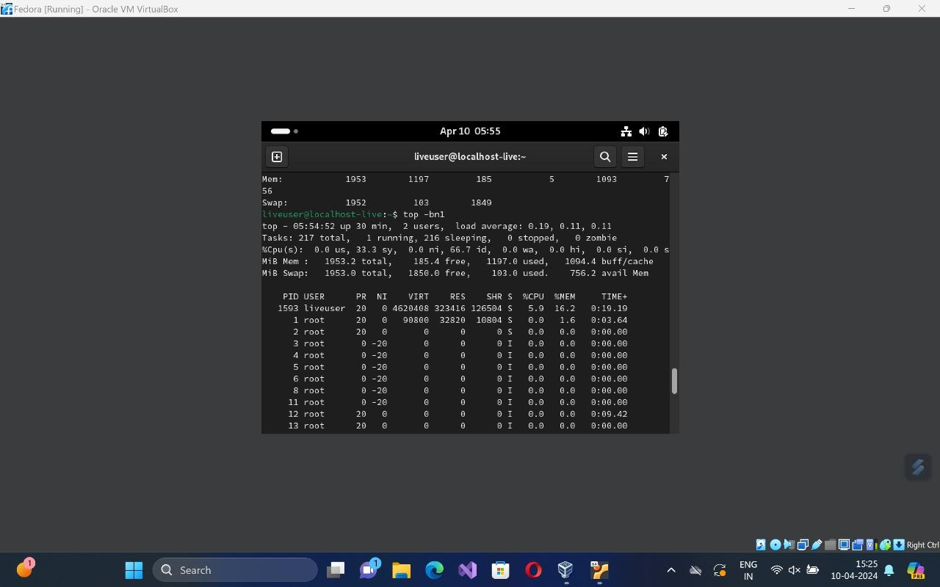

TPUT

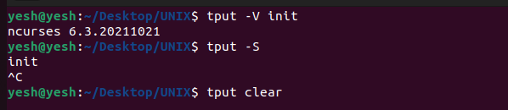

TTY



UNAME

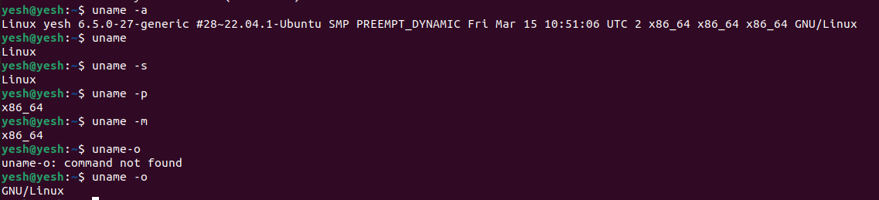

WC

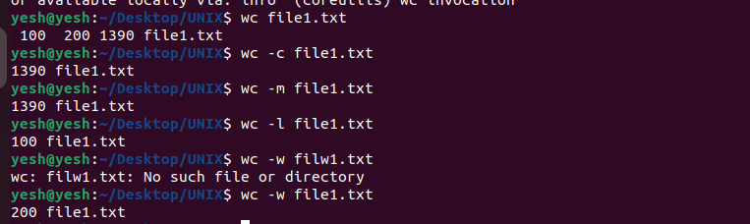

WHO

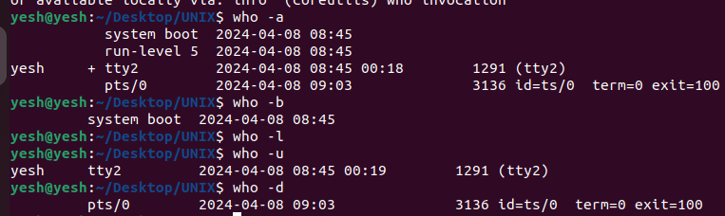

WRITE

