**INT108 PROJECT**

**Name- A.Krishna Teja**

**Registration no.- 12212103**

**Roll no.- 14**

**Section- K22AP**

**Project name- Guessing number**

**Guided by- Dr. Vipin Kumar**

**SOURCE CODE**

#This is a guess the number game.

Import random

Print(“Hello!”)

myName=input(“Enter Your name: “) print(“\nWelcome, “ + myName) choice=”yes” score=0 while(True): if(choice==”no”):

break

upper=int(input(“Enter lower range: “)) lower=int(input(“Enter upper range: “)) guessesTaken = 0

number = random.randint(upper,lower) while guessesTaken < 3:

print(“\nTake a guess.”) #There are four spaces in front of print.

Guess = input()

Guess = int(guess)

guessesTaken = guessesTaken + 1

if guess < number:

print(“\nHave one more try, Your guess is too low.”) # There are eight space in front of print.

Elif guess > number:

Print(“\nHave one more try, Your guess is too high.”)

Else:

Break

If guess == number:

Number = str(number)

Print(“\nCongrat’s”)

Score+=5

Else:

Number = str(number)

Print(“\nBetter Luck next time”)

Print(“Score is %d”%score)

Choice=input(“Do you want to play again? Yes-no

:”) ----------------------------------------xxx---------------------------------------------

# OUTPUT

## Output 1-

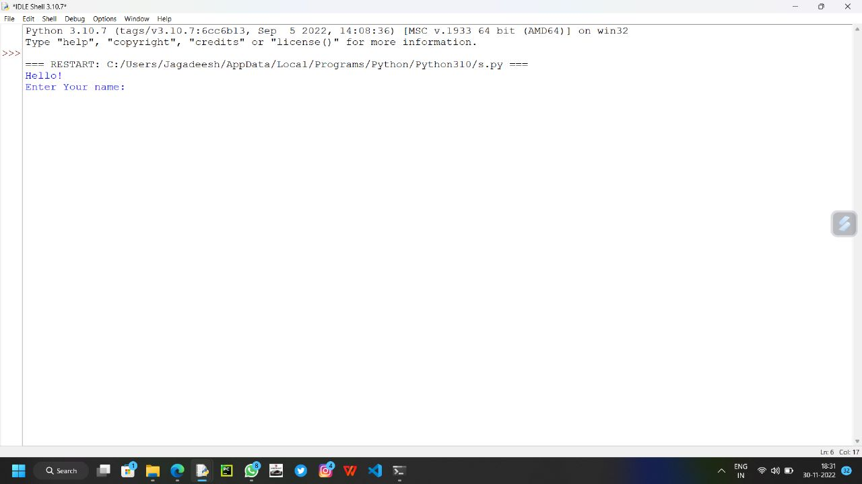

## Output 2-

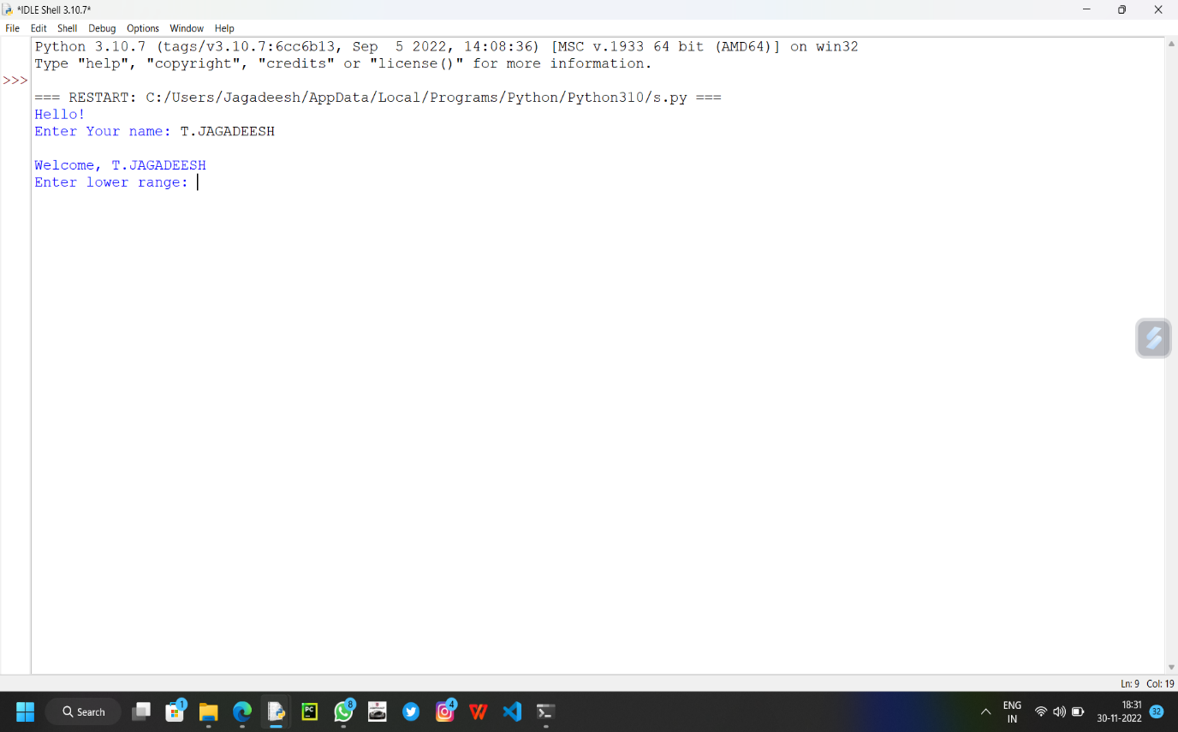

## Ouput 3-

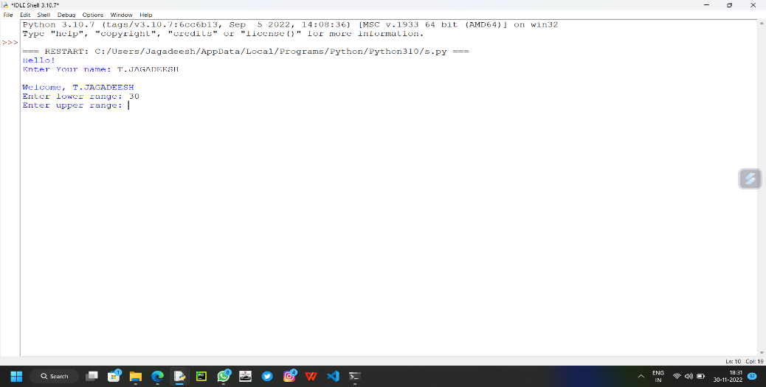

## Output 4-

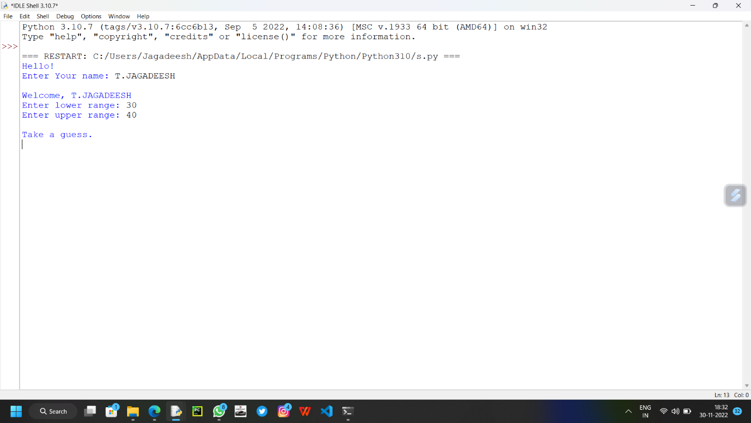

**Output 5-**

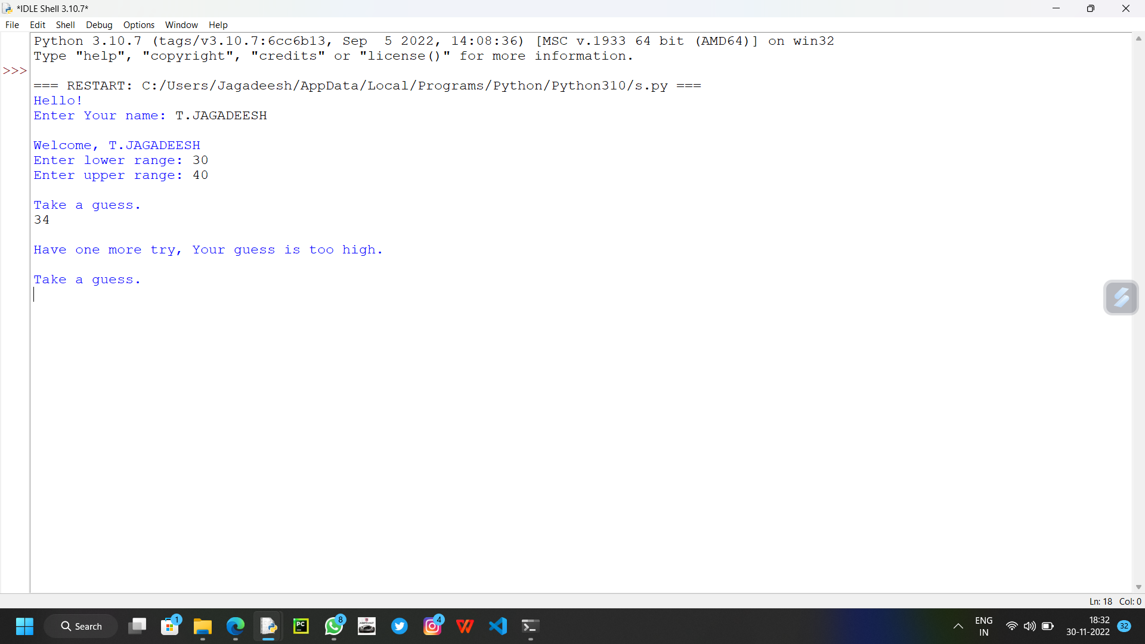

**Output 6-**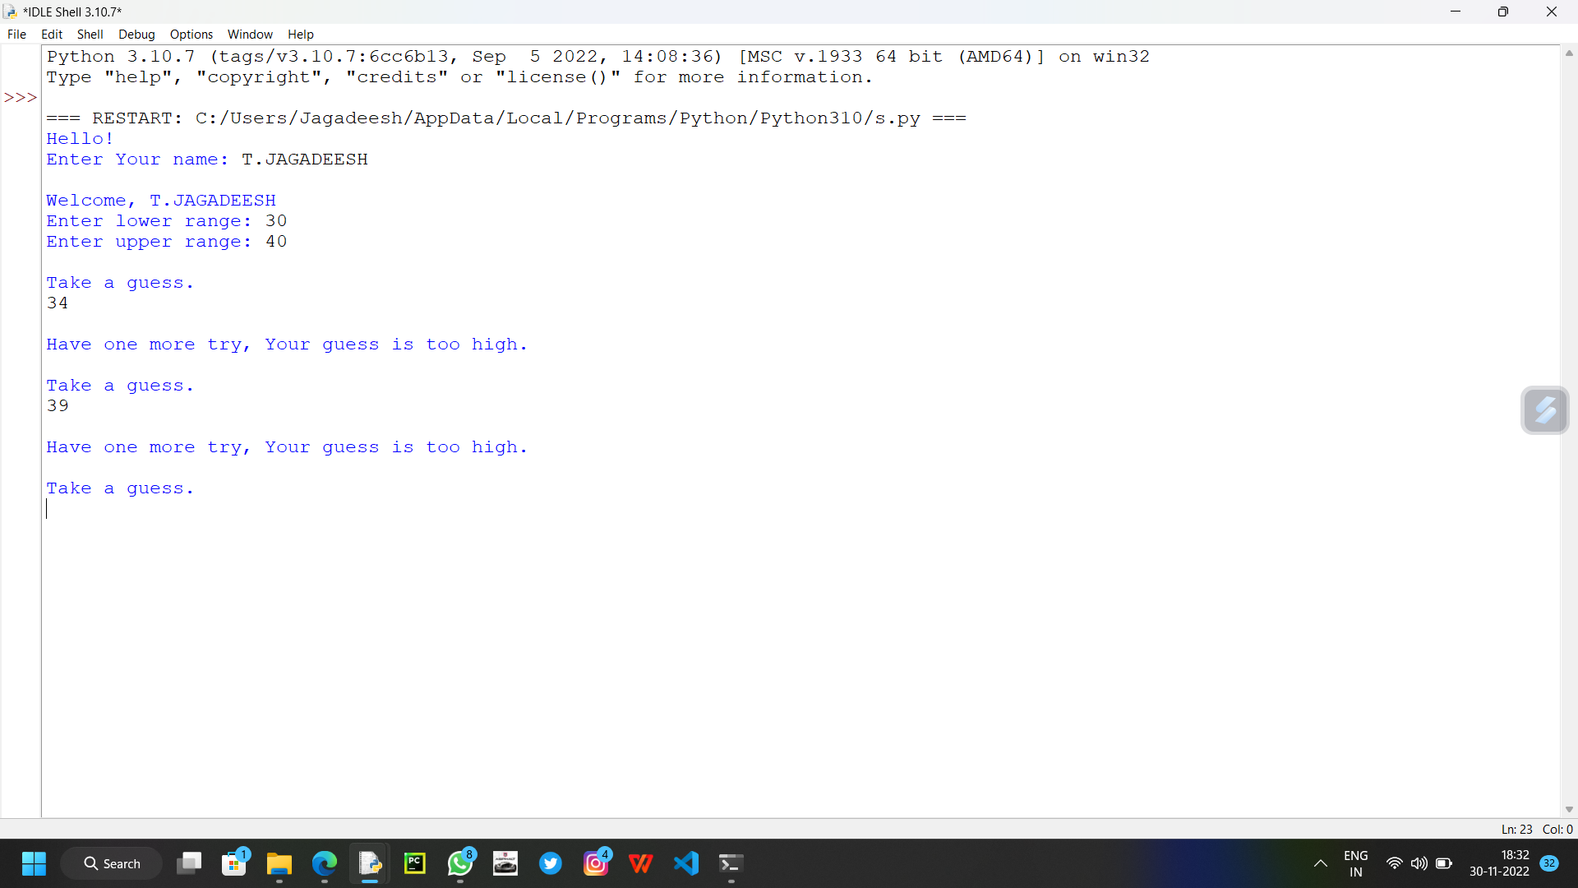

**Output 7-**

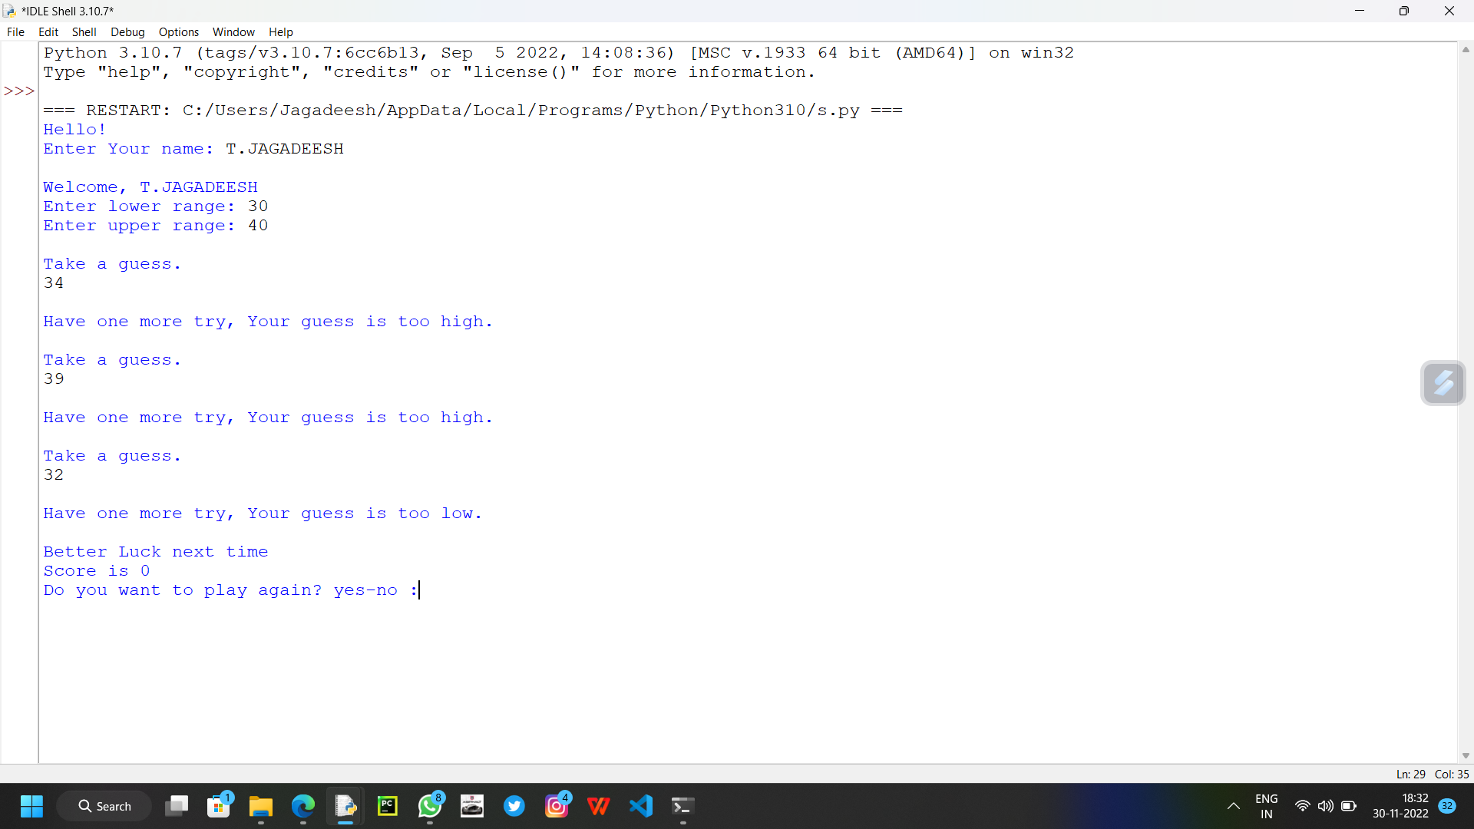

**----------------------xxx-----------------------**