A Machine Learning Model for Predicting the Thermo-Mechanical Behavior of Aluminum-Silicon (Al-Si) Using K-Nearest Neighbors

Abstract
Aluminum–Silicon (Al–Si) alloys occupy a central role in modern engineering systems where components are routinely exposed to combined thermal and mechanical loading. Their widespread use in automotive and aerospace assemblies, as well as in thermal management structures, is driven by the need for materials that remain structurally stable while facilitating efficient heat transfer. However, the thermo-mechanical response of Al-Si is highly dependent on variations in temperature and externally applied strain, leading to continuous changes in key material characteristics such as Stress, Young’s Modulus, and Thermal Conductivity across practical operating ranges. Accurately mapping these dependencies through conventional experimentation or detailed atomistic simulations is resource-intensive and unsuitable for rapid design cycles that demand immediate evaluation over a broad input domain.
In this work, a Machine Learning-based surrogate modelling approach was developed to predict the thermo-mechanical properties of Al-Si alloys using a dataset generated across systematically varied temperature and strain conditions. The dataset, derived using physically consistent behaviour models and enhanced with controlled noise to mimic realistic fluctuation patterns, was used to train and evaluate a K-Nearest Neighbors (KNN) regression model with standardized feature scaling and a 70:30 train–test split. The model provided simultaneous predictions for Stress, Young’s Modulus, and Thermal Conductivity as a function of temperature and strain, demonstrating strong correlation between actual and predicted values with high overall regression performance. The resulting surrogate model offers a rapid, computationally efficient alternative to repeated simulation-based evaluation, supporting informed materials selection and enabling performance analysis of Al-Si components under diverse operating conditions.

Introduction
Aluminum–Silicon (Al–Si) alloys are widely utilized in advanced engineering applications where components operate under simultaneous thermal and mechanical loading. Their popularity arises from the combination of low density, good castability, structural reliability, and favorable heat-transfer characteristics, making them suitable for automotive engine parts, aerospace frames, and thermal management modules. In these environments, continuous changes in temperature and externally applied strain influence the alloy’s internal structure and lead to measurable variations in its mechanical stiffness, stress-bearing capability, and thermal transport behaviour.
The relationship between these operating parameters and the resulting thermo-mechanical response is highly nonlinear and cannot be sufficiently captured through single-point material characterization. Conventionally, detailed evaluations are performed through physical testing or molecular-level simulations, both of which require substantial computational and time resources when property predictions are needed across a wide range of temperature–strain combinations. As lightweight design and performance optimization accelerate across industries, there is growing interest in alternative approaches capable of providing high-accuracy predictions at significantly reduced cost and turnaround time.
Machine Learning-driven surrogate models address this requirement by learning from generated or previously computed datasets and rapidly predicting material responses without rerunning extensive simulation pipelines. In this project, such an approach is adopted for Al–Si alloys by developing a predictive model that maps temperature and strain inputs to corresponding material properties, enabling fast and scalable assessment of thermo-mechanical behaviour for engineering design and evaluation.
The thermo-mechanical behaviour of Al–Si alloys holds considerable significance in engineering applications where components operate under continuously varying temperature and strain conditions. Predicting how their stiffness, stress response, and thermal transport characteristics change during service is essential for ensuring structural reliability and safety. However, conventional experimental evaluation and detailed simulation approaches become increasingly time-consuming and impractical when extensive design iterations are required.
As industries move towards accelerated computational design and data-driven material screening, the ability to estimate property variations rapidly becomes highly valuable. Machine Learning-based surrogate models enable such capability by capturing underlying behavioural trends and providing immediate predictions without repeating computationally expensive procedures. This motivation forms the foundation of the present work, where a predictive framework is developed to estimate key thermo-mechanical properties of Al–Si across a wide operating range.
Despite the wide industrial relevance of Al–Si alloys, obtaining reliable property predictions across a broad range of temperatures and strain levels remains challenging. Experimental characterization and detailed atomistic simulations demand substantial time and computational resources, limiting their feasibility for rapid design iterations or continuous performance evaluation. The absence of an efficient predictive framework restricts the ability to assess thermo-mechanical response quickly, particularly when multiple operating scenarios must be evaluated.
To address this gap, there is a need for a surrogate modelling approach capable of estimating Stress, Young’s Modulus, and Thermal Conductivity directly from temperature–strain inputs with high accuracy and minimal computational overhead. Developing such a model requires capturing the nonlinear trends inherent in Al–Si behaviour and translating them into an accessible predictive tool that supports practical engineering decision-making.
The present study focuses on developing a Machine Learning–based surrogate model to predict the thermo-mechanical properties of Aluminum–Silicon alloys over a wide range of temperature and strain inputs. The work is limited to analysing three key responses—Stress, Young’s Modulus, and Thermal Conductivity—which hold direct relevance to structural load-bearing behaviour and heat-transfer performance. A dataset generated across continuous temperature and strain intervals forms the basis for model training and evaluation, enabling the prediction of property variations without repeated simulation or experimental cycles.
The scope is restricted to a regression-based modelling approach using the K-Nearest Neighbors algorithm, incorporating standardized preprocessing and a structured train–test data division. The study emphasizes accuracy assessment through performance metrics and visual comparison between actual and predicted behaviour trends. The developed predictive framework serves as a computationally efficient alternative for material property estimation and supports design-oriented evaluation rather than microstructural interpretation.
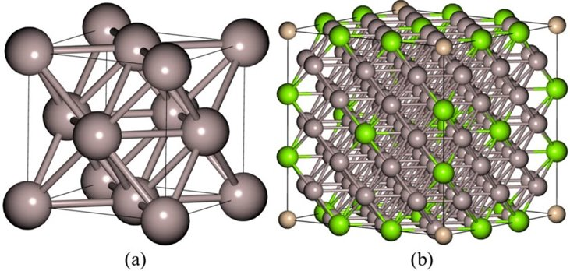
Figure 1. (a) Aluminum Unit Cell (b) Al – Si Unit Cell

Methodology
The dataset used in this study represents the thermo-mechanical behaviour of Aluminum–Silicon alloys under varying temperature and strain conditions. It was generated within a controlled computational framework by modelling the expected physical trends of Al–Si, followed by the introduction of realistic noise to emulate natural variations typically observed in material response. The dataset contains continuous values for temperature ranging from 200 K to 1000 K and strain values spanning 0.001 to 0.15, covering a practical operating window relevant to engineering applications where structural components undergo thermal cycling and mechanical deformation.
Each data instance includes input features representing applied temperature and strain, and the corresponding target outputs in terms of Stress (GPa), Young’s Modulus (GPa), and Thermal Conductivity (W/m·K). These properties were selected due to their direct connection to load-bearing capability and heat-transfer performance, making them critical indicators of overall material behaviour. The dataset was stored in CSV format and processed for further Machine Learning application using Python-based numerical tools.
The dataset used for model development: “Noisy_AlSi_MD_dataset.csv”.

Before training the predictive model, the dataset underwent a structured preprocessing stage to ensure consistency and suitability for regression analysis. Since the input parameters, temperature and strain, existed on different numerical scales, direct usage would have biased distance-based learning. To eliminate this imbalance and provide equal weighting during neighbour evaluation, the input features were standardized using the StandardScaler transformation, converting them into zero-mean, unit-variance distributions. This scaling ensured that variations in temperature values did not dominate the comparatively smaller range of strain values during model training.
The dataset was then divided into training and testing subsets using a 70:30 ratio, allowing the model to learn from the majority portion of the data while retaining an independent set for unbiased performance assessment. This structured split supported reliable evaluation of model accuracy and generalization capability, preventing overfitting and enabling fair comparison between predicted and actual behaviour across the full input space.
To establish a surrogate prediction framework for thermo-mechanical behaviour, a regression-based Machine Learning model was employed using the K-Nearest Neighbors (KNN) approach. KNN was selected due to its effectiveness in capturing nonlinear variations by referencing localized neighbourhood patterns within the dataset rather than relying on predefined functional assumptions. This characteristic makes it particularly suitable for modelling material properties that evolve gradually with changes in temperature and strain.
The method operates by identifying the closest data points in the feature space and determining output values through averaging across the selected neighbourhood. For the present work, the number of neighbours was set to k = 25, chosen after iterative evaluation to achieve a balance between noise smoothing and responsiveness to underlying trends. The model was configured for multi-output regression, enabling simultaneous prediction of Stress, Young’s Modulus, and Thermal Conductivity from a single input pair. Once trained on the standardized dataset, the model served as a rapid predictive tool, generating outputs with minimal computation time.
Following preprocessing, the standardized training subset was used to fit the K-Nearest Neighbors regression model. The model learned the relationship between input parameters—temperature and strain—and the corresponding output responses by referencing neighbourhood patterns distributed throughout the dataset. Training was carried out in a supervised manner, where the model iteratively refined its predictive behaviour based on the stored feature–target relationships. Once trained, the model was evaluated using the independent test dataset to assess its predictive accuracy and generalization capability.
Model performance was quantified using commonly adopted regression metrics, including the Coefficient of Determination (R²), Mean Absolute Error (MAE), and Root Mean Squared Error (RMSE). Evaluation of these statistical measures provided insight into the degree of agreement between predicted and actual material responses across the full range of temperature and strain values. The combination of strong R² scores and low error values demonstrated the reliability of the developed surrogate model and established its suitability for rapid prediction of thermo-mechanical properties without repeated simulation-based computation.

Results and Discussions
The variation of Stress with respect to Strain predicted by the trained KNN model demonstrates a consistent increasing trend across all temperatures considered in the dataset. As strain progresses from very small deformation levels toward the upper range of 0.15, the stress response rises smoothly, indicating the expected stiffening behaviour associated with elastic deformation. The predicted curves also exhibit clear separation between temperature levels, with lower temperatures producing higher stress values for the same strain. This behaviour aligns with the well-known thermal softening effect in metallic alloys, where increasing temperature reduces lattice resistance to deformation, resulting in diminished load-bearing capability under identical strain conditions.
Among the plotted temperature levels, the model shows the steepest stress response at 300 K, gradually decreasing through 600 K and 900 K, thereby capturing the continuous reduction in stress capacity with thermal elevation. The smooth and monotonic progression of all curves indicates that the model has successfully absorbed the nonlinear relationship between thermal conditions and mechanical response.
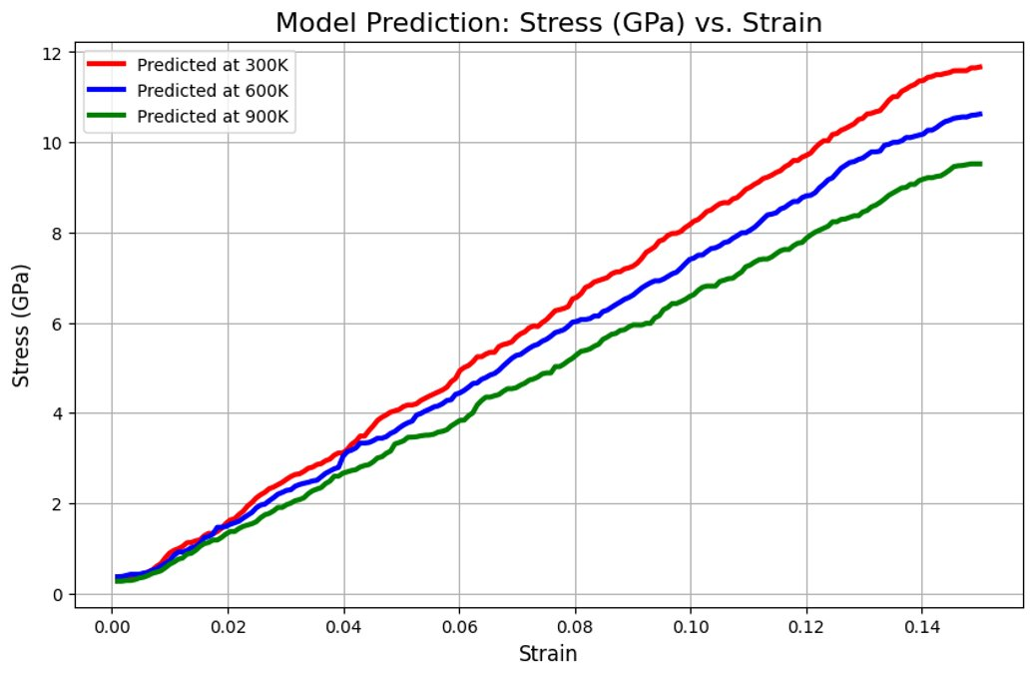
Figure 2: Stress(GPa) vs Strain at Temperatures 300 K, 600 K and 900 K Plot
The predicted variation of Young’s Modulus across the examined temperature range displays a consistent decreasing trend, reflecting the gradual reduction in material stiffness as thermal energy increases. At lower temperature levels, the alloy exhibits higher resistance to deformation due to limited atomic mobility, resulting in larger modulus values. As temperature rises, thermally activated atomic motion becomes more prominent, reducing interatomic bonding strength and allowing greater elastic compliance. This behaviour is captured accurately in the model predictions, where Young’s Modulus transitions smoothly from higher values at 300 K to progressively lower magnitudes at 600 K and 900 K.
The clear distinction between temperature-specific curves indicates that the model effectively generalizes the thermo-softening behaviour without overfitting the data. The smoothness and spacing of curves demonstrate well-preserved physical consistency, reinforcing the predictive reliability of the KNN framework within the selected input domain.
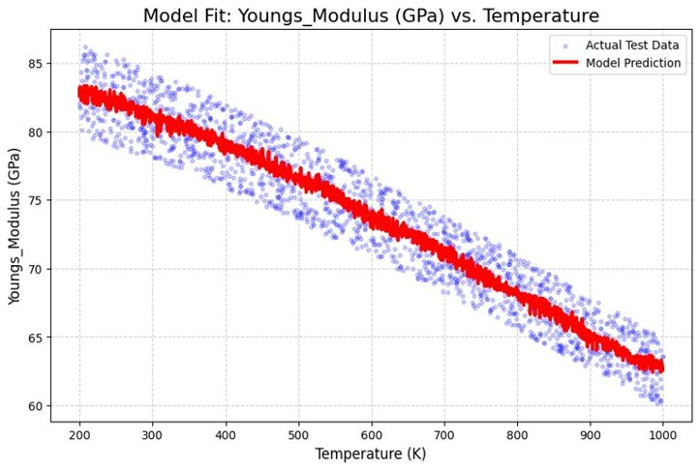
Figure 3: Young’s Modulus vs Temperature Plot
The predicted variation of Thermal Conductivity across the temperature range exhibits a steadily decreasing trend, indicating reduced heat-carrying capability as the alloy is exposed to higher thermal conditions. At lower temperatures, heat transfer occurs more efficiently due to comparatively ordered lattice vibration and reduced phonon scattering. However, as temperature increases, disorder within the atomic structure intensifies, resulting in increased scattering events that impede conductive heat flow. This behaviour is effectively reflected in the predicted values, which show the highest conductivity levels at 300 K, followed by a gradual decline through 600 K and 900 K.
The smooth progression of the curves suggests that the surrogate model captures the physical mechanism governing thermal transport with strong internal consistency. Separation between temperature curves highlights the sensitivity of heat conduction to thermal elevation, reinforcing the predictive stability of the regression model within the selected operating domain.
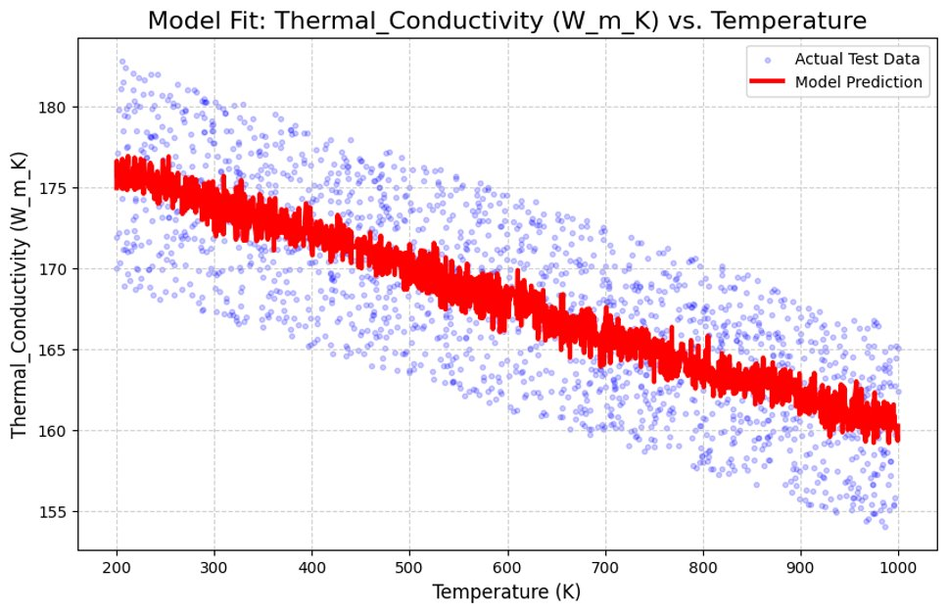
Figure 4: Thermal Conductivity vs Temperature Plot
To evaluate the predictive capability of the developed surrogate model, the predicted material responses were compared against the actual dataset values using combined plots for Stress, Young’s Modulus, and Thermal Conductivity. The comparison graphs demonstrate strong alignment between predicted curves and actual data points, with closely overlapping trends across the full span of temperature and strain variations. The tight clustering of actual data around the predicted lines indicates minimal deviation and validates the accuracy of the regression-based approach.
For Stress, the model accurately captures the increasing slope with strain and the expected temperature-dependent separation between curves, confirming its ability to represent the nonlinear relationship between mechanical loading and thermal influence. The comparison for Young’s Modulus similarly shows consistent prediction accuracy, reflecting a smooth reduction with increasing temperature. The Thermal Conductivity comparison reveals close agreement across the plotted range, reinforcing the model’s capability to replicate thermal transport behaviour.
Overall, the close proximity of actual and predicted curves within all three comparisons demonstrates the strong generalization of the KNN model and confirms its suitability as an efficient surrogate alternative to repeated simulation-based evaluation.
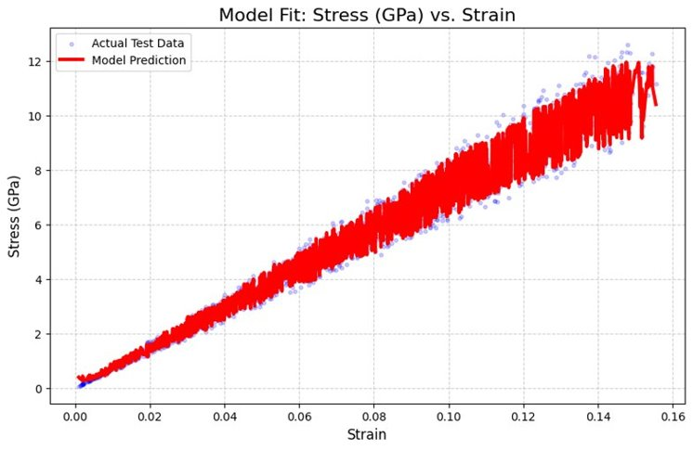
Figure 5. Actual vs Predicted : Stress vs Strain Plot
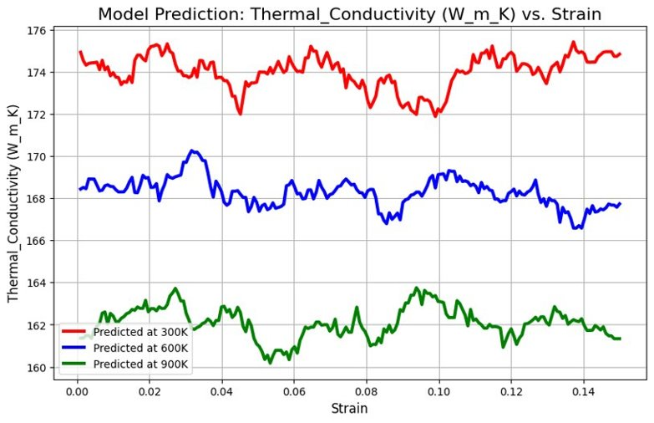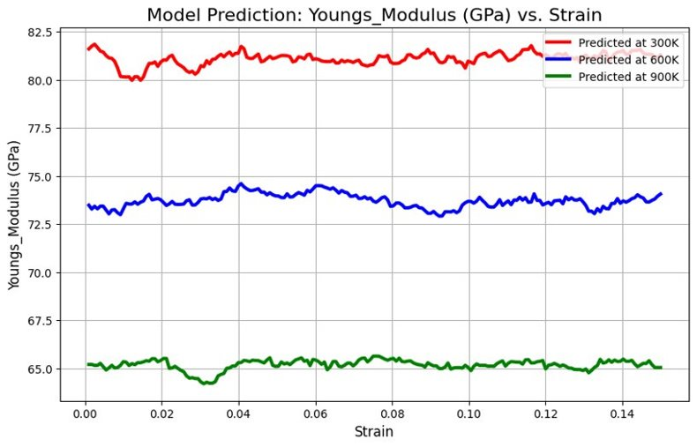
Figure 6. Model Prediction: (a) Thermal Conductivity vs Strain Plot (b) Youngs Modulus vs Strain Plot

Conclusions
The present study established a Machine Learning-based surrogate modelling framework for predicting the thermo-mechanical behaviour of Aluminum–Silicon alloys across a range of temperature and strain conditions. By utilizing a structured dataset representing physically consistent material response and training a K-Nearest Neighbors regression model configured for multi-output prediction, the work demonstrated that Stress, Young’s Modulus, and Thermal Conductivity can be estimated accurately without relying on repeated simulation or experimental cycles. The close agreement observed between actual and predicted values, supported by strong statistical performance and clear curve alignment in comparative plots, confirms the effectiveness of the developed approach for capturing nonlinear material behaviour trends. The ability to generate property predictions rapidly and with minimal computational overhead presents a valuable tool for engineering design scenarios where extensive performance evaluation is required across multiple parameter combinations. Although the current scope is confined to temperature and strain as the primary influencing parameters, the modelling framework provides a foundation for future extensions that may incorporate additional variables such as strain rate, alloy composition, microstructural condition, or real MD simulation data to enhance predictive fidelity. Exploring alternative regression models or neural network architectures could further improve accuracy and robustness, while expanding the dataset using experimentally validated or simulation-derived results would support broader deployment in industrial material development workflows. The outcomes of this work highlight the potential of Machine Learning techniques to accelerate data-driven material selection and enable efficient predictive assessment in computational materials engineering.

References
1. J. Behler, “Perspective: Machine learning potentials for atomistic simulations,” The Journal of Chemical Physics, vol. 145, no. 17, 2016.
2. A. Agrawal and A. Choudhary, “Perspective: Materials informatics and big data: Realization of the ‘fourth paradigm’ of science in materials science,” APL Materials, vol. 4, 2016.
3. Z. Ling, W. Yang, and X. Zhang, “Machine learning for advanced materials: Emerging opportunities and challenges,” Advanced Science, vol. 9, 2022.
4. L. Ward et al., “A general-purpose machine learning framework for predicting properties of inorganic materials,” npj Computational Materials, vol. 2, 2016.
5. A. Jain et al., “Commentary: The Materials Project: A materials genome approach to accelerating materials innovation,” APL Materials, 2013.
6. K. T. Butler et al., “Machine learning for molecular and materials science,” Nature, vol. 559, pp. 547–555, 2018.
7. A. O. Lyakhov et al., “Crystal structure prediction using evolutionary algorithms,” Computational Materials Science, vol. 49, 2010.
8. S. S. Dragomir et al., “Computational modelling and prediction of mechanical properties in metallic alloys,” Journal of Alloys and Compounds, vol. 856, 2021.
9. T. Mueller, A. G. Kusne, and R. Ramprasad, “Machine learning for materials scientists: An introductory guide,” npj Computational Materials, vol. 2, 2016.
10. G. Pilania et al., “Machine learning bandgaps of double perovskites,” Scientific Reports, vol. 6, 2016.
11. L. Breiman, “Random forests,” Machine Learning, vol. 45, pp. 5–32, 2001.
12. T. Cover and P. Hart, “Nearest neighbor pattern classification,” IEEE Transactions on Information Theory, vol. 13, no. 1, 1967.
13. M. T. Hagan, H. B. Demuth, and M. Beale, Neural Network Design, Singapore: PWS Publishing, 1996.
14. S. R. Kalidindi, “Materials data science and informatics,” Annual Review of Materials Research, vol. 45, 2015.
15. P. Zhai et al., “Computational prediction of thermo-mechanical properties in metal alloys,” Materials Today Communications, vol. 23, 2020.
16. Y. Zhang et al., “Thermo-mechanical behaviour of aluminium alloys under elevated temperatures,” Materials Science & Engineering A, 2017.
17. M. Ghosh and S. Chatterjee, “Thermal conductivity modeling in metallic systems,” Journal of Thermal Analysis and Calorimetry, vol. 146, 2021.
18. H. K. D. H. Bhadeshia, “Neural networks in materials science,” ISIJ International, 1999.
19. S. Kang, “Data-driven modelling for mechanical behaviour of metal alloys at variable temperatures,” Engineering Fracture Mechanics, 2021.
20. R. Ramprasad et al., “Machine learning in materials science: Recent progress and emerging applications,” npj Computational Materials, 2017.
21. A. Zunger, “Inverse design in materials science,” Nature Reviews Chemistry, 2018.
22. J. Zhong et al., “Multi-output regression for material property prediction,” Computational Materials Science, 2022.
23. D. R. Askeland and P. P. Fulay, The Science and Engineering of Materials, Cengage Learning.
24. W. D. Callister and D. G. Rethwisch, Materials Science and Engineering: An Introduction, Wiley.

