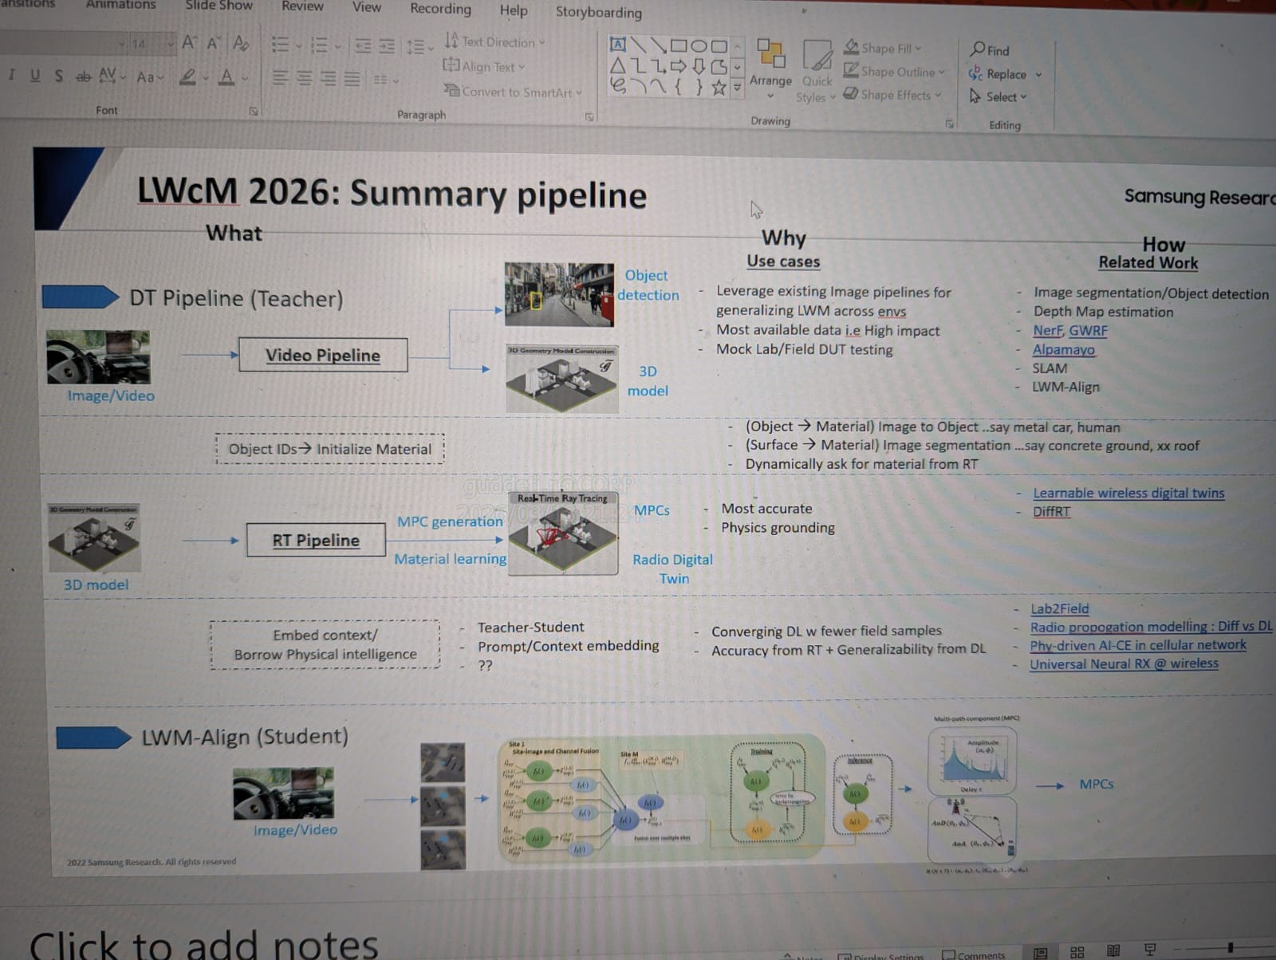
Personal Wireless Digital Twin Platform – Design / Vision Summary

1. Objective
Build a personal wireless digital twin platform leveraging Agentic AI for coding & opensource resources outside corporate firewall to enable experimentation with wireless propagation and AI models.
The platform should:
• Automatically construct site‑specific radio digital twins
• Use the digital twin as a physics‑based teacher model
• Generate interpretable wireless propagation data
• Enable fast AI-based inference models trained from the digital twin
• Support multiple wireless communication research applications

2. Core Concept
The platform consists of two interacting pipelines.

Pipeline 1 – Physics Teacher (Digital Twin + Ray Tracing)
Environment Data → 3D Digital Twin → Ray Tracing Simulation → Multipath Components (MPC) → Channel Responses

Pipeline 2 – Fast AI Inference
Digital Twin Outputs → Context Embeddings → Lightweight AI Model → Real‑Time Inference on Edge Devices

3. Digital Twin Creation Goals
- Simple Initialization
Initialize scenes using publicly available data sources such as OpenStreetMap, Google Maps, or NVIDIA Omniverse.

- Automatic Scene Construction
- Automate the workflow required to:
1. Obtain building layouts
2. Generate 3D objects
3. Assign surface materials
4. Convert scenes for ray tracing

- Scalable Site Generation
Cell ID → GPS → Scene Generation → Digital Twin

4. Physics Simulation Layer
Ray tracing simulations are generated using Sionna RT.

Outputs include:
• Multipath components (MPC)
• Channel impulse responses
• Coverage maps
• Propagation paths

These outputs act as ground truth datasets and teacher signals.

5. Development Workflow
Tools:
• Git – code and experiment synchronization
• Google Colab – experimentation environment
• Gemini – AI-assisted coding
• NotebookLM – research organization

Iteration Cycle:
Build Digital Twin → Run Simulation → Generate Dataset → Test AI Method → Evaluate Application

6. Target Applications
1. Coverage Map Prediction – initial application using simulated wireless propagation.
2. Location Fingerprinting – RSSI-based localization.
3. Physics-Informed Event Detection – detect network events using SINR/RSSI sequences and digital twin context.
4. Reference Signal Overhead Reduction – use digital twin context and UE location to reduce pilot transmissions.
5. Generative Channel Modeling – predict multipath propagation patterns using AI models trained from digital twin data.
6. Dynamic Digital Twin Updating – maintain real-time environment awareness using targeted sensing.

7. Related Work
Relevant work includes learnable digital twin research and wireless digital twin frameworks explored by research groups such as Meta AI (FAIR) and the Alkhateeb research group at Arizona State University.

8 . Vision
Develop a learnable wireless digital twin platform that combines:
• Physics-based propagation modeling
• Interpretable environmental reasoning
• Real-time AI inference
• Scalable site-specific deployment

The platform will support research in wireless sensing, semantic communications, channel prediction, and network optimization.

Advanced Features

Interpretability Goals
The digital twin should allow mapping channel taps to physical surfaces.

Example:
Tap 1 → Building Reflection
Tap 2 → Glass Reflection
Tap 3 → Diffraction Edge

This enables semantically interpretable wireless channels.

Context Embedding Concept
Instead of sending full channel information, the system sends compressed context embeddings derived from the digital twin.

Embedding inputs may include:
• Scene information
• User location
• Nearby surfaces
• Relevant propagation objects

These embeddings condition lightweight edge models for fast prediction.

Dynamic Digital Twin Updates
Digital twins should update automatically using sensing sources such as:
• Images
• Video
• Wireless measurements

Updates focus on semantically important changes such as moving vehicles or obstacles.

