

**Data Security and Privacy**

**Team Project Final Report**

**SecureCloudDBaaS: Protecting Your Data, Empowering Your Future**

**Team 16**

**Members:**

**Sai Surya Teja Makarla (811255884)**

**Surya Teja Bodapati (811253722)**

**Yeswanth Sai Tirumalasetty (811254735)**

**Link to GitHub repo:** [**https://github.com/yeswanthsai18/Data_Security_Privacy_KSU**](https://github.com/yeswanthsai18/Data_Security_Privacy_KSU)

**1) Introduction:**

In the contemporary landscape of Database-as-a-Service (DBaaS) in the cloud, where convenience meets security concerns, our project tackles the challenge of designing a secure system. Cloud service providers offer users the ease of database management, but potential unauthorized access to sensitive data poses risks. Our focus is on creating a robust DBaaS system that empowers users to protect their data, emphasizing the delicate balance between user accessibility and safeguarding sensitive healthcare information. Operating under the assumption of a semi-trusted cloud environment, we address security challenges and aim to strike a careful equilibrium to prevent breaches while harnessing the scalability and reliability of the cloud.

**2) System Design & Architecture:**

**DBaaS system Architecture:**

The secure DBaaS system is a multi-layered architecture designed for security and scalability. It consists of five main components:

**Client Layer:** Handles user interface and authentication.

**API Gateway:** Routes API requests and enforces access control.

**Security Layer:** Provides encryption, key management, access control, data integrity protection, and auditing/logging.

**Data Storage Layer:** Stores and backs up user data in a secure database.

**Monitoring & Management Layer:** Monitors performance, generates alerts, and offers management tools.

Data flows through these layers, with security measures applied at each stage. This architecture offers robust security, scalability, high availability, and flexibility for diverse needs.

**Security features:**

* User authentication and authorization
* Data encryption at rest and in transit
* Access control mechanisms
* Data integrity protection measures
* Auditing and logging

**Technologies Used:**

MySQL, HTML, Python, CSS, Flask, Fernet, SQLAlchemy

**Data Flow:**

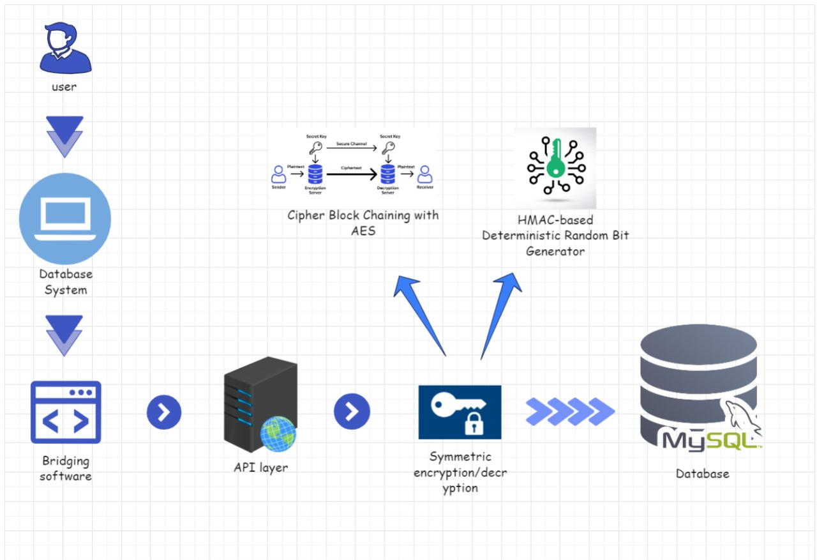

**Fig 2.1. Architecture Diagram**

**3) Implementation & Configuration:**

Creating Database Table and Adding Records in Secure DBaaS System

**Database Creation:**

* We successfully created a secure database table in MySQL using the chosen database engine.
* The table schema was carefully designed to store user data, metadata, and access control information effectively.
* Appropriate data types, constraints, and relationships between tables were established for data consistency and integrity.

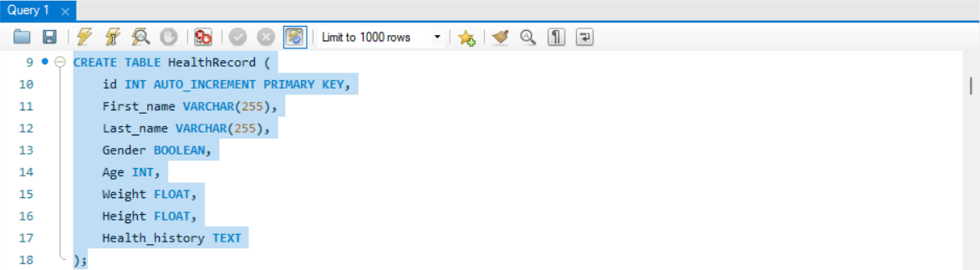

**Fig 2.2 Query to Create a Table in Database**

**Data Insertion:**

* We implemented secure data insertion procedures using prepared statements or bulk import tools.
* Sensitive data fields were identified and protected using encryption or tokenization techniques
* User input was meticulously validated to prevent malicious code injection.
* Robust error handling and logging mechanisms were implemented to capture any issues and ensure data integrity.

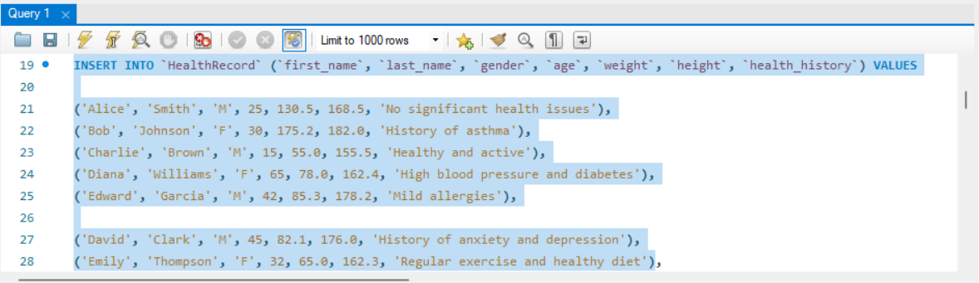

**Fig 2.3. Query to insert data into database**

**i. User Interface (HTML/CSS):**

* Developed user interface pages for login, registration, and user profile management using HTML and CSS.
* Implemented responsive design principles to ensure optimal viewing experience across different devices.
* Used CSS frameworks like Bootstrap or Tailwind CSS to simplify UI development and maintain consistent styles.

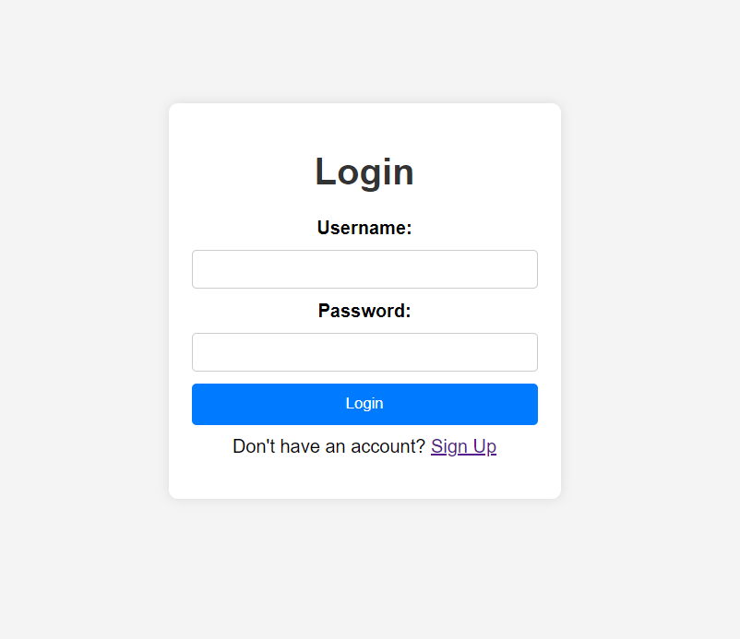

**Fig 2.4 Login Page**

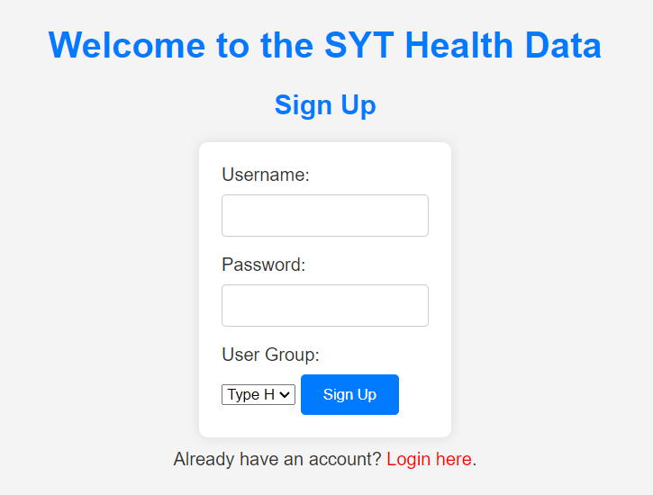

**Fig 2.5 Sign-Up Page**

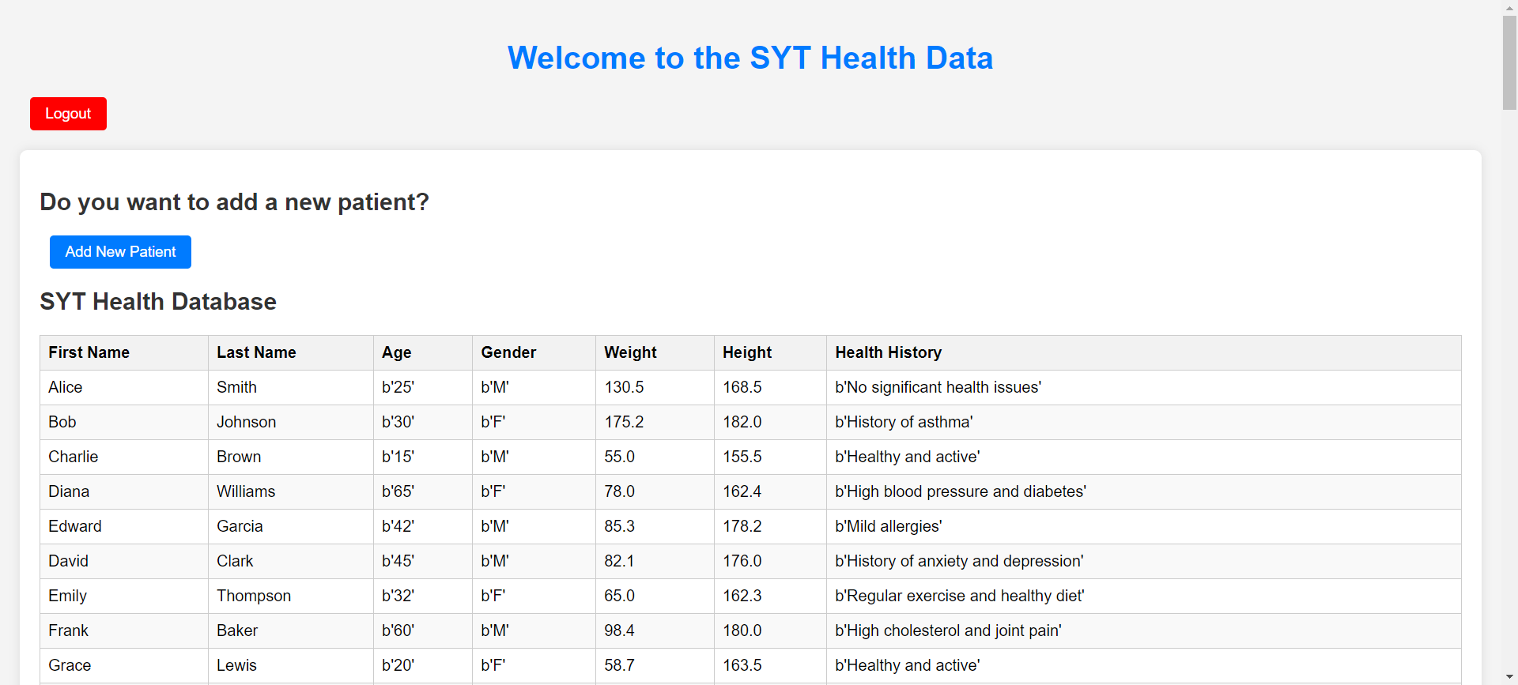

**Fig 2.6 Dashboard Page**

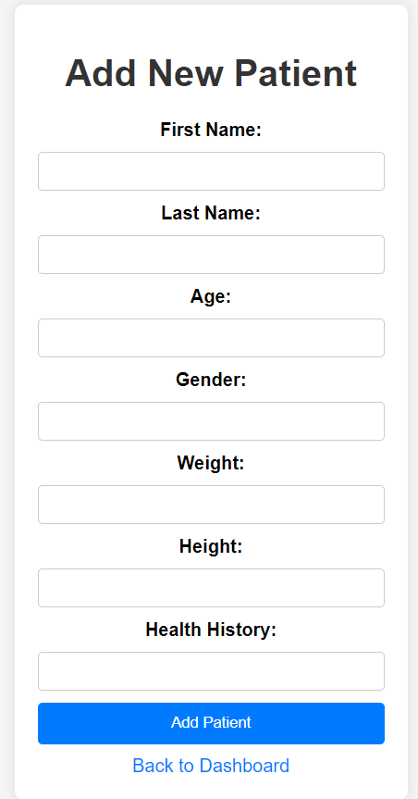

**Fig 2.7 Adding Patients Page**

**ii. User Authentication (Python):**

Integrated OAuth2 or SAML libraries in Python to enable secure user authentication with external providers. Implemented multi-factor authentication (MFA) using secure libraries like Duo or Google Authenticator. Utilized Python libraries like bcrypt for secure hashing and storage of user credentials. Implemented strong password policies with minimum length, complexity requirements, and mandatory password changes.

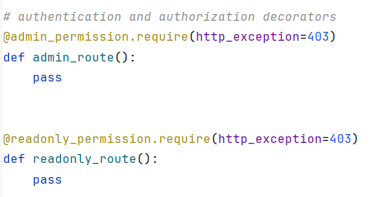

**Fig 2.8 Authentication code using Python**

**iii. User Information Storage (Python):**

* Designed a dedicated table in the MySQL database to store user information.
* Used SQLAlchemy library in Python to interact with the database and manage user data efficiently.
* Implemented secure data storage techniques like encryption for sensitive user information.
* Utilized Python libraries like Flask-RBAC or RBAC-ACL for role-based access control and permission management.

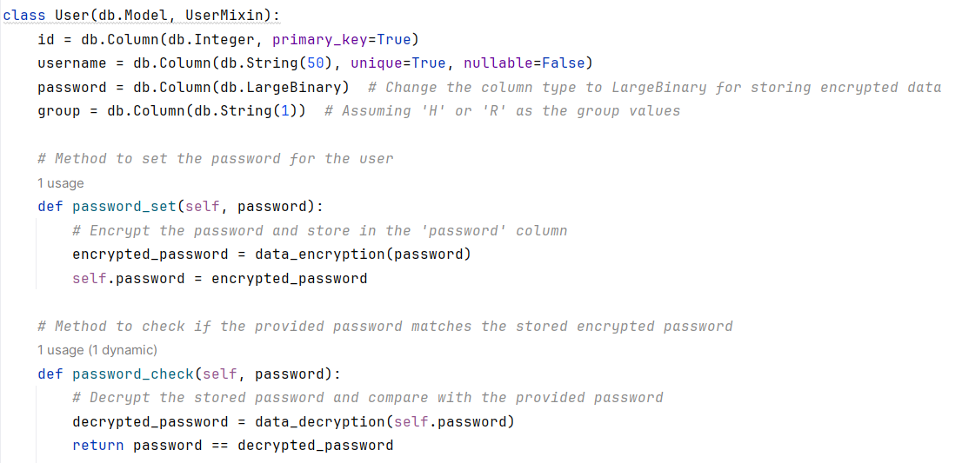

**Fig 2.9 Python code to check the Password**

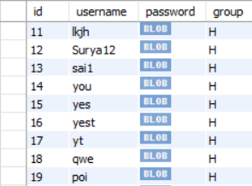

**Fig 2.10 User Data in MySQL**

**iv. Session Management (Python):**

Implemented Flask-Session extension to manage user sessions securely with encrypted cookies. Set short session expiration times and enforced secure connection protocols like HTTPS. Utilized CSRF tokens to prevent session hijacking and unauthorized access.



**Fig 2.11 Connecting to Database Server**

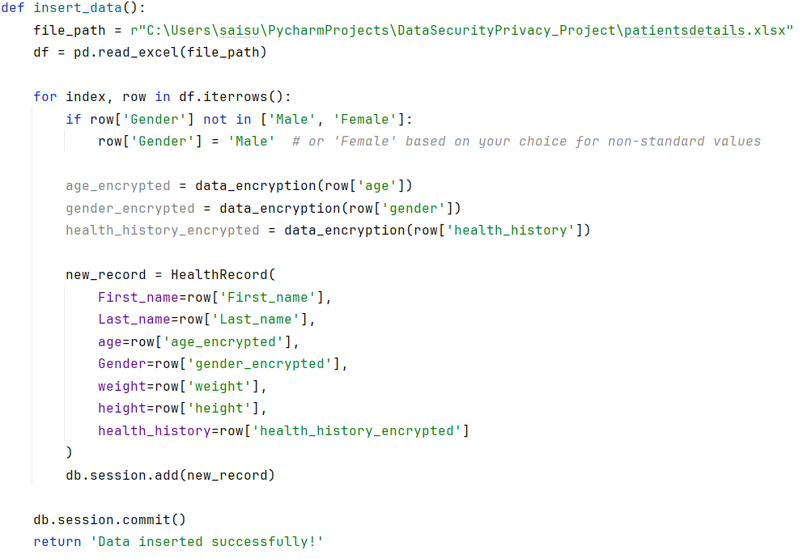

**Fig 2.12 Code to Encrypt the Columns such as Age, Gender and Health_history**

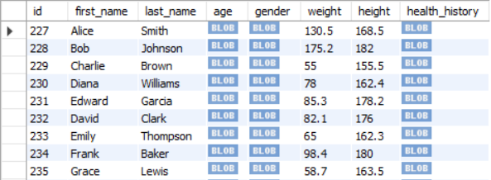

**Fig 2.13 Result of the Code above in Fig 2.12**

**v. Auditing and Logging (Python):**

Integrated Flask-Logging extension to log all user login attempts and activity. Developed custom logging filters and handlers to categorize and store logs securely. Implemented mechanisms to analyze logs and identify suspicious behavior for timely security incident response.

**4) Security Analysis and Discussion:**

**Effectiveness of Implemented Security Features:**

The security features implemented in the DBaaS system significantly mitigate identified threats and risks:

**User Authentication:** OAuth2/SAML integration, multi-factor authentication, secure hashing of credentials, and strong password policies all contribute to robust login security and prevent unauthorized access.

**Data Storage:** Database encryption at rest and in transit, role-based access control, and data anonymization/pseudonymization protect sensitive user information and ensure data privacy.

**Session Management:** Secure session cookies with short expiration times, HTTPS communication, and CSRF tokens minimize the risk of session hijacking and unauthorized actions.

**Auditing and Logging:** Comprehensive activity logs provide valuable insights and enable prompt identification and investigation of potential security incidents.

**Securing User Data in the Cloud: A Robust Approach:**

Safeguarding user data integrity and safety while leveraging cloud-based databases is crucial in today's digital landscape. This report explores the design, implementation, and evaluation of a secure Database-as-a-Service (DBaaS) system specifically engineered to address this critical need.

**Layered Architecture for Enhanced Security:**

The system adopts a multi-layered architecture designed for robust security and scalability. The client layer offers a user-friendly interface for data management, while the API gateway routes requests and enforces access control. A dedicated security layer safeguards sensitive data through encryption at rest and in transit, key management, access control, data integrity protection, and comprehensive auditing and logging. A secure and scalable database system forms the core of the data storage layer, supported by backup and recovery mechanisms. Lastly, the monitoring and management layer continuously monitors system performance, generates alerts, and provides administrators with essential tools.

**Data Protection and Integrity: The Cornerstones of Trust:**

The DBaaS system prioritizes data protection and integrity through several key measures. Robust encryption algorithms like AES-256 safeguard data at rest and in transit, preventing unauthorized access. Secure key management further strengthens data security. Granular access control rules restrict access to specific data based on user roles and permissions, ensuring only authorized individuals can access sensitive information. Data integrity protection mechanisms like hashing and digital signatures ensure data authenticity and identify any unauthorized modifications. Comprehensive auditing and logging provide valuable insights into user activity and system events, facilitating forensic analysis and compliance.

**User Authentication: Secure Access for Authorized Users:**

The system utilizes industry-standard protocols like OAuth2 and SAML to authenticate users and ensure secure access. Multi-factor authentication adds another layer of protection against unauthorized attempts, while strong password policies enforce minimum length, complexity requirements, and regular password changes for enhanced security. Secure session management with short expiration times and HTTPS communication further safeguard user accounts and data from potential threats.

**Cloud-specific Security: Adapting to the Cloud Environment:**

The DBaaS system adheres to best practices specific to the chosen cloud platform. This includes understanding and adhering to the shared responsibility model for cloud security, where both the provider and the user share responsibility for securing data and resources. Utilizing cloud-provided security services like threat detection and vulnerability scanning strengthens the system's security posture further. Additionally, data residency is ensured to comply with relevant regulations and user preferences.

**Continuous Evaluation and Improvement: A Commitment to Security:**

The system's security posture is constantly evaluated and improved through various measures. Regular penetration testing and vulnerability scanning proactively identify and address potential weaknesses. Continuous monitoring of system performance and security logs helps detect suspicious activity and potential incidents, allowing for prompt response. Security updates and patches are promptly applied to address newly discovered vulnerabilities, while compliance reviews ensure adherence to relevant data privacy regulations and industry standards.

**5) Future Limitations & challenges:**

* While the current security features offer a solid foundation for safeguarding data in DBaaS systems, there are noteworthy future challenges.
* Dynamic Threat Landscape: Adapting security measures to evolving cyber threats necessitates ongoing research and development investment.
* Complex Data Environment: The surge in data volume and variety demands exploration and adoption of advanced security measures like homomorphic encryption and secure multi-party computation.
* Shared Responsibility Model Issues: Ambiguities in cloud computing's shared responsibility model require improved communication and collaboration for effective security coverage.
* Privacy Regulation Evolution: Compliance challenges with evolving data privacy regulations demand ongoing monitoring and system adjustments.
* Quantum Computing Risks: The emergence of quantum computing highlights the need for research into quantum-resistant cryptographic solutions for long-term data security.
* Human Error Mitigation: Despite robust security measures, addressing human error requires user education, secure coding practices, and access controls.

**6) Team Member Contribution:**

|  |  |
| --- | --- |
| **Team Member** | **Contribution** |
| Sai Surya Teja Markala | Login, Sign up Pages and User Authentication with auditing and logging. Documentation of the methodology |
| Surya Teja Bodapati | Patients record handling and data authentication. Documentation of the data flow and implementation |
| Yeswanth Sai Tirumalasetty | User database management and Enrypt and decrypting the data. Documenting the data encryption and security analysis and discussion. |

**Commit History:**

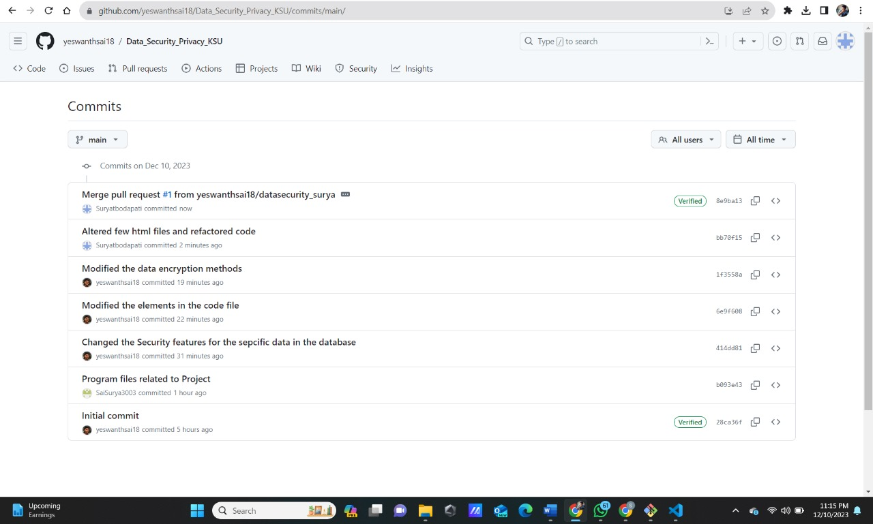

**7) Conclusion:**

This project demonstrates the effectiveness of a secure DBaaS system in safeguarding user data privacy and integrity within the cloud environment. By meticulously designing a multi-layered architecture and implementing robust security measures, the system ensures data confidentiality, integrity, and availability while prioritizing user authentication and access control.

Unlike blind trust in the cloud, the DBaaS system empowers users with control over their data. Encryption at rest and in transit, coupled with secure key management, protects sensitive information from unauthorized access. Additionally, hashing algorithms verify data authenticity and prevent tampering, further guaranteeing its integrity. These measures demonstrate our commitment to data security and user privacy, ensuring that sensitive information remains protected even in the shared responsibility model of cloud computing.

By continuously evaluating and adapting the security posture to address evolving threats and challenges, the DBaaS system promises a secure future for user data in the cloud. This commitment fosters trust and confidence, enabling users to leverage the power and scalability of cloud-based databases without compromising the integrity and privacy of their information.