Set 4: Product Inventory Management.
Dataset
Product ID | Product Name | Category | Price | Quantity Available
1 | Product A | Electronics | 1200 | 250
2 | Product B | Electronics | 850 | 175
3 | Product C | Furniture | 1500 | 300
4 | Product D | Furniture | 1100 | 200
5 | Product E | Accessories | 450 | 220

Task 1: Bar Chart (Quantity of Each Product)
Steps
- Open Tableau.
- Connect to Product_Inventory.csv.
- Click Sheet 1.
- Drag Product Name → Columns.
- Drag Quantity Available → Rows.
- In the Marks card, select Bar.
- Click Show Mark Labels (optional).
Title
Quantity Available for Each Product
Axis Labels
- X-axis: Product Name
- Y-axis: Quantity Available
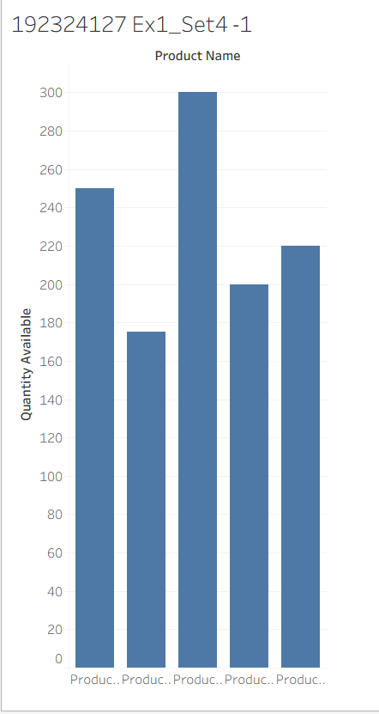

Task 2: Stacked Bar Chart (Quantity by Category)
Steps
- Create a New Worksheet.
- Drag Category → Columns.
- Drag Quantity Available → Rows.
- Select Bar in Marks.
- Drag Product Name → Color.
Tableau automatically creates a Stacked Bar Chart.
If it doesn't:
- Go to Analysis → Stack Marks → On.
Title
Quantity of Products by Category
Axis Labels
- X-axis: Category
- Y-axis: Quantity Available

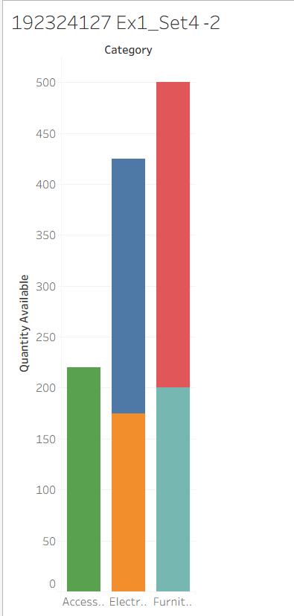

Task 3: Scatter Plot (Price vs Quantity)
Steps
- Create a New Worksheet.
- Drag Price → Columns.
- Drag Quantity Available → Rows.
- Click Show Me (top-right).
- Select Scatter Plot.
- Drag Product Name → Label.
- Drag Category → Color.
Title
Price vs Quantity Available
Axis Labels
- X-axis: Price
- Y-axis: Quantity Available
Findings
- Product C has the highest price (1500) and also the highest quantity (300).
- Product B has a lower price (850) and the lowest quantity (175).
- There is no strong positive or negative correlation between price and quantity in this small dataset.
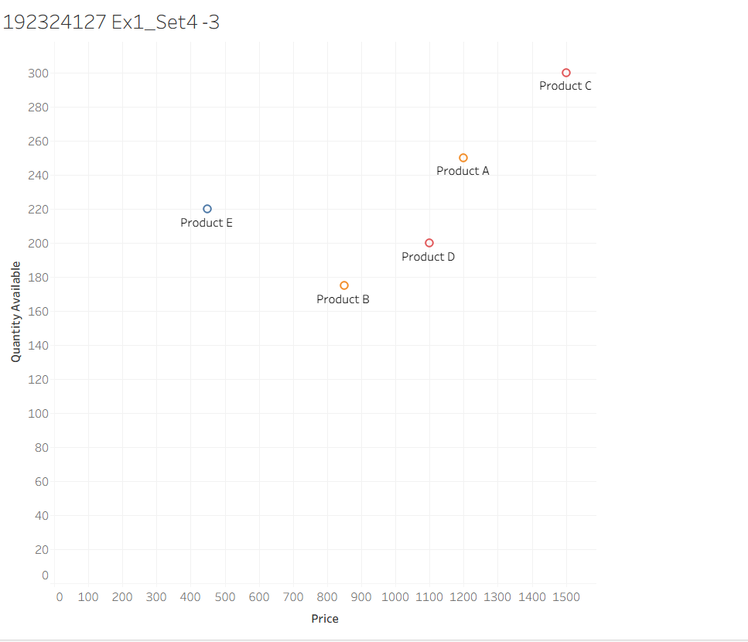
Task 4: Dashboard
Steps
- Click the New Dashboard icon.
- Set Size → Automatic.
- Drag these sheets onto the dashboard:
  - Quantity Available for Each Product (Bar Chart)
  - Quantity of Products by Category (Stacked Bar Chart)
- Arrange them side by side or one above the other.
- Click the drop-down menu on one chart.
- Select Use as Filter to make the dashboard interactive.
