**COMP5400M Coursework 1**

Student ID: 201373470

1. First I make the break off when the generation is about 500, and there is a remarkable increase between 200 and 300 epoch for both average fitness and best fitness. As the lines show on the plot, the red line is average fitness, and the best fitness is the green line. And the fitness remains stable after 500 epoch.

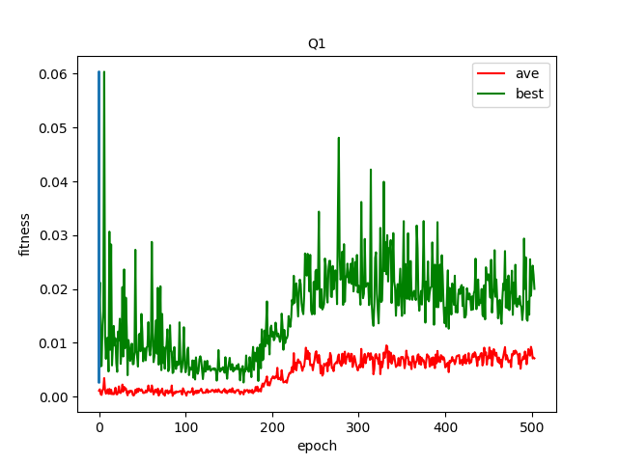

Then I expect there will be another increase, so I do two more experiments, one is 800 epoch, another is 1500 epoch. Both results show that fitness remains almost stable, so I think there will be no significant improvement after 500 generations. Therefore, within 500 generations is reasonable.

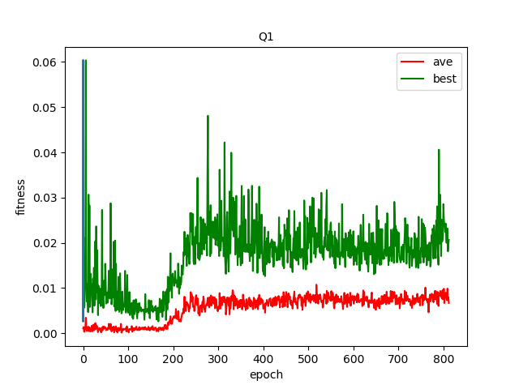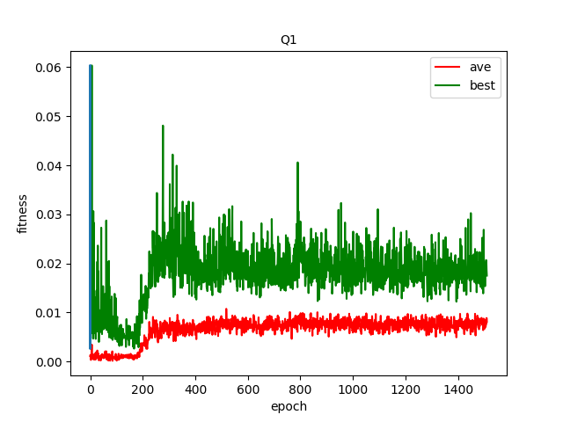

1. At the first 100 generations, the mice would simply go around and around, some of the circular paths have large radius, some of them are small. And there are no noticeable path changes according to its sensor. For example, even if the cheese is very close to the mouse, it will still keep on track rather than change it's heading toward the cheese. And when they bump into each other, they will continue to follow the fixed radius circular path; even their original position has changed. So, in this case, whether the mice can eat cheese is only a matter of luck. The mice can eat the cheese, only when the cheese is on their circular path.

After 100 generations, a few mice can change their path, doing the irregular movement. Also, most of the mice's searching area becomes much more extensive.

When it comes to about 200 generations, Some of the mice can change their path according to their sensors. For example, if the cheese is very close to the mouse but not on the circular way, a few mice would change it's heading towards the cheese. However, sometimes the mice are so close to the cheese that they are not able to turn their heading towards it. Thus, there are some mice just around the cheese in a circle and never able to eat it. And there is more collision because too many mice head towards the same cheese.

After 200 generations, the mice seem to slow down and are able to control their speed and have better movement towards cheese. Therefore, most of the mice would eat at least one cheeses during 100 time steps. And less collision, if another mouse has eaten the cheese that the mice are expected to eat, then it will turn it's heading to other available cheese.

After 300 generations, the mice's movement is more targeted and efficient for eating cheese rather than meaningless action. And these mice act more like a group, gather together and seek for cheese.

After 400 generations, the mice move faster and become more agile. And remain pretty much the same behaviour after this.

1. For the fitness function, it calculates each mouse’s fitness in each generation. If the cheese that the mouse has found is not 0, the fitness is the number of cheese has been eaten divided by the distance that the mouse has been travelled. If the cheese found number is 0, then the fitness for this mouse in this generation is 0.

For fitness function, it only effects by two parameters, the number of cheese found and the travel distance. And what I changed to this function is to assign more weight to the number of cheese found, so that the number of cheese found can affect the fitness more, and the travel distance becomes less critical to the fitness.

After I made these changes, recompile and run this program. The mice will only run faster towards the cheese. This changes can improve the performance of mice, because the mice would care more about the cheese rather than the distance. And the mice would increase their speed and run faster towards cheese without considering too much about the distance.

In genetic algorithm code, the parameter like the best, worst, average and total fitness score are also more about the number of cheese has been found. And it also stores the best, worst fitness; these parameter can be useful for rank selection. Thus, the ranking selection can also be affected more by the number of cheese found. The possibility of selecting the individual that can find more cheese is higher. And the ranking selection can also make the individual act more like a group.

1. These mice aim to find the cheese as effectively as possible during a period (100 time step). If the mice can find more cheese with less travel distance within a sure generation, then this fitness function has better performance.

My way to evaluate the performance is to count the total number of cheese eaten for the last generation. And compare them to determine which has better performance. The result show as below. (Please ignore the blue thing)

The cheese eaten priority fitness function eat more cheese and have better performance.

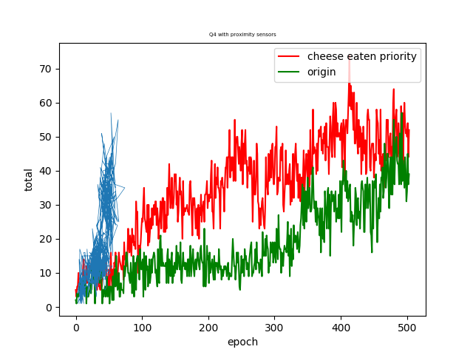

Then I change another sensor which is a proximity sensor to replace the original angle sensor. Proximity can be less precise, but it can let the mice know how far the cheese is. Ignore the distance. I thought it could run clearly and faster towards the cheese. But the result is not as good as the angle sensor. I think it's because it's inaccuracy.

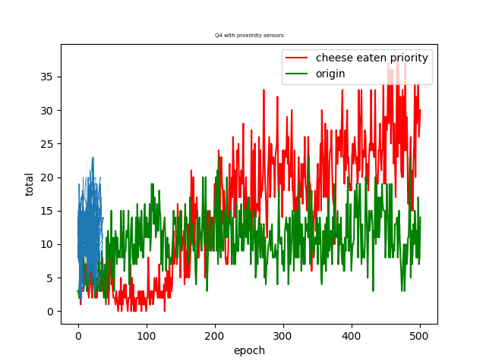

1. I think collective behaviour is several creatures or robots act like the one. And there are some characteristics. First, there is no central control in collective behaviour, and even a few agents break down, it won't affect the whole behaviour. For every mouse, it has its own control system, sensor, and so on. Second, every single agent can change the environment (e.g. mouse eat cheese, then cheese appears randomly). And that is the way how the communication with each other. (stigmergy). Third, every agent's behaviour is elementary, and it's easy to develop swarm intelligence. For example, at the beginning of the simulation, every mouse just goes around a simple circle with a different radius. After hundreds of generations, several mice would gather together. They keep distance with others to make sure no collision and have the same motion curve for eating cheese. The whole community movement is based on the movement of each mouse. And individual mouse adjusts their movement direction and states through their perception of the environment. There also are a few mice who go solo and some other groups with different movements, and they don't affect each other.
2. 10th generations: (prey on the left, predator on the right)

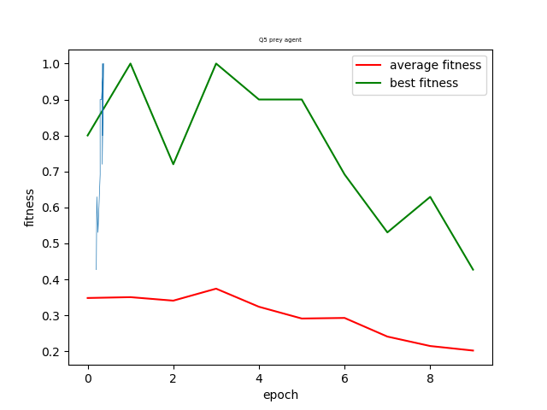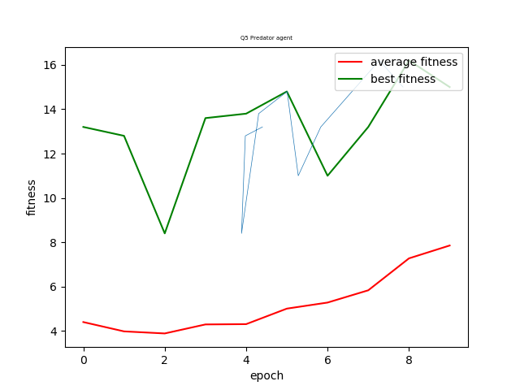

50th generations: (same rule as above)

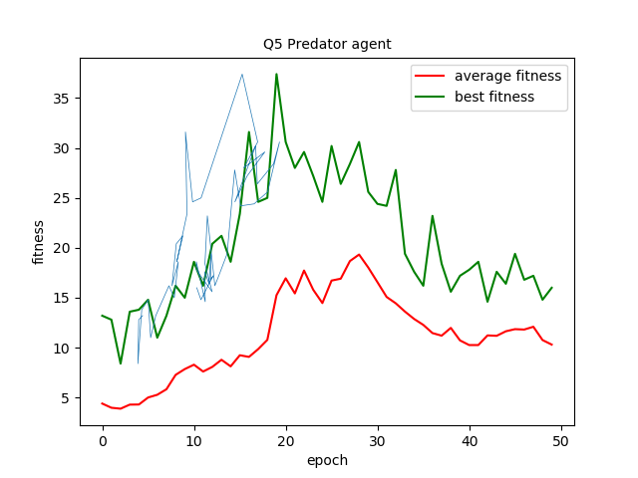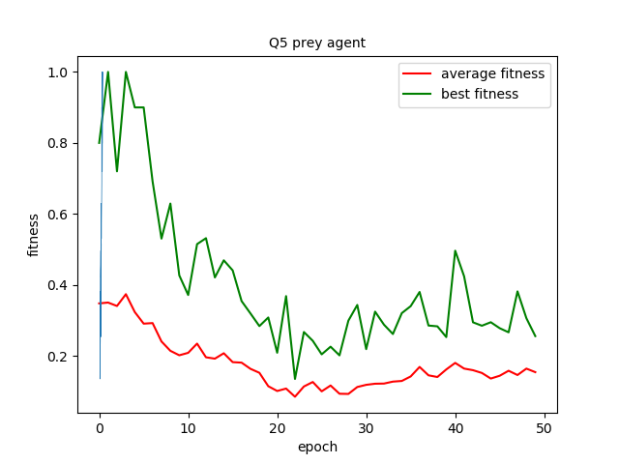

100th generation: (same)

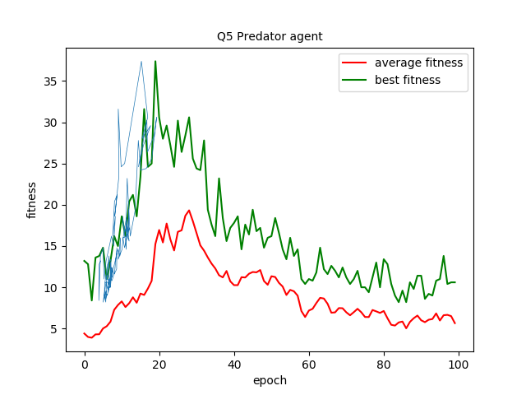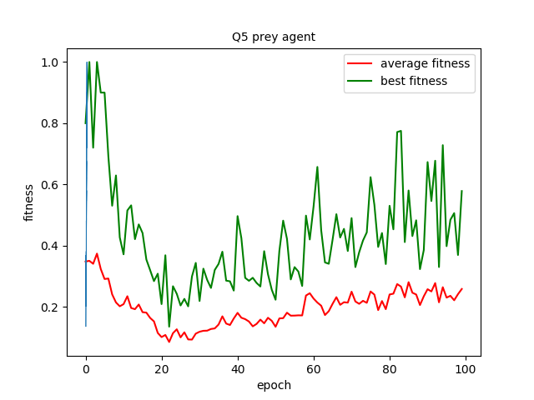

2000th generation: (same)

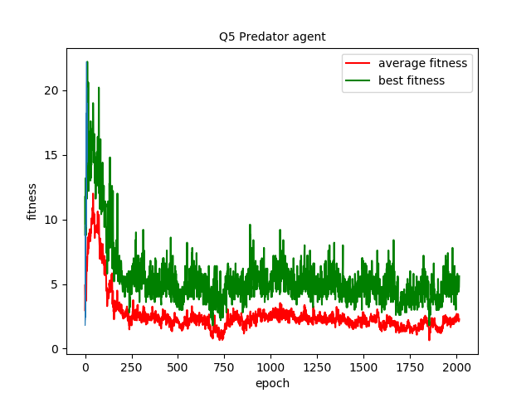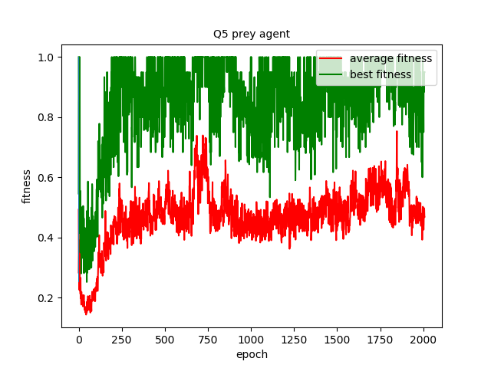

Below is my colleagues’ results:

Result from colleague A. 5000 generation. The above one is the fitness for pred, below on is for predator.

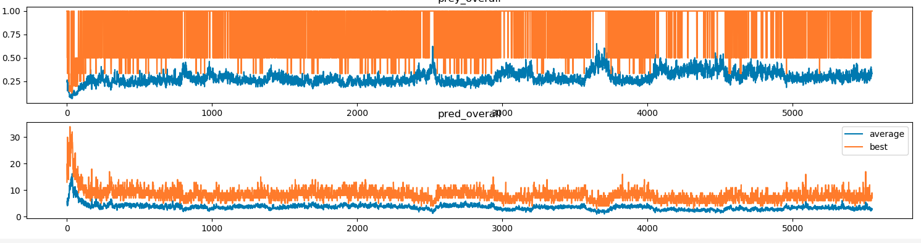

Result from colleague B. 1000 generation. Fitness for prey and predator.

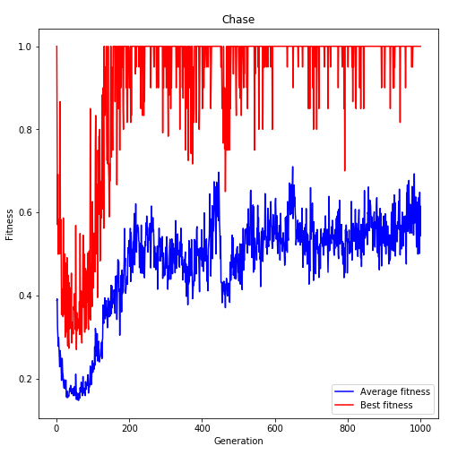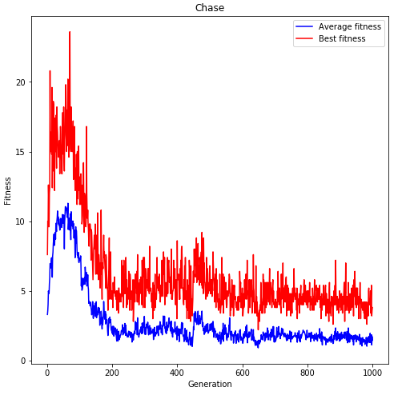

1. For the first generation, both prey and predator are moves around a simple circle with a different radius.

For the 10th generation, the predators' searching area and cruise range are larger. And there are no noticeable changes for the prey’s route. So in this generation, predators would hunt more prey.

For the 50th generation, a few preys trying to avoid predator when they detect the predator. So the predator hunts a little bit less prey, but still, predator performs better.

For the 100th generation, most of the prey would change their route when they detect the predator is coming. And the predator also can follow the prey until they catch the prey successfully.

For the 2000th generation, because both agents have the same speed, it’s harder for predator to hunt prey. There are some collective behaviours. Usually, two predator would hunt together, enlarge their searching area.

There is co-evolution after 50th generations. In previous generations, the performance of predators is getting better and better. They can hunt more prey after generations. But after this, the prey gradually learns how to avoid been caught. And the predator also has to evolve a better way to find the prey. So both of the agents are developing better strategy and movement to improve their fitness and performance. Once the predator behaviours is fixed or not change too much, then the prey behaviours or corresponding strategy also remain unchanged.

1. The plot shows that the predator reaches the peak of their fitness, and the fitness of prey are the lowest in the 20th generation. Then things gradually changed, the predators' fitness is going down and the prey's increase. These changes indicate that as one agent evolved and performed better, another agent will be effected and begin evolution as well. It's kind of like the game and also co-evolution.

And after this, there is a long period that the average fitness of predator remain at approximately 2. And the fitness of prey also remain a certain level. Both of them are not changed too much since then.

In conclusion, if one of them has evolved, the other will evolved as well. If one of them don’t evolve better performance any more, the other will stop evolve as well.

1. As far as I think, intelligence should be completely autonomous. Observe the environment and take action to achieve the goal. Just like creatures, there is no central control, but each of them can gather together as a group and have some collective behaviours. And here are some features of creatures and I believe intelligent should have the same. The agent should cope appropriately with changes in its dynamic environment. The agent should have a particular goal. And change its behaviour which depends on the circumstances it finds itself in to achieve the goal.

Back to predator-prey simulations. Both agents have sensors to detect the simulation world and react depending on the input sensor, just like intelligent creatures. The predator catches the prey, then run towards it. To the contrary, the prey runs away from the predator as soon as prey detect it. They are self-consciousness. They have their own intelligence control system, but there is no central control to rule their behaviours. So even one prey is caught many times, it won't affect other prey. People are not designing every movement for them, but only by giving agents control system or algorithms or decision-maker, and they have to evolve and act to adapt the environment and achieve the goal all by themselves. And that is intelligent enough for me.