

|  |
| --- |
| School of Computing  Faculty of Engineering |

Control System (AI) for Wrestling Robot

Fanhui Meng

Submitted in accordance with the requirements for the degree of  
MSc Advanced Computer Science (AI)

**Session 2019/2020**

The candidate confirms that the following have been submitted*:*

*<As an example>*

|  |  |  |
| --- | --- | --- |
| **Items** | **Format** | **Recipient(s) and Date** |
| *Deliverables 1* | *Report* | *SSO (xx/xx/xx)* |
| *Deliverables 2* | *Code and URL* | *SSO (xx/xx/xx)* |
| *Deliverable 3* | *Youtube video URL* | *Supervisor, assessor (xx/xx/xx)* |
| *Deliverable 5* | *User manuals* | *Client, supervisor (xx/xx/xx)* |

Type of Project: Exploratory Software

The candidate confirms that the work submitted is their own and the appropriate credit has been given where reference has been made to the work of others.

I understand that failure to attribute material which is obtained from another source may be considered as plagiarism.

(Signature of student)

© 2020 The University of Leeds and Fanhui Meng

# Summary

The artificial intelligence technology has been widely developped and used in many field. This project is focus on using AI technology, design a high-level control system for Zumo robot in the Sumo robot league.

The Sumo robot league is a popular robot competition, and the main rule of this competition is two vehicle-like robot without mechanical arm trying to push each other out of the ring. The Zumo robot that is going to be used in this project, it’s a off the shelf Arudino-based robot. Thus, no structure design or hardware design (e.g. circuit design) or low-level design (e.g. PWM motor speed control) in this project.

The high-level control system means the ‘brain’ of the robot. It has strategies to cope with different situations. There are many machine learning methods to develop strategies for the robot. Bascially, there are two kinds of machine learning can be applied in this project, which is supervised learning and unsupervised learning. One is to develop the control system by telling the robot which is the right thing to do and what is wrong. Another is to develop the control system by not telling what the robot should do, but only reward or punishment the robot according to the rules and it’s behaviours.

This project aim to implement and compare two different control systems, one is supervised and another is unsupervised.

Futhermore, this project will do more research about how the same control systems or the same ideas can be applied in other robot competitions or the robot in daily life.

# Acknowledgements

aaaaaaaaaaaaaaaaaaaaaaaaaaaaaaaaaaaaaaaaaaaaaaaaaa

*<This page should contain any acknowledgements to those who have assisted with your work. Where you have worked as part of a team, you should, where appropriate, reference to any contribution made by others to the project.*

*Note that it is not acceptable to solicit assistance on ‘proof reading’ which is defined as “the systematic checking and identification of errors in spelling, punctuation, grammar and sentence construction, formatting and layout in the text”; see* [*http://www.leeds.ac.uk/qat/documents/policy/Proof-reading-policy.pdf*](http://www.leeds.ac.uk/qat/documents/policy/Proof-reading-policy.pdf)*. >*

# Table of Contents

Summary iii

Acknowledgements iv

Table of Contents v

List of Figures

List of Tables

Chapter 1 Introduction

1.1 Overview 1

1.2 Aim and Objectives

Chapter 2 Tables and Figures 2

2.1 Tables using the ‘table caption’ and ‘table description’ Styles 2

2.2 Figures using the ‘figure caption’ and ‘figure description’ Styles 2

List of References 3

Appendix A External Materials 4

A.1 Level 2 Heading with ‘heading 2’ Style Applied by Pressing Ctrl Shift 2 4

A.1.1 Level 3 Heading with ‘heading 3’ Style Applied by Pressing Ctrl Shift 3 4

A.1.1.1 Level 4 Heading with ‘heading 4’ Style Applied by Pressing Ctrl Shift 4 4

Appendix B Ethical Issues Addressed 5

B.1 Level 2 Heading 5

# List of Figures

1.1 Main features of the Zumo 32U4 robot

# List of Tables

Table 2.1: Fuzzy rules for sumo robot (Erlan et al., 2013)

Table 2.2: Genes for robot attributes (Lehner et al., 2019)

# List of Abbreviations

BEAST Bio-inspired Evolutionary Agent Simulation Toolkit

GA Genetic algorithm

FLC Fuzzy Logic Control

# Chapter 1 Introduction

## Project Aim

The aim of this project is to design a fine robot high-level control system, which is the ‘brain’ of the non-arm Zumo robot. The control system would have it’s own strategy, and drive the robot’s movement during the competition. As for the strategy, it can be assigned with specific movement in different cases or the robot can develop it’s own strategies, which may related to evolutionary algorithm. And this will be discussed later in the report.

The main goal of this project is to make the Zumo robot be competitive and perform well in the Sumo robot competition. In addition, this project will find out if the idea of control system can be applied to a wider range of different robot, such as other robot competition or the robot service in daily life.

This project is going to use the Zumo 32U4 robot, which is a complete, versatile robot controlled by an Arduino-compatible Atmega32U4 microcontroller. Therefore, extra hardware structure and improvement is not considered in the project. The Zumo robot has two motors, one Atmega32U4 chip as the brain and a variety of sensors, including two front proximity sensors, two side proximity sensors, five line sensors (three of them are receiver, two of them are emission) and accelerometer. So the Zumo robot can detect the opponent and run towards or away from it, which satisfy every requirement of a robot in the Sumo league.

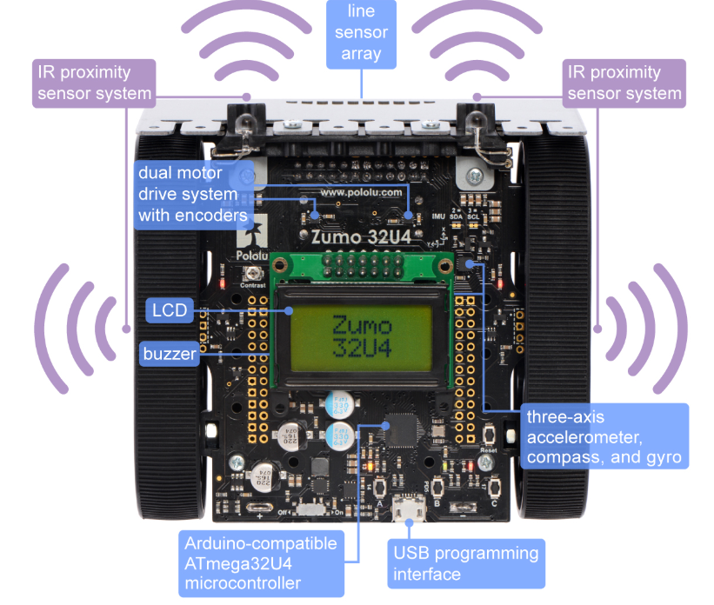

Figure 1.1: Main features of the Zumo 32U4 robot

Sumo robot league is a very popular international robot wrestling competition, which is two robots attempt to push each other out of the ring. Thus, the wrestling robot must be capable of autonomously locating the opposing robot and pushing it out of the ring (Wilson et al., 2016). The last stand robot in the ring is the winner. Also, there are other rules in the Sumo league, which the control system should be designed according to these rules. And these rules will be explained in details in the next chapter.

### Objectives:

* To get familiar with the hardware functions of Zumo robot.
* Conduct a theory study to compare different control system in the wrestling case.
* Implement two or more different control system and compare it’s advantages and disadvantages.
* Create wrestling simulation environment. (Due to the lockdown policy, it’s hard to find the opponent in the real world)
* Evaluate the results with it’s performance in different simulation cases.

#### Deliverables

1. A software product that can simulate the Sumo robot wrestling. Built using BEAST.
2. A Github repository that contains the source code of the system.
3. A developer documentation that provides:

* An overview of the simulation, algorithm used, programming languages and style.
* Instructions for setting up the project in a local development environment. (Provide VM for Mac or Windows user)

1. The MSc project report.

#### Ethical, legal, and social issues

Need to be done.

No Ethical, legal and social issues related to this project.

# Chapter 2 Background Research

## 2.1 Literature Survey

The sumo robot contest feature two self-controlled robots trying to push each other out of a ring. (Anon, n.d.) The basic rules is the first robot that touches outsides of the ring loses the round, and the last stand robot win the round. The match is the best of three set. And the robot wins the most matches are wining the contest.

Several structure requirements for the participant robot (e.g. robot size, mass, etc) are clearly defined in the sumo robot rules. But these requirements are not being considered in this report, since this project’s experiement and simulation are based on ready-made Zumo robot, which already satisify all the hardware and structure aspect requirements.

About the contest environment. It’s a large, flat ring. It’s made of smooth, rigid wood. The top surface is dull black, and all of these black areas are in bounds.

A robot is usually started by pressing a button or other ways, such as had clapping, a whistle and so forth. After start command, the contestants immediately leave the exterior area around the ring. During the round, all people and object must be kept out of the ring and exterior area to avoid distracting the robots or altering the outcome. Upon pressing the start buttons, each robot must not move at all for five seconds.

A robot loses a round when any portion (including touch sensors, whiskers, scoops, or skirts) of the robot touches outside the ring. It doesn’t matter if the robot falls out on its own or is puhsed out.

If the match satisfiy any of the conditions below, the reference may choose to restart a round.

* Three minutes have expired
* No progress has been made in some period of time
* The robots fail to touch each other for some period of time
* The robots are hopelessly entangled or otherwise deadlocked
* Both robots fail to start or both contestants signal stoppage

This project design is based on the sumo rules above.

There are pretty much studies in Sumo robot control, and even more research on the general intelligence control system. And there are also different aspects of these project. Some are fucus on the low-level development, some are meant to design the hardware or the construction of the Sumo robot, some are focus on the electronics and so on. And this project is going to focus on the high-level design.

One study is to develop the Neuro-Fuzzy (NF) hybrid system as the control system (Erdem, 2011). In other word, it use two system, which is ANN and Fuzzy Inference System (FIS). FIS is for detecting and tracking the opponent, which relates sensor output (IR sensor) to motor control pulses. ANN is used for rule extraction and tuning the FIS parameters. And the result shows that this control system can improve the robot responses during competition. This is a good thought to develop a good control system. It’s pettery much the low-level development. It’s just like human work out to improve physical strength, but I would focus on the brain development. However, the wrestling environment is uncertain and the data is non-linear. Thus, the method that using ANN to improve the fuzzy control is a good thought for high-level control as well.

Simularly, one project also use fuzzy logic as the main idea of sumo robot control. It use single fuzzy logic control (FLC) as the microcontroller for detection and tracking of opponenet in competition ring. Three infrared sharp sensors for target detection. Then the fuzzy controller fuses the sensor data and provide the control signal to the motor for driving the robot toward the opponent (Erdem, 2007).

Then the author develop the fuzzy rules, which are intuitive rules that can be driven by all possible scenarios with input sensor values. For example, one of the fuzzy rule is that, if S1 and S2 detects weak signal and S3 detects medium signal, the logical action of the robot is to control the motor to take a small turn to right. The optimized rules for detection and tracking of target are shown in below.

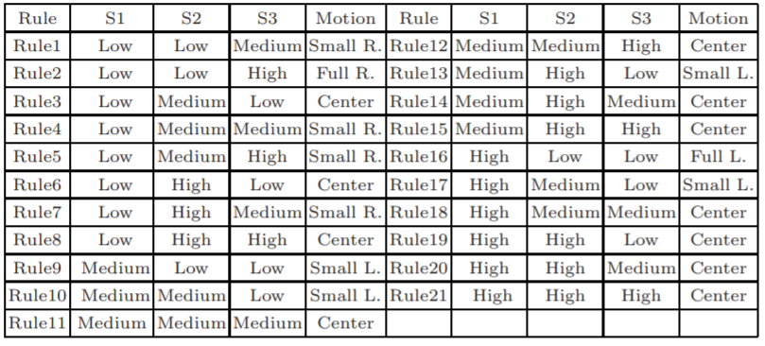

Table 2.1: Fuzzy rules for sumo robot (Erdem, 2007)

For every sensor, there are three fuzzy sets, including Low, Medium, High. The five singleton membership functions are Full Left, Small right, etc. Based on the output of fuzzy controller, the motor will make the robot turn left or right.

Besides, a few studies use genetic algorithm (GA) to optimize sumo robot. One study use Java with Eclipse and the *dyn4j physics engine* for simulating the sumo robot fight (Lehner et al., 2019). Each robot has six attributes (e.g. the speed, serach range), which are allocated to gene positions and can be controlled by the GA. The intensity of each genetically controlled capability is the characteristics, which is expressed with a vale ranging from 1 to 9.

The genes for robot attributes and it’s controlled capability is shown below.

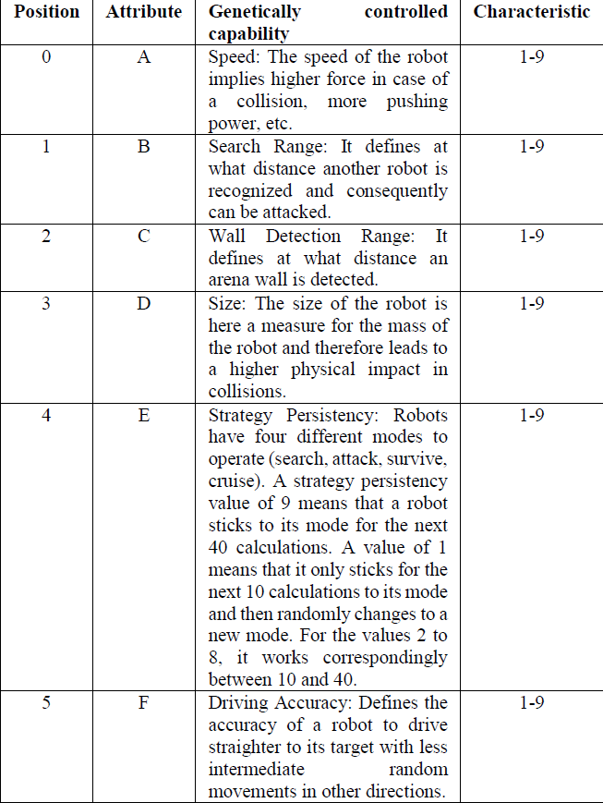

Table 2.2: Genes for robot attributes (Lehner et al., 2019)

The process for each individual robot is, in the start of the fight, each robot receives a randomly selected mix of values, which is the mix characteristics for the robot. Then run the fight to determine highest fitness. The fitness is defined as how many movements are requred until it’s lose or stands last. The next step is the crossover and selection for the next generation. This project uses *roulette wheel selection*, which distributes the probability for the selection of each robot based on their relative probaility of the fitness. And 50% mutation rate per gene is also applied to increase the probability of changing the characteristics randomly. Finally, create new generation and transfers the new generation in a new loop. After thousands of generations, the last robot stands in the ring is the final winning genes of the GA optimizaiton.

## 2.2 Methods and Techniques

2.2.1 Fuzzy Logical Control System

Fuzzy control is an intelligent control method based on fuzzy set theory and fuzzy logic inference. It’s an intelligent control method that imitates human’s fuzzy inference and decision-making process from the behavior. The method first compiles the experience of the operator or expert into fuzzy rules, then fuzzifies the real-time signal from the sensor. Use the fuzzed signal as the input of the fuzzy rule, completes the fuzzy inference and output the inference.

Several things are important for defining a fuzzy controller. First is the fuzzy interface, which is for performing a conversion from a real certain value of input into a fuzzy set. For example, in this project, it may transfer the proximity sensor output, such as a number value, to a fuzzy set, like low, medium or high. Secondly, the knowledge base, which is consist of data base and rule base. The data base stores all the input and fuzzy set. While the rule base is the fuzzy rules usually based on expert knowledge or personal experiment. Fuzzy rules are normally connected by a series of relational words, and the most commonly used relational words are if-then, else, etc. Finally, is the inference and defuzzy-interface. The result of the inference indicates that the rule inference funtion of fuzzy control has been completed. However, the result obtained still cannot be used directly as a control variable. A conversion must be made to have a clear control variable output, which is the defuzzification. In this project, this could be used for determination of real value for directing of motors or other controls.

Fuzzy logic control doesn’t require accurate mathematical model. However, the factors such as the integrity of fuzzy control rules, the definition of fuzzy subsets and the fuzzy inference mechanism will have an impact on the performance of the fuzzy controller. Thus, most of the factors depend on the experience of experts. For this project, the mian basis of control is based on a large amount of personal experience, knowledge and strategy in the sumo league.

2.2.1 Decision tree based Control System

Similarily to FLC, the performance of decision tree based control system is also depend more on personal experience and strategy in wrestling robot.

# List of References

Anon n.d. Autonomous Sumo Robot Rules - Robot Room. *www.robotroom.com*. [Online]. Available from: <https://www.robotroom.com/SumoRules.html#:~:text=Mini%2Dclass%20Sumo%20robots%20may%20be%2010%20centimeters%20(3.93%20inches>

Erdem, H. 2007. A Practical Fuzzy Logic Controller for Sumo Robot Competition. *Springer-Verlag Berlin Heidelberg 2007*. (LNCS 4815), pp.217–225.

Erdem, H. 2011. Application of Neuro-Fuzzy Controller for Sumo Robot control. *Expert Systems with Applications*. **38**(8), pp.9752–9760.

‌ Erlan, C., Lima, O., Almeida De Araújo, F., Bibiano Da, M., Júnior, S., Edson, A., Filho, R., De Andrade, R., Rabêlo, L., Allisson, T., Da Silva, R., Jose, A. and Alves, O. 2013. *An Enhancement in Conventional Potential Field Using a Fuzzy System for Navigation of a Sumo Robot*.

Lehner, J., Dornberger, R., Simić, R. and Hanne, T. 2019. *Optimization of Multi-Robot Sumo Fight Simulation by a Genetic Algorithm to Identify Dominant Robot Capabilities*.

Wilson, B., Author, S., Germann, T. and Al-Olimat, K. 2016. *Sumo Robot Competition* [Online]. [Accessed 4 August 2020]. Available from: http://people.cst.cmich.edu/yelam1k/asee/proceedings/2016/student_regular_papers/2016_asee_ncs_paper_58.pdf.

# Appendix A External Materials

<Level 1 Heading with ‘heading 1’ Style Applied by Pressing Ctrl Shift 1> Text under appendix heading. Text under appendix heading. Text under appendix heading. Text under appendix heading. Text under appendix heading. Text under appendix heading.

## A.1 Level 2 Heading with ‘heading 2’ Style Applied by Pressing Ctrl Shift 2

Text under level 2 heading. Text under level 2 heading. Text under level 2 heading. Text under level 2 heading.

### A.1.1 Level 3 Heading with ‘heading 3’ Style Applied by Pressing Ctrl Shift 3

Text under level 3 heading. Text under level 3 heading. Text under level 3 heading. Text under level 3 heading.

#### A.1.1.1 Level 4 Heading with ‘heading 4’ Style Applied by Pressing Ctrl Shift 4

Text under level 4 heading. Text under level 4 heading. Text under level 4 heading. Text under level 4 heading.

# Appendix B Ethical Issues Addressed

Text under appendix heading. Text under appendix heading. Text under appendix heading. Text under appendix heading. Text under appendix heading. Text under appendix heading.

## B.1 Level 2 Heading

Text under level 2 heading. Text under level 2 heading. Text under level 2 heading. Text under level 2 heading.