Atmospheric Refraction:
How Electromagnetic Waves Bend
in the Atmosphere and Why It Matters

LCDR Bruce W. Ford

“If you know the enemy and know yourself, your victory will not stand in doubt; if you know the weather and know the ground, you may make your victory complete”
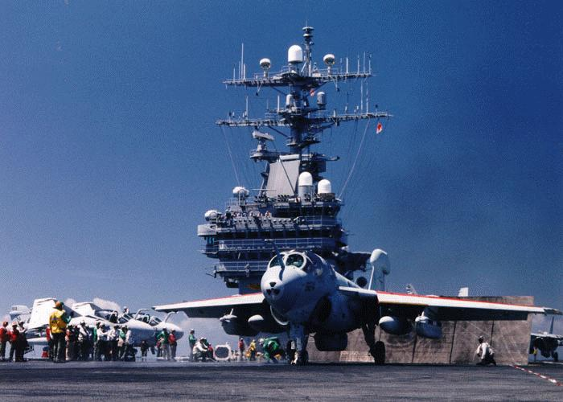
-- Sun Tzu, The Art of War

Actual Cases

Case 1: At night in the Gulf of Tonkin during the Viet Nam war, radar operators on the US MADDOX (DD-731) and the USS TURNER JOY (DD-951) reported echoes that were evaluated as attacking torpedo boats. General quarters was set for both ships and crewmen on both ships prepared to ward off the attackers. Combat Information Center personnel reported contacts at “1500 yards and closing,” then “1000 yards and closing.” Then the contacts would disappear. Several times within a few hours, numerous echoes were observed and evaluated as unfriendly attackers, only to disappear from the radar display when the range closed to 1000 yards.

Case 2: An Aircraft Carrier Strike Group (BG) is conducting flight operations in the Arabian Gulf. Enemy forces have deployed a reconnaissance aircraft to observe the activity. None of the radars on the BG ships detects the enemy aircraft; the first to see the contact is a lookout on the aircraft carrier.
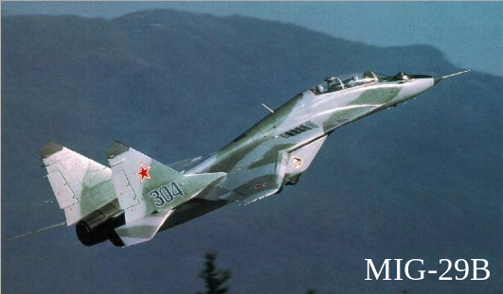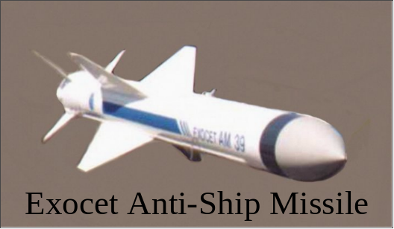

An unexpected visit by one of these could ruin your day!

These types of situations can occur with even the most sophisticated radar equipment, and rarely are they caused by equipment malfunction or operator error. Often, they are caused by variations in atmospheric conditions.

The purpose of this module is to provide an introduction to atmospheric variables that cause anomalous propagation (AP) and refraction of radar and radio waves. Understanding the concepts presented in this module will assist you in understanding how Tactical Decision Aids (TDAs) depict these effects. Radar operators and operational commanders who understand this information can make the atmosphere work for, rather than against, them.

Anomalous Propagation: What is it?

Electromagnetic Radiation and Propagation

Electromagnetic (EM) radiation is energy propagating in the form of an advancing disturbance, or wave, in the electrical and magnetic fields. In a vacuum, the wave propagates at the speed of light. In the atmosphere, the wave propagates with a speed slower than the speed of light. The wave’s speed, direction of propagation, and amplitude are dependent upon several atmospheric variables including temperature, moisture, and pressure.

What is the speed of light?
The speed of light in vacuum is 299,792,458 m/s (meters per second). When people refer to the speed of light, they usually mean the speed of light in a vacuum. This speed is normally rounded to 300,000 kilometers per second or 186,000 miles per second.
The speed of light depends on the material that the light moves through. For example: light moves slower in water, glass, and through the atmosphere than in a vacuum. The ratio of the speed in a vacuum to the speed in a medium is the absolute refractive index for the medium.
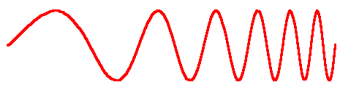

Absorption, Refraction and Anomalous Propagation

As EM energy propagates through the atmosphere, it is attenuated (i.e., undergoes a loss in overall energy) by absorption and scattering. The major gaseous absorbers in the atmosphere are water vapor, carbon dioxide, ozone, and oxygen. Each is selective about what it absorbs, (e.g., oxygen absorbs UV energy), but for most radar, absorption is fairly negligible in terms of its effect on EM propagation. EM energy is also scattered by liquids and solids in the atmosphere. This effect is greatly dependent on the size of the particle in relation to the wavelength, but as with absorption, scattering represents a small factor in EM propagation.

Changes in temperature, moisture, and pressure in the atmospheric column cause a change in atmospheric density, which in turn causes variations in the speed of EM waves in both the vertical and horizontal. These changes in speed lead to changes in the propagation direction, or bending, of the waves. The bending of EM waves as they pass through the atmosphere is an example of refraction (see Figure 1). Refraction is always such that the waves turn toward the medium in which they ravel more slowly, as they pass from a faster speed medium into a slower speed medium. This is the case shown in Figure 1, where medium a is the faster speed medium. Refraction causes waves to turn back toward the slower speed medium as they pass from the slower into the faster medium. You can visualize this case if you mentally reverse the arrow directions in Figure 1.

Refraction can cause waves to bend back toward the slower speed medium as they try to propagate into a faster speed medium. This analogous to the way a car that veers onto a soft sandy shoulder on the side of a road turns toward the sandy area in which it travels more slowly. This bending toward the slow speed medium can lead to trapping in which waves are unable to propagate out of the slow speed medium.

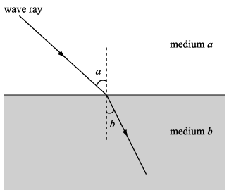
Figure 1 – A simple refraction

Some amount of refraction is always present in our atmosphere, and is quite normal. However, when the structure of the atmosphere causes abnormal bending of the energy waves, anomalous propagation (AP) occurs. AP takes place when an unusual, other-than-normal vertical distribution of temperature, moisture, and pressure exists within the atmosphere. Figure 2 shows schematically some examples of normal and anomalous radar heights and ranges. The AP regions indicate the height and range effects of anomalous temperature, moisture, and pressure distributions. Note that AP can greatly extend, or reduce, the height and/or range of radar.

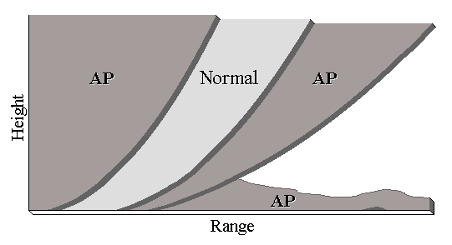
Figure 2 - Anomalous Propagation

AP occurs in many forms. One type of refractive condition can extend the normal detection range of radar and, if conditions intensify, produce false echoes or ghosting. Ghosting can cause returning echoes to fool the radar equipment into displaying faraway echoes as though they are much closer than they actually are. This was the case in our first example, and a great deal of time and energy were expended reacting to false echoes.

With another type of refractive condition, AP may produce a shadow zone (commonly referred to as a radar hole), sometimes allowing an aircraft or ship to approach within visual range but to remain undetected by radar, as in our second example. In this case, the radar equipment operated properly. But one can only imagine the consternation caused within the strike group!

Another naturally occurring AP feature is known as a duct. Simply put, a duct is a region of the atmosphere that traps EM waves (prevents them from spreading out), and thus allows them and their energy to propagate over long ranges. Ducts provide significant opportunities to exploit the atmosphere. The challenge in exploiting a duct is to: 1) know it is there, and 2) put a sensor in it! A duct is a transitory feature, and will only trap certain frequencies. The wider the duct, the higher (and, typically, the more useful) the frequency that can be trapped and exploited. The exploitation of ducts is a common tactic, and a very important part of the overall exploitation of the atmosphere.

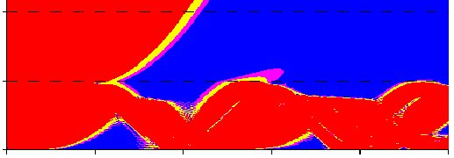
0 25 50 75 100 125 125
2000

1000

0
Figure 3 - Anomalous radar propagation heights and ranges (in red). Vertical axis is height (in ft) and horizontal axis is range (in nm). The extensive area of red between the surface and 1000 ft indicates trapping in a surface duct leading to long distance propagation of the radar signal.

Anomalous propagation occurs frequently and must be factored into any warfare commander’s decision making process. METOC forecasters must:

- Understand the effects of atmospheric variables on radio and radar performance.
- Collect, analyze, and evaluate available data to accurately describe the existing atmospheric propagation condition, and how it will change over time.
- Provide radar operators and operational commanders with this information on a timely basis.

A Little Deeper

Refractive conditions are categorized into four basic classifications: Normal, and (AP) Super-refractive, Trapping, and Sub-refractive (figure 2).

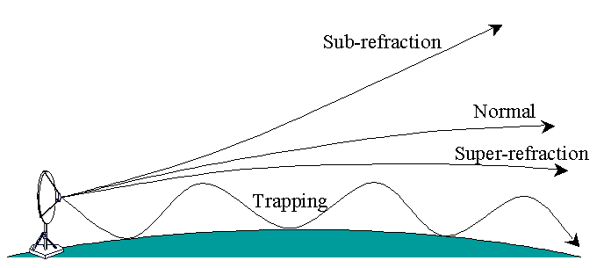
Figure 4 - Four Classifications of Refraction

Normal Refraction

In free space, an EM wave will travel in a straight line because conditions are uniform and the index of refraction is the same throughout the column. Within Earth’s atmosphere, however, the velocity of the wave is less than that of free space. So the propagating wave will be bent downward from a straight line. This is described as normal refraction occurs.

Normal refractivity exists in most areas about 50% of the time. AP is not present under normal refractive conditions.

Super-Refraction

In this situation, the vertical distributions of temperature, moisture, and pressure cause the radar waves to bend more toward the surface of Earth than under normal conditions.

As the refractivity gradient continues to decrease, the wave path’s curve will approach the radius of curvature of the earth.

Super-refractive conditions can extend radar coverage up to 50% above normal.

Trapping

If the radius of curvature for the wave becomes smaller than Earth’s, waves may become trapped between two areas: Earth’s surface, and the negative gradient causing the downward refraction.

Trapping produces the greatest extremes in radar performance and can significantly extend radar ranges. Radar waves refracting sharply downwards, then reflecting off of Earth’s surface, may travel distances well beyond normal. Trapping can occur between the surface and an overlying region of the atmosphere with faster speed characteristics. It can also occur between two layers of the atmosphere that have different characteristics. This is known as an elevated duct.

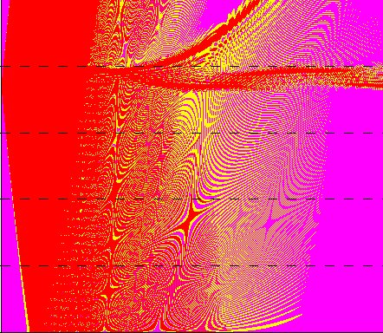
Elevated
duct
Figure 5 – Elevated Duct

Sub-refraction

The effects of the fourth type of refraction are significantly different than those of the other three types.

Sub-refractive conditions cause the radar waves to be refracted les than normal and therefore upward and away from Earth’s surface. Waves that are curved upward offer the smallest ranges and worst opportunity for distant detection.

Three Conspiring Amigos:

Moisture, Temperature, and Pressure

Moisture

Of the three atmospheric variables that influence refraction (temperature, moisture, and pressure), moisture – or more specifically, water vapor – has the greatest effect on refraction. Temperature has the next greatest effects on refraction, followed by pressure. The simple rule of thumb for moisture effects is:

More moisture means more refraction.

Temperature

The simple rule of thumb for temperature effects is:

Higher temperature means less refraction.

Moisture and temperature can (and frequently do) work together to significantly alter refraction.

Pressure

Although pressure is one of the meteorological elements that influences refraction, its effects are small. Pressure variations alone provide no significant change in refraction.

So now let us put this all together and examine how moisture, temperature, and pressure affect each type of propagation.
Normal refractive conditions are found in areas with very weak (or no) inversions, deep moisture, moderate to strong winds, and very unstable, well-mixed conditions. There are often showers in the area, and distinct cloud elements (CU/CB, open convective cells, wave clouds, streaks, or convective cloud lines). Synoptic influences include a cyclonic influence, post-frontal or unstable prevailing conditions.

Normal Refraction

Normal refraction occurs under normal (standard) atmospheric conditions in which moisture, temperature, and pressure all decrease with altitude.

Sub-refraction
In hot, dry areas (temperature > 30° C, RH < 40%), solar heating produces a homogenous surface layer, sometimes hundreds of feet thick. Sub-refractive areas are also formed by warm, moist air moving over a cooler, drier surface, and near warm fronts because of warmer temperatures and an influx of moisture.

When the temperature and moisture distribution creates increased refractivity with height, the wave path bends upward and the energy travels away from the surface.

Super-refraction
Super-refractive layers are largely associated with temperature and humidity variations near the earth’s surface (e.g., surface inversions). Inversions aloft, due to large-scale subsidence, will lead to super-refractive layers aloft. Regardless of where they form, these layers lead to increased radar detection ranges and extensions of the radio horizon.

Temperature increasing with height and/or rapid moisture decreases with height will cause EM waves to bend downward more than normal.

Trapping

As previously described, if the radius of curvature for the wave becomes smaller than Earth’s, a trapping layer results. This refractive condition is called trapping because the wave is confined to a narrow region of the atmosphere.

Trapping is an extension of super-refraction because the meteorological conditions for both are the same. The conditions that form a trapping layer are more intense than those that form a super-refractive layer.

Trapping refractive conditions can cause confinement of EM waves to a thin layer of the troposphere. If trapped in this region, EM energy can propagate over great ranges. The confinement region is commonly called a duct.

Weather and EM Refraction: The Gouge!

With knowledge of the overall synoptic weather pattern, it is possible to make a rough determination of the refractive conditions associated with the high and low pressure areas and associated frontal regions (Figure 6).

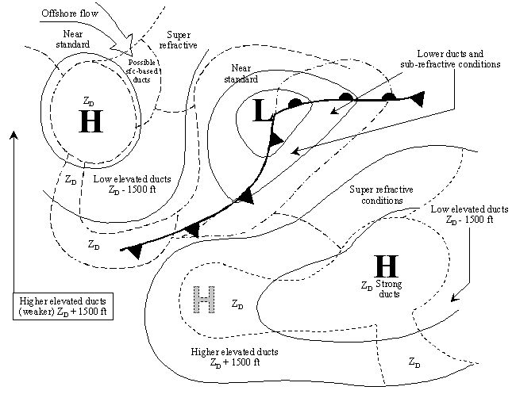
Figure 6 - Ducting conditions associated with typical midlatitude synoptic weather situations

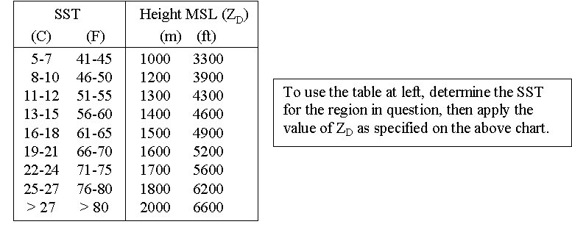
Figure 7 – Approximate mean elevated duct heights for indicated sea surface temperature (SST) intervals.

There’s Help!

METOC personnel throughout the world have state of the science Tactical Decision Aids (TDAs) that can readily assist decision makers in determining how EM waves will refract in the current atmosphere.
Ask for this help!

Determination of refractive conditions can tell you the following and more:

- How far away enemy sensors will detect friendly assets (missiles, aircraft, ships, boats)
- How far away friendly sensors will detect enemy assets
- Where reconnaissance platforms need to be placed to exploit the atmosphere and extend friendly detection capability
- What altitudes provides aircraft with the greatest weapons stand-off range
- From what direction friendly assets should approach the enemy to give the greatest detection advantage

Bibliography

- Advanced Refractive Effects Prediction System (AREPS) Version 2.0 User’s Manual, TD-3101, SPAWAR Systems Center, San Diego, January 2000.
- Effective Use of the Electromagnetic Products of TESS and IREPS, TD-1369, Naval Ocean Systems Center, San Diego CA, October 1988.
- Meteorology Today, 4th ed., 1991
- Principles of Naval Weapons Systems, 1985.

