

Network Programming (IE2102)
2nd Year, 2nd Semester

Assignment

Design and Implementation of a
Secure Multiprocessor TCP Application Server
with Custom Protocol and Session Management

Submitted to
Sri Lanka Institute of Information Technology

IT24100284
Jayaratne M. Y. I. De S.

In partial fulfillment of the requirements for the
Bachelor of Science Special Honors Degree in Information Technology

12th April 2026
Declaration
I certify that this report does not incorporate without acknowledgement, any material previously submitted for a degree or diploma in any university, and to the best of my knowledge and belief it does not contain any material previously published or written by another person, except where due reference is made in text.

Introduction
This assignment is about developing a TCP server using C programming and clients using Python. The system uses a client-server architecture where multiple clients can connect to the server and the server is capable of handling multiple clients using fork(). Basic commands such as REGISTER and LOGIN are implemented and system includes logging functionality to record user activities.

- Hostname Configuration
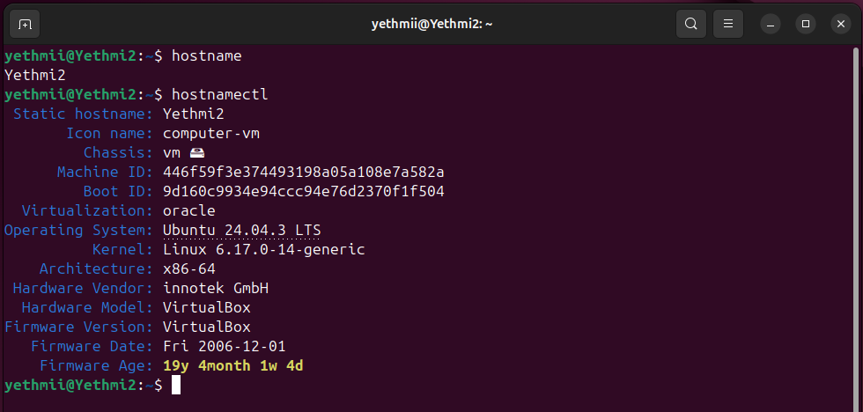

Figure 1

Figure 2
For the hostname configuration we use the hostname and hostnamectl commands. The hostname command simply displays or temporarily sets the system’s hostname, which is the name that identifies the computer on a network. The hostnamectl command, on the other hand, is a systemd utility that provides more detailed system information and allows to permanently set the hostname.

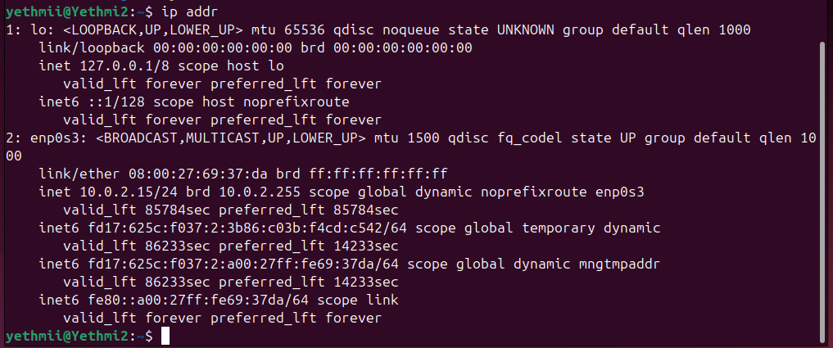
- Network Configuration

Figure 3
For the network configuration we use basic settings to define how a computer connects to a network. This involves assigning an IP address, subnet mask, gateway, and DNS servers so the system can communicate with other devices and access the internet. Proper configuration ensures stable connectivity and allows services like servers and clients to function correctly.
- Server running
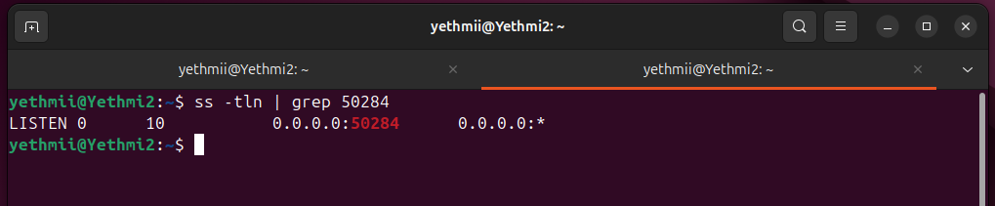
Figure 4

Figure 5
For the server running configuration we start the compiled server program so it begins listening on the assigned port and waits for client connections. This step demonstrates that the server is active, ready to accept requests, and able to handle multiple clients through its multiprocessing design. Running the server ensures that all subsequent commands such as REGISTER, LOGIN, TOKEN, and LOGOUT can be processed correctly, and it provides the foundation for verifying user authentication and session management in your assignment.

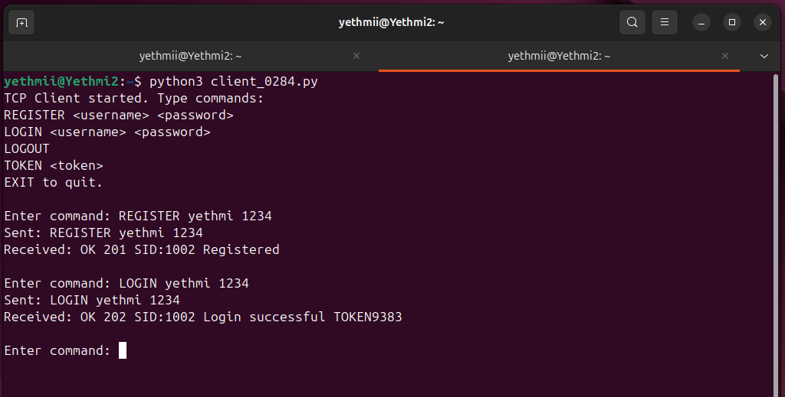
- Successful REGISTER and LOGIN

Figure 6

Successful registration and login confirm that the server correctly accepts new user details, stores them securely, and then verifies the credentials during login. Once authenticated, the system issues a valid session or token, showing that the authentication process works properly and that users can securely access the system.
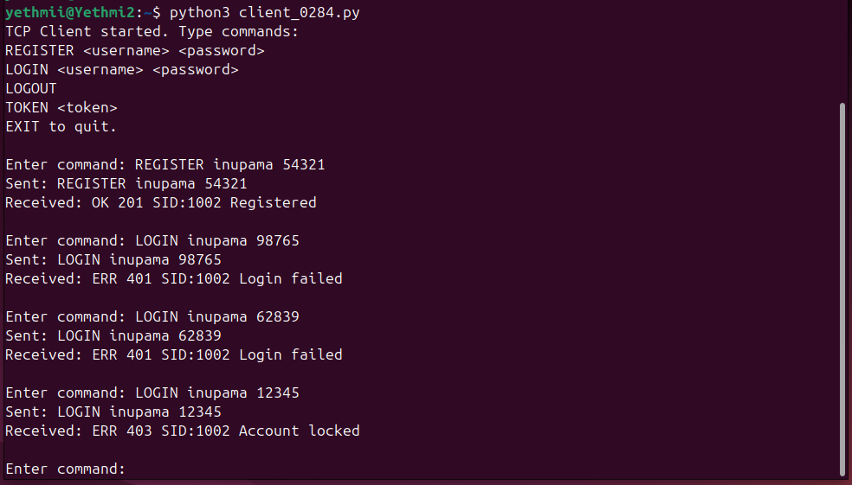
- Failed login + lockout proof

Figure 7
When a user attempts to log in with the wrong password, the server rejects the request and records the failed attempt. If this happens repeatedly, the system enforces a security measure by locking the account after a set number of failures. This mechanism protects against brute-force attacks, ensures that unauthorized access is prevented, and demonstrates that the authentication process includes both validation and account protection features.
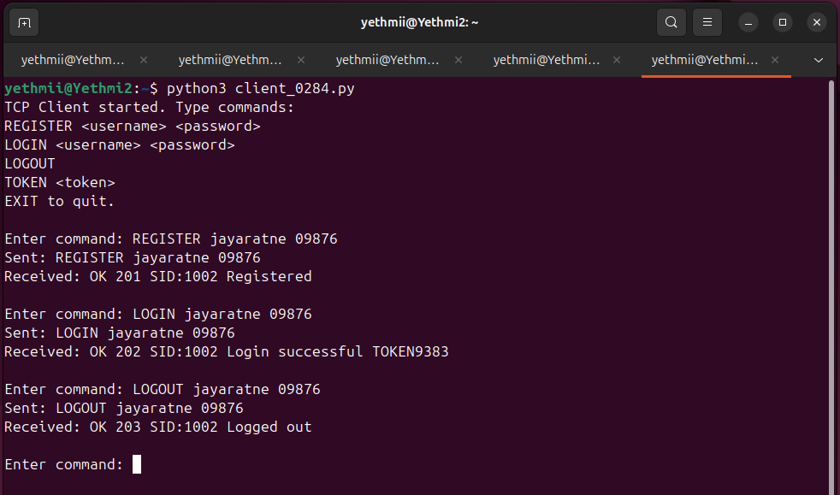

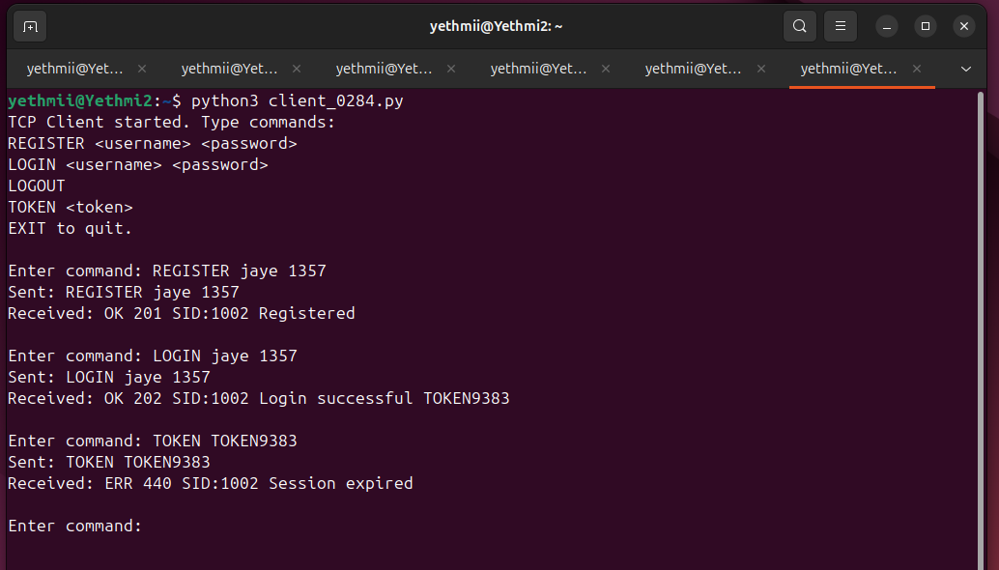

Figure 8
Successful registration, login, and logout together demonstrate the complete authentication cycle of the system. During registration, new user details are securely stored. In login, those credentials are verified, granting access and issuing a valid session or token. Finally, logout ends the session, revoking access and ensuring the account is protected from unauthorized use. This sequence confirms that the server correctly handles account creation, secure access, and proper session termination.

- Multiple forked processes (ps output)

Figure 9
Multiple forked processes indicate that the server is running in a multiprocessing mode, where each client connection is handled by a separate child process. This design allows the server to manage multiple requests simultaneously without blocking, ensuring better performance and responsiveness. Observing several active processes confirms that the server successfully spawns and manages concurrent sessions, demonstrating proper implementation of parallel handling in the system.

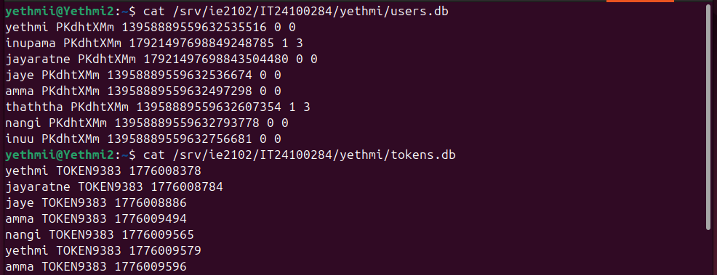
- Log file entries

Figure 10

The users.db file stores registered user information such as usernames and securely hashed passwords, ensuring that credentials are saved in a protected format. The tokens.db file records active session tokens issued during successful logins, linking them to the corresponding user accounts. Together, these databases demonstrate how the server manages account creation, authentication, and session tracking, providing both security and proper user management.

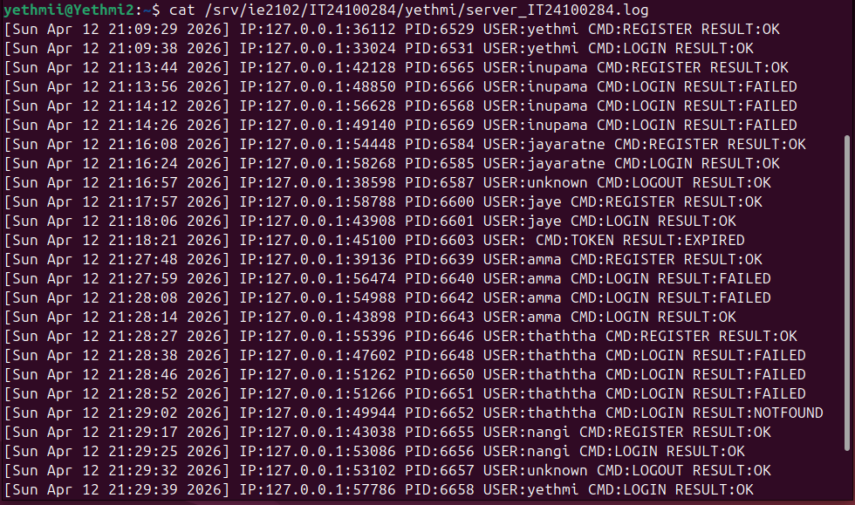

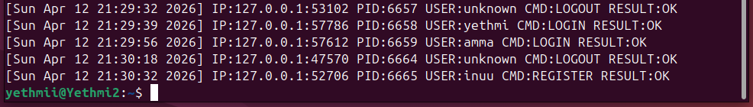

Figure 11
The server log records all major activities and events that occur while the server is running. It typically includes details such as when the server starts, client connections and disconnections, successful or failed login attempts, account lockouts, and issued tokens. By reviewing this log, you can trace the sequence of operations, verify that authentication and session management are working correctly, and identify any errors or unusual behavior. This provides clear evidence of how the server handles requests and enforces its security mechanisms.

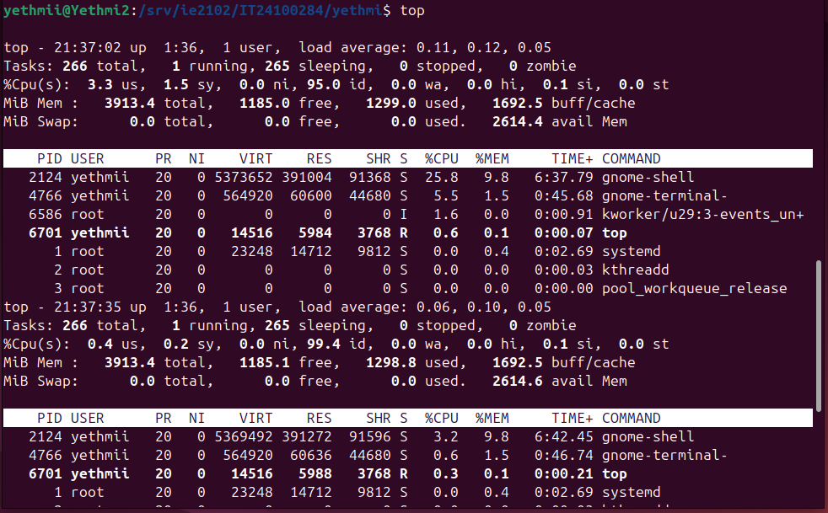
- Proper child cleanup (no zombie process
Figure 12

Proper child cleanup ensures that when a forked process finishes its task, it is terminated cleanly and removed from the process table. The parent process collects the child’s exit status, preventing zombie processes and freeing system resources. This confirms that the server manages concurrency efficiently and maintains stability during multiple client sessions.

