Capstone Project: Agentic Public Records Compliance Assistant
Selected Agent: Research Assistant Checkpoint 5.1: Multi-Agent Architecture and Coordination

1. Problem and Need for Multiple Agents
My capstone project is an Agentic Public Records Compliance Assistant designed to help public-records staff review documents, transcripts, audio, and video requested under New Jersey’s Open Public Records Act (OPRA). It identifies potentially sensitive information, retrieves applicable NJ OPRA/GRC policies, recommends redactions with supporting evidence, and presents findings for human review.
A single agent could perform these tasks, but combining record analysis, policy research, interpretation, and quality validation increases complexity and the risk of overlooking information. Specialized agents provide clearer responsibilities, auditable outputs, and independent validation.

2. Proposed Multi-Agent Architecture
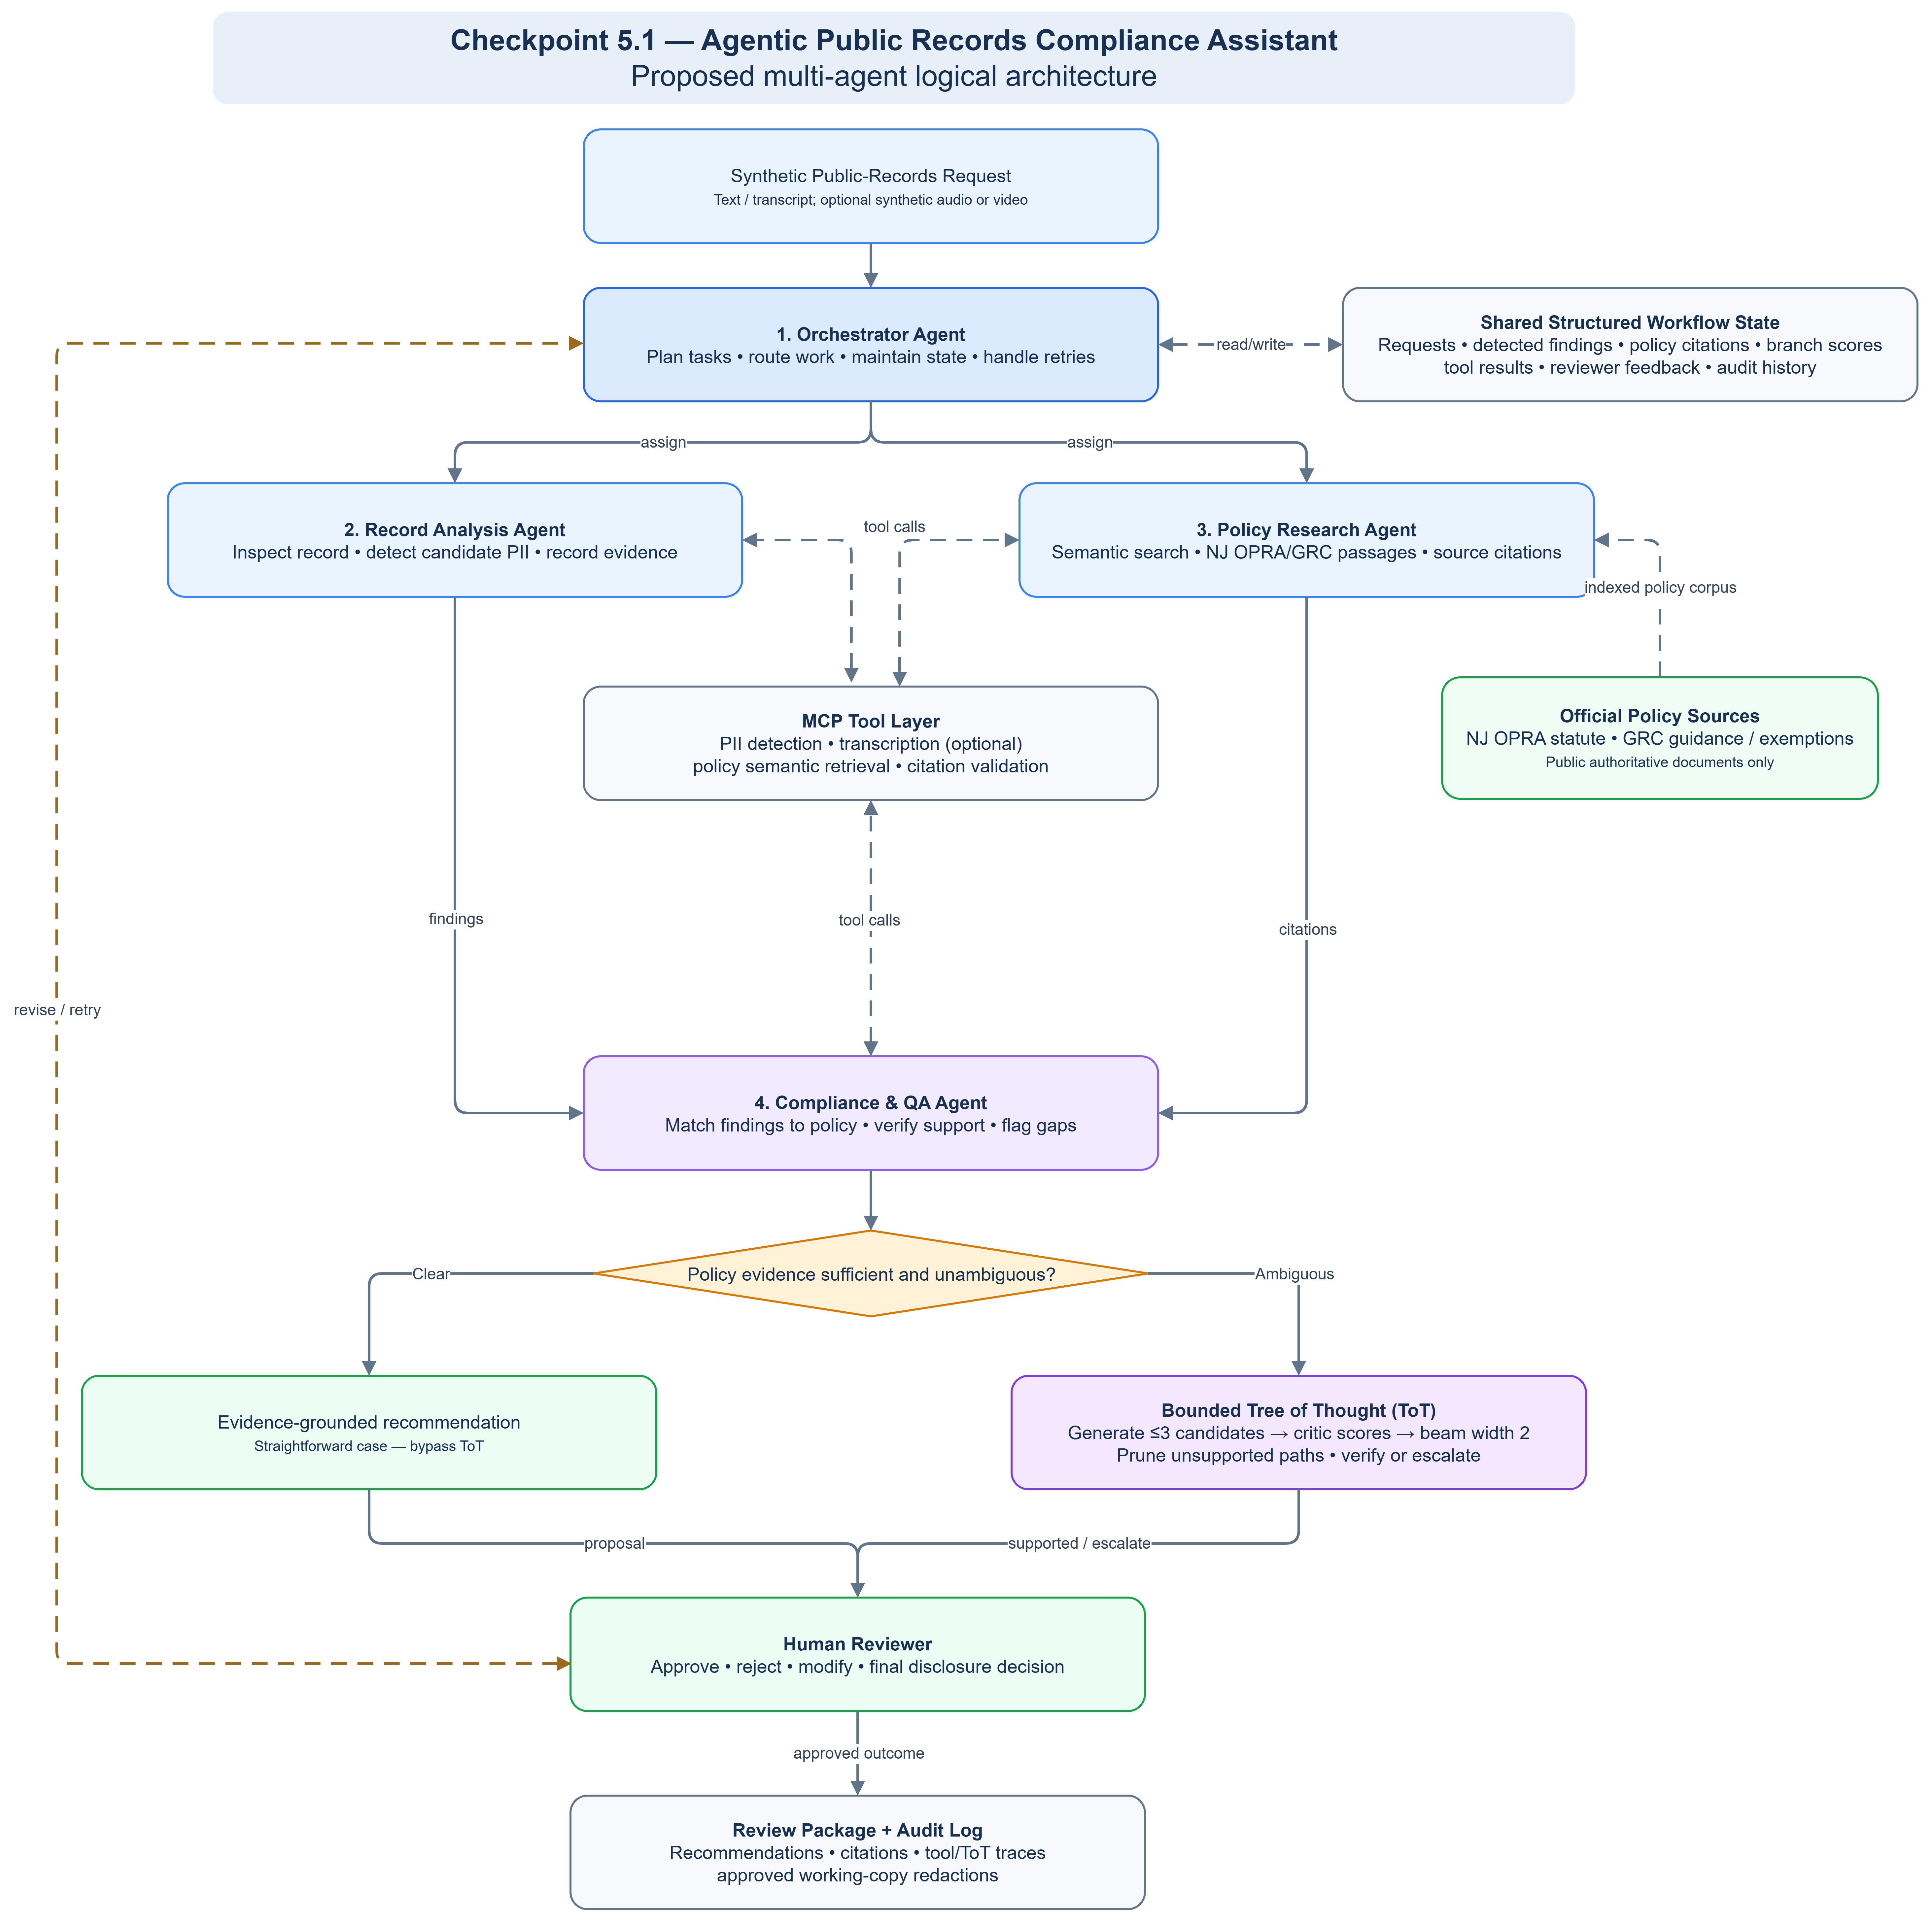

I propose four agents: one orchestrator and three specialized workers. This is enough to separate distinct tasks without creating unnecessary coordination overhead.
Agent | Responsibility
Orchestrator Agent | Understands requests, routes tasks, maintains workflow state, controls retries, and escalates uncertainty.
Record Analysis Agent | Examines synthetic records, uses detection/transcription tools to locate candidate sensitive data.
Policy Research Agent | Uses semantic retrieval to find NJ OPRA/GRC passages, source citations, and potential exceptions.
Compliance & QA Agent | Connects findings with policies, proposes redactions, validates citations, and checks missing or unsupported findings.

3. Coordination Strategy
I will use a hybrid graph-based workflow, ordered steps for normal processing, parallel work where independent, and bounded feedback loops for exceptions. The orchestrator receives a synthetic request and coordinates record analysis and policy research. The Compliance & QA Agent combines their results and checks whether evidence supports the proposed redactions.
Straightforward cases proceed to human review. When sources conflict or an exception may apply, the QA step activates the bounded Tree of Thought (ToT) process proposed in Checkpoint 4.1 to compare evidence-based alternatives. Unresolved questions are escalated, the orchestrator limits retries and prevents unbounded loops.

4. Agent Communication
Agents exchange structured results through shared workflow state rather than unrestricted conversations. Messages contain the request identifier, detected findings, evidence passages and citations, recommendation, uncertainty, and processing status. Information flows one way for routine tasks, validation can trigger a targeted return request through the orchestrator. For example, QA may ask the Policy Research Agent for another passage if the first result does not support the proposed action. MCP exposes retrieval and detection tools, the workflow manages state and branch tracking.

5. Design Trade-offs and Scalability
Specialization improves clarity and allows independent testing, but each additional agent adds tool calls, latency, and coordination overhead. Four agents balance these costs. Structured messages, bounded retries, and conditional ToT reduce unnecessary work, while mandatory human approval prevents the system from treating an AI recommendation as a legal release decision.
The architecture can expand to new record types by adding analysis tools rather than new agents. Policy retrieval and record analysis can improve independently, helping the system remain maintainable as its workload grows.

6. Conclusion
This four-agent design combines focused responsibilities, evidence-grounded research, controlled coordination, and independent QA. It aims to reduce repetitive public-records review while preserving traceability and human authority over final disclosure decisions.

