Agentic Public Records Compliance Assistant: Final Capstone Report
Course: Carnegie Mellon University, Building Agentic AI Systems. Capstone, Research Assistant track. Date: November 2026. Final evaluation commit: 7a1a875.
Evidence rule for this report. Every number, trace excerpt and screenshot comes from a run that was actually executed and saved in the repository. Where a design element was proposed but not built, or built differently, the report says so. Status labels used throughout:
Label | Meaning
Implemented | Code exists, runs, and has tests or recorded runs
Partially implemented | Code exists, but not all of it has been run or exercised
Changed | Built differently from the proposal
Proposed / deferred | Not built

1. Executive summary
The Agentic Public Records Compliance Assistant helps a public-records reviewer prepare a synthetic record for release under New Jersey's Open Public Records Act (OPRA). It runs as a sequence of steps:
1. Detect. The Record Analysis Agent finds candidate personal information.
2. Retrieve. The Policy Research Agent retrieves the governing text from five official nj.gov policy documents.
3. Recommend and check. The Compliance & QA Agent proposes redactions, validates every citation and classifies the evidence.
4. Route. The Orchestrator Agent routes each case to the standard ReAct path, a targeted retrieval, or a bounded Tree of Thought (ToT) subgraph.
5. Human review. The workflow stops for a person. A named reviewer approves, rejects, modifies or sends items back for re-evaluation. Only after explicit authorization is a deterministic redacted derivative written, with a hash-chained audit trail. Nothing is published.
What was built. The four agents run on a LangGraph StateGraph. All tools are served by an MCP server built with the official MCP Python SDK. ToT is a conditional subgraph, not a fifth agent.
The agents are deterministic and rule-based. No LLM is called anywhere in the workflow. The "ReAct" behaviour is a bounded, rule-driven decide → call tool → observe loop. A Claude planner was built in Milestone 3 but was tested only with a fake client.
Evaluation. 22 synthetic scenarios were run under two configurations, ReAct-only (A) and ReAct + selective ToT (B), for 44 runs:
Result | A | B
PII detection precision | 1.000 | 1.000
PII detection recall | 0.895 (17/19) | 0.895 (17/19)
Unsupported redactions | 0 | 0
Escalation recall | 11/11 | 11/11
End-to-end success | 22/22 | 22/22

- What ToT changed: exactly one decision. In S12 (a retired judge's home address) it selected a fully verified, cited redaction instead of abstaining. Cost: 13 extra tool calls and about 0.11 s per ToT case.
- Before evaluation-driven fixes, ToT was harmful: it made two unsupported redactions. Comparing A against B exposed four defects, which are now fixed and covered by regression tests.
- Safety: 16 of 16 safety checks passed over all runs, 40 of 40 mapped guardrail tests passed, and the full suite passed 314 of 314 tests.
- Conclusion: selective ToT did no harm after the fixes and helped one ambiguous case. The evidence does not support a general accuracy claim.

2. Problem statement and intended users
The task. Before a public record is released under OPRA, a custodian must:
- find personal information such as personal phone numbers, driver licence numbers, home addresses and IP addresses;
- determine whether the statute or Government Records Council (GRC) guidance requires redaction;
- redact consistently and record the basis.
The work is manual and repetitive. Errors cut both ways: a missed value is a privacy breach, and an unsupported redaction wrongly withholds public information.
Intended users. Public-records custodians and review staff, as stated in the original proposal.
The assistant's role is to reduce repetitive work while "keeping the final decision with a human reviewer" (proposal). It finds candidates, retrieves and cites the governing text, explains uncertainty, and prepares the derivative. It never decides disclosure.
Scope. Synthetic text records only. Public nj.gov policy documents only. No real records, personal data, evidence-management integrations or release operations.

3. Why a standalone LLM is insufficient
A single prompt to an LLM | What the task requires | How this system provides it
May produce a plausible but non-existent statute or section | Every redaction tied to authoritative text | Recommendations can cite only chunk ids returned by retrieval. validate_citations checks that each chunk exists, the excerpt is verbatim, and the source is official. The QA agent vetoes invalid citations
Knows only its training data | Current statute text (OPRA as amended by P.L. 2024, c.16) | Retrieval over five official nj.gov documents ingested with provenance
Cannot act | Detection, retrieval, validation, redaction | Tools exposed through MCP
One pass; no recovery | Retries, fallbacks, escalation | Bounded loops: ≤ 2 detection attempts, ≤ 2 queries per category, one targeted retry, step limit 30, tool timeouts
May follow instructions embedded in documents | Documents are evidence, not instructions | Rule-based agents never execute passage text; a provenance guard prevents non-official text from being cited
No record of why | Auditable decisions | Typed state, tool-call history, ToT node tables, hash-chained review events, audit report
Implies a decision | Human authority over disclosure | LangGraph interrupt() before completion; finalization requires a named reviewer and explicit authorization

4. Evolution from Checkpoint 1.1 through Checkpoint 5.1
Full mapping, with gaps: checkpoint_traceability.md.
Checkpoint | Decision | Outcome in the final system
1.1 Proposal (assumed to be the project proposal document) | Research assistant for OPRA redaction of video, audio and documents; policy-backed reasons; approve, reject or modify; escalate when unclear | Implemented for text; audio and video deferred
2.1 Reasoning, memory, tools (known only from 4.1's summary) | ReAct; short-term and long-term memory; external tools | Rule-based ReAct loop; typed state; ChromaDB + BM25 index
3.1 Executed retrieval | Real nj.gov ingestion; the phone-number query; agent over MCP; missing evidence | Reproducible (python -m app.checkpoint_3_1). 47:1A-5(a) retrieved at rank 2 (cosine 0.6537). Re-verified in Milestone 7
4.1 Tree of Thought | Two versions were written: "do not use ToT" and "use ToT selectively". The selective version was implemented: 3 / 3 / 2 beam search, 30/30/25/15 rubric, minimum 70 | Implemented as a LangGraph subgraph; the critic is deterministic instead of a CrewAI/LangChain critic agent
5.1 Multi-agent architecture | Orchestrator plus three workers; hybrid graph; structured shared state; QA can request more evidence | Implemented on LangGraph; research runs after detection (it depends on the findings) and in parallel across categories

The ToT reversal. The 4.1 drafts record a real design debate. The first draft argued that the problem is evidence, not breadth of reasoning, and that more branches could mean more unsupported answers. The final design adopts ToT selectively, guarded by mandatory evidence checks. The evaluation partly vindicated the first draft: before the fixes, ToT's extra branches produced two unsupported redactions that the ReAct path did not.

5. Overall logical architecture
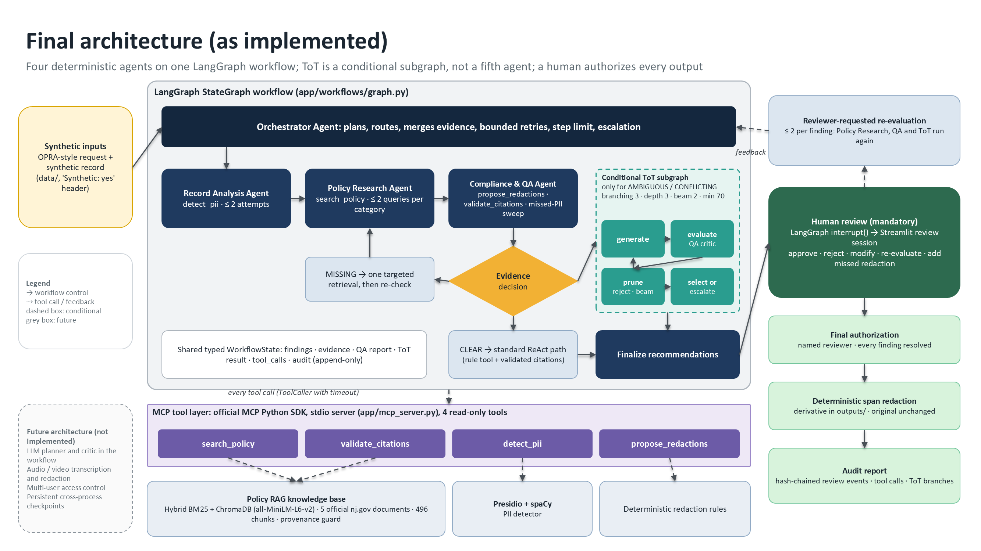
Figure 1. Final architecture as implemented. Editable sources: architecture/final_architecture.drawio, architecture/final_architecture.pptx, and Mermaid diagrams in architecture/README.md.
Layer | Components
Inputs | Synthetic OPRA-style request and record (data/). Every file carries a Synthetic: yes header, and the loader refuses files without it
Workflow | LangGraph StateGraph (app/workflows/graph.py) with a typed WorkflowState. Nodes: orchestrator_start, record_analysis, policy_research, evidence_merge, compliance_qa, evidence_decision, targeted_retrieval, error_recovery, tot (subgraph), finalize_recommendations, human_review (interrupt), complete
Agents | Orchestrator, Record Analysis, Policy Research, Compliance & QA (app/workflows/agents.py, graph.py)
Reasoning | Standard path for CLEAR evidence; targeted retrieval for MISSING; ToT subgraph (app/workflows/tot.py) for AMBIGUOUS or CONFLICTING
Tools | MCP server (app/mcp_server.py): detect_pii, search_policy, propose_redactions, validate_citations
Knowledge | Policy index (app/policies/): 5 documents, 496 chunks, BM25 + ChromaDB; Presidio + spaCy detector; deterministic redaction rules
Human review | app/review/ (session, re-evaluation, redaction, report) and the Streamlit app app/review_app.py
Outputs | Derivative in outputs/derivatives/ (never the original path); review sessions in outputs/reviews/; audit report JSON

6. MCP tool integration
Status: Implemented.
The server is app/mcp_server.py. It uses the official MCP Python SDK 2.3.0 (MCPServer) over stdio. Its four tools wrap one validated ToolService (app/tools/service.py). Configuration comes from environment variables: PRA_DATA_DIR, PRA_SEMANTIC, PRA_POLICY_DOC_IDS and PRA_LOG_LEVEL.
Tool | Input → output | Called by | Notes
detect_pii | record id → findings (category, span, text, confidence) | Record Analysis | Presidio 2.2.364 + spaCy en_core_web_md; custom recognizers for street addresses (case-sensitive since fix F3), NJ driver licence, date of birth
search_policy | query, k → status + verbatim passages with metadata | Policy Research; the ToT targeted retrieval | Hybrid retrieval with evidence thresholds
propose_redactions | record id, finding ids, chunk ids → per-finding action | Compliance & QA | Accepts chunk ids only, never free-text citations; REDACT requires a supporting chunk
validate_citations | chunk ids (+ excerpts) → exists / verbatim / official / valid | Compliance & QA; ToT critic | Marks non-nj.gov sources invalid (fix F1)

Safety properties:
- every tool is read-only, so none writes records or publishes;
- unknown tools are refused;
- inputs and outputs are validated with Pydantic.
Tested by test_every_mcp_tool_is_read_only, test_unknown_tools_are_refused and test_call_unknown_tool.
Transport evidence:
- python -m app.mcp_client_demo discovers and calls all four tools.
- The Milestone 4 and 5 demos run every agent tool call through the stdio server; their traces record transport mcp.
- tests/test_mcp_integration.py starts the server as a subprocess.
- All of these were re-run successfully in Milestone 7.
- The Milestone 6 evaluation used the in-process executor around the same ToolService to keep runs fast. This is stated in its environment block.

7. ReAct reasoning and tool-use workflow
Status: Implemented as deterministic, rule-based ReAct. LLM-driven ReAct is only partially implemented: the Claude planner was tested with a fake client only.
- Single agent (Milestone 3, `app/agents/react_agent.py`): a bounded loop. A planner chooses the next action, an executor (in-process or MCP) runs it, the observation is recorded, and the loop repeats until finish or a limit.
- Planners:
- RulePlanner (used everywhere);
- ClaudePlanner, which builds tool-use requests for the Claude API but has never been run against the live API, because no API key was configured (tests/test_claude_planner.py uses a fake client).
- Guardrails: step limit, repeated-failure stop, and no REDACT without a policy reference (enforced by the schema).
- In the multi-agent workflow, each worker runs its own bounded decide → act → observe loop:
- Record Analysis: calls detect_pii; on failure, retries (≤ 2 attempts) and never invents findings.
- Policy Research: queries per category. If no passage names the category, it reformulates (≤ 2 queries). For categories OPRA lists outright, it continues until operative statutory text is found (fix F4).
- Compliance & QA: runs propose_redactions, then independently validates every citation, classifies evidence (CLEAR / AMBIGUOUS / CONFLICTING / MISSING), and sweeps the text for possibly missed values.
Recorded trace, Scenario A (docs/milestone_4/execution_traces/scenario_A.md). Record: "…My personal phone number is 609-555-0142."
# | Agent | Tool | Result
1 | record_analysis | detect_pii | PHONE_NUMBER (0.75)
2 | policy_research | search_policy | SUFFICIENT: grc_exemptions:0026, opra_statute:0053, opra_statute:0052, grc_handbook:0031
3 | compliance_qa | propose_redactions | REDACT
4 | compliance_qa | validate_citations | 5/5 valid

Route: standard (ToT not invoked). Result: REDACT citing N.J.S.A. 47:1A-5(a), paused for human approval.

8. Semantic retrieval and policy knowledge base
Status: Implemented.
Element | Implementation
Sources | 5 official nj.gov documents (data/policy_documents/manifest.json): OPRA statute, GRC readable version (Sept 2024, P.L. 2024 c.16); GRC OPRA exemptions list; GRC "Redacting Government Records" page; GRC Handbook for Records Custodians, 8th ed. (Jan 2025); AG Directive 2022-1 (body-worn cameras)
Ingestion | PDF/HTML extraction and cleaning; section-aware chunking (496 chunks), each carrying title, section label (for example N.J.S.A. 47:1A-5(a)), page, effective date and source URL. Checkpoint 3.1 ingestion checks the downloaded PDF against the indexed copy by SHA-256
Keyword | BM25
Semantic | ChromaDB with all-MiniLM-L6-v2 (ONNX) embeddings
Hybrid | Reciprocal-rank fusion, k = 4
Evidence gate | Keyword: BM25 ≥ 6.0 plus term-coverage rules. Semantic: cosine ≥ 0.55. Otherwise INSUFFICIENT, and the only possible outcome is HUMAN_REVIEW_REQUIRED
Provenance guard | Only passages whose source URL starts with an official nj.gov prefix can support a recommendation. Others are recorded in excluded_sources (fix F1)
Untrusted content | Passages are data. Nothing in a passage is executed or followed

Executed example (Checkpoint 3.1, re-run in Milestone 7).
- Query: "What New Jersey law applies when a public record contains someone's personal telephone number?"
- Result: rank 2, chunk opra_statute:0052, N.J.S.A. 47:1A-5(a), p. 15, cosine 0.6537.
- Excerpt: "…the custodian thereof shall redact from that record any information which discloses the social security number, credit card number, personal telephone number, or driver license number of any person…"
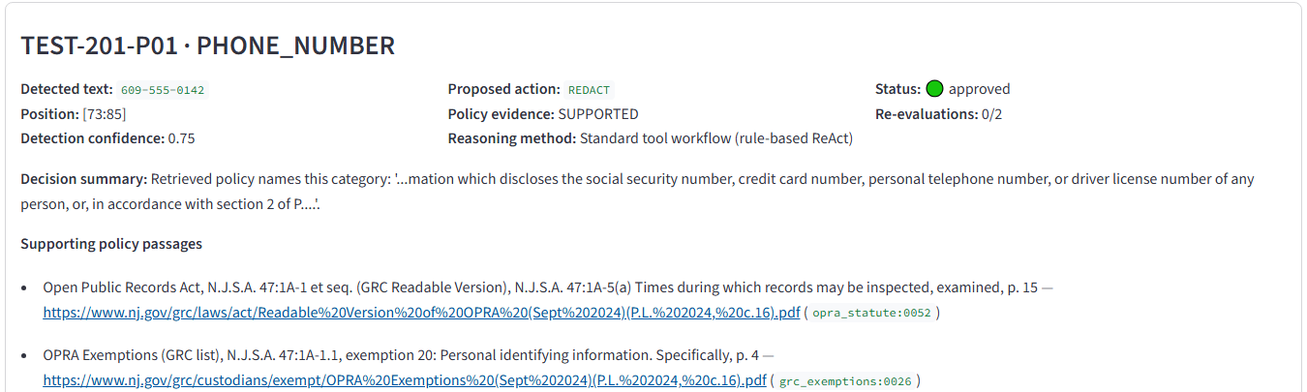
Figure 2. Real reviewer UI (Scenario A): the recommendation shows the source title, statutory section, page, URL and chunk id for each supporting passage.
Missing evidence (Scenario C, IP address).
- Three searches returned passages, but none names IP addresses: two queries plus one targeted retry.
- The result is HUMAN_REVIEW_REQUIRED with no citation. The system never writes a citation of its own.

9. Multi-agent orchestration and communication
Status: Implemented.
Agent | Responsibility | Bounded loop
Orchestrator | Plans; routes; merges findings with evidence; decides the route; invokes ToT; handles retries, step limit, escalation, termination | Step limit 30; LangGraph recursion limit
Record Analysis | Detects candidate personal data with offsets and confidence | ≤ 2 attempts; ≤ 1 recovery cycle
Policy Research | Retrieves verbatim passages per category; reformulates; performs targeted retrievals on request | ≤ 2 queries per category; 1 targeted retry
Compliance & QA | Proposes redactions; validates citations; classifies evidence; sweeps for missed values; acts as the ToT critic | One proposal and one validation pass per round

Coordination:
- Sequential where outputs feed inputs: detect → research → merge → QA.
- Parallel inside policy research, one search task per category.
- Conditional at evidence_decision, in priority order: step limit, then detection failure, then MISSING (retry once), then AMBIGUOUS or CONFLICTING (ToT), then standard.
Communication:
- Through shared typed state only. Agents never message each other.
- Appended fields. List fields (tool_calls, audit, transitions, escalations) use operator.add reducers and are append-only.
- Owned fields. Every other field is written by its owning node.
- The ToT keeps its own state. Each thought node has a branch-local copy of evidence, so one branch cannot contaminate another. This is checked by a test and by a safety check over all evaluation runs.
Recorded evidence: five Milestone 4 scenarios, all checks passing, re-run in Milestone 7:
Scenario | Route | Result
A | standard | REDACT, ToT not invoked
B | tot | REDACT, score 100
C | targeted retry | escalated, no citations
D | ToT | unsupported branch rejected; escalated
D-budget | ToT | tool budget enforced; escalated

10. Selective ToT design and implementation
Status: Implemented (LangGraph subgraph `app/workflows/tot.py`), with the changes listed in the table at the end of this section.

10.1 Why ToT only for ambiguous scenarios
Most findings have one clear answer. For a personal phone number, 47:1A-5(a) requires redaction, and exploring alternatives there only adds cost. Selective ToT keeps the standard path for CLEAR evidence and spends extra reasoning only where an interpretation depends on conditions. For example, a home address is protected only for certain classes of person. The measured cost on ToT cases is 1–3 extra tool calls each.

10.2 The ambiguity trigger
app/workflows/evidence.py classifies each finding from retrieved text and the record only:
Class | Rule | Route
CLEAR | Category listed without qualification (phone, driver licence, SSN, month and day of birth), operative language in a retrieved passage, detection confidence ≥ 0.6, no applicable exclusion | Standard path
AMBIGUOUS | Evidence exists but depends on conditions (who the person is, a definition or balancing test, low confidence) | ToT
CONFLICTING | A redaction provision and a possibly applicable exclusion (for example "shall not include … telephone number of a public agency") | ToT
MISSING | No retrieved passage names the category | One targeted retrieval, then escalate

Measured: ToT activated on 7 of 7 ambiguous scenarios and on 0 of 14 straightforward ones.

10.3 Thought, node and branch representation
- Thought: an evidence-based interpretation. Example: "Redact: 47:1A-1.1 protects this home address if the person is a covered person."
- Node (`ThoughtNode`):
- proposed action (REDACT or HUMAN_REVIEW_REQUIRED);
- provision type;
- cited chunk ids, with a branch-local copy of their text;
- assumptions, each FACTUAL or LEGAL with a status (SUPPORTED / UNVERIFIED / REJECTED);
- unresolved questions;
- status and score.
- Branch: a path from a depth-1 interpretation through verification. The id records it, for example d1.1>2.

10.4 Branching factor 3, depth 3, beam width 2
Depth | Stage | What happens
1 | INTERPRETATION | Up to 3 candidates built only from retrieved provisions (restricted class, general operative, definition or balancing), always including a conservative HUMAN_REVIEW candidate
2 | VERIFICATION | FACTUAL assumptions are checked against the record near the finding. If operative text is missing or a LEGAL assumption is open, the branch may spend the run's single targeted retrieval
3 | CONCLUSION | Remaining gaps are recorded as unresolved questions

After each depth, at most 2 eligible branches are kept (beam). ToTConfig defaults:
- max_branching=3, max_depth=3, beam_width=2, min_score=70;
- max_tool_calls=6, time_budget_s=60.
A test confirms that these limits cannot be raised beyond the design values (test_tot_limits_cannot_be_raised_beyond_design).

10.5 Scoring rubric, mandatory checks and critic evaluation
The Compliance & QA Agent acts as the critic. It is deterministic, and it validates citations through the validate_citations MCP tool.
Criterion | Points | How it is scored
Policy relevance | 30 | 15 if a cited passage names the category. For REDACT: +10 for operative language, +5 for a statutory (primary) source
Citation validity | 30 | 30 if all citations validate. 15 for a REDACT candidate whose valid citations lack operative language. 0 if they could not be validated
Consistency with facts and conditions | 25 | 25 minus 12 for each assumption still UNVERIFIED
Explanation and uncertainty | 15 | Stated interpretation, unresolved questions listed, human-approval condition attached

Mandatory checks reject a branch immediately:
- a fabricated citation (the chunk does not exist), an altered excerpt, or a non-official source;
- a FACTUAL assumption the record does not support;
- a REDACT branch with no evidence.
Selection constraint. A REDACT branch is selectable only if:
- every assumption is SUPPORTED;
- it cites an operative provision;
- it scores ≥ 70.
Low-confidence detections (< 0.6) add a FACTUAL "detection is correct" assumption that only a reviewer can confirm (fix F2).

10.6 Beam-search selection, pruning and termination
Rule | Behaviour
Pruning | Rejected branches are pruned with the reason recorded; branches beyond the beam get a "beam width" reason
Uncertain branches | Kept as UNVERIFIED, not discarded. This is the Checkpoint 4.1 mitigation for premature pruning
Selection | The highest-scoring selectable branch
Ties | Stronger primary source wins: statute, then GRC list, then handbook. A remaining tie between different actions is an unresolved material conflict and escalates
Termination | Search ends when no open branches remain, depth 3 is reached, or the tool or time budget runs out. When a budget runs out, the event is recorded and nothing unverifiable can be selected

10.7 Missing evidence, unresolved conflicts and human escalation
- If no branch qualifies, the outcome is ESCALATED, with the unresolved questions listed.
- A selected REDACT still goes to the human reviewer as a recommendation. No branch can authorize disclosure.
- In review, the reviewer can answer FACTUAL conditions (covered_person, not_agency_number, detection_correct) and request re-evaluation. ToT then reruns with those answers.
- A reviewer cannot satisfy a LEGAL condition or create a citation (test_reviewer_facts_are_factual_input_only).

10.8 Real execution: Scenario B (retired judge's home address)
Source: docs/milestone_4/execution_traces/scenario_B.md.
Branch | Depth | Action | Provision | Rel | Cit | Cons | Expl | Total | Status
d1.1 | 1 | REDACT | RESTRICTED_CLASS | 20 | 15 | 13 | 15 | 63 | evaluated (covered status unverified)
d1.2 | 1 | HUMAN_REVIEW_REQUIRED | CONDITIONAL_REVIEW | 15 | 30 | 25 | 15 | 85 | evaluated
d1.1>2 | 2 | REDACT | RESTRICTED_CLASS | 30 | 30 | 25 | 15 | 100 | selected

How the selection happened:
- At depth 2, the covered-person assumption was SUPPORTED by the record ("retired Superior Court judge").
- The one targeted retrieval ("custodian shall redact home address judicial officer prosecutor law enforcement officer") added the operative 47:1A-5(a) passage opra_statute:0052.
Reviewer feedback in Milestone 5. The reviewer answered covered_person = unconfirmed. ToT reran, both REDACT branches became non-selectable (88, unverified), d1.2 (85) was selected, and the item escalated.
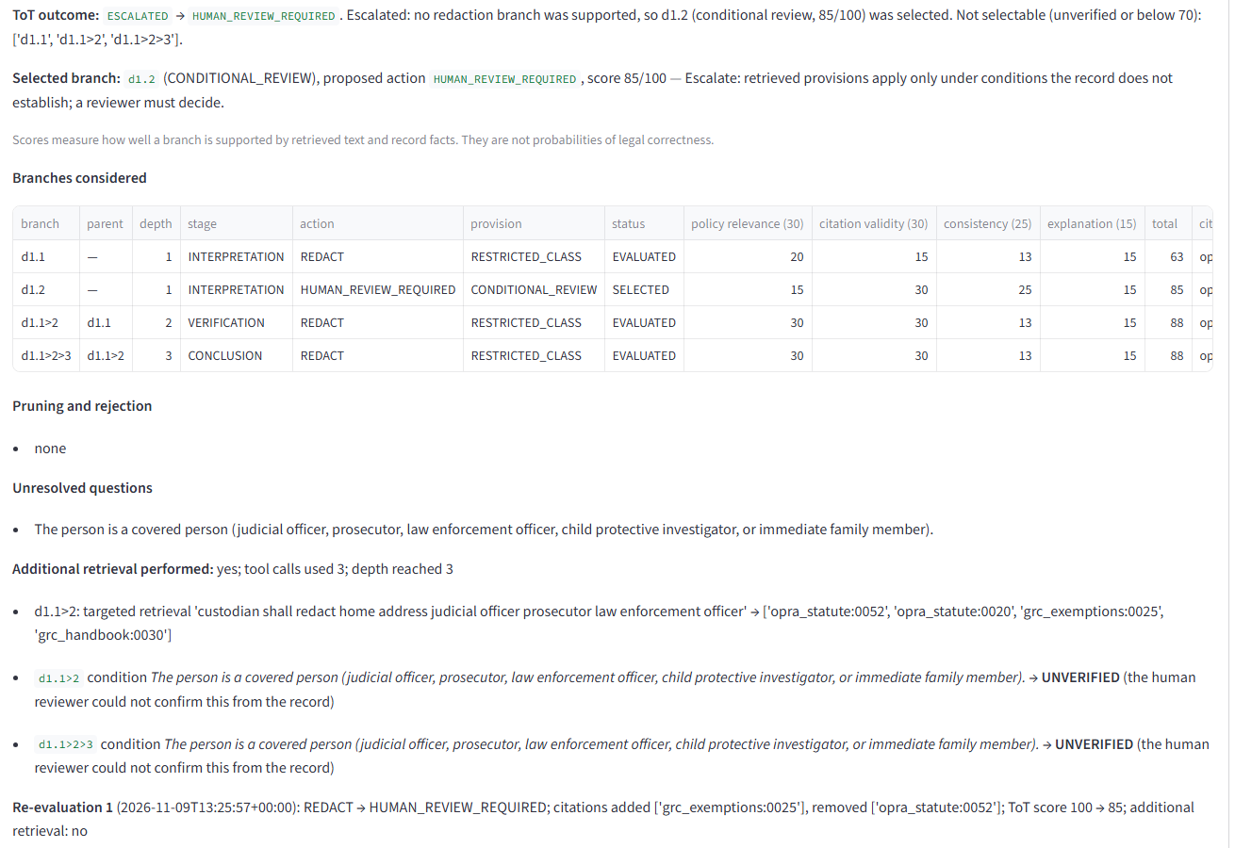
Figure 3. Real reviewer UI (Scenario B after re-evaluation): ToT outcome, selected branch, every branch with its actual scores, unresolved questions and the targeted retrieval. Scores carry the note that they are not probabilities of legal correctness.

10.9 Implemented vs proposed (Checkpoint 4.1)
4.1 design element | Status
ToT only when evidence is ambiguous or conflicting | Implemented
Thought / node / branch representation (evidence, assumptions, action, open questions) | Implemented
Branching 3, depth 3, beam 2, beam search | Implemented and enforced
30/30/25/15 rubric; minimum 70 | Implemented
Reject fabricated citations and unsupported factual assumptions | Implemented (2 rejections in the evaluation)
Ties go to stronger primary-source evidence; unresolved conflicts go to human review | Implemented. Covered by unit tests only, because no scenario produced a tie
Uncertain branches marked, not pruned; one targeted retrieval before pruning | Implemented (13 uncertain branches preserved)
Time, depth and tool-call limits | Implemented
Critic agent (CrewAI + LangChain) assessing relevance and explanation quality | Changed: a deterministic rubric inside the Compliance & QA Agent. Explanation quality is checked structurally only
Thought generator in CrewAI; controller in LangChain | Changed: a single LangGraph subgraph (generate → evaluate → prune → select)
Example branch types A (redact) / B (exception) / C (escalate) | Implemented in spirit. Exceptions such as "use by any government agency" are surfaced as open questions, not reasoned about as separate branches

11. Human feedback, approval, redaction and auditability
Status: Implemented.
The workflow pauses at human_review (LangGraph interrupt()). A ReviewSession snapshot drives the Streamlit app (streamlit run app/review_app.py).
Capability | Behaviour
Per-finding decisions | Approve (refused for escalated items: nothing supported to approve); reject with an optional reason; modify exact spans (spans must be confirmed)
Re-evaluation | Reviewer-requested only, never automatic on rejection. Takes a structured reason, optional factual answers and an optional extra query. Runs through the same Policy Research and QA agents, plus ToT if still ambiguous. Limited to 2 per finding, then MANUAL_RESOLUTION_REQUIRED. Records a before/after comparison
Reviewer-added redaction | For text the detector missed. QA flags possible misses (spelled-out or 7-digit numbers) as escalations. The reviewer selects the exact text, a category and a reason, then confirms. It is recorded as a human decision with no system policy basis claimed
Finalization | A separate step. Blocked, with reasons recorded, unless every finding is resolved, every escalation is acknowledged, a named reviewer authorizes, the event chain verifies, the source file is unchanged, and span validation passes
Deterministic redaction | The derivative is built by slicing the original text at validated offsets. Overlapping spans merge. Untouched segments are verified byte-identical. A redacted value repeated elsewhere blocks finalization
Originals | Never modified. The derivative goes to outputs/derivatives/…. The original record's hash is checked
Audit | Append-only, hash-chained review events (actor, UTC time, payload, previous hash). The audit report contains the workflow snapshot, tool calls, ToT tables, re-evaluations, decisions and finalization. published: false

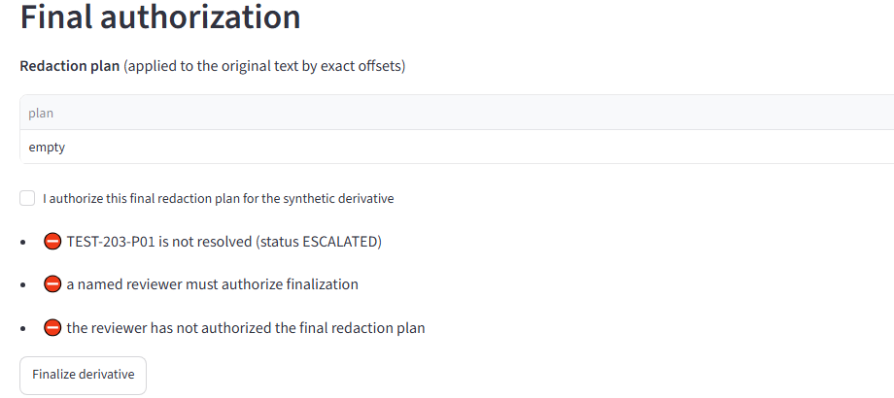
Figure 4. Real reviewer UI (Scenario C): finalization refused for an escalated finding with no policy basis.
Full-page captures of all three scenarios are in docs/final_capstone/screenshots/. Recorded sessions and audit reports are in docs/milestone_5/.

12. Evaluation methodology
Details: evaluation_summary.md.
Item | Choice
Dataset | 22 synthetic scenarios, 19 expected findings: clear categories, detector edge cases, decoys, missing evidence, ambiguous and conflicting policy, tool faults, prompt injection (in a retrieved document and in the record), reviewer rejection
Configurations | A: enable_tot=False. B: enable_tot=True. Everything else identical
Runs | 44 (one trial each; agents are deterministic)
Metrics | Detection precision and recall; recommendation in acceptable set and preferred; grounded citation accuracy; unsupported redactions; workflow completion; end-to-end success; escalation recall and false escalation rate; tool-failure safe handling and recovery; latency; tool calls; ToT activation, branch validity, pruning, termination, invariants; 16 safety checks
Reviewer | Scripted from scenario definitions
Integrity | Expected outcomes were not changed to make results pass. The pre-fix run is preserved. All metrics are recomputable from raw traces (python -m app.evaluation.verify, 33/33 match)

13. Actual evaluation results
Metric | A: ReAct-only | B: ReAct + ToT
Detection precision | 1.000 (17/17) | 1.000 (17/17)
Detection recall | 0.895 (17/19) | 0.895 (17/19)
Recommendation in acceptable set | 1.000 (17/17) | 1.000 (17/17)
Preferred recommendation | 0.882 (15/17) | 0.941 (16/17)
Grounded citation accuracy | 1.000 (6/6) | 1.000 (7/7)
Unsupported redactions | 0 | 0
Workflow completion | 22/22 | 22/22
End-to-end success | 22/22 | 22/22
Escalation recall / false escalation rate | 11/11 / 0/9 | 11/11 / 0/9
Tool failure: safe handling / full recovery | 3/3 / 3/3 | 3/3 / 3/3
Latency mean / median / p95 (s) | 0.377 / 0.371 / 1.059 | 0.388 / 0.364 / 0.987
Mean tool calls per scenario | 3.59 | 4.18
LLM calls / cost | 0 / $0 | 0 / $0

ToT (B):
- Activation: 7 TP, 0 FP, 0 FN, 14 TN (S16 not scored).
- Branches: 8 runs; 25 branches (20 supported by official evidence); 2 rejected for unsupported factual assumptions; 0 for fabricated citations; 13 uncertain branches preserved, 0 lost.
- Limits: 0 invariant violations.
- Outcomes: 1 fully supported REDACT, 7 escalations.
- Cost: 13 extra tool calls.
Detection misses. S04 (phone spelled out in words) and S05 (7-digit number). Both still succeed end to end, because QA flags them and the scripted reviewer adds the redaction. The detector itself does not catch them.
Defects found and fixed (pre-fix B: 2 unsupported redactions, 3 false activations):
# | Defect | Fix
F1 | Injected non-official text could be cited | Provenance guard
F2 | ToT ignored low detection confidence | Reviewer-only "detection is correct" condition
F3 | Case-insensitive address regex | Recognizer made case-sensitive
F4 | Retrieval missed operative text for a listed category | Research continues until operative text is found

14. ReAct-only vs ReAct+ToT comparison
Details: react_vs_tot_comparison.md.
Question | Measured answer
Decision quality | +1 preferred decision (S12). All 17 matched findings were acceptable in both configurations
Evidence coverage | S12 gained the operative 47:1A-5(a) citation through the targeted retrieval. Grounded accuracy was 1.000 in both
Escalation behaviour | No change (11/11, 0/9)
Safety | No difference after the fixes. Worse with ToT before the fixes (2 unsupported redactions)
Cost | +13 tool calls in total (1–3 per ToT case); +0.111 s mean per ToT case; $0
Conclusion | Inconclusive for general accuracy. Selective ToT did no harm after the fixes and helped one ambiguous case. A rubric score measured consistency, not correctness: before the fixes, ToT rated two wrong selections "fully supported"

15. Safety controls and failure handling
Risk | Control | Evidence
Fabricated citations | Chunk-id-only citations; validate_citations; QA veto; ToT rejection | 5 guardrail tests; safety check "every citation is an existing chunk of an official source" (44/44 runs)
Unsupported legal conclusions | INSUFFICIENT or MISSING → HUMAN_REVIEW_REQUIRED; schema forbids REDACT without a reference; REDACT selection needs verified assumptions | 4 guardrail tests; Scenario C
Prompt injection | Rule-based agents; provenance guard; record text never treated as instructions | S20: injected document never cited and injected citation 47:1A-99 never repeated (A and B). S22: instructions inside the record ignored; expected outcome in both configurations
Modifying originals | Read-only tools; hash checks; derivative path checks | 3 tests; safety check over 44 runs
Finalization without approval | interrupt(); named reviewer plus explicit authorization; blockers | 7 tests; Scenario C blocked
Unbounded loops | Step limit, retry limits, ToT depth, beam and tool budgets, re-evaluation limit | 7 tests; 0 invariant violations
Tool failure | Timeouts (ToolCaller); retry, then escalate; failed policy search becomes MISSING, never invented policy | S17–S19: 3/3 safe handling and recovery
Cross-branch contamination | Branch-local evidence copies | Test plus safety check
Secrets and sensitive data | .env git-ignored; no keys needed; synthetic-only loader; reserved example values (555-01xx phones, RFC 5737 IPs, example.com) | Milestone 7 scan: final_verification.md

16. Limitations, lessons learned and future improvements
Full list: limitations.md.

Limitations
- No LLM in the loop. The agents are deterministic, so the results do not speak to LLM planning, LLM hallucination or LLM injection resistance.
- Detector gaps. Recall is 17/19. Spelled-out and 7-digit numbers are flagged for the reviewer, not detected; other formats would be missed.
- Small evaluation set. 22 self-authored scenarios, 7 ToT cases, and a simulated reviewer.
- Narrow corpus. Five documents; retrieval is sensitive to wording.
- Prototype operation. Text only; single local reviewer; no access control; in-memory graph checkpoints.

Lessons learned
1. A baseline comparison finds what unit tests do not. Running A against B exposed four defects. Two of them produced harm only when ToT was on.
2. Scores are not correctness. ToT rated two wrong selections as fully supported. The protection came from mandatory evidence checks and the human gate, not from the score.
3. Controlling evidence beats generating more reasoning. The provenance guard and operative-text requirement did more for safety than additional branches.
4. Deterministic first. Rule-based agents made every decision reproducible and every metric recomputable. That made the evaluation trustworthy, at the cost of LLM flexibility.
5. Escalation is a feature. Most ambiguous cases end correctly with "human review required"; the system's job there is to package the evidence and questions.

Future improvements (not implemented)
- An LLM thought generator or critic behind the same validation gates, evaluated against these scenarios plus independently written ones.
- Detector improvements for spelled-out and partial numbers.
- More policy sources (agency rules, GRC decisions) with provenance checks.
- Synthetic audio and video (transcription, frame redaction): the original Stage 8.
- Multi-user review with authentication and second-reviewer sign-off.
- A usability study with records staff.

Appendix A. Feature verification matrix
Verified in Milestone 7 against code, tests and recorded runs. "Run in M7" means it was re-executed during Milestone 7 (see final_verification.md).
Feature | Status | Evidence | Run in M7
Synthetic data + loader refusing non-synthetic files | Implemented | app/data_loader.py; tests/test_data_loader.py (17) | Yes (python -m app.main)
Pydantic schemas (findings, references, recommendations, decisions, state) | Implemented | app/schemas.py, app/workflows/state.py; tests/test_schemas.py (26) | Yes (suite)
Policy ingestion from nj.gov with provenance | Implemented | app/policies/ingest.py; docs/checkpoint_3_1/01_* | Network download failed in M7 (no DNS in this environment); local-copy path passed
Keyword (BM25), semantic (ChromaDB) and hybrid retrieval with thresholds | Implemented | app/policies/; tests/test_policy_* | Yes
PII detection (Presidio + custom recognizers) | Implemented; recall 17/19 | app/tools/pii.py; tests/test_tools_pii.py | Yes
MCP server with 4 read-only tools (official SDK, stdio) | Implemented | app/mcp_server.py; tests/test_mcp_integration.py; mcp_client_demo | Yes
Single ReAct agent, rule-based planner | Implemented | app/agents/; tests/test_agent.py (13) | Yes (agent_demo, local and MCP)
LLM-driven ReAct (Claude planner) | Partially implemented: fake client only, never run live | tests/test_claude_planner.py | Not run (no API key)
Four-agent LangGraph orchestration | Implemented | app/workflows/; tests/test_m4_workflow.py, test_m4_scenarios.py | Yes (m4_demo, 5/5 scenarios)
Standard cases bypass ToT | Implemented | Scenario A; 14/14 TN in the evaluation | Yes
Ambiguous cases invoke ToT | Implemented | Scenario B; 7/7 TP | Yes
ToT branching, depth, beam, scoring, pruning, budgets | Implemented | tests/test_m4_tot.py (18); 0 invariant violations | Yes
ToT tie-breaking and beam pruning in real scenarios | Implemented; unit-test evidence only | test_beam_width_limits_retained_candidates, test_tie_goes_to_stronger_primary_source, test_unresolved_material_conflict_escalates | Yes (suite)
LLM critic agent for ToT | Not implemented (changed to a deterministic critic) | — | —
Missing evidence → safe escalation | Implemented | Scenario C; S10, S11, S18 | Yes
Human review interrupt / resume | Implemented | test_only_human_approval_authorizes_disclosure | Yes
Streamlit reviewer UI | Implemented | app/review_app.py; tests/test_m5_app.py (6); screenshots | Yes (screenshots captured in M7)
Re-evaluation with structured feedback (≤ 2) | Implemented | tests/test_m5_review.py; Scenario B | Yes (m5_demo)
Reviewer-added redaction for missed text | Implemented | tests/test_m6_manual_redaction.py (11 test functions) | Yes (suite)
Deterministic redaction + validation | Implemented | app/review/redact.py; tests/test_m5_redact.py (9) | Yes
Finalization blockers / explicit authorization | Implemented | tests/test_m5_review.py; Scenario C | Yes
Hash-chained audit log and audit report | Implemented | app/review/session.py, report.py | Yes
Prompt-injection resistance (retrieved document, record text) | Implemented (rule-based agents) | S20, S22; F1 tests | Yes (evaluation.run)
Evaluation harness, metrics, A/B comparison | Implemented | app/evaluation/; tests/test_m6_evaluation.py (17) | Yes (rerun identical; verify 33/33)
Audio / video redaction | Deferred | — | —
Multi-user access control, persistent checkpoints | Not implemented | — | —

Appendix B. Differences from the original proposal
Area | Originally planned (proposal and checkpoints) | Implemented | Why changed | Effect on reliability and scope
Record types | Video, audio, transcripts, documents | Text records only | Time; text covers the core reasoning; synthetic media pipeline not needed to demonstrate agents | Narrower scope; transcription tool and OpenCV/FFmpeg deferred (Stage 8)
Reasoning engine | ReAct with an LLM (implied by 2.1/3.1/4.1) | Deterministic rule-based ReAct; Claude planner built but untested live | No API credentials; reproducible, testable behaviour; avoid hallucination risk in a compliance task | Every result reproducible and recomputable; no evidence about LLM behaviour
Frameworks for ToT | CrewAI + LangChain + MCP | LangGraph + MCP | One orchestration framework (LangGraph was already the workflow engine); fewer dependencies | Simpler state handling; branch state isolated by design
ToT critic | "Critic agent" assessing relevance and explanation quality | Deterministic rubric inside Compliance & QA | Without an LLM, explanation quality cannot be judged semantically | Explanation criterion is structural; mandatory checks unchanged
ToT adoption | 4.1 drafts: first "no ToT", then "selective ToT" | Selective ToT | Ambiguous provisions (restricted classes, exclusions) needed structured alternatives | One measured gain (S12); pre-fix harms found and fixed
Agent coordination | Record analysis and policy research coordinated, partly in parallel (5.1) | Research runs after detection; parallel across categories | What to research depends on what was found | Clearer data flow; no wasted retrieval
Feedback on rejection | "If a proposed redaction is rejected, the agent can review the evidence and policy again" (proposal) | Rejection is final; re-evaluation is an explicit reviewer request, ≤ 2 per finding | Avoid automatic loops; keep the human in control | Bounded, auditable feedback
Missed-PII check | "A final review step can also check the proposed output for possible missed sensitive information" | QA sweep for two missed formats + reviewer-added redaction | Detector gaps found in evaluation (S04, S05) | Gaps flagged, not solved
Evaluation transport | Not specified | In-process executor for the evaluation; MCP for demos and integration tests | Speed and determinism of 44 runs | Same ToolService; MCP covered separately
Additions not in the proposal | — | Provenance guard; low-confidence condition; hash-chained events; finalization blockers; metric recomputation script | Found necessary during evaluation and review design | Stronger safety guarantees

Appendix C. Reproducibility
- Final evaluation commit: 7a1a875 ("Milestone 6: evaluation, guardrails, ToT validation, reviewer-added redactions").
- Environment: Python 3.14.7 on Windows 10. Package versions are pinned in requirements.txt; key ones are langgraph 1.2.20, chromadb 1.5.9, presidio-analyzer 2.2.364, mcp 2.3.0, streamlit 1.66.0.
- Clean-clone check (Milestone 7): install exit 0 in 272 s, then 314 tests passed.
python -m venv .venv && .venv/Scripts/activate # Windows; use source .venv/bin/activate elsewhere
pip install -r requirements.txt
python -m pytest # 314 passed
python -m app.checkpoint_3_1 # real-source retrieval demo (needs network; --offline uses the local copy)
python -m app.m4_demo # four-agent workflow + ToT scenarios over MCP
python -m app.m5_demo # review scenarios A/B/C
streamlit run app/review_app.py # reviewer UI
python -m app.evaluation.run --tag rerun # evaluation (does not overwrite the committed final results)
python -m app.evaluation.verify # recompute committed metrics from raw traces

Appendix D. Evidence index
Evidence | Location
Real-source retrieval demo | docs/checkpoint_3_1/
Workflow and ToT traces | docs/milestone_4/execution_traces/
Review sessions, audit reports | docs/milestone_5/review_scenarios.md, docs/milestone_5/scenarios/
Evaluation results, ToT comparison, safety tests, raw traces | docs/milestone_6/
Screenshots of the running app | docs/final_capstone/screenshots/
Milestone 7 verification logs | docs/final_capstone/verification_logs/
Architecture sources | docs/final_capstone/architecture/

