1. Mapping

batmeth2-align -g index -i imputfile -o outputprefix -p 6 -n 2

1. Get Methylation

split -o result -g index -n 2 -i mappingresult -m outputfile

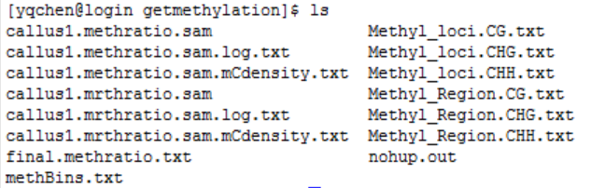

1. DNA Methylation Level and Density

methyGff -o outprefix -G index -g GFF file/-b bed file -m final.methratio.txt -B -P --TSS --TTS

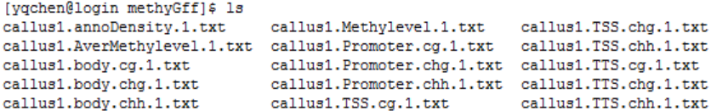

Ps:用awk命令截取gff文件

4、Visulization (required R package : ggplot2{install.packages("ggplot2")})

methyPlot methBins.txt chrosome.methy.pdf 0.025 Methylevel.1.txt methlevel.pdf TSS TTS AverMethylevel.1.txt elements.pdf

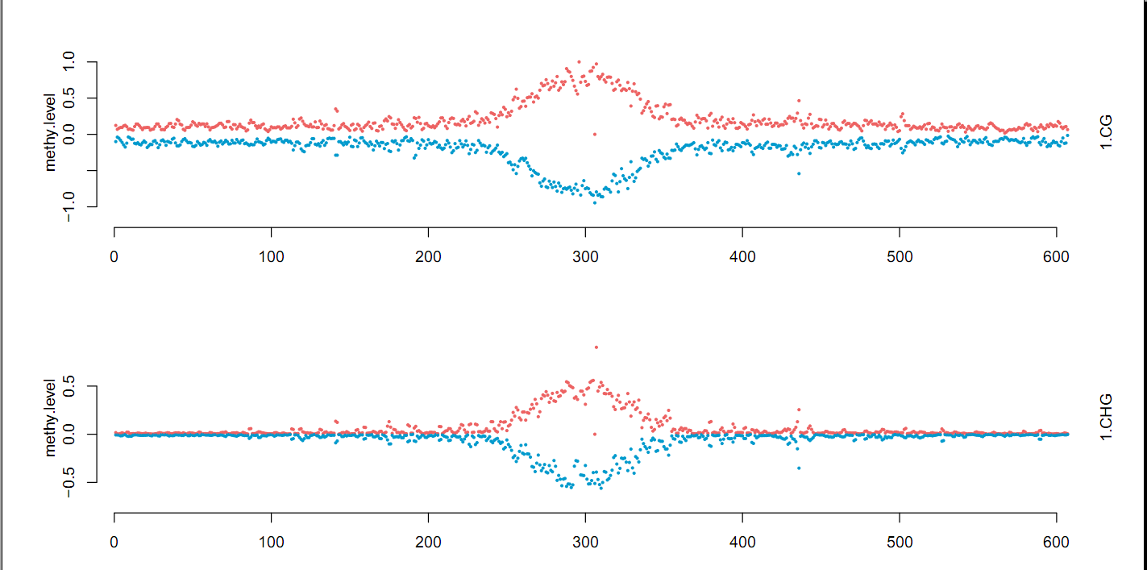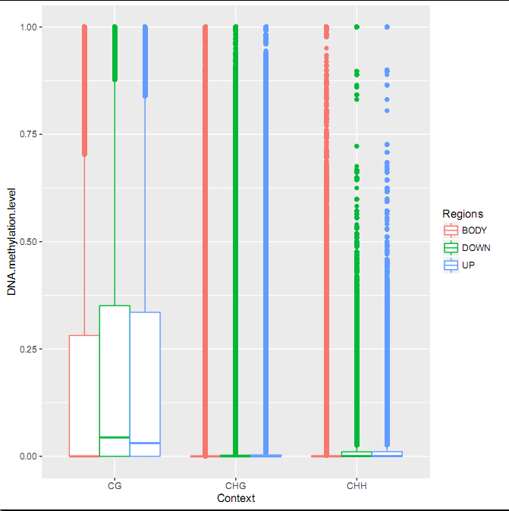

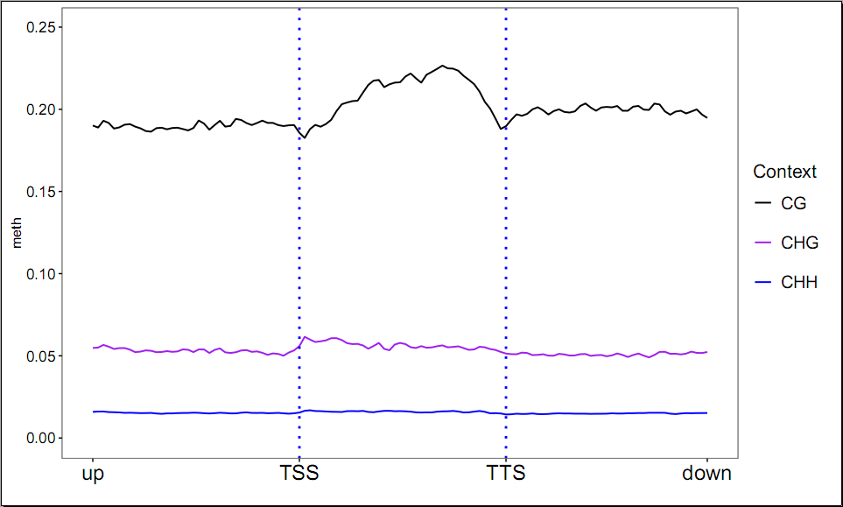

5、DNA Methylation Heatmap

GeneMethHeatmap wildtypefile mutantfile CG-ceil（1.0）CHG-ceil（0.6）CHH-ceil（0.2）

6、Define DMR region

batDMR -g index -o_dm dm.output.txt/-o_dmr dmr.output.txt -1 [sample1.methC.txt replicates ..] -2 [sample2.methC.txt replicates ..]

7、DM annotation

DMCannotationPlot -o outputfile -G index -g <GFF files.. eg: TE.gff gene.gff CDS.gff intron.gff lncRNA.gff ...> -d outputfile -c <mC context default: CG>

