POJI
Home and vehicle services, booked properly. Malta.
Malta has one home-services app and it books cleaners. Poji books 33 trades — electricians, plumbers, AC technicians, appliance repair, locksmiths, water filters, roadside callouts, transport, and cleaning.
The software is built and running. It needs payments switched on, providers on the ground, and six months of runway.
Investment sought: €100,000 for 20% of Pojico Ltd.
Yetkin Berberoglu · Malta · October 2026

The short version
What it is | One app to book a verified tradesperson in Malta, with the price fixed before anyone turns up and the money held until the work is approved.
Who pays | Households and small landlords. 20% commission on labour, 5% on parts.
Who supplies | Self-employed tradespeople already working in Malta, currently found through Facebook groups and word of mouth.
Why now | Malta grew to 588,254 people and 29.4% are foreign nationals with no local network to ask.
Why not already done | Malta’s one existing app does cleaning only. Twenty-eight other trades have no marketplace at all.
Built | Yes. Booking, verification, escrow logic, dispute handling, chat, notifications, admin. Live at po-ji.com.
Missing | Card payments (Stripe Connect under application), providers, clients.
Honest odds | Roughly one in two this becomes a small profitable business. Roughly one in five it becomes something larger. One in three it does not work.

What Poji actually does
Booking a tradesperson in Malta today means asking a Facebook group, getting four replies, picking one on instinct, and having no idea what it will cost until they are standing in your hallway.
Poji replaces that with a booking. The client picks what they need, sees who does it with each provider’s own price, picks a time, and confirms. Their card is held, not charged.
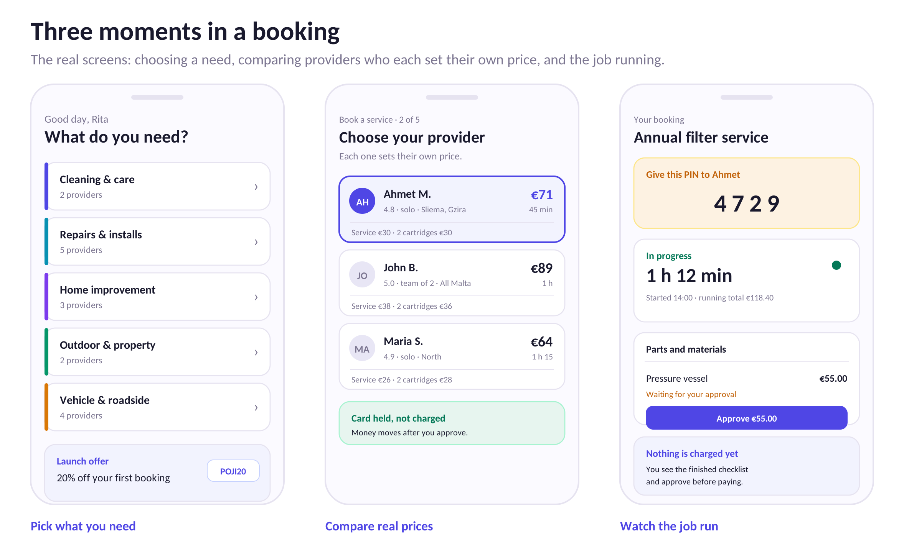
Three screens from the working app. Each provider sets their own price, so the same job costs differently depending on who takes it.
The mechanics that make it work
Most of the build went into the parts that stop the obvious failures.
- A PIN at the door. The server generates a four-digit code the client reads out. The job only starts when the provider enters it. Nobody can bill for a visit that did not happen.
- The clock is the bill. Hourly work is timed from that PIN and settled on the server, rounded up to the quarter hour. The client watches the same clock the provider does.
- Parts need approval. A plumber who finds a failed valve adds it as a line; the client approves it before it reaches the bill. Parts carry 5% commission, not 20% — high enough to record, low enough that nobody bothers going around it.
- Money is settled server-side. Prices, commission and payouts are calculated in the database. Nothing the app sends can change what anyone is paid.
- A six-hour window. When work is marked done the client reviews a completed checklist and approves. Six hours of silence approves it automatically.
- Nobody shows up, nobody pays. Fifteen minutes past the hour the client can cancel at no cost, gets 10% off their next booking, and the no-show goes on the provider’s record. Three ends in suspension.
- Messages are scanned. Phone numbers, IBANs and "let’s do this off the app" are flagged for review. Contact details only open two hours before the job.
Three ways work gets priced
This is what separates Poji from a cleaning app, and it was the hardest part to get right.
Model | Used for | How
By the hour | Cleaning, gardening, handyman, man-and-van | Estimate up front, billed on real time
Fixed price | AC service, water filters, roadside, car valet | Provider sets their own price per service
Quoted | Rewires, bathrooms, house moves, appliance faults | They talk first, send a figure, nobody travels until it is accepted
Providers set their own prices, write their own questions, and list their own options. A water filter specialist who fits six-stage systems adds that option and prices it; the platform does not decide for them.
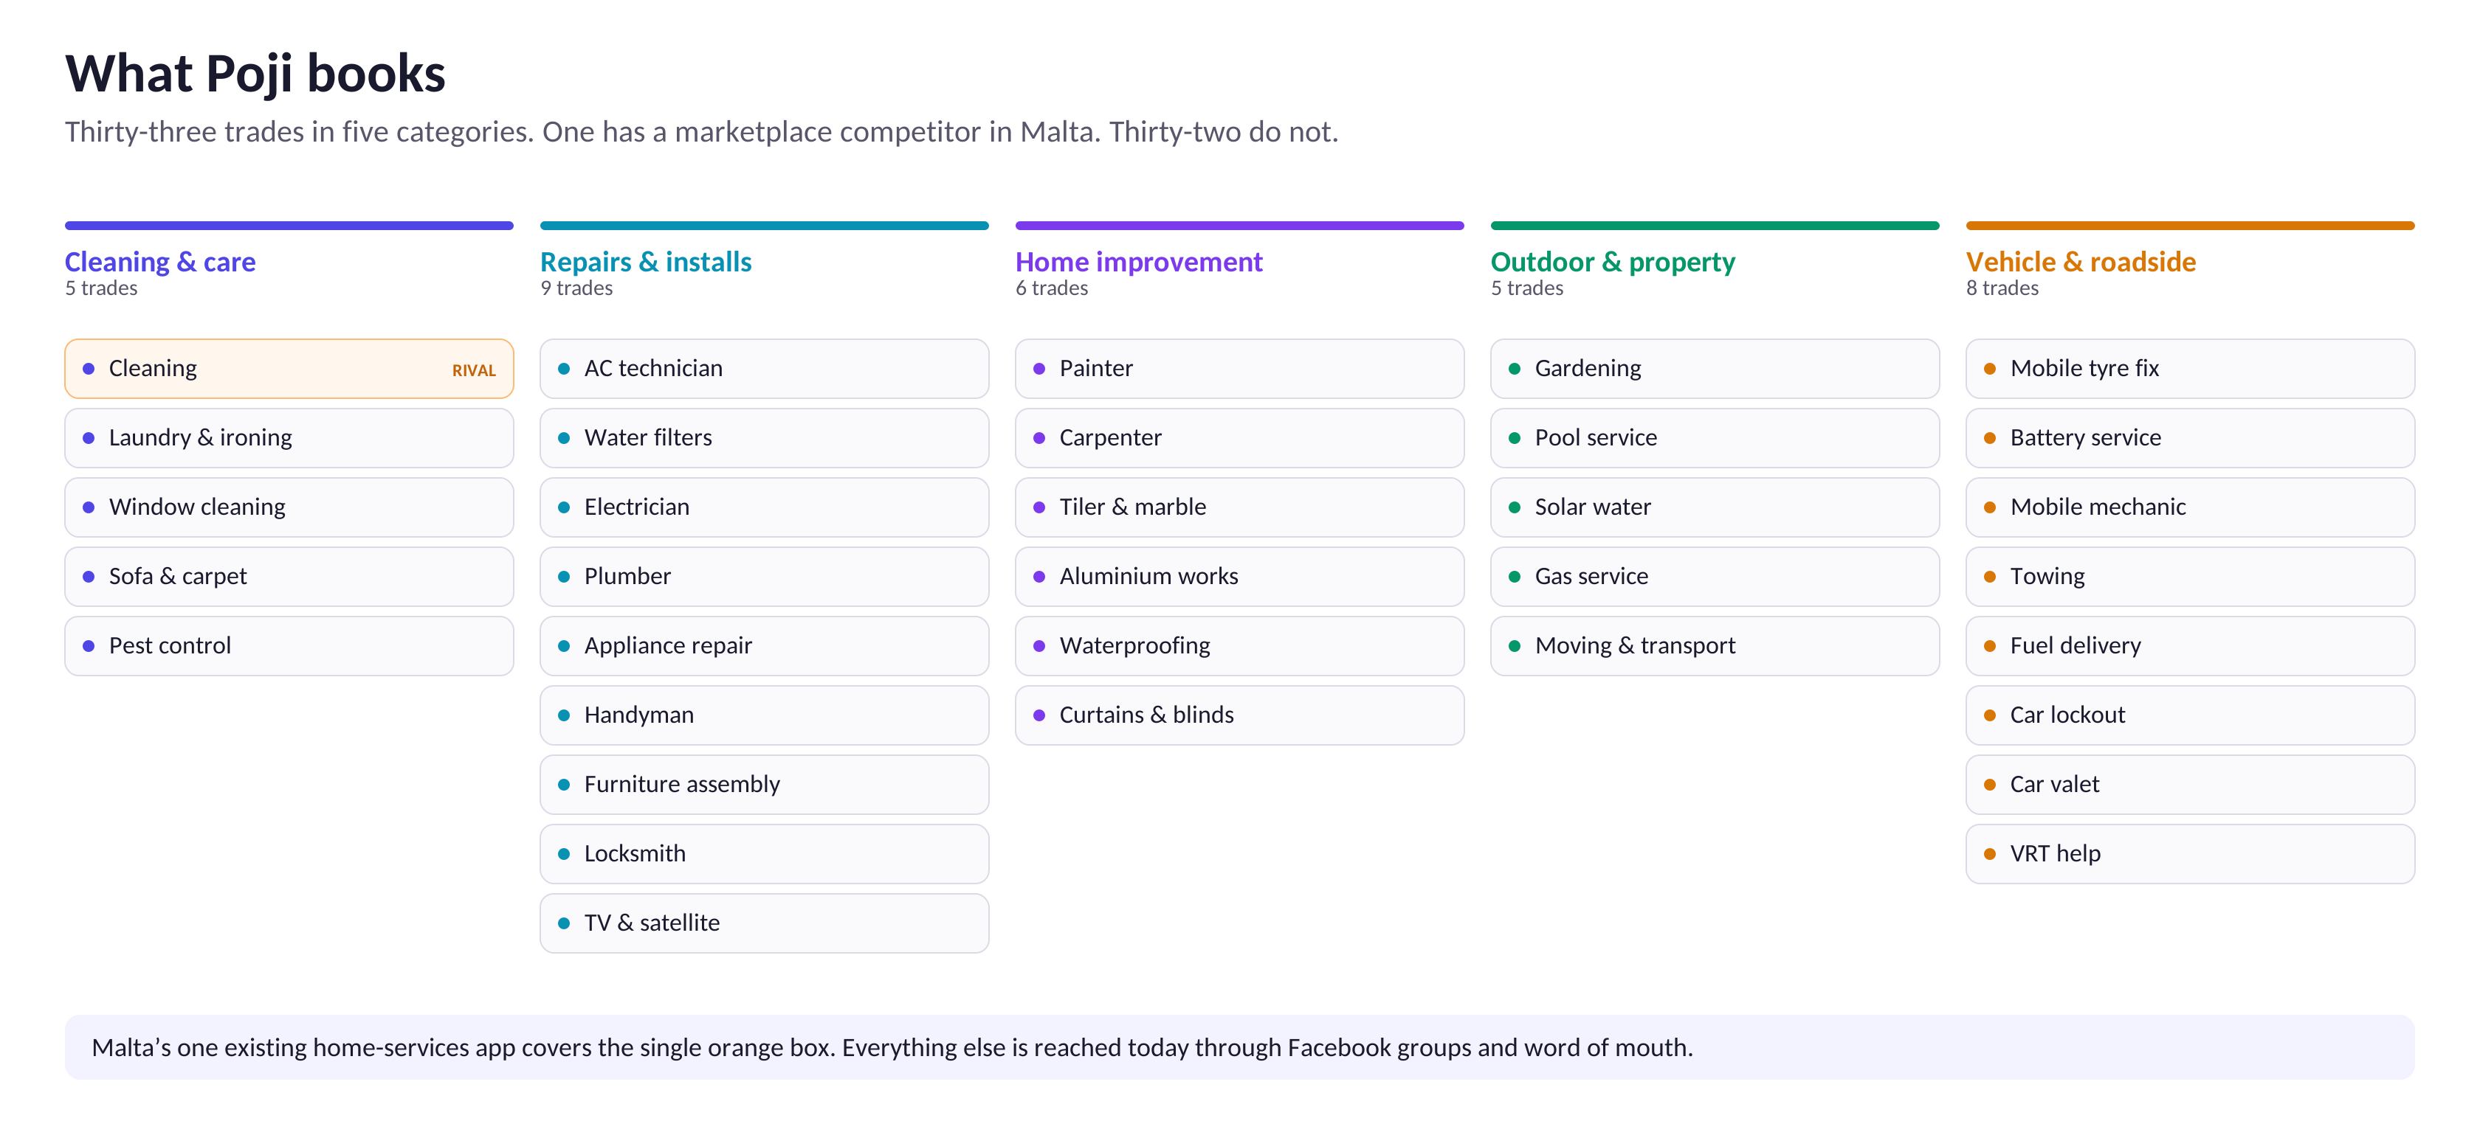
Twenty-eight of these have no marketplace competitor in Malta at all. The quoted jobs — a rewire, a bathroom, a full house move — carry commissions of several hundred euro each. One of those is worth forty cleans.

One household, many jobs
The breadth is the business, but not for the reason it first appears.
A cleaning app serves one moment in a household’s year, repeatedly. That is a good business — cleaning recurs weekly and the relationship is sticky. It is also the only moment that app can serve. When the AC stops in July, when someone is locked out at midnight, when a tyre goes on the Coast Road, that app is no use and the household goes back to Facebook.
Poji is built for all of those moments, which changes three things.
Urgency gets the app installed
Nobody plans a puncture. Nobody schedules a lockout. These are the moments when a person will install an app in ninety seconds because the alternative is standing in the road ringing numbers from a Google result.
A cleaning app cannot capture that moment. Roadside work is a poor business on its own — low frequency, thin margins — but it is an excellent way to get onto a phone. Once Poji is installed for a flat tyre, booking a plumber six weeks later is one tap.
The second booking costs nothing to win
Acquiring a household is the expensive part. A cleaning app recovers that cost through repeat cleans. Poji recovers it across categories: an AC service in summer, a filter change in autumn, a plumber when a tap fails, a man-and-van when they move flat.
A household’s year | Bookings | To Poji
AC service and a gas top-up | 2 | €22
Water filter service, twice | 2 | €33
Plumber or electrician callout | 1 | €14
Roadside, once | 1 | €9
Occasional deep clean | 2 | €24
Total from one household | 8 | €102
A household that books a weekly clean is worth more than this to a cleaning app — that is the honest comparison, and it is why cleaning is a good business. But that household has to be won against an incumbent with two years of reviews. The eight bookings above are won against nobody.
Higher value per job, where it is uncontested
Category | Typical booking | To Poji | Competition in Malta
Cleaning, 4 hours | €73 | €12 | Established app
AC service | €109 | €11 | None
Water filter, annual | €128 | €17 | None
Electrician, fuse board | €150–2,500 | €30–500 | None
House move, quoted | €250–2,500 | €50–500 | None
Roadside, puncture | €76 | €9 | None
Twenty-eight of the thirty-three trades have no marketplace competitor at all. That is where the margin is, and nobody is defending it.

The market
588,254 | people in Malta and Gozo | NSO, end 2025
+2.4% | population growth in one year | NSO
29.4% | are foreign citizens | NSO
215,691 | occupied dwellings | Census 2021
51,278 | of those lived in by non-Maltese | Census 2021
84% | of homes have air conditioning, up from 52% | Census 2021
Why the foreign share matters more than the headcount
A Maltese family has a cousin who does tiling and a neighbour who fixes boilers. A Dutch compliance officer who moved to Sliema last year has neither. Nearly a quarter of occupied homes in Malta are lived in by someone who arrived recently, and the number has risen fivefold in a decade.
These are the people who already search, already pay by card, and already expect to book things on a phone. They are also the people who get overcharged most, because they have no way to tell a fair price from a chancer.
What the work is worth
Cleaning in Malta runs €12–€25 an hour through a platform, with a two-bedroom clean at €50–€120. Repairs, AC servicing and water filter work sit higher — €70 to €200 a visit. Roadside callouts run €40 to €90.
A conservative read: 215,691 occupied dwellings, a quarter of which buy some paid home service in a year, at an average of €240 a year. That is roughly €13 million of addressable spend. Poji needs well under one per cent of it to be a sound business.

Who else is doing this
There is a real competitor and it would be dishonest to bury it.
Rozie.app
Rozie is an established on-demand cleaning marketplace in Malta, with roughly 22,700 users, 140 or so active cleaners, coverage in Times of Malta, and apps on both stores. It has a two-year head start and it is good.
It is also cleaning only.
 | Rozie | Poji
Trades covered | Cleaning | 33, across five categories
Pricing models | Hourly and extras | Hourly, fixed, and quoted
Roadside | No | Yes, with GPS
Transport | No | Yes, priced by distance band
Provider sets own prices | Limited | Fully, including their own questions
Head start | Two years, ~22,700 users | None
The honest read on that
Poji will not win cleaning from Rozie by being a slightly better cleaning app. It should not try.
What Rozie has proved is more useful than what it has taken: Maltese households will book a tradesperson through an app and pay by card. That question is answered, and someone else paid to answer it.
The gap is everywhere else. Nobody in Malta is running a verified marketplace for electricians, plumbers, AC technicians, appliance repair, locksmiths, roadside work or transport. Those jobs still happen through Facebook groups, at a worse price, with no recourse.
Rozie would need to build three pricing models, a quoting flow, GPS dispatch, a parts-approval system and distance-band transport pricing to follow. That is most of a year of work, and it is work they have no reason to do while cleaning is growing. By the time it is worth their while, Poji should hold the trades that matter.
The strategy is to own the trades nobody has digitised, and let cleaning come later as a convenience for people already on the platform rather than as the beachhead.
Others
Simply Clean, Briiz, Malta Elite and similar are cleaning companies with booking forms, not marketplaces — they employ their own staff and do not scale past their payroll. Handy, Helpling and the European platforms do not operate in Malta; the market is too small to be worth their localisation.

How the money works
Per booking
A booking | Cleaning, 4h | AC service | Filter service
Labour | €60.00 | €45.00 | €75.00
Parts | — | €45.00 | €30.00
VAT 18% (collected, remitted) | €10.80 | €16.20 | €18.90
Client pays | €72.88 | €108.56 | €127.79
Provider keeps | €48.00 | €78.75 | €88.50
Poji keeps | €12.00 | €11.25 | €16.50
Blended across the mix Poji nets roughly €14 a booking. VAT passes through — Poji collects it as a disclosed agent and remits it, so it is neither revenue nor cost.
What that needs to work
At €14 a booking and around €6,300 a month of cost, break-even sits at roughly 450 bookings a month. That is fifteen a day across 33 trades.
For comparison, Rozie reports 5,200 homes cleaned. Fifteen jobs a day is not an unreasonable target for a second year. It is an ambitious one for month six.
Six-month projection
Month | Bookings | Revenue | Costs | Net
1 | 0 | €0 | €7,400 | −€7,400
2 | 40 | €560 | €6,300 | −€5,740
3 | 110 | €1,540 | €6,300 | −€4,760
4 | 200 | €2,800 | €6,300 | −€3,500
5 | 310 | €4,340 | €6,300 | −€1,960
6 | 430 | €6,020 | €6,300 | −€280
Total | 1,090 | €15,260 | €38,900 | −€23,640
This is the base case and it does not reach profit inside six months. Month six lands within a few hundred euro of break-even, which means month eight or nine is where it turns — if growth holds.
The low case is half these numbers and needs a second raise or a cut to a one-person operation. The high case is roughly double, driven by one category taking off faster than the rest — roadside is the likeliest, because the need is urgent and there is no competitor at all.

Where €50,000 goes
Where it goes | Monthly | Six months
People
Founder, full time | €2,000 | €12,000
Part-time operations and support | €900 | €5,400
Getting providers and clients
Provider recruitment — field work, incentives | €800 | €4,800
Client acquisition — social, expat groups, local press | €1,500 | €9,000
Launch promotions absorbed by Poji | €600 | €3,600
Running it
Supabase, Vercel, Twilio, domains | €180 | €1,080
Accounting and VAT filing | €180 | €1,080
Platform liability insurance | €90 | €540
One-offs
Company formation, Pojico Ltd | — | €600
Legal review of terms and provider agreement | — | €1,200
App Store and Play Store release | — | €600
Subtotal | €6,250 | €39,900
Contingency, 15% | — | €6,000
Total | — | €45,900
The €50,000 leaves roughly €4,000 of headroom. It does not fund a second six months — that comes from revenue, a second round, or cutting to a leaner shape.
What the money is really buying
Not software. The software exists and was built without outside money. What this buys is six months in which one person works on Poji instead of something that pays, plus enough marketing budget to reach the point where providers and clients bring each other.

What could go wrong
The cold start, which is the real risk
A marketplace with no providers is useless to clients, and a marketplace with no clients is useless to providers. Every two-sided business dies here if it dies.
The mitigation is narrow focus. Not 33 trades at launch — three, in two or three localities, with ten providers who have been met in person. Sliema, Gzira and St Julian’s hold the densest concentration of exactly the foreign professionals who most need this.
Stripe
Connect approval is applied for and not granted. Without it there are no card payments, and taking cash would make commission uncollectable and the whole model unenforceable. If Connect is refused to a sole trader, incorporating first and re-applying adds four to six weeks and about €600.
Providers going around the platform
A cleaner who meets a client once can take the next booking in cash. The platform scans messages, holds contact details back until two hours before, and runs a documented penalty ladder. None of that is a cure; what actually holds people is that Poji brings work they would not otherwise get. A provider with a full book will leave. A provider with gaps in their week will not.
Market size
Malta is 588,000 people. A business here does not become large by staying here. The upside case depends on the same software working in Cyprus, Sicily or the Balearics — comparable islands, comparable informal trade markets, no incumbent. That is a second-round question, not a first-round one, and it should not be priced in now.
One founder
The platform was built by one person who also runs a car wash and drives for Uber. That is the reason it exists at all, and it is the single largest risk in the business. The first hire should be an operations person who can recruit and manage providers, so that the founder is not the only point of failure.

The honest odds
No investor is helped by a number pulled from the air, so here is the reasoning rather than a figure.
What is already true: the product is built and works, which removes the risk that eats most seed money. The founder has run service businesses in Malta and knows the trades personally. The market has been validated by a competitor. The regulatory model — VAT agency, disclosed invoicing — is worked out. The commission mechanics cannot be gamed from a phone.
What is not yet true: no payments, no users, no company, no team, and a competitor with a two-year head start in the largest single category.
Outcome | Chance | What it looks like
Does not work | ~30% | Never passes 100 bookings a month. Money is spent, software remains.
A small, real business | ~45% | 400 to 900 bookings a month, €5,000–€12,000 monthly profit, two or three people. A good living, a modest return.
Grows past Malta | ~20% | Malta works, the model is exported to one or two comparable islands. Worth a real multiple.
Large | ~5% | Becomes the default across several small European markets. Acquisition or a proper round.
Weighted honestly, this is not a venture-scale bet and should not be sold as one. It is a sound small-market business with a built product, a real gap, and a founder who has already done the hard part without funding. The most likely good outcome is a profitable company in Malta, not an exit.

The ask
€50,000 for 20% of Pojico Ltd, to be incorporated on completion.
Six months of runway. Month one incorporates, closes Stripe Connect, and recruits the first ten providers in person. Months two and three launch in three localities across three trades. Months four to six widen the trades and the map.
What triggers a conversation about more money
- 150 bookings in a single month, or
- 30 active providers with a job each in the past fortnight, or
- Any single category passing 60 bookings a month
Any of those says the thing works and is worth pushing harder. None of them by month six says the opposite, and that conversation should be just as honest as this one.

Yetkin Berberoglu · po-ji.com · Malta
Sources: National Statistics Office Malta (population estimates to end 2025; Census of Population and Housing 2021). Competitor figures are as published by Rozie.app. Projections are the author’s own and are not guarantees.

