|  |  |  |
| --- | --- | --- |
| Assignment Code | : | C.L.P0003 |
| Assignment Name | : | Simple Slot Machine. |
| Student Name | : | Le Thi Thanh Nhan |
| Time/Date | : | 01h00,1/10/2019 |

Approach

Create a file for store money. Convert number in file to a variable call money and rewrite number money when what to save.

Create a function play(float *mon) with inputed money and create 3 variables a,b,c and random them from 0 to 9.

* If all 3 equal each others, plus $10 to money and print out the announcement;
* If 2 of 3 equal, plus $0.5 to money and print out the announcement;
* Else print out the annoucement not win anything.

Default money is $10, after input option, use switch case to do the actions.

* If option is 1, call function play(mon) with mon=&money.
* If option is 2, print out announcement that money is saved.
* If option is 3, print out thanks, bye, the last money and end.
* If money equal 0, print out warning and end.

Flowchart

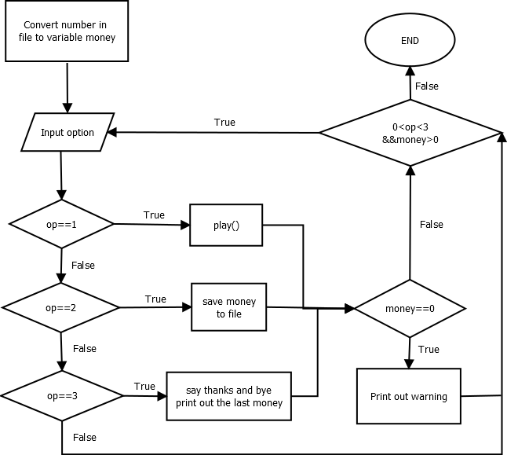

play()

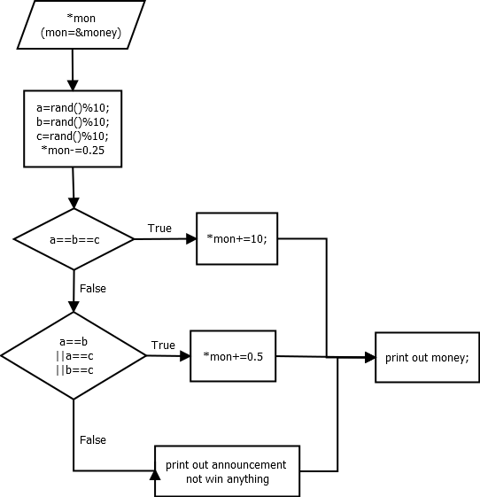

Source code

#include <stdio.h>

#include <stdlib.h>

#include <conio.h>

int play(float *mon)

{

    int a, b, c;

    srand(time(NULL));

    a = rand() % 10;

    b = rand() % 10;

    c = rand() % 10;

    printf("The slot machine shows %d%d%d\n", a, b, c);

    *mon -= 0.25;

    if (a == b && a == c)

    {

        printf("You win the big prize\n");

        *mon += 10;

    }

    else if (a == b || a == c || b == c)

    {

        printf("You win 50 cents!\n");

        *mon += 0.5;

    }

    else

        printf("Sorry you don't win anything.\n");

    printf("You have $%f\n", *mon);

}

int main()

{

    FILE *fp = fopen("longlab3.txt", "r+");

    float money;

    if (fp == NULL)

    {

        printf("\nCan't open file or file doesn't exist.");

        exit(0);

    }

    fscanf(fp, "%f", &money);

    float *mon;

    mon = &money;

    int op;

    do

    {

        printf("Choose one of the following menu options:\n");

        printf("1) Play the slot machine.\n");

        printf("2) Save game.\n");

        printf("3) Cash out.\n");

        scanf("%d", &op);

        switch (op)

        {

        case 1:

        {

            play(mon);

            break;

        }

        case 2:

        {

            rewind(fp);

            fprintf(fp,"%f", *mon);

            printf("Your money had saved!\n");

            break;

        }

        case 3:

        {

            printf("Thank you for playing! You end with $%f\n", *mon);

            break;

        }

        default:

            break;

        }

        if (*mon == 0)

            printf("You don't have enough money to play!!");

        printf("\n\n");

    } while (op > 0 && op < 3 && *mon > 0);

    getch();

    return 0;

}

Result

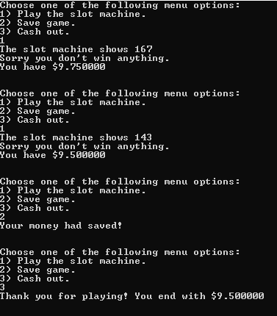

Reference