|  |  |  |
| --- | --- | --- |
| Assignment Code | : | C.L.P0004 |
| Assignment Name | : | Quiz Bowl |
| Student Name | : | Le Thi Thanh Nhan |
| Time/Date | : | 1h00,22/11/2019 |

Approach

Read data from file. Input number of questions and random to find questions. Print question, if it is multiple choice question then print question follow the form, input answer and check if it is correct plus point of the question else minus point.

Flowchart

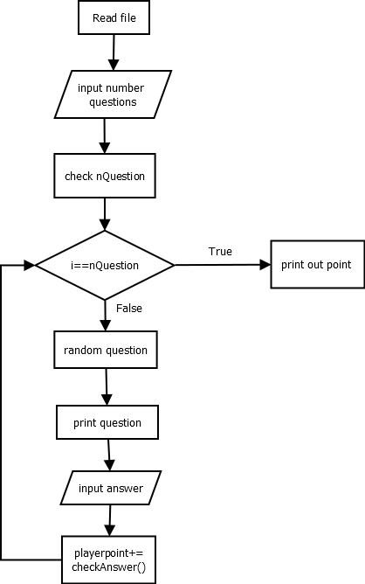

Source code

#include <stdio.h>

#include <stdlib.h>

#include <conio.h>

#include <string.h>

typedef char string[100];

typedef struct QuesType

{

    char kind[3];

    int point;

    string ques;

    int numChoices;

    string *choiceList;

    string ans;

} QuesType;

QuesType *ReadFile(string fn, int *n)

{

    FILE *f = fopen(fn, "r");

    fscanf(f, "%d\n", n);

    QuesType *QB = (QuesType *)malloc((*n) * sizeof(QuesType));

    for (int i = 0; i < *n; i++)

    {

        QuesType q;

        fscanf(f, "%s %d\n", q.kind, &q.point);

        fscanf(f, "%[^\n]\n", q.ques);

        if (strcmp(q.kind, "MC") == 0)

        {

            fscanf(f, "%d\n", &q.numChoices);

            q.choiceList = (string *)malloc((q.numChoices) * sizeof(string));

            for (int j = 0; j < q.numChoices; j++)

            {

                fscanf(f, "%[^\n]\n", q.choiceList[j]);

            }

        }

        fscanf(f, "%s\n", q.ans);

        QB[i] = q;

    }

    fclose(f);

    return QB;

}

void playgame(QuesType *QB, int n)

{

    int nQuestion, playerPoint;

    for (;;)

    {

        printf("\nHow many questions would you like (out of 3)?\n");

        scanf("%d", &nQuestion);

        if (nQuestion > n)

            printf("Sorry, that is too many.\n");

        else if (nQuestion == 0)

            exit(0);

        else if (nQuestion < 0)

            printf("Please enter a positive number!\n");

        else

        {

            printf("\n");

            playerPoint = 0;

            int *mark = (int *)malloc(n * sizeof(int));

            int num;

            for (int i = 0; i < nQuestion; i++)

            {

                do

                {

                    num = rand() % n;

                } while (mark[num] == 1);

                mark[num] = 1;

                displayQuestion(QB[num]);

                printf("Your answer: ");

                string answer;

                scanf("%s", answer);

                playerPoint += checkAnswer(QB[num], answer);

            }

            printf("your game is over!\n");

            printf("Your Final Points: %d", playerPoint);

        }

    }

}

int checkAnswer(QuesType Q, string answer)

{

    int point = 0;

    if (strcmp(answer, Q.ans) == 0)

    {

        printf("Correct! You get %d points\n\n", Q.point);

        point += Q.point;

    }

    else

    {

        printf("Incorrect! You lose %d points\n\n", Q.point);

        point -= Q.point;

    }

    return point;

}

void displayQuestion(QuesType Q)

{

    char q[100] = {'A', 'B', 'C', 'D', 'E', 'F'};

    printf("Points: %d\n", Q.point);

    printf("Question: %s\n", Q.ques);

    if (strcmp(Q.kind, "MC") == 0)

    {

        for (int j = 0; j < Q.numChoices; j++)

            printf("%c.%s\n", q[j], Q.choiceList[j]);

    }

}

int main()

{

    QuesType *QuesBank;

    int numQues;

    QuesBank = ReadFile("longlab4.txt", &numQues);

    playgame(QuesBank, numQues);

    getch();

    return 0;

}

Result

