|  |  |  |
| --- | --- | --- |
| Assignment Code | : | C.L.P0006 |
| Assignment Name | : | Hangman |
| Student Name | : | Le Thi Thanh Nhan |
| Time/Date | : | 22h00,19/10/2019 |

Approach

Store data from file to array line[LINE][LETTER].

Random to find puzzle.

Create a loop:

Print out the word if the letter was guessed show that letter else print “_”.

Input guess and check. If false 5 time, fail, break the loop.

Print out the word if not fail.

Flowchart

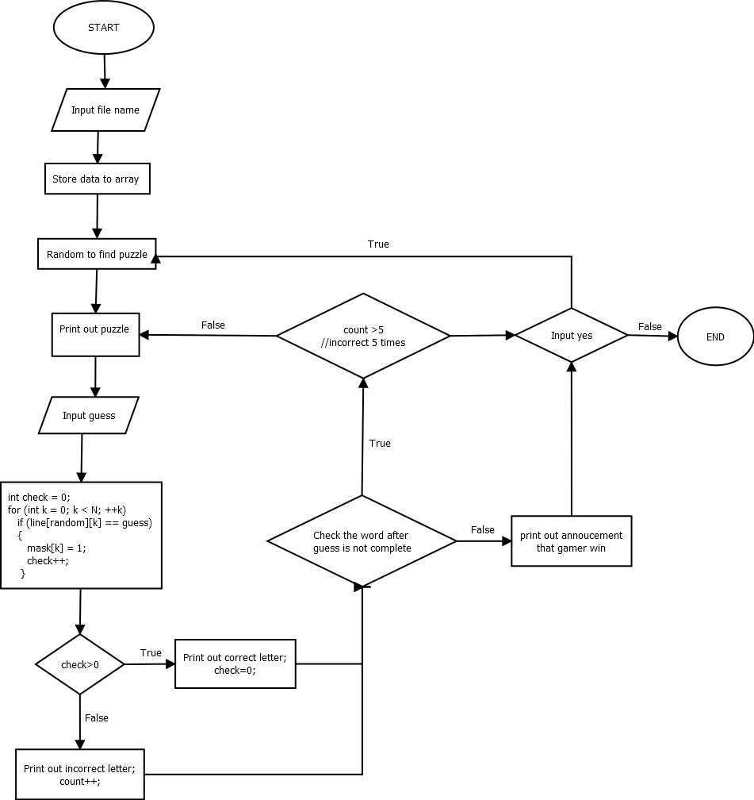

Source code

#include <conio.h>

#include <stdio.h>

#include <string.h>

#define LINE 1000

#define LETTER 10

int main()

{

    char line[LINE][LETTER];

    char fname[20];

    FILE *fptr = NULL;

    int i = 0;

    int tot = 0;

    printf("What the file stores the puzzle words about animals?\n");

    scanf("%s", fname);

    fptr = fopen(fname, "r");

    while (fgets(line[i], LINE, fptr))

    {

        line[i][strlen(line[i]) - 1] = '\0';

        i++;

    }

    tot = i;

    char play[5];

    do

    {

        srand(time(NULL));

        int random = rand() % tot;

        int N = strlen(line[random]);

        int mask[N];

        for (int i = 0; i < N; ++i)

            mask[i] = 0;

        int gameover = 0, count = 0;

        while (!gameover)

        {

            printf("\nHere is your puzzle:\n ");

            for (int j = 0; j < N; ++j)

                if (mask[j])

                    printf("%c", line[random][j]);

                else

                    printf("_ ");

            printf("\n");

            char guess;

            printf("Please enter your guess.\n");

            fflush(stdout);

            scanf(" %c", &guess);

            int check = 0;

            for (int k = 0; k < N; ++k)

                if (line[random][k] == guess)

                {

                    mask[k] = 1;

                    check++;

                }

            if (check > 0)

            {

                printf("Congratulations, you guessed a letter in the puzzle!");

                check = 0;

            }

            else

            {

                printf("Sorry, that letter is NOT in the puzzle.\nYou currently have %d incorrect guesses", count);

                count++;

            }

            gameover = 1;

            for (int m = 0; m < N; ++m)

            {

                if (!mask[m])

                {

                    gameover = 0;

                    break;

                }

            }

            if (count > 5)

            {

                printf(", you lose.\n");

                break;

            }

        }

        if (count < 5)

            printf("\nCongratulations, you got the correct word, \"%s\".\n", line[random]);

        printf("----------------------------------------");

        printf("\n\nWould you like to play hangman (yes,no)?\n");

        fflush(stdin);

        gets(play);

    } while (strcmp(play, "yes") == 0);

    getch();

    return 0;

}

Result

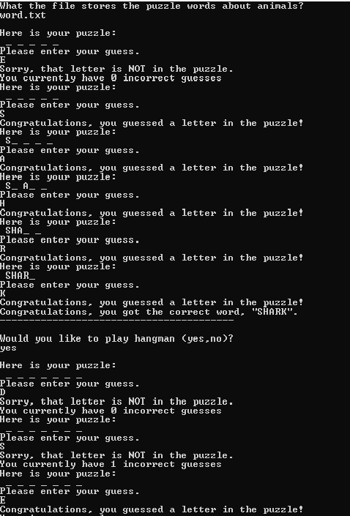

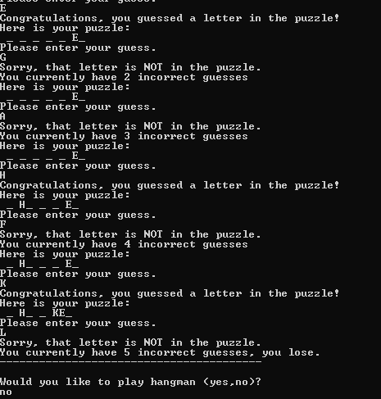

Reference

<https://www.w3resource.com/c-programming-exercises/file-handling/c-file-handling-exercise-4.php>