|  |  |  |
| --- | --- | --- |
| Assignment Code | : | C.S.P0014 |
| Assignment Name | : | Casino player |
| Student Name | : | Le Thi Thanh Nhan |
| Time/Date | : | 2h00,2/11/2019 |

Approach

1. Buy: Input cash, if it > *money, not buy, else *chips plus the biggest number of chips which multiply 11 is smaller than cash and *money minus the cash bought chips.
2. Sell: Input numbers of chips to sell, if it > *chips, not sell, else *chips minus sold chips and *money plus the numbers of sold chips multiply 10.
3. Craps: if input ‘r’, ramdom sum numbers of dices(di) and print out di:

* If di equal 7 or 11, print out the player win;
* If di equal 2, 3 or 12, print out the player lost;
* Else continue ramdom until find (dic) 7 or di:
* If dic equal 7, print out the player lost;
  + If dic equal di, print out the player win;

1. Arup: if input ‘r’, ramdom sum numbers of dices(di) and print out di:

* If di equal 11 or 12, print out the player win;
* If di equal 2, print out the player lost;
* Else continue ramdom (dic) :
* If dic smaller than di, print out the player lost;
  + If dic equal or bigger than di, print out the player win;

1. Report: print out the numbers of money and chips;

Flowchart

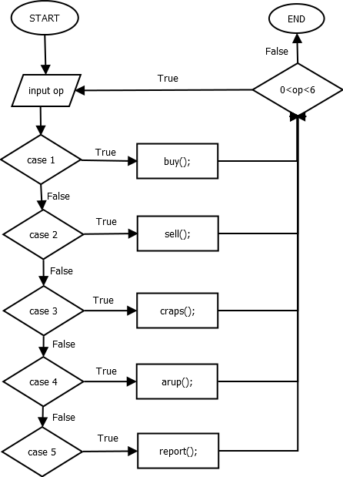

Source code

#include <stdio.h>

#include <conio.h>

#include <string.h>

#include <stdlib.h>

int buy(int *money, int *chips)

{

    int cash;

    printf("How much cash do you want to spend for chips?");

    scanf("%d", &cash);

    if (cash > *money)

        printf("Sorry,you do not have that much money. No chips bought.");

    else

    {

        *chips += (cash / 11);

        *money -= (cash - cash % 11);

        report(money, chips);

    }

}

int sell(int *money, int *chips)

{

    int chip;

    printf("How many chips do you want to sell?");

    scanf("%d", &chip);

    if (chip > *chips)

        printf("Sorry, you do not have that many chips. No chips sold.");

    else

    {

        *chips -= chip;

        *money += (chip * 10);

    }

}

int random()

{

    srand(time(NULL));

    return 2 + rand() % (12 + 1 - 2);

}

int craps(int k, int *chips)

{

    char r;

    int di;

    int chip, dic;

    printf("How many chips would you like to bet?");

    scanf("%d", &chip);

    if (chip == 0)

        printf("Sorry, that is not allowed.No game played.");

    else if (chip > *chips)

        printf("Sorry you don't have many chips to bet. No game played.");

    else

    {

        printf("Press 'r' and hit enter for your first roll.\n");

        scanf(" %c", &r);

        if (r == 'r')

        {

            di = random();

            printf("You rolled a %d.", di);

        }

        if (di == 7 || di == 11)

        {

            printf("You win!");

            *chips += chip;

        }

        else if (di == 2 || di == 3 || di == 12)

        {

            printf("You lose!");

            *chips -= chip;

        }

        else

        {

            do

            {

                printf("\nPress 'r' and hit enter for your next roll.\n");

                scanf(" %c", &r);

                if (r == 'r')

                {

                    dic = random();

                    printf("You rolled a %d.", dic);

                }

                if (dic == di)

                {

                    printf("You win!");

                    *chips += chip;

                }

                else if (dic == 7)

                {

                    printf("Sorry, you lose!");

                    *chips -= chip;

                }

            } while (dic != 7 && dic != di && r == 'r');

        }

    }

}

int arup(int k, int *chips)

{

    char r;

    int di;

    int chip, dic;

    printf("How many chips would you like to bet?");

    scanf("%d", &chip);

    if (chip == 0)

        printf("Sorry, that is not allowed.No game played.");

    else if (chip > *chips)

        printf("Sorry you don't have many chips to bet. No game played.");

    else

    {

        printf("Press 'r' and hit enter for your first roll.\n");

        scanf(" %c", &r);

        if (r == 'r')

        {

            di = random();

            printf("You rolled a %d.", di);

        }

        if (di == 11 || di == 12)

        {

            printf("You win!");

            *chips += chip;

        }

        else if (di == 2)

        {

            printf("You lose!");

            *chips -= chip;

        }

        else

        {

            printf("\nPress 'r' and hit enter for your next roll.\n");

            scanf(" %c", &r);

            if (r == 'r')

            {

                dic = random();

                printf("You rolled a %d.", dic);

            }

            if (dic >= di)

            {

                printf("You win!");

                *chips += chip;

            }

            else

            {

                printf("Sorry, you lose!");

                *chips -= chip;

            }

        }

    }

}

int report(int *money, int *chips)

{

    printf("You currently have %d left and %d chips", *money, *chips);

}

int main()

{

    int op, k, money = 1000, chips = 0;

    do

    {

        printf("\nWelcome to the Casino. Here are your choices: ");

        printf("\n1) Buy chips");

        printf("\n2) Sell chips");

        printf("\n3) Play Craps");

        printf("\n4) Play Arup's Game of Dice");

        printf("\n5) Status Report");

        printf("\n6) Quit");

        printf("\nEnter your choice: ");

        scanf("%d", &op);

        switch (op)

        {

        case 1:

            buy(&money, &chips);

            report(&money, &chips);

            break;

        case 2:

            sell(&money, &chips);

            report(&money, &chips);

            break;

        case 3:

            craps(k, &chips);

            break;

        case 4:

            arup(k, &chips);

            break;

        case 5:

            report(&money, &chips);

            break;

        }

    } while (0 < op && op < 6);

}

Result

