|  |  |  |
| --- | --- | --- |
| Assignment Code | : | C.S.P0001 |
| Assignment Name | : | File Handling |
| Student Name | : | Le Thi Thanh Nhan |
| Time/Date | : | 2h00,10/11/2019 |

Approach

1) Use fread() to read file.

2) Use fread() to read file to copy and fwrite() to write data to target file.

3) Use fgetc() and fputc to copy 2 data from 2 file to file result.

4) Create a struct to store all file names and use readdir to read all file name and store them to struct.

5) Use remove() to delete file.

Flowchart

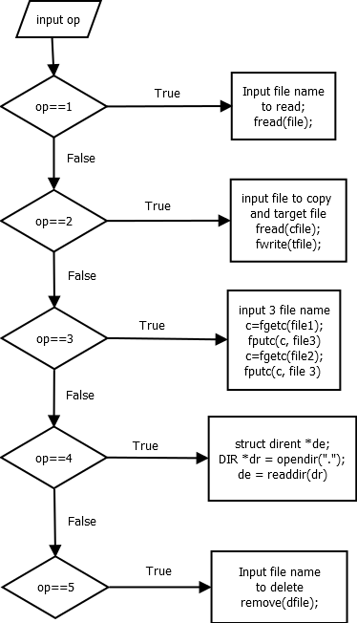

Source code

#include <stdio.h>

#include <conio.h>

#include <string.h>

#include <dirent.h>

int main()

{

    FILE *fp1, *fp2, *fp3, *fp4, *fp5, *fp6;

    char rfile[30], cfile[30], tfile[30], ffile[30], sfile[30], result[30], dfile[30];

    struct dirent *de;

    DIR *dr = opendir(".");

    printf("1) Read file");

    printf("\n2) Copy files");

    printf("\n3) Merge two files");

    printf("\n4) List files in a directory");

    printf("\nDelete file");

    int op;

    do

    {

        printf("\n\nChoice features: ");

        scanf("%d", &op);

        switch (op)

        {

        case 1:

            printf("Enter the name of file you wish to see: ");

            fflush(stdin);

            gets(rfile);

            char buffer1[600000];

            fp1 = fopen(rfile, "r");

            if (fp1 != NULL)

            {

                fread(buffer1, 1, 600000, fp1);

                fclose(fp1);

                printf("\n%s", buffer1);

            }

            else

                printf("File Not Found!");

            break;

        case 2:

            printf("Enter the name of file to copy: ");

            fflush(stdin);

            gets(cfile);

            printf("Enter the name of target file: ");

            fflush(stdin);

            gets(tfile);

            char buffer2[600000];

            fp2 = fopen(cfile, "r");

            if (fp2 != NULL)

            {

                fread(buffer2, 1, 600000, fp2);

                fclose(fp2);

            }

            fp3 = fopen(tfile, "a+");

            fwrite(buffer2, 1, strlen(buffer2), fp3);

            fclose(fp3);

            printf("File copied successfully!!");

            break;

        case 3:

            printf("Enter the name of first file: ");

            fflush(stdin);

            gets(ffile);

            printf("Enter the name of second file: ");

            fflush(stdin);

            gets(sfile);

            printf("Enter the name of file which will store contents of two files:");

            fflush(stdin);

            gets(result);

            FILE *fp4 = fopen(ffile, "r");

            FILE *fp5 = fopen(sfile, "r");

            FILE *fp6 = fopen(result, "w");

            char c;

            while ((c = fgetc(fp4)) != EOF)

                fputc(c, fp6);

            while ((c = fgetc(fp5)) != EOF)

                fputc(c, fp6);

            fclose(fp4);

            fclose(fp5);

            fclose(fp6);

            printf("Two file were merges into %s file successfully!!", result);

            break;

        case 4:

            if (dr == NULL)

                printf("Could not open current directory");

            while ((de = readdir(dr)) != NULL)

                printf("%s\n", de->d_name);

            closedir(dr);

            break;

        case 5:

            printf("Enter the name of file you wish to delete: ");

            fflush(stdin);

            gets(dfile);

            if (remove(dfile) == 0)

                printf("Deleted successfully");

            else

                printf("Unable to delete the file");

            break;

        }

    }while(op>0&&op<6);

}

Result

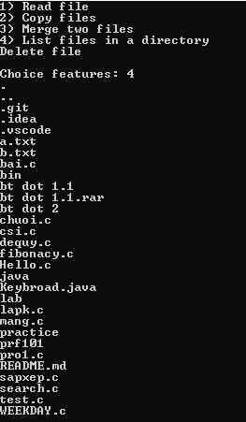

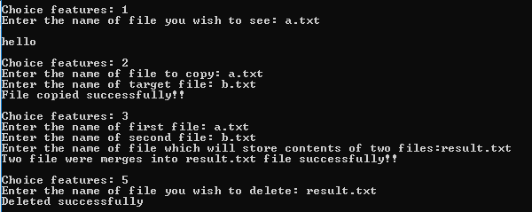

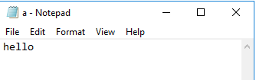

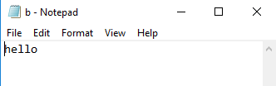

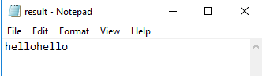

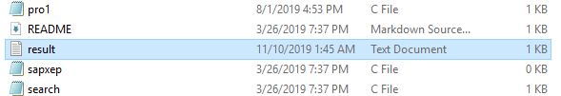



Reference

<https://www.geeksforgeeks.org/c-program-list-files-sub-directories-directory/>

<https://www.geeksforgeeks.org/c-program-merge-contents-two-files-third-file/>

<https://www.geeksforgeeks.org/c-program-delete-file/>