|  |  |  |
| --- | --- | --- |
| Assignment Code | : | C.S.P0001 |
| Assignment Name | : | Reverse a string |
| Student Name | : | Le Thi Thanh Nhan |
| Time/Date | : | 22h00,11/9/2019 |

Approach

Input: A string

Output: The reversed string

1. Input a string (str).
2. Declare another string to store reversed string (revstr).
3. Find a word from the end of str.
4. Put it in revstr.
5. Repeat step 3-4 till the beginning of str.
6. Print out str and revstr.
7. Use while loop to repeat step 1-6 when press ENTER and exit when press ESC

Flowchart

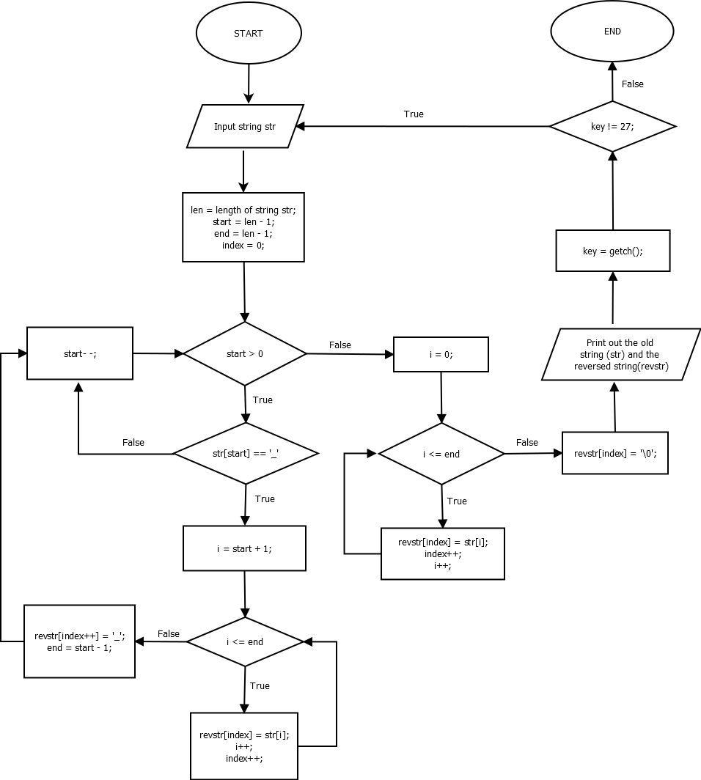

Source code

#include <stdio.h>

#include <conio.h>

#include <stdlib.h>

#include <string.h>

int main()

{

    int key;

    do

    {

        char str[100], revstr[100];

        int i, index, start, end;

        fflush(stdin);

        printf("Please enter string: ");

        gets(str);

        int len = strlen(str);

        start = len - 1;

        end = len - 1;

        index = 0;

        while (start > 0)

        {

            if (str[start] == ' ')

            {

                i = start + 1;

                while (i <= end)

                {

                    revstr[index] = str[i];

                    i++;

                    index++;

                }

                revstr[index++] = ' ';

                end = start - 1;

            }

            start--;

        }

        for (i = 0; i <= end; i++)

        {

            revstr[index] = str[i];

            index++;

        }

        revstr[index] = '\0';

        printf("\nThe old string: %s\n\n", str);

        printf("The reversed string: %s\n\n", revstr);

        printf("Press enter to continue another reverse, ESC to exit\n\n");

        key = getch();

    } while (key != 27);

    getch();

    return 0;

}

Result

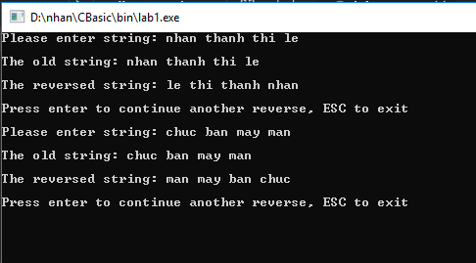

Reference

<https://codeforwin.org/2016/10/c-program-to-reverse-order-of-words-in-string.html>

<https://daynhauhoc.com/t/lenh-bat-phim-trong-lap-trinh-c/16736/2>