|  |  |  |
| --- | --- | --- |
| Assignment Code | : | C.S.P0002 |
| Assignment Name | : | Number to word |
| Student Name | : | Le Thi Thanh Nhan |
| Time/Date | : | 20h00,13/9/2019 |

Approach

Input: 34678

Output: thirty four thousand six hundred seventy eight

Count the digits of the number and then turn each digit into a letter, add “thousand” and “hundred”. If tens and tens of thousands equal to 1, use the function two(), if them equal to 2-9 use the function ten(), the rest use the function one(). If the number is 0, print out “zero”, the number is 10 print out ten, the number is 10xxx print out ten thousand…

Flowchart

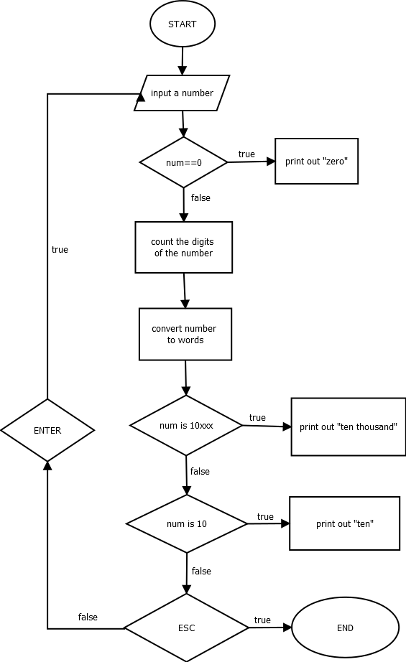

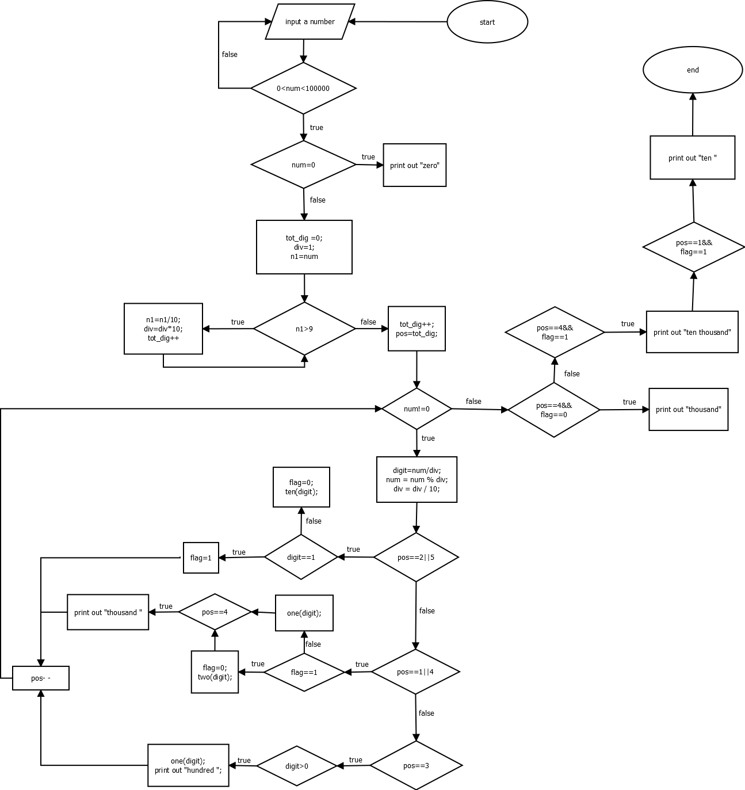

Source code

#include <stdlib.h>

#include <stdio.h>

#include <conio.h>

void one(int digit)

{

    switch (digit)

    {

    case 1:

        printf("one ");

        break;

    case 2:

        printf("two ");

        break;

    case 3:

        printf("three ");

        break;

    case 4:

        printf("four ");

        break;

    case 5:

        printf("five ");

        break;

    case 6:

        printf("six ");

        break;

    case 7:

        printf("seven ");

        break;

    case 8:

        printf("eight ");

        break;

    case 9:

        printf("nine ");

    }

}

void two(int digit)

{

    switch (digit)

    {

    case 0:

        printf("ten ");

        break;

    case 1:

        printf("eleven ");

        break;

    case 2:

        printf("twelve ");

        break;

    case 3:

        printf("thirteen ");

        break;

    case 4:

        printf("fourteen ");

        break;

    case 5:

        printf("fifteen ");

        break;

    case 6:

        printf("sixteen ");

        break;

    case 7:

        printf("seventeen ");

        break;

    case 8:

        printf("eighteen ");

        break;

    case 9:

        printf("nineteen ");

    }

}

void ten(int digit)

{

    switch (digit)

    {

    case 2:

        printf("twenty ");

        break;

    case 3:

        printf("thirty ");

        break;

    case 4:

        printf("forty ");

        break;

    case 5:

        printf("fifty ");

        break;

    case 6:

        printf("sixty ");

        break;

    case 7:

        printf("seventy ");

        break;

    case 8:

        printf("eighty ");

        break;

    case 9:

        printf("ninty ");

    }

}

void main()

{

    int key;

    do

    {

        long num, div, n1;

        int flag, digit, pos, tot_dig;

        do

        {

            printf("\nEnter a number: ");

            scanf("%ld", &num);

            if (num > 99999)

                printf("please enter a number between 0 and 99999\n");

        } while (0 > num || num > 99999);

        //0

        if (num == 0)

            printf("Zero\n");

        // count the digits of the number

        tot_dig = 0; //total digit =0

        div = 1;

        n1 = num;

        while (n1 > 9)

        {

            n1 = n1 / 10;

            div = div * 10;

            tot_dig++;

        }

        tot_dig++;

        pos = tot_dig;

        //convert number to words

        while (num != 0)

        {

            digit = num / div;

            num = num % div;

            div = div / 10;

            switch (pos)

            {//tens and tens thousand

            case 2:

            case 5:

                if (digit == 1)

                    flag = 1;

                else

                {

                    flag = 0;

                    ten(digit);

                }

                break;

            //unit and thousands

            case 1:

            case 4:

                if (flag == 1)

                {

                    flag = 0;

                    two(digit);

                }

                else

                    one(digit);

                if (pos == 4)

                    printf("thousand ");

                break;

            //hundred

            case 3:

                if (digit > 0)

                {

                    one(digit);

                    printf("hundred ");

                }

                break;

            }

            pos--;

        }

        //10xxx

        if (pos == 4 && flag == 0)

            printf("thousand");

        else if (pos == 4 && flag == 1)

            printf("ten thousand");

        //10

        if (pos == 1 && flag == 1)

            printf("ten ");

        key = getch();

    } while (key != 27);

    getch();

}

Result

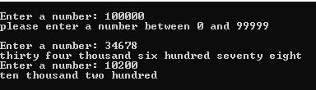

Reference

<https://c-program-example.com/2012/05/c-program-to-convert-number-to-words.html>