|  |  |  |
| --- | --- | --- |
| Assignment Code | : | C.S.P0008 |
| Assignment Name | : |  |
| Student Name | : | Le Thi Thanh Nhan |
| Time/Date | : | 18h30,20/9/2019 |

Approach

Create a int array to count how many time each letter appear. If the letter appear once then print out it.

Source code

#include <stdio.h>

#include <string.h>

#include <conio.h>

#include <ctype.h>

int main()

{

    char str[100];

    int i, len, key;

    int count[26];

    do

    {

        printf("\nEnter any string: ");

        gets(str);

        len = strlen(str);

        for (i = 0; i < 26; i++)

            count[i] = 0;

        tolower(str);

        for (i = 0; i < len; i++)

            count[str[i] - 97]++;

        printf("\nFound character:\n");

        for (i = 0; i < 26; i++)

            if (count[i] == 1)

                printf("%c   ", (i + 97));

        printf("\nPress enter to continue another reverse, ESC to exit\n\n");

        key = getch();

    } while (key != 27);

    getch();

    return 0;

}

Result

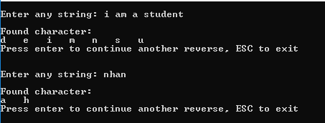

Reference