|  |  |  |
| --- | --- | --- |
| Assignment Code | : | C.S.P0036 |
| Assignment Name | : | Count the number of the appearance of letters in a string |
| Student Name | : | Le Thi Thanh Nhan |
| Time/Date | : | 17h15,25/9/2019 |

Approach

Enter a string. Convert all upcaser letters to lowercase letters. Create a array and count the appear time of all letter.

Source code

#include <stdio.h>

#include <string.h>

#include <conio.h>

#include <ctype.h>

int main()

{

    char str[100];

    int i, len, max = 0, key;

    int count[26];

    do

    {

        printf("Enter any string: ");

        gets(str);

        len = strlen(str);

        for (i = 0; i < 26; i++)

            count[i] = 0;

        strlwr(str);

        for (i = 0; i < len; i++)

            count[str[i] - 97]++;

        for (i = 0; i < 26; i++)

            if (count[i] != 0)

                printf("'%c' = %d\n", (i + 97), count[i]);

        key = getch();

    } while (key != 27);

    getch();

    return 0;

}

Result

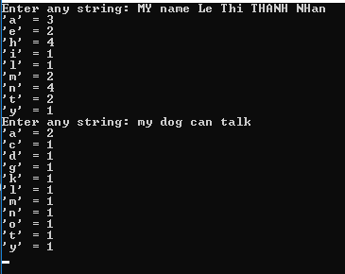

Reference

<https://codeforwin.org/2015/04/c-program-to-calculate-the-frequency-of-each-character-in-a-line.html>