TASK1

1. What is the Purpose of using git and Github in Software Dev and each complement each other:
2. Git helps to keep track of changes and file. It helps to manage all version of the file.
3. With git, you can manage source code, fixing bug
4. GitHub, meanwhile, is where people can share and collaborate on the files they have created.
5. Easier to make changes to the project

GitHub

Github helps to

* Create : It is called “a social coding platform”GitHub lets users create requests from one another and internally discuss the iterations
* Store : it is a SCM – source code manager
* Change : It allows developers to edits and make changes that the other collaborators also see and interact.
* Merge : developers can make changes in github, changes merged during collaboration
* collaborate on files or code : Github is used in software development by helping access the GitHub repository.

T1

1. How do you initiate Git repository and significant of git add and git commit commands in version control:

To initiate git repository, we follow the following steps:

1. Create a folder or repository in our local
2. Assuming this folder created is still empty –
3. We make sure we are in the file by using “pwd” command
4. We use cd command to move into our local repository

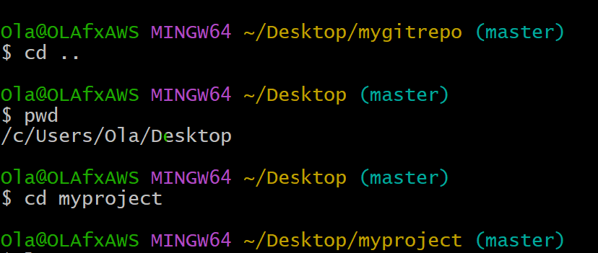

From above illustration, we are in a directory called myproject (can be found on the Desktop)

We have used git add . command to add document to this folder( by doing “ls” command. Ls linux command tells us if the file is empty. In this case, we have

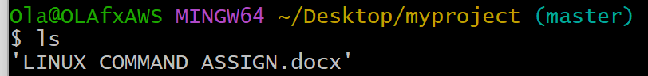

Linux Command Assign.docx in “myproject” folder.

Git Commit: for git to make changes, we need to track the changes by committing the changes: We use “git commit” command.

“Git commit” take a snapshot of the code

1. Explain the purpose of using branches in git, and how to create branch using git command
2. What is the importance of creating descriptive commit messages when recording changes in Git repository?

Whenever we are looking at our snapshot to know where to go back to, detailed and clear message is vital good to see what we have done. Detail message tells us what we did on the previous commit should we need to go back to the commit.

Commit help us/ or point in time where we can save the project and come back to it at a later date. We have done the following: “git commit -m”

-m shows adding detail message to the project.

1. Making some changes
2. Adding to the changes
3. And commit to it(save)