Android CapStone_Stage1 Proposal

**Project:** Random-dot-Stereogram Messenger

**GitHub Username**: yeuchi

**First Draft:** July 15, 2018

**Second Draft**: July 21, 2018

**Author:** Chi T. Yeung

# 

**Description** **2**

**Introduction** **3**

Problem(s) Solved 3

Intended User 3

**Features** 4

Screen 1 Splash + Main page 5

Screen 2 View files 6

Screen 3 Settings 6

Screen 4 - Share options 7

Screen 5 Recipient/Settings Tab page 8

Screen 6 Message text Tab page 8

Screen 7 Message Shape Tab page 9

Screen 8 Preview Tab page 9

Screen 9 Widget 10

**Data** **10**

**Key Considerations** **11**

How will your app handle data persistence? 11

Describe any edge or corner cases in the UX. 11

Describe any libraries you’ll be using and share your reasoning for including them. 12

Describe how you will implement Google Play Services or other external services. 12

**Next Steps: Required Tasks** **12**

Task 0: Libraries 12

Task 1: Project Setup 13

Task 2: Implement UI for Each Activity and Fragment 13

Task 3: Physical device 14

Task 4: Toasts 14

Task 5: Utilize AsyncTask and IntentService for performance 14

**References** **15**

# 

# Description

Compose your 1-2 words (or simple shape) message in a random-dot-stereogram and share it with others via email, facebook or other social media. Make it extra challenging by encoding it in selective colors and use it as a color blindness tester.

# Introduction

## Background

Random-dot-stereogram technique was first published by Dr. Julesz[1] in 1970s. Since then, Random dot stereogram has experienced surges of popularity. The algorithm is available from GPU Gems - Chapter 41 Real-Time Stereogram[2] and I have already tested it in javascript (available in appendix)[3].

## Use-case

This document describe the design of a message application. The unique property is random-dot-stereogram as the message. Below diagram presents the user’s interaction with message composition, archival and share. The receiving user views the message via gmail, face, Google drive or other 3rd party social services. Additional, the user can view previously generated message in the viewer portion of the application.

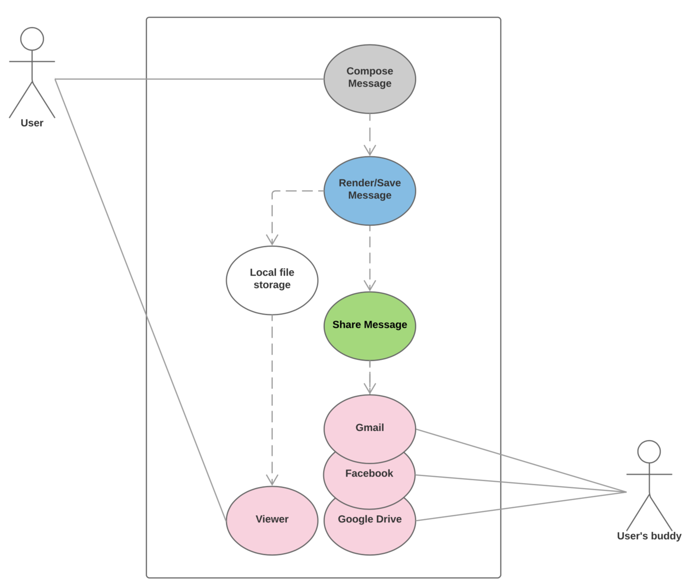

*Figure 1. Use case diagram*

## Problem(s) Solved

This is a fun messaging application for sending a 1-2 words encoded message in Text + shape graphics. The message is encoded in a random stereogram (auto-stereo-pair VR-View or Single-interlaced image).

## Intended User

* User must have good eyesight and patience.
* User must already have knowledge to cross eyes when viewing single-interlaced image.
* User with Virtual Reality viewer will be able to view the stereo-pair images.
* For the selective color feature, users with color-blindness may find some content prohibitive to decode.

# Features

With this application user will be able to use the following features.

* Create 1-2 words (and/or shape) message.
* View random-dot-stereogram with VR Viewer
* View random-dot-stereogram as single-interlaced image.
* Share message via email, facebook, google-drive.

From the perspective as a development requirement list, below list granular capabilities in this application.

* Provide a view with text entry and upload shapes.
* Support Right-To-Left (RTL) for the Arabic language.
* Provide sizing capability on text and shapes.
* Render a random-dot-stereogram into 2 auto-stereo-pairs for VR Viewer.
* Render a random-dot-stereogram into a single-interlaced image for unaided viewing.
* Archive above mentioned rastered files to local or Google drive service.
* Share above mentioned files with 3rd party services such as email, facebook, etc.
* Load/render previously archived files.
* Accessibility with Google voice access service[6] or speech recognition service[5].
* Provide a widget for archive listing and quick application launch to viewer.
* Persist application states and configuration between uses as well as phone reboots.
* Support (defeatured) offline usage.
* Use AsyncTask for network download so User interface remains responsive.
* Use IntentService for rendering, shape image upload so user interface is responsive.

User Interface Mocks

The user experience consists of six view activities, where four are tabs. The view hierarchy is shallow with only 1 sub-viewActivity from mainActivity.

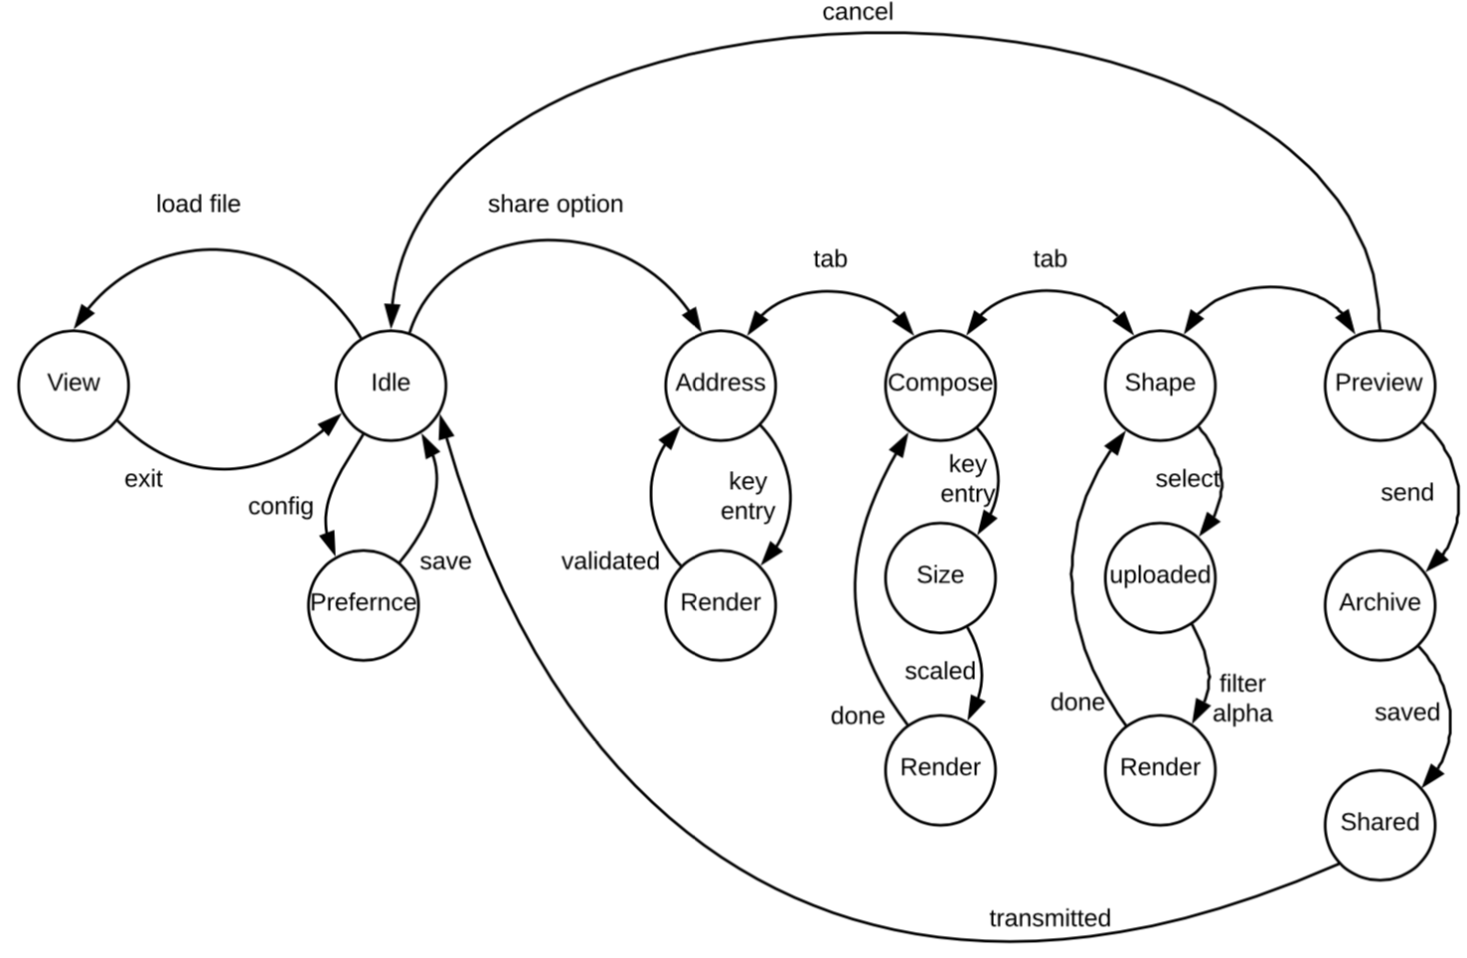

*Figure 2. UI state diagram*

## **Screen 1 Splash + Main page**

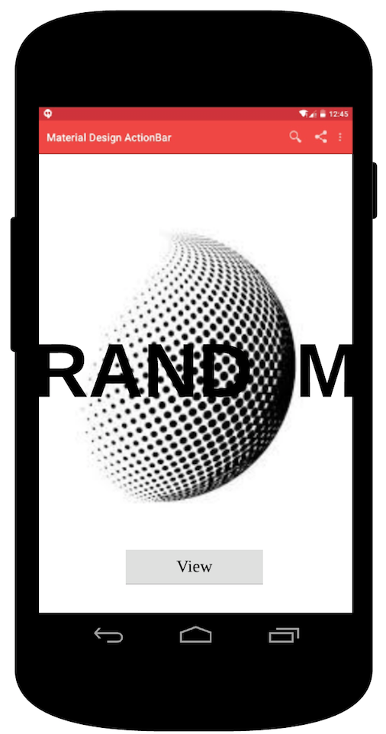

*Figure 3. MainActivity page*

Splash

Animating transition of graphic and text introduces user into the main page.

Menu selections

On the AppToolBar, user can select general settings and shared options. Shared options allow user to compose and send new random-dot-stereogram for destinations such as facebook, email or file. User may also select ‘Settings’ from menu at anytime.

View button

navigate to random-dot-stereogram view.

## **Screen 2 View files**

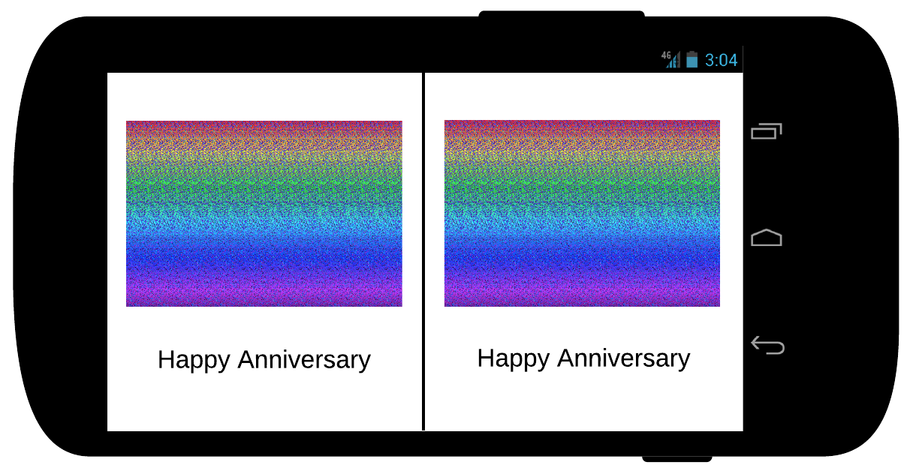

*Figure 4. ViewerActivity page*

User may view rendered random-dot-stereogram on file system that were shared previously. This particular mock-up image depicts an auto-stereo pair for Virtual reality viewer.

## **Screen 3 Settings**

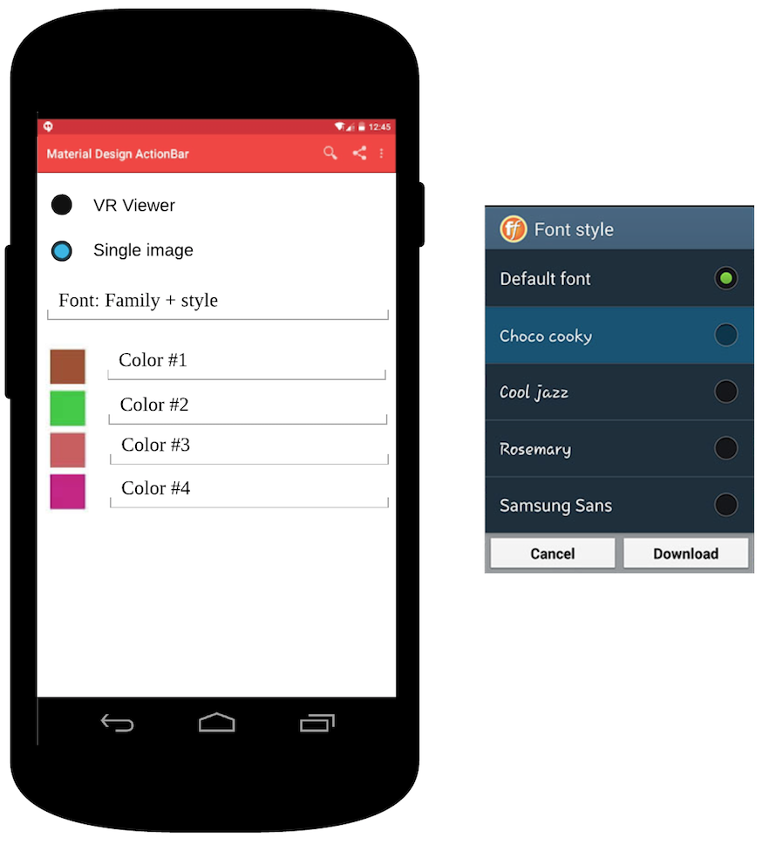

*Figure 5. PreferenceActivity page*

At anytime, user can change application settings. These settings include the following:

1. Target rendered image type
2. auto-stereo image pair for VR viewer.
3. single interlaced image.
4. Font type
5. Colors used for the random dot dithering.

## **Screen 4 - Share options**

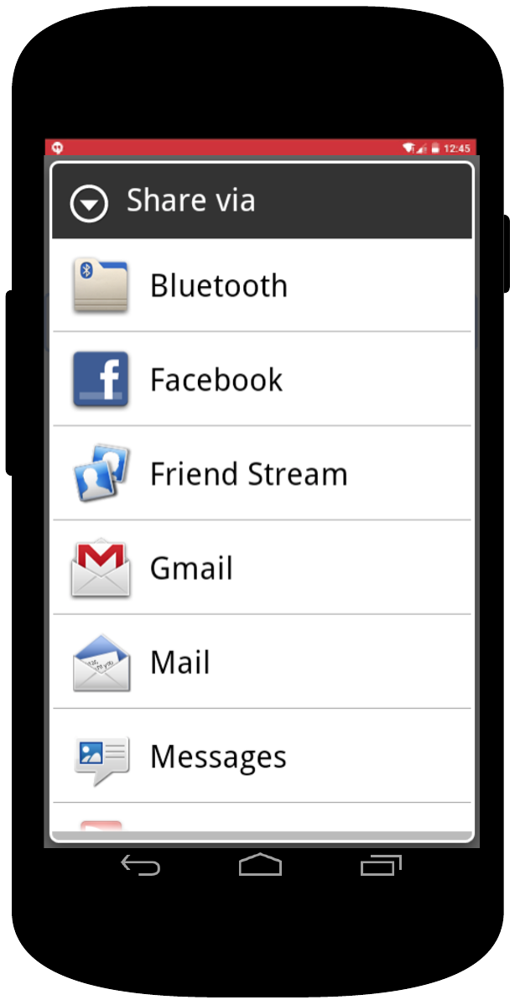

*Figure 6. SharedOption dialog*

First implementation will include three options:

* Facebook feed
* Email message (HTML body) embedded content
* Google drive file storage

## **Screen 5 Recipient/Settings Tab page**

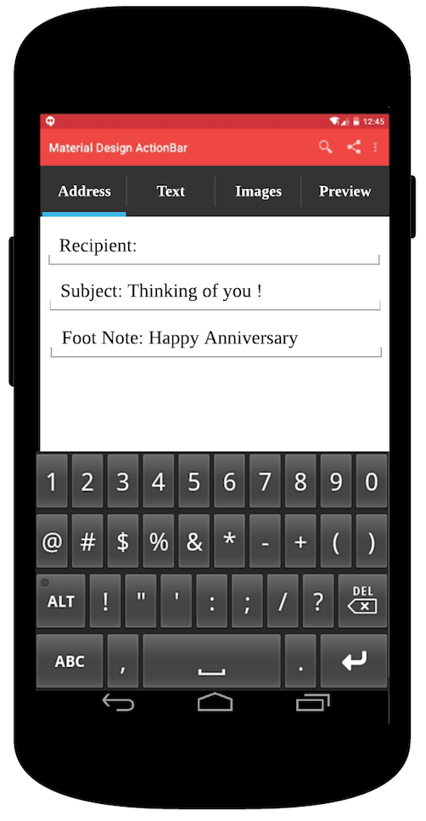

*Figure 7. AddressActivity page*

For the email scenario, user will input the following:

* Recipient - standard receiving user, destination.
* Subject - standard email subject line.
* Footer - a brief text message that will be visible along with the random-dot-image.

## **Screen 6 Message text Tab page**

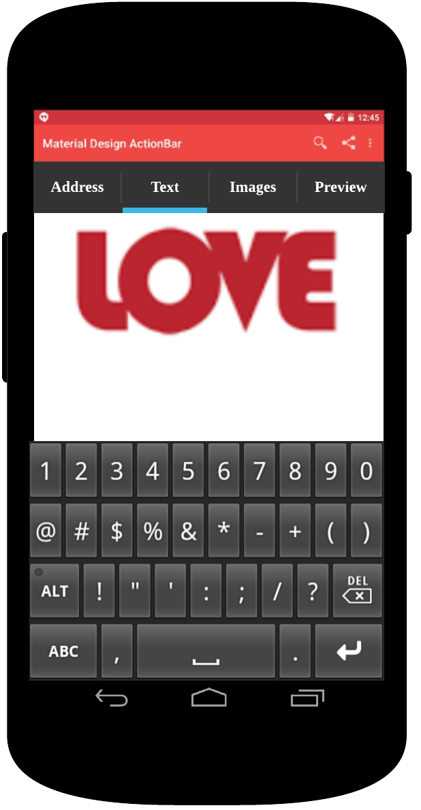

*Figure 8. TextMsgActivity page*

Use keyboard entry to develop a 1-2 word(s) message.

## **Screen 7 Message Shape Tab page**

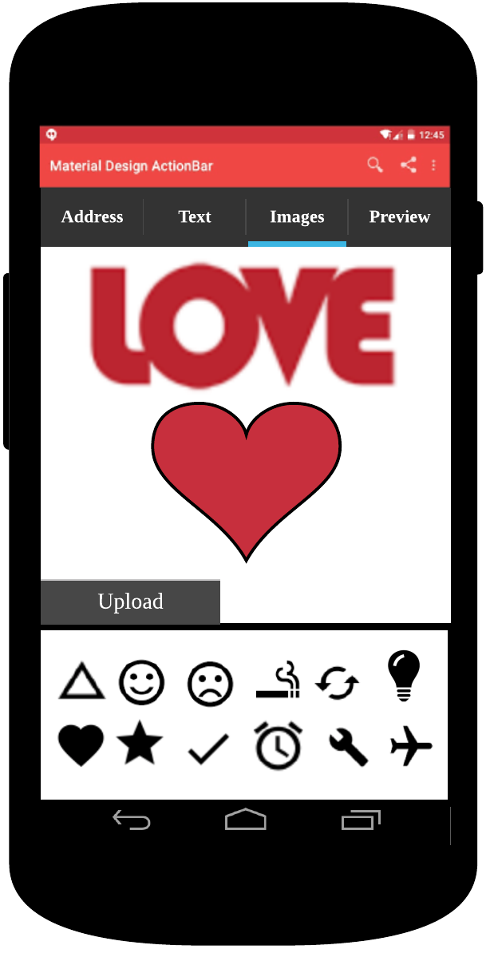

*Figure 9. ShapeMsgActivity page*

Upload custom shape from file or select existing to accent your expression. Image shape should be simple and binary in nature, 1 bit per pixel alpha channel SVG.

## **Screen 8 Preview Tab page**

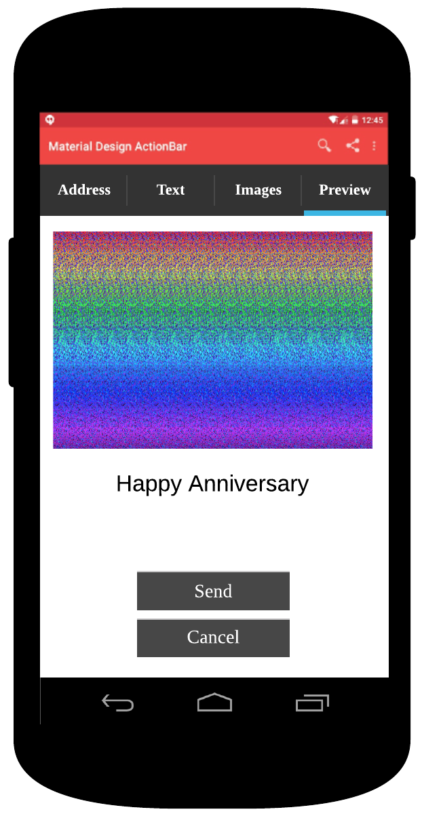

*Figure 10. PreviewActivity page*

Preview message in an encoded Random-dot-stereogram. Depress Send button to commit.

## **Screen 9 Widget**

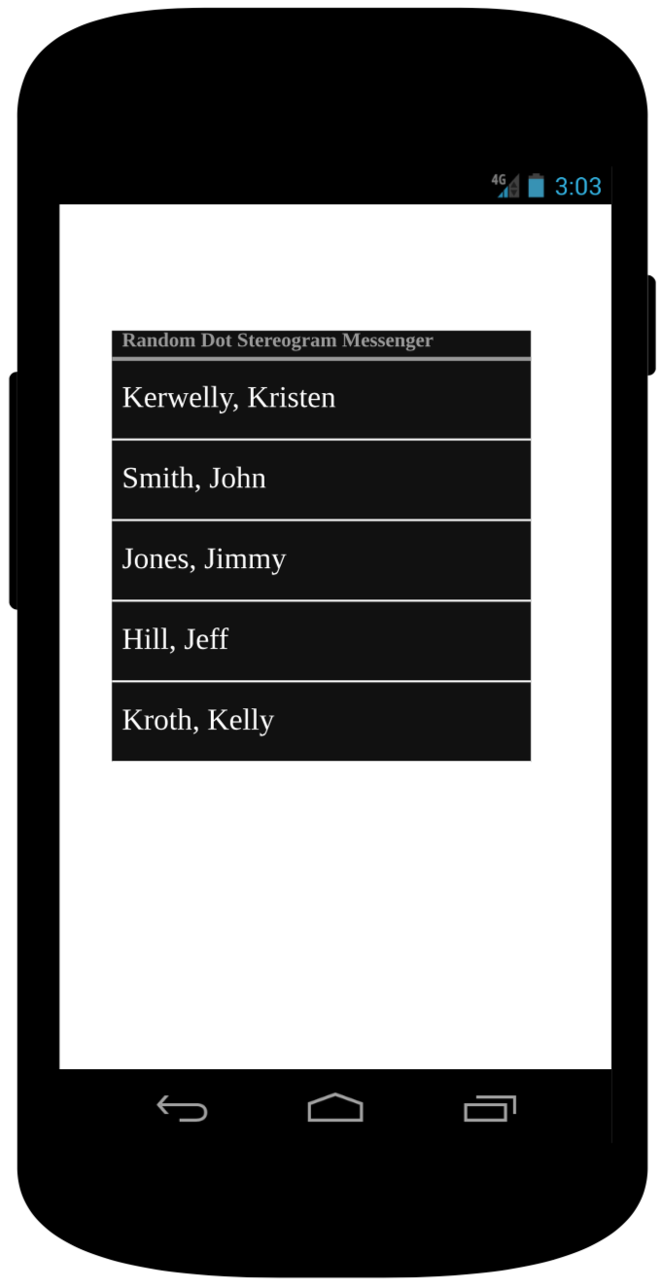

*Figure 11. Widget page*

Send list available on widget. Click selection to launch full application viewer for content.

# Data

A general collection of entities and their relationship is presented in a logically separation below.

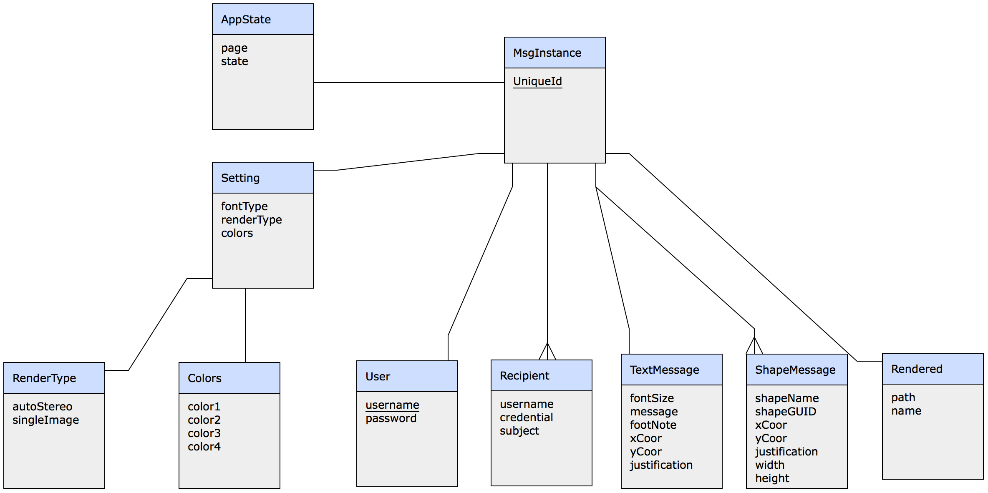

*Figure 12. Application Entity diagram [4]*

# Key Considerations

### **How will your app handle data persistence?**

Random-dot-stereogram (rendered) image files

Rendered images will be stored on local directory by default.

One of shared option will be Google drive service. I will be using example source code from [JoaquimLey](https://github.com/JoaquimLey)/[google-sync-adapter](https://github.com/JoaquimLey/google-sync-adapter)[7] .

Message Instance

A local SQL-Lite with Content Provider make sense to manage all application state, resources and variables for a current message instance. Each instance can be uniquely identified by recipient entity + GUID.

Application settings

Font, color and rendering types are specific to the message instance above mentioned. This data is also store in the SQL-Lite database.

Credentials

User passwords will be maintained with CredentialOptions object.

### **Describe any edge or corner cases in the UX.**

Blank message

‘Send’ button will only be enabled if message content exists.

Large message

Pending on the viewing device’s physical dimension, a long message may have to be clipped in a small window. Scaling down the image may reduce acuity of the text. One possible solution is an animating scroll window.

Complex Upload shape

Random-dot-stereogram is best when viewing simply and commonly recognizable shapes.

Complicated and unfamiliar shapes are not recommended.

Only SVG format is supported for the upload feature. SVG (bi-tonal) is preferred and will be treated as alpha channel data. If alpha channel is available, all the pixel color information is ignored. Highly compressed JPG images contain undesirable block artifacts.

Page transitions - Tab pages

Users are expected to move between tab pages. Application will maintain states and variables in SQL-Lite database for storage. When user completes the workflow, application will return to main view. If user leaves the application for any reason otherwise, the application will restore last known state.

To return main view from message composition, user can select ‘cancel’ button in preview.

### **Describe any libraries you’ll be using and share your reasoning for including them.**

1. Picasso will be used to load and cache images (version 2.71828 or later).
2. Random-dot-stereogram auto-stereo-pair renderer, to be written by me.
3. Random-dot-stereogram single-interlaced renderer, to be written by me.
4. ~~PNG parser to extract alpha channel for shape, to be written by me.~~
5. SVG rendering to bitmap -- androidSVG or similar library.
6. Convert Google drive service example to library: [JoaquimLey](https://github.com/JoaquimLey)/[google-sync-adapter](https://github.com/JoaquimLey/google-sync-adapter)[7]

Google Services

1. Google Speech recognizer

As an optional feature, user will be able to navigate through the application using basic voice commands such as ‘next page’, ‘tab’, ‘click’, etc. I have already tested this service via my android dictation application exercise [5].

1. Google Service - com.google.android.gms.drive

Source to retrieve file for viewer and one of shared option destination.

Other tools

1. Android studio IDE (version 3.1.3 or later)
2. Gradle (version 4.4-all or later)

### **Describe how you will implement Google Play Services or other external services.**

Database

Content provider service will be used to communicate with SQL-Lite database.

ShareIntent

Message will be shared with destinations such as Gmail, Facebook.

# Next Steps: Required Tasks

Below is a break down of my application development. It consist of tangible technical tasks that I can complete one at a time until a finished app is realized.

## **Task 0: Libraries**

Digital image processing is an expensive task. Native development kit (NDK) in low level languages (C, C++) may offer more effective image rendering and filters. I will implement and compare with Java to offer the best performance.

1. Implement Random-dot-stereogram auto-stereo-pair library.
2. Implement Random-dot-stereogram interlace library.
3. ~~Implement PNG filtering library (extract alpha channel).~~

## **Task 1: Project Setup**

Steps I will take to setup and/or configure this project.

1. Create Default android project with main view.
2. Add this proposal and and additional feedback from Udacity advisor(s).
3. Add ReadME page.
4. Add SQLite database to data directory.
5. Implement Content Provider.
6. Implement Content Resolver.
7. Implement Cursor Loader.
8. Include above Task 0 libraries.

## **Task 2: Implement UI for Each Activity and Fragment**

User interface development include the following activities which are already described above in the mock-ups.

Common

1. Read/Write from sharedPreference and DB when application start/stop/pause.

MainActivity

1. Animating transition for graphics, text.
2. Menu with Settings, shared options selectors.
3. Shared options dialog to select Facebook, email, etc.
4. View button to invoke ViewerActivityIntent.

SettingsActivity

1. Font configuration dialog
2. Colors selection
3. Radio buttons - random-dot-stereogram type selection

Tab pages

1. Address
2. Recipient text field
3. Subject text field
4. Footer text field
5. Text message
6. Key entry rendered in Vector graphics on display.
7. Scale to fit screen.
8. Shape
9. Upload custom SVG.
10. List selection of shapes in memory.
11. Scale to fit screen.
12. Preview
13. Execute render to generate raster image.
14. Send button to execute shareIntent.
15. Cancel button to dispose all and return to MainActivity.

Widget

1. Implement send list.
2. Add SharedIntent to handle click item event; launch full application.

## **Task 3: Physical device**

In addition to the basic user interface, I also need to consider device dimension (tablet vs phone) and orientation (landscape vs portrait).

## **Task 4: Toasts**

I need error and success handling with toasts.

## **Task 5: Utilize AsyncTask and IntentService for performance**

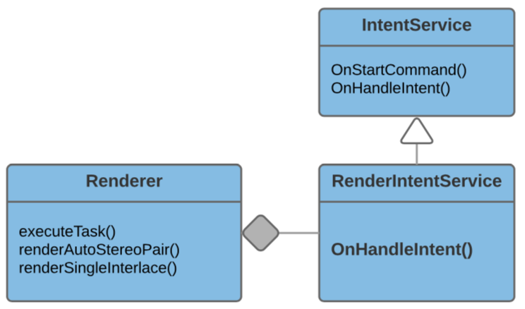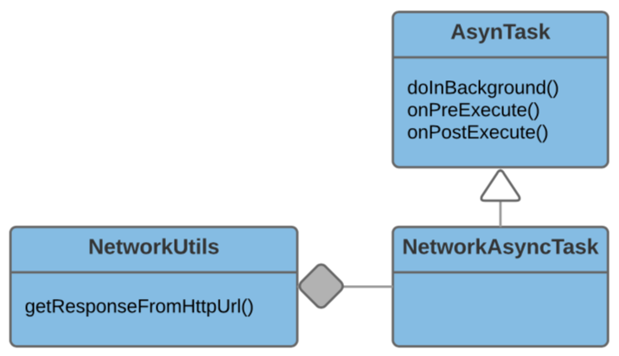

*Figure 13. AsyncTask, IntentService class diagrams.*

Two common patterns I have learned to keep user interface responsive are AsyncTasks and IntentServices. In many of the projects, I have used asyncTask to retrieve content across network. IntentServices will be used for more complex tasks such as rendering, google drive service create/update files. Rendering and Google drive tasks will be implemented as services.

# References

1. [Julesz, Béla](https://en.wikipedia.org/wiki/B%C3%A9la_Julesz) (1971). *Foundations of Cyclopean Perception*. Chicago: The University of Chicago Press. [ISBN](https://en.wikipedia.org/wiki/International_Standard_Book_Number) [0-226-41527-9](https://en.wikipedia.org/wiki/Special:BookSources/0-226-41527-9).
2. GPU Gems Chapter41

<http://developer.download.nvidia.com/books/HTML/gpugems/gpugems_ch41.html>

1. My Random-dot-stereogram implementation

<http://www.ctyeung.com/wordpress/?p=630>

1. Application entity diagram

<http://erdraw.com/graphs/257151464379/edit>

1. My Android dictation service exercise

<https://github.com/yeuchi/Dictation>

1. Google voice access service

<https://play.google.com/store/apps/details?id=com.google.android.apps.accessibility.voiceaccess>

1. [JoaquimLey](https://github.com/JoaquimLey)/[google-sync-adapter](https://github.com/JoaquimLey/google-sync-adapter)

<https://github.com/JoaquimLey/google-sync-adapter>