Tuesday December 20, 2011

12:30 pm The beginning of the effort begins with a bmp decoder as template.
http://devongovett.github.com/bmp.js/

My first goal is to write a simple STL decoder, render the (x,y) wireframe for validation.

I have already written a STL decoder and renderer at Jostens. Now, I need to rewrite a similar one in javascript minus the 3D rendering.

STL file format specification.
http://en.wikipedia.org/wiki/STL_%28file_format%29#Binary_STL

3:30 pm able to access STL file content but it is stored in 32bit float. Javascript does not have byte array to float ? Wow, how can this be ? Another opportunity to exercise !
Otherwise, we are rendering !

Wednesday December 21, 2011

Amazing just how lacking javascript is ! There is no byteArray to float nor byteArray to double. Sadly, no one has posted solution. Comes to show how advanced Flex is.

Byte array to double
http://stackoverflow.com/questions/8361086/convert-byte-array-to-numbers-in-javascript

Claims a binary parser for float here.. but I don’t see the sign bit being used.
http://snippets.dzone.com/posts/show/685

Here is a very useful application to check my work.
http://www.h-schmidt.net/FloatApplet/IEEE754.html

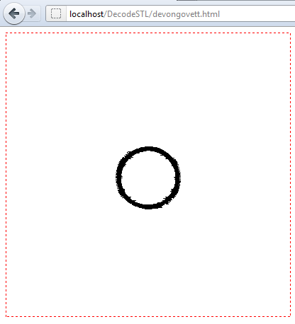
strange, working for a period of time and then can’t clear context anymore.
STL loading OK.
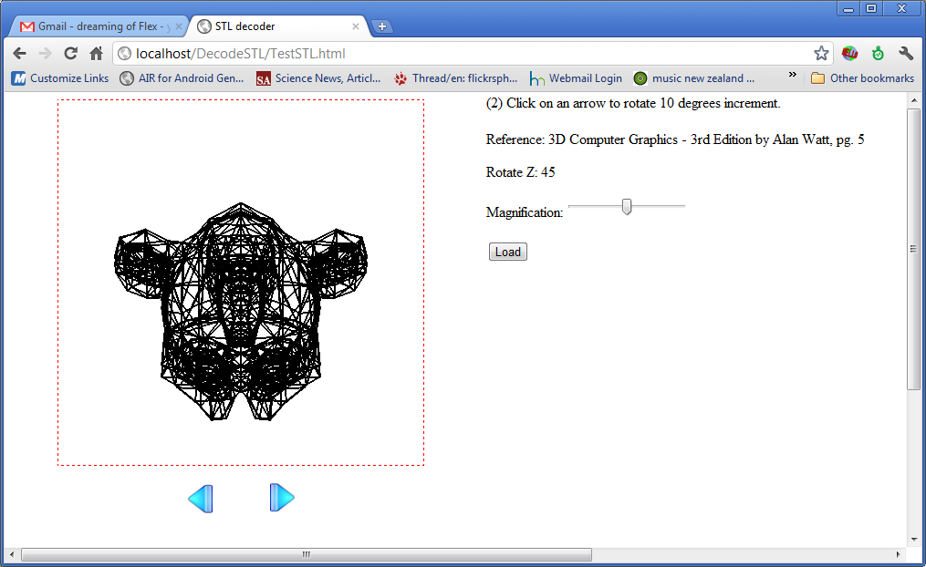
Sunday December 25, 2011

The rotation is somewhat screwed up.. I will need to check my math.
Here is an article to look at too.
http://www.fastgraph.com/makegames/3drotation/

Yesterday, I added additional small binary STL models for demonstration.
Source code updated in SVN and GITHub repository.
It was a good exercise for GITHub and got me started again.
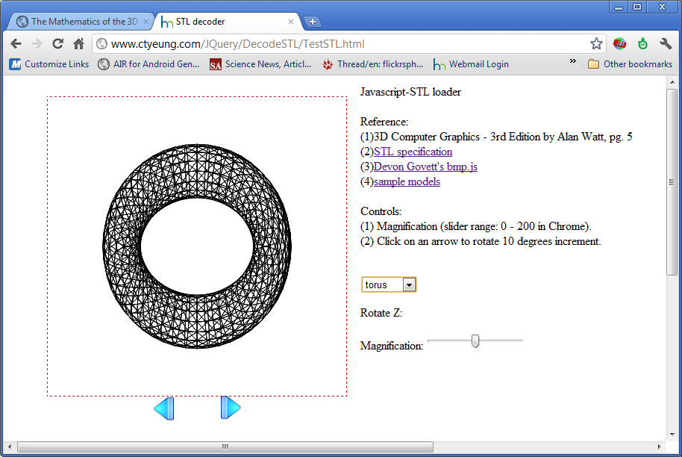

Just ordered both of these books.

Graphics Gems by Andrew Glassner
http://www.glassner.com/andrew/writing/books/gems.htm

3D Math Primer for Graphics and Game Development by Dunn Fletcher

Next to implement quaternion to avoid gimbal lock.

http://www.cprogramming.com/tutorial/3d/quaternions.html

