Yeukhon Wong 8066
Fall 2012
Dad-Son Problem

To solve the problem, we have to create two semaphores.
/* STUDENT SOLUTION BEGIN */
int mutex, roomToAccess;
mutex=semget(IPC_PRIVATE,1,PERMS | IPC_CREAT);
roomToAccess=semget(IPC_PRIVATE,1,PERMS | IPC_CREAT);
sem_create(mutex, 1);
sem_create(roomToAccess, N_Att);
/* STUDENT SOLUTION END */

Then we perform the following before entering critical section and before leaving critical section.
P(roomToAccess);
P(mutex);
{ CS }
V(mutex);
V(roomToAccess);

This works because Dad / Son1 / Son2 must wait until there is room to access and mutex is positive again. The screenshot below shows when N = 1 (Dad deposits once). Dad is producer, and sons are consumers.

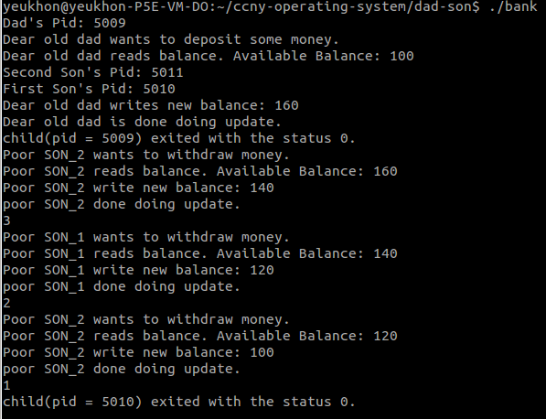

Here is the screenshot when N = 3 (dad deposits three times, but keeps max attempt = 3 for sons).

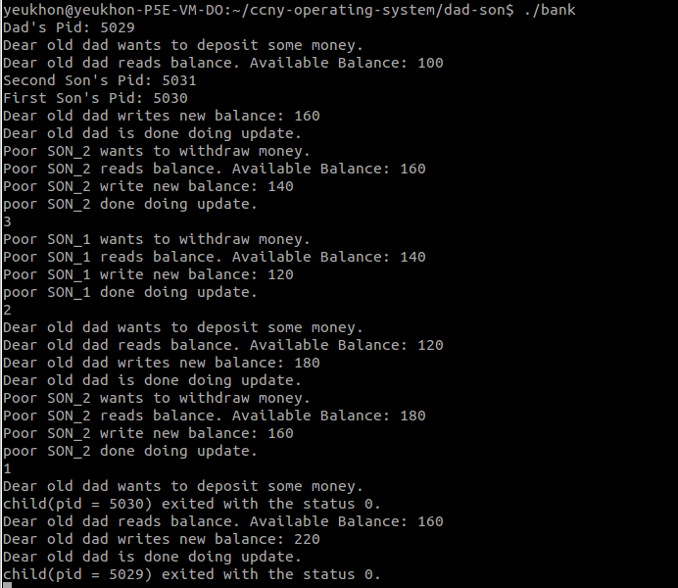

#include <stdio.h>
#include <stdlib.h>
#include "sem.h"

#define CHILD 0 /* Return value of child proc from fork call */
#define TRUE 0
#define FALSE 1
#define PERMS 0666
FILE *fp1, *fp2, *fp3, *fp4; /* File Pointers */

main()
{
int pid; // Process ID after fork call
int i; // Loop index
int N; // Number of times dad does update
int N_Att = 3; // Number of time sons allowed to do update
int status; // Exit status of child process
int bal1, bal2; // Balance read by processes
int flag, flag1; // End of loop variables

/* STUDENT SOLUTION BEGIN */
int mutex, roomToAccess;
mutex=semget(IPC_PRIVATE,1,PERMS | IPC_CREAT);
roomToAccess=semget(IPC_PRIVATE,1,PERMS | IPC_CREAT);
sem_create(mutex, 1);
sem_create(roomToAccess, N_Att);
/* STUDENT SOLUTION END */

//Initialize the file balance to be $100
fp1 = fopen("balance","w");
bal1 = 100;
fprintf(fp1, "%d\n", bal1);
fclose(fp1);

//Initialize the number of attempts to be 20
fp4 = fopen("attempt", "w");
N_Att = 3;
fprintf(fp4, "%d\n", N_Att);
fclose(fp4);

//Create child processes that will do the updates
if ((pid = fork()) == -1)
{
//fork failed!
perror("fork");
exit(1);
}

if (pid == CHILD)
{
//First Child Process. Dear old dad tries to do some updates.
printf("Dad's Pid: %d\n",getpid());
N=1;
for(i=1; i<=N; i++)
{
/* STUDENT SOLUTION BEGIN */
P(roomToAccess);
P(mutex);
/* STUDENT SOLUTION END */

printf("Dear old dad wants to deposit some money.\n");
fp1 = fopen("balance", "r+");
fscanf(fp1, "%d", &bal2);
printf("Dear old dad reads balance. Available Balance: %d \n", bal2);

//Dad has to think (0-14 sec) if his SON is really worth it
sleep(rand()%2);
fseek(fp1,0L,0);
bal2 += 60;
printf("Dear old dad writes new balance: %d \n", bal2);
fprintf(fp1, "%d \n", bal2);
fclose(fp1);

printf("Dear old dad is done doing update. \n");
sleep(rand()%2); /* Go have coffee for 0-4 sec. */

/* STUDENT SOLUTION BEGIN */
V(mutex);
V(roomToAccess);
/* STUDENT SOLUTION END */

}
}

else
{
//Parent Process. Fork off another child process.
if ((pid = fork()) == -1)
{
//Fork failed!
perror("fork");
exit(1);
}
if (pid == CHILD)
{
printf("First Son's Pid: %d\n",getpid());
//Second child process. First poor SON tries to do updates.
flag = FALSE;
while(flag == FALSE)
{

/* STUDENT SOLUTION BEGIN */
P(roomToAccess);
P(mutex);
/* STUDENT SOLUTION END */

fp3 = fopen("attempt" , "r+");
fscanf(fp3, "%d", &N_Att);
if(N_Att == 0)
{
fclose(fp3);
flag = TRUE;
}
else
{

printf("Poor SON_1 wants to withdraw money.\n");
fp2 = fopen("balance", "r+");
fscanf(fp2,"%d", &bal2);
printf("Poor SON_1 reads balance. Available Balance: %d \n", bal2);
if (bal2 == 0)
{
fclose(fp2);
fclose(fp3);
}
else
{
sleep(rand()%5);
fseek(fp2,0L, 0);
bal2 -=20;
printf("Poor SON_1 write new balance: %d \n", bal2);
fprintf(fp2,"%d\n", bal2);
fclose(fp2);
printf("poor SON_1 done doing update.\n");
printf("%d\n", N_Att);
fseek(fp3,0L, 0);
N_Att -=1;
fprintf(fp3, "%d\n", N_Att);
fclose(fp3);
}
}

/* STUDENT SOLUTION BEGIN */
V(mutex);
V(roomToAccess);
/* STUDENT SOLUTION END */
}

}
else
{
//Parent Process. Fork off one more child process.
if ((pid = fork()) == -1)
{
//fork failed!
perror("fork");
exit(1);
}
if (pid == CHILD)
{
printf("Second Son's Pid: %d\n",getpid());
//Third child process. Second poor SON tries to do updates.
flag1 = FALSE;
while(flag1 == FALSE)
{
/* STUDENT SOLUTION BEGIN */
P(roomToAccess);
P(mutex);
/* STUDENT SOLUTION END */

fp3 = fopen("attempt" , "r+");
fscanf(fp3, "%d", &N_Att);
if(N_Att == 0)
{
fclose(fp3);
flag = TRUE;
}
else
{
printf("Poor SON_2 wants to withdraw money.\n");
fp2 = fopen("balance", "r+");
fscanf(fp2,"%d", &bal2);
printf("Poor SON_2 reads balance. Available Balance: %d \n", bal2);
if (bal2 == 0)
{
fclose(fp2);
fclose(fp3);
}
else
{
sleep(rand()%2);
fseek(fp2,0L, 0);
bal2 -=20;
printf("Poor SON_2 write new balance: %d \n", bal2);
fprintf(fp2,"%d\n", bal2);
fclose(fp2);

printf("poor SON_2 done doing update.\n");
printf("%d\n", N_Att);
fseek(fp3,0L, 0);
N_Att -=1;
fprintf(fp3, "%d\n", N_Att);
fclose(fp3);
}
}
/* STUDENT SOLUTION BEGIN */
V(mutex);
V(roomToAccess);
/* STUDENT SOLUTION END */
}
}
else
{
//Now parent process waits for the child processes to finish
pid = wait(&status);
printf("child(pid = %d) exited with the status %d. \n", pid, status);

pid = wait(&status);
printf("child(pid = %d) exited with the status %d. \n", pid, status);

pid = wait(&status);
printf("child(pid = %d) exited with the status %d. \n", pid, status);
}
exit(0);
}
exit(0);
}
exit(0);
}

