Appendix A

Updated Baseline Model Calibration Details and Results

Appendix A

Updated Baseline Model Calibration Details and Results

Observed Head Data used in Calibration
Following are a series of selected maps showing locations of measured hydraulic heads used in the inverse simulation of the period from 1944 through 2005 with the updated baseline model.
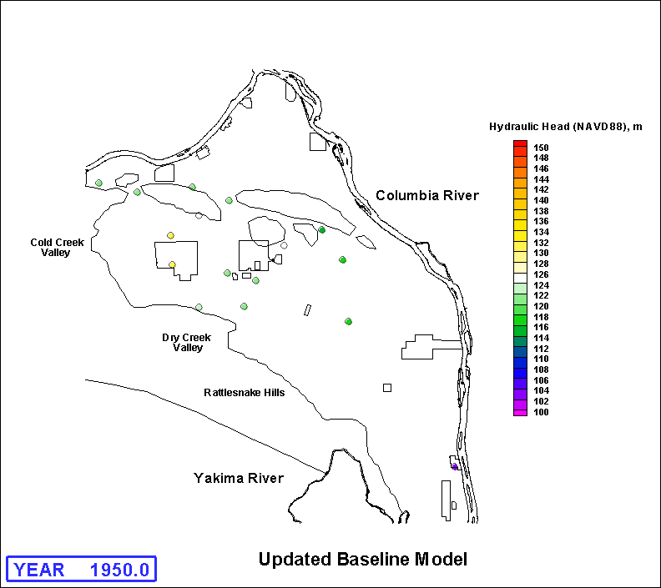
Figure A.1a. Locations of Measured Hydraulic Heads for 1950
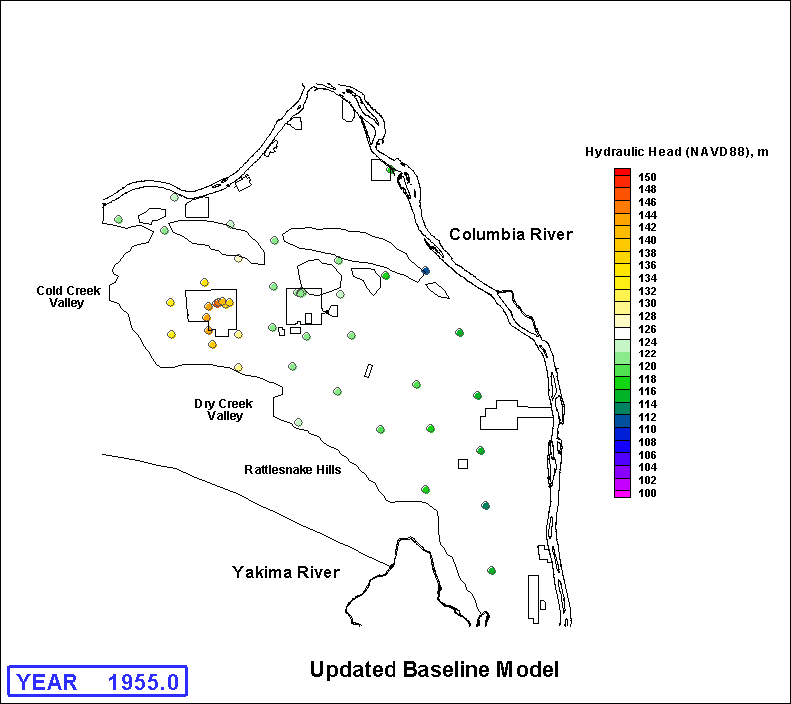
Figure A.1b. Locations of Measured Hydraulic Heads for 1955
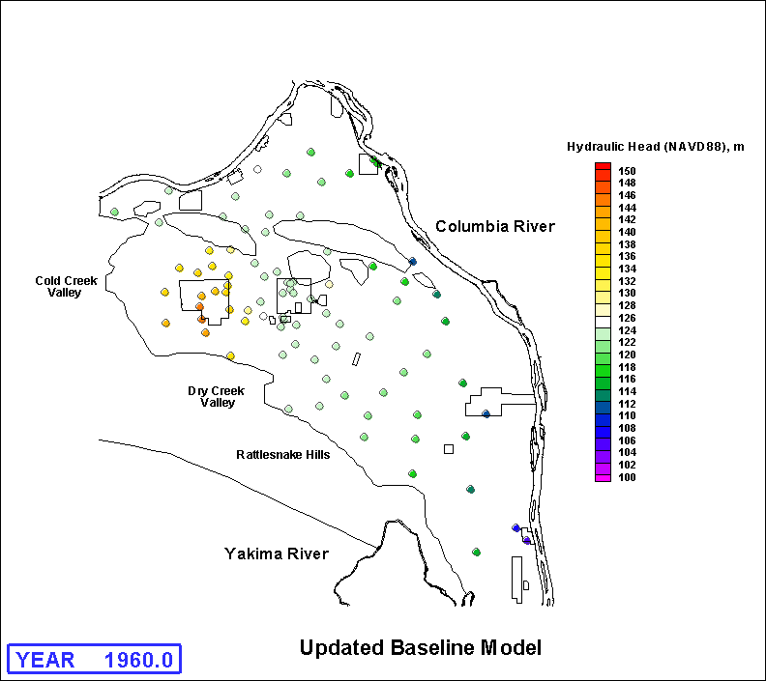
Figure A.1c. Locations of Measured Hydraulic Heads for 1960
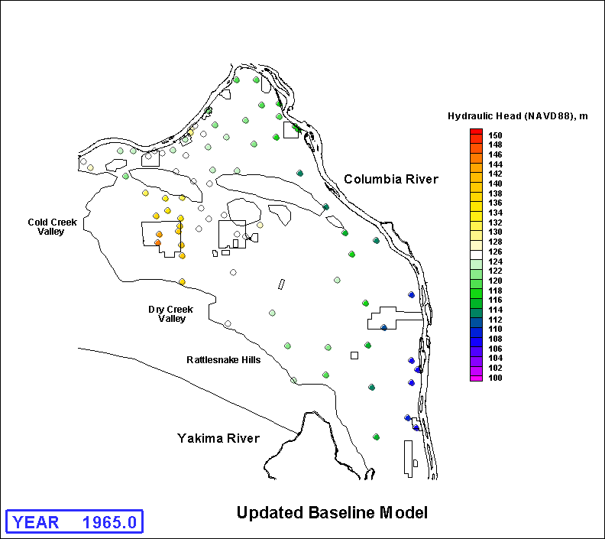
Figure A.1d. Locations of Measured Hydraulic Heads for 1965
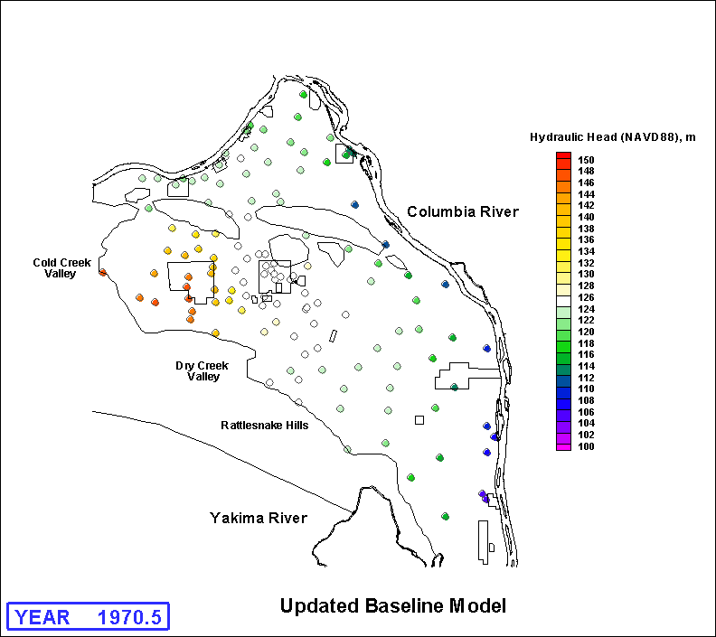
Figure A.1e. Locations of Measured Hydraulic Heads for 1970
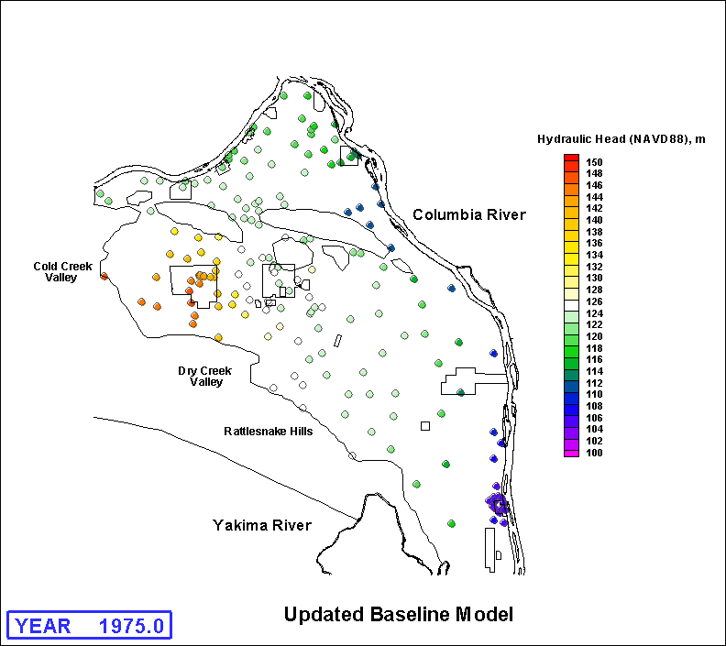
Figure A.1f. Locations of Measured Hydraulic Heads for 1975
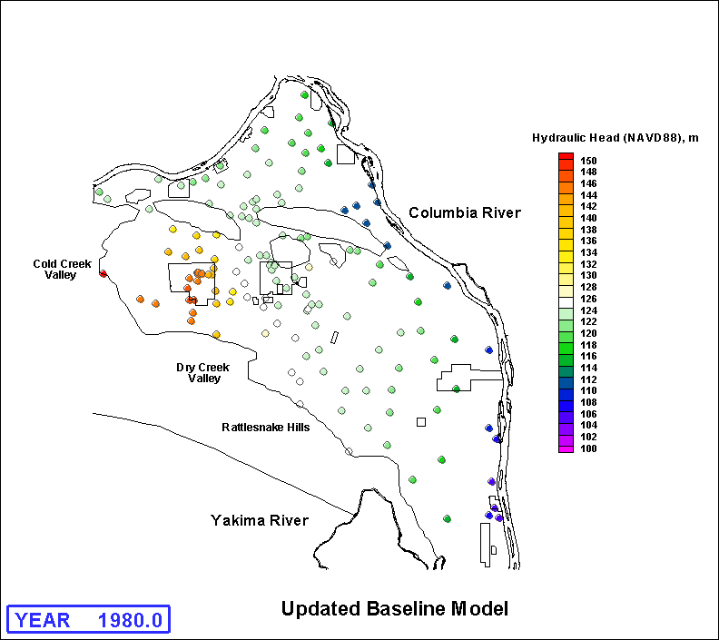
Figure A.1g. Locations of Measured Hydraulic Heads for 1980
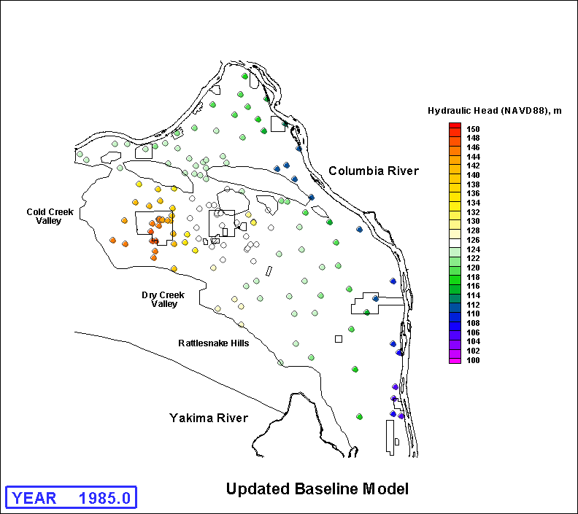
Figure A.1h. Locations of Measured Hydraulic Heads for 1985
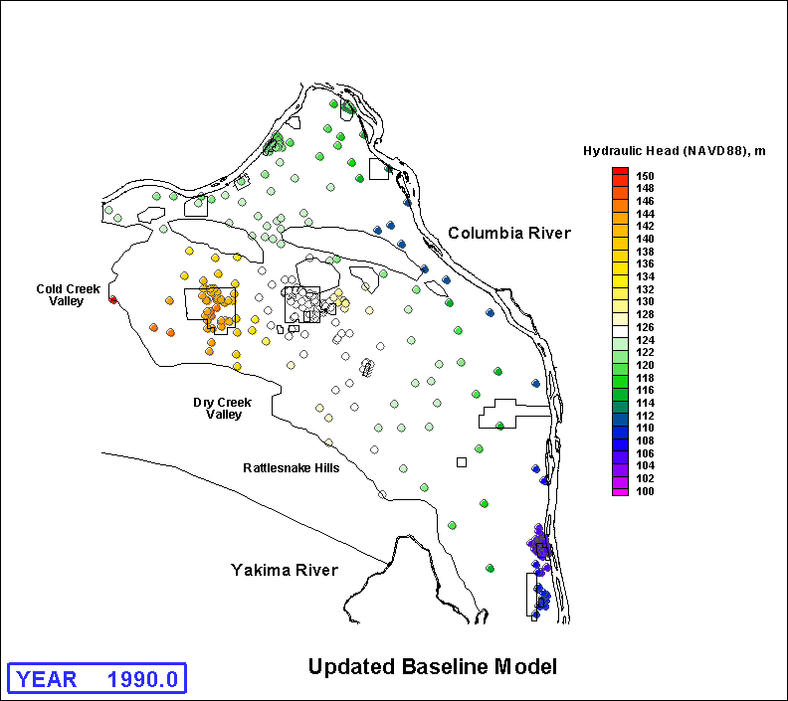
Figure A.1i. Locations of Measured Hydraulic Heads for 1990
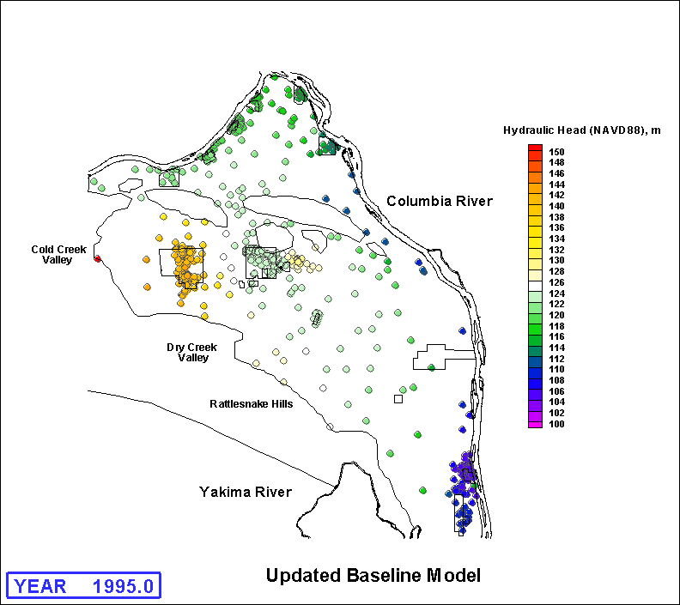
Figure A.1j. Locations of Measured Hydraulic Heads for 1995
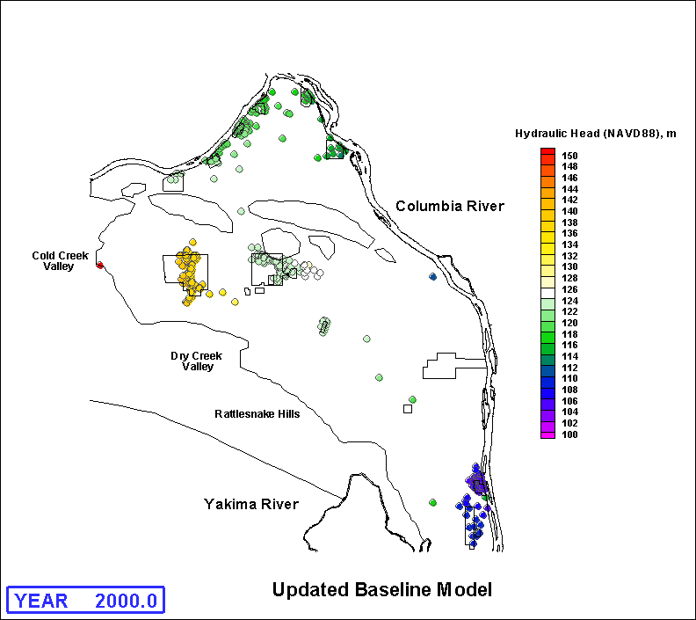
Figure A.1k. Locations of Measured Hydraulic Heads for 2000
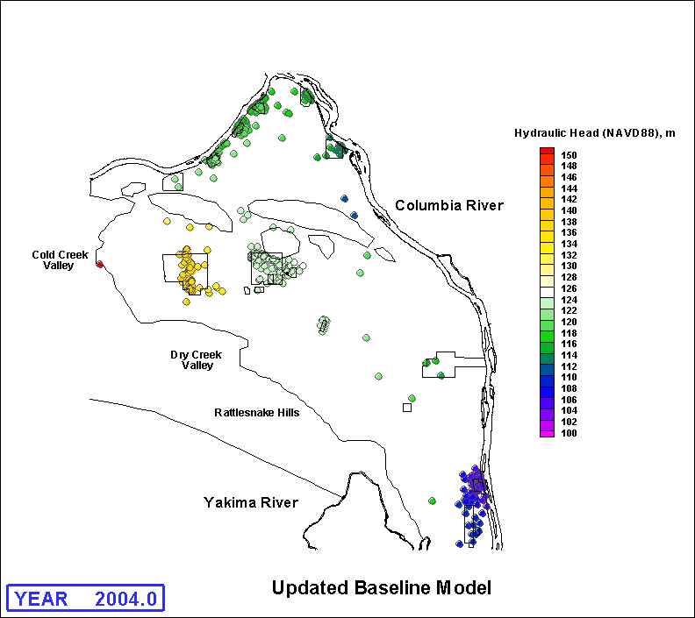
Figure A.1L. Locations of Measured Hydraulic Heads for 2004

Selected Predicted Water Tables
Following are a series of selected water-table elevation maps resulting from simulation of the period from 1944 through 2005 with the updated best-fit baseline model.
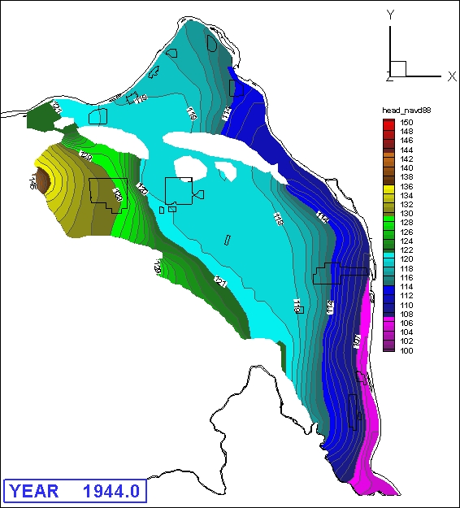
Figure A.2a. Simulated Water-Table Elevations for 1944
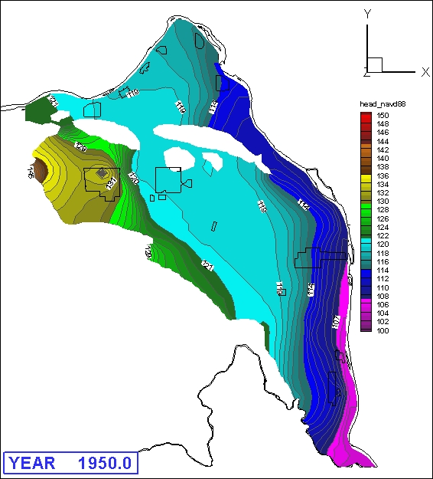
Figure A.2b. Simulated Water-Table Elevations for 1950
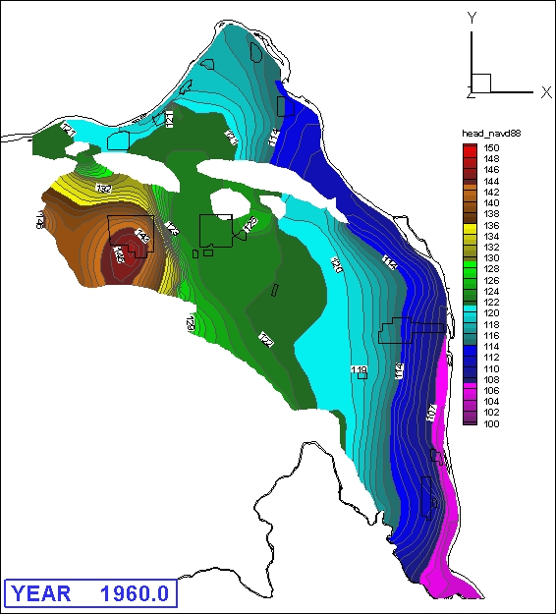
Figure A.2c. Simulated Water-Table Elevations for 1960
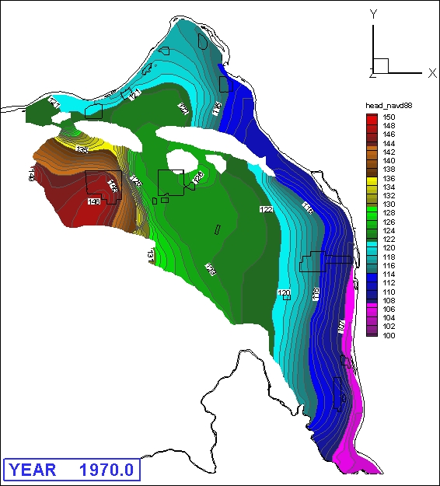
Figure A.2d. Simulated Water-Table Elevations for 1970
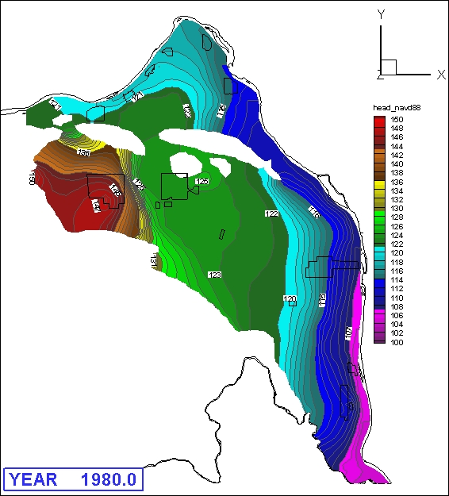
Figure A.2e. Simulated Water-Table Elevations for 1980
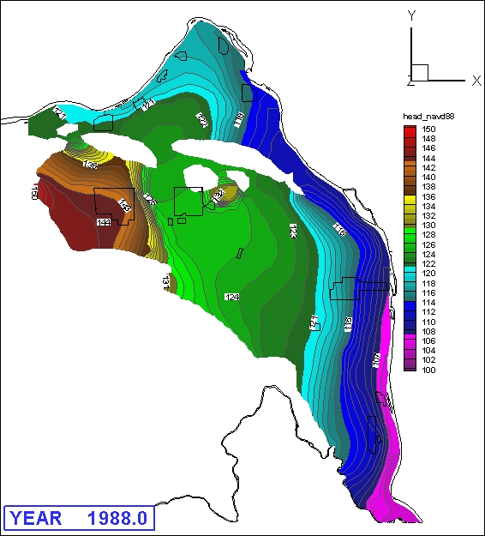
Figure A.2f. Simulated Water-Table Elevations for 1988
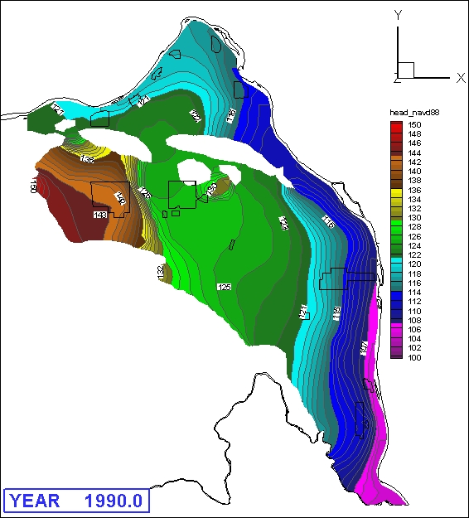
Figure A.2g. Simulated Water-Table Elevations for 1990
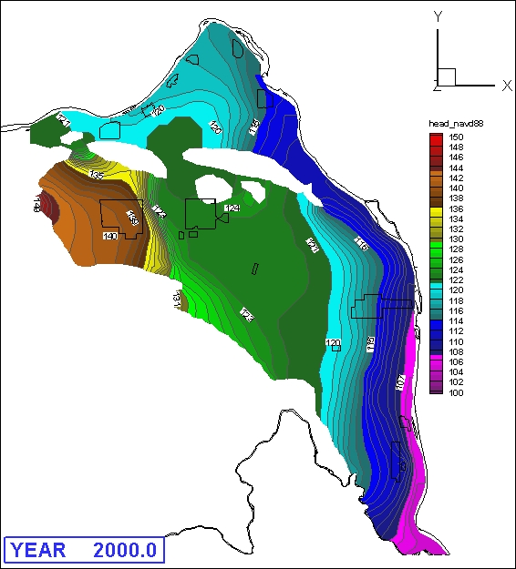
Figure A.2h. Simulated Water-Table Elevations for 2000
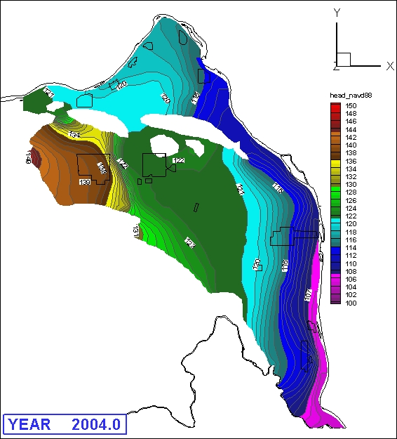
Figure A.2i. Simulated Water-Table Elevations for 2004
A.3 – A.5 Hydraulic Head Residuals
Following are a series of selected areal head residual maps, simulated heads versus observed heads scatter grams, and head residuals versus observed head scatter grams resulting from simulation of the period from 1944 through 2005 with the updated best-fit baseline model.
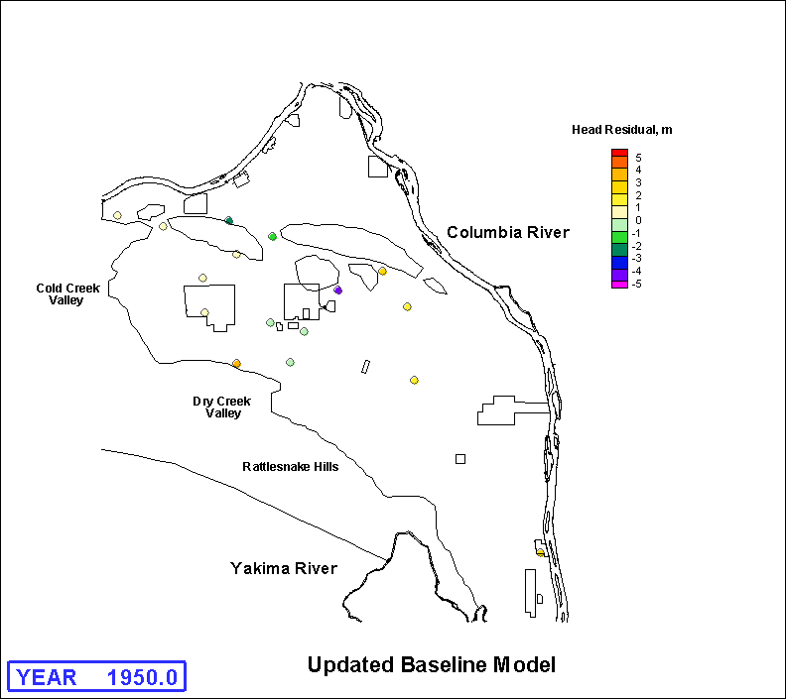
Figure A.3a. Hydraulic Head Residuals (simulated - measured water levels) for 1950

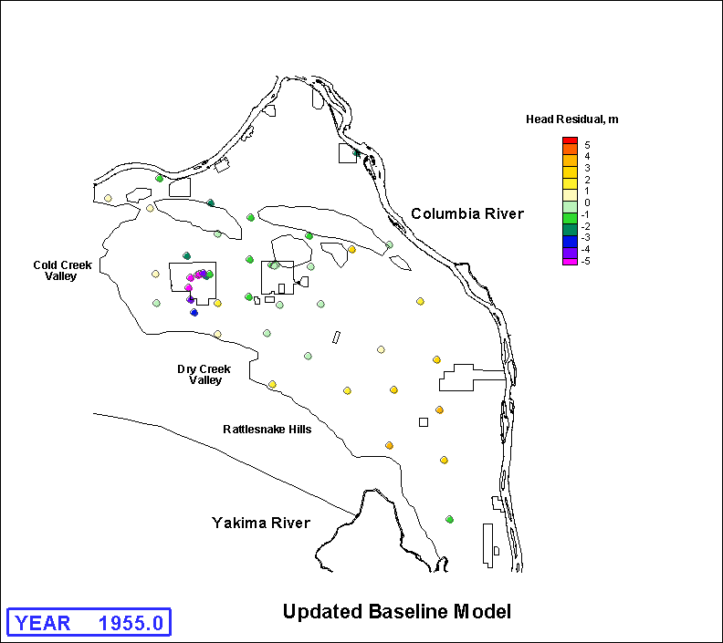
Figure A.3b. Hydraulic Head Residuals (simulated - measured water levels) for 1955
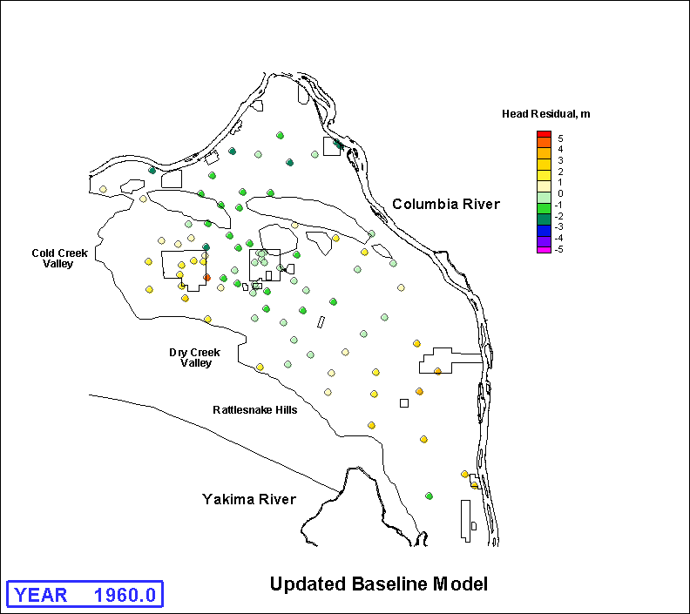
Figure A.3c. Hydraulic Head Residuals (simulated - measured water levels) for 1960
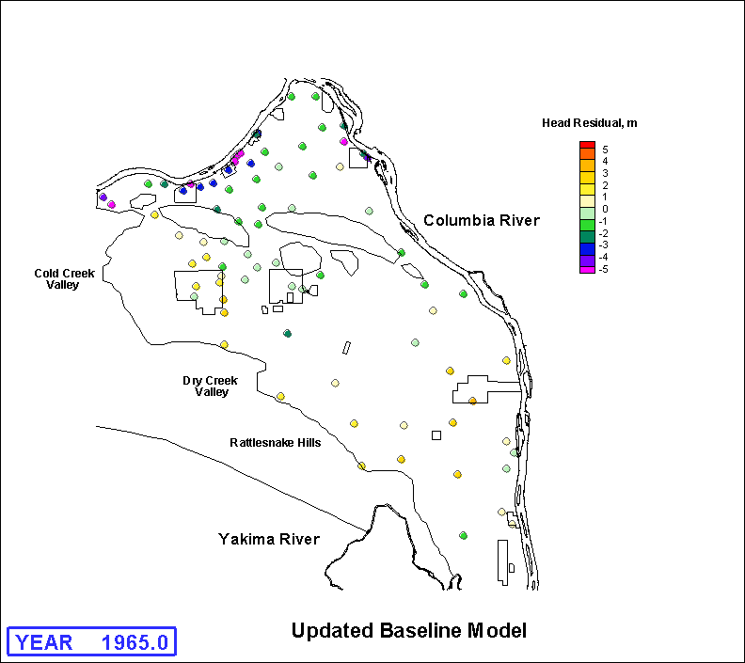
Figure A.3d. Hydraulic Head Residuals (simulated - measured water levels) for 1965
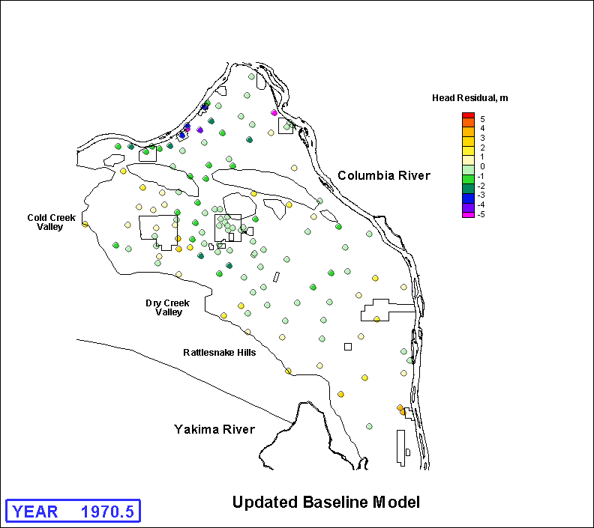
Figure A.3e. Hydraulic Head Residuals (simulated - measured water levels) for June 1970
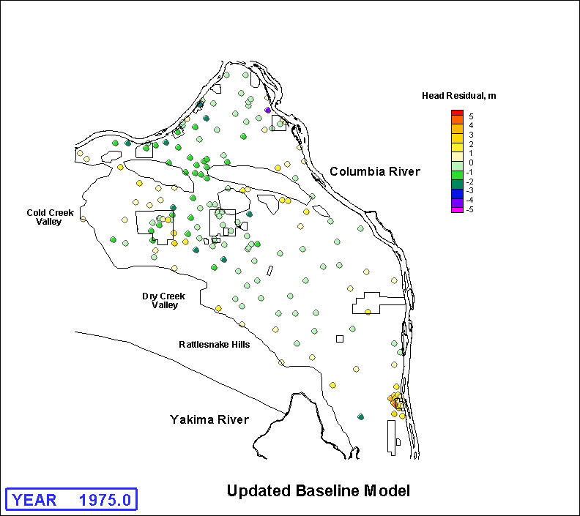
Figure A.3f. Hydraulic Head Residuals (simulated - measured water levels) for 1975
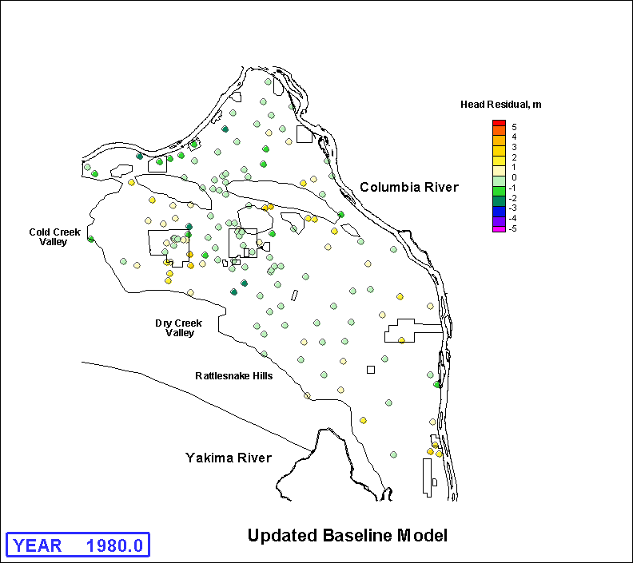
Figure A.3g. Hydraulic Head Residuals (simulated - measured water levels) for 1980
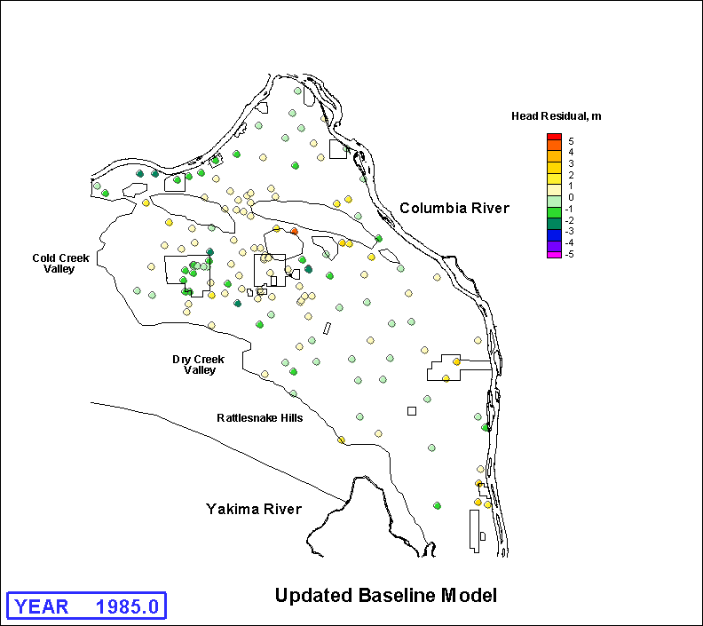
Figure A.3h. Hydraulic Head Residuals (simulated - measured water levels) for 1985
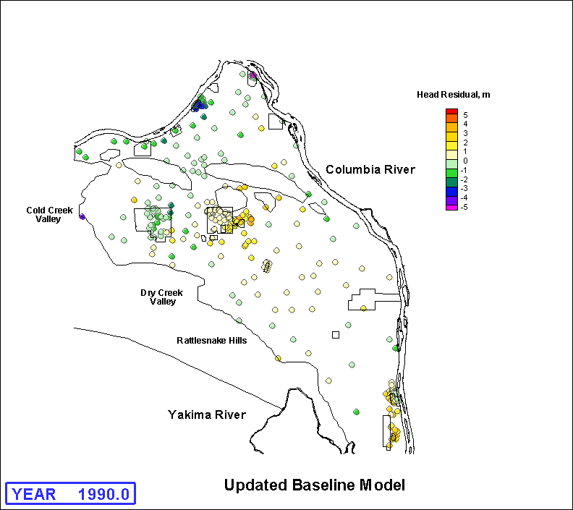
Figure A.3i. Hydraulic Head Residuals (simulated - measured water levels) for 1990
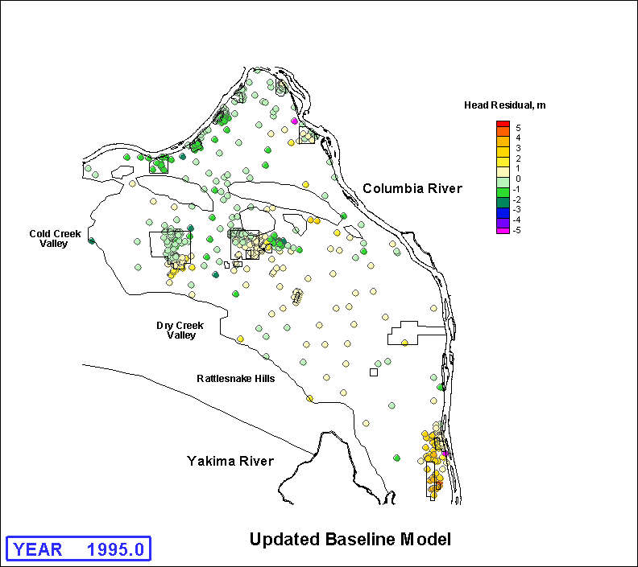
Figure A.3j. Hydraulic Head Residuals (simulated - measured water levels) for 1995
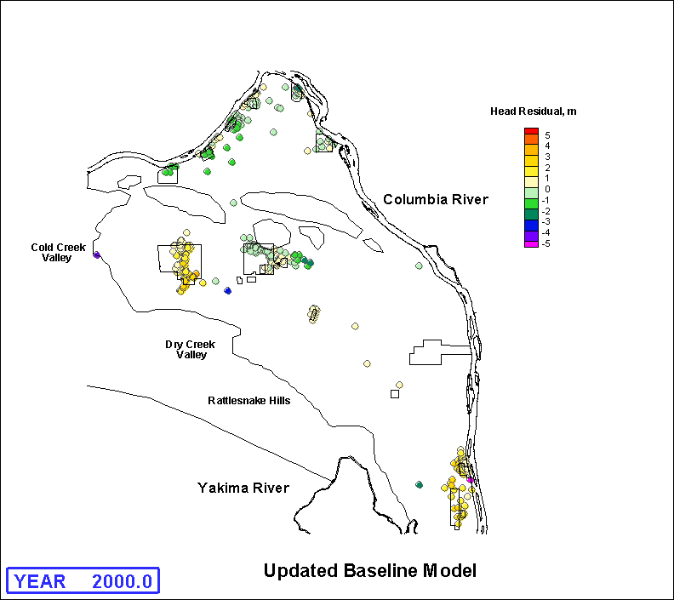
Figure A.3k. Hydraulic Head Residuals (simulated - measured water levels) for 2000
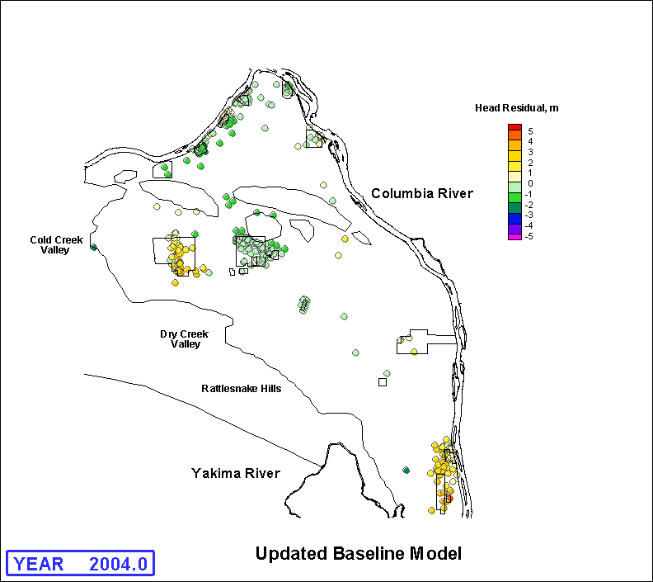
Figure A.3L. Hydraulic Head Residuals (simulated - measured water levels) for 2004
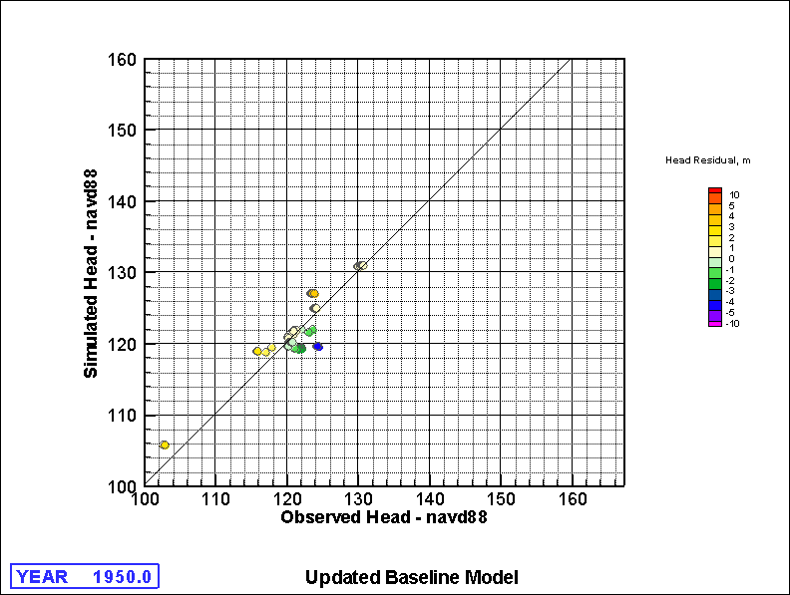
Figure A.4a. Comparison of Simulated versus Measured Water Levels for 1950
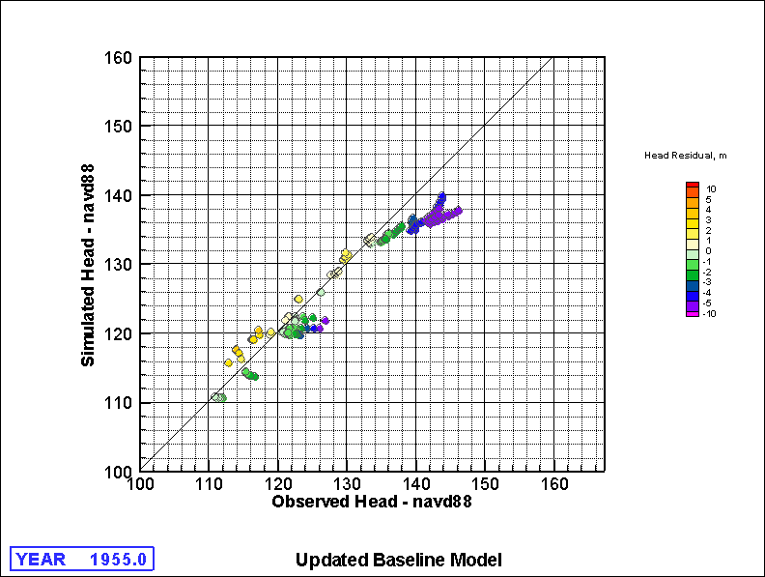
Figure A.4b. Comparison of Simulated versus Measured Water Levels for 1955
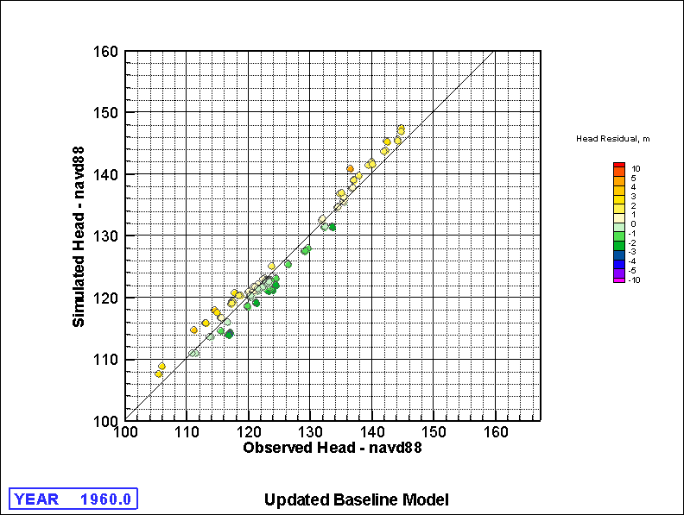
Figure A.4c. Comparison of Simulated versus Measured Water Levels for 1960
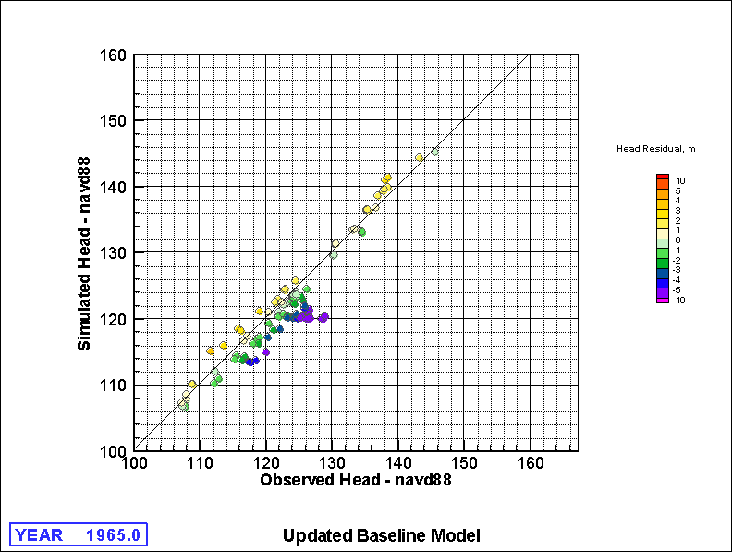
Figure A.4d. Comparison of Simulated versus Measured Water Levels for 1965
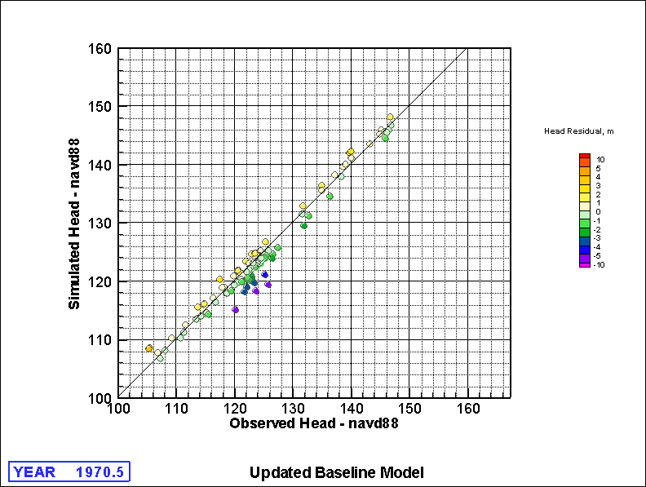
Figure A.4e. Comparison of Simulated versus Measured Water Levels for 1970
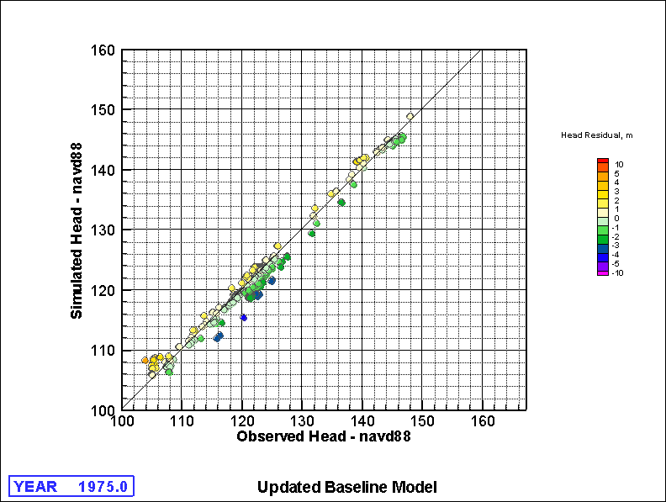
Figure A.4f. Comparison of Simulated versus Measured Water Levels for 1975
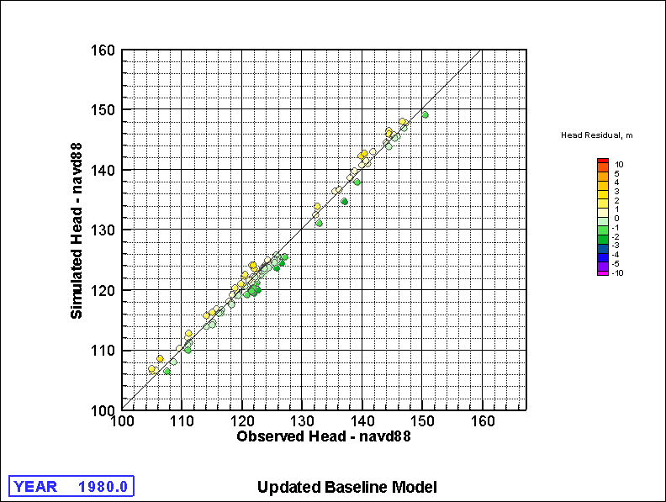
Figure A.4g. Comparison of Simulated versus Measured Water Levels for 1980
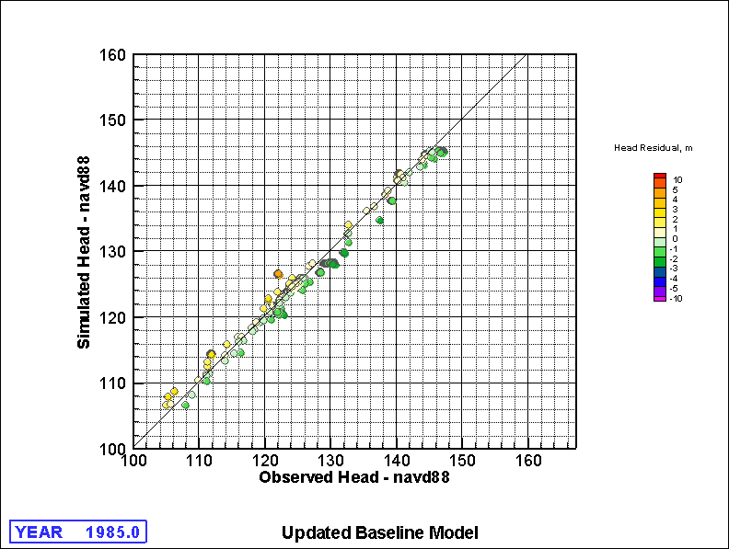
Figure A.4h. Comparison of Simulated versus Measured Water Levels for 1985
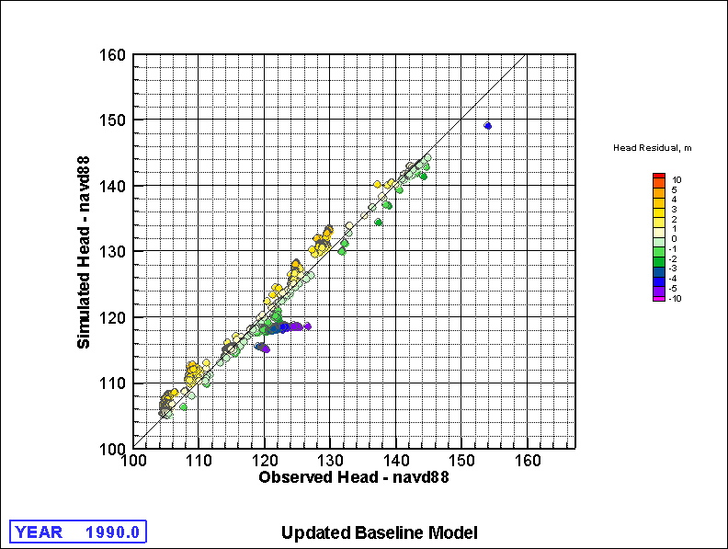
Figure A.4i. Comparison of Simulated versus Measured Water Levels for 1990
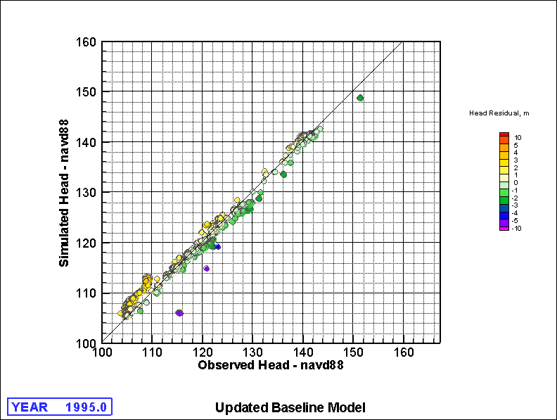
Figure A.4j. Comparison of Simulated versus Measured Water Levels for 1995
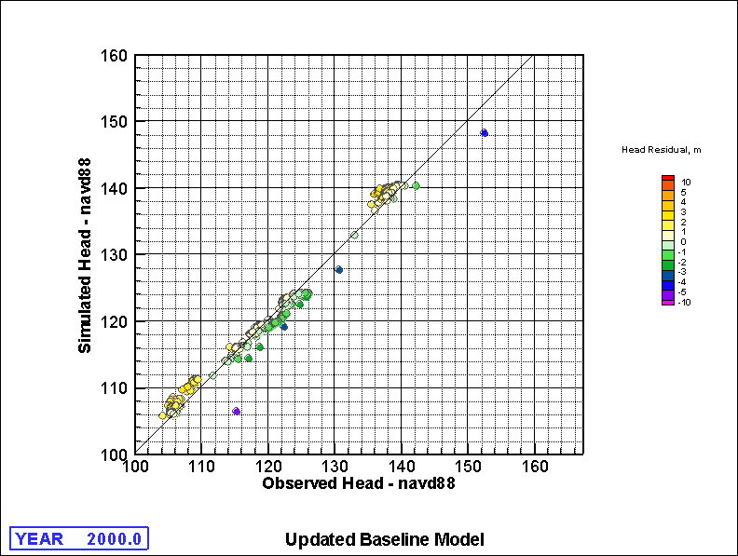
Figure A.4k. Comparison of Simulated versus Measured Water Levels for 2000
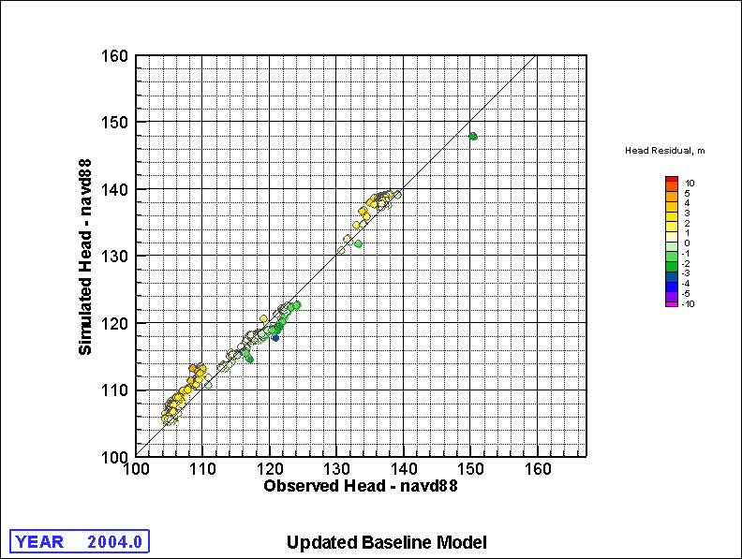
Figure A.4L. Comparison of Simulated versus Measured Water Levels for 2004
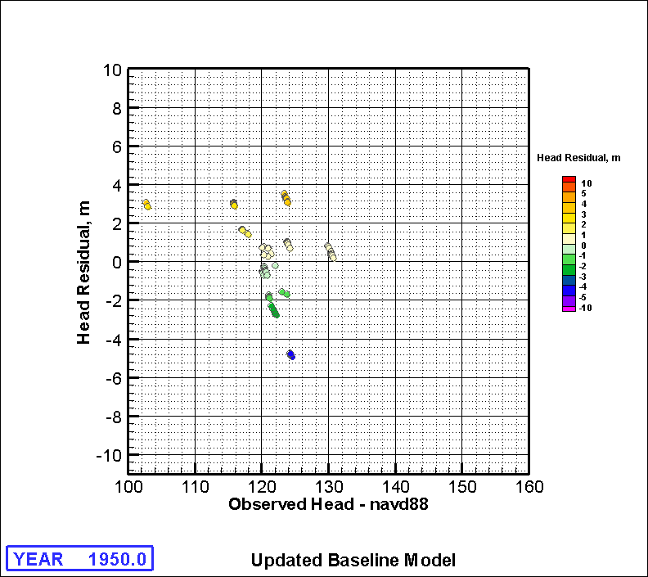
Figure A.5a. Hydraulic Head Residuals (residual - measured water levels) for 1950
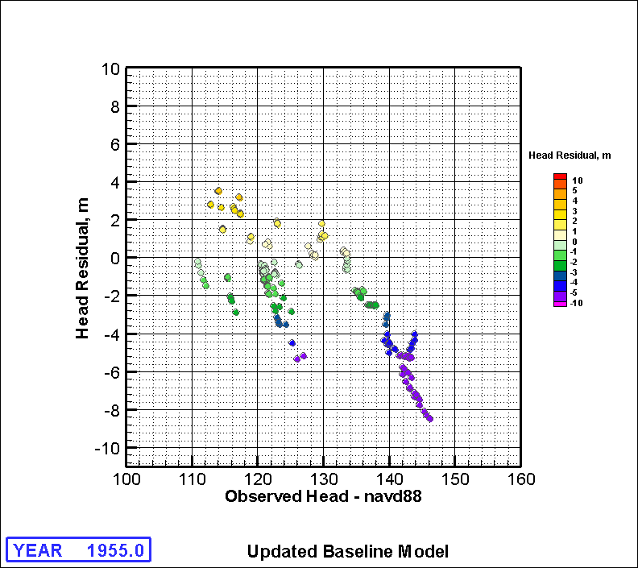
Figure A.5b. Hydraulic Head Residuals (residual - measured water levels) for 1955
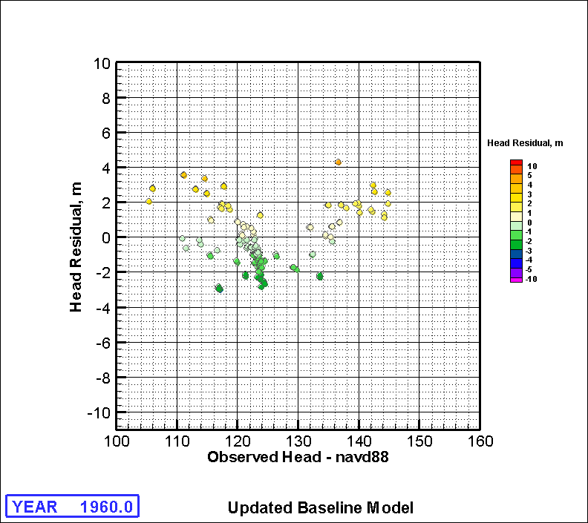
Figure A.5c. Hydraulic Head Residuals (residual - measured water levels) for 1960
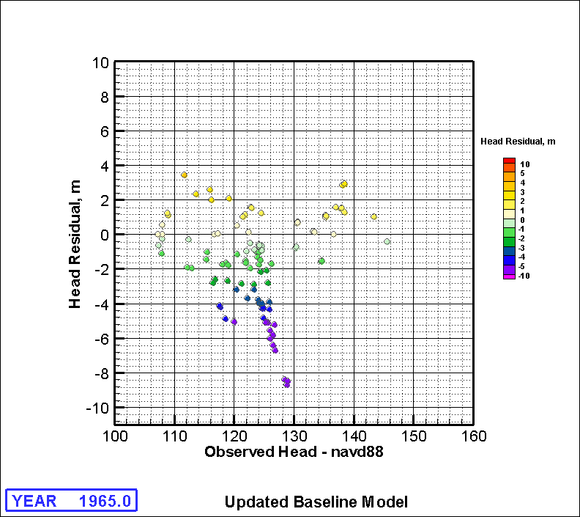
Figure A.5d. Hydraulic Head Residuals (residual - measured water levels) for 1965
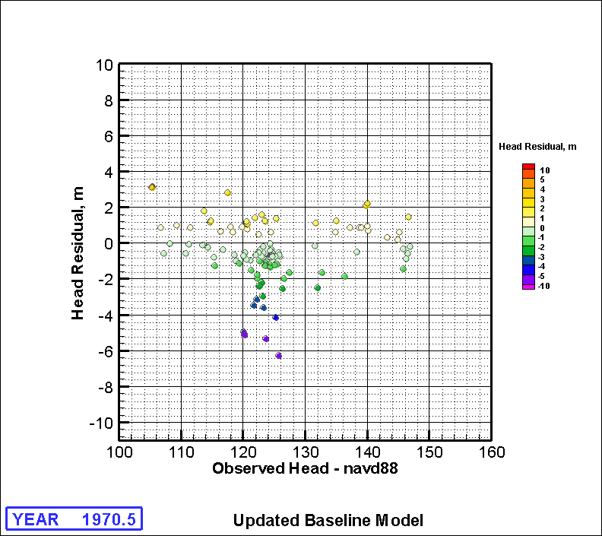
Figure A.5e. Hydraulic Head Residuals (residual - measured water levels) for 1970
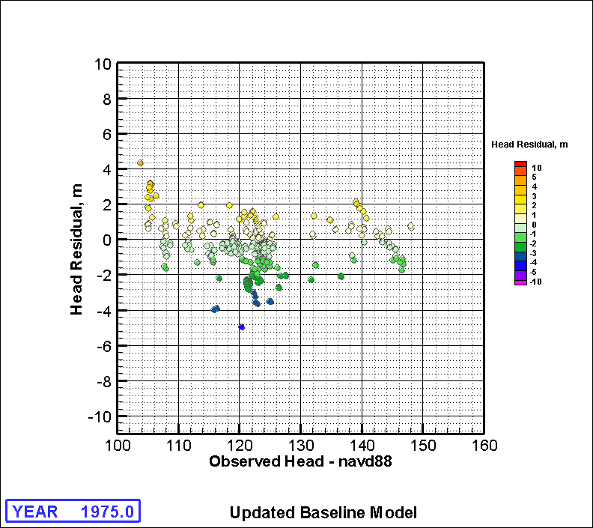
Figure A.5f. Hydraulic Head Residuals (residual - measured water levels) for 1975
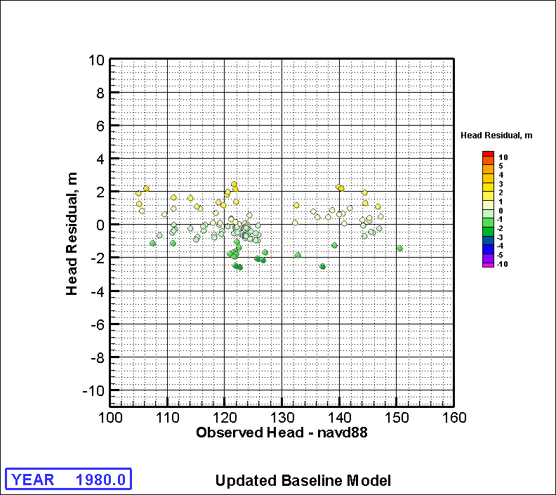
Figure A.5g. Hydraulic Head Residuals (residual - measured water levels) for 1980
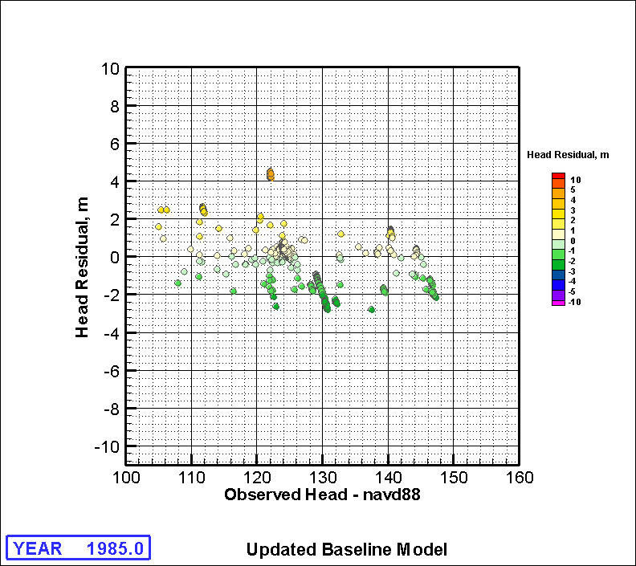
Figure A.5h. Hydraulic Head Residuals (residual - measured water levels) for 1985
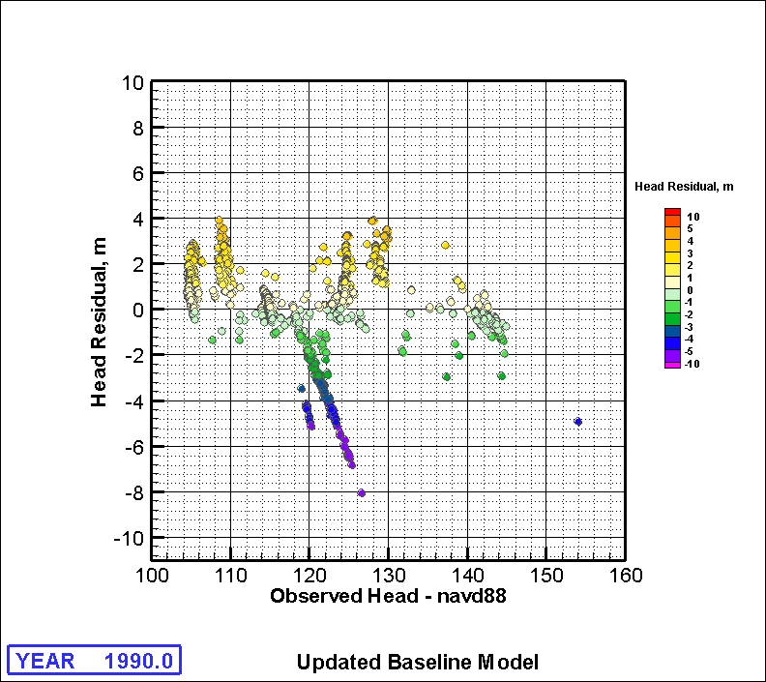
Figure A.5i. Hydraulic Head Residuals (residual - measured water levels) for 1990
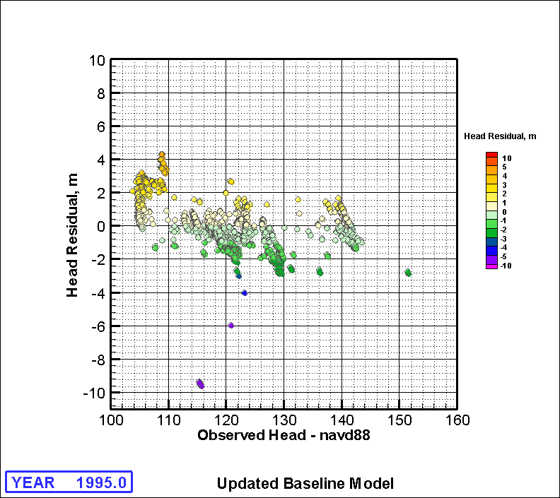
Figure A.5j. Hydraulic Head Residuals (residual - measured water levels) for 1995
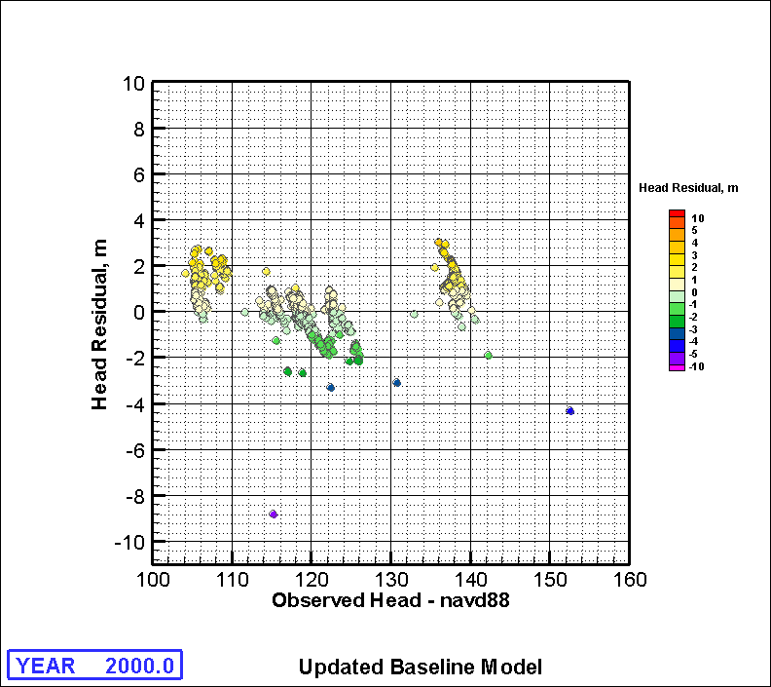
Figure A.5k. Hydraulic Head Residuals (residual - measured water levels) for 2000
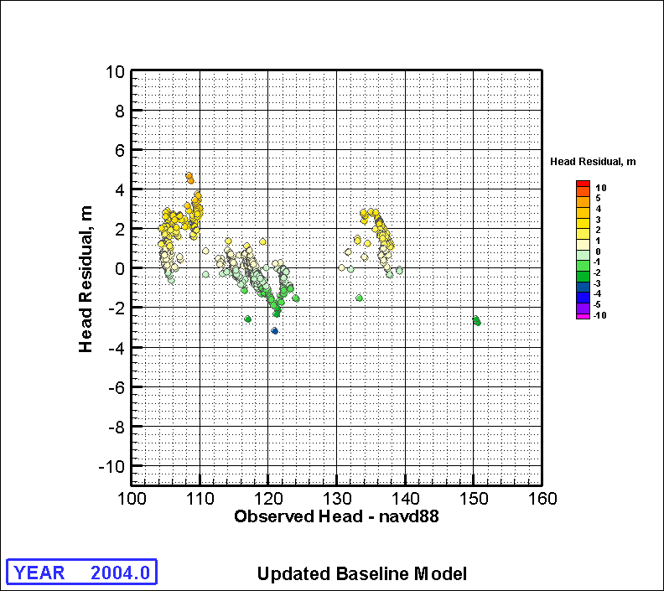
Figure A.5L. Hydraulic Head Residuals (residual - measured water levels) for 2004
A.6 Final Hydraulic Property Distribution Maps (Major Hydrogeologic Units)
Following is series of plots that show the resulting distributions of the hydraulic conductivity of the major hydrogeologic units for the updated baseline best-fit model.
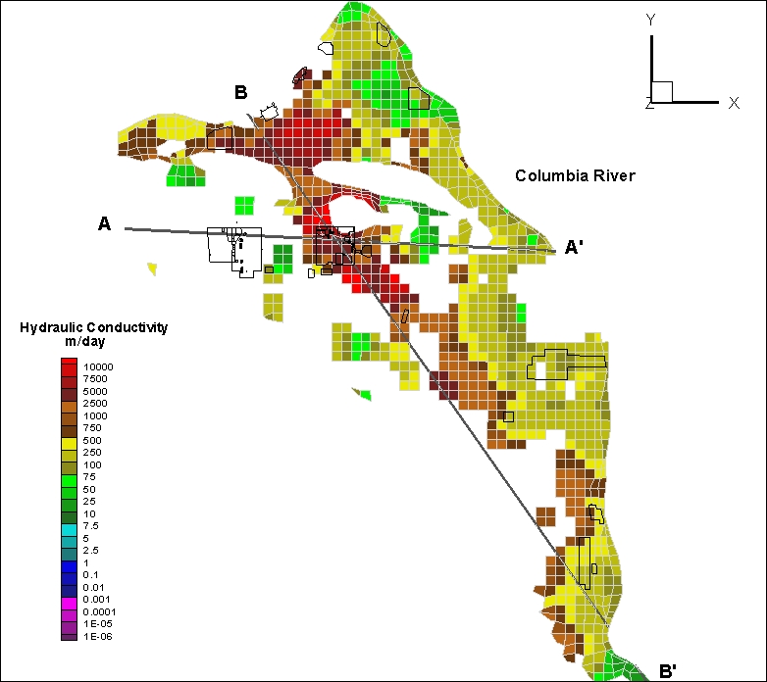
Figure A.6a. Hydraulic Conductivity of Hydrogeologic Unit 1
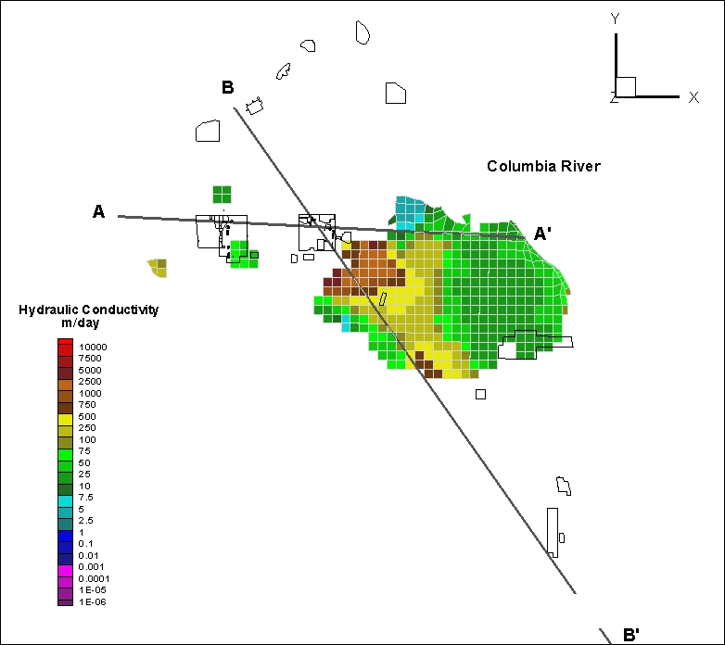
Figure A.6b. Hydraulic Conductivity of Hydrogeologic Unit 3
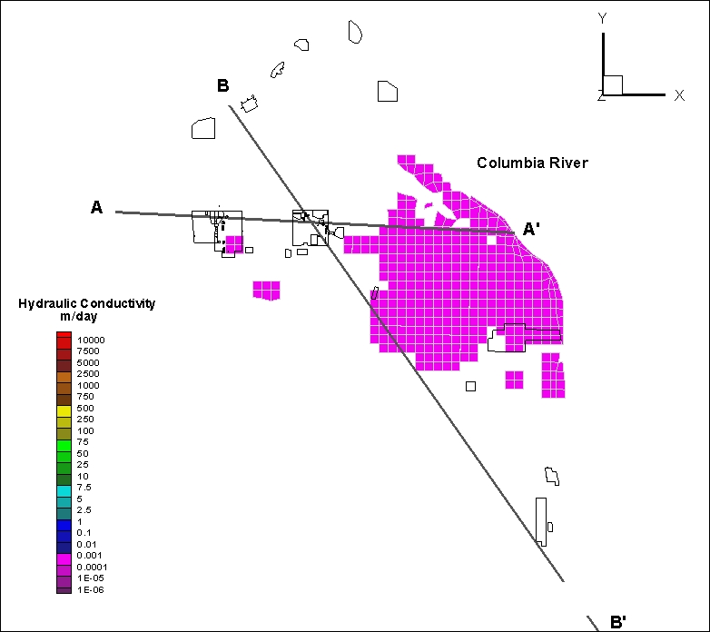
Figure A.6c. Hydraulic Conductivity of Hydrogeologic Unit 4
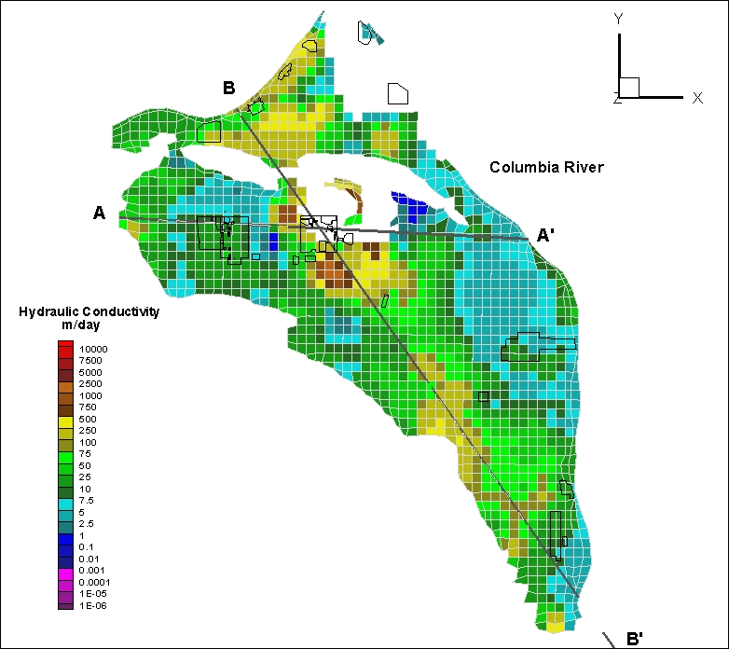
Figure A.6d. Hydraulic Conductivity of Hydrogeologic Unit 5
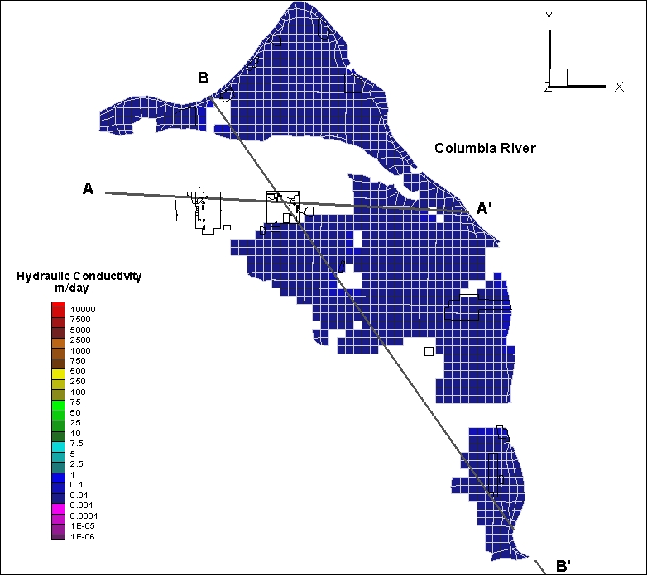
Figure A.6e. Hydraulic Conductivity of Hydrogeologic Unit 6
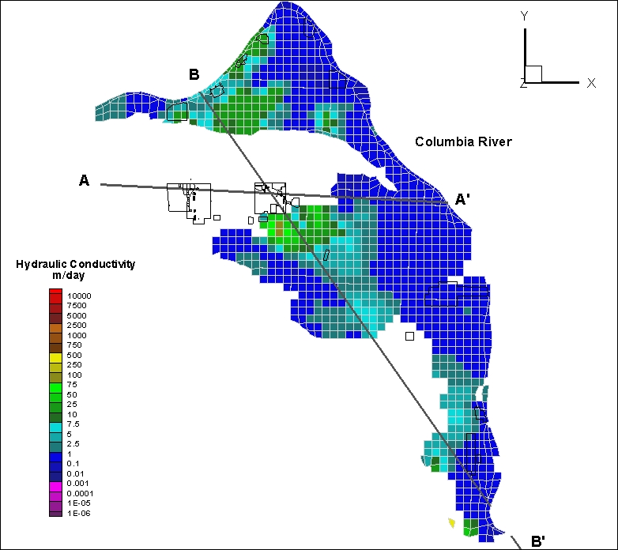
Figure A.6f. Hydraulic Conductivity of Hydrogeologic Unit 7
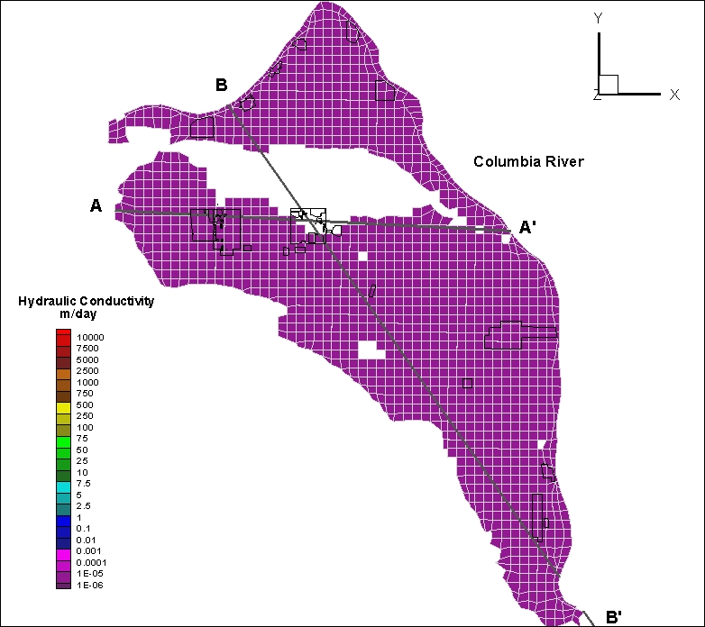
Figure A.6g. Hydraulic Conductivity of Hydrogeologic Unit 8
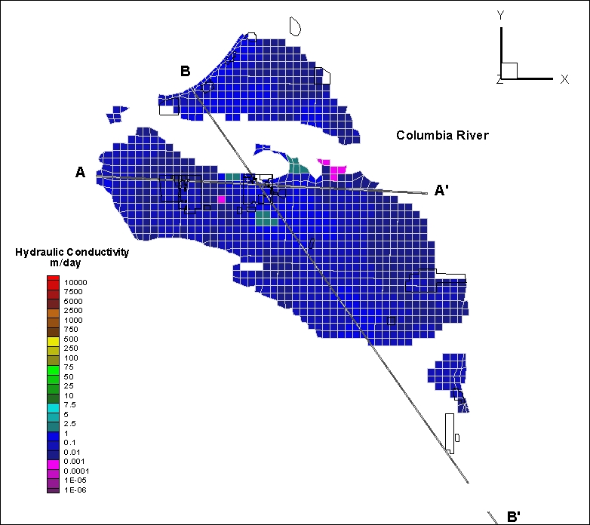
Figure A.6h. Hydraulic Conductivity of Hydrogeologic Unit 9

