Topic: IoT-Based Smart Parking System (COMP4436-25-P10)
Member: Yeung Hang(22027226d), Yeung Tsz Kwan (23103029d) Chan Kin Wang (23031551d)
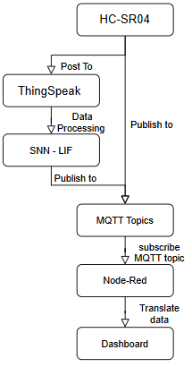
  - Introduction: Car Park traffic is longtime difficult for management companies. The accurate forecasting and instant information can provide extra revenue for dynamic pricing. For traditional statistic methods may require many pre-processing techniques and related domain knowledge, The deep learning method able to investigate the hidden pattern from the collection of the data thereby able to establish and correct and cheap prediction to increase enterprise turnover.
Data Collection: Since the smart parking system make predictions based on 7-days historical parking data, The ultrasonic sensor (HC-SR04) property of object distance measurement can be implemented for car detection. The sensor will obtain the distance between object and sensor. In this project, 3 ultrasonic sensor setups beneath the parking location, the existing car will consider while object occur distance between 5m to 50m and polling each second of the microcontroller, accumulating for 30 times each minute of detected of car will indicate no room of the parking place.
Data Processing: The Received Data from the sensor will be sent through serial to computer. The computer will publish the data to Node Red server through MQTT and send requests to the Thingspeak Cloud. The 7 days of historical data will be acquired from Thingspeak Cloud. The hour and date of week as X input to SNN (LIF neuron model), to predict 3 parking occupy rate (as y).
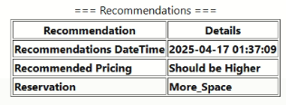
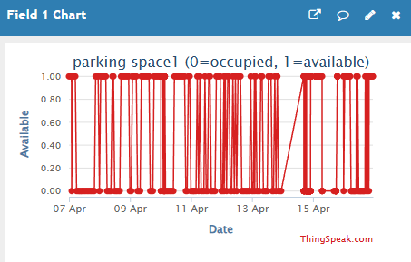
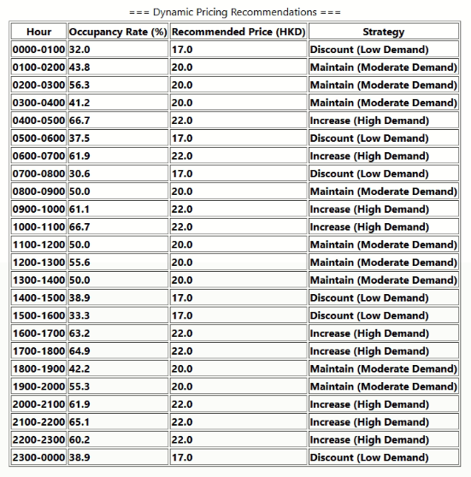
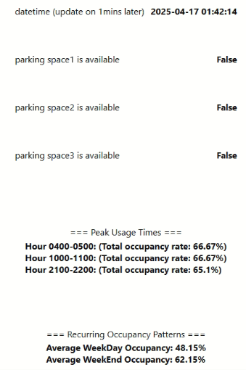


Output: The estimation records will produce various reports at node red terminal with the MQTT, the first page of node red will be used predicting occupy rate by hourly, by interval or by holiday each day to suggest the price raising or reducing short-term. The second page will show the predicted occupy rate by hourly, by weekly position to suggest the adjustment of long-term pricing.

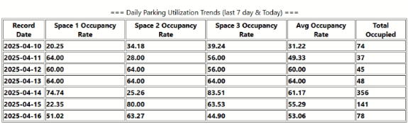
  - Code
Github Repository :715yeung/comp4436_AIOT_GP_Group12
Thingspeak:https://thingspeak.mathworks.com/channels/2909595

