

Safety Plan Lane Assistance

**Document Version:** 2.0

**Template Version 1.0, Released on 2017-06-21**



# Document history

|  |  |  |  |
| --- | --- | --- | --- |
| Date | Version | Editor | Description |
| 2018-02-02 | 1.0 | Greg Yeutter | Initial Safety Plan Draft |
| 2018-02-05 | 2.0 | Greg Yeutter | Safety Culture Modification |
|  |  |  |  |
|  |  |  |  |
|  |  |  |  |

# Table of Contents

Document history

Table of Contents

Introduction

Purpose of the Safety Plan

Scope of the Project

Deliverables of the Project

Item Definition

Goals and Measures

Goals

Measures

Safety Culture

Safety Lifecycle Tailoring

Roles

Development Interface Agreement

Confirmation Measures

# Introduction

## Purpose of the Safety Plan

The purpose of the functional safety plan is to provide a framework for the safety aspects of the Lane Assistance system. In addition, the safety plan assigns functional safety roles and responsibilities for individual job titles.

## Scope of the Project

For the lane assistance project, the following safety lifecycle phases are in scope:

Concept phase

Product Development at the System Level

Product Development at the Software Level

The following phases are out of scope:

Product Development at the Hardware Level

Production and Operation

## Deliverables of the Project

The deliverables of the project are:

Safety Plan

Hazard Analysis and Risk Assessment

Functional Safety Concept

Technical Safety Concept

Software Safety Requirements and Architecture

# Item Definition

The Lane Assistance system attempts to determine when a driver has departed a lane unintentionally. The system monitors the vehicle’s position within a lane and also takes driver intention into account, especially the use of turn signals. The system attempts to alert the driver and to steer the vehicle back into the original “ego” lane.

The Lane Assistance system has two primary roles:

1. Lane Departure Warning: Provides an alert to the driver when a lane is departed unintentionally. In this case, the warning includes a display and a haptic signal provided by applying oscillating torque to the steering wheel.
2. Lane Keeping Assistance: Provides torque to the steering system, attempting to help the vehicle remain in the ego lane.

There are three subsystems involved in the Lane Assistance system. Those are: 1) the camera subsystem, 2) the electronic power steering subsystem, and 3) the car display system. All three subsystems play a role in both the lane departure warning and lane keeping assistance roles.

The system, subsystems, and system boundaries are detailed in Figure 1.

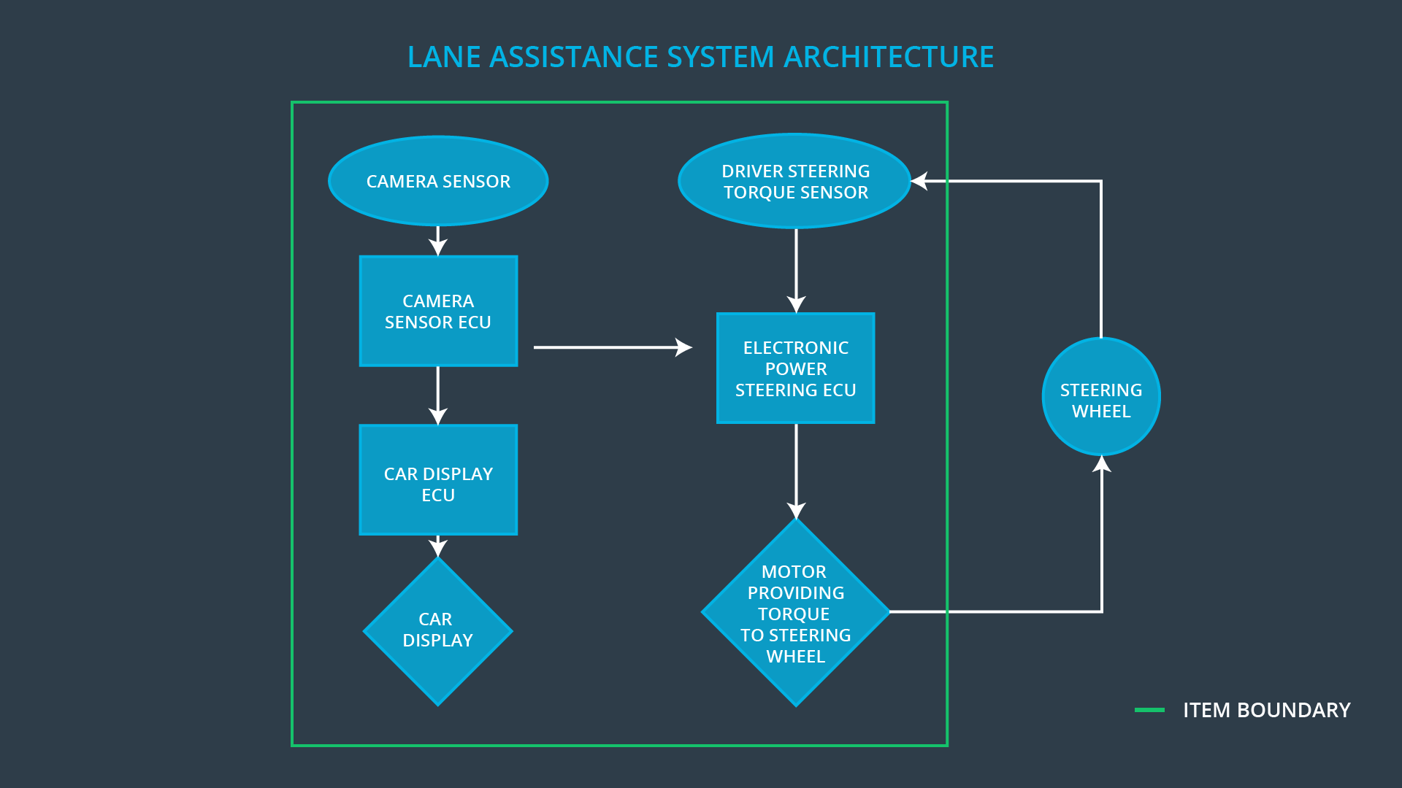

Figure : Lane Assistance System Architecture

# Goals and Measures

## Goals

Vehicles are complex systems with both sociological and technical requirements. Safety includes not only analysis of individual software and hardware components, but also the interaction between systems and subsystems, as well as the safety culture of an organization.

The Functional Safety Plan outlines roles and responsibilities of individual team members, as well as the overarching safety culture of the organization and the product safety lifecycle. ISO 26262 is the standard to which this plan is written.

## Measures

|  |  |  |
| --- | --- | --- |
| Measures and Activities | Responsibility | Timeline |
| Follow safety processes | All Team Members | Constantly |
| Create and sustain a safety culture | Safety Manager | Constantly |
| Coordinate and document the planned safety activities | Safety Manager | Constantly |
| Allocate resources with adequate functional safety competency | Project Manager | Within 2 weeks of start of project |
| Tailor the safety lifecycle | Safety Manager | Within 4 weeks of start of project |
| Plan the safety activities of the safety lifecycle | Safety Manager | Within 4 weeks of start of project |
| Perform regular functional safety audits | Safety Auditor | Once every 2 months |
| Perform functional safety pre-assessment prior to audit by external functional safety assessor | Safety Manager | 3 months prior to main assessment |
| Perform functional safety assessment | Safety Assessor | Conclusion of functional safety activities |

# Safety Culture

In this organization, safety has the **highest priority**, greater than other considerations like productivity and cost.

The processes assure **accountability** such that decisions are traceable back to the people and teams who made the decisions. This organization **rewards** the achievement and motivation of functional safety, while **penalizing** shortcuts and decisions that jeopardize quality and safety.

Teams who design and develop products are **independent** from those who audit the work. All stakeholders adhere to **well-defined processes**.

This organization puts an emphasis on **communication** between team members and teams, encouraging early disclosure of potential problems. All projects and teams are allocated the necessary **resources**, including individuals with the appropriate skills, to successfully do their work. **Intellectual diversity** is sought, valued, and integrated into processes.

# Safety Lifecycle Tailoring

The following safety lifecycle phases are in scope for this project:

Concept phase

Product Development at the System Level

Product Development at the Software Level

The following phases are out of scope:

Product Development at the Hardware Level

Production and Operation

# Roles

|  |  |
| --- | --- |
| Role | Org |
| Functional Safety Manager- Item Level | OEM |
| Functional Safety Engineer- Item Level | OEM |
| Project Manager - Item Level | OEM |
| Functional Safety Manager- Component Level | Tier-1 |
| Functional Safety Engineer- Component Level | Tier-1 |
| Functional Safety Auditor | OEM or external |
| Functional Safety Assessor | OEM or external |

# Development Interface Agreement

The Development Interface Agreement (DIA) defines the roles and responsibilities between companies developing a product.

The ultimate goal of the DIA is the ensure that all parties contribute to the development of safe vehicles in accordance with ISO 26262. It does this by specifying evidence and work products provided by each vendor to prove work was completed according to the agreement. It also helps avoid disputes, limit liability, and make clear which party should fix safety issues, should they arise.

The Tier 1 vendor will be responsible for:

1. Appointing these positions:

a. Functional Safety Manager

b. Functional Safety Engineer

2. Joint tailoring of the safety lifecycle of the Lane Assistance subsystems

3. Analysis of the Lane Assistance subsystems from a functional safety viewpoint

4. Modification of the Lane Assistance subsystems from a functional safety viewpoint

5. Providing tools and/or processes to ensure compatibility with OEM technologies

6. Documentation of all above activities

7. Completion and exchange of the following work products:

a. Hazard Analysis and Risk Assessment

b. Functional Safety Concept

c. Technical Safety Concept

d. Software Requirements and Architecture

e. Fully developed and tested subsystems

The OEM will be responsible for:

1. Appointing these positions:

a. Item Level Functional Safety Manager

b. Item Level Functional Safety Engineer

c. Item Level Project Manager

d. Functional Safety Auditor

e. Functional Safety Assessor

2. Joint tailoring of the safety lifecycle of the Lane Assistance system

3. Analysis of the Lane Assistance system as a whole from a functional safety viewpoint

4. Modification of the Lane Assistance system as a whole from a functional safety viewpoint

5. Providing tools and/or processes to ensure compatibility with Tier 1 vendor technologies

6. Documentation of all above activities

# Confirmation Measures

Confirmation measures ensure that:

* The project and processes conform to ISO 26262
* The project really does improve safety

Those executing confirmation measures must be independent from those who developed the project.

A confirmation review ensures the project complies with ISO 26262. This review is carried out by an independent party.

A functional safety audit ensures the actual implementation of the project conforms to the safety plan.

A functional safety assessment confirms that plans, designs, and developed products actually achieve functional safety.