

Functional Safety Concept Lane Assistance

**Document Version:** 1.0

**Template Version 1.0, Released on 2017-06-21**



# Document history

|  |  |  |  |
| --- | --- | --- | --- |
| Date | Version | Editor | Description |
| 2018-02-02 | 1.0 | Greg Yeutter | Initial Draft |
|  |  |  |  |
|  |  |  |  |
|  |  |  |  |
|  |  |  |  |

# Table of Contents

Document history

Table of Contents

Purpose of the Functional Safety Concept

Inputs to the Functional Safety Analysis

Safety goals from the Hazard Analysis and Risk Assessment

Preliminary Architecture

Description of architecture elements

Functional Safety Concept

Functional Safety Analysis

Functional Safety Requirements

Refinement of the System Architecture

Allocation of Functional Safety Requirements to Architecture Elements

Warning and Degradation Concept

# Purpose of the Functional Safety Concept

The Functional Safety Concept analyzes system functions and malfunctions methodically, converting potential malfunctions in functional safety requirements.

# Inputs to the Functional Safety Concept

## Safety goals from the Hazard Analysis and Risk Assessment

|  |  |
| --- | --- |
| **ID** | **Safety Goal** |
| Safety_Goal_01 | The oscillating torque to the steering wheel from the lane keeping departure warning function shall be limited to prevent driver loss of control. |
| Safety_Goal_02 | The lane keeping assistance function shall be time limited and the additional steering torque shall end after a given time interval so that the driver cannot misuse the system for autonomous driving. |

## Preliminary Architecture

Refer to Figure 1 for a system architecture diagram.

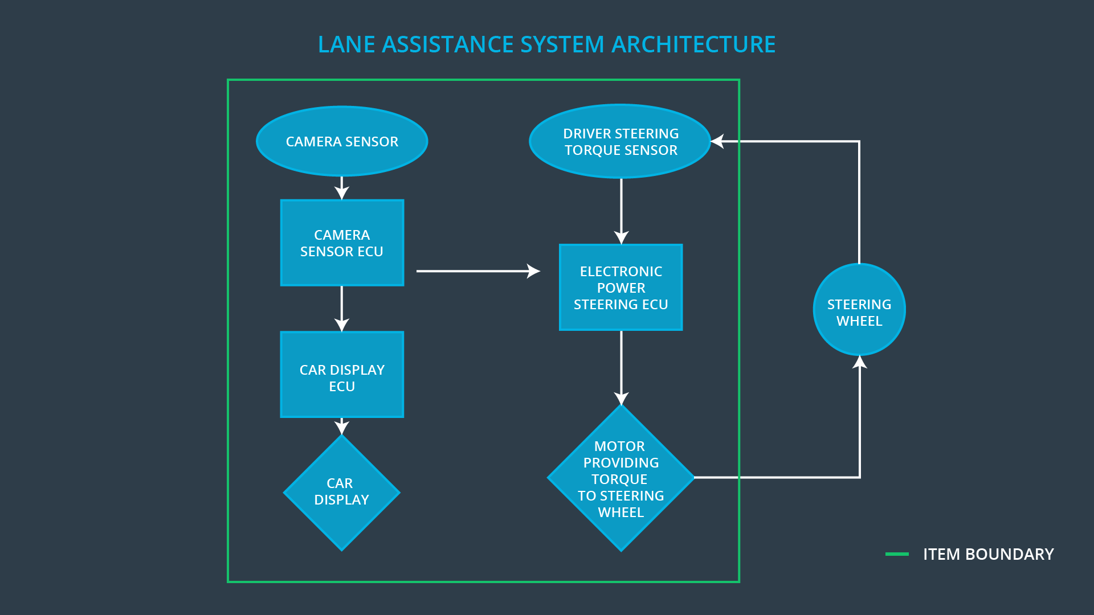

Figure 1: Lane Assistance System Architecture Diagram

### Description of architecture elements

|  |  |
| --- | --- |
| **Element** | **Description** |
| Camera Sensor | Captures images of the road surface and sends the images to the Camera Sensor ECU. |
| Camera Sensor ECU | Receives input from the Camera Sensor. Identifies when the vehicle has accidentally departed the ego lane and sends the appropriate signals to the Car Display ECU and Electronic Power Steering ECU. |
| Car Display | Displays warnings generated by the Car Display ECU to the driver about the status of various subsystems. |
| Car Display ECU | Receives status from the Camera Sensor ECU and Electronic Power Steering ECU and activates lights on the car display if a warning is to be displayed. |
| Driver Steering Torque Sensor | Senses the amplitude and frequency of steering torque and sends the information to the Electronic Power Steering ECU. |
| Electronic Power Steering ECU | Processes steering torque information from the Driver Steering Torque Sensor as well as steering information from the Camera Sensor ECU. Generates signals to the steering motor when haptic feedback or steering adjustments are to be made. |
| Motor | Receives input from the Electronic Power Steering ECU. Adjusts the steering angle by providing the appropriate torque amplitude and frequency to the steering wheel. |

# Functional Safety Concept

The functional safety concept consists of:

* Functional safety analysis
* Functional safety requirements
* Functional safety architecture
* Warning and degradation concept

## Functional Safety Analysis

|  |  |  |  |
| --- | --- | --- | --- |
| **Malfunction ID** | **Main Function of the Item Related to Safety Goal Violations** | **Guidewords (NO, WRONG, EARLY, LATE, MORE, LESS)** | **Resulting Malfunction** |
| Malfunction_01 | Lane Departure Warning (LDW) function shall apply an oscillating steering torque to provide the driver a haptic feedback | MORE | The lane departure warning function applies an oscillating torque with very high torque amplitude (above limit) |
| Malfunction_02 | Lane Departure Warning (LDW) function shall apply an oscillating steering torque to provide the driver a haptic feedback | MORE | The lane departure warning function applies an oscillating torque with very high torque frequency (above limit) |
| Malfunction_03 | Lane Keeping Assistance (LKA) function shall apply the steering torque when active in order to stay in ego lane | NO | The lane keeping assistance function is not limited in time duration which leads to misuse as an autonomous driving function |

## Functional Safety Requirements

Lane Departure Warning (LDW) Requirements:

|  |  |  |  |  |
| --- | --- | --- | --- | --- |
| **ID** | **Functional Safety Requirement** | **ASIL** | **Fault Tolerant Time Interval** | **Safe State** |
| Functional  Safety  Requirement  01-01 | The lane keeping item shall ensure that the lane departure warning oscillating torque amplitude is below Max_Torque_Amplitude | C | 50 ms | LDW will set the oscillating torque amplitude to 0. |
| Functional  Safety  Requirement  01-02 | The lane keeping item shall ensure that the lane departure warning oscillating torque amplitude is below Max_Torque_Frequency | C | 50 ms | LDW will set the oscillating torque amplitude to 0. |

Lane Departure Warning (LDW) Verification and Validation Acceptance Criteria:

|  |  |  |
| --- | --- | --- |
| **ID** | **Validation Acceptance**  **Criteria and Method** | **Verification Acceptance**  **Criteria and Method** |
| Functional  Safety  Requirement  01-01 | Test whether the chosen Max_Torque_Amplitude is appropriate for drivers | When Max_Torque_Amplitude is exceeded, test whether the lane assistance output is set to zero within the 50 ms FTTI by fault injection |
| Functional  Safety  Requirement  01-02 | Test whether the chosen Max_Torque_Frequency is appropriate for drivers | When Max_Torque_Frequency is exceeded, test whether the lane assistance output is set to zero within the 50 ms FTTI by fault injection |

Lane Keeping Assistance (LKA) Requirements:

|  |  |  |  |  |
| --- | --- | --- | --- | --- |
| **ID** | **Functional Safety Requirement** | **ASIL** | **Fault Tolerant Time Interval** | **Safe State** |
| Functional  Safety  Requirement  02-01 | The electronic power steering ECU shall ensure that the lane keeping assistance torque is applied for only Max_Duration | B | 500 ms | The LKA function is turned off. |

Lane Keeping Assistance (LKA) Verification and Validation Acceptance Criteria:

|  |  |  |
| --- | --- | --- |
| **ID** | **Validation Acceptance**  **Criteria and Method** | **Verification Acceptance**  **Criteria and Method** |
| Functional  Safety  Requirement  02-01 | Test whether the chose Max_duration dissuades drivers from removing hands from the steering wheel | Test whether the system turns off if the lane keeping assistance exceeds max_duration |

## Refinement of the System Architecture

The refined System Architecture diagram is found in Figure 2.

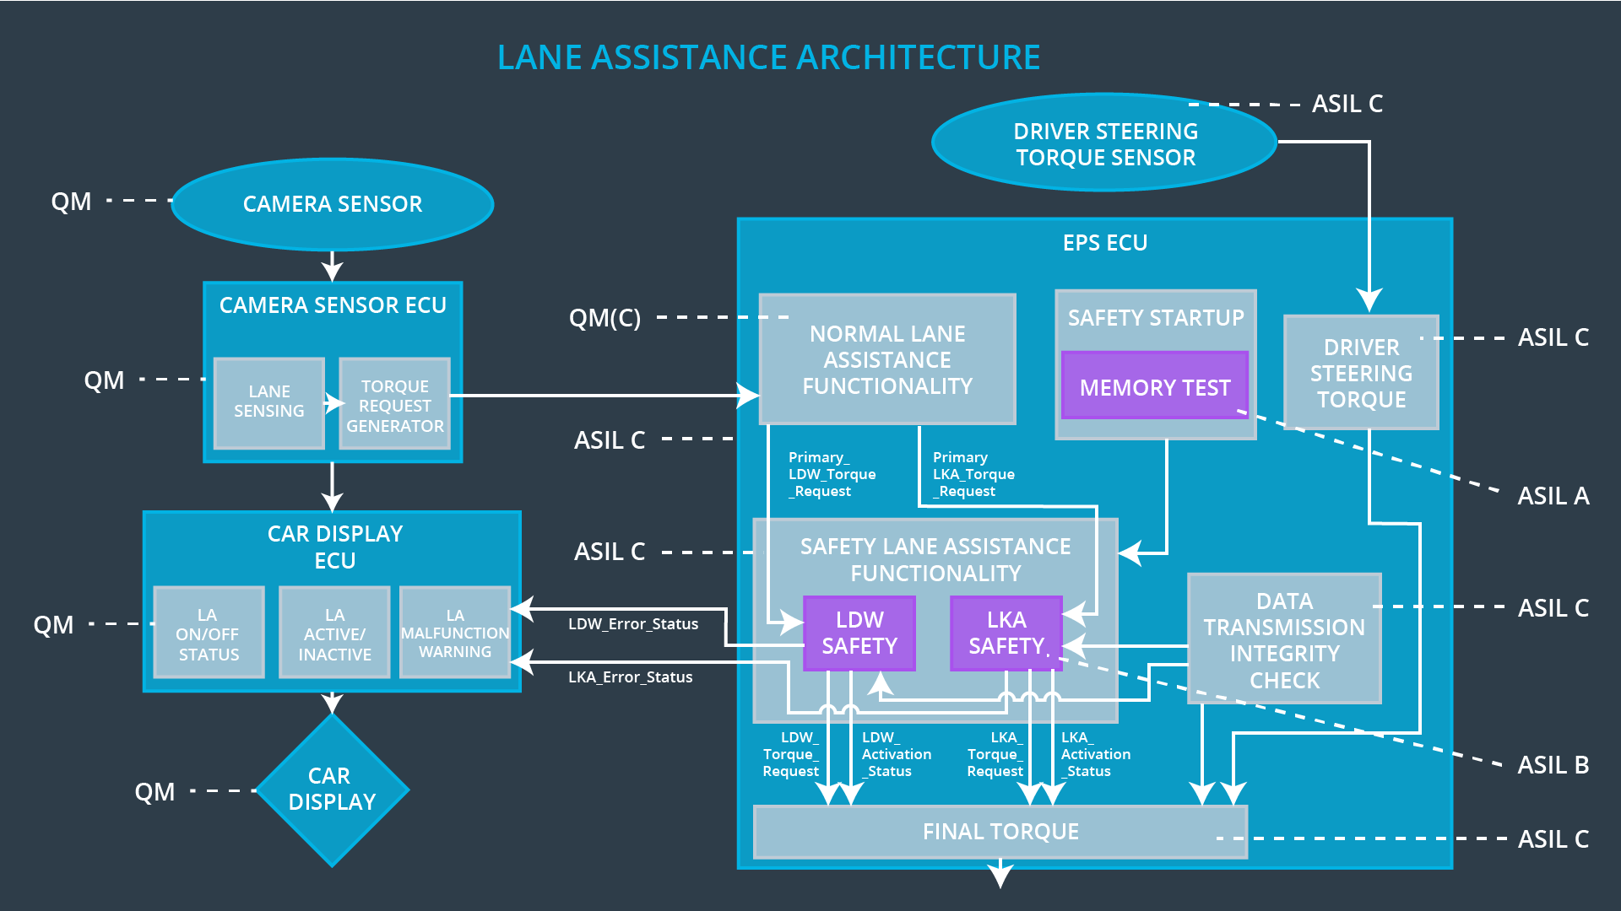

Figure 2: Refined System Architecture

## Allocation of Functional Safety Requirements to Architecture Elements

|  |  |  |  |  |
| --- | --- | --- | --- | --- |
| **ID** | **Functional Safety Requirement** | **Electronic Power Steering ECU** | **Camera ECU** | **Car Display ECU** |
| Functional  Safety  Requirement  01-01 | The lane keeping item shall ensure that the lane departure warning oscillating torque amplitude is below Max_Torque_Amplitude | **X** |  |  |
| Functional  Safety  Requirement  01-02 | The lane keeping item shall ensure that the lane departure warning oscillating torque amplitude is below Max_Torque_Frequency | **X** |  |  |
| Functional  Safety  Requirement  02-01 | The electronic power steering ECU shall ensure that the lane keeping assistance torque is applied for only Max_Duration | **X** |  |  |

## Warning and Degradation Concept

|  |  |  |  |  |
| --- | --- | --- | --- | --- |
| **ID** | **Degradation Mode** | **Trigger for Degradation Mode** | **Safe State invoked?** | **Driver Warning** |
| WDC-01 | Steering torque frequency and/or amplitude are degraded. | Steering torque exceeds Max_Torque_Frequency and/or Max_Torque_Amplitude | Yes | Warning light on dashboard. |
| WDC-02 | Lane keeping assistance function will turn off. | Torque is applied for a duration exceeding Max_Duration | Yes | Warning light on dashboard. |