**SAMPLE serie: YR_3_11Aout2020 / Line 2**

**Peak Position**

From the plots below, the shift of the peaks at the ePDF spectra is not clear, but the Fq plot shows some shift of the peaks (or is it only in my eyes?):

Qmax-inst=13.3 A-1; Qmax=11.8 A-1. R-poly=0.9; Qmin=1.2

Exposure time 2sec:

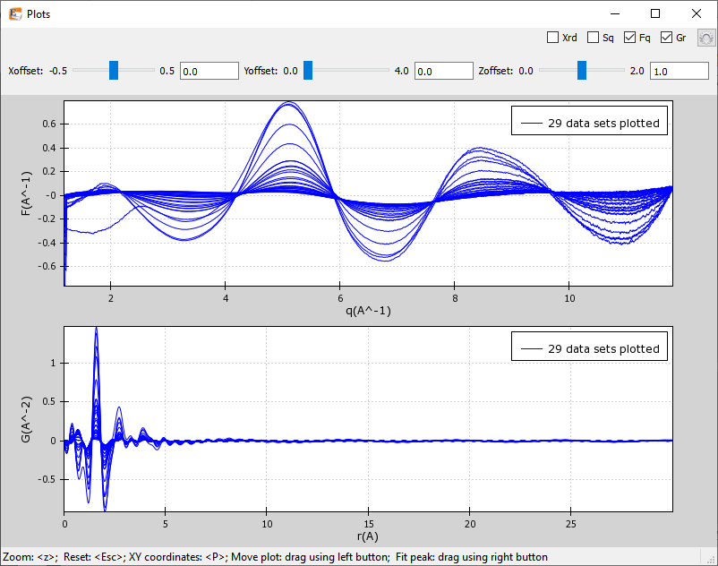

Exposure time 1sec:

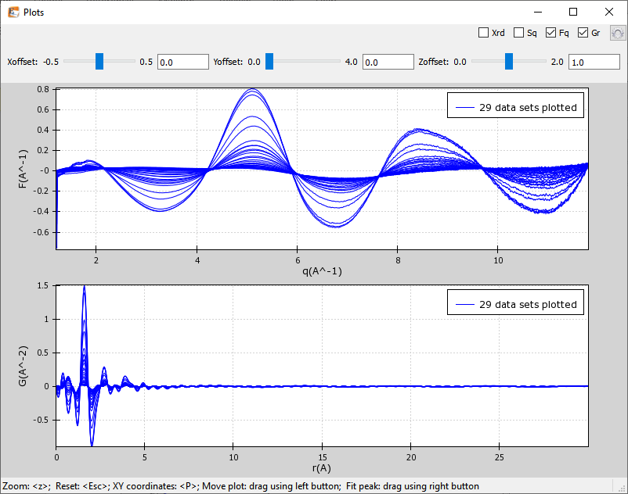

**Peak Height**

Exposure time 1 sec:

Exposure time 2 sec:

**SAMPLE serie: YR_3_13Aout2020 / Line 2b**

**Peak Position**

From the plots below, the shift of the peaks at the ePDF spectra is not clear, but the Fq plot shows some shift of the peaks:

Qmax-inst=13.2 A-1; Qmax=11.7 A-1. R-poly=0.9; Qmin=1.2

Exposure time 2sec:

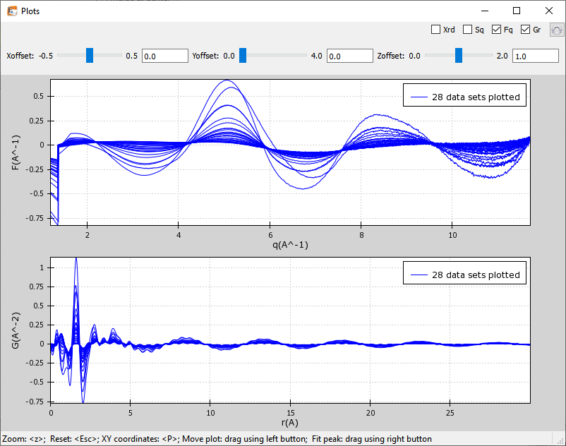

Exposure time 4sec:

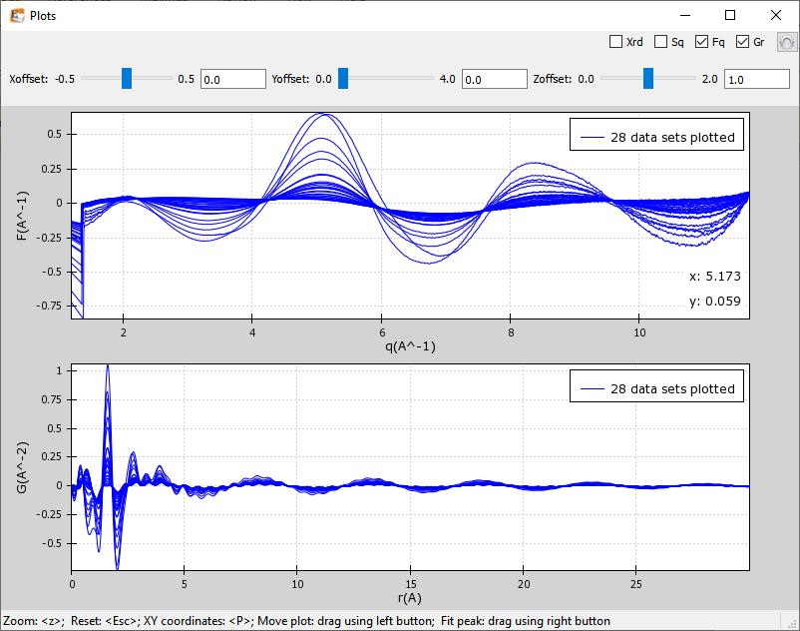

**Peak Height**

Exposure time 2 sec:

Exposure time 4 sec:

**SAMPLE serie: YR_3_14Aout2020 / Line 2c**

**Peak Position**

From the plots below, the shift of the peaks at the ePDF spectra is not clear, but the Fq plot shows some shift of the peaks:

Qmax-inst=13.2 A-1; Qmax=11.7 A-1. R-poly=0.9; Qmin=1.0

Exposure time ?sec:

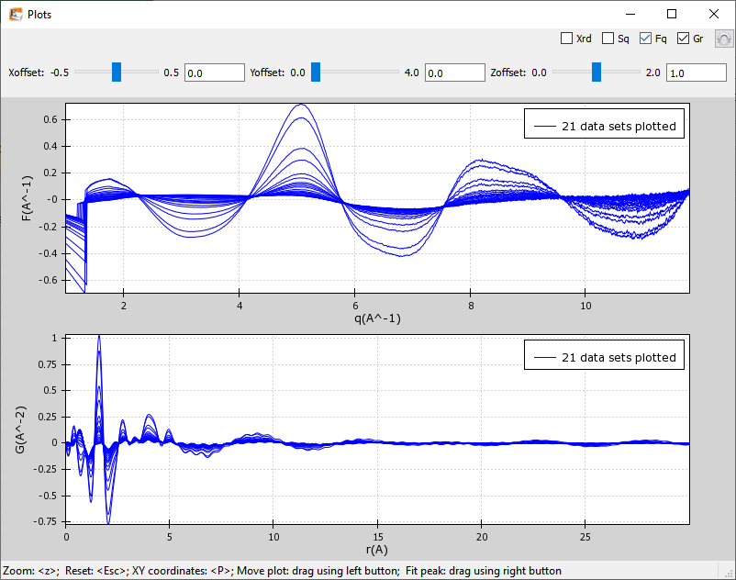

**Peak Height**